1. **Test Chrome extensions**

Step 1: Open Chrome

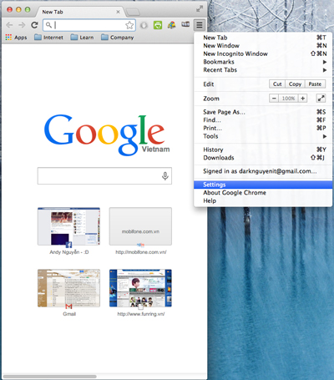

Step 2: Install extensions

1. Select extensions Google Chrome Setting
2. Drag package to Extension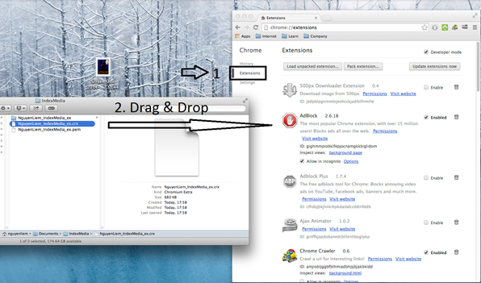

Step 3. Click Add

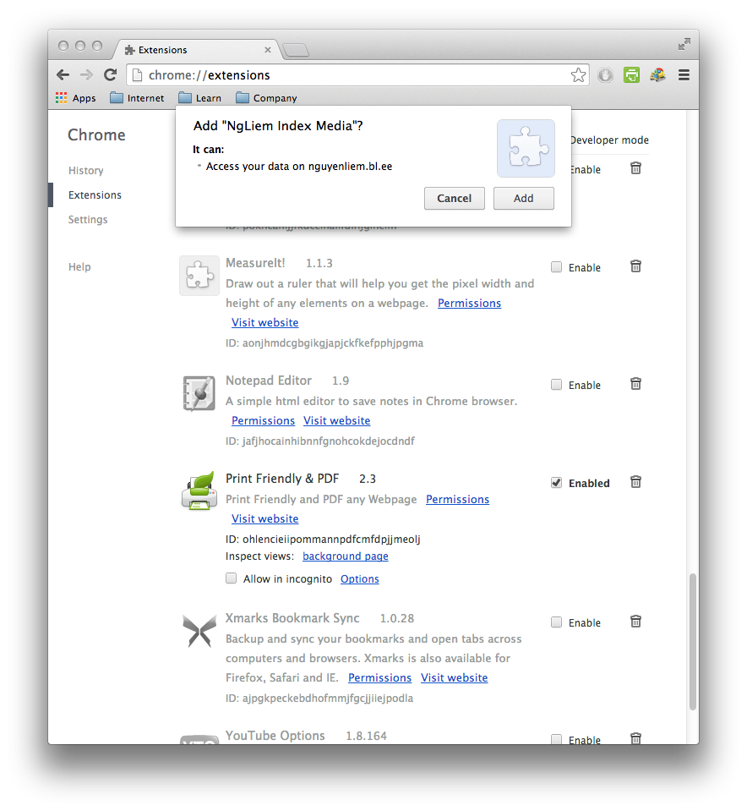

Step4: Check Endabled – make sure it checked.

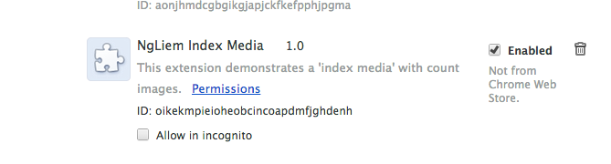

Step 5: Check and click to use extension

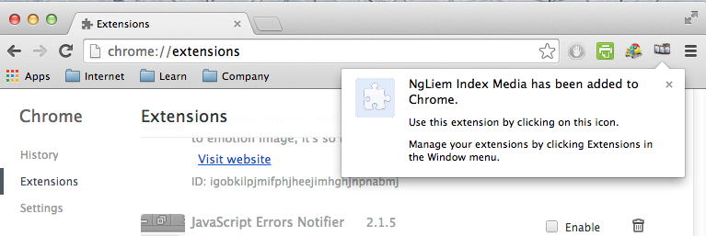

Step6: See result

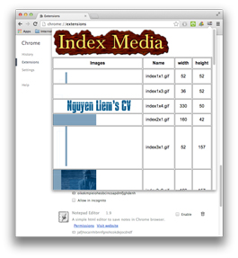

Expect:



1. **Run on web**

Step 1: open web with URL Demo: <http://nguyenliem.bl.ee/indexmedia.html>

* Init bookmarklet by click the link. It’s will create javascript link

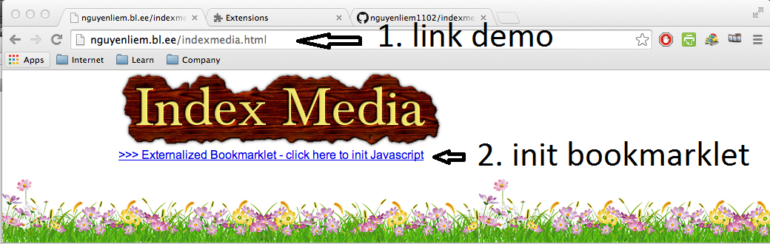

Step 2: click on button count images at page: index2.html (just write and tested on it)

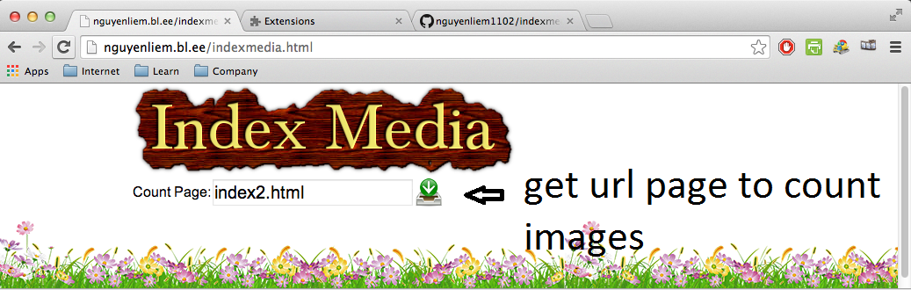

Step3: click button: Ajax post to SERVER. (post Array links Images to SERVER);

* Click WikiFrame to open and search on wiki

