S Project

Software Requirements Specification

2.0

11/06/2024

**Prepared for**

Group4

[1. Introduction](https://docs.google.com/document/d/1haYefIUYDCfefNBvKdEY_NRAqWxsxlUxYnjeq8modUA/edit#heading=h.gjdgxs)

[1.1 Purpose](https://docs.google.com/document/d/1haYefIUYDCfefNBvKdEY_NRAqWxsxlUxYnjeq8modUA/edit#heading=h.30j0zll)

[1.2 Scope](https://docs.google.com/document/d/1haYefIUYDCfefNBvKdEY_NRAqWxsxlUxYnjeq8modUA/edit#heading=h.1fob9te)

[1.3 Definitions, Acronyms, and Abbreviations](https://docs.google.com/document/d/1haYefIUYDCfefNBvKdEY_NRAqWxsxlUxYnjeq8modUA/edit#heading=h.3znysh7)

[1.4 References](https://docs.google.com/document/d/1haYefIUYDCfefNBvKdEY_NRAqWxsxlUxYnjeq8modUA/edit#heading=h.2et92p0)

[2. Specific Requirements](https://docs.google.com/document/d/1haYefIUYDCfefNBvKdEY_NRAqWxsxlUxYnjeq8modUA/edit#heading=h.tyjcwt)

[2.1 External Interface Requirements](https://docs.google.com/document/d/1haYefIUYDCfefNBvKdEY_NRAqWxsxlUxYnjeq8modUA/edit#heading=h.3dy6vkm)

[2.1.1 User Interfaces](https://docs.google.com/document/d/1haYefIUYDCfefNBvKdEY_NRAqWxsxlUxYnjeq8modUA/edit#heading=h.1t3h5sf)

[2.1.2 Hardware Interfaces](https://docs.google.com/document/d/1haYefIUYDCfefNBvKdEY_NRAqWxsxlUxYnjeq8modUA/edit#heading=h.4d34og8)

[2.1.3 Software Interfaces](https://docs.google.com/document/d/1haYefIUYDCfefNBvKdEY_NRAqWxsxlUxYnjeq8modUA/edit#heading=h.2s8eyo1)

[2.1.4 Communications Interfaces](https://docs.google.com/document/d/1haYefIUYDCfefNBvKdEY_NRAqWxsxlUxYnjeq8modUA/edit#heading=h.17dp8vu)

[3.1 Front End Details](https://docs.google.com/document/d/1haYefIUYDCfefNBvKdEY_NRAqWxsxlUxYnjeq8modUA/edit#heading=h.3rdcrjn)

[3.2 Technical Requirements](https://docs.google.com/document/d/1haYefIUYDCfefNBvKdEY_NRAqWxsxlUxYnjeq8modUA/edit#heading=h.26in1rg)

[3.3 Functional validations](https://docs.google.com/document/d/1haYefIUYDCfefNBvKdEY_NRAqWxsxlUxYnjeq8modUA/edit#heading=h.lnxbz9)

[3.4 Classes / Objects](https://docs.google.com/document/d/1haYefIUYDCfefNBvKdEY_NRAqWxsxlUxYnjeq8modUA/edit#heading=h.35nkun2)

[3.5 Non-Functional Requirements](https://docs.google.com/document/d/1haYefIUYDCfefNBvKdEY_NRAqWxsxlUxYnjeq8modUA/edit#heading=h.1ksv4uv)

[3.6 Inverse Requirements](https://docs.google.com/document/d/1haYefIUYDCfefNBvKdEY_NRAqWxsxlUxYnjeq8modUA/edit#heading=h.44sinio)

[3.7 Design Constraints](https://docs.google.com/document/d/1haYefIUYDCfefNBvKdEY_NRAqWxsxlUxYnjeq8modUA/edit#heading=h.2jxsxqh)

[3.8 Logical Database Requirements](https://docs.google.com/document/d/1haYefIUYDCfefNBvKdEY_NRAqWxsxlUxYnjeq8modUA/edit#heading=h.z337ya)

[3.9 Other Requirements](https://docs.google.com/document/d/1haYefIUYDCfefNBvKdEY_NRAqWxsxlUxYnjeq8modUA/edit#heading=h.3j2qqm3)

[4. Analysis Models](https://docs.google.com/document/d/1haYefIUYDCfefNBvKdEY_NRAqWxsxlUxYnjeq8modUA/edit#heading=h.1y810tw)

[5. Change Management Process](https://docs.google.com/document/d/1haYefIUYDCfefNBvKdEY_NRAqWxsxlUxYnjeq8modUA/edit#heading=h.4i7ojhp)

# 1. Introduction

In the current diamond industry landscape, professionals involved in diamond valuation face significant challenges in accurately assessing the quality and value of diamonds. On average, diamond valuation processes consume a considerable amount of time and resources, with professionals spending a substantial portion of their workday on evaluation tasks. This extensive time investment not only impacts operational efficiency but also contributes to delays in customer service and potential revenue loss.Furthermore, the lack of real-time access to market data and pricing information poses a significant challenge for diamond valuation professionals.To address these challenges and enhance the efficiency and accuracy of diamond valuation the Diamond Valuation System (DVS) is a software application designed to facilitate the valuation process of diamonds. This system aims to provide diamond traders, jewelers, and gemologists with a reliable and efficient tool for assessing the quality and value of diamonds based on various parameters such as carat weight, cut, color, clarity, and certification.

## 1.1 Purpose

The primary purpose of the Diamond Valuation System is to streamline the diamond valuation process, enabling users to accurately assess the worth of diamonds quickly and efficiently. By providing comprehensive tools and features, DVS aims to enhance the productivity and accuracy of diamond valuation, ultimately benefiting diamond industry professionals and customers alike.

## 1.2 Scope

The scope of the Diamond Valuation System encompasses the following key aspects:

Customer Request Management: The system will manage customer requests for diamond valuation, including communication with customers, sample reception, valuation execution, result recording, and result delivery.

Valuation Criteria: Users will be able to estimate the value of diamonds based on a wide range of criteria, including diamond origin, shape & cut, measurements, carat weight, color, clarity, cut, proportions, polish, symmetry, and fluorescence.

Certification-based Valuation: The system will allow users to estimate diamond value based on the certification provided by the company's diamond appraisal certificates.

Valuation Process Management: The system will facilitate the management of the diamond valuation process, including workflow tracking, task assignment, status monitoring, and approval management.

Document Generation: Users will be able to generate valuation certificates and sealed reports according to the company's predefined templates, ensuring consistency and professionalism in document presentation.

Seal and Commitment Management: The system will support the creation of sealing protocols and commitment documents for handling cases where customers fail to collect valuation results or lose valuation receipts, requiring managerial approval for execution.

Pricing and Service Configuration: Users will be able to configure pricing tables and service timelines for different types of valuation services offered by the company.

Parameter Configuration: The system will allow users to define and synchronize parameter datasets used in the valuation process, ensuring alignment with industry standards and online jewelry business platforms.

Dashboard and Reporting: The system will provide a dashboard for statistical analysis and reporting, offering insights into valuation performance, customer trends, and operational efficiency.

By addressing these aspects, the Diamond Valuation System aims to provide a comprehensive and efficient solution for diamond valuation management, catering to the needs of jewelry companies and professionals in the industry.

## 1.3 Definitions, Acronyms, and Abbreviations

|  |  |
| --- | --- |
| **Abbreviation** | **Word** |
| DVS | Diamond Valuation System |
| SRS | Software Requirements Specification |
| CRM | customer relationship management |
| UI | User Interface |
| UX | User Experience |
| API | Application Programming Interface |
| GUI | Graphical User Interface |
| SQL | Structured Query Language |
| HTTPS | Hypertext Transfer Protocol Secure |
| MTBF | Mean Time Between Failures |
| MTTR | Mean Time To Repair |
| GIA | Gemological Institute of America |
| IGI | International Gemological Institute |
| IDC | International Diamond Council |
| W3C | World Wide Web Consortium. |

## 1.4 References

*Nil*

# 2. Specific Requirements

The Bank will have 2 roles

1. Manager
2. Customer

Following features/modules will be available to these 2 different roles

|  |  |
| --- | --- |
| **Manager** | **Customer** |
| New Customer | Balance enquiry |
| Edit Customer | Fund Transfer |
| Delete Customer | Mini Statement |
| New Account | Customized Statement |
| Edit Account | Change Password |
| Delete Account | Login & Logout |
| Deposit |  |
| Withdrawal |  |
| Fund Transfer |  |
| Change Password |  |
| Balance Enquiry |  |
| Mini Statement |  |
| Customized Statement |  |
| Login & Logout |  |

Description of the modules

|  |  |  |
| --- | --- | --- |
| **Module Name** | **Applicable**  **Roles** | **Description** |
| Balance Enquiry | Manager  Customer | **Customer:** A customer can have multiple bank accounts. He can view balance of his accounts only  **Manager:** A manager can view balance of all the customers who come under his supervision |
| Fund Transfer | Manager  Customer | **Customer:** A customer can have transfer funds from his “own” account to any destination account.  **Manager:** A manager can transfer funds from any source bank account to destination account |
| Mini Statement | Manager  Customer | A Mini statement will show last 5 transactions of an account  **Customer:** A customer can see mini-statement of only his “own” accounts  **Manager:** A manager can see mini-statement of any account |
| Customized Statement | Manager  Customer | A customized statement allows you to filter and display transactions in an account based on date, transaction value  **Customer:** A customer can see Customized- statement of only his “own” accounts  **Manager:** A manager can see Customized -statement of any account |
| Change Password | Manager  Customer | **Customer:** A customer can change password of only his account.  **Manager:** A manager can change password of only his account. He cannot change passwords of his customers |
| New Customer | Manager | **Manager:** A manager can add a new customer. |
|  | Manager | **Manager:** A manager can edit details like address, email , telephone of a customer. |
| New Account | Manager | Currently system provides 2 types of accounts   * Saving * Current   A customer can have multiple saving accounts (one in his name , other in a joint name etc).  He can have multiple current accounts for different companies he owns.  Or he can have a multiple current and saving accounts.  **Manager:** A manager can add a new account for an existing customer. |
| Edit Account | Manager | **Manager:** A manager can add a edit account details for an existing account |
| Delete Account | Manager | **Manager:** A manager can add a delete an account for a customer. |
| Delete Customer | Manager | A customer can be deleted only if he/she has  no active current or saving accounts  **Manager:** A manager can delete a customer. |
| Deposit | Manager | **Manager:** A manager can deposit money into any account. Usually done when cash is deposited at a bank branch. |
| Withdrawal | Manager | **Manager:** A manager can withdraw money from any account. Usually done when cash is withdrawn at a bank branch. |

## 2.1 External Interface Requirements

### 2.1.1 User Interfaces

None

### 2.1.2 Hardware Interfaces

None

### 2.1.3 Software Interfaces

None

### 2.1.4 Communications Interfaces

None

## 3.1 Front End Details

This section describes the Front end of Bank.

It also lists a few use cases to describe the functioning of the system

Following is a list of module wise fields

**Fund Transfer**

* Payers account no
* Payees account no
* Amount
* Submit
* Reset

**Change Password**

* Old Password
* New Password
* Confirm Password
* Submit
* Reset

**Balance enquiry**

* Account No
* Submit
* Reset

**Mini Statement**

* Account No
* Submit
* Reset

**Customized Statement**

* Account No
* From Date
* To Date
* Minimum Transaction Value
* Number Of Transaction
* Submit
* Reset

**New Customer**

* Customer Name
* Gender
* Date of Birth
* Address
* City
* State
* PIN
* Mobile Number
* Email Id
* Submit
* Reset

**New Account**

* Customer Id
* Account Type
* Initial deposit
* Submit
* Reset

**Deposit**

* Account Number
* Amount Deposit
* Description
* Submit
* Reset

**Withdraw**

* Account Number
* Amount
* Description
* Submit
* Reset

**Fund Transfer**

* Payers Account Number
* Payees Account Number
* Amount
* Description
* Submit
* Reset

**Change Password**

* Old Password
* New Password
* Confirm Password
* Submit
* Reset

**Delete Customer**

* Customer Id
* Submit
* Reset

**Edit Account**

* Account Number
* Submit
* Reset

**Form after submitting Edit Account**

* Customer Id (Disabled)
* Account Type (Drop Down - Saving or Current)
* Balance (Disabled)
* Submit
* Reset

**Delete Account**

* Account Number
* Submit
* Reset

**Edit Customer**

* Customer Id
* Submit
* Reset

**Form after submitting Edit Customer**

* Customer Name (Disabled)
* Gender (Disabled)
* Date of Birth (Disabled)
* Address
* City
* State
* PIN
* Mobile Number
* Email Id
* Submit
* Reset

## 3.2 Technical Requirements

**Sign up new account**

**T1** Username - Username is required

**T2** Username - First character cannot have space

**T3** Username - At least 4 character

**T4** Full name - Full name is required

**T5** Full name - First character cannot have space

**T6** Full name - No number allowed

**T7** Full name - Full name cannot contain special characters

**T8** Phone number - Phone number is required

**T9** Phone number - First number cannot have space

**T1**0 Phone number - Phone number must be 10 number

**T11** Phone number - Phone number cannot have space between number

**T12** Phone number -  Character are not allowed

**T13** Password - Password is required

**T14** Password -  Password must be 8 character

**T15** Confirm password - Confirm password is required

**T16** Confirm password - Confirm password must be match with password

## 3.3 Functional validations

**Balance Enquiry**

Manager

**F1** Manager can view balance of accounts associate with him

**F2** Account number entered should exist in database

Customer

**F3** Customer can view balance of only his accounts

**F4** Account number entered should exist in database

**Fund Transfer**

Manager

**F5** If these source and destination account numbers are invalid, system displays an error

**F6** If these source and destination account numbers are same, system displays an error

**F7** If the source account does not have the necessary balance, system displays an error

**F8** If the source account does not associated with manager, System displays an error

Customer

**F9** If the destination account number is not valid, system displays an error

**F10** If these source and destination account numbers are same, system displays an error

**F11** If the source account does not have the necessary balance, system displays an error

**F12** If the source account is not associate with customer itself, System displays an error.

**Withdrawal**

Manager

**F13** If source account number is invalid, system displays an error

**F14** If source account does not have the necessary balance, system displays an error

**F15** If source account does not associate with manager, System displays an error.

Customer

**F16** If source account number is invalid, system displays an error

**F17** If source account does not have the necessary balance, system displays an error

**F18** If source account does not associate with customer, System displays an error.

**Deposit**

Manager

**F19** If destination account number is invalid, system displays an error

**F20** If destination account number does not associate with manager, System displays an error.

Customer

**F21** If destination account number is invalid, system displays an error

**F22** If destination account number does not associate with customer, System displays an error.

**Delete Customer**

Manager

**F23** If Customer Id is invalid, system displays an error.

**F24** If account associate with Customer Id, System displays an error.

**F25** If Customer Id does not associate with manager, System displays an error.

**Delete Account**

Manager

**F26** If Account Number is invalid, system displays an error

**F27** If account does not associate with manager logged in, System displays an error.

**Edit Account**

Manager

**F28** If Account Number is invalid, system displays an error.

**F29** If Account number does not associate with manager, System displays an error.

**New Account**

Manager

**F30** If Customer ID is invalid, system displays an error.

**F31** If initial deposit is less than 500, System displays an error.

**F32** If Customer Id does not associate with manager, System displays an error.

**New Customer**

Manager

**F33** If same Email Id exist in the system, system shows an error.

**Edit Customer**

Manager

**F34** If same Email Id exist in the system, system shows an error.

**F35** If Customer Id is invalid, System displays an error.

**F36** If Customer Id does not associate with Manager, System displays an error.

**Change Password**

Manager

**F37** If Old Password is invalid, System shows an error.

Customer

**F38** If Old Password is invalid, System displays an error

**Customized Statement**

Manager

**F39** If account no is invalid, System displays an error

**F40** If From Date is greater than To Date, System dispalys an error.

Customer

**F41** If account no is invalid, System displays an error

**F42** If From Date is greater than To Date, System displays an error.

**Mini Statement**

Manager

**F43** If account no is invalid, System displays an error

**F44** If transaction not exist in system, System displays an error.

**F45** If account not associate with manager itself, System displays an error.

Customer

**F46** If account no is invalid, System displays an error.

**F47** If account associate with customer itself, System displays an error.

**Balance Enquiry**

Manager

**F48** If account no is invalid, System displays an error

Customer

**F49** If account no is invalid, System displays an error

## 3.4 Classes / Objects

3.5.1.1 Attributes

3.5.1.2 Functions

## 3.5 Non-Functional Requirements

Nil

## 3.6 Inverse Requirements

Nil.

## 3.7 Design Constraints

Many of the Bank users may not have adequate computer knowledge to use the site. Hence, System must be intuitive and easy to understand.

## 3.8 Logical Database Requirements

Nil

## 3.9 Other Requirements

Nil

# 4. Analysis Models

Nil

# 5. Change Management Process

Changes to the SRS either from the development, testing team or the client side will be communicated to the project sponsor Mr Krishny Rungtasha.

Any change made to the SRS will require a sign off from the Development lead , QA lead and the client.

Once approved changed will be made to the SRS and the new SRS will be circulated to all stakeholders

**A. Appendices**

*Nil*

**Link**: <http://demo.guru99.com/V2/>

# 6. UI

Home

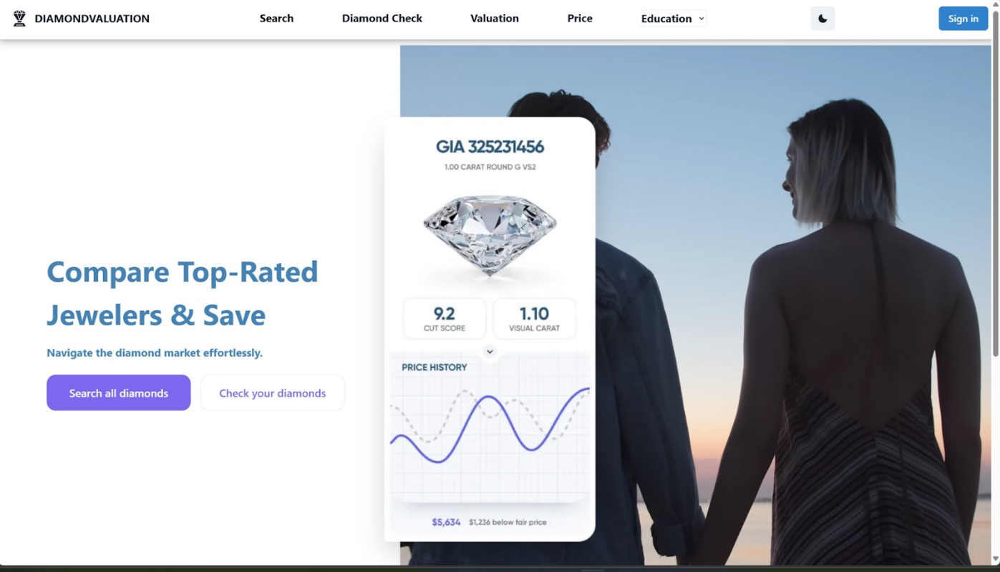

Search

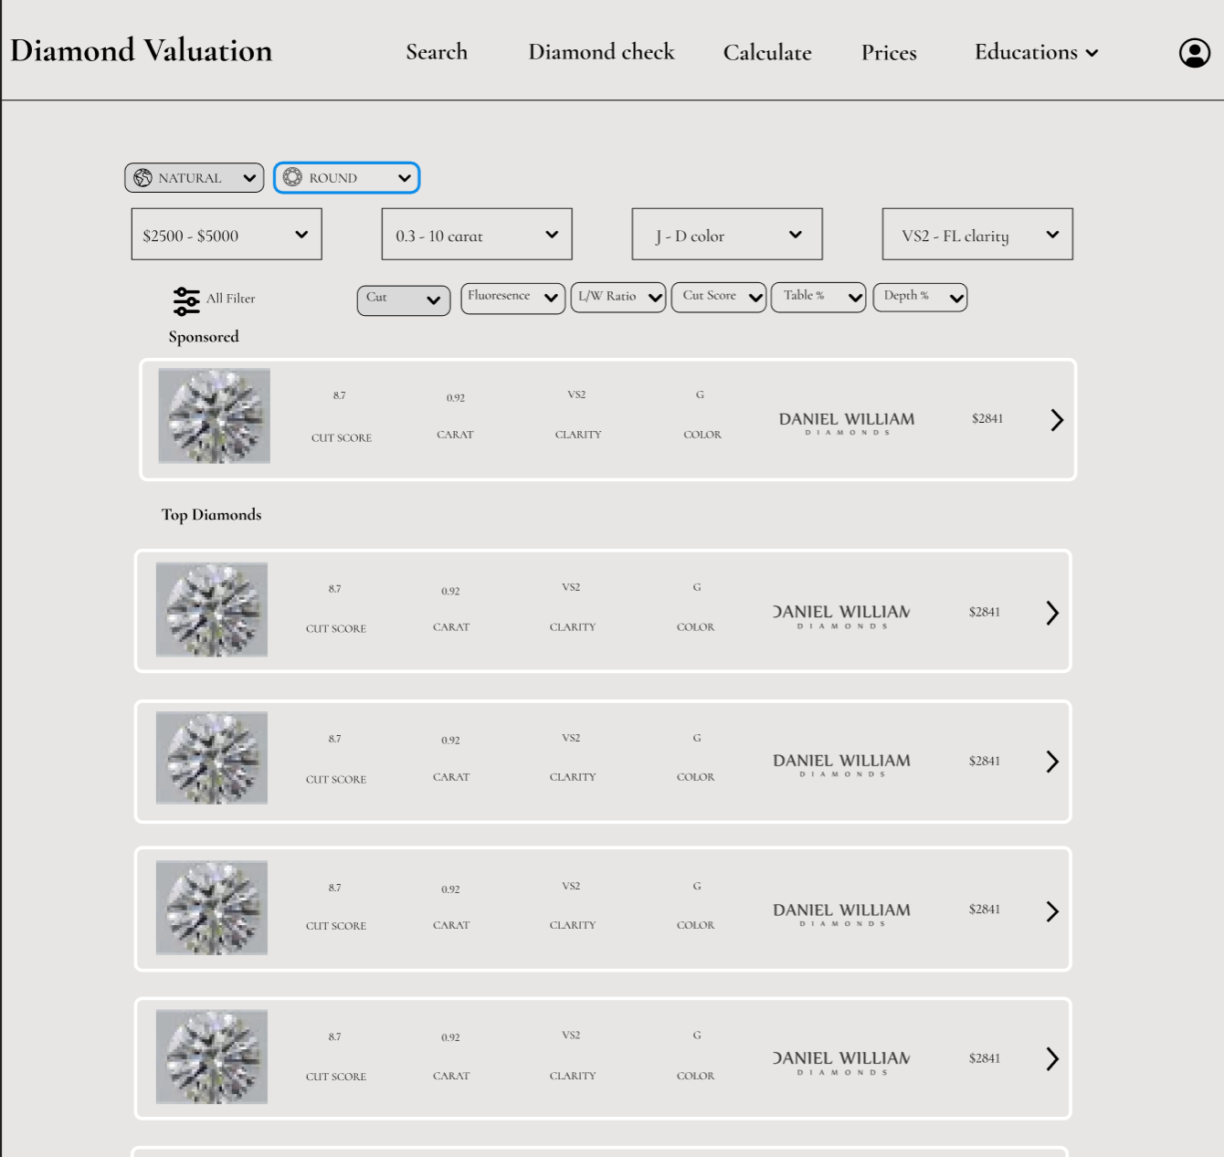

Valuation

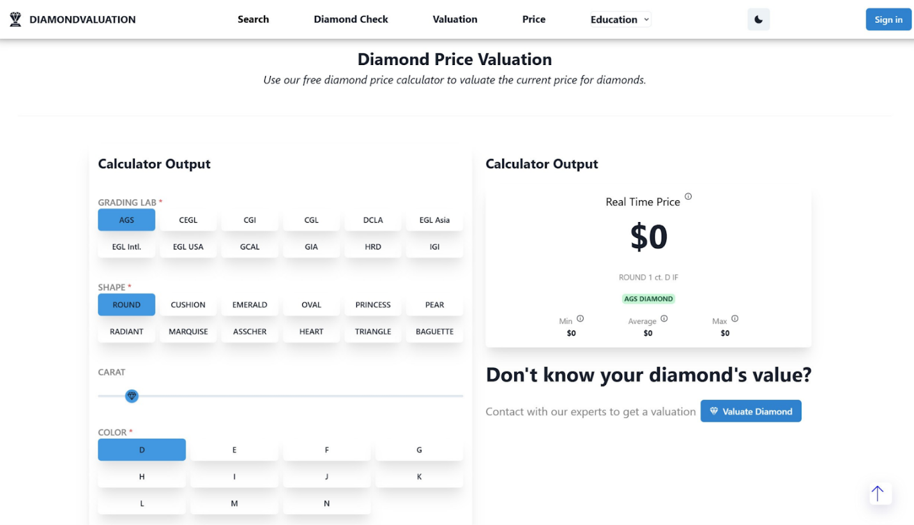

Check Diamond

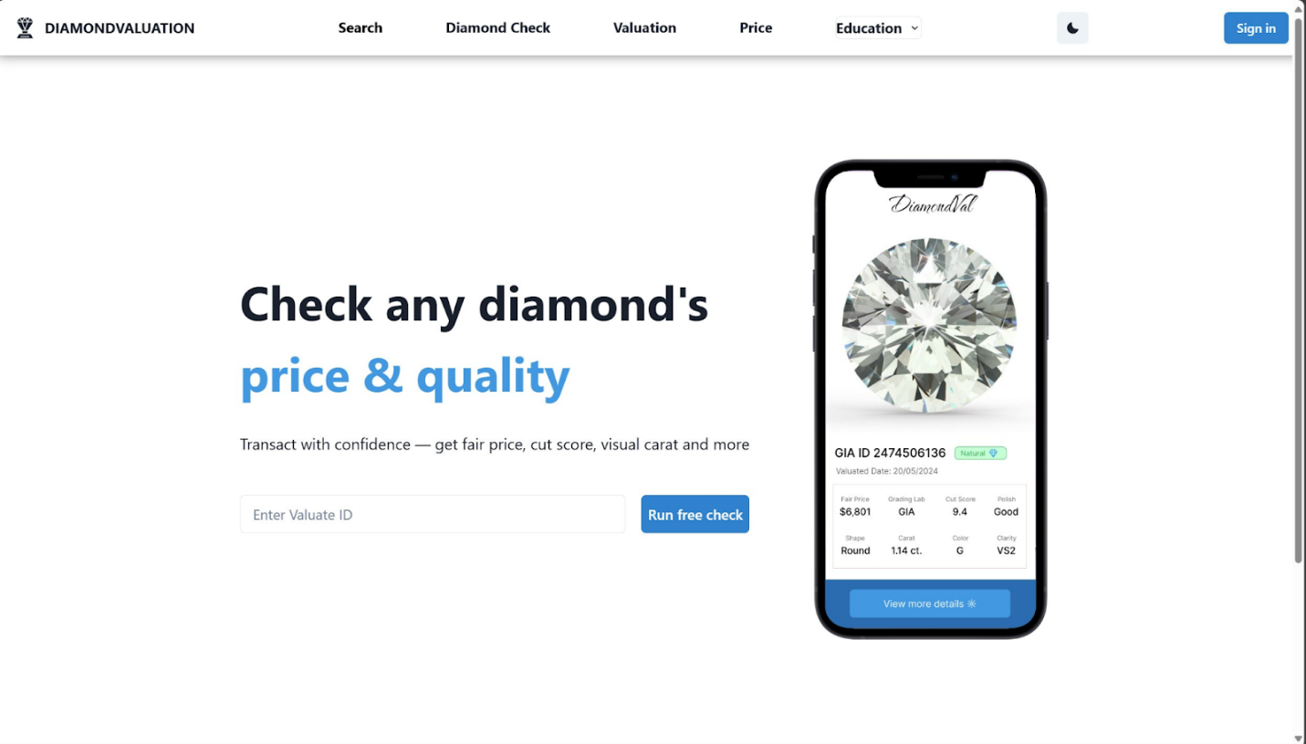

Check result

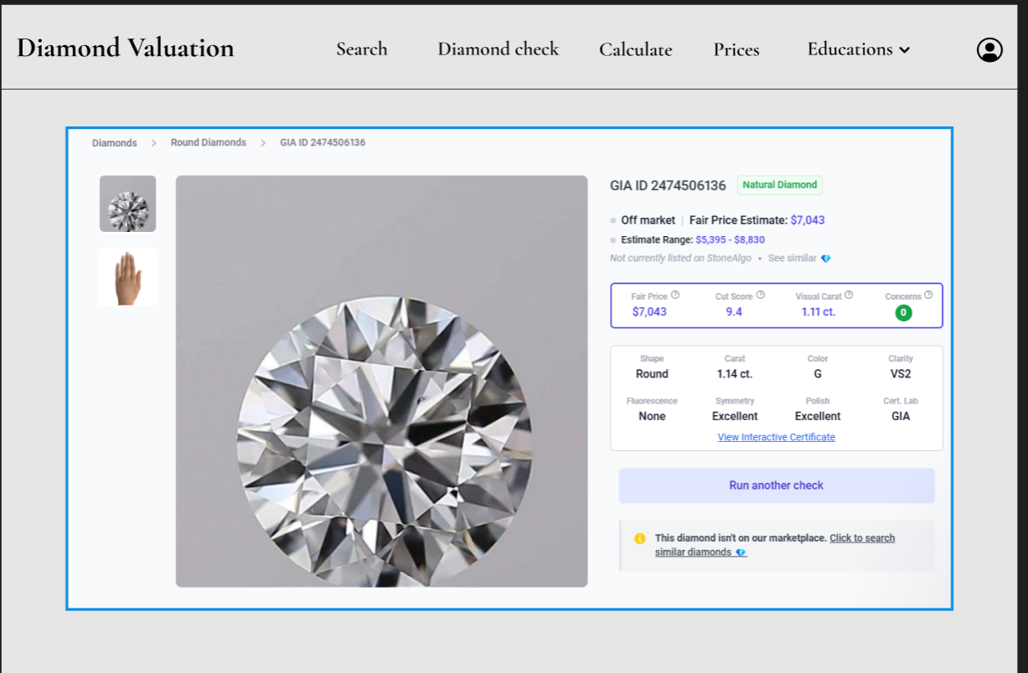

Price

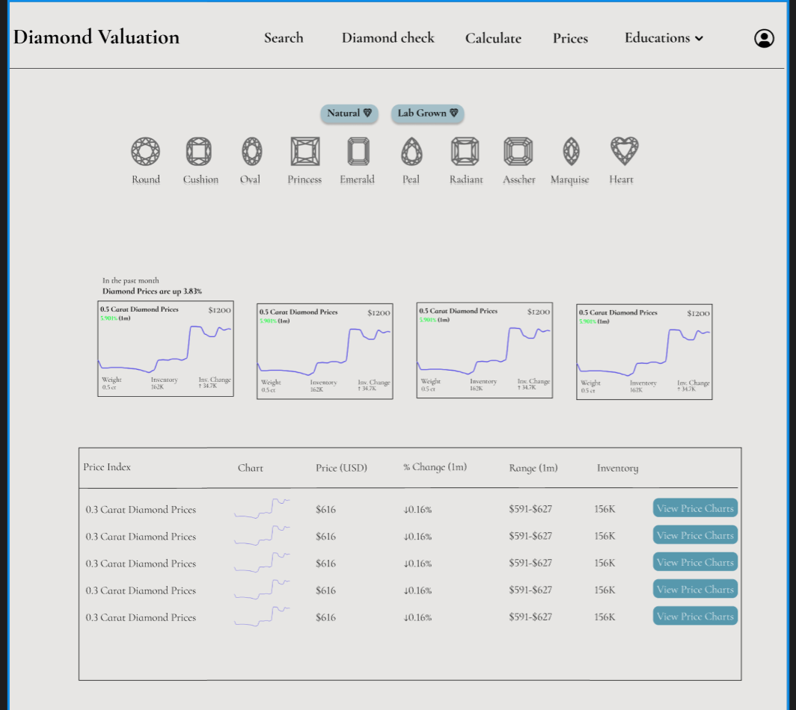

Education

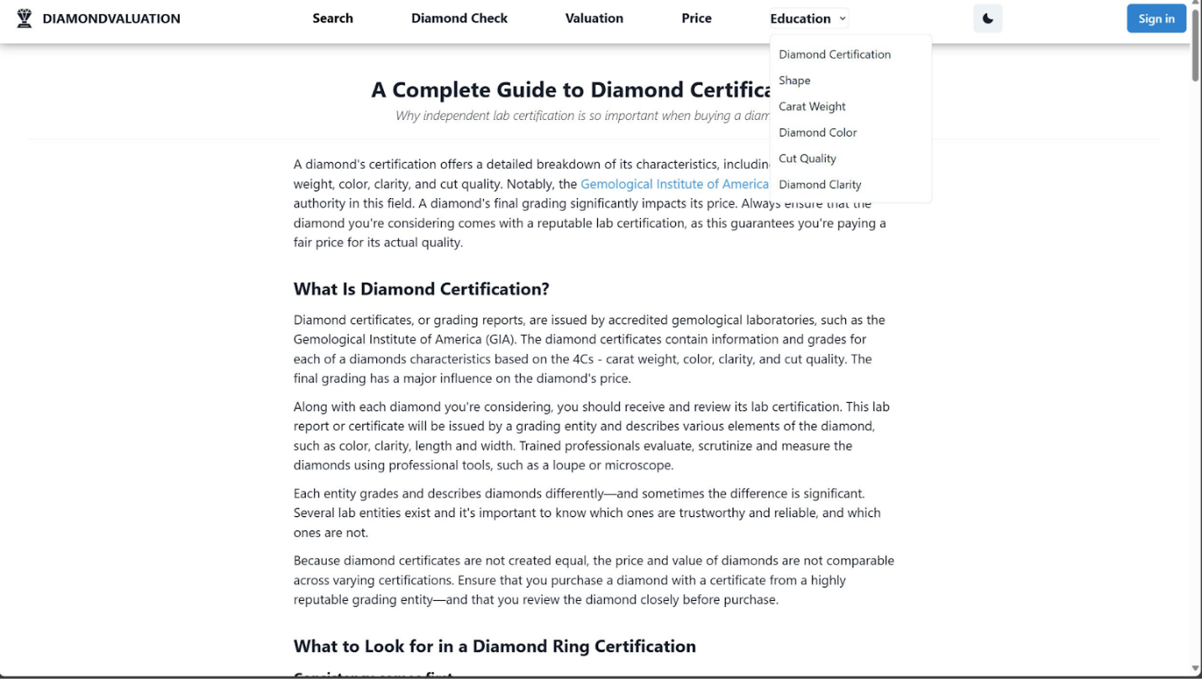

# 7. ERD

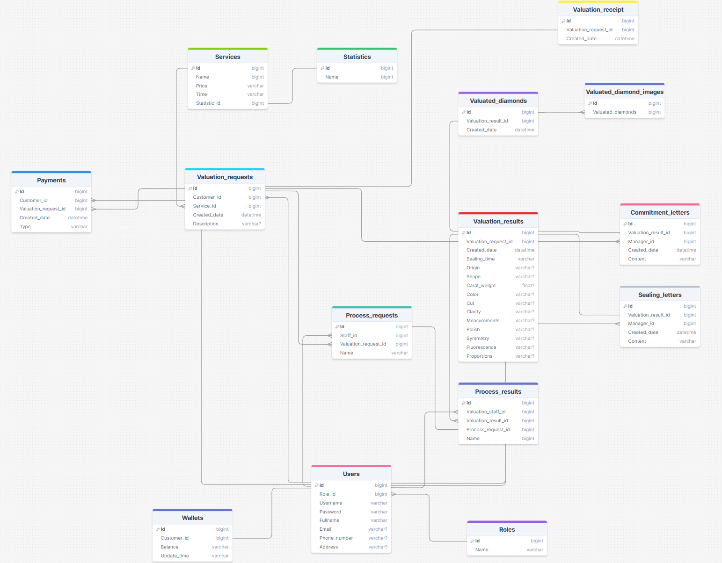

# 8. UC List

|  |  |  |  |
| --- | --- | --- | --- |
| **ID** | **Use Case** | **Actors** | **Use Case Description** |
| UC-01 | Login System | Customer,  Manager,  Admin,  Consulting staff,  Valuation staff | Logging into the system |
| UC-02 | Register | Customer,  Manager,  Admin,  Consulting staff,  Valuation staff | Registering a new account. |
| UC-03 | Change Password | Customer,  Manager,  Admin,  Consulting staff,  Valuation staff | Users change their password for security purposes. |
| UC-04 | Confirm Password | Customer,  Manager,  Admin,  Consulting staff,  Valuation staff | Users confirm their password when register |
| UC-05 | Search Diamond | Customer,  Manager,  Admin,  Consulting staff,  Valuation staff | Search products by diamond criteria |
| UC-06 | View result valuation | Customer | Customers view the valuation results of their diamonds |
| UC-07 | Contact | Customer,  Consulting staff | Consulting Staff members contact customers when customers make requests |
| UC-08 | Evaluate through criteria | Customer | Customers evaluate diamonds through available criteria |
| UC-09 | valuate through request | Customer | Customer submits request for diamond valuation |
| UC-10 | Approve the sealed minutes | Manager | Management approves diamond sealing minutes |
| UC-11 | Approve the commitment letter | Manager | Management approves commitment forms to receive customer valuation samples |
| UC-12 | Declare Pricing list | Manager | The manager declares and updates the pricing list for products or services offered by the company. |
| UC-13 | Declare service performance time | Manager | This Use Case defines the procedure for a manager to declare the performance time for a specific service. |
| UC-14 | Declare Valuation Parameters | Manager | the Manager sets or updates the parameters that are used to determine the valuation of services or products. |
| UC-15 | Send results and valuation samples | Consulting staff | Consulting staff sends results and valuation samples to customers |
| UC-16 | Receive samples | Consulting staff | Private employees still receive diamond samples from customers |
| UC-17 | Prepare valuation receipts | Consulting staff | The consultant staff prepares the valuation receipt |
| UC-18 | Record data | Manager | Manager is recording or updating data into the system |
| UC-19 | View reports | Manager | views various reports via the system. |
| UC-20 | generate monthly report | Manager | Manager generates a monthly report for business analysis and strategic decision-making purposes. |
| UC-21 | Synchronize price data | Manager | Manager synchronizes price data in the system to maintain up-to-date pricing information of products or services |
| UC-22 | update price | Manager | Manager updates the price of a product or service in the system in accordance with the latest market conditions or internal business decisions |
| UC-23 | Print valuation paper | Valuation staff | Valuation Staff will generate and print a valuation report based on the value evaluated for a particular product or service. |
| UC-24 | Evaluate samples | Valuation staff | Valuation Staff assess the quality of product samples and decide their value according to the established valuation procedures |
| UC-25 | Analysis samples | Valuation staff | Valuation Staff analyzes the samples to determine their quality. |
| UC-26 | Create a Sealing record | Valuation staff | Valuation Staff creates a sealing record, documenting all the information about the sealing operation |
| UC-27 | Make a commitment document | Valuation staff | Valuation Staff creates a commitment document, manifesting the commitment towards the agreed upon terms and conditions for certain operations, dealings, or responsibilities |
| UC-28 | Grant access | Admin | Admin grants access to specific system functionalities or information for users based on their roles and responsibilities. |
| UC-29 | Update staff | Admin | The admin updates information or status of the staff as per requirement or changes in circumstances. |
| UC-30 | Create staff | Admin | Admin creates new staff profiles in the system upon recruitment or addition of new personnel. |
| UC-31 | View staff | Admin | View all information about each staff in system |
| UC-32 | Delete staff | Admin | Admin removes a staff profile from the system due to reasons such as termination, retirement, or role change. |