**Project outline - Movie Streaming Service Database System  
1. Context**

The explosive growth of streaming platforms like Netflix, Disney+, and HBO Max has led to a significant demand for efficient data management systems. These platforms handle enormous amounts of data related to users, content, interactions, and payments. For example, Netflix processes data from millions of users daily, including their viewing history, subscription status, and personalized recommendations.

To meet these demands, the system must ensure fast data retrieval, high concurrency handling, and stability to serve millions of simultaneous users. Efficient data management is crucial for both operational performance and user experience. A system capable of analyzing user behavior, tracking watch times, and managing large-scale payments is essential for streaming platforms.

Moreover, users expect personalized content recommendations tailored to their tastes, meaning the system needs to aggregate and analyze viewership data to offer content suggestions in real-time. For instance, Netflix offers movie suggestions based on a user's past watching habits, providing a tailored experience that enhances engagement.

**2. Descriptions**

The movie streaming service database system is designed to manage user subscriptions, payments, and content.

Each account is uniquely identified by an id, some attributes of user account including password hash, account status (active/on hold/suspended/deleted), their name (first name and last name) and their nationality.

An account can subscribe to a pre-determined subscription pack. The avaialable subscription packs differs by level of access (1, 2, 3 – Default level is 1) and duration ( 6 months and 12 months). When they pay for the pack, a record of that subscription is added. Each level can access a certain number of contents. When a user is created, the user will automatically subscribe to a level 1 pack with unlimited duration.

Each content (includes movies and series) contains at least 1 episode. We consider movies as a series that have only one episode, however they will still be differentiated by content type: movies or series. Each content can belong to many different genres and involves different actors or actresses. Each content also has a list of available subtitles which correspond to some countries.

Each time an user watches an episode, the timestamp and the last checkpoint of the episodes will be recorded. We also consider if the user has finished their movies or not. Users can also mark some contents as their favorite and rate each content by giving a point from 1 to 5.

**3. Requirements:**

* **User authentication**: new users can register account(s) to use the service
* **Purchasing subscription**: users can choose between several pre-defined subscription packs, each with its own limitation, and purchase it for a certain amount of time. Users can choose to unsubscribe any time they want and see their payment history.
* **Browsing**: users can search for content by genre, keywords (in title/description), by actor, director. The system will show what contents match the keywords, sorted by rating.
* **Personalized experience:** users can watch content, add content to their own favourite list, rate the content, see their history.

**\*\* Recommendation system**: a procedure runs behind the system to recommend contents to users. Each action (viewing content, whether they finished watching it, view history, browsing history) will be accounted for the procedure.

**Different types of recommendations:**

* **By accumulated views in recent time period.** Users are recommended to watch contents viewed most by accounts in the same geographical location. Criteria that also used including average age of user and release date. How much each criterion contributes to the order of recommendation is taken by weighted sum.
* **By user historical data.**

Genre: Through watching history, selecting genre with most content watched by user, prioritized by recent date, then recommend contents from that genre.

Director/actor: select director/actor with most content watched by user, prioritized by recent date, then recommend content also has that director/actor.

Contents with available subtitles in user’s language of choice will also be prioritized.

* **By similarity of 2 users:**

For a target user, select some other users and compare their historical rating of the same content. Using Pearson correlation

**Regular user:**

- Authentication process (registration, login procedure, managing account details)

- Content browsing, query for content based on genres, ratings, or recommendations by the system.

- User interactions: adding to favorite playlist, leaving ratings, purchasing subscriptions

**Content Producer:**

- Can create, delete content entries, updating metadata attributes (description) belonging to their ID

- Add, update, remove episodes within series entries belong to their ID

**Administrators:**

- Having full access to all database tables

- Create, read, update and delete all records across all tables

- Update system settings (modify relation & constraint)

* Sub-division: **Content Manager**

- Limiting access to content-related (Content, Movies, Series, Episodes) tables

- Create, read, update, delete content entries

**User Manager**

- Limiting access to user profile related (User, Subscription, ...) tables

- Create, read, update, delete user account, update account status

**Data Analysts**

**-** Read access to all tables, including user activity logs and viewing statistics

**4. ERD**

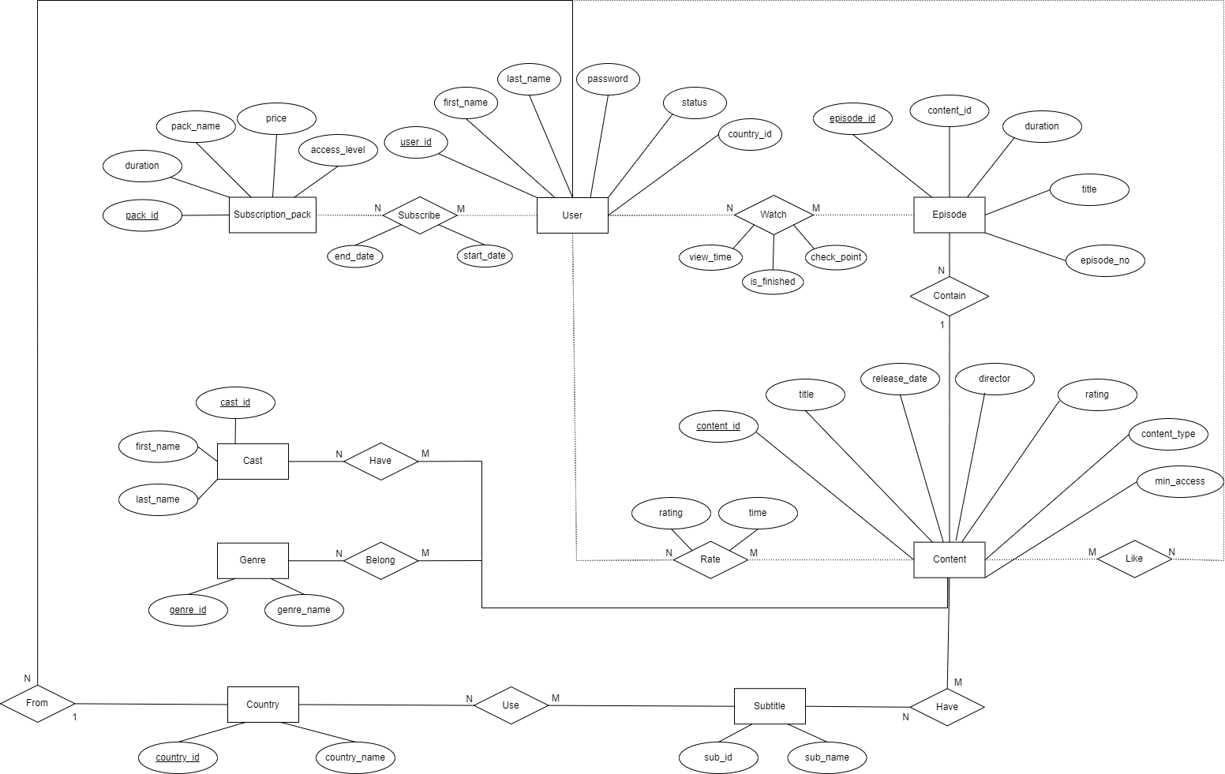

**Entities:**

1. User  
   Represents individuals who are using the streaming platform.
2. Country  
   Represents the countries where users are located.
3. Subscription_pack  
   Represents various subscription plans available on the platform. These packs may differ in pricing, duration, and the level of access they provide.
4. Content  
   Represents movies or series. Each piece of content contains basic information, such as title and director, and it can belong to various genres. Content may also be rated by users and linked to multiple episodes or 1 for movies.
5. Episode  
   Represents individual episodes
6. Cast  
   Represents the actors and actresses featured in the platform's content. Multiple cast members can be associated with the same content, and a single actor can appear in multiple shows or movies.
7. Genre  
   Represents different categories or genres of content, such as drama, comedy, or action. A single content item can belong to multiple genres, and genres help users discover content of their interest.
8. Subtitle  
   Represents subtitles available for the content.

**Relationships:**

1. Subscribe (between User and Subscription_pack)  
   A user can subscribe to multiple subscription packs. Each subscription pack has its own duration, which is independent of other packs. Therefore, if a user subscribes to multiple packs, the total duration of their subscriptions is not cumulative.  
   Many-to-Many (N-M)
2. Accessed (between User_level and Content)  
   Indicates which content items are accessible at a given user level. Higher levels may unlock more exclusive content.  
   Many-to-Many (N-M)
3. From (between User and Country)  
   Describes the association between a user and their country. A user must belong to a specific country, while multiple users can be from the same country.  
   Many-to-One (N-1)
4. Watch (between User and Episode)  
   Tracks which episodes a user has watched and how far they progressed (e.g., view time and checkpoints). It also records whether the episode was finished.  
   Many-to-Many (N-M)
5. Contain (between Content and Episode)  
   Describes the relationship between a content item (such as a TV show) and its episodes. A single content item can contain multiple episodes.  
   One-to-Many (1-N)
6. Have (between Content and Cast)  
   Represents the connection between content and the actors/actresses involved in it. A piece of content can feature many cast members, and a single actor can appear in multiple shows or movies.  
   Many-to-Many (N-M)
7. Belong (between Content and Genre)  
   Describes which genres a content item belongs to. Content can fall under multiple genres, and each genre can include many pieces of content.  
   Many-to-Many (N-M)
8. Rate (between User and Content)  
   Represents user feedback in the form of ratings. A user can rate multiple pieces of content, and each content item can have ratings from multiple users.  
   Many-to-Many (N-M)
9. Like (between User and Content)  
   Tracks which content is the favourite of a user. A user can like many content items, and each content item can receive likes from multiple users.  
   Many-to-Many (M-N)
10. Use (between Country and Subtitle)  
    Represents the availability or use of specific subtitles in a given country. Different countries may prefer or require different subtitles.  
    Many-to-Many (N-M)
11. Have (between Content and Subtitle)  
    Describes the availability of subtitles for content. A piece of content can have multiple subtitles in different languages.  
    Many-to-Many (N-M)
12. Link (between User_level and Subscription_pack)  
    Defines which subscription packs are linked to specific user levels. Certain packs may correspond to higher access levels, giving users more content or features.  
    Many-to-Many (M-N)

**5. Relational Schema**

**Tables**

**Country**

Represents the countries where the platform is available.

* **country_id:** Unique identifier for each country (Primary Key).
* **country_name:** Name of the country (e.g., 'USA', 'India').

**Users**

Stores user information and their registration details.

* user_id: Unique identifier for each user (Primary Key).
* first_name: User's first name.
* last_name: User's last name.
* email: Unique email address for the user (must be unique).
* password: User's hashed password with security requirements (at least one uppercase letter, lowercase letter, number, and special character).
* status: Current status of the user ('active' or 'inactive'), defaults to 'active'.
* country_id: Country associated with the user (Foreign Key referencing Country.country_id).

Content

Represents movies and series available on the platform.

* content_id: Unique identifier for each content item (Primary Key).
* title: Title of the movie or series.
* release_date: Release date of the content.
* director: Name of the director.
* rating: Viewer rating for the content (1.0 to 5.0).
* content_type: Type of content ('movie' or 'series').
* access_level: Access level required to view the content (1 to 3), defaults to 1.

Episode

Details episodes for series content.

* content_id: Identifier for the series (Foreign Key referencing Content.content_id).
* episode_no: Episode number within the series (Primary Key in combination with content_id).
* title: Title of the episode.
* duration: Duration of the episode.

Genre

Defines the different genres for content classification.

* genre_id: Unique identifier for each genre (Primary Key).
* genre_name: Name of the genre (e.g., 'Action', 'Comedy').

Casts

Stores information about actors or actresses in content.

* cast_id: Unique identifier for each cast member (Primary Key).
* first_name: First name of the cast member.
* last_name: Last name of the cast member.

Subscription_pack

Details the subscription plans offered by the platform.

* pack_id: Unique identifier for each subscription plan (Primary Key).
* pack_name: Name of the subscription plan.
* price: Cost of the subscription plan.
* duration: Duration of the subscription ('6', '12', or 'infinity').
* access_level: Access level provided by the subscription plan (1 to 3).

View_history

Tracks users' viewing activities on the platform.

* user_id: Identifier of the user (Foreign Key referencing Users.user_id).
* content_id: Identifier of the content (Foreign Key referencing Episode.content_id).
* episode_no: Episode number (Foreign Key referencing Episode.episode_no).
* view_time: Timestamp of when the viewing occurred (Primary Key).
* check_point: The timestamp in the video where the user paused or stopped.
* is_finished: Indicates if the episode or content was completely viewed (boolean).

Subscription

Tracks users' subscriptions.

* user_id: Identifier of the user (Foreign Key referencing Users.user_id).
* pack_id: Identifier of the subscription plan (Foreign Key referencing Subscription_pack.pack_id).
* start_time: Start date of the subscription (Primary Key in combination with user_id and pack_id).
* end_time: End date of the subscription, defaults to 'infinity'.

Rate

Records user ratings for content.

* content_id: Identifier of the content (Foreign Key referencing Content.content_id).
* user_id: Identifier of the user (Foreign Key referencing Users.user_id).
* time: Timestamp when the rating was given.
* rating: User's rating for the content (1 to 5).

Favourite_list

Tracks users' favorite content.

* content_id: Identifier of the content (Foreign Key referencing Content.content_id).
* user_id: Identifier of the user (Foreign Key referencing Users.user_id).

Content_genre

Maps content items to their respective genres.

* content_id: Identifier of the content (Foreign Key referencing Content.content_id).
* genre_id: Identifier of the genre (Foreign Key referencing Genre.genre_id).

Content_cast

Links content items to their cast members.

* content_id: Identifier of the content (Foreign Key referencing Content.content_id).
* cast_id: Identifier of the cast member (Foreign Key referencing Casts.cast_id).

Language

Represents the available languages.

* language_id: Unique identifier for each language (Primary Key).
* language_name: Name of the language (e.g., 'English', 'Spanish').

Language_available

Tracks languages in which content is available.

* content_id: Identifier of the content (Foreign Key referencing Content.content_id).
* language_id: Identifier of the language (Foreign Key referencing Language.language_id).

Country_language

Maps countries to their officially supported languages.

* country_id: Identifier of the country (Foreign Key referencing Country.country_id).
* language_id: Identifier of the language (Foreign Key referencing Language.language_id).

**7. Constraint**

**Primary Keys**

* Unique IDs: user_id, content_id, genre_id, cast_id, pack_id, level_id, episode_id, view_id, subscription_id, rate_id, content_genre_id, content_actor_id,country_id, subtitle_id, country_subtitle_id, subtitle_available_id, access_id.

**Foreign Keys**

* User: region_id → Region.region_id
* Episode: content_id → Content. content_id
* View_history: user_id → User.user_id, content_id → Content.content_id
* Subscription_pack: level_id → User_level.level_id
* Subscription: user_id → User.user_id
* Rate: content_id → Content.content_id, user_id → User.user_id
* Content_genre: content_id → Content.content_id, genre_id → Genre.genre_id
* Content_actor: content_id → Content.content_id, cast_id → Cast.cast_id
* Country_subtitle: subtitle_id → Subtitle.subtitle_id, country_id → Country.country_id
* Subtitle_available: content_id. → Content.content_id, subtitle_id → Subtitle.subtitle_id

**Check**

* **Content.content_type:** (Series, Movies)
* **Subscription_pack.access_level, Content.minimum_access:** (1, 2, 3)
* **Rate.rating:** between 1 and 5

**Cascade**

* **View_history**, **Rate**, **Subscription**: Cascade on delete for related users or content.