

CAPSTONE PROJECT REPORT
Report 3 – Software Requirement Specification

CryptoPilot – Crypto Trading Support System

Version 1.0

– Ho Chi Minh City, September 2026 –
Table of Contents
I. Record of Changes 5
II. Software Requirement Specification 6
1. Product Overview 6
2. User Requirements 9
2.1 Actors 9
2.2 Use Cases 9
2.2.1 Diagram(s) 9
2.2.2 Descriptions 10
3. Functional Requirements 13
3.1 System Functional Overview 13
3.1.1 Screens Flow 13
3.1.2 Screen Descriptions 13
3.1.3 Screen Authorization 15
3.1.4 Non-Screen Functions 16
3.1.5 Entity Relationship Diagram 17
3.2 Authentication and Account Management 19
3.2.1 Register Account 19
3.2.2 Verify Email 19
3.2.3 Log In and Log Out 19
3.2.4 Reset Password 20
3.2.5 Manage Profile and Settings 20
3.3 Market Data and Analysis 21
3.3.1 View Public Market Overview 21
3.3.2 Analyze Spot Pair 21
3.3.3 Analyze Futures Pair 21
3.3.4 Market Data Ingestion 22
3.3.5 Indicator and Setup Score Calculation 22
3.4 Watchlist and Alerts 24
3.4.1 Manage Watchlist 24
3.4.2 Create or Edit Alert 24
3.4.3 View and Manage Alerts 24
3.4.4 Alert Evaluation 25
3.4.5 View Notifications 25
3.5 Trading Plan and Simulation 26
3.5.1 Create or Edit Trading Plan 26
3.5.2 View Trading Plans 26
3.5.3 Manage Trading Plan and Position 26
3.5.4 Simulated Order Matching 27
3.6 Trading Journal and Performance 28
3.6.1 View Trading Journal and Write Trade Review 28
3.6.2 Record Manual Trade 28
3.6.3 View Performance Dashboard 28
3.7 Community Forum 29
3.7.1 View Community Feed and Post Detail 29
3.7.2 Create or Edit Post 29
3.7.3 Comment and React 29
3.7.4 Report Post 29
3.8 News Aggregation 31
3.8.1 View News Feed 31
3.8.2 News Crawling and Summarization 31
3.9 AI Trading Assistant 32
3.9.1 Ask AI Assistant 32
3.9.2 AI Request Processing 32
3.10 Subscription and Payment 33
3.10.1 Purchase Subscription 33
3.10.2 View Payment Result and History 34
3.10.3 Payment Notification and Reconciliation 34
3.10.4 Subscription Lifecycle 34
3.11 Administration 36
3.11.1 View Admin Dashboard and Reports 36
3.11.2 Manage User Accounts 36
3.11.3 Moderate Reported Posts 36
3.11.4 Manage Supported Pairs and Leverage Brackets 36
3.11.5 Manage Subscription Packages and Payment Transactions 37
3.11.6 Manage News Sources 37
3.11.7 Configure AI Assistant 37
3.11.8 Configure System Settings 37
3.11.9 View Audit Log 38
4. Non-Functional Requirements 39
4.1 External Interfaces 39
4.1.1 User Interfaces 39
4.1.2 Software Interfaces 39
4.1.3 Communication Interfaces 39
4.2 Quality Attributes 40
4.2.1 Usability 40
4.2.2 Reliability 40
4.2.3 Performance 40
4.2.4 Security 41
4.2.5 Maintainability and Deployment 41
5. Requirement Appendix 42
5.1 Business Rules 42
5.2 Common Requirements 45
5.3 Application Messages List 45
5.4 Other Requirements 47
5.4.1 Assumptions and Open Decisions 47
5.4.2 Context Diagram Data Dictionary 48

I. Record of Changes
Date | A*, M, D | In charge | Change Description
28/09/2026 | A | CryptoPilot Team | Initial draft: product overview, user requirements, functional requirements, non-functional requirements and requirement appendix.
21/10/2026 | A, M | CryptoPilot Team | Aligned with the implemented system: realized, fee, funding and net profit/loss of a trade and the liquidation clearance fee (BR-35, BR-36, BR-38, BR-42, sections 3.5 and 3.6, MSG23, MSG24); added Demo Trading (section 3.12; UC-54 to UC-58, SCR-45 to SCR-47, NSF-19, NSF-20, BR-68 to BR-73, demo trading entities); community forum aligned with the registered topic (Guest read access, post removal by Admin, official post categories, video posting on PRO and PREMIUM), with search and the public member page (UC-59, SCR-48, section 3.7.5) and comment notifications; Futures MARKET entry at the mark price and fills from 1-minute candles (BR-33, section 3.5.4); settled funding rates in FUNDING_RATE_HISTORY; order book and trade streams (NSF-03); timeframe and threshold units of FUNDING_RATE and OPEN_INTEREST_CHANGE alerts; rate limits and MSG50; Market List without the setup score column; English user interface first (to confirm).
23/10/2026 | A, M | CryptoPilot Team | Supervisor feedback GY-03 of 07/10/2026 (trading plan validity, entry deviation and realistic fills): STOP (stop-market) entries, the INVALIDATED plan status and the optional invalidation price (BR-32, BR-33, BR-74, NSF-09, sections 3.5.1 to 3.5.4), entry deviation in R with confirmation and refusal of a late MARKET entry (BR-75, MSG51, MSG52), fees by liquidity role and simulated slippage (BR-36), the Futures last price from the 1-minute candle stream (BR-33, confirmed item 28), learning data of a simulated trade (BR-76, MSG55), plan expiry and invalidation notifications (MSG53, MSG54), settings of section 3.11.8, MSG16 for a price on the wrong side; a HIDDEN post cannot be edited and the media of a hidden or reported post is kept as moderation evidence (BR-47, section 3.7.2, MSG56); demo trading aligned with the implemented system: orders checked against the exchange filters of the pair and refused instead of rounded, idempotent order lists, pending orders of OTO and OTOCO, orders of a pair that stops trading cancelled (BR-69, BR-70, sections 3.12.3 and 3.12.6, NSF-01). The business rules of GY-03 are numbered BR-74 to BR-76 because BR-68 to BR-73 are the demo trading rules.

*A - Added M - Modified D - Deleted

II. Software Requirement Specification

1. Product Overview
CryptoPilot is a web and mobile platform that helps cryptocurrency traders analyze the Binance Spot and USD-M Futures markets, plan trades with clear risk limits, practice through simulated execution and review their results in a trading journal. CryptoPilot is a decision-support and paper-trading system. It does not place real orders, does not connect to users' exchange accounts, does not hold user funds or digital assets and does not give investment advice.
Retail crypto traders have to collect market information from many places: exchanges, charting tools, news sites and social communities. The market trades 24/7 and is highly volatile, especially in leveraged futures, so it is hard to follow it systematically. Many traders also open positions without calculating position size, risk/reward or liquidation price, and seldom review their past trades.
CryptoPilot collects public market data from Binance, calculates technical indicators and a setup score, and lets traders build trading plans with automatic risk calculation and warnings. Active plans are executed in a simulation against live prices, and each result is recorded in a trading journal with performance statistics. A demo trading exchange lets Traders practice placing orders with virtual funds against live Binance prices. The platform also includes a community forum, aggregated crypto news and an AI assistant that explains the analysis using the trader's own data. Traders use one of three subscription plans. FREE covers the Spot workflow with low limits. The paid plans PRO and PREMIUM are bought through VNPay or MoMo and add Futures analysis and plans, setup score details, higher limits, indicator alerts with email and push delivery, the full performance dashboard, AI news insight, the AI Assistant and video posting.
The product consists of a web application for Guests and Traders, a web administration console for Admins, and a Flutter mobile application that covers the core Trader features (market analysis, watchlist and alerts, trading journal, AI chat). All clients use the same backend services.
The scope of the product is summarized below.
In scope | Out of scope
Public market data of Binance Spot and USD-M perpetual futures for pairs enabled by Admin | Real order execution, exchange account linking, exchange API keys
Technical indicators, support/resistance and setup score | Custody of funds or digital assets, deposits and withdrawals
Trading plans with risk calculation and warnings | Investment advice or buy/sell recommendations
Simulated (paper) execution of trading plans; demo trading with virtual funds (Spot); manual recording of trades made elsewhere | Copy trading, trading bots, automated strategies
Trading journal and performance statistics | Backtesting on historical data (future release)
Community forum, aggregated news, AI assistant | Payment in cryptocurrency, automatic subscription renewal, cancellation with refund, in-system refunds, stored credit balance
Subscription plans FREE, PRO and PREMIUM; purchase and upgrade via VNPay and MoMo | Social sign-in (Google, Facebook) and data sources other than RSS for news

Figure 1.1 shows CryptoPilot as a single process and the external entities that exchange data with it. Each arrow is a composite data flow. The composite flows are listed in the table below, and their elementary data flows are given in the Context Diagram Data Dictionary (section 5.4.2).
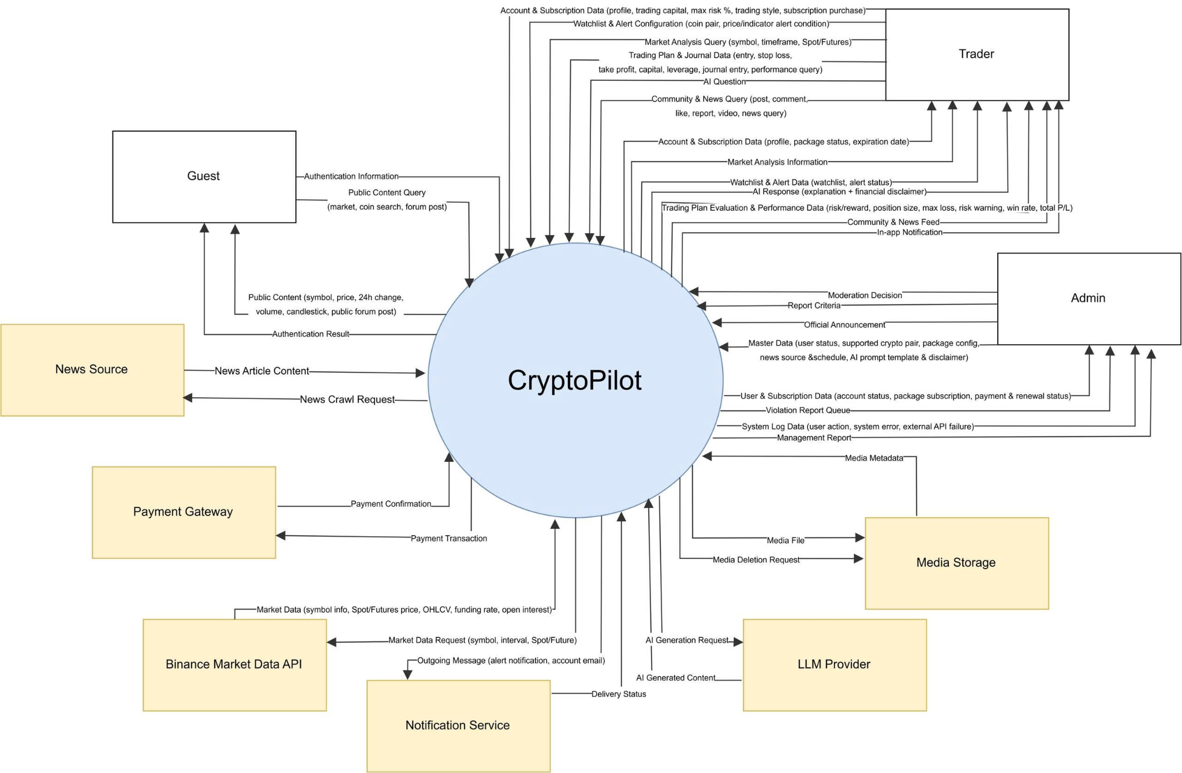
Figure 1.1: Context Diagram of CryptoPilot
Composite data flows of the context diagram:
# | External Entity | Direction | Data Flow | Description
1 | Guest | In | Authentication Information | Registration details, email verification code, login credentials, password reset request, new password
2 | Guest | In | Public Market Query | Pair, market type and timeframe to view
3 | Guest | Out | Public Market Information | Public market overview and basic price history
4 | Guest | Out | Authentication Result | Session tokens or error, email verification status
5 | Guest | Out | Public Community Content | Published posts, comments, pinned announcements and public member pages
6 | Trader | In | Account Information | Updated profile, trading style, risk profile, risk questionnaire answers, notification preference, device token
7 | Trader | In | Market Analysis Query | Pair, market type, timeframe and indicators to analyze
8 | Trader | In | Monitoring Configuration | Watchlist items and alert rules
9 | Trader | In | Trading Plan Information | Trading plan details, plan status change, position closing request
10 | Trader | In | Journal Entry | Trade review content and manually recorded trades
11 | Trader | In | Performance Query | Period, pair, strategy and market filters for statistics
12 | Trader | In | Community Content | Forum post, video post, comment, reaction, bookmark, violation report
13 | Trader | In | News Query | Coin, sentiment and time filters
14 | Trader | In | AI Question | Question and selected analysis context
15 | Trader | In | Subscription Purchase Information | Subscription order (new, renewal, upgrade or lower tier) and payment return parameters
16 | Trader | In | Demo Trading Information | Demo account opening, wallet transfer, demo order placement and cancellation
17 | Trader | Out | Account Details | Profile details, suggested risk profile, current plan, subscriptions and usage of plan limits
18 | Trader | Out | In-app Notification | Alert, trading plan, moderation, comment and subscription notifications
19 | Trader | Out | Market Analysis Information | Spot and futures market data, indicators, setup score with preset and version
20 | Trader | Out | Monitoring Details | Watchlist details and alert rule list
21 | Trader | Out | Trading Plan Evaluation | Risk assessment result and trading plan status
22 | Trader | Out | Trading Performance Information | Journal entry details and performance statistics
23 | Trader | Out | Community Feed | Posts, videos, comments and reaction counts
24 | Trader | Out | News Feed | Article titles, summaries, sentiment and links
25 | Trader | Out | AI Response | Answer, disclaimer and remaining quota
26 | Trader | Out | Subscription Information | Plan comparison, package list, upgrade credit, payment URL, subscription status, payment history
27 | Trader | Out | Demo Trading Details | Demo wallets and balances, orders, fills, ledger, transfers, account worth and PnL
28 | Admin | In | User Administration Information | Account status change and role assignment
29 | Admin | In | Moderation Decision | Decision on reported content (hide, remove, dismiss, warn, ban)
30 | Admin | In | Official Announcement | Official post with its category published to the community
31 | Admin | In | Report Criteria | Report type and period
32 | Admin | In | System Configuration | Supported pairs, risk parameters, packages and plan limits, news sources, AI and system settings
33 | Admin | Out | User List | Accounts with role, status and subscription
34 | Admin | Out | Violation Report Queue | Pending reports with reported content
35 | Admin | Out | Management Report | Payment transactions, revenue, user activity, audit log
36 | Binance Market Data API | Out | Market Data Request | REST query parameters and WebSocket stream subscription
37 | Binance Market Data API | In | Symbol Information | Exchange information: symbols, status, tick size, step size
38 | Binance Market Data API | In | Spot Market Data | Spot klines, 24h ticker, best bid/ask, order book depth and aggregated trades
39 | Binance Market Data API | In | Futures Market Data | Futures klines, mark price, funding rate, open interest, long/short ratio
40 | LLM Provider | Out | AI Generation Request | Chat completion and news summarization requests
41 | LLM Provider | In | AI Generated Content | Chat responses, news summaries and sentiment labels
42 | Payment Gateway | Out | Payment Request | Signed payment request for a subscription order
43 | Payment Gateway | Out | IPN Acknowledgement | Confirmation that a payment notification was received
44 | Payment Gateway | Out | Transaction Query | Status query used for reconciliation
45 | Payment Gateway | In | Payment Result | IPN payment result and transaction query result
46 | News Source | In | RSS Feed Item | Title, link, publish time and excerpt of articles
47 | Email Service | Out | Email Message | Verification, password reset, alert, receipt and reminder emails
48 | Push Notification Service | Out | Push Notification | Push message to registered mobile devices
49 | Push Notification Service | In | Delivery Failure Feedback | Invalid or expired device token
50 | Media Storage | Out | Media File | Uploaded images and videos
51 | Media Storage | Out | Media Deletion Request | Identifier of media to delete
52 | Media Storage | In | Media Metadata | Media identifier, URL, duration, processing status

Direction "In" means from the external entity to CryptoPilot; "Out" means from CryptoPilot to the external entity.

2. User Requirements

2.1 Actors
# | Actor | Description
1 | Guest | A visitor who has not logged in. A Guest can view the public market overview, register an account, verify the email address, log in and reset a forgotten password. A Guest can also read the community forum: published posts, comments, pinned announcements and public member pages.
2 | Trader | A registered, verified user with role TRADER. A Trader analyzes the market, manages the watchlist and alerts, creates trading plans, follows simulated positions, keeps a trading journal, practices on the demo trading exchange with virtual funds, participates in the community, reads news and buys subscriptions. Each Trader has exactly one effective plan: FREE by default, or PRO or PREMIUM while a paid subscription is active. The plan determines limits and features such as indicator alerts, the AI Assistant and video posting (BR-62); it is an entitlement of the Trader, not a separate role.
3 | Admin | An operator with role ADMIN who uses the administration console to manage user accounts, moderate reported posts, publish official announcements, configure supported pairs, risk parameters, subscription packages, news sources, the AI Assistant and system settings, and to view reports and the audit log.
4 | Binance Market Data API | External system (secondary actor) that provides public Spot and USD-M Futures market data through REST and WebSocket interfaces. No API key or user account is used. It interacts with CryptoPilot only through non-screen functions NSF-01 to NSF-04 and is therefore not associated with any use case.
5 | LLM Provider | External system (secondary actor), the Anthropic Claude API, that generates AI Assistant answers and news summaries.
6 | Payment Gateway | External systems VNPay and MoMo (secondary actors) that process subscription payments and send payment result notifications (IPN).
7 | News Source | External crypto news websites that publish RSS feeds collected by the system.
8 | Email Service | External transactional email service that delivers verification, password reset, alert, receipt and reminder emails.
9 | Push Notification Service | Firebase Cloud Messaging, which delivers push notifications to the mobile application. It interacts with CryptoPilot only through non-screen function NSF-15 and is therefore not associated with any use case.
10 | Media Storage | Cloudinary, which stores and serves images and videos uploaded by users.

2.2 Use Cases

2.2.1 Diagram(s)
The use cases are presented in seven diagrams, one per functional area. The included use case UC-53 is drawn in every diagram whose use cases include it:
Figure | Area | Use cases | Actors
Figure 2.1 | Authentication and Account | UC-01 to UC-08 | Guest, Trader, Admin, Email Service, Media Storage
Figure 2.2 | Market Analysis and Trading Plan | UC-09 to UC-11, UC-16 to UC-21, UC-53 | Guest, Trader
Figure 2.3 | Watchlist, Trading Journal and Alert | UC-12 to UC-15, UC-22 to UC-25, UC-53 | Trader
Figure 2.4 | Community and News | UC-26 to UC-34, UC-53, UC-59 | Guest, Trader, Media Storage
Figure 2.5 | AI Assistant and Subscription | UC-35 to UC-39, UC-53 | Trader, LLM Provider, Payment Gateway
Figure 2.6 | Administration | UC-40 to UC-52 | Admin, Media Storage, Payment Gateway, News Source
Figure 2.7 | Demo Trading | UC-54 to UC-58 | Trader
Primary actors are drawn on the left of each diagram and secondary actors (external systems) on the right. A secondary actor is associated with a use case only when CryptoPilot exchanges data with it to produce the result of that use case, either within the use case flow or through a non-screen function that the use case triggers and waits for. External systems that only supply or receive data through scheduled or event-driven non-screen functions (Section 3.1.4) are not associated with the use cases that later read the stored data. Steps, alternative flows and variants of a use case are specified in Section 3 and are not drawn as separate use cases.

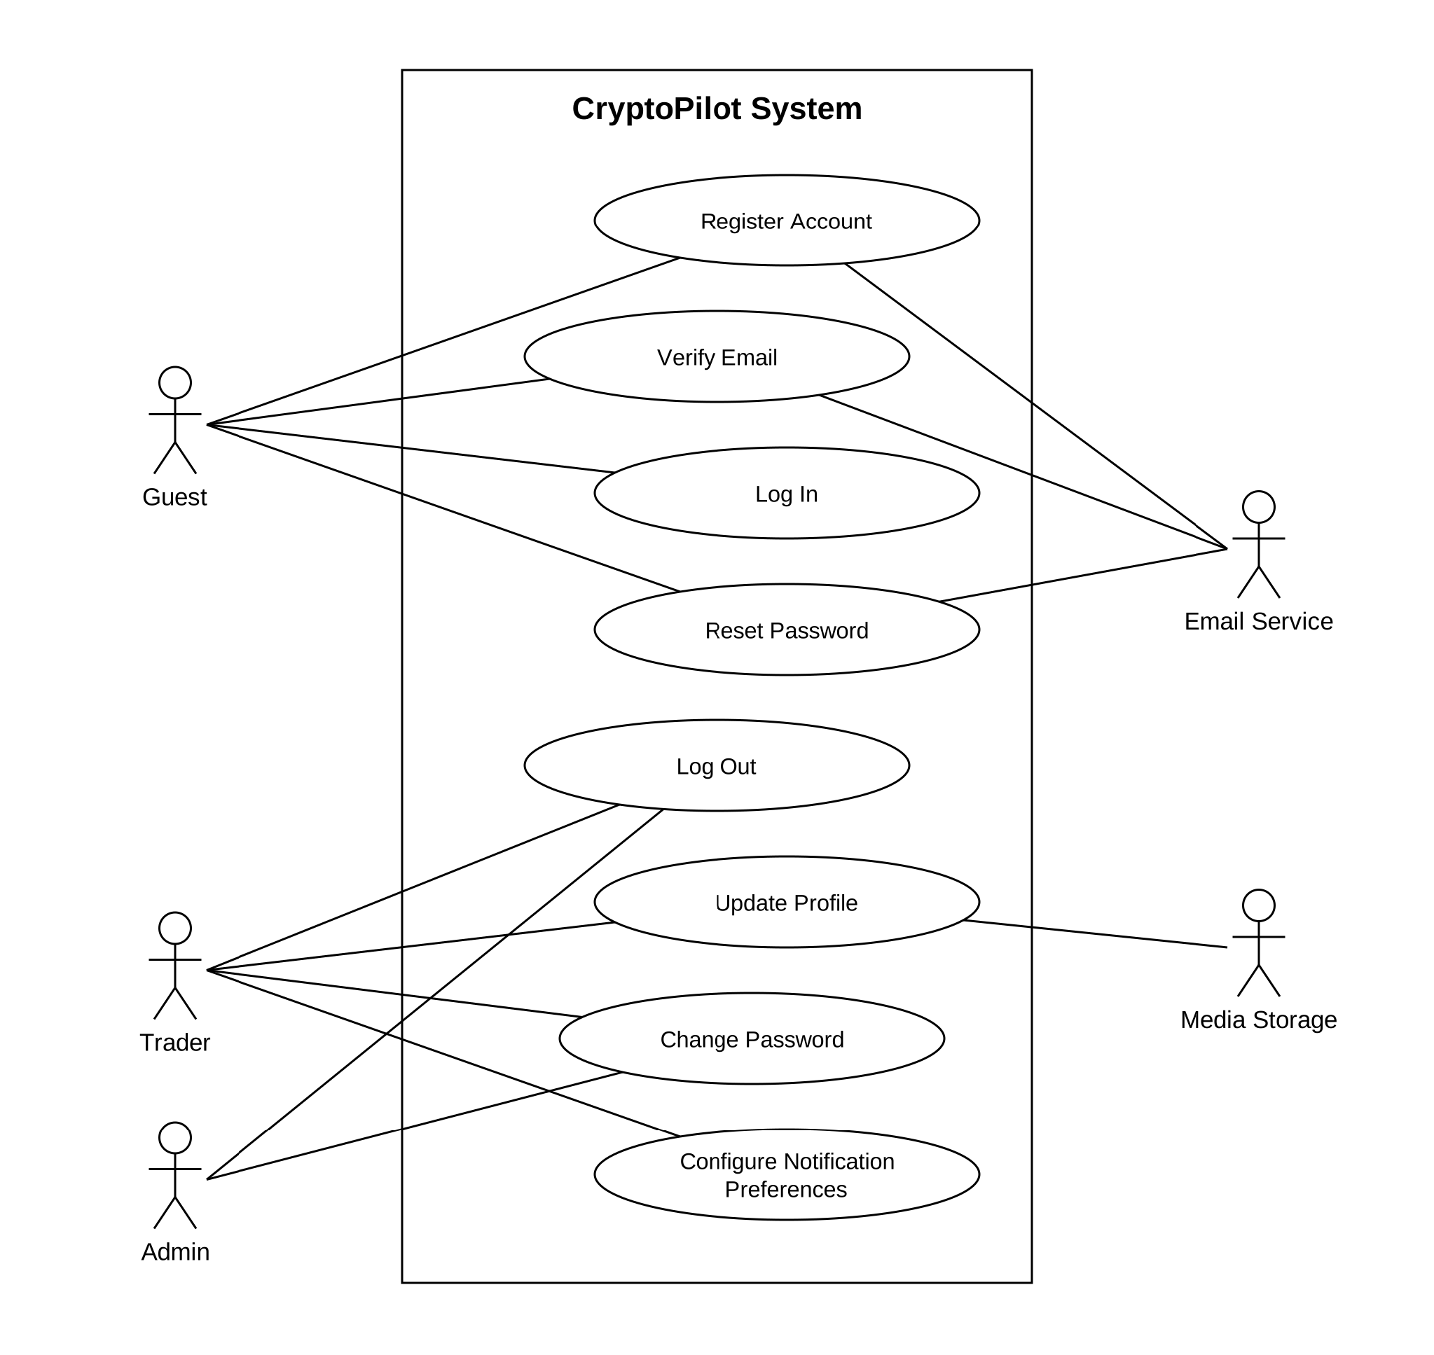
Figure 2.1: Use Case Diagram – Authentication and Account
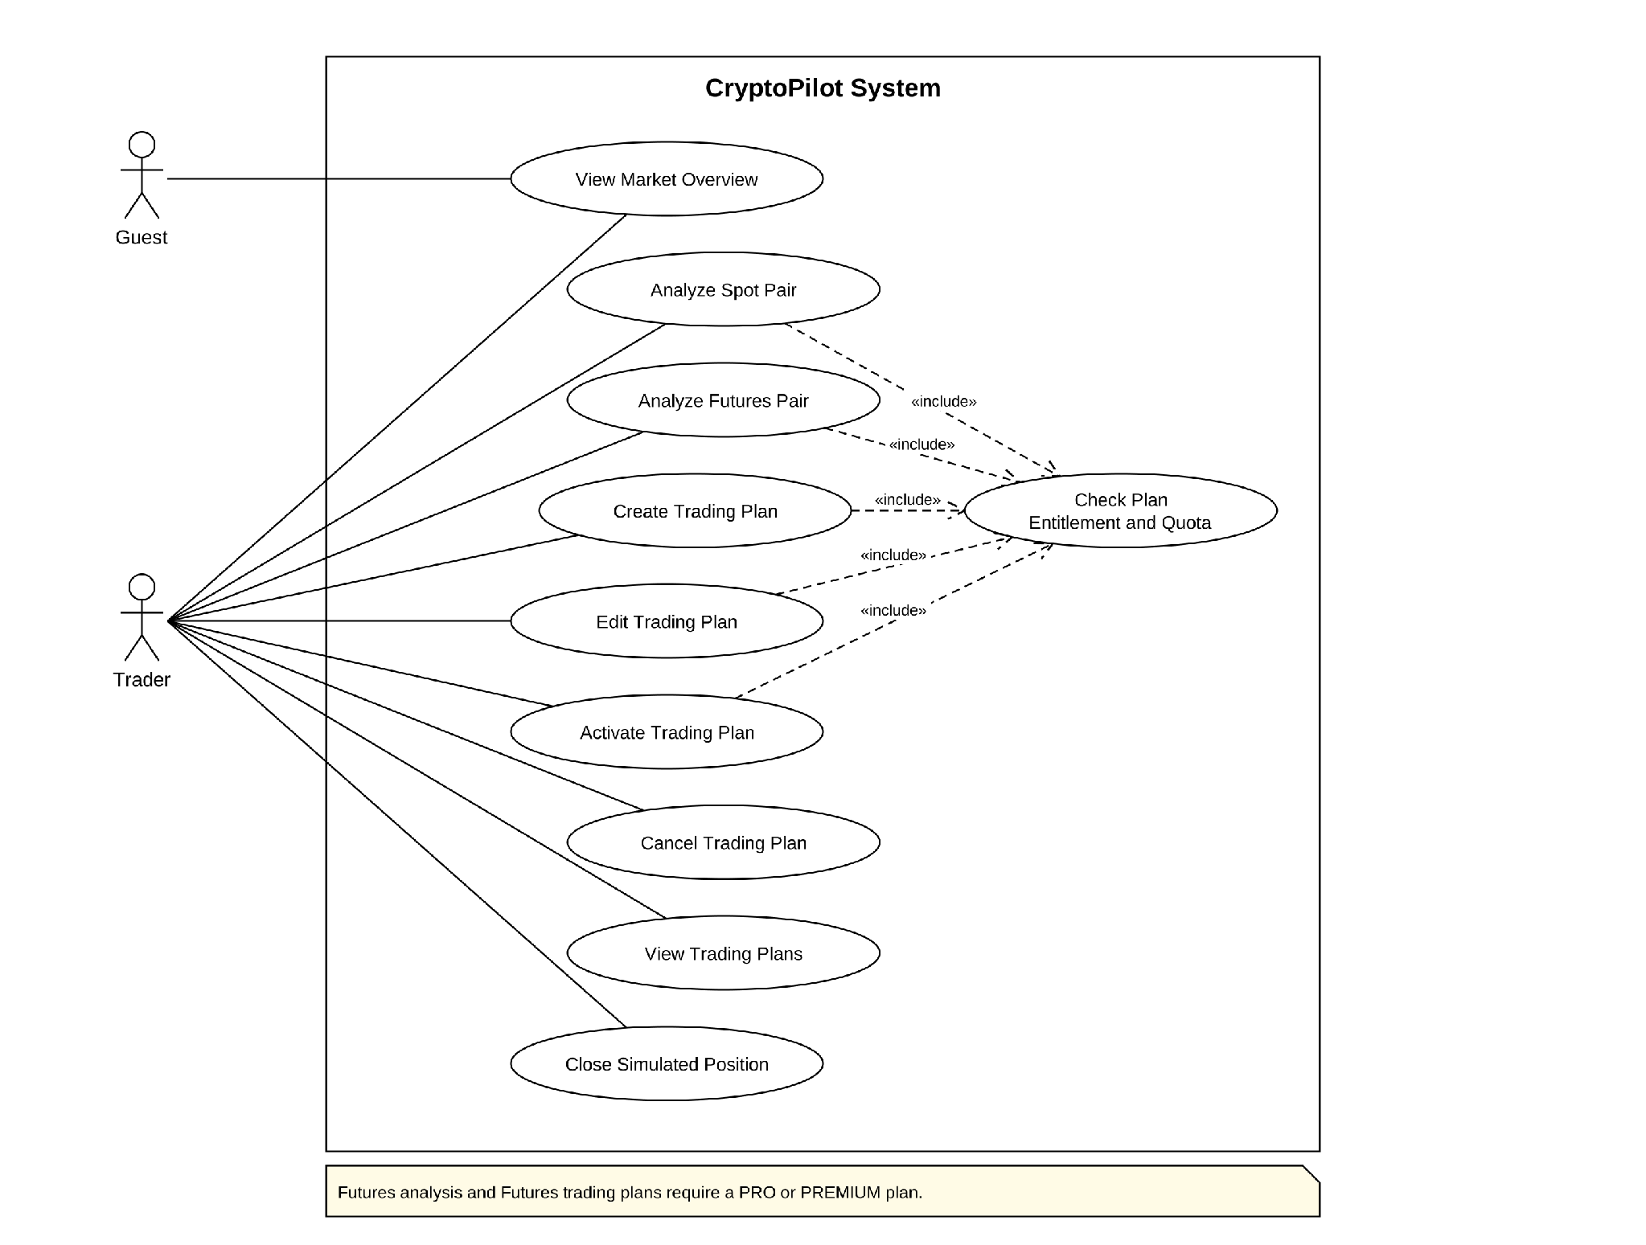
Figure 2.2: Use Case Diagram – Market Analysis and Trading Plan
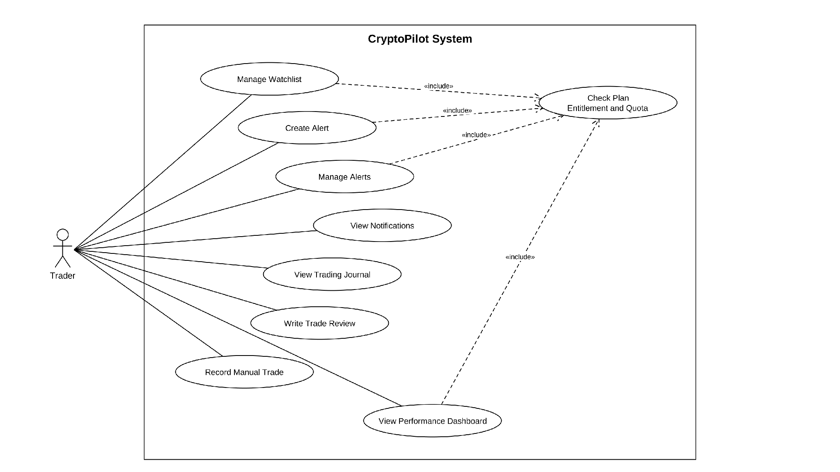
Figure 2.3: Use Case Diagram – Watchlist, Trading Journal and Alert
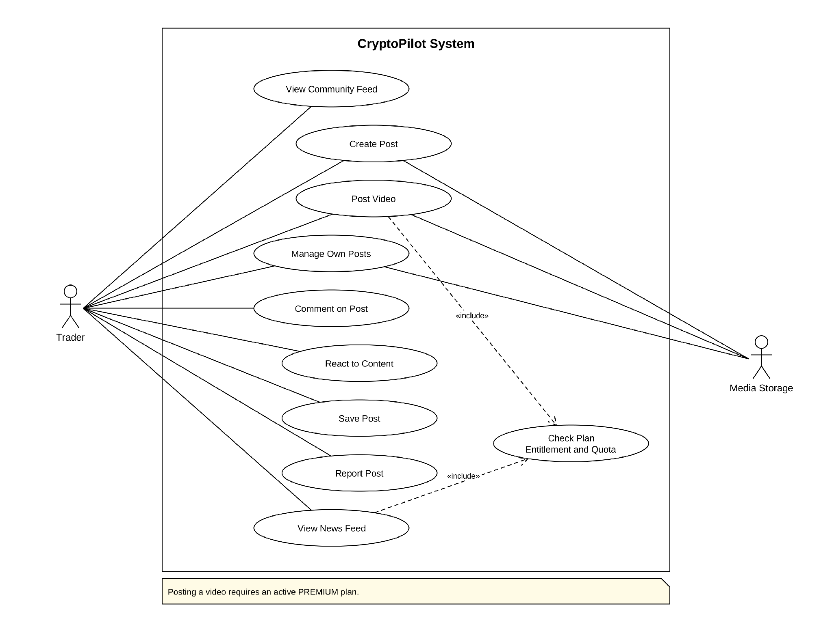
Figure 2.4: Use Case Diagram – Community and News
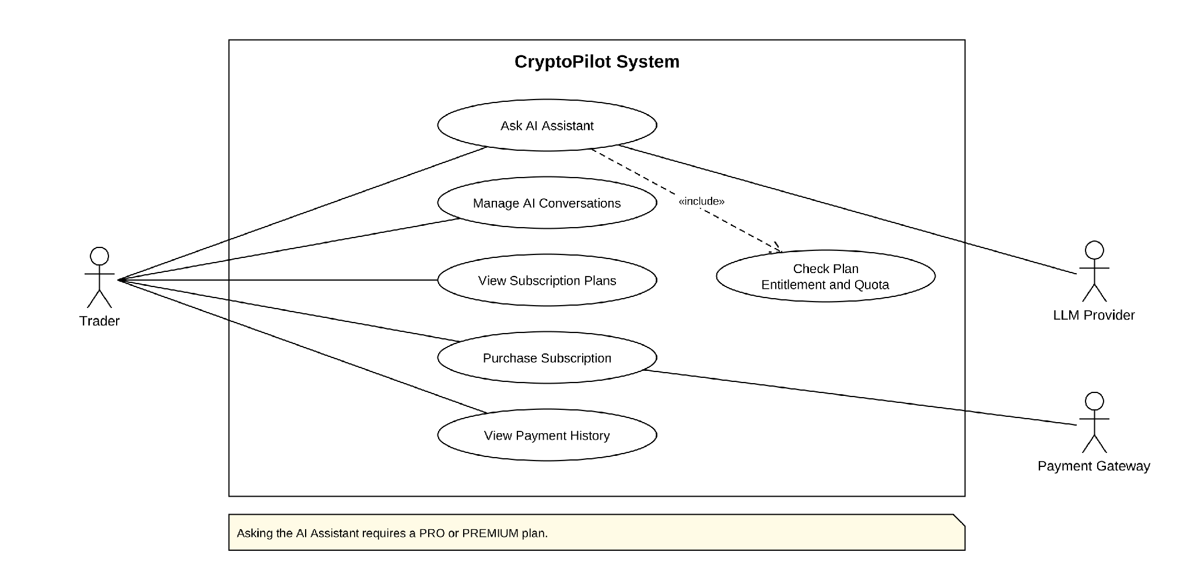
Figure 2.5: Use Case Diagram – AI Assistant and Subscription
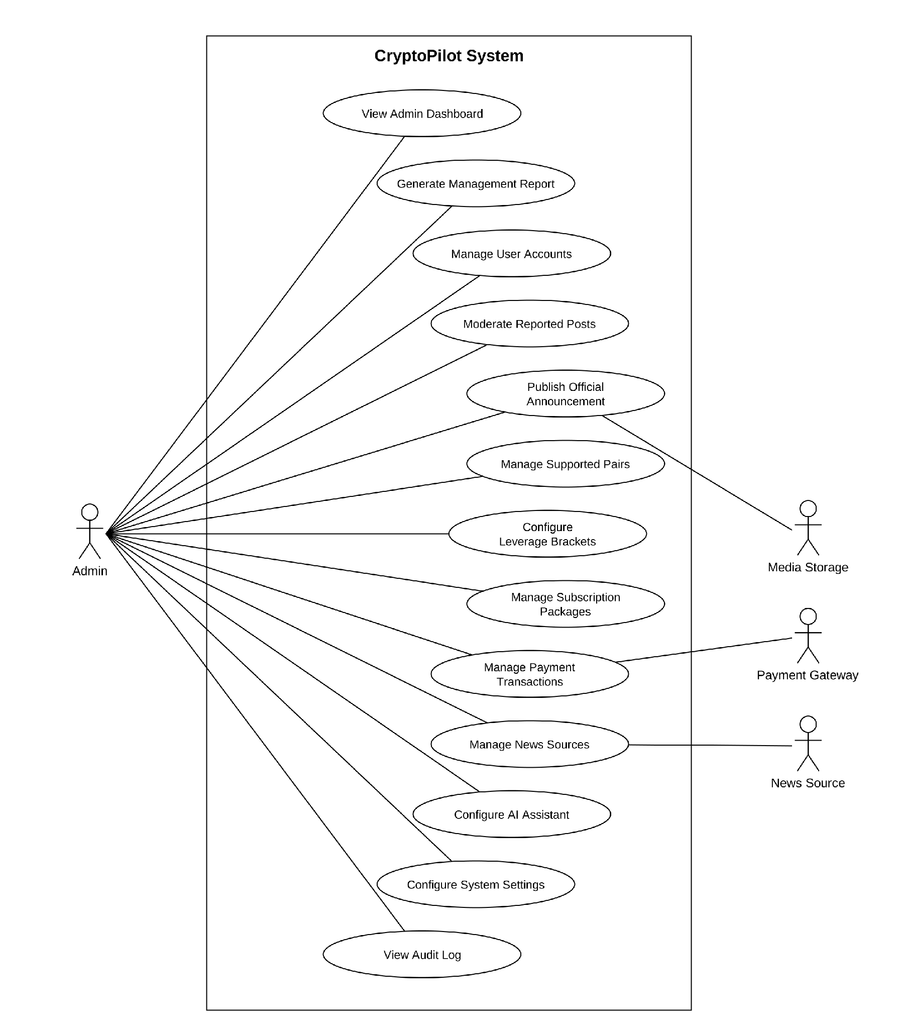
Figure 2.6: Use Case Diagram – Administration
[ Insert use case diagram (UC-54 to UC-58) ]
Figure 2.7: Use Case Diagram – Demo Trading

2.2.2 Descriptions
ID | Use Case | Actors | Use Case Description
UC-01 | Register Account | Guest, Email Service | Guest creates a Trader account with email and password and receives a verification email.
UC-02 | Verify Email | Guest, Email Service | Guest confirms ownership of the email address through the verification link, or requests a new verification email when the link is invalid or expired.
UC-03 | Log In | Guest | A registered user authenticates with email and password and is routed to the Trader or Admin area according to role.
UC-04 | Reset Password | Guest, Email Service | Guest requests a reset link by email and sets a new password.
UC-05 | Log Out | Trader, Admin | User ends the current session; the refresh token is revoked.
UC-06 | Update Profile | Trader, Media Storage | Trader updates display name, avatar, default trading parameters, trading style and risk profile, optionally using the profile suggested by the risk questionnaire.
UC-07 | Change Password | Trader, Admin | User changes the password after confirming the current one.
UC-08 | Configure Notification Preferences | Trader | Trader enables or disables email and push notifications.
UC-09 | View Market Overview | Guest, Trader | User views realtime prices and 24h statistics of enabled pairs and a basic price chart.
UC-10 | Analyze Spot Pair | Trader | Trader views the spot chart with indicators, support/resistance and setup score of a pair.
UC-11 | Analyze Futures Pair | Trader | Trader with a PRO or PREMIUM plan views the futures chart with mark price, funding rate, open interest, long/short ratio and setup score.
UC-12 | Manage Watchlist | Trader | Trader adds, removes, groups and reorders pairs in the watchlist within the limit of the subscription plan.
UC-13 | Create Alert | Trader | Trader creates a price alert, or an indicator alert on PRO and PREMIUM plans, on a watchlist pair within the active alert limit of the subscription plan.
UC-14 | Manage Alerts | Trader | Trader edits, pauses, resumes or deletes alerts and views their trigger history.
UC-15 | View Notifications | Trader | Trader views in-app notifications, marks them as read and opens the referenced alert, plan, post or subscription.
UC-16 | Create Trading Plan | Trader | Trader enters entry, stop loss, take profit, capital, risk and leverage and receives the risk calculation and warnings; Futures plans require a PRO or PREMIUM plan.
UC-17 | Edit Trading Plan | Trader | Trader modifies a plan that is still in DRAFT status.
UC-18 | Activate Trading Plan | Trader | Trader activates a plan without blocking warnings, within the subscription plan limit of ACTIVE plans and open positions, so that the simulation can execute it.
UC-19 | Cancel Trading Plan | Trader | Trader cancels a DRAFT or ACTIVE plan.
UC-20 | View Trading Plans | Trader | Trader lists plans by status and views plan details and live position status.
UC-21 | Close Simulated Position | Trader | Trader closes an open simulated position at the current market price.
UC-22 | View Trading Journal | Trader | Trader lists simulated and manual trades with their results.
UC-23 | Write Trade Review | Trader | Trader records setup description, lessons learned, mistakes, strategy and a chart image for a trade.
UC-24 | Record Manual Trade | Trader | Trader records a trade executed on another platform.
UC-25 | View Performance Dashboard | Trader | Trader views basic statistics (FREE) or the full dashboard with R-multiple, equity curve and breakdowns by coin, strategy and market (PRO, PREMIUM).
UC-26 | View Community Feed | Guest, Trader | User browses, searches, filters and opens community posts and official announcements; a Guest can only read.
UC-27 | Create Post | Trader, Media Storage | Trader publishes a text post with optional images, coin tags and market type.
UC-28 | Post Video | Trader (PRO, PREMIUM), Media Storage | Trader with an active PRO or PREMIUM plan publishes a video post.
UC-29 | Manage Own Posts | Trader, Media Storage | Trader edits or deletes own posts.
UC-30 | Comment on Post | Trader | Trader comments on a post or replies to a comment, and edits or deletes own comments.
UC-31 | React to Content | Trader | Trader likes or unlikes a post or a comment.
UC-32 | Save Post | Trader | Trader bookmarks a post and views saved posts.
UC-33 | Report Post | Trader | Trader reports a post that violates community rules.
UC-34 | View News Feed | Trader | Trader reads aggregated news filtered by coin; AI summaries and sentiment are shown on PRO and PREMIUM plans.
UC-35 | Ask AI Assistant | Trader (PRO, PREMIUM), LLM Provider | Trader with a PRO or PREMIUM plan asks questions about a pair, a trading plan or, on PREMIUM, own performance and receives an explanation, within the daily quota of the subscription plan.
UC-36 | Manage AI Conversations | Trader | Trader views, renames and deletes AI conversations; conversations remain readable after the paid plan ends.
UC-37 | View Subscription Plans | Trader | Trader compares the FREE, PRO and PREMIUM plans, the packages for sale and the current and scheduled subscriptions.
UC-38 | Purchase Subscription | Trader, Payment Gateway | Trader buys a new, renewal, upgrade or lower-tier package through VNPay or MoMo; an upgrade is charged the package price less the unused value of the current subscriptions. The subscription is activated or scheduled on confirmed payment.
UC-39 | View Payment History | Trader | Trader views own subscription orders and their status.
UC-40 | View Admin Dashboard | Admin | Admin views key indicators on users, revenue, reports, AI usage and data ingestion status.
UC-41 | Generate Management Report | Admin | Admin generates revenue and user activity reports for a period and exports them.
UC-42 | Manage User Accounts | Admin | Admin searches accounts, locks, unlocks or bans them and assigns roles.
UC-43 | Moderate Reported Posts | Admin | Admin reviews reported posts and hides or removes content, dismisses reports, warns or bans users.
UC-44 | Publish Official Announcement | Admin, Media Storage | Admin publishes a pinned official post with a category (announcement, platform update or education) to the community.
UC-45 | Manage Supported Pairs | Admin | Admin enables, disables and orders the pairs and markets supported by the system.
UC-46 | Configure Leverage Brackets | Admin | Admin maintains maintenance margin tiers used for liquidation price calculation.
UC-47 | Manage Subscription Packages | Admin | Admin creates, updates and deactivates subscription packages and maintains the limits of each plan tier.
UC-48 | Manage Payment Transactions | Admin, Payment Gateway | Admin views subscription orders, triggers reconciliation of a pending order with the gateway and marks flagged orders as handled.
UC-49 | Manage News Sources | Admin, News Source | Admin maintains RSS sources and views crawl logs.
UC-50 | Configure AI Assistant | Admin | Admin creates and activates AI configuration versions (model, system prompt, parameters).
UC-51 | Configure System Settings | Admin | Admin maintains fee rates, warning thresholds and other system limits.
UC-52 | View Audit Log | Admin | Admin searches the log of administrative and security-relevant actions.
UC-53 | Check Plan Entitlement and Quota | Trader (included use case) | System determines the effective plan of the Trader and checks the feature, limit or daily quota before the action; included by UC-10, UC-11, UC-12, UC-13, UC-14, UC-16, UC-17, UC-18, UC-25, UC-28, UC-34 and UC-35.
UC-54 | Open Demo Account | Trader | Trader opens the demo trading account once, receives the virtual starting funds in the Spot and Futures wallets and views the wallet balances and their estimated value.
UC-55 | Transfer Demo Funds | Trader | Trader moves USDT between the Spot and Futures demo wallets and views the transfer history.
UC-56 | Place Demo Spot Order | Trader | Trader places a demo Spot order (limit, market, post-only, stop, trailing stop, OCO, OTO, OTOCO) that is matched against live Binance prices and order book.
UC-57 | Manage Demo Orders | Trader | Trader cancels open demo orders, one or all of a pair, and views open orders, order history, trade history and the ledger.
UC-58 | View Demo PnL Analysis | Trader | Trader views the account worth, today's PnL, the worth over 7, 30 or 90 days and the average cost and unrealized PnL of each Spot coin.
UC-59 | View Member Page | Guest, Trader | User views the public page of a community member with display name, avatar, join date, number of posts, likes received and the member's posts.

3. Functional Requirements

3.1 System Functional Overview
This section gives an overview of the screens, their authorization, the non-screen functions and the data entities of CryptoPilot.

3.1.1 Screens Flow
The screens are organized into three areas. The public area (SCR-01 to SCR-06) is reachable without logging in, and a Guest can also read the community screens SCR-24, SCR-25 and SCR-48; after a successful login the user is routed to the Trader area (SCR-07 to SCR-32 and SCR-45 to SCR-48) or to the administration console (SCR-33 to SCR-44) according to the role. Pop-up screens are SCR-14 (Create/Edit Alert), SCR-19 (Close Position) and SCR-27 (Report Post). SCR-07 (Profile & Settings) is a multi-tab screen with the tabs Profile, Security, Notifications and Subscription.
Main navigation of the Trader area: Dashboard (SCR-08) is the home screen and links to Market List (SCR-09), Watchlist (SCR-12), Alerts (SCR-13), Trading Plans (SCR-16), Journal (SCR-20), Performance (SCR-23), Community (SCR-24), News (SCR-28), AI Assistant (SCR-29), Subscription (SCR-30) and Demo Trading (SCR-45). The header gives access to the Notification Center (SCR-15) and, through the avatar menu, to Profile & Settings (SCR-07). From Market List or Watchlist the Trader opens the Spot or Futures analysis screen (SCR-10, SCR-11), from which Create Alert (SCR-14), Create Trading Plan (SCR-17) and AI Assistant (SCR-29) are opened with the selected pair pre-filled. An executed plan (SCR-18) links to its journal entry (SCR-21). Demo Trading (SCR-45) links to the demo wallets and orders (SCR-46) and the PnL analysis (SCR-47); the author of a post opens the member page (SCR-48).
The mobile application implements SCR-04 to SCR-06, SCR-08 to SCR-15, SCR-18 to SCR-21 and SCR-29. All other screens are available on the web application only.
Figures 3.1a to 3.1c show the screens flow of the public area, the Trader area and the administration console. Pop-up screens are drawn as ovals, screens that are also implemented in the mobile application are shaded, and a dashed box refers to a screen shown in another figure.
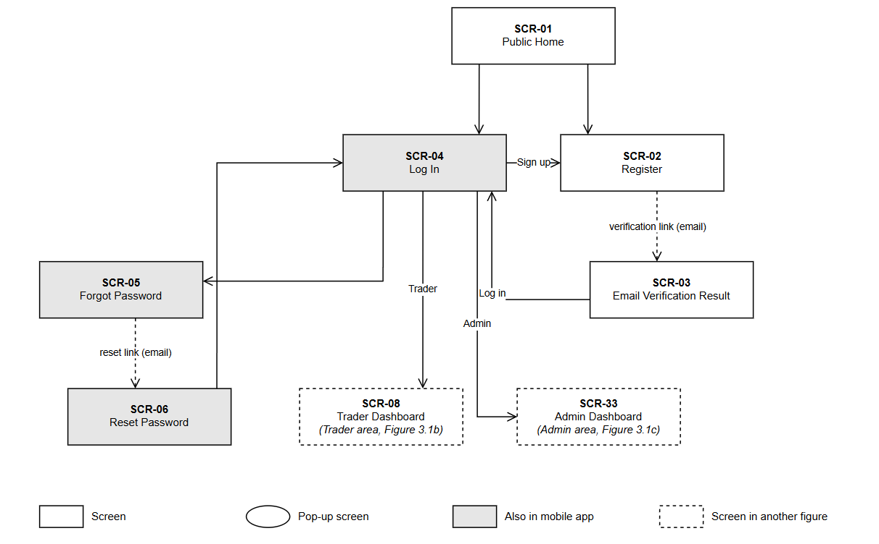
Figure 3.1a: Screens Flow – Public Area
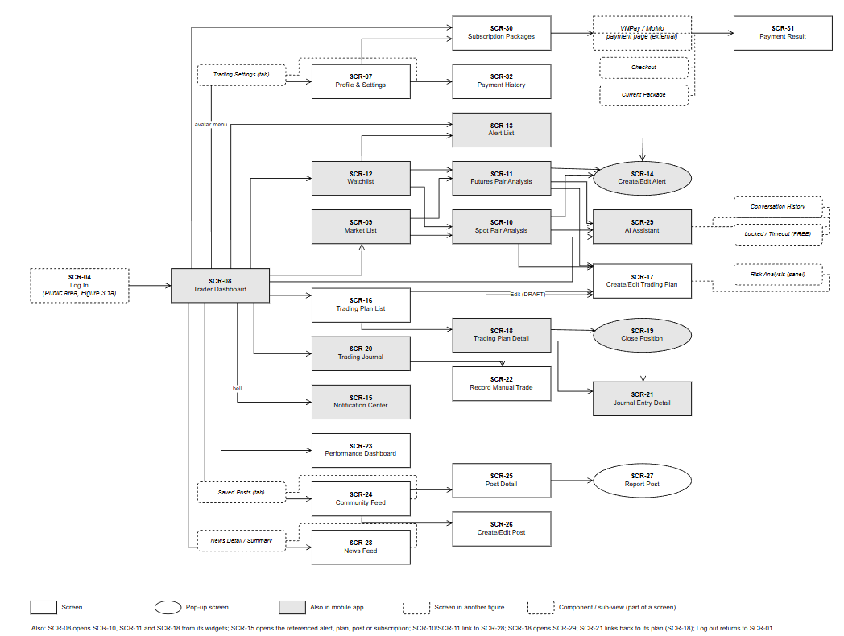
Figure 3.1b: Screens Flow – Trader Area
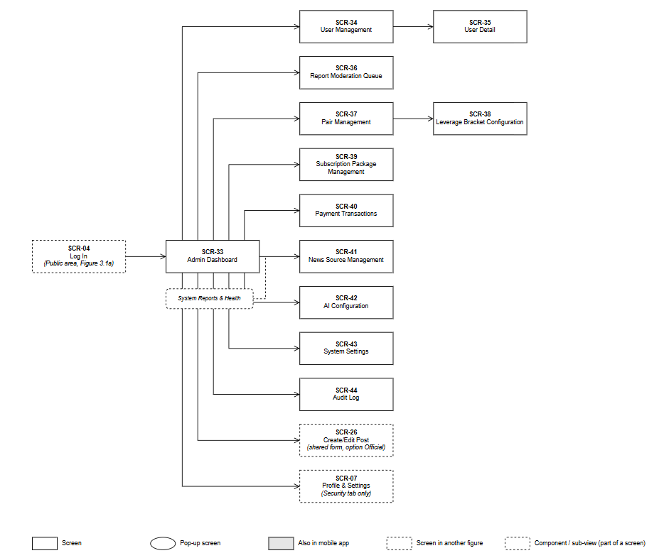
Figure 3.1c: Screens Flow – Administration Console

3.1.2 Screen Descriptions
# | Feature | Screen | Description
SCR-01 | Market Data | Public Home | Public market overview of enabled pairs with realtime prices, 24h statistics and a basic price chart; entry to Register and Log In.
SCR-02 | Authentication | Register | Registration form with email, display name, password and disclaimer confirmation.
SCR-03 | Authentication | Email Verification Result | Result of opening the verification link; allows resending the verification email.
SCR-04 | Authentication | Log In | Login form with email, password and Remember me; links to Register and Forgot Password.
SCR-05 | Authentication | Forgot Password | Form to request a password reset link by email.
SCR-06 | Authentication | Reset Password | Form to set a new password from a valid reset link.
SCR-07 | Account | Profile & Settings | Tabs: Profile (display name, avatar, default capital, risk %, trading style, risk profile and risk questionnaire), Security (change password), Notifications (email and push), Subscription (current plan, end date, scheduled subscriptions, usage of limits and AI quota, links to SCR-30 and SCR-32).
SCR-08 | Market Data | Trader Dashboard | Home of the Trader: watchlist snapshot, active plans and open positions, recent notifications, performance summary, latest news.
SCR-09 | Market Data | Market List | Tabs Spot and Futures listing enabled pairs with price, 24h change, 24h high and low and volume (Futures also mark and index price, funding rate and next funding time); search and sort. The setup score is shown on SCR-10, SCR-11 and SCR-12.
SCR-10 | Market Analysis | Spot Pair Analysis | Candlestick chart with timeframe selector, indicator overlays and panels, support/resistance, setup score card, market statistics and actions.
SCR-11 | Market Analysis | Futures Pair Analysis | Spot analysis content plus mark/index price, funding rate and countdown, open interest and long/short ratio charts.
SCR-12 | Watchlist & Alerts | Watchlist | Pairs watched by the Trader grouped by label, with price, change, setup score and number of active alerts.
SCR-13 | Watchlist & Alerts | Alert List | Alerts with type, condition, status, trigger count and last trigger time; pause, resume, edit, delete.
SCR-14 | Watchlist & Alerts | Create/Edit Alert (pop-up) | Form for price or indicator alert conditions, trigger mode, channels and expiry.
SCR-15 | Notification | Notification Center | List of notifications with unread status; navigation to the referenced object.
SCR-16 | Trading Plan | Trading Plan List | Plans grouped by status (Draft, Active, Executed, Cancelled/Expired) with key figures and filters.
SCR-17 | Trading Plan | Create/Edit Trading Plan | Plan input form with live risk calculation panel and warnings.
SCR-18 | Trading Plan | Trading Plan Detail | Plan inputs, calculation snapshot, warnings and, once executed, live position status; actions Activate, Cancel, Close Position.
SCR-19 | Trading Plan | Close Position (pop-up) | Confirmation of closing an open simulated position with estimated exit price and profit/loss.
SCR-20 | Journal & Performance | Trading Journal | List of simulated and manual trades with filters and results.
SCR-21 | Journal & Performance | Journal Entry Detail | Trade facts (read-only for simulated trades) and editable review fields.
SCR-22 | Journal & Performance | Record Manual Trade | Form to record a trade executed on another platform.
SCR-23 | Journal & Performance | Performance Dashboard | Performance metrics, equity curve and breakdowns by coin, strategy and market.
SCR-24 | Community | Community Feed | Tabs Latest, Most Liked, Saved, My Posts (Saved and My Posts after login); search in titles and content; filters by coin, market and author; pinned official announcements with a category filter. Readable by Guests.
SCR-25 | Community | Post Detail | Post content and media, reactions, bookmarks and threaded comments; the author name opens SCR-48. Readable by Guests.
SCR-26 | Community | Create/Edit Post | Form for title, content, coin tags, market type, images or video; for Admin also Official with its category.
SCR-27 | Community | Report Post (pop-up) | Form to select a reason and describe a violation.
SCR-28 | News | News Feed | Aggregated news with AI summary, sentiment, coin tags, filters and 24h sentiment summary.
SCR-29 | AI Assistant | AI Assistant | Conversation list, chat panel and context selector (pair, market, timeframe, trading plan).
SCR-30 | Subscription | Subscription Packages | Comparison of the FREE, PRO and PREMIUM plans, packages for sale, current and scheduled subscriptions, upgrade credit and checkout with gateway selection.
SCR-31 | Subscription | Payment Result | Result page after returning from the payment gateway.
SCR-32 | Subscription | Payment History | List of own subscription orders and statuses.
SCR-33 | Administration | Admin Dashboard | Key indicators and management reports with period filters and CSV export.
SCR-34 | Administration | User Management | Search and filter user accounts.
SCR-35 | Administration | User Detail | Account information, subscription, activity and actions lock, unlock, ban, change role.
SCR-36 | Administration | Report Moderation Queue | Reported posts grouped by post with reasons; moderation decisions (hide, remove, dismiss, warn, ban) and restore.
SCR-37 | Administration | Pair Management | Supported pairs, enabled markets, maximum leverage and display order.
SCR-38 | Administration | Leverage Bracket Configuration | Maintenance margin tiers per futures pair.
SCR-39 | Administration | Subscription Package Management | Create, update and deactivate packages; edit the limits of each plan tier.
SCR-40 | Administration | Payment Transactions | Subscription orders with gateway status and reconciliation action.
SCR-41 | Administration | News Source Management | RSS sources, crawl interval, status and crawl logs.
SCR-42 | Administration | AI Configuration | AI configuration versions and activation.
SCR-43 | Administration | System Settings | Limits, fee rates and warning thresholds.
SCR-44 | Administration | Audit Log | Search and view administrative and security-relevant actions.
SCR-45 | Demo Trading | Demo Spot Trading | Demo trading screen of a Spot pair: pair selector, 24h ticker, candlestick chart with own orders, order book (20 levels), market trades, order form (limit, market, post-only, stop limit, trailing stop, OCO, limit with TP/SL) and panel of open orders, order history, trade history and funds; a banner states that funds are virtual.
SCR-46 | Demo Trading | Demo Wallets and Orders | Spot and Futures demo wallets with free and locked balances and estimated value, transfer between wallets, transfer history, ledger, open orders, order history and trade history.
SCR-47 | Demo Trading | Demo PnL Analysis | Account worth with its Spot and Futures parts, today's PnL, worth over 7, 30 or 90 days, and average cost, value and unrealized PnL of each Spot coin.
SCR-48 | Community | Member Page | Public page of a member: display name, avatar, join date, number of posts, likes received and the member's published posts. Readable by Guests.

3.1.3 Screen Authorization
"Trader (PRO/PREMIUM)" means a Trader whose effective plan is PRO or PREMIUM. Plans are entitlements of the Trader role, not separate roles. Rows starting with "Activity" are actions inside a screen that are allowed only for the marked columns. Plan limits (trading plans, watchlist items, active alerts, AI quota) are defined in Table 3.1 and BR-62 and are checked on top of this table. Admin accounts use only the administration console.
Screen / Activity | Guest | Trader (FREE) | Trader (PRO/PREMIUM) | Admin
SCR-01 Public Home | X | X | X | X
SCR-02 to SCR-06 Register, Verify, Log In, Password Reset | X
SCR-07 Profile & Settings (Admin: Security tab only) |  | X | X | X
SCR-08 to SCR-15 Dashboard, Market, Watchlist, Alerts, Notifications |  | X | X
SCR-16 to SCR-19 Trading Plans and Position |  | X | X
SCR-20 to SCR-23 Journal and Performance |  | X | X
SCR-45 to SCR-47 Demo Trading (Spot) |  | X | X
SCR-24, SCR-25, SCR-48 Community Feed, Post Detail, Member Page (Guest: read only) | X | X | X
SCR-26, SCR-27 Create/Edit Post, Report Post |  | X | X
Activity: Post Video (SCR-26), PRO and PREMIUM |  |  | X
Activity: Create indicator alert (SCR-14) |  |  | X
Activity: Futures analysis (SCR-11) and Futures plans (SCR-17) |  |  | X
Activity: Setup score components (SCR-10, SCR-11) |  |  | X
Activity: Email and push alert channels (SCR-14) |  |  | X
Activity: Full performance dashboard (SCR-23) |  |  | X
Activity: News AI summary and sentiment (SCR-28) |  |  | X
SCR-28 News Feed |  | X | X
SCR-29 AI Assistant (FREE: read existing conversations and upgrade prompt; performance context PREMIUM only) |  | X | X
SCR-30 to SCR-32 Subscription and Payment |  | X | X
SCR-33 to SCR-44 Administration console |  |  |  | X
Activity: Publish Official Announcement |  |  |  | X
Query Public Data (market overview) | X | X | X | X
Query Own Data (plans, journal, alerts, notifications, orders, conversations, demo account and orders) |  | X | X
Query Community Data (published posts, comments, member pages; news for Trader and Admin only) | X | X | X | X
Query All Data (users, reports, orders, audit log) |  |  |  | X
Add New Data (own plans, alerts, posts, comments, reports, orders, demo orders and transfers) |  | X | X
Update Own Data |  | X | X | X
Update All Data (configuration, moderation, account status) |  |  |  | X
Delete Own Data (as allowed by business rules) |  | X | X
Delete Configuration Data (e.g. news sources, leverage brackets) |  |  |  | X

3.1.4 Non-Screen Functions
# | Feature | System Function | Description
NSF-01 | Market Data | Symbol Synchronization | At start-up and daily at 00:05 UTC reads exchange information of Spot and Futures, updates tick size, step size, minimum notional, the other Spot symbol filters and exchange status of enabled pairs, and notifies Admin of pairs no longer trading.
NSF-02 | Market Data | Historical Candle Backfill | Downloads missing closed candles through REST when a pair or market is enabled, at start-up and after a stream gap; inserts idempotently by primary key.
NSF-03 | Market Data | Realtime Market Stream Ingestion | Subscribes to the kline streams (analysis timeframes and 1 minute) and 24h ticker of enabled pairs, for Spot also the best bid/ask, 20-level order book and aggregated trade streams, and the futures mark price stream; stores closed candles, caches latest prices, pushes updates to clients and stores periodic market snapshots.
NSF-04 | Market Data | Futures Metrics Collection | Every 5 minutes collects open interest and long/short ratio; at each funding time stores the settled funding rate in FUNDING_RATE_HISTORY.
NSF-05 | Market Analysis | Indicator and Setup Score Calculation | After each closed candle, calculates the indicators, the nearest support/resistance and the setup score components, then pushes the result to clients. The total setup score is calculated on request using the preset of the Trader.
NSF-06 | Watchlist & Alerts | Alert Evaluation | Evaluates price alerts on price updates and indicator alerts after indicator calculation; creates notifications on trigger.
NSF-07 | Trading Simulation | Simulated Order Matching | Monitors active plans and open simulated positions against the 1-minute klines and the mark price; fills entries, closes positions at take profit, stop loss or liquidation, computes profit and loss; replays missed 1-minute klines after an interruption.
NSF-08 | Trading Simulation | Funding Fee Settlement | At each funding time applies funding payments to open simulated futures positions.
NSF-09 | Trading Simulation | Trading Plan Expiry and Invalidation | Every minute expires ACTIVE plans whose expiry time has passed (MSG53); with each price evaluation of NSF-07, sets ACTIVE plans whose invalidation condition is met to INVALIDATED (BR-74, MSG54); notifies the Trader with the reason.
NSF-10 | News | News Crawling | Fetches RSS feeds of active sources according to their interval, removes duplicates, tags coins and logs each crawl.
NSF-11 | News | News Summarization | Requests AI summaries and sentiment labels for new articles through the AI Service.
NSF-12 | Subscription & Payment | Payment Notification Handling | Receives and verifies IPN from VNPay/MoMo, updates the order, activates, schedules or upgrades the subscription according to the order type and acknowledges the gateway.
NSF-13 | Subscription & Payment | Payment Reconciliation | Every 5 minutes queries the gateway for pending orders without IPN and expires unpaid orders.
NSF-14 | Subscription & Payment | Subscription Lifecycle and Reminder | Every hour expires ended subscriptions, activates SCHEDULED subscriptions whose start time has come, applies the limits of the new effective plan (BR-64) and sends reminders 3 days before expiry.
NSF-15 | Notification | Notification Dispatch | Delivers notifications in-app, by email and by push according to preferences; deactivates invalid device tokens.
NSF-16 | AI Assistant | AI Request Processing | AI Service processes queued AI requests with the active configuration, calls the LLM Provider and stores the response and token usage.
NSF-17 | Maintenance | Data Retention Cleanup | Daily removes expired snapshots, expired refresh tokens, notifications older than 90 days and uploaded media files that no post carries after 24 hours, according to retention rules.
NSF-18 | Security | Audit Logging | Records administrative, security-relevant and payment events with old and new values.
NSF-19 | Demo Trading | Demo Order Matching | Matches resting and triggered demo orders against the live aggregated trades, best bid/ask and 20-level order book of the pair (BR-71); replays missed 1-minute klines after an interruption; pushes order, fill and balance updates to the Trader.
NSF-20 | Demo Trading | Demo Equity Snapshot | Daily at 00:00 UTC, and when an account is opened, stores the worth of each demo account in USDT for today's PnL and the worth chart; an account with a coin without a current price is retried every 5 minutes until 23:55 UTC.

3.1.5 Entity Relationship Diagram
[ Insert the logical ERD (CryptoPilot_Logical_Model) exported from draw.io ]
Figure 3.2: Entity Relationship Diagram (logical model)
Entities Description
# | Entity | Description
1 | USER | Account of a Trader or Admin: email, password hash, role, account status, verification and login times.
2 | USER_PROFILE | One-to-one profile of a user: display name, avatar, default capital, default risk %, trading style, risk profile, notification preferences.
3 | USER_TOKEN | Hashed tokens with expiry for email verification, password reset and session refresh.
4 | USER_DEVICE | Mobile devices of a user with the FCM token used for push notifications.
5 | COIN | Crypto asset (e.g. BTC, ETH, USDT) used as base or quote of pairs and as tag of posts and news.
6 | CRYPTO_PAIR | Trading pair (e.g. BTCUSDT) with enabled markets, tick size, step size, minimum notional, maximum leverage and display order.
7 | OHLCV | Closed candle of a pair per market type and timeframe: open, high, low, close, volume, trade count.
8 | TECHNICAL_INDICATOR | Indicators, nearest support/resistance and setup score component scores (with component version) computed for one closed candle; the setup score is computed when read by applying a preset (BR-13).
9 | SPOT_MARKET_DATA | Periodic snapshot of spot market: last price, best bid/ask, 24h statistics.
10 | FUTURES_MARKET_DATA | Periodic snapshot of futures market: mark and index price, funding rate, open interest, long/short ratio.
11 | FUNDING_RATE_HISTORY | Settled funding rate of a futures pair at each funding time with the mark price; kept without retention because simulated profit/loss depends on it (BR-37).
12 | LEVERAGE_BRACKET | Maintenance margin tiers of a futures pair (notional range, maximum leverage, maintenance margin rate) configured by Admin.
13 | WATCHLIST | A pair watched by a Trader, with label, order and note; unique per Trader and pair.
14 | ALERT | Price or indicator alert rule on a watchlist pair with trigger mode, cooldown, channels, status and expiry.
15 | NOTIFICATION | Message to a user created by an alert or by trading, moderation, comment or subscription events, with read status.
16 | TRADING_STRATEGY | System-defined strategy category (e.g. Breakout, Swing, Scalping) used to classify trades.
17 | TRADING_PLAN | Trader's plan: pair, market, direction, entry, stop loss, take profit, capital, risk %, leverage, calculation snapshot and status.
18 | TRADING_PLAN_WARNING | Risk warning raised for a plan with type and severity (INFO, WARNING, BLOCKING).
19 | TRADING_JOURNAL | Record of a simulated or manual trade: execution facts, fees, funding, realized profit/loss (BR-35; net profit/loss is derived, BR-38) and the Trader's review.
20 | FORUM_POST | Community post (text or video) with market type, status, official flag and, for official posts, the category (ANNOUNCEMENT, PLATFORM_UPDATE, EDUCATION).
21 | POST_COIN | Association between posts and the coins they are tagged with.
22 | FORUM_COMMENT | Comment on a post; may reply to another comment.
23 | ENGAGEMENT | Like or save action of a user on exactly one post or comment.
24 | POST_MEDIA | Image or video attached to a post, stored in Media Storage.
25 | POST_REPORT | Violation report on a post, with reason, status and the Admin's resolution.
26 | NEWS_SOURCE | RSS source managed by Admin with crawl interval and status.
27 | NEWS_CRAWL_LOG | Result of one crawl of a source: time, status, articles found and inserted, error.
28 | NEWS_ARTICLE | Collected article: title, original URL, excerpt, AI summary, sentiment, publish time.
29 | NEWS_TAG | Topic tag of news articles.
30 | NEWS_ARTICLE_TAG | Association between articles and topic tags.
31 | NEWS_ARTICLE_COIN | Association between articles and mentioned coins, with primary flag.
32 | AI_CONVERSATION | Conversation of a Trader with the AI Assistant, optionally in the context of a pair.
33 | AI_MESSAGE | Question or answer in a conversation with context snapshot, token usage and status.
34 | AI_CONFIGURATION | Versioned AI settings (model, system prompt, temperature, token limit); exactly one active.
35 | SUBSCRIPTION_PACKAGE | Package of a plan tier (FREE, PRO, PREMIUM) with tier rank, price, duration, purchasable flag, active flag and the entitlements of the tier (Table 3.1): Futures analysis, setup score components, maximum ACTIVE plans and open positions, watchlist items, active alerts, indicator alerts, external alert channels, full performance dashboard, news AI insight, AI daily quota, AI performance context, video posting. FREE is a single package that cannot be purchased.
36 | SUBSCRIPTION_ORDER | Purchase of a package by a Trader: order type (NEW, RENEW, UPGRADE, DOWNGRADE), list price, upgrade credit, amount, gateway, status, manual-handling flag and gateway transaction data.
37 | USER_SUBSCRIPTION | Subscription period created by a paid order, with start, end and status (SCHEDULED, ACTIVE, EXPIRED, REPLACED); at most one ACTIVE subscription per Trader.
38 | SYSTEM_SETTING | Key-value configuration maintained by Admin (limits, fee rates, warning thresholds).
39 | AUDIT_LOG | Log of administrative and security-relevant actions with actor, entity, old and new values.
40 | PAPER_ACCOUNT | Demo trading account of a Trader, at most one per Trader, opened once with the virtual starting funds (BR-68).
41 | PAPER_BALANCE | Balance of one coin in the Spot or Futures demo wallet: free and locked amount and average cost in USDT (BR-73).
42 | PAPER_LEDGER_ENTRY | Immutable record of one demo balance change with its type and the balance after it (BR-69).
43 | PAPER_TRANSFER | Transfer of USDT between the Spot and Futures demo wallets, unique per client transfer id.
44 | PAPER_ORDER | Demo order: pair, market, side, type, time in force, prices, quantities, filled and locked amounts, status and status reason; unique per client order id.
45 | PAPER_ORDER_LIST | Group of linked demo orders (OCO, OTO, OTOCO) with its status.
46 | PAPER_FILL | Execution of a demo order: price, quantity, fee and fee coin, maker or taker, time, live or replayed, and the USDT price of the quote coin used for the cost.
47 | PAPER_EQUITY_SNAPSHOT | Worth of a demo account in USDT at the start of a UTC day (NSF-20).

Performance statistics by coin, strategy and market are derived views over TRADING_JOURNAL, not stored entities. The demo Futures tables (settings, positions, funding payments) are reserved for Futures demo trading (section 5.4.1, item 25). Technical tables (event publication registry, migration history, exchange ban state, matching watermarks) are not business entities and are not shown in the ERD.

3.2 Authentication and Account Management

3.2.1 Register Account
Function trigger: Guest clicks "Sign up" in the header of any public page or on the Log In screen (SCR-04).
Function description: Allows a Guest to create a Trader account (UC-01). Output: an unverified account and a Verification Email sent through the Email Service.
Screen layout: [Mockup of SCR-02 to be inserted]
Function details:
- Input: Email (required, valid format, maximum 255 characters), Display name (required, 2-50 characters), Password and Confirm password (required, BR-02, must match), confirmation that CryptoPilot does not provide investment advice (required). Violations show MSG01, MSG02 or MSG03.
- The email is compared case-insensitively; an existing email shows MSG04.
- On success the system creates the USER with role TRADER and status ACTIVE, a USER_PROFILE with default values (risk profile CONSERVATIVE, BR-66), and an EMAIL_VERIFICATION token valid for 24 hours (BR-01); the Verification Email is sent and MSG05 is shown.
- The password is stored only as a salted hash (section 4.2.4).
- If the Email Service fails, the account is still created; the user can request a new verification email from SCR-03 or SCR-04 (MSG11).

3.2.2 Verify Email
Function trigger: Guest opens the verification link received by email.
Function description: Confirms ownership of the email address (UC-02).
Screen layout: [Mockup of SCR-03 to be inserted]
Function details:
- A valid, unused and unexpired token sets USER.email_verified_at, marks the token as used and shows MSG06 with a link to Log In.
- An expired, used or unknown token shows MSG07 with the action "Resend verification email".
- Resending is limited per email address to once per 60 seconds and 5 times in any rolling 24 hours; a new token invalidates previous unused verification tokens (BR-65). A request over the limit shows MSG46.

3.2.3 Log In and Log Out
Function trigger: Guest clicks "Log in"; or the system redirects to SCR-04 when a protected screen is opened without a valid session. Log out is triggered from the avatar menu.
Function description: Authenticates a Trader or Admin and issues the session tokens (UC-03, UC-05).
Screen layout: [Mockup of SCR-04 to be inserted]
Function details:
- Input: Email, Password, Remember me.
- Wrong email or password shows MSG08 without revealing which field is wrong. After 5 consecutive failures the account is temporarily locked for 15 minutes (BR-03, MSG09).
- An unverified account shows MSG11 with a resend link; a LOCKED or BANNED account shows MSG10 (BR-06).
- On success the system issues an access token valid for 15 minutes and a refresh token valid for 7 days (30 days with Remember me), stored hashed in USER_TOKEN, updates last_login_at and routes a Trader to SCR-08 and an Admin to SCR-33.
- Log out revokes the current refresh token and returns to SCR-01. An expired session shows MSG44.

3.2.4 Reset Password
Function trigger: Guest clicks "Forgot password?" on SCR-04.
Function description: Allows a user to set a new password through an emailed link (UC-04).
Screen layout: [Mockup of SCR-05, SCR-06 to be inserted]
Function details:
- SCR-05: the Guest enters the email; the system always shows MSG12 to prevent account enumeration. If a verified account exists, a PASSWORD_RESET token valid for 30 minutes and usable once is created (BR-04) and the Password Reset Email is sent.
- SCR-06: the Guest enters New password and Confirm password (BR-02). On success MSG13 is shown, all refresh tokens of the user are revoked and the Guest is redirected to SCR-04.
- An invalid, used or expired link shows MSG07.

3.2.5 Manage Profile and Settings
Function trigger: User selects "Profile & Settings" from the avatar menu.
Function description: Allows a Trader to update profile, password and notification preferences (UC-06, UC-07, UC-08). Admin uses only the Security tab.
Screen layout: [Mockup of SCR-07 to be inserted]
Function details:
- Profile tab: display name (2-50 characters), avatar (JPG, PNG or WEBP, maximum 2 MB, stored in Media Storage), default capital (greater than 0), default risk % (0.1-10, BR-30; initially the risk per trade of the risk profile), trading style (SCALPING, DAY, SWING, POSITION; selects the setup score preset, BR-13) and risk profile (CONSERVATIVE, BALANCED, AGGRESSIVE; default CONSERVATIVE, BR-66). Default capital and risk % pre-fill new trading plans.
- Risk questionnaire: 6 questions, 3 on the capacity to bear financial loss and 3 on the attitude to risk, suggest a risk profile (BR-67). The suggestion is only displayed and is not saved; the risk profile changes only when the Trader chooses a profile and saves. Choosing AGGRESSIVE requires confirmation of MSG48; without the confirmation the profile is not changed.
- Security tab: current password, new password and confirmation (BR-02). A wrong current password shows MSG08; on success all other sessions are revoked.
- Notifications tab: switches for email and push notifications; in-app notifications are always on.
- Subscription tab: current plan and end date, scheduled subscriptions, usage of the watchlist and alert limits and of today's AI quota, with links to SCR-30 and SCR-32.
- The mobile application registers the FCM device token after login and deactivates it on logout.
- Successful saves show MSG14.

3.3 Market Data and Analysis

3.3.1 View Public Market Overview
Function trigger: User opens the home URL of CryptoPilot. The screen is available to all users.
Function description: Shows the realtime overview of pairs enabled by Admin (UC-09).
Screen layout: [Mockup of SCR-01 to be inserted]
Function details:
- Tabs Spot and Futures list enabled pairs (BR-07) with logo, symbol, last price, 24h change %, 24h high and low and 24h quote volume; the Futures tab also shows mark price and funding rate.
- The list can be sorted by any column and searched by symbol; default order is the display order set by Admin.
- Prices are updated by realtime push (section 4.2.3). If the realtime connection is lost, a "Delayed" badge is shown and the screen polls every 10 seconds until reconnection.
- Selecting a pair shows a basic 1d price chart of the last 90 closed candles without indicators, with an invitation to register for full analysis.
- The disclaimer MSG42 is shown in the footer (BR-60).

3.3.2 Analyze Spot Pair
Function trigger: Trader selects a pair on the Spot tab of SCR-09, on SCR-12 or on SCR-08.
Function description: Provides the technical analysis of a spot pair (UC-10).
Screen layout: [Mockup of SCR-10 to be inserted]
Function details:
- Candlestick chart with timeframe selector 15m, 1h, 4h, 1d (BR-08), default 1h, showing the latest 500 closed candles and the forming candle marked as provisional.
- Overlays SMA20, EMA20, EMA50, EMA200 and Bollinger Bands; panels Volume with Volume SMA20, RSI14 and MACD(12,26,9) (BR-12). The Trader can toggle each item; the selection is remembered on the device.
- Nearest support and resistance levels are drawn as horizontal lines (BR-14).
- The Setup Score card shows the total score 0-100 computed with the preset of the Trader's trading style, the preset name and version and the disclaimer (BR-13, BR-60); on PRO and PREMIUM it also shows the score of each component, on FREE the components are locked (CR-08). When fewer than 200 closed candles exist, indicators that cannot be computed and the score show "Insufficient data".
- Market statistics: last price, best bid, best ask, spread, 24h high, low, change and volume.
- Actions: Add to Watchlist (SCR-12), Create Alert (SCR-14), Create Trading Plan (SCR-17 pre-filled with pair, market SPOT and the last price as entry) and Ask AI (SCR-29, PRO and PREMIUM plans only, otherwise MSG29).
- Latest news tagged with the base coin is listed below the chart (link to SCR-28).
- If Admin disables the pair while it is open, the screen shows that the pair is no longer available and returns to SCR-09.

3.3.3 Analyze Futures Pair
Function trigger: Trader with a PRO or PREMIUM plan selects a pair on the Futures tab of SCR-09, on SCR-12 or on SCR-08; on FREE the Futures tab lists prices, but opening the analysis shows MSG29.
Function description: Provides the analysis of a USD-M perpetual futures pair (UC-11).
Screen layout: [Mockup of SCR-11 to be inserted]
Function details:
- All content of Analyze Spot Pair using futures candles.
- Mark price, index price, current funding rate and a countdown to the next funding time read from the source (BR-11).
- Open interest and open interest value chart and global long/short account ratio chart for the data retained by the system (BR-10); if less than the selected range is available, the chart states the available period.
- The Setup Score includes the derivatives component; directional components use the higher of the LONG and SHORT evaluation, and the dominant side (LONG, SHORT or NEUTRAL) is shown next to the score without being part of it (BR-13).
- Create Trading Plan opens SCR-17 pre-filled with market FUTURES.

3.3.4 Market Data Ingestion
Function trigger: Non-screen functions NSF-01 to NSF-04 started with the application and by schedules.
Function description: Collects and stores public market data from the Binance Market Data API (BR-09). No user interface.
Screen layout: Not applicable (non-screen function).
Function details:
- NSF-01 Symbol Synchronization: at start-up and daily at 00:05 UTC reads Spot and Futures exchange information and updates tick size, step size and minimum notional of enabled pairs, and for Spot also the price, lot size, market lot size, notional, percent price by side and trailing delta filters and the maximum numbers of open and stop orders used by demo trading (BR-70). A pair whose status is no longer TRADING is flagged on SCR-37 and Admin is notified.
- NSF-02 Historical Candle Backfill: when a pair or market is enabled, at start-up and when a gap is detected, downloads missing closed candles through REST in pages of up to 1,000 candles within the source request-weight limits; rows are inserted idempotently by primary key (pair, market type, timeframe, open time).
- NSF-03 Realtime Market Stream Ingestion: subscribes to the kline streams of enabled pairs for the analysis timeframes and for 1 minute (used by the simulation and the alerts), the spot 24h ticker stream, the spot best bid/ask, 20-level order book and aggregated trade streams (used by demo trading, section 3.12) and the futures mark price stream. A candle is stored only when the source marks it closed (BR-08). Latest prices are cached and pushed to connected clients; SPOT_MARKET_DATA and FUTURES_MARKET_DATA snapshots are stored every minute.
- Stream connections are re-established with exponential back-off (1 s up to 60 s) and renewed before the 24-hour connection lifetime of the source; any detected gap triggers NSF-02.
- NSF-04 Futures Metrics Collection: every 5 minutes collects open interest and long/short account ratio; at each funding time stores the settled funding rate with the mark price in FUNDING_RATE_HISTORY, which is kept without retention (BR-11, BR-37).

3.3.5 Indicator and Setup Score Calculation
Function trigger: Non-screen function NSF-05, triggered after a closed candle is stored.
Function description: Computes indicators, support/resistance and setup score for the closed candle.
Screen layout: Not applicable (non-screen function).
Function details:
- Uses at least 200 previous closed candles of the same pair, market type and timeframe; values that cannot be computed are stored as null.
- Indicator definitions follow BR-12; support and resistance follow BR-14; component scores follow BR-13 and are stored with their version. The setup score is not stored per user; it is computed when read by applying the weights of a preset.
- The calculation completes within 10 seconds after the candle closes (section 4.2.3) and the result is pushed to clients viewing the pair and passed to NSF-06.

3.4 Watchlist and Alerts

3.4.1 Manage Watchlist
Function trigger: Trader opens "Watchlist" in the main menu or clicks "Add to Watchlist" on SCR-09, SCR-10 or SCR-11.
Function description: Maintains the list of pairs followed by the Trader (UC-12).
Screen layout: [Mockup of SCR-12 to be inserted]
Function details:
- The list shows symbol, last price, 24h change, 1h setup score and number of active alerts, grouped by label; the Trader can drag to reorder and edit the label and note of a row.
- Adding a pair already in the watchlist shows MSG45; adding beyond the watchlist limit of the subscription plan (BR-15, BR-62) shows MSG27. A successful add shows MSG25.
- Removing a pair that has alerts asks for confirmation MSG26; on confirmation the pair and its alerts are deleted (BR-16).

3.4.2 Create or Edit Alert
Function trigger: Trader clicks "Create Alert" on SCR-10, SCR-11, SCR-12 or SCR-13, or "Edit" on SCR-13.
Function description: Defines a price or indicator alert (UC-13).
Screen layout: [Mockup of SCR-14 to be inserted]
Function details:
- The pair must be in the watchlist; if the Trader starts from an analysis screen and the pair is not yet watched, it is added automatically (BR-16).
- Fields: market (Spot or Futures, according to the pair), alert type PRICE or INDICATOR.
- PRICE: condition CROSS_ABOVE, CROSS_BELOW, GREATER_THAN or LESS_THAN and target price greater than 0, rounded to the tick size.
- INDICATOR: indicator RSI_14, MACD_CROSS (MACD line crossing the signal line), EMA_CROSS (EMA20 crossing EMA50), FUNDING_RATE (Futures only) or OPEN_INTEREST_CHANGE (Futures only, % change over 1 hour); timeframe for RSI_14, MACD_CROSS and EMA_CROSS, while FUNDING_RATE and OPEN_INTEREST_CHANGE always use 1h, set by the system. MACD_CROSS and EMA_CROSS take only CROSS_ABOVE or CROSS_BELOW and no threshold; RSI_14 takes a level from 0 to 100; FUNDING_RATE and OPEN_INTEREST_CHANGE take a threshold in percent.
- Trigger mode ONCE, ONCE_PER_BAR or EVERY_TIME with cooldown of at least 1 minute (BR-19); channels email and push in addition to in-app on PRO and PREMIUM (in-app only on FREE); optional expiry up to 90 days. Alerts on the Futures market, including FUNDING_RATE and OPEN_INTEREST_CHANGE, require a plan with Futures analysis (BR-62).
- Creating or resuming an alert beyond the active alert limit of the subscription plan shows MSG27 (BR-17). INDICATOR alerts require the PRO or PREMIUM plan; on FREE the INDICATOR option shows a lock icon and opens MSG29 (CR-08). Saving sets status ACTIVE and shows MSG14.

3.4.3 View and Manage Alerts
Function trigger: Trader opens "Alerts" from the main menu or from SCR-12.
Function description: Lists and manages the Trader's alerts (UC-14).
Screen layout: [Mockup of SCR-13 to be inserted]
Function details:
- Columns: pair, market, type, condition, status, trigger count, last triggered time, expiry. Filters by status and type.
- Actions: Edit (SCR-14), Pause (ACTIVE to PAUSED), Resume (PAUSED to ACTIVE), Delete (with confirmation). Expired or triggered ONCE alerts can be re-activated by editing.
- Trigger history shows the notifications created by the alert.
- Alerts paused because of a plan change (BR-64) are marked; resuming them is subject to the limits of the current plan (MSG27, MSG29).

3.4.4 Alert Evaluation
Function trigger: Non-screen function NSF-06, triggered by price updates and by NSF-04 and NSF-05 results.
Function description: Checks alert conditions and creates notifications.
Screen layout: Not applicable (non-screen function).
Function details:
- PRICE alerts are evaluated on price updates of the pair (at most once per second per pair) against the last price of the selected market (BR-18). FUNDING_RATE uses the predicted funding rate of the mark price stream, at most once per second per pair; OPEN_INTEREST_CHANGE uses NSF-04 results; RSI_14, MACD_CROSS and EMA_CROSS are evaluated after NSF-05 for the alert timeframe and trigger at most once per candle in every trigger mode.
- Crossing semantics follow BR-20 and trigger modes follow BR-19. Alerts past their expiry become EXPIRED and are no longer evaluated.
- On trigger the system increases trigger_count, sets last_triggered_at, creates a NOTIFICATION of type ALERT referencing the alert with content MSG28 and passes it to NSF-15.
- Target latency: 5 seconds for PRICE alerts and 60 seconds after candle close for indicator alerts (section 4.2.3).

3.4.5 View Notifications
Function trigger: Trader clicks the bell icon in the header, or opens a push notification on the mobile device.
Function description: Shows the Trader's in-app notifications (UC-15). Delivery by email and push is performed by NSF-15 and is not part of this use case.
Screen layout: [Mockup of SCR-15 to be inserted]
Function details:
- The bell shows the number of unread notifications; the list is ordered newest first with type, title, time and read status. The Trader can mark one or all as read; opening a notification marks it read and navigates to the referenced alert, plan, post or subscription. COMMENT notifications are created for new comments on the Trader's posts (section 3.7.3); new notifications are pushed to the open client in realtime.
- NSF-15 Notification Dispatch: every notification is shown in-app; it is also emailed if the user enabled email and, for ALERT notifications, the alert enabled email and the subscription plan allows external alert channels; it is pushed to active devices under the same conditions. Account, payment and subscription emails are always sent. Failed deliveries are retried 3 times; device tokens reported invalid by the Push Notification Service are deactivated.
- Notifications older than 90 days are deleted by NSF-17.

3.5 Trading Plan and Simulation

3.5.1 Create or Edit Trading Plan
Function trigger: Trader clicks "New Plan" on SCR-16 or "Create Trading Plan" on SCR-10/SCR-11 (pre-filled); "Edit" on a DRAFT plan in SCR-18.
Function description: Captures a trading plan and calculates its risk (UC-16, UC-17).
Screen layout: [Mockup of SCR-17 to be inserted]
Function details:
- Fields: pair (enabled), market (Spot or Futures according to the pair; Futures only on PRO and PREMIUM, otherwise MSG29), direction (fixed LONG for Spot, BR-21), entry type LIMIT, MARKET or STOP (BR-33), entry price (required for LIMIT; the stop price for STOP; for MARKET the current last price is shown read-only), invalidation price (optional, LIMIT and STOP, BR-74), maximum entry deviation in R (optional, BR-75), analysis timeframe (15m, 1h, 4h or 1d; required; default from the Trader’s trading style: SCALPING 15m, DAY 1h, SWING and POSITION 4h, none 1h; BR-76), stop loss, take profit, capital (default from profile), risk % (default from profile), leverage (Futures only, integer 1 to the maximum allowed, default 1), margin mode ISOLATED (fixed, BR-26), expiry (optional, default 7 days for LIMIT), note.
- Prices are rounded to the tick size; ranges follow BR-30 (MSG15); price order follows BR-22 (MSG16).
- The risk panel is recalculated on every change (within 300 ms): quantity, notional value, initial margin, risk amount, reward amount, risk/reward ratio, estimated liquidation price and the maintenance margin rate used (BR-23 to BR-27).
- Warnings are evaluated according to BR-28 and BR-29 and shown with their severity (MSG17). A quantity below the step size or a notional below the minimum notional of the pair is shown as a validation error (MSG15).
- Actions: Save as Draft (allowed with warnings) or Save and Activate (not allowed while a BLOCKING warning exists, MSG18). Only DRAFT plans can be edited (BR-32). Warnings are stored in TRADING_PLAN_WARNING and replaced on each save.

3.5.2 View Trading Plans
Function trigger: Trader opens "Trading Plans" in the main menu.
Function description: Lists the Trader's plans (UC-20).
Screen layout: [Mockup of SCR-16 to be inserted]
Function details:
- Tabs: Draft, Active, Executed (open and closed positions), Cancelled/Expired (including INVALIDATED plans with their reason, BR-74).
- Columns: pair, market, direction, entry, stop loss, take profit, risk/reward, status, created time; for executed plans also position status and profit/loss.
- Filters by pair, market and period; 20 rows per page (CR-04). Selecting a row opens SCR-18.

3.5.3 Manage Trading Plan and Position
Function trigger: Trader opens a plan from SCR-16 or SCR-08.
Function description: Shows plan details and allows activation, cancellation and manual closing (UC-18, UC-19, UC-21).
Screen layout: [Mockup of SCR-18, SCR-19 to be inserted]
Function details:
- SCR-18 shows the plan inputs, the calculation snapshot, warnings and the status history. For an executed plan it shows the live position: current price (mark price for liquidation distance in Futures), unrealized profit/loss by mark price without fees (LONG = (mark price − entry price) × quantity, SHORT = (entry price − mark price) × quantity), distance to stop loss, take profit and liquidation price, accumulated fees and funding, and a link to the journal entry (SCR-21). The close-position confirmation shows an estimated net profit/loss with its parts: price result at the current price, entry fee paid, estimated exit fee at the taker rate (a manual close is a market order) and funding paid or received so far; after the close the journal entry shows net profit/loss (BR-38).
- Activate (DRAFT): the system re-validates the plan with the current price and checks the subscription plan limit of ACTIVE plans and open positions (BR-62, MSG27); if a BLOCKING warning exists MSG18 is shown, otherwise the plan becomes ACTIVE, activated_at is set, the snapshot is stored (BR-31) and MSG19 is shown. A MARKET plan is filled immediately at the current last price (BR-33) after the entry deviation check of BR-75 (MSG51, MSG52). Activation is refused, using the last price, when a STOP plan’s stop price is already reached (MSG16 on the entry price; the plan is not changed to MARKET) or when the take profit of a LIMIT plan, the stop loss of a STOP plan or the invalidation price of a LIMIT or STOP plan is already reached (MSG16 on that field). At activation the setup score of the plan is taken (BR-76).
- Cancel (DRAFT or ACTIVE): confirmation MSG20; the plan becomes CANCELLED.
- Close Position (open position): SCR-19 shows the estimated exit price and profit/loss; on confirmation (MSG21) NSF-07 closes the position at the current last price (BR-39).

3.5.4 Simulated Order Matching
Function trigger: Non-screen functions NSF-07, NSF-08 and NSF-09 running continuously and on schedule.
Function description: Executes active plans against live prices and settles simulated positions.
Screen layout: Not applicable (non-screen function).
Function details:
- NSF-07 checks every ACTIVE plan and every open position of a pair on each update of the pair's 1-minute kline (its high and low) and of its mark price.
- Entry fill follows BR-33; on fill the plan becomes EXECUTED and a TRADING_JOURNAL record with source SIMULATED and status OPEN is created with the fill price, the planned quantity and the entry fee (BR-34, BR-36); the Trader receives MSG22.
- Exit follows BR-35: take profit and stop loss by last price, liquidation by mark price (Futures), stop loss first when both are reached in the same evaluation. On exit the journal record receives exit price, exit time, close reason, realized profit/loss (BR-35) and fees (BR-36) and becomes CLOSED; the Trader receives MSG23 or MSG24.
- After a restart or a stream interruption, the 1-minute klines missed since the last processed one are fetched through REST and replayed in order, applying the same rules; a fill from a candle keeps the open time of that candle. A plan cancelled by the Trader during the replay stays cancelled, and plans of a pair being replayed are not expired until the replay ends.
- NSF-08 applies funding payments to open Futures positions at each funding time (BR-37).
- NSF-09 runs every minute and sets ACTIVE plans whose expiry has passed to EXPIRED, with a notification (MSG53); an ACTIVE plan whose invalidation condition is met on a price evaluation becomes INVALIDATED, with a notification of the reason (BR-74, MSG54). Entry fills record the deviation of BR-75 and the learning data of BR-76.

3.6 Trading Journal and Performance

3.6.1 View Trading Journal and Write Trade Review
Function trigger: Trader opens "Journal" in the main menu, or the journal link on SCR-18.
Function description: Lists trades and lets the Trader review them (UC-22, UC-23).
Screen layout: [Mockup of SCR-20, SCR-21 to be inserted]
Function details:
- SCR-20 columns: pair, market, direction, entry and exit price, net profit/loss (BR-38), result (BR-42), strategy, source, status, entry time. Filters by period, pair, market, source, strategy and result.
- SCR-21 shows trade facts, read-only for SIMULATED trades (BR-40), and the editable review: strategy, setup description, lessons learned, mistakes (each up to 4,000 characters) and one chart image (JPG, PNG or WEBP, maximum 5 MB). Saving shows MSG14.
- A simulated trade links to its originating plan (SCR-18).

3.6.2 Record Manual Trade
Function trigger: Trader clicks "Record Manual Trade" on SCR-20.
Function description: Records a trade executed outside CryptoPilot (UC-24).
Screen layout: [Mockup of SCR-22 to be inserted]
Function details:
- Fields: pair, market, direction (Spot: LONG), leverage (Futures), entry price, quantity, entry time, stop loss and take profit (optional), exit price and exit time (empty while the trade is open), fees, funding fee, strategy, review fields.
- Validation: prices and quantity greater than 0; entry time not in the future; exit time not earlier than entry time; price order of BR-22 when stop loss and take profit are provided.
- Realized profit/loss is computed by BR-35 from the prices, and net profit/loss by BR-38 with the fees and funding fee entered. The record has source MANUAL (BR-41), can be edited and deleted by its owner and is shown separately in statistics.

3.6.3 View Performance Dashboard
Function trigger: Trader opens "Performance" in the main menu or the performance widget on SCR-08.
Function description: Shows statistics of closed trades (UC-25).
Screen layout: [Mockup of SCR-23 to be inserted]
Function details:
- Filters: period, market, pair, strategy and source (default SIMULATED; MANUAL or both can be selected, BR-41).
- Metrics available on every subscription plan: number of trades, wins, losses, breakeven, win rate and total net profit/loss (BR-38). On PRO and PREMIUM also: average win, average loss, profit factor (gross profit divided by gross loss), average planned risk/reward, average realized R, largest win, largest loss, maximum consecutive losses (BR-42).
- Charts and tables (PRO and PREMIUM; locked on FREE, CR-08): cumulative profit/loss curve; breakdowns by coin, by strategy and by market.
- An empty result shows MSG41. The dashboard is returned within 2 seconds for up to 5,000 trades.

3.7 Community Forum

3.7.1 View Community Feed and Post Detail
Function trigger: User (Guest or Trader) opens "Community" in the main menu, or a post link from a notification.
Function description: Displays community posts and their discussions (UC-26).
Screen layout: [Mockup of SCR-24, SCR-25 to be inserted]
Function details:
- Tabs: Latest, Most Liked (last 7 days), Saved (own bookmarks), My Posts. Saved and My Posts require login. Search in titles and content (2-100 characters) and filters by coin tag, market type and author. Official announcements are pinned at the top and can be filtered by category (BR-61).
- Each post shows author, time, title, excerpt, media preview, coin tags, like and comment counts. Posts with status HIDDEN or DELETED are not shown to other users (BR-47).
- SCR-25 shows the full content and media, like and save buttons, and comments ordered oldest first with replies indented one level. Selecting the author opens the member page (SCR-48).
- Guests can read the Latest and Most Liked tabs, pinned announcements, post details, comments and coin discussions; liking, saving, commenting, posting and reporting require a Trader account.

3.7.2 Create or Edit Post
Function trigger: Trader clicks "New Post" on SCR-24, or "Edit" on an own post. Admin uses the same form from the administration console with the option Official.
Function description: Publishes or updates a post (UC-27, UC-28, UC-29, UC-44).
Screen layout: [Mockup of SCR-26 to be inserted]
Function details:
- Fields: title (5-150 characters), content (1-10,000 characters), coin tags (0-5 enabled coins), market type (optional), up to 4 images or 1 video (BR-44).
- Posting a video requires an active PRO or PREMIUM plan (BR-43, BR-62); otherwise MSG29 is shown.
- Media is uploaded to Media Storage; the post is published when all media are READY; invalid or failed media show MSG32. Publishing shows MSG33. Files uploaded but not attached to a post are deleted after 24 hours (NSF-17).
- The author can edit an own post while it is neither HIDDEN nor DELETED, and delete it while it is not DELETED. An edit of a post whose media is kept as the evidence of the moderation (see below) cannot remove any of its media (MSG56); its title, content, coin tags and market type can still change and media can be added. Deletion is a soft delete (BR-47) and a Media Deletion Request is sent for its media, unless the post is HIDDEN or has a report that is OPEN, REVIEWING or resolved with HIDE_POST, REMOVE_POST or BAN_USER: those files are kept as the evidence of the moderation (BR-47).
- Only Admin can set is_official; an official post has the category ANNOUNCEMENT, PLATFORM_UPDATE or EDUCATION and is pinned in the feed (BR-61).

3.7.3 Comment and React
Function trigger: Trader uses the comment box, like or save buttons on SCR-25 (like is also available on SCR-24).
Function description: Adds comments, replies, likes and bookmarks (UC-30, UC-31, UC-32).
Screen layout: [Mockup of SCR-25 to be inserted]
Function details:
- Comment: 1-2,000 characters; a reply references a parent comment. The author can edit or delete own comments; deleted comments show "Comment deleted" when they have replies.
- Like and save are toggles; a user can like a post or comment and save a post at most once (BR-45). Counts are updated immediately.
- The post author is notified of new comments (notification type COMMENT, SCR-15).

3.7.4 Report Post
Function trigger: Trader selects "Report" in the menu of a post that is not their own.
Function description: Reports a post that violates community rules (UC-33).
Screen layout: [Mockup of SCR-27 to be inserted]
Function details:
- Reason: SPAM, SCAM, ABUSE, MISLEADING or OTHER; description required for OTHER (maximum 500 characters).
- A user can report a post only once (BR-46); a repeated report shows MSG34 (already reported). A new report is saved with status OPEN, appears in SCR-36 and MSG34 (submitted) is shown.

3.7.5 View Member Page
Function trigger: User selects the name of an author on SCR-24 or SCR-25.
Function description: Shows the public page of a community member (UC-59).
Screen layout: [Mockup of SCR-48 to be inserted]
Function details:
- Shows display name, avatar, join date, number of published posts and likes received, and the member's published posts (the feed filtered by author). No email or other personal data is shown.
- The page is readable by Guests and Traders. An unknown or banned member shows MSG41.

3.8 News Aggregation

3.8.1 View News Feed
Function trigger: Trader opens "News" in the main menu, or the news block on SCR-08, SCR-10 or SCR-11.
Function description: Displays aggregated crypto news (UC-34).
Screen layout: [Mockup of SCR-28 to be inserted]
Function details:
- Each item shows title, source, publish time and coin tags; on PRO and PREMIUM also the AI summary (or the excerpt while no summary exists) and the sentiment chip (BULLISH, NEUTRAL, BEARISH), on FREE the excerpt. Selecting an item opens the original article in a new tab.
- Filters: coin and period (24 hours, 7 days, 30 days); on PRO and PREMIUM also sentiment, with a summary bar showing the number of articles per sentiment in the last 24 hours.
- News is available to Traders only.

3.8.2 News Crawling and Summarization
Function trigger: Non-screen functions NSF-10 and NSF-11 run by schedule.
Function description: Collects, deduplicates, tags and summarizes articles.
Screen layout: Not applicable (non-screen function).
Function details:
- NSF-10 fetches the RSS feed of each active source when its interval has elapsed (BR-49), with a 30-second timeout. Each item's URL is normalized (tracking parameters removed) and hashed; an existing URL hash, or an identical title hash within 48 hours, is skipped (BR-48).
- Only title, URL, publish time and an excerpt of at most 500 characters are stored (BR-48).
- Coin tagging matches symbols and names of coins in the system, using whole words; symbols are matched only in upper case to avoid false matches; the first coin found in the title is primary.
- Each run writes NEWS_CRAWL_LOG; after 5 consecutive failures of a source, Admin is notified.
- NSF-11 sends articles without summary to the AI Service, which returns a summary of at most 60 words and a sentiment label; failures are retried at the next run.

3.9 AI Trading Assistant

3.9.1 Ask AI Assistant
Function trigger: Trader opens "AI Assistant" in the main menu or clicks "Ask AI" on SCR-10, SCR-11 or SCR-18.
Function description: Answers the Trader's questions using the data of the system (UC-35, UC-36).
Screen layout: [Mockup of SCR-29 to be inserted]
Function details:
- Asking questions requires the PRO or PREMIUM plan (BR-50, BR-62); on FREE the upgrade prompt MSG29 is shown.
- Layout: conversation list, chat panel and context selector (pair, market, timeframe and optionally one of the Trader's plans).
- Question: 1-1,000 characters. The system builds a context snapshot from the latest indicators, setup score components, support/resistance, futures metrics, the selected plan's calculation and warnings and, when asked on the PREMIUM plan, the Trader's performance summary; no personal data is included (BR-51). The snapshot is stored in AI_MESSAGE.
- The answer is produced asynchronously (status PENDING, then COMPLETED); a typing indicator is shown. On failure or after 60 seconds the message becomes FAILED, MSG31 is shown and no quota is used.
- Each completed question uses one unit of the daily quota of the subscription plan (BR-50, BR-62); an exhausted quota shows MSG30.
- Every answer shows the disclaimer; the assistant explains analysis but does not give buy or sell instructions (BR-51).
- The Trader can rename and delete own conversations. When the subscription plan no longer includes the AI Assistant, conversations remain readable but no new question can be asked (BR-52).

3.9.2 AI Request Processing
Function trigger: Non-screen function NSF-16, triggered by queued AI requests.
Function description: Calls the LLM Provider through the separate AI Service.
Screen layout: Not applicable (non-screen function).
Function details:
- The AI Service reads the active AI_CONFIGURATION (model, system prompt, temperature, maximum output tokens), sends the question and context snapshot to the LLM Provider and stores the answer with input and output token counts.
- Request timeout is 60 seconds; transient errors are retried once; requests are queued to respect the provider's rate limit.
- The same service processes news summarization requests from NSF-11.

3.10 Subscription and Payment
Every Trader has one effective plan, the tier of the ACTIVE subscription or FREE when there is none. The default entitlements of each plan are listed below (BR-62); prices and limits are configuration data maintained by Admin (SCR-39). Order types, upgrades and lower-tier purchases follow BR-55, BR-63 and BR-56.
Entitlement | FREE | PRO | PREMIUM
Market overview, Spot analysis with indicators | Yes | Yes | Yes
Futures analysis (SCR-11), Futures trading plans and Futures alerts | No | Yes | Yes
Setup score | Total score only | Total and components | Total and components
ACTIVE plans and open simulated positions (maximum) | 3 | Unlimited | Unlimited
Watchlist items (maximum) | 5 | 50 | 100
Active alerts (maximum) | 3 | 20 | 50
Indicator alerts | No (price alerts only) | Yes | Yes
Alert channels | In-app only | In-app, email, push | In-app, email, push
Trading journal and manual trades | Yes | Yes | Yes
Demo trading with virtual funds (Spot) | Yes | Yes | Yes
Performance dashboard | Basic (trades, win rate, total P/L) | Full | Full
News | Title and excerpt | AI summary and sentiment | AI summary and sentiment
AI Assistant questions per day | 0 | 30 | 100
AI context with own performance summary | No | No | Yes
Forum: read, text posts, comments, reactions | Yes | Yes | Yes
Video posting | No | Yes | Yes
Packages at release (price, duration) | Free, no end date | 99,000 VND / 30 days; 990,000 VND / 365 days | 199,000 VND / 30 days; 1,990,000 VND / 365 days
Table 3.1: Subscription plans and entitlements

3.10.1 Purchase Subscription
Function trigger: Trader opens "Subscription" from the main menu, SCR-07, or an upgrade prompt (MSG29).
Function description: Lets the Trader buy a package through VNPay or MoMo (UC-37, UC-38).
Screen layout: [Mockup of SCR-30 to be inserted]
Function details:
- The screen compares the FREE, PRO and PREMIUM plans (Table 3.1), lists the active packages with name, price (VND) and duration, and shows the current plan, its end date and any scheduled subscriptions.
- The order type is determined from the selected package and the ACTIVE subscription: NEW when there is no ACTIVE subscription, RENEW for the same tier, UPGRADE for a higher tier and DOWNGRADE for a lower tier (BR-55).
- For UPGRADE the screen shows the list price, the credit for the unused value of the current and scheduled subscriptions and the amount to pay (BR-63); when the credit is not less than the list price the purchase is refused with MSG47. For RENEW and DOWNGRADE the screen shows the start date of the new subscription, which follows the last current or scheduled subscription.
- The Trader selects a package and a gateway; the system creates a SUBSCRIPTION_ORDER with status PENDING, a unique order code, the order type, the list price (BR-56), the credit, the amount and an expiry of 15 minutes (BR-54), then redirects the Trader to the gateway payment URL.

3.10.2 View Payment Result and History
Function trigger: The gateway redirects the Trader back to CryptoPilot after payment; the Trader opens "Payment History" from SCR-07.
Function description: Shows the result of a payment and the order history (UC-39).
Screen layout: [Mockup of SCR-31, SCR-32 to be inserted]
Function details:
- SCR-31 uses the return parameters only to identify the order; the displayed result is taken from the order status: PAID shows MSG35 with the plan and the start and end date of the subscription, FAILED or cancelled shows MSG36, PENDING shows MSG37 and refreshes every 5 seconds for up to 2 minutes.
- SCR-32 lists order code, package, order type, list price, credit, amount, gateway, status, created and paid time.

3.10.3 Payment Notification and Reconciliation
Function trigger: Non-screen functions NSF-12 (IPN received from the gateway) and NSF-13 (every 5 minutes).
Function description: Confirms payments and activates subscriptions.
Screen layout: Not applicable (non-screen function).
Function details:
- NSF-12 verifies the signature of the IPN, that the order exists, that the amount equals the order amount and that the order is PENDING (BR-53). A successful result sets the order to PAID with paid time and gateway transaction number and applies the order type: NEW creates an ACTIVE subscription, RENEW and DOWNGRADE create a SCHEDULED subscription (BR-55) and UPGRADE replaces the current subscriptions (BR-63); it then creates a notification and sends the Payment Receipt Email. A failure result sets FAILED. The acknowledgement required by the gateway is returned in all cases.
- A repeated IPN for an order already processed is acknowledged without changing data; an IPN with an invalid signature or amount is rejected and recorded in the audit log.
- An UPGRADE order whose current subscriptions have changed since the order was created is set to PAID without changing any subscription, flagged for manual handling in SCR-40 and recorded in the audit log (BR-63).
- NSF-13 queries the gateway for PENDING orders older than 5 minutes without IPN and applies the result as above; orders confirmed unpaid after their expiry become EXPIRED.

3.10.4 Subscription Lifecycle
Function trigger: Non-screen function NSF-14, run every hour.
Function description: Ends expired subscriptions, starts scheduled subscriptions and reminds Traders.
Screen layout: Not applicable (non-screen function).
Function details:
- Subscriptions whose end time has passed become EXPIRED and SCHEDULED subscriptions whose start time has come become ACTIVE; entitlements are checked at request time, so access changes exactly at the end time.
- Three days before the end time the Trader receives MSG38 in-app and by email.
- When the effective plan becomes a plan with lower limits, BR-64 is applied and the Trader receives MSG49. Videos already posted remain visible (BR-43); AI conversations become read-only when the new plan has no AI Assistant (BR-52).

3.11 Administration

3.11.1 View Admin Dashboard and Reports
Function trigger: Admin logs in (landing screen) or selects "Dashboard" in the administration console.
Function description: Provides key indicators and management reports (UC-40, UC-41).
Screen layout: [Mockup of SCR-33 to be inserted]
Function details:
- Indicators: total users, new users in the period, active users (logged in during the last 7 days), active subscriptions, revenue of PAID orders by period and package, open reports, AI questions per day, time of the latest stored candle per market (data ingestion status).
- Report criteria: period and grouping by day, week or month; reports can be exported to CSV.

3.11.2 Manage User Accounts
Function trigger: Admin selects "Users" in the administration console.
Function description: Allows Admin to search accounts and change their status or role (UC-42).
Screen layout: [Mockup of SCR-34, SCR-35 to be inserted]
Function details:
- SCR-34: search by email or display name; filters by role, status and subscription; 20 rows per page.
- SCR-35: profile, status, subscription, counts of plans, trades and posts, recent audit entries.
- Actions Lock, Unlock, Ban and Change Role require a reason and confirmation (MSG39). Locking or banning revokes the sessions of the user (BR-06). Admin cannot lock, ban or demote their own account or the last active Admin (BR-58). All actions are audited (BR-57).

3.11.3 Moderate Reported Posts
Function trigger: Admin selects "Reports" in the administration console.
Function description: Resolves violation reports (UC-43).
Screen layout: [Mockup of SCR-36 to be inserted]
Function details:
- The queue lists posts that have OPEN or REVIEWING reports, grouped by post, with number of reports, reasons and a content preview; opening an item sets its reports to REVIEWING.
- Decisions: HIDE_POST (post status HIDDEN), REMOVE_POST (post status DELETED, visible only to Admin; its media are kept as evidence), DISMISS, WARN_USER (notification to the author) and BAN_USER (account BANNED and post HIDDEN). All reports of the post are resolved together with resolved_by, resolution action and time; the author and the reporters are notified (a dismissal is notified to the reporters only).
- A hidden post can be restored by Admin. All decisions are audited (BR-57).

3.11.4 Manage Supported Pairs and Leverage Brackets
Function trigger: Admin selects "Pairs" in the administration console.
Function description: Maintains supported pairs and the risk parameters used for liquidation price calculation (UC-45, UC-46).
Screen layout: [Mockup of SCR-37, SCR-38 to be inserted]
Function details:
- SCR-37: add a pair from the symbols returned by NSF-01 (base and quote coin), enable Spot and/or Futures, set maximum leverage and display order, enable or disable the pair. Enabling a market starts NSF-02; disabling follows BR-59 (MSG40).
- SCR-38: for each futures pair, rows of bracket number, notional floor and cap, maximum leverage, maintenance margin rate and maintenance amount. Brackets must be contiguous and non-overlapping, the maintenance margin rate between 0 and 1, and maximum leverage must not increase with the bracket number.
- Changes apply to new calculations only; stored plan snapshots are not changed (BR-31). All changes are audited.

3.11.5 Manage Subscription Packages and Payment Transactions
Function trigger: Admin selects "Packages" or "Payments" in the administration console.
Function description: Maintains packages and monitors orders (UC-47, UC-48).
Screen layout: [Mockup of SCR-39, SCR-40 to be inserted]
Function details:
- Packages: unique code, name, plan tier (FREE, PRO, PREMIUM) and tier rank, price in VND (integer, not negative), duration in days (1-366; empty for FREE), purchasable flag, active flag and the limits of the tier (BR-62). Limits are edited per tier and saved to all packages of that tier. The FREE package cannot be purchased, deactivated or deleted. A package that has orders cannot be deleted, only deactivated; price changes do not affect existing orders (BR-56).
- Payments: list and filter orders by status, order type, gateway, period and manual-handling flag; view gateway response data; trigger reconciliation of a PENDING order (NSF-13); mark a flagged order as handled with a note (audited).

3.11.6 Manage News Sources
Function trigger: Admin selects "News Sources" in the administration console.
Function description: Maintains RSS sources (UC-49).
Screen layout: [Mockup of SCR-41 to be inserted]
Function details:
- Fields: name, feed URL (unique, http or https, validated by a test fetch before saving), crawl interval in minutes (at least 15, BR-49), active flag.
- The crawl log of each source shows time, status, articles found and inserted, and errors.

3.11.7 Configure AI Assistant
Function trigger: Admin selects "AI Configuration" in the administration console.
Function description: Maintains versions of the AI configuration (UC-50).
Screen layout: [Mockup of SCR-42 to be inserted]
Function details:
- A new version contains model name, system prompt, temperature (0-1) and maximum output tokens (256-4,096).
- Activating a version deactivates the previous one; exactly one version is active; previous versions are kept for history. Changes are audited.

3.11.8 Configure System Settings
Function trigger: Admin selects "System Settings" in the administration console.
Function description: Maintains configurable limits and thresholds (UC-51).
Screen layout: [Mockup of SCR-43 to be inserted]
Function details:
- Each setting has a key, value, value type and description; the value is validated against its type and range.
- Settings include: spot and futures maker/taker fee rates, the liquidation clearance fee rate, the slippage SLIPPAGE_BPS (BR-36), the entry deviation thresholds ENTRY_DEVIATION_CONFIRM_R and ENTRY_DEVIATION_BLOCK_R (BR-75), the setup score drop warning SETUP_SCORE_DROP_WARN (BR-76), the warning thresholds of BR-29 that are not defined by the risk profile, upload size limits, ORDER_EXPIRY_MINUTES and the resend limits of BR-65. Plan limits are maintained in SCR-39; risk profile parameters and setup score presets are configuration values (BR-13, BR-66).
- Changes take effect for new operations and are audited (BR-57).

3.11.9 View Audit Log
Function trigger: Admin selects "Audit Log" in the administration console.
Function description: Allows Admin to review recorded actions (UC-52).
Screen layout: [Mockup of SCR-44 to be inserted]
Function details:
- Filters: actor, action, entity type, period. Each entry shows time, actor, action, entity, IP address and the old and new values.
- The log is read-only and kept for 1 year.

3.12 Demo Trading
Demo trading is a demo exchange modeled on Binance Demo Trading, on which a Trader practices with virtual funds against live Binance prices. It is independent of trading plans (section 3.5): demo orders do not create or change plans, simulated positions or journal records. No real order is placed and virtual funds have no value (BR-09). This release covers the demo wallets and Spot trading; Futures demo trading is planned (section 5.4.1, item 25).

3.12.1 Open Demo Account and View Wallets
Function trigger: Trader opens "Demo Trading" in the main menu (SCR-45) for the first time, or opens SCR-46.
Function description: Opens the Trader's demo account and shows the demo wallets (UC-54).
Screen layout: [Mockup of SCR-45, SCR-46 to be inserted]
Function details:
- On first entry the system opens one PAPER_ACCOUNT for the Trader and grants the starting funds once (BR-68); opening it again returns the existing account.
- Spot wallet: each coin with total, free and locked amount and its estimated value in USDT, and the wallet total in USDT and BTC. Futures wallet: USDT only. When a coin has no current price the estimate is marked incomplete.
- A banner states that demo funds are virtual and that no real order is placed; the disclaimer MSG42 is shown in the footer (BR-60).

3.12.2 Transfer Demo Funds
Function trigger: Trader clicks "Transfer" on SCR-45 or SCR-46.
Function description: Moves USDT between the Spot and the Futures demo wallet (UC-55).
Screen layout: [Mockup of SCR-46 to be inserted]
Function details:
- Fields: from wallet (Spot or Futures; the other one receives), asset (USDT only; another asset shows MSG15), amount (greater than 0, at most 8 decimals; more than the free balance shows MSG01).
- Both balances and their ledger entries are updated in one transaction (BR-69); a repeated request with the same client transfer id returns the first transfer.
- The transfer history lists time, direction, asset and amount, newest first.

3.12.3 Place Demo Spot Order
Function trigger: Trader submits the order form on SCR-45.
Function description: Places a demo Spot order on an enabled pair (UC-56).
Screen layout: [Mockup of SCR-45 to be inserted]
Function details:
- Pair: an enabled Spot pair whose base and quote coins can be valued in USDT (BR-73); otherwise the order is refused (MSG43).
- Order types and fields follow BR-70: Limit (price, quantity, time in force GTC, IOC or FOK), Market (quantity, or total in the quote coin), Post-only, Stop Limit and Stop Market (stop loss or take profit), Trailing Stop (trailing delta 0.1% to 20%, optional activation price), OCO, and Limit with TP/SL (OTO, OTOCO).
- The form shows the free balance, a slider of 0-100% of it, the maximum buy or sell quantity and the estimated total. Price, quantity and notional are checked against the exchange filters of the pair (BR-70) and an order that does not satisfy them is refused, never rounded (MSG15); more open orders or stop orders on the pair than the exchange allows shows MSG43; a pair the exchange no longer trades takes no new order; a balance that cannot cover the order shows MSG01.
- On placement the balance the order needs is locked (quote coin for a buy, base coin for a sell). An order that can execute on arrival executes at once against the order book (BR-71); the rest waits (GTC), expires (IOC), or nothing executes (FOK). A Post-only order that would execute on arrival and a stop order whose stop is already reached are refused (MSG43).
- Fees follow BR-72. At most 50 new orders per 10 seconds are accepted per Trader (MSG50). A repeated request with the same client order id, or for an order list the same list client order id, returns the first order or group, even after the pair stopped trading or its filters changed.
- Order, fill and balance changes are pushed to the Trader in realtime.

3.12.4 Manage Demo Orders and History
Function trigger: Trader uses the orders panel of SCR-45 or opens SCR-46.
Function description: Cancels demo orders and shows the order and balance history (UC-57).
Screen layout: [Mockup of SCR-45, SCR-46 to be inserted]
Function details:
- Open orders: time, pair, type, side, price, stop price, quantity, filled % and total; an OCO or OTOCO group is shown as one group. Cancel cancels one order, or its whole group; Cancel All cancels every open order of the selected pair; the locked balance is released. An order that is no longer open cannot be cancelled (MSG43).
- Order history with status NEW, PARTIALLY_FILLED, FILLED, CANCELED, EXPIRED or REJECTED and average price; trade history of fills with price, quantity, fee and fee coin and Maker/Taker role; ledger of every balance change. Lists are filtered by pair and period and paginated (CR-04).

3.12.5 View Demo PnL Analysis
Function trigger: Trader opens "PnL Analysis" in the demo trading navigation.
Function description: Shows the results of demo trading (UC-58).
Screen layout: [Mockup of SCR-47 to be inserted]
Function details:
- Account worth in USDT with its Spot and Futures parts; today's PnL and % against the snapshot at 00:00 UTC (NSF-20); Spot unrealized PnL.
- Chart of the worth at the start of each UTC day over 7, 30 or 90 days.
- Each Spot coin with amount, average cost, last price, value, unrealized PnL and % (BR-73); a coin whose cost is unknown shows a dash and the totals are marked incomplete.

3.12.6 Demo Order Matching
Function trigger: Non-screen functions NSF-19 and NSF-20 running continuously and on schedule.
Function description: Executes demo orders and records the worth of demo accounts.
Screen layout: Not applicable (non-screen function).
Function details:
- NSF-19 matches demo orders by BR-71 on each aggregated trade, best bid/ask and order book update of the pair, triggers stop and trailing orders on the last price and places or cancels the linked orders of OCO, OTO and OTOCO groups (BR-70). The pending orders of an OTO or OTOCO wait from the fill of the working order, also after a restart; a pending stop already reached at that moment triggers at once. When the exchange stops trading a Spot pair, its open demo orders are cancelled with the reason PAIR_NOT_TRADING and the locked balance is released, from the synchronization event, a check every 5 minutes, or the next fill or trigger that reaches them.
- After a restart or a stream interruption the 1-minute klines missed since the last processed one are replayed in order; fills from the replay are marked REPLAY.
- A fill, its fee, the balance changes and the ledger entries are stored in one transaction and pushed to the Trader after commit.
- NSF-20 stores the daily equity snapshot of every demo account.

4. Non-Functional Requirements

4.1 External Interfaces

4.1.1 User Interfaces
- Web application (Trader area, public pages and administration console): responsive layout from 360 px to 1920 px width; supported browsers are the latest two versions of Chrome, Edge, Firefox and Safari.
- Mobile application: Flutter application for Android 8.0 or later and iOS 14 or later, covering the screens listed in section 3.1.1.
- The user interface is in English in this release; every text is kept in a translation dictionary so that Vietnamese can be added without code changes (section 5.4.1, item 15). Price increases are shown in green and decreases in red, always together with a sign so that meaning does not rely on color alone.
- Realtime screens show a connection status indicator (Live / Delayed). Messages follow the types defined in section 5.3.

4.1.2 Software Interfaces
System | Purpose | Interface | Data exchanged | Constraints
Binance Spot public API | Spot market data | REST (HTTPS, JSON) and WebSocket streams | Exchange information, klines, 24h ticker, best bid/ask, order book depth (20 levels), aggregated trades | No API key; request-weight rate limits; stream connections have a maximum lifetime of 24 hours.
Binance USD-M Futures public API | Futures market data | REST (HTTPS, JSON) and WebSocket streams | Exchange information, klines, mark/index price, funding rate and history, open interest, long/short ratio | No API key; open interest and long/short ratio history is limited to the latest 30 days; funding interval varies by symbol.
LLM Provider (Anthropic Claude API) | AI answers and news summaries | REST (HTTPS, JSON), called only by the AI Service | Prompt, context snapshot, generated text, token usage | API key stored as a secret; provider rate limits; 60-second timeout; no personal data sent.
VNPay | Subscription payment | Signed payment URL (redirect), IPN callback, transaction query API | Order code, amount, result code, gateway transaction number | HMAC-SHA512 signature; sandbox environment for development and demonstration.
MoMo | Subscription payment | Create payment API, IPN callback, transaction query API | Order code, amount, result code, gateway transaction number | HMAC-SHA256 signature; sandbox environment for development and demonstration.
News sources (RSS) | News collection | HTTP(S) GET of RSS 2.0 or Atom feeds | Title, link, publish time, description | Only title, link, time and a short excerpt are stored.
Email Service | Transactional email | SMTP or provider REST API over TLS | Recipient, subject, HTML body | Sender domain authenticated (SPF/DKIM).
Firebase Cloud Messaging | Push notifications | FCM HTTP v1 API | Device token, title, body, deep link | Invalid token responses deactivate the device.
Cloudinary | Image and video storage | Signed upload and delete API (HTTPS) | Media file, public ID, URL, duration, status | Size and format limits of BR-44.

4.1.3 Communication Interfaces
- All communication between clients and the backend uses HTTPS with TLS 1.2 or later. Realtime updates (prices, candles, indicators, order book and trades, notifications, position status, demo orders, fills and balances) are delivered over WebSocket on TLS.
- The backend exposes versioned REST APIs (prefix /api/v1) with JSON payloads; all timestamps are exchanged in ISO 8601 UTC.
- The monolithic backend and the AI Service communicate over the private network of the deployment through an internal request queue; the AI Service is not exposed to the Internet.

4.2 Quality Attributes
The quantitative targets below are proposed for the capstone evaluation environment and are to be agreed with the supervisor.

4.2.1 Usability
- A new Trader can create and activate a first trading plan within 5 minutes without external help, using the pre-filled values and inline explanations.
- Main functions (analysis, watchlist, new plan, journal, AI Assistant) are reachable within 2 clicks from the Dashboard.
- Every indicator, metric and warning has a tooltip explaining its meaning and formula in plain language.
- Input errors are shown inline next to the field as soon as the field loses focus, using the messages of section 5.3.
- Text and essential graphics meet a contrast ratio of at least 4.5:1 (WCAG 2.1 AA).
- Numbers use thousand separators; prices are shown with the precision of the pair's tick size; all times are shown in UTC+7 with the time zone indicated.

4.2.2 Reliability
- Availability: at least 99.0% per month during the evaluation period, excluding planned maintenance announced 24 hours in advance.
- Mean Time To Repair (MTTR): at most 1 hour for critical incidents during the evaluation period.
- Backup and recovery: database backed up daily and kept for 7 days; recovery point objective (RPO) 24 hours; recovery time objective (RTO) 4 hours.
- Market data continuity: after a stream interruption, missing candles are backfilled within 10 minutes of reconnection (NSF-02).
- Payment processing is exactly-once: repeated IPN or reconciliation results never create duplicate subscriptions (BR-53).
- Accuracy: prices, quantities and amounts are stored as fixed-point decimals (no floating-point types); risk calculation results match the formulas of section 5.1 with rounding to the pair's tick and step size.
- Defect rate: no open Critical or Major defect at release. Critical: loss or corruption of data, wrong financial calculation, security breach, or unavailability of login, analysis or trading plan functions. Major: a function unusable without workaround.

4.2.3 Performance
Operation / Capacity | Target
Read API response time (95th percentile) with 200 concurrent users | ≤ 500 ms
Risk calculation on SCR-17 (95th percentile) | ≤ 300 ms
Realtime price delivery from source event to client | ≤ 2 s
Chart initial load (500 candles with indicators) on a 10 Mbps connection | ≤ 3 s
Closed candle stored after candle close | ≤ 5 s
Indicators and setup score available after candle close | ≤ 10 s
PRICE alert notification after condition is met | ≤ 5 s
Indicator alert notification after candle close | ≤ 60 s
Simulated fill or exit after the price reaches the level | ≤ 3 s
AI Assistant answer (90th percentile, depends on LLM Provider) | ≤ 30 s
Performance Dashboard for up to 5,000 trades | ≤ 2 s
Capacity | 1,000 registered users; 200 concurrent users; up to 50 pairs x 2 markets x 4 timeframes; 5 years of candle history

4.2.4 Security
- Passwords are hashed with a slow adaptive algorithm (bcrypt with cost at least 12, or Argon2id); plain passwords are never stored or logged.
- Authentication uses short-lived access tokens (15 minutes) and rotating refresh tokens stored hashed; logout and password change revoke refresh tokens.
- Authorization is enforced on the server for every request: role (TRADER, ADMIN), ownership of data, and plan entitlements of Table 3.1 checked at request time (BR-62).
- Protection against OWASP Top 10 risks: parameterized database access, output encoding, CSRF protection where cookies are used, validation of uploaded files by content type and size.
- Rate limiting: login 10 requests per minute per client address; other public authentication requests 20 per minute per client address; requests without an account (public market data and forum reads) 300 per minute per client address; authenticated API 120 requests per minute per user; demo order placement 50 per 10 seconds per user; AI Assistant 10 requests per minute per user. A request over the limit is refused with MSG50.
- Secrets (API keys, gateway secret keys, database credentials) are provided through environment variables or a secret store and never committed to source code.
- Payment callbacks are accepted only with a valid signature and a matching amount (BR-53).
- No personal data (email, name) is sent to the LLM Provider (BR-51).
- Administrative and security-relevant actions are recorded in the audit log (BR-57).

4.2.5 Maintainability and Deployment
- The backend is a modular monolith organized by module and then by layer (controller, service, repository, entity, dto), with module boundaries verified by automated architecture tests; the AI Service is a separate deployable component.
- All REST APIs are documented with OpenAPI 3.
- Every formula in section 5.1 is covered by automated unit tests; business logic has at least 70% line coverage.
- Structured logs carry a correlation identifier across the backend and the AI Service.
- Limits, fees and thresholds are changed through System Settings without redeployment; database changes are applied through versioned migrations.
- The system is deployed as Docker containers and can run on a single virtual private server with Docker Compose (PostgreSQL with TimescaleDB, Redis, backend, AI Service, web client).

5. Requirement Appendix

5.1 Business Rules
ID | Rule Definition
BR-01 | An account must verify its email address before it can log in. The verification link is valid for 24 hours and can be used once.
BR-02 | A password has 8-64 characters and contains at least one uppercase letter, one lowercase letter and one digit.
BR-03 | After 5 consecutive failed login attempts the account cannot log in for 15 minutes. A successful login resets the counter.
BR-04 | A password reset link is valid for 30 minutes and can be used once. A successful reset revokes all refresh tokens of the account.
BR-05 | Each account has exactly one role, TRADER or ADMIN. Self-registered accounts are always TRADER; only an Admin can assign the ADMIN role.
BR-06 | A LOCKED or BANNED account cannot log in; changing an account to LOCKED or BANNED revokes all its sessions.
BR-07 | Only pairs and markets enabled by Admin are shown, collected and available for alerts and trading plans.
BR-08 | Only closed candles are stored and used for indicators. Supported analysis timeframes are 15m, 1h, 4h and 1d. Times are stored in UTC and displayed in UTC+7.
BR-09 | Market data comes only from the public Binance Market Data API. The system uses no exchange API key, links no exchange account and places no real order.
BR-10 | Open interest and long/short ratio history older than 30 days is not available from the source; the system provides history only from its own stored snapshots.
BR-11 | The funding time and interval of a futures pair are read from the source (next funding time) and are never assumed to be fixed.
BR-12 | Indicators: SMA20; EMA20, EMA50, EMA200; RSI14 with Wilder smoothing; MACD with EMA12, EMA26 and signal EMA9; Bollinger Bands SMA20 ± 2 standard deviations; Volume SMA20. All are calculated on closed candles only. RSI14 special cases: when the average loss is 0 and the average gain is greater than 0, RSI = 100; when the average gain is 0 and the average loss is greater than 0, RSI = 0; when both are 0 (flat prices), RSI = 50.
BR-13 | Setup score = weighted sum of the component scores (each 0-100), rounded to an integer. The weights come from one trading style preset: SCALPING, DAY_TRADING (default) or SWING. The Trader's trading style selects the preset: SCALPING uses SCALPING, DAY uses DAY_TRADING, SWING and POSITION use SWING. Primary timeframes: SCALPING 15m, DAY_TRADING 1h, SWING 4h. In each preset the weights sum to 100% and each weight is greater than 0% and at most 40%. Presets are versioned configuration values; the components, their formulas and the version 1 weights are defined in the Technical Design. Component scores are calculated and stored once per pair, market type and timeframe for each closed candle; the total score is calculated on request and returned with the preset name and version. The risk profile is not an input of the score. For Spot, directional components are evaluated for LONG. For Futures, they use the higher of the LONG and SHORT evaluation, and the winning side of the trend component is displayed as the dominant side (LONG, SHORT or NEUTRAL); the dominant side is not part of the score and is not stored. Users cannot change the weights in this release. The score is an analysis indicator, not a trading signal.
BR-14 | Support is the nearest swing low below the close and resistance the nearest swing high above the close within the last 200 candles; a swing low (high) is a candle whose low (high) is lower (higher) than the 2 candles before and after it.
BR-15 | A pair can appear only once in a Trader's watchlist. The number of watchlist items is limited by the Trader's subscription plan (BR-62).
BR-16 | An alert always belongs to a pair in the Trader's watchlist. Creating an alert for a pair not yet watched adds the pair to the watchlist; removing a pair from the watchlist deletes its alerts after confirmation.
BR-17 | The number of ACTIVE alerts of a Trader is limited by the Trader's subscription plan; INDICATOR alerts require a plan with indicator alerts (BR-62).
BR-18 | PRICE alerts are evaluated against the last traded price of the selected market; indicator alerts are evaluated when a candle of the alert timeframe closes.
BR-19 | Trigger modes: ONCE sets the alert to TRIGGERED after the first trigger; ONCE_PER_BAR triggers at most once per candle of the alert timeframe (for PRICE alerts, per 1h); EVERY_TIME triggers each time the condition becomes true, not more often than the cooldown (at least 1 minute). Alerts are not evaluated after their expiry.
BR-20 | CROSS_ABOVE is met when the previous value is below the threshold and the current value is equal to or above it; CROSS_BELOW is the opposite. GREATER_THAN and LESS_THAN are met whenever the current value satisfies the comparison.
BR-21 | A Spot plan has direction LONG only, no leverage and no liquidation price.
BR-22 | For LONG: stop loss < entry price < take profit. For SHORT: take profit < entry price < stop loss.
BR-23 | Quantity = (capital × risk%) / |entry price − stop loss|, rounded down to the pair's step size.
BR-24 | Risk amount = quantity × |entry price − stop loss|; reward amount = quantity × |take profit − entry price|; risk/reward ratio = reward amount / risk amount.
BR-25 | For Spot, notional value = quantity × entry price must not exceed capital; otherwise a BLOCKING INSUFFICIENT_CAPITAL warning is raised.
BR-26 | Futures plans require a plan with Futures analysis (BR-62) and use isolated margin only. Leverage is an integer from 1 to the maximum leverage of the matching leverage bracket. Initial margin = notional value / leverage and must not exceed capital; otherwise a BLOCKING INSUFFICIENT_CAPITAL warning is raised.
BR-27 | Estimated liquidation price (isolated, one-way, fees ignored), where Q is the quantity, E the entry price, L the leverage, WB = Q × E / L the initial margin, and MMR and cum the maintenance margin rate and the maintenance amount of the leverage bracket that contains the notional value: LONG = (Q × E − WB − cum) / (Q × (1 − MMR)); SHORT = (Q × E + WB + cum) / (Q × (1 + MMR)). Maintenance margin = notional value × MMR − cum. The result is rounded to the tick size towards the position (LONG up, SHORT down) and shown as an estimate.
BR-28 | A LONG futures plan requires stop loss > liquidation price and a SHORT plan requires stop loss < liquidation price; otherwise a BLOCKING SL_BEYOND_LIQUIDATION warning is raised.
BR-29 | Warnings (8 types; INSUFFICIENT_CAPITAL and SL_BEYOND_LIQUIDATION are BLOCKING under BR-25, BR-26 and BR-28): LOW_RR (WARNING) when risk/reward < 1.5; OVERSIZED_POSITION (WARNING) when risk % is greater than the risk per trade of the Trader's risk profile (BR-66); HIGH_LEVERAGE (WARNING) when leverage is greater than the maximum leverage of the risk profile; TOTAL_OPEN_RISK (WARNING) when the risk amount of the plan plus the risk amounts of the Trader's other ACTIVE plans and open positions, as a percentage of capital, is greater than the maximum total open risk of the risk profile (BR-66); WIDE_STOP_LOSS (INFO) when |entry − stop loss| / entry > 10%; HIGH_FUNDING_RATE (WARNING) when |funding rate| ≥ 0.1% and the position would pay funding. Thresholds not defined by the risk profile are configurable in System Settings. A plan with a BLOCKING warning cannot be activated.
BR-30 | Input ranges: capital > 0; risk % from 0.1 to 10; leverage integer from 1 to the allowed maximum; all prices > 0 and rounded to the tick size.
BR-31 | Calculation results are stored as a snapshot when a plan is saved and re-calculated at activation. Later changes of leverage brackets, fees or settings do not change stored snapshots.
BR-32 | Plan lifecycle: DRAFT → ACTIVE → EXECUTED; DRAFT or ACTIVE → CANCELLED by the Trader; ACTIVE → EXPIRED when the expiry time passes before the entry is filled; ACTIVE → INVALIDATED when a condition of BR-74 is met before the entry is filled. EXECUTED, CANCELLED, EXPIRED and INVALIDATED are final. Only DRAFT plans can be edited.
BR-33 | Entry types are LIMIT, MARKET and STOP (stop-market). A LIMIT entry of a LONG plan is filled when the last price is equal to or below the entry price, and of a SHORT plan when it is equal to or above the entry price; reached after activation, it fills at the entry price, also when the price moved past it. A STOP entry of a LONG plan is triggered when the last price is equal to or above the stop price, and of a SHORT plan when it is equal to or below it; it fills at the stop price, or at the opening price of the 1-minute candle when that price is already beyond the stop price. The prices are read from the 1-minute klines of the pair (high and low); a candle that opened before the activation time does not fill the plan. If a LIMIT condition is already met at activation, or the entry type is MARKET, the plan is filled immediately at the current last price (a MARKET plan after the check of BR-75). The last price is the last trade price on both markets; on Futures it is taken from the 1-minute candle stream, and the mark price is used only for liquidation and unrealized profit/loss. A fill executed against the market includes the slippage of BR-36. The quantity of the plan snapshot is used.
BR-34 | Filling an entry sets the plan to EXECUTED and creates a journal record with source SIMULATED and status OPEN.
BR-35 | An open position is closed when the last price reaches the take profit or the stop loss; a futures position is liquidated when the mark price reaches the liquidation price. Realized profit/loss is the price result of the trade only, without fees or funding: LONG = (exit price − entry price) × quantity; SHORT = (entry price − exit price) × quantity. On liquidation the exit price is the liquidation price (BR-27) and realized profit/loss is the price result at that price, with no floor; the liquidation clearance fee is a fee under BR-36. If stop loss and take profit are both reached within the same evaluation (including candle-based evaluation after downtime), the stop loss is applied first.
BR-36 | Simulated fees follow the liquidity role of each fill: the maker rate when the order rested and was then reached (a LIMIT entry filled after activation, a take profit exit); the taker rate when it executed against the market (MARKET and STOP entries, a LIMIT entry already reached at activation, stop loss and manual close). A taker fill price is moved against the Trader by the configurable slippage SLIPPAGE_BPS (default 0 basis points): a buy at price × (1 + slippage), a sell at price × (1 − slippage), rounded to the tick against the Trader; maker fills and liquidations have no slippage. Fee = fill price × quantity × rate, where fill price × quantity is the notional at that fill and is not reduced by leverage. The fee amount of a trade (≥ 0) is its entry fee plus its exit fee; Futures plans use the Futures rates and Spot plans the Spot rates. A liquidation exit is charged the liquidation clearance fee instead of the taker fee: clearance fee = min(notional at the liquidation price × liquidation clearance fee rate, maintenance margin of the position at the liquidation price), where the maintenance margin is notional × MMR − cum of the bracket under BR-27; it is added to the fee amount together with the entry fee. Default rates: Spot 0.1% maker and taker; Futures 0.02% maker and 0.05% taker; liquidation clearance fee 1.25% (configurable). The funding of a Futures trade is the signed sum of its settlements under BR-37, positive when received and negative when paid; a Spot trade has no funding. Net profit/loss follows BR-38.
BR-37 | At each funding time an open futures position pays or receives funding = mark price × quantity × funding rate; a LONG pays when the rate is positive and receives when negative; a SHORT does the opposite.
BR-38 | Net profit/loss = realized profit/loss (BR-35) − fees (BR-36) + net funding (BR-37; 0 for Spot): LONG = (exit price − entry price) × quantity − fees + net funding; SHORT = (entry price − exit price) × quantity − fees + net funding; for a liquidation the fees include the liquidation clearance fee (BR-36). It is derived from the stored amounts, not stored. The journal list, performance statistics and AI Assistant trade summaries use net profit/loss; the trade detail shows realized profit/loss, fees, funding and net profit/loss separately.
BR-39 | The Trader can close an open simulated position at any time at the current last price with the taker fee.
BR-40 | Execution facts of a SIMULATED trade (prices, quantity, times, fees, funding, profit/loss) cannot be edited; only the review fields can be changed.
BR-41 | Manually recorded trades have source MANUAL, can be edited and deleted by their owner and are reported separately from simulated trades.
BR-42 | Result: WIN if net profit/loss (BR-38) > 0, LOSS if < 0, BREAKEVEN if = 0. Win rate = wins / (wins + losses). Realized R = net profit/loss / planned risk amount (trades without stop loss are excluded from R statistics). Average planned risk/reward = mean of the risk/reward ratio (BR-24) of the plan snapshots of simulated trades and of manual trades that have both stop loss and take profit.
BR-43 | Posting requires a Trader account; posting a video requires the PRO or PREMIUM plan. After the paid subscription ends or the Trader moves to a plan without video posting, existing videos remain visible but new videos cannot be posted.
BR-44 | Media limits (configurable): up to 4 images of at most 5 MB each (JPG, PNG, WEBP) or 1 video of at most 100 MB and 5 minutes (MP4, WEBM) per post.
BR-45 | A user can like a post or a comment at most once and save a post at most once; repeating the action removes it.
BR-46 | A user can report a post only once and cannot report their own post.
BR-47 | Deleting a post or comment changes its status to DELETED (soft delete); a post removed by Admin (REMOVE_POST) also becomes DELETED. HIDDEN and DELETED posts are visible only to Admin and, for HIDDEN, to the author. A HIDDEN post cannot be edited by its author. The media of a post that is HIDDEN, or has a report OPEN, REVIEWING or resolved with HIDE_POST, REMOVE_POST or BAN_USER, is not deleted from Media Storage.
BR-48 | For each article only the title, original URL, publish time, an excerpt of at most 500 characters and the AI summary are stored; the full article content is not stored. Articles with an existing URL hash, or the same title hash within 48 hours, are not stored again.
BR-49 | The crawl interval of a news source is at least 15 minutes.
BR-50 | The AI Assistant is available only on plans with a daily question quota greater than 0 (PRO and PREMIUM). The quota of the effective plan is reset at 00:00 UTC+7; failed questions do not use quota. After an upgrade the new quota applies immediately and questions already asked that day are counted.
BR-51 | AI answers are based on the context snapshot provided by the system, always include the disclaimer and do not instruct the user to buy or sell. The Trader's performance summary is included only on the PREMIUM plan. No personal data is sent to the LLM Provider.
BR-52 | When the effective plan no longer includes the AI Assistant, the Trader can read but not continue AI conversations.
BR-53 | A subscription is activated only by a payment result whose signature is valid, whose amount equals the order amount and whose order is PENDING. Each order is processed at most once.
BR-54 | A subscription order not paid within ORDER_EXPIRY_MINUTES (default 15) becomes EXPIRED.
BR-55 | The subscriptions of a Trader form a queue: at most one ACTIVE subscription, followed by SCHEDULED subscriptions, each starting when the previous one ends. The order type compares the selected package with the ACTIVE subscription: NEW when none exists, RENEW for the same tier, DOWNGRADE for a lower tier, UPGRADE for a higher tier (BR-63). When paid, a NEW order starts an ACTIVE subscription at payment time; a RENEW or DOWNGRADE order creates a SCHEDULED subscription starting at the end of the last subscription in the queue. Each subscription lasts duration_days of its package. There is no automatic renewal, no cancellation of a paid subscription, no stored credit balance and no in-system refund.
BR-56 | The list price of an order is the package price at order time; the upgrade credit and the amount are also fixed at order time. Later price changes do not affect existing orders.
BR-57 | Every change of account status or role, moderation decision and configuration change (pairs, leverage brackets, packages, news sources, AI configuration, system settings) is recorded in the audit log with old and new values.
BR-58 | An Admin cannot lock, ban or change the role of their own account, and the last active Admin account cannot be locked, banned or demoted.
BR-59 | A pair or market with open simulated positions cannot be disabled; ACTIVE plans of a disabled pair are cancelled and their owners notified.
BR-60 | Screens that show analysis, setup score, trading plans or AI answers display the disclaimer that CryptoPilot does not provide investment advice (MSG42).
BR-61 | Only Admin can publish official announcements; official posts are pinned at the top of the community feed and have one category: ANNOUNCEMENT, PLATFORM_UPDATE or EDUCATION.
BR-62 | Plan entitlements (default values of Table 3.1, maintained per tier in SCR-39). FREE: Spot analysis, total setup score only, 3 ACTIVE plans and open positions, 5 watchlist items, 3 active price alerts on the Spot market with in-app delivery, basic performance statistics, news titles and excerpts, no AI Assistant, no video posting. PRO: adds Futures analysis, Futures plans and Futures alerts, setup score components, unlimited ACTIVE plans and positions, 50 watchlist items, 20 active alerts including indicator alerts, email and push alert delivery, the full performance dashboard, news AI summary and sentiment, 30 AI questions per day, video posting. PREMIUM: as PRO with 100 watchlist items, 50 active alerts, 100 AI questions per day with the own performance context. The effective plan is the tier of the ACTIVE subscription, or FREE when none exists; entitlements are checked at request time. All packages of one tier have the same entitlements; exactly one FREE package exists, with price 0, no duration and not purchasable.
BR-63 | An UPGRADE order selects a package of a higher tier than the ACTIVE subscription. Credit = sum over the ACTIVE and SCHEDULED subscriptions of the list price of each subscription's order × its unused time / its total time (a SCHEDULED subscription counts its full list price), rounded down to 1,000 VND. Amount = list price of the new package − credit; when the credit is not less than the list price the order is refused (MSG47). When the order is paid, the ACTIVE and SCHEDULED subscriptions become REPLACED and the new subscription starts at payment time for the full duration of its package. If these subscriptions have changed since the order was created, the order is set to PAID without changing any subscription, flagged for manual handling and audited.
BR-64 | When the effective plan changes to a plan with lower entitlements (expiry or start of a lower-tier subscription): existing data is kept and only new actions are limited. Watchlist items and ACTIVE plans beyond the new limit are kept, but none can be added or activated until the number is below the limit; open simulated positions, including Futures positions, continue until they are closed; ACTIVE alerts beyond the new limit are set to PAUSED, keeping the most recently created alerts ACTIVE; INDICATOR and Futures alerts are set to PAUSED when the new plan does not include them; email and push delivery of alerts stops when the new plan has in-app delivery only; AI conversations become read-only (BR-52); posted videos remain visible (BR-43). The Trader is notified with MSG49.
BR-65 | Verification email resend is limited per email address, regardless of IP address, to 1 request per 60 seconds and 5 requests in any rolling 24 hours. Each new verification token invalidates the previous unused ones. Requests over the limit are rejected with the waiting time (MSG46).
BR-66 | Risk profiles (version 1, configuration values): CONSERVATIVE: risk per trade 0.5% of capital, maximum futures leverage 3x, maximum total open risk 2% of capital; BALANCED: 1%, 5x, 4%; AGGRESSIVE: 2%, 10x, 6%. A minimum setup score for notifications (75, 65, 55) is configured but not used in this release. No profile may exceed the AGGRESSIVE values. Every Trader starts with CONSERVATIVE and keeps it until the Trader chooses another profile; the risk questionnaire only suggests a profile (BR-67). Choosing AGGRESSIVE requires explicit confirmation (MSG48). The risk profile is used only for money management and warnings (BR-29) and is never an input of the setup score (BR-13). Users cannot customize profile parameters in this release.
BR-67 | Risk questionnaire (version 1): 6 questions, 3 about the capacity to bear financial loss and 3 about the attitude to risk; each answer gives 1 to 3 points. The total of each group maps to a risk profile, and the suggested profile is the lower of the two. The question texts, points and score bands of version 1 are defined in the Technical Design; changing them requires a new questionnaire version. The questionnaire only suggests a profile; the Trader chooses the profile (BR-66).
BR-68 | A Trader has at most one demo account. Opening it grants the starting funds once (configuration values): Spot wallet 10,000 USDT, 0.1 BTC, 1 ETH and 10 BNB; Futures wallet 5,000 USDT. There is no reset, deposit or withdrawal, and demo funds have no real value. Demo trading is available on every plan and is independent of trading plans, simulated positions and the trading journal.
BR-69 | Every change of a demo balance is an immutable ledger entry with its type (INITIAL_GRANT, TRADE, FEE, TRANSFER; REALIZED_PNL, FUNDING_FEE and LIQUIDATION_FEE for Futures) and the balance after it. A balance has a free and a locked part. Only USDT moves between the Spot and Futures wallets, which hold USD-M margin. Orders, order lists and transfers are idempotent per client id: a repeated request returns the first result, and a client id reused with other values is refused.
BR-70 | Demo Spot orders: LIMIT (GTC, IOC, FOK); MARKET by base quantity or by quote amount; LIMIT_MAKER (post-only), refused when it would execute on arrival; STOP_LOSS and TAKE_PROFIT (market when triggered) and STOP_LOSS_LIMIT and TAKE_PROFIT_LIMIT (limit when triggered), triggered by the last price, refused when the stop is already reached at placement; trailing stops with a delta of 10 to 2,000 basis points (0.1% to 20%) and an optional activation price; order lists OCO (when one order fills or triggers, the other expires), OTO and OTOCO (the pending orders are placed when the working order is fully filled; a pending stop already reached then triggers at once). An order must satisfy the exchange filters of the pair: price within the price range and on the tick, quantity within the lot size (the market lot size for MARKET) and on the step, notional within the minimum and maximum notional, price within the percent price by side of the last price, trailing delta within the trailing delta filter, and no more open orders and stop orders on the pair than the exchange allows; an order that does not is refused, never rounded. Orders are accepted only on a pair the exchange trades; the open orders of a pair it stops trading are cancelled. The balance an order needs is locked at placement and released by cancellation or expiry. Cancelling one order of a list cancels the list. At most 50 new orders per 10 seconds per Trader.
BR-71 | Demo matching uses the live data of the pair. An order that executes on arrival (MARKET, or LIMIT crossing the book) takes the 20 levels of the order book best level first, one fill per level at that level's price (average price = VWAP); when the levels shown are not enough, the rest executes at the price of the last level and the order is marked DEPTH_EXHAUSTED; without order book data the best bid/ask is used, and without the trading streams the last price. A resting LIMIT order fills at its own price as maker on the market trade that reaches it, in price-time priority: it waits behind the quantity shown at its price when it started waiting, and a trade through its price always fills it. Demo orders do not change the real order book.
BR-72 | Demo Spot fees: maker 0.1% and taker 0.1% (configurable); maker for a resting order and taker for the part that executes on arrival. The fee is taken from the coin received.
BR-73 | Demo valuation in USDT, by the average cost method: a buy adds the USDT value of the quote amount paid to the cost of the base coin; a sell adds the USDT value of the quote amount received, net of the fee, to the cost of the quote coin; the coin paid out keeps its average cost; USDT has no cost. A quote coin other than USDT is valued at its current price against USDT, else at the close of its latest 1-minute candle not older than 15 minutes, else the cost becomes unknown. A Spot pair can be traded only when its base and quote coins are each USDT or the base coin of an active Spot pair quoted in USDT. Unrealized PnL = value at the last price − cost; today's PnL compares the account worth with the snapshot at 00:00 UTC.
BR-74 | Invalidation of a waiting plan: an ACTIVE LIMIT or STOP plan becomes INVALIDATED, before its entry is filled, when (a) for LIMIT the last price reaches the take profit, (b) for STOP the last price reaches the stop loss, or (c) the last price reaches the optional invalidation price. The invalidation price must lie on the other side of the current price from the entry, so that the price can reach it before the entry; it is checked when the plan is saved and when it is activated (MSG16). A MARKET plan has no invalidation price. When one 1-minute candle reaches both the entry and an invalidation level, the level that its opening price is already beyond decides; otherwise the plan is invalidated. Prices from before the activation are not used, and candles evaluated after downtime follow the same rules. An INVALIDATED or EXPIRED plan no longer counts toward the limit of ACTIVE plans (BR-62); the Trader is notified with the reason (MSG53, MSG54).
BR-75 | Entry deviation: the planned entry price is the entered price for LIMIT and STOP plans and the reference price at the last draft save for MARKET plans. Deviation in R = d × (fill price − planned entry price) / |planned entry price − stop loss|, with d = +1 for LONG and −1 for SHORT; a positive value is a worse entry. When a MARKET plan is activated, a deviation below ENTRY_DEVIATION_CONFIRM_R (default 0.25) is accepted; a deviation from that value up to and including ENTRY_DEVIATION_BLOCK_R (default 0.75) requires the Trader to confirm the recalculated quantity, risk/reward and deviation (MSG51); a larger deviation, or a price at or beyond the take profit, is refused (MSG52). A plan may set its own maximum deviation, which must not be higher than ENTRY_DEVIATION_BLOCK_R (MSG15 when saved); the lower of the two applies, and when the plan’s value is below ENTRY_DEVIATION_CONFIRM_R there is no confirmation step. The risk amount stays as planned and the quantity is recalculated. Every fill records its deviation.
BR-76 | Learning data of a simulated trade: at the fill the system stores the planned entry price, the deviation (BR-75), the liquidity role (BR-36), the planned risk amount, the setup score of the plan and at the fill, and the indicator values at the fill (RSI14, EMA20, EMA50, EMA200, MACD). The setup score of the plan is computed at activation with the Trader’s preset at that time and stored with the preset name and version; the score at the fill uses the same preset; both scores and the indicator values use the latest closed candle of the plan’s analysis timeframe, never a forming candle; when either score is unknown there is no comparison. A drop of the setup score of at least SETUP_SCORE_DROP_WARN points (default 15) adds a warning to the journal entry and notifies the Trader (MSG55); it never blocks the fill. While the position is open the system keeps its most adverse and most favourable price. Derived and not stored: R-multiple = net profit/loss / planned risk amount (the realized R of BR-42); expectancy = average R-multiple; average deviation and cost of late entry = sum of the deviations in R; maximum adverse and favourable excursion in R = excursion × quantity / planned risk amount.

5.2 Common Requirements
ID | Requirement
CR-01 | Date and time are stored in UTC and displayed in UTC+7 in the format dd/MM/yyyy HH:mm.
CR-02 | Prices are displayed with the precision of the pair's tick size; USDT amounts with 2 decimals; VND amounts without decimals; percentages with 2 decimals.
CR-03 | Quantities are rounded down to the step size and prices to the nearest tick; displayed amounts are rounded half-up; calculations use full precision.
CR-04 | Lists are paginated with 20 items per page by default (maximum 100) and ordered newest first unless specified otherwise.
CR-05 | Validation is performed on both client and server; the server result is authoritative and errors use the messages of section 5.3.
CR-06 | Mutable records store created and updated times. Forum content uses soft delete; other deletions are permanent unless stated otherwise.
CR-07 | Unexpected errors show MSG43 with a reference code and never expose technical details.
CR-08 | Features not included in the Trader's plan remain visible with a lock icon and open the upgrade prompt MSG29 instead of being hidden; reaching a plan limit shows MSG27.
CR-09 | Screens with realtime data indicate whether data is Live or Delayed.

5.3 Application Messages List
# | Message code | Message Type | Context | Content
1 | MSG01 | In red, under the field | Required field is empty | The {field} field is required.
2 | MSG02 | In red, under the field | Email format is invalid | Please enter a valid email address.
3 | MSG03 | In red, under the field | Password does not meet the policy | Password must be 8-64 characters and include uppercase, lowercase letters and a digit.
4 | MSG04 | In red, under the field | Email already registered | This email is already registered.
5 | MSG05 | Toast message | Registration successful | Account created. Please check {email} to verify your account.
6 | MSG06 | In line | Email verified | Your email has been verified. You can now log in.
7 | MSG07 | In line | Verification or reset link invalid or expired | This link is invalid or has expired.
8 | MSG08 | In line | Wrong credentials | Incorrect email or password. Please check again.
9 | MSG09 | In line | Temporary lock after failed logins | Too many failed attempts. Please try again after {minutes} minutes.
10 | MSG10 | In line | Account locked or banned | Your account has been {status}. Please contact support.
11 | MSG11 | In line | Email not verified | Please verify your email before logging in. Resend verification email?
12 | MSG12 | Toast message | Password reset requested | If the email is registered, a reset link has been sent.
13 | MSG13 | Toast message | Password reset successful | Your password has been changed. Please log in again.
14 | MSG14 | Toast message | Data saved | Saved successfully.
15 | MSG15 | In red, under the field | Value out of range or below the pair minimum | {field} must be between {min} and {max}.
16 | MSG16 | In red, under the field | Price on the wrong side for the direction (BR-22, BR-74, 3.5.3) | For {direction} positions: {rule}.
17 | MSG17 | Warning panel | Plan has warnings | {severity}: {warning message}
18 | MSG18 | Error banner | Activation blocked | This plan has blocking warnings and cannot be activated.
19 | MSG19 | Toast message | Plan activated | Trading plan activated.
20 | MSG20 | Confirmation dialog | Cancel plan | Cancel this trading plan? This action cannot be undone.
21 | MSG21 | Confirmation dialog | Close position | Close this position at about {price}? Estimated P/L: {pnl}.
22 | MSG22 | Notification | Entry filled | {pair} {direction} entry filled at {price}.
23 | MSG23 | Notification | Position closed; {pnl} is the net profit/loss of BR-38 (after the entry fee, the exit fee and funding), the same value as the journal entry | {pair} position closed by {reason} at {price}. P/L: {pnl}.
24 | MSG24 | Notification | Position liquidated; {pnl} is the net profit/loss of BR-38 (after the entry fee, the liquidation clearance fee and funding), the same value as the journal entry | {pair} position was liquidated at {price}. Loss: {pnl}.
25 | MSG25 | Toast message | Pair added to watchlist | {pair} added to watchlist.
26 | MSG26 | Confirmation dialog | Remove watched pair with alerts | Removing {pair} will also delete {n} alerts. Continue?
27 | MSG27 | In line | Plan limit reached | You have reached the limit of {max} {items} of the {plan} plan. Upgrade to increase the limit?
28 | MSG28 | Notification | Alert triggered | {pair}: {condition} ({value}).
29 | MSG29 | Dialog | Feature not included in the plan | This feature is available on the {plan} plan or higher. View plans?
30 | MSG30 | In line | AI quota exhausted | You have used today's {quota} questions. Quota resets at 00:00.
31 | MSG31 | In line | AI request failed | The AI Assistant is temporarily unavailable. Please try again.
32 | MSG32 | In red, under the field | File invalid | File type or size is not supported (maximum {size}).
33 | MSG33 | Toast message | Post published | Your post has been published.
34 | MSG34 | Toast message | Report submitted / already reported | Thank you, your report has been submitted. / You have already reported this post.
35 | MSG35 | In line | Payment successful | Payment successful. Your {plan} subscription is active from {start} until {end}.
36 | MSG36 | In line | Payment failed or cancelled | Payment was not completed. Your subscription has not been changed.
37 | MSG37 | In line | Payment pending | We are confirming your payment with {gateway}. Please wait...
38 | MSG38 | Notification and email | Subscription expiring | Your subscription expires on {date}.
39 | MSG39 | Confirmation dialog | Admin changes account status | {action} account {email}? Reason is required.
40 | MSG40 | In line | Pair cannot be disabled | {pair} has open simulated positions and cannot be disabled.
41 | MSG41 | In line | No data | No results found.
42 | MSG42 | Footer / banner | Disclaimer | Information on CryptoPilot is for reference and education only and is not investment advice.
43 | MSG43 | Toast message | Unexpected error | Something went wrong. Please try again. (Ref: {code})
44 | MSG44 | Dialog | Session expired | Your session has expired. Please log in again.
45 | MSG45 | In line | Pair already watched | {pair} is already in your watchlist.
46 | MSG46 | In line | Verification email resend limit reached | Please wait {time} before requesting another verification email.
47 | MSG47 | In line | Upgrade refused because the credit covers the package | The remaining value of your current subscriptions ({credit}) covers this package. Please choose a longer package.
48 | MSG48 | Confirmation dialog | Aggressive risk profile selected | The Aggressive profile allows higher risk per trade and higher leverage and can lead to large losses. Continue?
49 | MSG49 | Notification | Effective plan changed to lower limits | Your plan is now {plan}. {n} alerts have been paused because of the plan limits.
50 | MSG50 | Toast message | Request rate limit reached (section 4.2.4) | Too many requests. Please try again in {seconds} seconds.
51 | MSG51 | Confirmation dialog | Market entry moved from the plan (BR-75) | The price has moved {deviation}R from your plan. New quantity {quantity}, risk/reward {rr}. Activate anyway?
52 | MSG52 | Error banner | Market entry refused (BR-75) | The price has moved {deviation}R from your plan, beyond the allowed {max}R or past the take profit. The plan was not activated.
53 | MSG53 | Notification | Plan expired (NSF-09) | {pair} {direction} plan expired before its entry was filled.
54 | MSG54 | Notification | Plan invalidated (BR-74) | {pair} {direction} plan was invalidated before its entry was filled: {reason}.
55 | MSG55 | Notification | Setup score dropped at the fill (BR-76) | {pair} entry filled with a setup score of {scoreAtFill}, down from {scoreAtPlan} when planned.
56 | MSG56 | In red, under the field | Media kept for moderation (BR-47) | This post is under moderation review, so its images and videos cannot be removed. You can still edit the text or add media.

5.4 Other Requirements

5.4.1 Assumptions and Open Decisions
The following decisions are applied in this version. Items marked "To confirm" must be confirmed by the team and the supervisor; changes will be recorded in the Record of Changes.
# | Item | Decision applied in this version | Status
1 | Manual trades in the journal | Allowed (source MANUAL) and reported separately (BR-41). | To confirm
2 | Take profit | One take profit per plan; no partial closing. | To confirm
3 | Margin mode | Isolated margin only for trading plans (BR-26). Futures demo trading (section 3.12) is planned with Cross and Isolated margin. | To confirm
4 | Entry types | LIMIT, MARKET and STOP (stop-market); no stop-limit (BR-33). | To confirm
5 | Fees and funding in simulated P/L | Included (BR-36, BR-37). | To confirm
6 | Alert and watchlist | An alert requires a watched pair; the pair is added automatically (BR-16). | To confirm
7 | Setup score | Weights per trading style preset SCALPING, DAY_TRADING, SWING, version 1 (BR-13); the risk profile does not affect the score. | Confirmed
8 | Supported pairs and timeframes | Up to 50 pairs; timeframes 15m, 1h, 4h, 1d (BR-08). | To confirm
9 | Subscription packages | Plans FREE, PRO and PREMIUM with monthly and yearly packages (Table 3.1, BR-62): FREE covers the Spot workflow with low limits; Futures, score details, external alert channels, full dashboard, news insight and AI are paid. Upgrades charge the difference (BR-63); renewals and lower tiers are scheduled after the current subscription (BR-55). | To confirm
10 | AI history after expiry | Read-only when the subscription plan has no AI Assistant (BR-52). | To confirm
11 | News for Guests | Not available; news is for Traders only. | To confirm
12 | Official announcements | Included; FORUM_POST has attributes is_official and official_category (BR-61). | To confirm
13 | Deletion policy | Soft delete for forum content; permanent deletion for manual trades, alerts and AI conversations. | To confirm
14 | Reporting comments | Only posts can be reported, following the conceptual model. | To confirm
15 | User interface language | English in this release; the texts are kept in a translation dictionary so that Vietnamese can be added without code changes. | To confirm
16 | Quality targets of section 4.2 | Proposed values, to be agreed with the supervisor. | To confirm
17 | Verification email resend | Per email address, 60 seconds apart and 5 in any rolling 24 hours (BR-65). | Confirmed
18 | RSI of flat prices | RSI = 50 when prices are flat (BR-12). | Confirmed
19 | SCALPING timeframe | Primary timeframe 15m because 5m candles are not collected (BR-08, BR-13). | To confirm
20 | Risk profile parameters | Values of BR-66; the maximum total open risk is used by the TOTAL_OPEN_RISK warning (BR-29). | Confirmed
21 | AI trial on FREE | Not included (0 questions per day); a small daily trial quota may be added later. | To confirm
22 | Default risk profile | CONSERVATIVE for every Trader until the Trader chooses another profile; the risk questionnaire only suggests a profile (BR-66, BR-67). | Confirmed
23 | Invitation to the risk questionnaire | Not included in this release; the questionnaire is opened from SCR-07. | To confirm
24 | Average planned risk/reward | Shown on the full performance dashboard (BR-42). | To confirm
25 | Demo trading | Independent demo exchange modeled on Binance Demo Trading with virtual funds (section 3.12), available on every plan; this release covers the wallets and Spot orders. Futures demo trading (leverage, margin modes, positions, liquidation, funding) is planned for a later iteration, for plans with Futures analysis, and will be specified when built. | Confirmed
26 | Community forum scope | Follows the registered topic: Guests read posts and coin discussions, Admin can hide or remove reported posts, video posting on PRO and PREMIUM, official posts have a category; public member pages and search are added. Following, Bullish/Bearish voting, hashtags and polls are not included. | Confirmed
27 | Setup score in the Market List | Not shown on SCR-09; the score is shown on SCR-10, SCR-11 and SCR-12. | To confirm
28 | Futures MARKET entry price | The last trade price, taken from the futures 1-minute candle stream; the mark price is used only for liquidation and unrealized profit/loss (BR-33; supervisor feedback of 07/10/2026). | Confirmed

5.4.2 Context Diagram Data Dictionary
Elementary data flows that compose the composite flows of Figure 1.1.
ID | Data Flow | From | To | Content
F01 | Registration Details | Guest | System | Email, password, display name
F02 | Email Verification Code | Guest | System | Verification token from the email link
F03 | Login Credentials | Guest | System | Email, password
F04 | Password Reset Request | Guest | System | Email of the account to recover
F05 | New Password | Guest | System | Reset token, new password
F06 | Public Market Query | Guest | System | Pair, market type, timeframe
F07 | Public Market Overview | System | Guest | Pairs, price, 24h change, 24h volume
F08 | Basic Price History | System | Guest | Basic OHLCV history
F09 | Authentication Result | System | Guest | Session tokens or error, verification status
F10 | Updated Profile | Trader | System | Display name, avatar, default capital, default risk %, trading style, risk profile, risk questionnaire answers, new password
F11 | Notification Preference | Trader | System | Enabled channels
F12 | Device Token | Trader | System | FCM token of the mobile device
F13 | Market Analysis Query | Trader | System | Pair, market type, timeframe, indicators
F14 | Watchlist Item | Trader | System | Pair added or removed
F15 | Alert Rule | Trader | System | Type, condition, threshold, timeframe, trigger mode, channels, expiry
F16 | Trading Plan Details | Trader | System | Market, pair, direction, entry type, entry, SL, TP, leverage, capital, risk %, expiry
F17 | Plan Status Change | Trader | System | Activate or cancel plan
F18 | Position Closing Request | Trader | System | Request to close an open simulated position
F19 | Journal Entry | Trader | System | Setup, lessons, mistakes, strategy, chart image, manual trade
F20 | Performance Query | Trader | System | Period, pair, strategy, market, source
F21 | Forum Post | Trader | System | Title, content, coin tags, market type
F22 | Video Post | Trader | System | Video file and description (subscription)
F23 | Forum Comment | Trader | System | Comment content, parent post or comment
F24 | Forum Reaction | Trader | System | Like or unlike
F25 | Bookmark | Trader | System | Save or unsave post
F26 | Violation Report | Trader | System | Reported post, reason, description
F27 | News Query | Trader | System | Coin, sentiment, period
F28 | AI Question | Trader | System | Question and context (subscription)
F29 | Subscription Order | Trader | System | Package, gateway
F30 | Payment Return Parameters | Trader | System | Gateway return parameters (display only)
F31 | Profile Details | System | Trader | Account information, trading style, risk profile, suggested risk profile, current plan, usage of plan limits
F32 | In-app Notification | System | Trader | Alert, plan, moderation, comment, subscription notifications
F33 | Spot Market Data | System | Trader | Realtime price, OHLCV, bid/ask, 24h statistics
F34 | Futures Market Data | System | Trader | Mark/index price, funding rate, next funding, OI, long/short ratio
F35 | Technical Indicator Data | System | Trader | MA, EMA, RSI, MACD, Bollinger Bands, support/resistance
F36 | Setup Score | System | Trader | Score 0-100 and components
F37 | Watchlist Details | System | Trader | Watched pairs with price and change
F38 | Alert Rule List | System | Trader | Alerts and statuses
F39 | Risk Assessment Result | System | Trader | Quantity, notional, margin, R:R, max loss, liquidation price, warnings
F40 | Trading Plan Status | System | Trader | Plan and position status, P/L
F41 | Journal Entry Details | System | Trader | Journal content with trade facts
F42 | Performance Statistics | System | Trader | Trades, win rate, P/L, R by coin/strategy/market
F43 | Community Feed | System | Trader | Posts, videos, comments, likes
F44 | News Feed | System | Trader | Title, summary, sentiment, link
F45 | AI Response | System | Trader | Answer, disclaimer, remaining quota
F46 | Subscription Plan List | System | Trader | Packages, price, duration, benefits
F47 | Payment URL | System | Trader | Signed payment link
F48 | Subscription Status | System | Trader | Current package, start and end date
F49 | Payment History | System | Trader | Orders and statuses
F50 | Account Status Change | Admin | System | Lock, unlock, ban, reason
F51 | Role Assignment | Admin | System | Role of an account
F52 | Moderation Decision | Admin | System | Hide, remove or restore, dismiss, warn, ban
F53 | Official Announcement | Admin | System | Official post with category (announcement, platform update, education)
F54 | Report Criteria | Admin | System | Report type, period
F55 | Supported Symbol Configuration | Admin | System | Enabled pairs and markets
F56 | Risk Parameter Configuration | Admin | System | Leverage brackets, MMR, maximum leverage
F57 | Subscription Plan Configuration | Admin | System | Price, duration, benefits, AI quota
F58 | News Source Configuration | Admin | System | Feed URL, interval, status
F59 | System Limit Configuration | Admin | System | Limits, fee rates, warning thresholds, AI configuration
F60 | User List | System | Admin | Accounts, role, status, package
F61 | Violation Report Queue | System | Admin | Pending reports and reported content
F62 | Payment Transaction List | System | Admin | Orders and statuses
F63 | Revenue Report | System | Admin | Revenue by package and period
F64 | User Activity Report | System | Admin | New and active users, feature usage
F65 | Audit Log | System | Admin | Administrative actions history
F66 | Market Data Request | System | Binance | REST parameters: symbol, interval, time range, limit
F67 | Stream Subscription | System | Binance | WebSocket streams to receive
F68 | Exchange Information | Binance | System | Symbols, status, tick size, step size, contract type
F69 | Spot Kline Data | Binance | System | Spot candles with closed flag
F70 | Spot Ticker Data | Binance | System | Last price, 24h statistics, best bid/ask
F71 | Futures Kline Data | Binance | System | Perpetual futures candles
F72 | Mark Price Data | Binance | System | Mark price, index price, funding rate, next funding time
F73 | Open Interest Data | Binance | System | Open interest and its value
F74 | Long/Short Ratio Data | Binance | System | Long/short account ratio (last 30 days)
F75 | Funding Rate History | Binance | System | Settled funding rates
F76 | Chat Completion Request | System | LLM Provider | Prompt, question, context snapshot without personal data
F77 | News Summarization Request | System | LLM Provider | Title and excerpt
F78 | Chat Completion Response | LLM Provider | System | Answer text, token usage
F79 | News Summary | LLM Provider | System | Summary and sentiment label
F80 | Payment Request | System | Payment Gateway | Order code, amount, description, return URL, signature
F81 | IPN Acknowledgement | System | Payment Gateway | Response code confirming receipt
F82 | Transaction Query | System | Payment Gateway | Order code, time, signature
F83 | IPN Payment Result | Payment Gateway | System | Order code, amount, gateway transaction number, result code, signature
F84 | Transaction Query Result | Payment Gateway | System | Transaction status, amount
F85 | RSS Feed Item | News Source | System | Title, link, publish time, excerpt
F86 | Verification Email | System | Email Service | Recipient, verification link
F87 | Password Reset Email | System | Email Service | Recipient, reset link
F88 | Alert Email | System | Email Service | Recipient, alert content
F89 | Payment Receipt Email | System | Email Service | Recipient, payment details
F90 | Subscription Expiry Reminder | System | Email Service | Recipient, package, end date
F91 | Push Notification | System | Push Notification Service | Device token, title, body, deep link
F92 | Delivery Failure Feedback | Push Notification Service | System | Invalid or expired token
F93 | Media File | System | Media Storage | Image or video with metadata
F94 | Media Deletion Request | System | Media Storage | Public ID of media to delete
F95 | Media Metadata | Media Storage | System | Public ID, URL, duration, processing status
F96 | Public Community Content | System | Guest | Published posts, comments, pinned announcements, member pages
F97 | Demo Account Request | Trader | System | Request to open the demo account
F98 | Demo Transfer | Trader | System | Asset (USDT), from wallet, amount, client transfer id
F99 | Demo Order | Trader | System | Pair, side, type, price, stop price, trailing delta, quantity or quote amount, time in force, client order id; order list legs; cancellation
F100 | Demo Account Details | System | Trader | Wallet balances (free, locked), estimated value, orders, fills, ledger, transfers, account worth, Spot PnL
F101 | Order Book and Trade Data | Binance | System | Best bid/ask, 20-level order book, aggregated trades, 1-minute klines

