

CAPSTONE PROJECT REPORT
Report 4 – Software Design Document
CryptoPilot – Crypto Trading Support System

– Ho Chi Minh City, October 2026 –

Table of Contents
I. Record of Changes 4
II. Software Design Document 5
1. System Design 5
1.1 System Architecture 5
1.2 Package Diagram 8
1.3 Technology Declaration 11
2. Database Design 13
2.1 Database Files 13
2.2 Entity Relationship Diagrams 13
2.3 Table Descriptions 19
2.4 Reconciliation of the ERD with the Database Script 23
3. Detailed Design 23
3.1 Market Data and Technical Analysis 23
3.2 Trading Plan and Simulated Execution 25
3.3 Watchlist, Alerts and Notifications 28
3.4 Paper Trading 30
3.5 Authentication and Account 32
3.6 Subscription Packages and Payment 33
3.7 AI Trading Assistant 35
3.8 Community Forum and Moderation 36
3.9 News Aggregation, Journal and Administration 38
4. State Machine Diagrams 39
4.1 USER (account_status) 39
4.2 TRADING_PLAN (plan_status) 39
4.3 TRADING_JOURNAL (trade_status) 40
4.4 ALERT (alert_status) 41
4.5 PAPER_ORDER (order_status) 42
4.6 PAPER_POSITION (position_status) 42
4.7 SUBSCRIPTION_ORDER (order_status) 43
4.8 USER_SUBSCRIPTION (subscription_status) 44
4.9 AI_MESSAGE (message_status) 45
4.10 FORUM_POST (post_status) 46
4.11 POST_REPORT (report_status) 47
5. Activity Diagrams of the Main Workflows 48
5.1 WF-01 – Plan a trade and review it 48
5.2 WF-02 – Monitor the market and act on an alert 51
5.3 WF-03 – Practise in the paper exchange 53
5.4 WF-04 – Upgrade and ask the AI Assistant 55
5.5 WF-05 – Publish, report and moderate a post 57
6. Cross-cutting Design 59
7. Traceability 59

I. Record of Changes
Date | A*  M, D | In charge | Change Description
20/10/2026 | A | CryptoPilot Team | Version 1.0 for Review 2: system architecture, package design, technology declaration, database design with the logical ERD reconciled with the database script (V1–V26) and the paper trading entities, detailed design (class and sequence diagrams) of eight features, state machines of 11 entities, activity diagrams of the five main workflows.
*A - Added M - Modified D - Deleted

II. Software Design Document

1. System Design

1.1 System Architecture
CryptoPilot is a decision-support and paper-trading system. It reads public market data from Binance, never places real orders, never uses exchange API keys and never holds user funds. The system is one deployable backend organised as a modular monolith, plus a stateless AI Service, two client applications and two data stores, deployed with Docker Compose on one VPS (ADR-001). Figure 1 shows the sub-systems, the external systems and the main data flows.

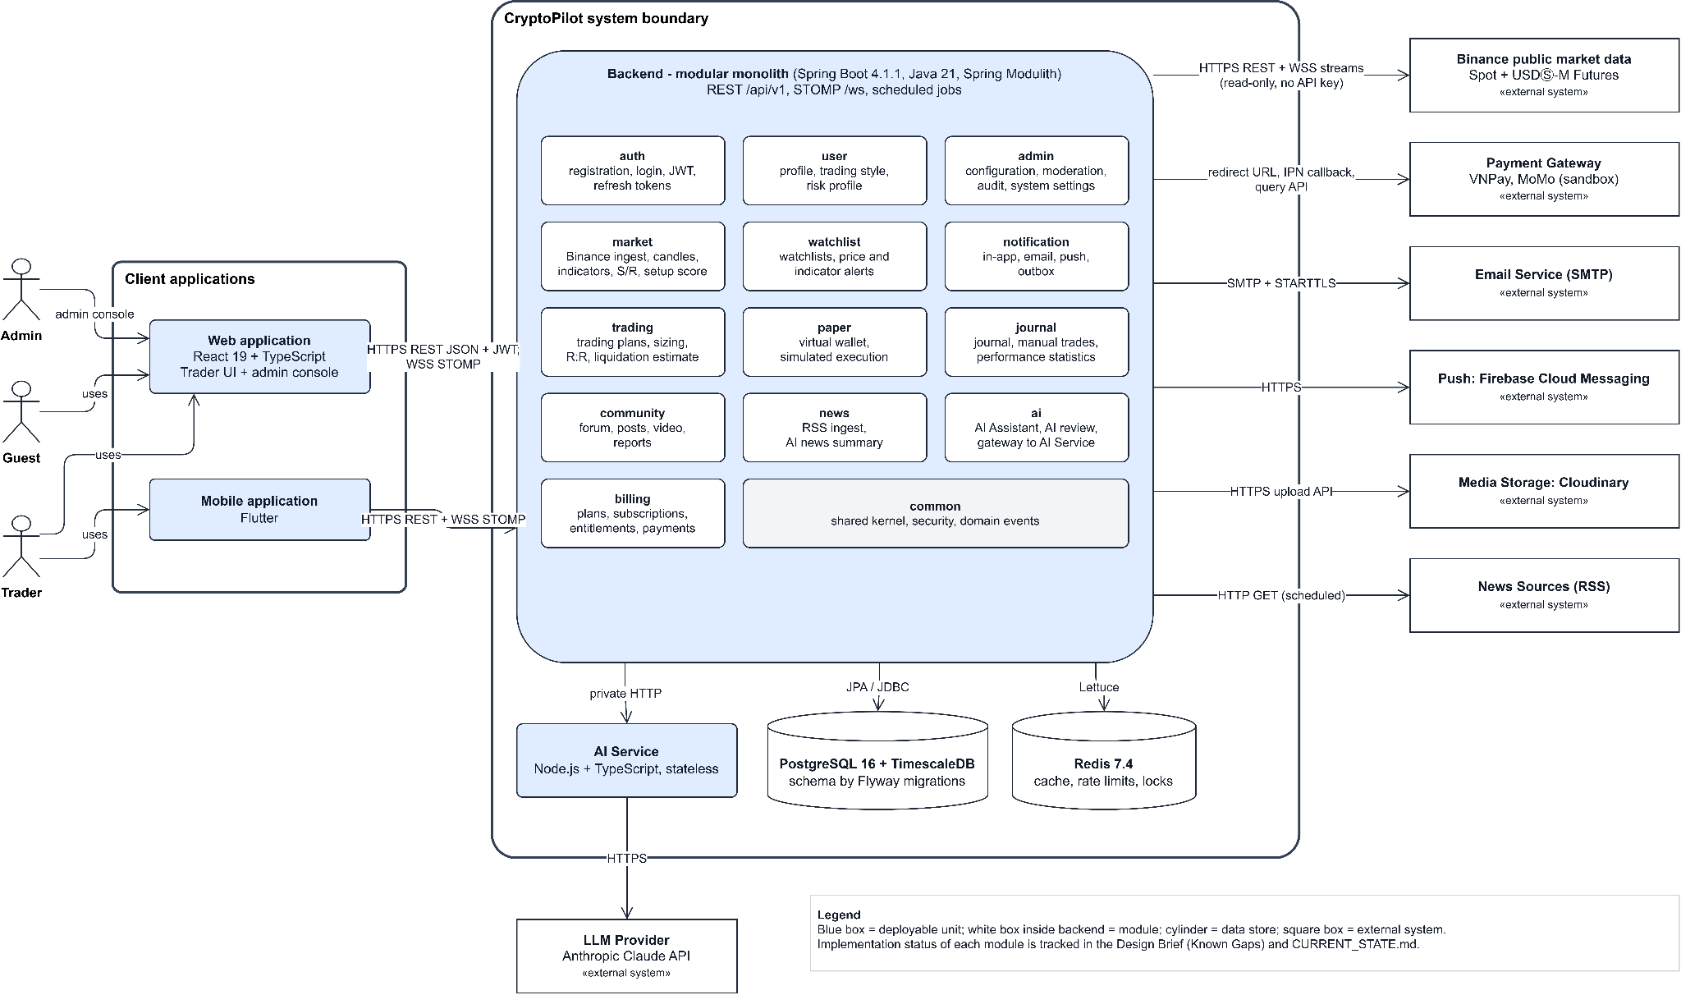

Figure 1: System architecture (System Overview)
Table 1: Components of CryptoPilot
No | Component | Technology | Responsibility
01 | Web application and Admin console | React 19, TypeScript, Vite, TanStack Query, Lightweight Charts, STOMP client | Public pages for Guests, the Trader area (analysis, plans, paper trading, journal, forum, news, AI) and the administration console.
02 | Mobile application | Flutter, Riverpod, dio, stomp_dart_client | Planned (P14). Core Trader features: market overview, watchlist and alerts, journal, AI chat; receives push notifications.
03 | Nginx | Nginx reverse proxy | TLS termination, routing of /api and /ws to the backend; the backend trusts X-Forwarded-For only from it (D-81).
04 | Backend (modular monolith) | Java 21, Spring Boot 4.1.1, Spring Modulith 2.1.1, Spring Security, JPA, Flyway | All business logic: REST API /api/v1, realtime STOMP endpoint /ws, Binance stream ingestion, indicator pipeline, alert and matching engines, paper exchange, community and in-app notifications, schedulers, transactional outbox. Only writer of the database.
05 | AI Service | Node.js LTS, TypeScript, Fastify, zod, Anthropic SDK | Planned (P11). Receives the active AI configuration and a context snapshot from the backend, calls the LLM, returns text and token usage. No database access, not exposed to the Internet (ADR-004).
06 | PostgreSQL + TimescaleDB | PostgreSQL 16, TimescaleDB 2.30.1 | System of record; candles, snapshots and funding history are hypertables.
07 | Redis | Redis 7.4.11 | Latest prices, rate-limit counters, replay locks. Cache only: losing it never loses business data.

Table 2: External systems
No | External system | Interface | Use
01 | Binance public API (Spot, USD-M Futures) | REST + WebSocket, no API key | Exchange information, klines, tickers, trades, depth, mark price, funding, open interest, long/short ratio.
02 | LLM Provider (Anthropic Claude API) | HTTPS, called only by the AI Service | AI Assistant answers and news summaries.
03 | VNPay, MoMo (sandbox) | Signed redirect / create-payment API, IPN callback, query API | Package payments.
04 | RSS news sources | HTTP GET of RSS 2.0 / Atom | News articles (title, link, time, excerpt).
05 | Email service | SMTP with STARTTLS | Verification, password reset, alert and receipt emails.
06 | Firebase Cloud Messaging | FCM HTTP v1 | Push notifications to the mobile app.
07 | Cloudinary | Signed direct upload, delete API | Images and videos of forum posts (implemented: signed direct upload, file check through the Admin API, deletion through the outbox, daily sweep of unattached files); avatars planned.

Main data flows: (1) market data flows from Binance streams into the backend, is stored as closed candles and pushed to clients over STOMP within 2 s; (2) Trader commands (plans, alerts, orders, posts) go through REST, are validated, stored and published as events in the same transaction; (3) side effects (email, push, AI requests) are delivered after commit through the Spring Modulith event publication registry, which retries incomplete publications (ADR-010); (4) in-app notifications are written once per event and recipient and pushed to /user/queue/notifications after commit.

1.2 Package Diagram
The backend is packaged by module, then by layer (ADR-003). Each direct sub-package of com.cryptopilot is a Spring Modulith application module: it writes only its own tables, exposes a public API in its root package (for example MarketApi, EntitlementApi, AdminApi) and reacts to other modules through events. ModularityTest, LayerRulesTest and PackageConventionTest fail the build when a boundary is crossed. Figure 2 shows the modules and their dependencies on develop (612b201, read from the imports of each module: solid; events: dotted with the event names) and those designed for later sprints (dashed).
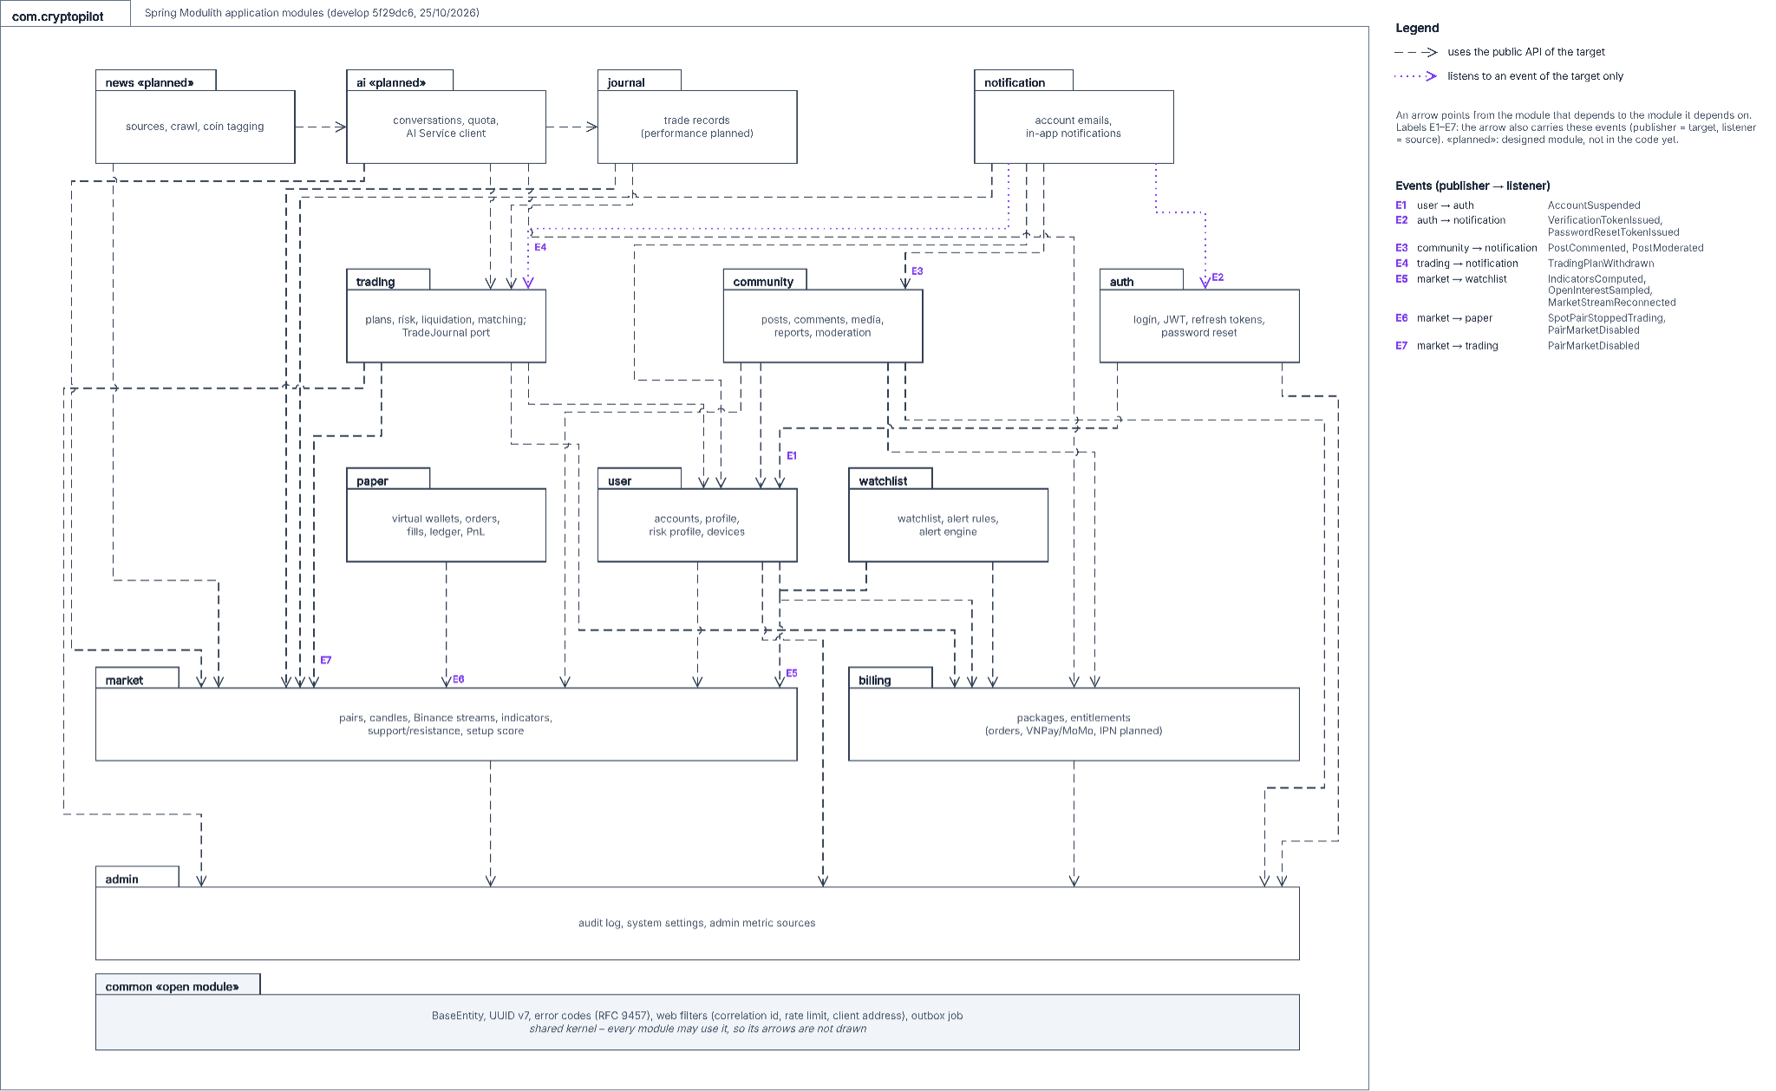
Figure 2: Package (module) diagram of the backend
Table 3: Package descriptions (modules)
No | Package | Description
01 | auth | Registration, email verification, login, JWT access tokens, rotating refresh tokens, password reset and change. Tables: user_token.
02 | user | Accounts, roles and status, profile, trading style, risk profile and questionnaire, devices. Tables: user_account, user_profile, user_device.
03 | market | Coins, pairs, Binance REST and stream clients, candle backfill, snapshots, futures metrics, indicators, support/resistance, setup score, leverage brackets, STOMP market hub.
04 | watchlist | Watchlist, alert rules and the alert engine (price, RSI, MACD, EMA cross, funding rate, open interest). Tables: watchlist, alert.
05 | trading | Trading plans, position size, risk/reward, liquidation price, warnings, simulated matching of plans, exit rules and trade result. Designed (GY-03, D-111, D-112): STOP entry, invalidation and the INVALIDATED status, entry deviation in R, analysis timeframe, liquidity role (TP-A, branch feature/TP-A-plan-validity). Tables: trading_plan, trading_plan_warning, trading_strategy, matching_watermark.
06 | paper | Paper exchange: virtual Spot and Futures wallets, transfers, Spot orders and order lists checked against the exchange symbol filters (V30), matching on live trades and depth, fills, ledger, PnL and equity; Futures orders and positions planned. Tables: paper_*.
07 | journal (planned) | Simulated and manual trade records, trade reviews, performance statistics. Table: trading_journal.
08 | community | Posts with coin tags and market type, feed tabs, coin discussion, comments, likes and saves, media on Cloudinary, reports, moderation queue and decisions, official posts with a category, member pages. Merged into develop on 22/10/2026 (PR #64). Tables: forum_post, post_coin, forum_comment, engagement, post_media, post_report.
09 | news (planned) | RSS sources, crawling, de-duplication, coin tagging, AI summaries.
10 | ai (planned) | Conversations, messages, AI configuration versions, daily quota, client of the AI Service.
11 | billing | Subscription packages and entitlements (done); orders, VNPay/MoMo gateways, IPN, reconciliation, subscriptions (planned).
12 | notification | Account emails over SMTP and the in-app notification centre for community events (comments, moderation decisions) with a 90-day sweep (done); alert, plan and subscription notifications and push dispatch (planned). Tables: notification.
13 | admin | Audit log writer, system settings reader (done); pair, system setting, user management and report endpoints built on local branches (T-082, T-083, T-085, T-086, not merged); dashboard planned. Tables: audit_log, system_setting.
14 | common | Shared kernel: BaseEntity, UUID v7, rounding, error codes and RFC 9457 errors, web filters (correlation id, rate limit, client address), outbox job.

Table 4: Layer packages inside every module
No | Layer package | Description
01 | controller | REST controllers; validate input, call one service, map the result. No business logic.
02 | service / service.impl | service holds interfaces only; service.impl holds the @Service implementations and helpers (D-48).
03 | calculator, matching | Pure domain calculations and engines (indicators, setup score, risk, liquidation, matching books); unit-tested without Spring.
04 | entity / repository | JPA entities (one aggregate per repository, D-23) and Spring Data repositories.
05 | dto.request / dto.response | Records crossing the API; never depend on entities.
06 | model / model.enums | Internal records and enums; enums exported with @NamedInterface("enums").
07 | client | Adapters to external systems (Binance, SMTP, Cloudinary, gateways).
08 | job / event | Schedulers, stream workers, listeners; events published to other modules.

1.3 Technology Declaration
Table 5: Third-party services
No | Third-party service | Purpose | Data sent
01 | Binance public market data API | Market data (Spot, USD-M Futures) | Symbols, intervals, stream subscriptions. No API key, no user data.
02 | Anthropic Claude API (via AI Service) | AI APIs: answers, news summaries | Question text, context snapshot (indicators, setup score, plan figures, performance summary), article text. No email, no name (BR-51).
03 | VNPay, MoMo (sandbox) | Payment | Order code, amount, order description, return and IPN URLs.
04 | SMTP email server | Email delivery | Recipient address, subject, message body.
05 | Firebase Cloud Messaging | Push notifications | Device token, title, body, deep link.
06 | Cloudinary | Storage of images and videos | Files uploaded by users, public id, folder.
07 | RSS news sources | News collection | Nothing (HTTP GET only).

Table 6: Development technologies
No | Area | Technology and version
01 | Back-end | Java 21 (Eclipse Temurin), Spring Boot 4.1.1, Spring Modulith 2.1.1, Spring Security (OAuth2 resource server, JWT HS256, BCrypt 12), Spring Data JPA, Flyway, springdoc-openapi 3.1.1, java-uuid-generator 5.2.0, Maven wrapper
02 | Back-end tests and quality | JUnit 5, AssertJ, Mockito, Testcontainers, ArchUnit 1.4.2, Spring Modulith test, JaCoCo 0.8.13, Spotless 2.46.1 with Palantir Java Format 2.78.0
03 | Database and cache | PostgreSQL 16 + TimescaleDB 2.30.1 (image timescale/timescaledb:2.30.1-pg16), Redis 7.4.11 (redis:7.4.11-alpine)
04 | Front-end | React 19, TypeScript (strict), Vite, Tailwind CSS 4, TanStack Query, React Router, React Hook Form + zod, @stomp/stompjs, TradingView Lightweight Charts, big.js for decimals (D-100, D-102; web repository cryptopilot-frontend, ADR-015)
05 | Mobile | Flutter (stable channel), Riverpod, dio, go_router, stomp_dart_client; chart library per ADR-012
06 | AI Service | Planned (P11): Node.js LTS, TypeScript, Fastify, zod, @anthropic-ai/sdk, bottleneck

Table 7: Source code and DevOps
No | Item | Declaration
01 | Platform | GitHub: nguyenluc2411/cryptopilot_project (code, public since 27/09/2026); project documents in a private repository.
02 | CI | GitHub Actions: job build-and-test (./mvnw verify: compile with warnings as errors, Spotless check, unit, architecture and Testcontainers integration tests, JaCoCo gates line 95 % / branch 90 %); job secret-scan (gitleaks) on every pull request.
03 | CD | Planned (RF-13): build and push Docker images on develop and main, deploy to the staging VPS with Docker Compose.
04 | Branch rules | main (release) ← develop (integration) ← feature/T-xxx, fix/…, test/…; pull request with one reviewer and a green CI; Conventional Commits with a Refs: T-xxx footer.
05 | Contributors | From the git history of develop at 612b201 (23/10/2026), non-merge commits: Nguyễn Đình Lực (nguyenluc2411, team lead, 206; market, auth, trading, entitlements; merges every pull request), Đoàn Trung Trực (TrucFPTU, 57; watchlist and alerts, outbox and email, audit log, risk profile, seeds, paper PnL fixes), Lưu Trần Quốc Vũ (Vuhayya, 49; paper exchange, community and moderation, in-app notifications). Hoàng Văn Huy works on the web client in the separate repository cryptopilot-frontend.

Table 8: Deployment environments
No | Environment | Where | How deployed / rolled back
01 | dev | Developer machine | deploy/docker-compose.dev.yml starts PostgreSQL + TimescaleDB and Redis; backend runs from the IDE or Maven with profile dev; demo data is a repeatable Flyway migration loaded only in dev.
02 | staging (demo) | One VPS, Docker Compose, profile prod | docker compose pull + up -d with a versioned image tag; Flyway migrates forward on start; rollback = redeploy the previous image tag, database restored from the daily backup when a migration must be undone (RPO 24 h, RTO 4 h). Used for the Defense 1.1 demo.
03 | production | Same VPS as staging for the capstone | Same procedure; payment gateways stay in sandbox mode.

Table 9: AI tools
No | AI tool and model | Stages used | Rules
01 | Claude (Anthropic) on claude.ai, Claude Opus models | Specification (SRS drafting), design (ADRs, technical design, diagrams), review (design review, self-review report BM02) | Every output is reviewed by the owner before use; no real user data, passwords or keys are given to the tool.
02 | Claude Code (coding agent), Claude Opus models | Code, tests, PR review | Works under the team's agent rules: mandatory codebase analysis, one task per session, tests before merge, no AI attribution in commits; every change is reviewed in a pull request.

2. Database Design
The database is one PostgreSQL 16 schema with the TimescaleDB extension. The schema is owned by Flyway SQL migrations in backend/src/main/resources/db/migration; ddl-auto is validate, so the JPA mapping is checked against the script at start-up. Primary keys are UUID v7 generated by the application (ADR-009); money, prices and quantities are numeric (ADR-008); every entity table also has version, created_at and updated_at (technical columns, not drawn). Time series (ohlcv, spot_market_data, futures_market_data, funding_rate_history) are hypertables. This version describes develop at 612b201 (23/10/2026), migrations V1–V31.

2.1 Database Files
Table 10: Database script files
No | File | Description
01 | V1__baseline_schema.sql | All tables of the logical model with keys, CHECK constraints and indexes; Spring Modulith event_publication.
02 | V2__timescale_hypertables.sql | Hypertables and retention for candles, snapshots and funding history.
03 | V3__seed_reference_data.sql | Coins, strategies, system settings, bootstrap administrator (password hash from the environment).
04 | V4–V6 | Login lockout, refresh token family, password change counter.
05 | V7–V9, V20 | Binance ban state, exchange status of pairs, indicator row without stored setup score, dropped backfill gaps.
06 | V10–V14 | Plan tiers and entitlements of packages, package seed, risk profile, warning thresholds.
07 | V15–V19, V26 | Trading plan status instants, risk/reward width, alert constraints, fill price, matching watermark, liquidation clearance fee.
08 | V21–V25 | Paper trading tables, LIMIT_MAKER, cost basis, Spot order types, quote USDT price of fills.
09 | V27–V29 | Community alignment with the registered topic (REMOVE_POST, official category), video posts for PRO, in-app notifications (COMMENT type, source_key, indexes).
10 | V30–V31 | Spot symbol filters of crypto_pair, client id of paper order lists, activation time of OTO/OTOCO legs.
11 | V32 (designed) | Plan validity of TP-A (D-111, D-112): STOP entry, INVALIDATED, invalidation price, entry deviation, analysis timeframe, journal learning data, four settings. Written as V30 on feature/TP-A-plan-validity; renumbered before merge because develop took V30 and V31.
12 | db/demo (repeatable, dev only) | Demo pairs, demo Traders on each plan tier, seeded plans.

2.2 Entity Relationship Diagrams
The logical model has 51 entities: the 39 entities of the logical model (38 in SRS 3.1.5 plus FUNDING_RATE_HISTORY) and the 12 paper trading entities. The diagrams are drawn from the database script of develop (V1–V31): every column except version, created_at and updated_at, the keys of the script and the values of its CHECK constraints. Columns designed by TP-A (D-111, D-112) and not yet merged are shaded yellow. It is drawn in five domain diagrams; an entity of another domain is shown with its key only.
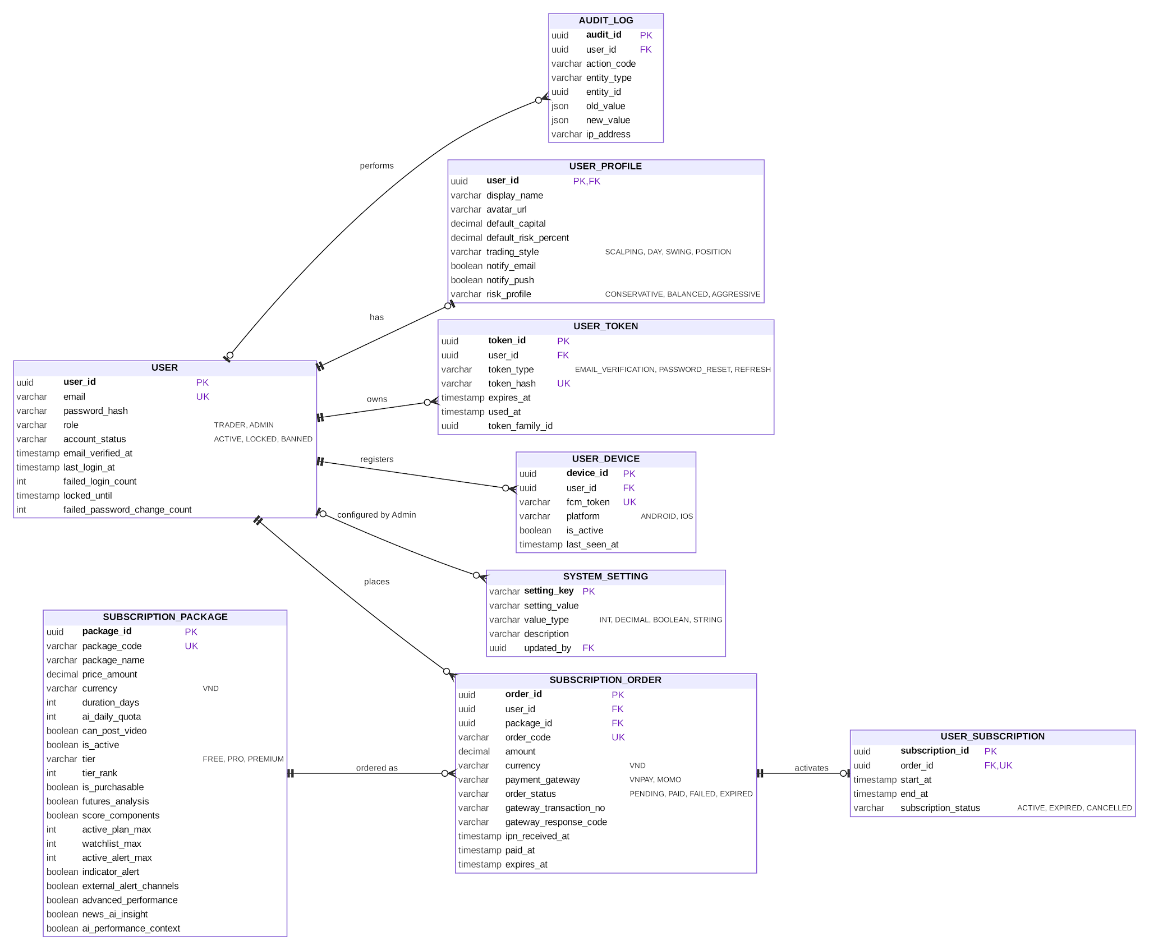
Figure 3: ERD – identity, subscription, configuration and audit
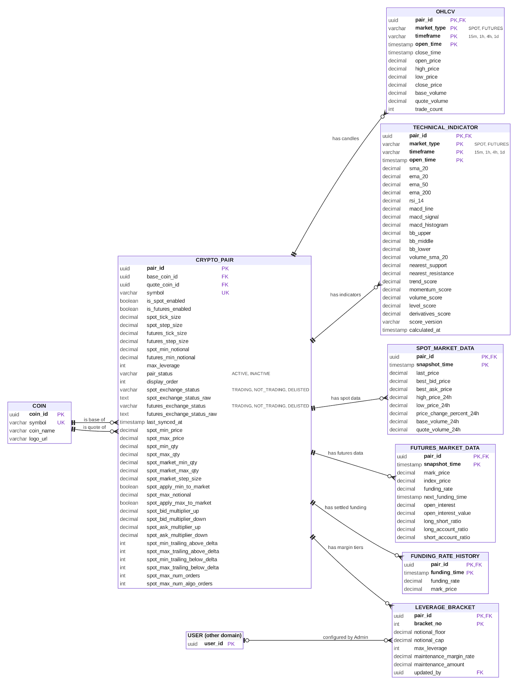
Figure 4: ERD – market data and analysis
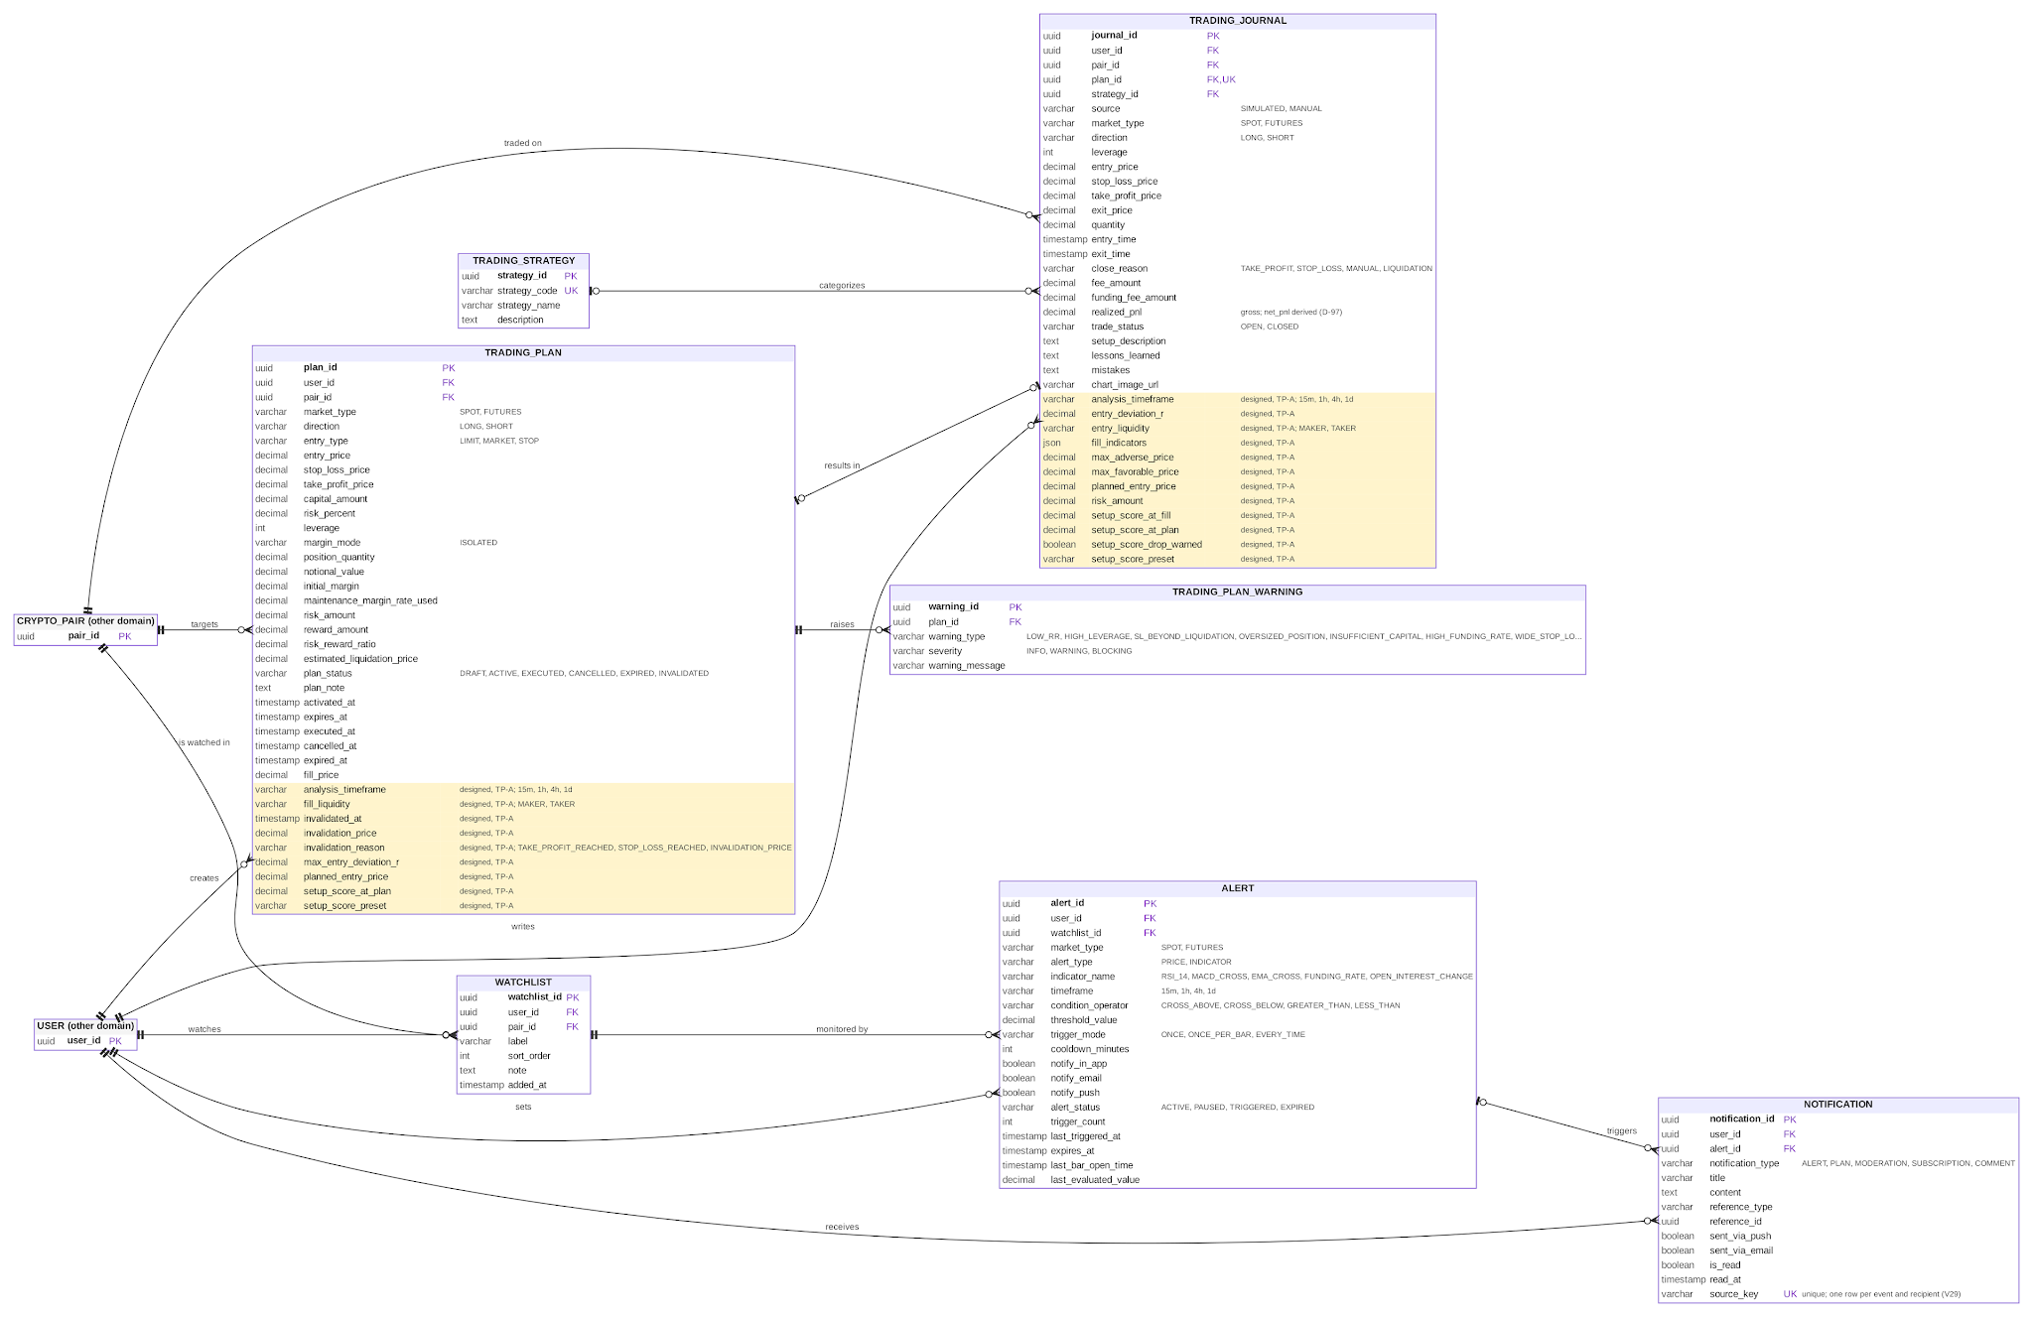
Figure 5: ERD – watchlist, alerts, notifications, trading plans and journal
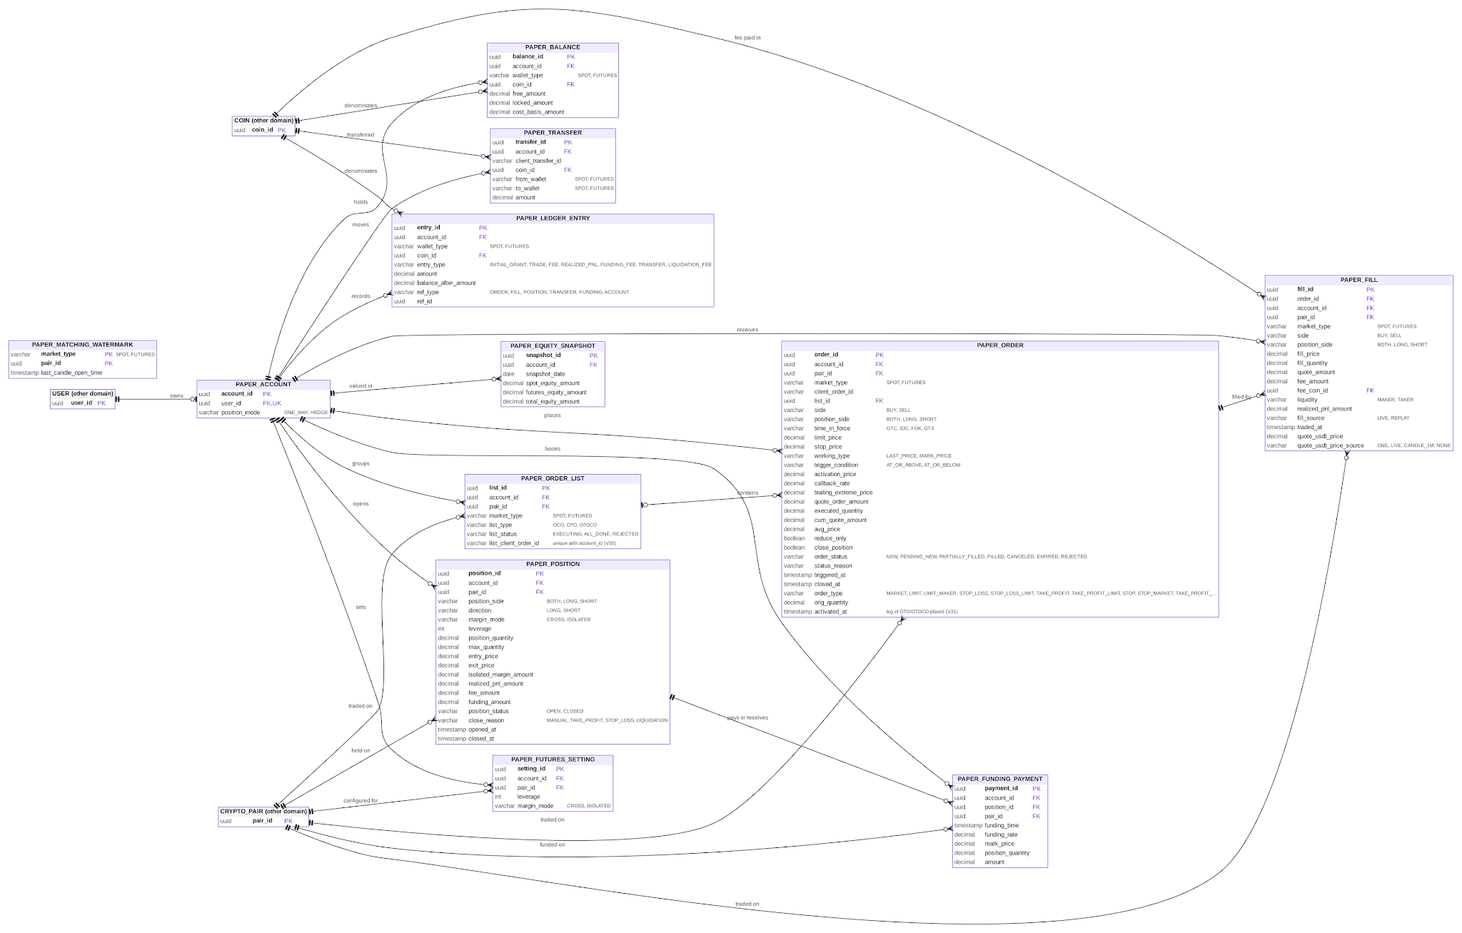
Figure 6: ERD – paper trading
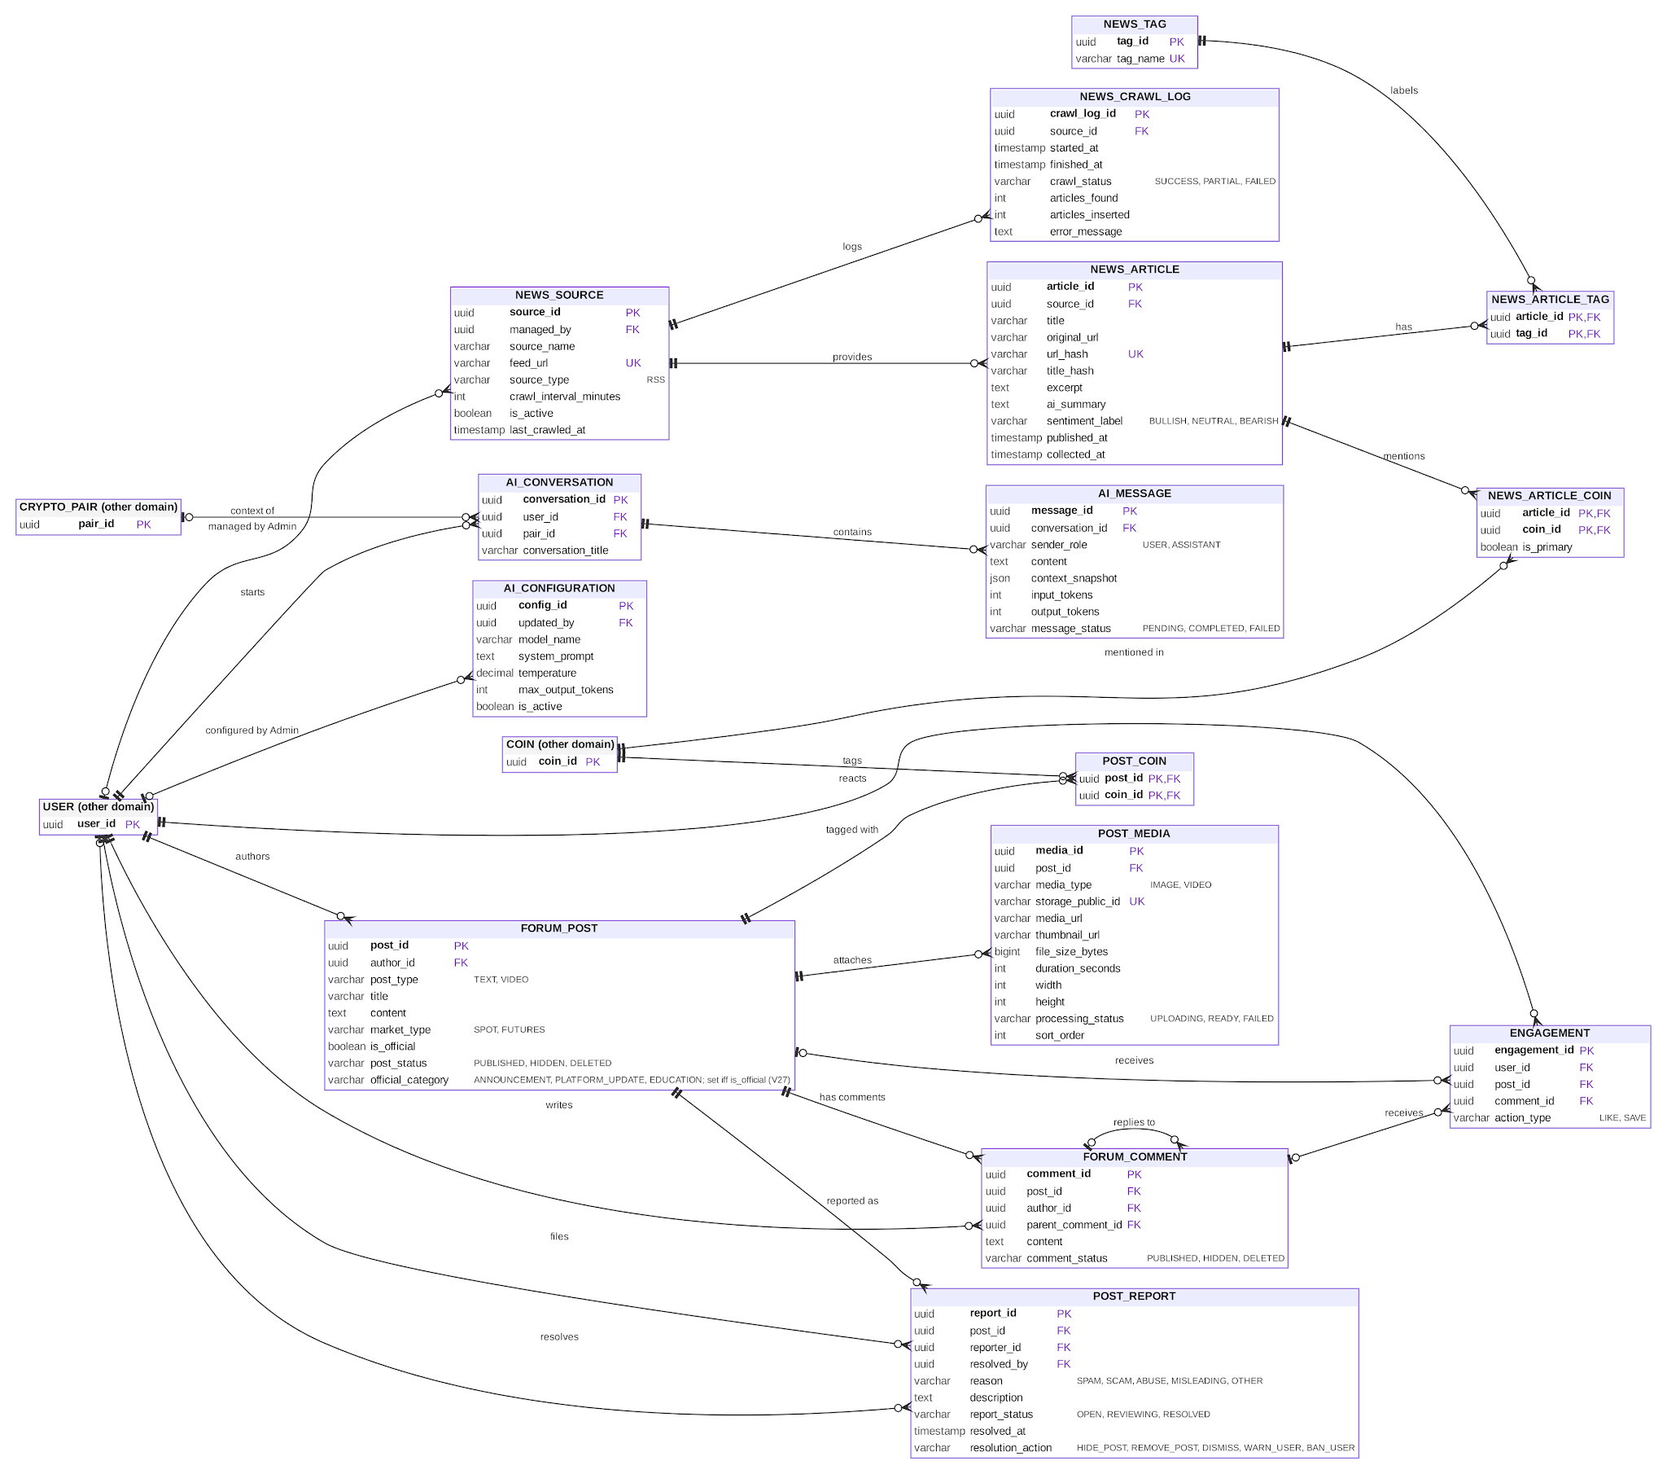
Figure 7: ERD – community, news and AI Assistant

2.3 Table Descriptions
Table 11: Table descriptions
No | Table | Description
01 | user_account | Account of a Trader or Admin: email, password hash, role, account status, verification and login times.  - Primary keys: user_id  - Foreign keys: —
02 | user_profile | One-to-one profile of a user: display name, avatar, default capital, default risk %, trading style, risk profile, notification preferences.  - Primary keys: user_id  - Foreign keys: user_id
03 | user_token | Hashed tokens with expiry for email verification, password reset and session refresh.  - Primary keys: token_id  - Foreign keys: user_id
04 | user_device | Mobile devices of a user with the FCM token used for push notifications.  - Primary keys: device_id  - Foreign keys: user_id
05 | coin | Crypto asset (e.g. BTC, ETH, USDT) used as base or quote of pairs and as tag of posts and news.  - Primary keys: coin_id  - Foreign keys: —
06 | crypto_pair | Trading pair (e.g. BTCUSDT) with enabled markets, tick size, step size, minimum notional, maximum leverage, display order, exchange status and the Spot symbol filters paper orders are checked against (price, quantity, market quantity, notional, percent price by side, trailing delta, order counts; V30).  - Primary keys: pair_id  - Foreign keys: base_coin_id, quote_coin_id
07 | ohlcv | Closed candle of a pair per market type and timeframe: open, high, low, close, volume, trade count.  - Primary keys: pair_id, market_type, timeframe, open_time  - Foreign keys: pair_id
08 | technical_indicator | Indicators, nearest support/resistance and setup score component scores (with component version) computed for one closed candle; the setup score is computed when read by applying a preset (BR-13).  - Primary keys: pair_id, market_type, timeframe, open_time  - Foreign keys: pair_id
09 | spot_market_data | Periodic snapshot of spot market: last price, best bid/ask, 24h statistics.  - Primary keys: pair_id, snapshot_time  - Foreign keys: pair_id
10 | futures_market_data | Periodic or funding-settlement snapshot of futures market: mark and index price, funding rate, open interest, long/short ratio.  - Primary keys: pair_id, snapshot_time  - Foreign keys: pair_id
11 | funding_rate_history | Settled funding rate and mark price of a Futures pair at each funding time; kept for ever for PnL (A-12).  - Primary keys: pair_id, funding_time  - Foreign keys: pair_id
12 | watchlist | A pair watched by a Trader, with label, order and note; unique per Trader and pair.  - Primary keys: watchlist_id  - Foreign keys: user_id, pair_id
13 | alert | Price or indicator alert rule on a watchlist pair with trigger mode, cooldown, channels, status and expiry.  - Primary keys: alert_id  - Foreign keys: user_id, watchlist_id
14 | notification | Message to a user created by an alert or by trading, moderation, comment or subscription events, with read status and a unique source key so an event delivered again writes nothing (V29); kept 90 days (NSF-17).  - Primary keys: notification_id  - Foreign keys: user_id, alert_id
15 | trading_strategy | System-defined strategy category (e.g. Breakout, Swing, Scalping) used to classify trades.  - Primary keys: strategy_id  - Foreign keys: —
16 | trading_plan | Trader's plan: pair, market, direction, entry type, entry, stop loss, take profit, capital, risk %, leverage, calculation snapshot and status. Designed (TP-A): STOP entry, INVALIDATED status with reason and time, invalidation price, planned entry price, maximum entry deviation, analysis timeframe, setup score at activation, fill liquidity.  - Primary keys: plan_id  - Foreign keys: user_id, pair_id
17 | trading_plan_warning | Risk warning raised for a plan with type and severity (INFO, WARNING, BLOCKING).  - Primary keys: warning_id  - Foreign keys: plan_id
18 | trading_journal | Record of a simulated or manual trade: execution facts, fees, funding, realized profit/loss (BR-35; net profit/loss is derived, BR-38) and the Trader's review. Designed (TP-A, BR-76): learning data — planned entry, entry deviation in R, entry liquidity, planned risk, setup score at plan and at fill, indicators at fill, most adverse and most favourable prices.  - Primary keys: journal_id  - Foreign keys: user_id, pair_id, plan_id, strategy_id
19 | paper_account | Paper trading account of a Trader, created on first use with the initial virtual balance.  - Primary keys: account_id  - Foreign keys: user_id
20 | paper_balance | Balance of one coin in the Spot or Futures wallet: free and locked amounts, cost basis in USDT.  - Primary keys: balance_id  - Foreign keys: account_id, coin_id
21 | paper_transfer | Transfer of a coin between the Spot and Futures wallets; idempotent by client transfer id.  - Primary keys: transfer_id  - Foreign keys: account_id, coin_id
22 | paper_ledger_entry | Immutable record of every balance change (grant, trade, fee, realized PnL, funding, transfer, liquidation fee) with the balance after it.  - Primary keys: entry_id  - Foreign keys: account_id, coin_id
23 | paper_futures_setting | Leverage and margin mode chosen by the Trader for one Futures pair.  - Primary keys: setting_id  - Foreign keys: account_id, pair_id
24 | paper_order_list | Group of orders placed together: OCO, OTO, OTOCO; idempotent by its list client order id (V30).  - Primary keys: list_id  - Foreign keys: account_id, pair_id
25 | paper_order | Simulated order: type, side, time in force, prices, quantities, status and status reason; a leg of an OTO or OTOCO keeps the time it was placed (activated_at, V31).  - Primary keys: order_id  - Foreign keys: account_id, pair_id, list_id
26 | paper_fill | One execution of an order: price, quantity, quote amount, fee, maker/taker, source (live or replay).  - Primary keys: fill_id  - Foreign keys: order_id, account_id, pair_id, fee_coin_id
27 | paper_position | Simulated Futures position: side, leverage, margin, entry and exit price, realized PnL, fees, funding, status.  - Primary keys: position_id  - Foreign keys: account_id, pair_id
28 | paper_funding_payment | Funding paid or received by an open position at a funding time.  - Primary keys: payment_id  - Foreign keys: account_id, position_id, pair_id
29 | paper_equity_snapshot | Daily valuation of the Spot and Futures wallets in USDT.  - Primary keys: snapshot_id  - Foreign keys: account_id
30 | paper_matching_watermark | Technical: last candle matched per market and pair, used to replay after a restart.  - Primary keys: market_type, pair_id  - Foreign keys: ---
31 | ai_conversation | Conversation of a Trader with the AI Assistant, optionally in the context of a pair.  - Primary keys: conversation_id  - Foreign keys: user_id, pair_id
32 | ai_message | Question or answer in a conversation with context snapshot, token usage and status.  - Primary keys: message_id  - Foreign keys: conversation_id
33 | ai_configuration | Versioned AI settings (model, system prompt, temperature, token limit); exactly one active.  - Primary keys: config_id  - Foreign keys: updated_by
34 | subscription_package | Package of a plan tier (FREE, PRO, PREMIUM) with tier rank, price, duration, purchasable flag, active flag and the entitlements of the tier (Table 3.1): Futures analysis, setup score components, maximum ACTIVE plans and open positions, watchlist items, active alerts, indicator alerts, external alert channels, full performance dashboard, news AI insight, AI daily quota, AI performance context, video posting. FREE is a single package that cannot be purchased.  - Primary keys: package_id  - Foreign keys: —
35 | subscription_order | Purchase of a package by a Trader: unique order code, amount, currency, gateway, status, gateway transaction data, IPN, payment and expiry times. The order type, list price, upgrade credit and manual-handling flag of the SRS are added with the billing work (section 2.4).  - Primary keys: order_id  - Foreign keys: user_id, package_id
36 | user_subscription | Subscription period created by a paid order, with start, end and status; the SRS defines SCHEDULED, ACTIVE, EXPIRED, REPLACED and at most one ACTIVE subscription per Trader, which the script does not enforce yet (section 2.4).  - Primary keys: subscription_id  - Foreign keys: order_id
37 | forum_post | Community post (text or video) with market type, status, official flag and, for an official post, its category: ANNOUNCEMENT, PLATFORM_UPDATE or EDUCATION (V27).  - Primary keys: post_id  - Foreign keys: author_id
38 | post_coin | Association between posts and the coins they are tagged with.  - Primary keys: post_id, coin_id  - Foreign keys: post_id, coin_id
39 | forum_comment | Comment on a post; may reply to another comment.  - Primary keys: comment_id  - Foreign keys: post_id, author_id, parent_comment_id
40 | engagement | Like or save action of a user on exactly one post or comment.  - Primary keys: engagement_id  - Foreign keys: user_id, post_id, comment_id
41 | post_media | Image or video attached to a post, stored in Media Storage.  - Primary keys: media_id  - Foreign keys: post_id
42 | post_report | Violation report on a post, with reason, status and the Admin's resolution (HIDE_POST, REMOVE_POST, DISMISS, WARN_USER, BAN_USER).  - Primary keys: report_id  - Foreign keys: post_id, reporter_id, resolved_by
43 | news_source | RSS source managed by Admin with crawl interval and status.  - Primary keys: source_id  - Foreign keys: managed_by
44 | news_crawl_log | Result of one crawl of a source: time, status, articles found and inserted, error.  - Primary keys: crawl_log_id  - Foreign keys: source_id
45 | news_article | Collected article: title, original URL, excerpt, AI summary, sentiment, publish time.  - Primary keys: article_id  - Foreign keys: source_id
46 | news_tag | Topic tag of news articles.  - Primary keys: tag_id  - Foreign keys: —
47 | news_article_tag | Association between articles and topic tags.  - Primary keys: article_id, tag_id  - Foreign keys: article_id, tag_id
48 | news_article_coin | Association between articles and mentioned coins, with primary flag.  - Primary keys: article_id, coin_id  - Foreign keys: article_id, coin_id
49 | leverage_bracket | Maintenance margin tiers of a futures pair (notional range, maximum leverage, maintenance margin rate) configured by Admin.  - Primary keys: pair_id, bracket_no  - Foreign keys: pair_id, updated_by
50 | system_setting | Key-value configuration maintained by Admin (limits, fee rates, warning thresholds).  - Primary keys: setting_key  - Foreign keys: updated_by
51 | audit_log | Log of administrative and security-relevant actions with actor, entity, old and new values.  - Primary keys: audit_id  - Foreign keys: user_id
52 | event_publication | Technical: Spring Modulith event publication registry (transactional outbox, ADR-010).
53 | flyway_schema_history | Technical: applied migrations (Flyway).
54 | binance_ban | Technical: end of a Binance IP ban, kept across restarts (A-31).
55 | matching_watermark | Technical: last 1m candle matched per market and pair by the plan simulator (T-043).
56 | dropped_backfill_gap | Technical: candle gaps the backfill could not fill, kept for inspection (V20).

2.4 Reconciliation of the ERD with the Database Script
This version of the ERD was drawn from migrations V1–V31 of develop, so the ERD and the script agree column by column; the technical columns version, created_at and updated_at are not drawn. Four items remain between the script and the SRS or the design:
• USER_SUBSCRIPTION.subscription_status: the SRS and the state machine of section 4.8 use SCHEDULED, ACTIVE, EXPIRED, REPLACED; the V1 CHECK, drawn in Figure 3, still allows ACTIVE, EXPIRED, CANCELLED. A migration aligns the script before the billing work (RF-08, Lưu Trần Quốc Vũ, 17/11/2026).
• SUBSCRIPTION_ORDER and USER_SUBSCRIPTION: the order type (NEW, RENEW, UPGRADE, DOWNGRADE), list price, upgrade credit, manual-handling flag and idempotency key of the SRS are not in the script, and user_subscription has no user_id, so "at most one ACTIVE subscription per Trader" is not enforced yet. Added by the billing migration (RF-08).
• TRADING_PLAN and TRADING_JOURNAL: the TP-A columns (D-111, D-112) are on feature/TP-A-plan-validity as V30, shaded in Figure 5. develop already uses V30 and V31, so the migration is renumbered (V32) before it merges.
• TRADING_JOURNAL: net PnL is derived (realized_pnl − fee_amount + funding_fee_amount, D-97) and is not a column.

3. Detailed Design
Each feature gives its class diagram and its sequence diagrams. Status: Implemented = on develop with tests; Local = built on unmerged branches; Designed = classes named in the technical design, to be built. Features with the same structure refer to the diagrams of an earlier feature.

3.1 Market Data and Technical Analysis
Status: Implemented (NSF-01…05, UC-09…11). Owner: Nguyễn Đình Lực (Spot trades and depth streams for the paper exchange: Lưu Trần Quốc Vũ; deterministic stream tests: Đoàn Trung Trực).

3.1.1 Class Diagram
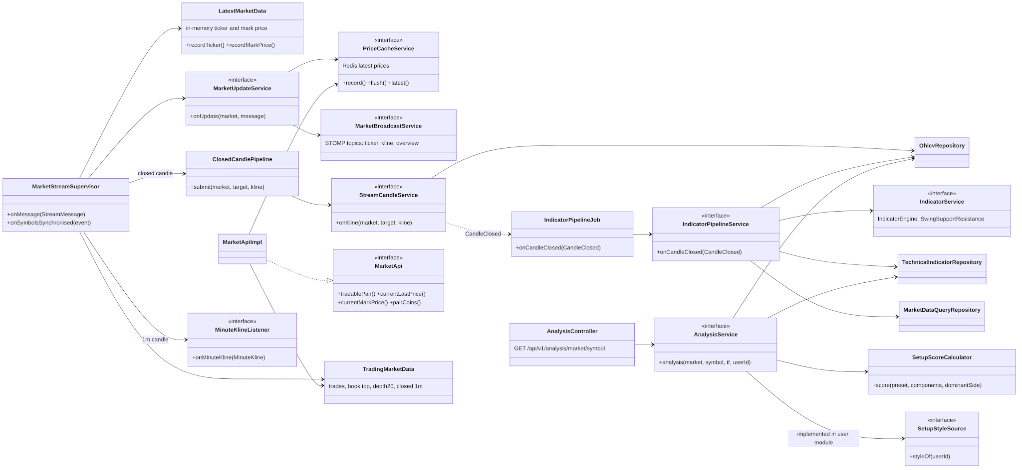
Figure 8: Class diagram – market data and analysis
Table 12: Class specifications – Market Data and Technical Analysis
No | Class | Responsibility
01 | MarketStreamSupervisor | Opens Binance stream shards, renews them before 24 h, reconnects with back-off, detects gaps (NSF-03).
02 | ClosedCandlePipeline | Hands each closed candle of a stored timeframe (15m, 1h, 4h, 1d) to StreamCandleService, one worker per pair; StreamCandleService stores it idempotently in its own transaction, reports a gap (NSF-02) and publishes CandleClosed, which IndicatorPipelineJob turns into indicators (IndicatorPipelineService).
03 | IndicatorEngine | Incremental SMA, EMA, RSI (Wilder), MACD, Bollinger Bands per series; checked against TA-Lib golden data (BR-12).
04 | SetupComponents / SetupScoreCalculator | Direction-free component scores stored per candle; the setup score is computed on read with the Trader's style preset (BR-13, ADR-013).
05 | AnalysisService | Assembles the latest indicators, support/resistance and setup score for a pair and timeframe.
06 | MarketApi | Public API of the module: tradable pairs and filters, latest last and mark prices for other modules.
07 | LatestMarketData / MarketUpdateService / PriceCacheService | Latest ticker and mark price kept in memory; every stream message recorded in the Redis latest-price cache (flushed by PriceCacheJob) and broadcast to the STOMP topics, at most one message per second per topic (NSF-04).

3.1.2 Sequence – closed candle to indicators
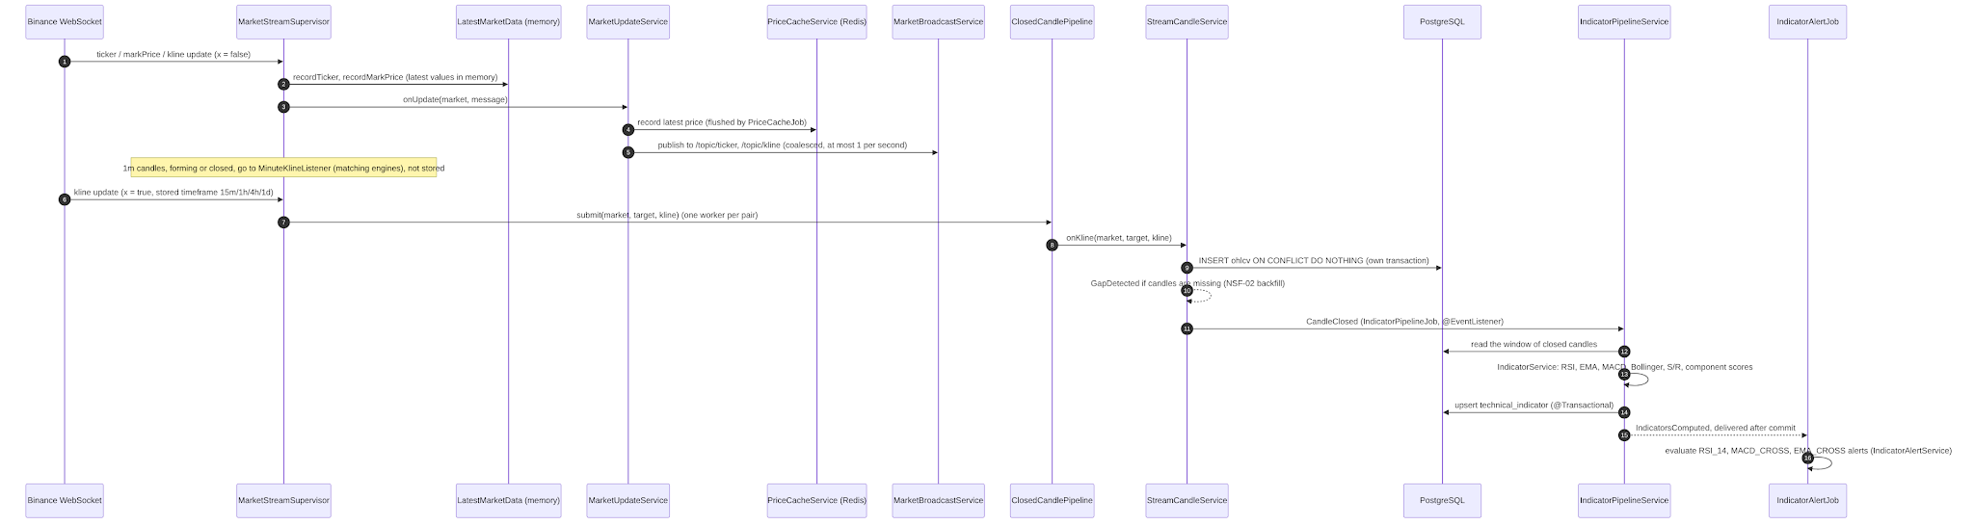
Figure 9: Sequence – closed candle to indicators

3.1.3 Sequence – read the analysis of a pair
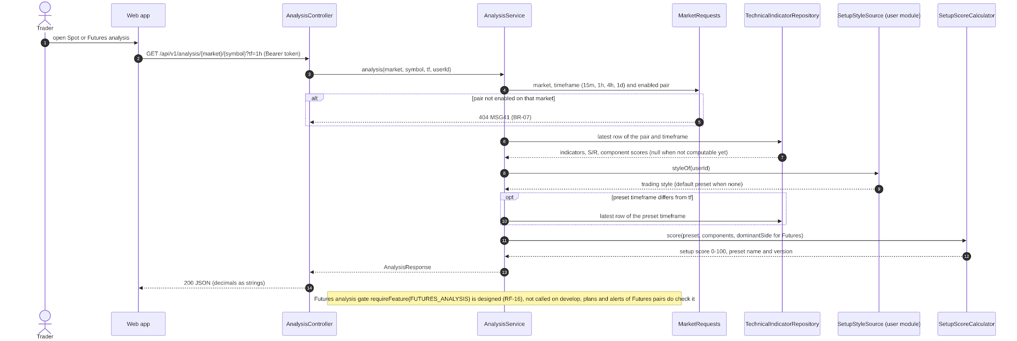
Figure 10: Sequence – read the analysis of a pair

3.2 Trading Plan and Simulated Execution
Status: Implemented: plan API, risk, liquidation, warnings, entry fills, exit rules and trade result (calculation layer, PR #61). Designed: plan validity and entry deviation (GY-03; D-111, D-112; schema, domain and API built on feature/TP-A-plan-validity, PR not opened; matching TP-B, fees and slippage TP-0, TP-C), exit wiring and journal (T-048). Owner: Nguyễn Đình Lực (matching engine skeleton T-042: Đoàn Trung Trực, PR #46).

3.2.1 Class Diagram
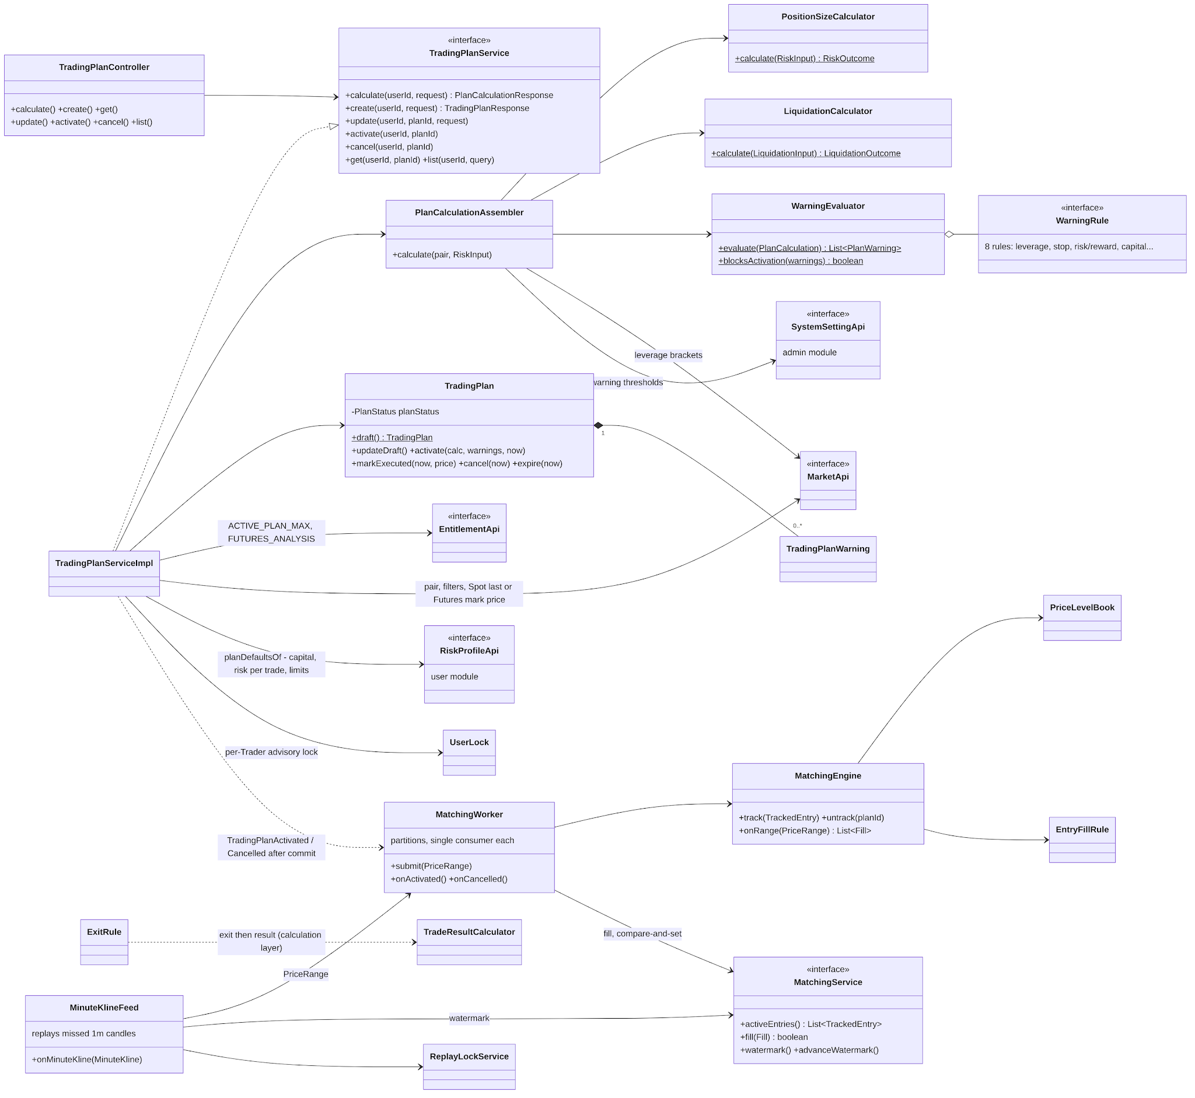
Figure 11: Class diagram – trading plan and matching
Table 13: Class specifications – Trading Plan and Simulated Execution
No | Class | Responsibility
01 | TradingPlanServiceImpl | Create, edit, activate, cancel and list plans; one transaction with a per-user advisory lock for limits (D-63); capital and risk defaults from RiskProfileApi; MARKET entry at the Spot last price or the Futures mark price (BR-33).
02 | PositionSizeCalculator | Quantity from risk amount and stop distance, floored to the step size; notional, margin, RR (BR-21…25).
03 | LiquidationCalculator | Isolated-margin liquidation price with the maintenance bracket and its cumulative amount (BR-26, BR-27).
04 | WarningEvaluator / WarningRule | Eight warning rules with INFO, WARNING, BLOCKING severity; thresholds from the system settings (LOW_RR, WIDE_STOP_LOSS, HIGH_FUNDING_RATE) and the risk profile (BR-28, BR-29).
05 | TradingPlan | Aggregate with the status transition table; owns its warnings.
06 | MatchingWorker / MatchingEngine / PriceLevelBook | Partitioned consumers; sorted books of entry levels; fill when a 1m range reaches a level (BR-33, ADR-011).
07 | ExitRule / TradeResultCalculator | Exit by range (stop loss before take profit) or by mark price (liquidation); realized PnL, fees, clearance fee (BR-35, BR-36, D-97).
08 | TradingPlan (designed, TP-A) | Adds STOP entries, the INVALIDATED status with its reason and time, the invalidation price and the maximum entry deviation; activation refuses a reached STOP trigger, TP, SL or invalidation price with MSG16 and checks the MARKET entry deviation (MSG51, MSG52; BR-74, BR-75).
09 | MatchingEngine / EntryFillRule (designed, TP-B) | STOP triggers on the last price; invalidation levels in the books, invalidation wins on a candle that reaches both; fees by liquidity role and slippage on taker fills (TP-0, TP-C; BR-36).

3.2.2 Sequence – create and activate a plan
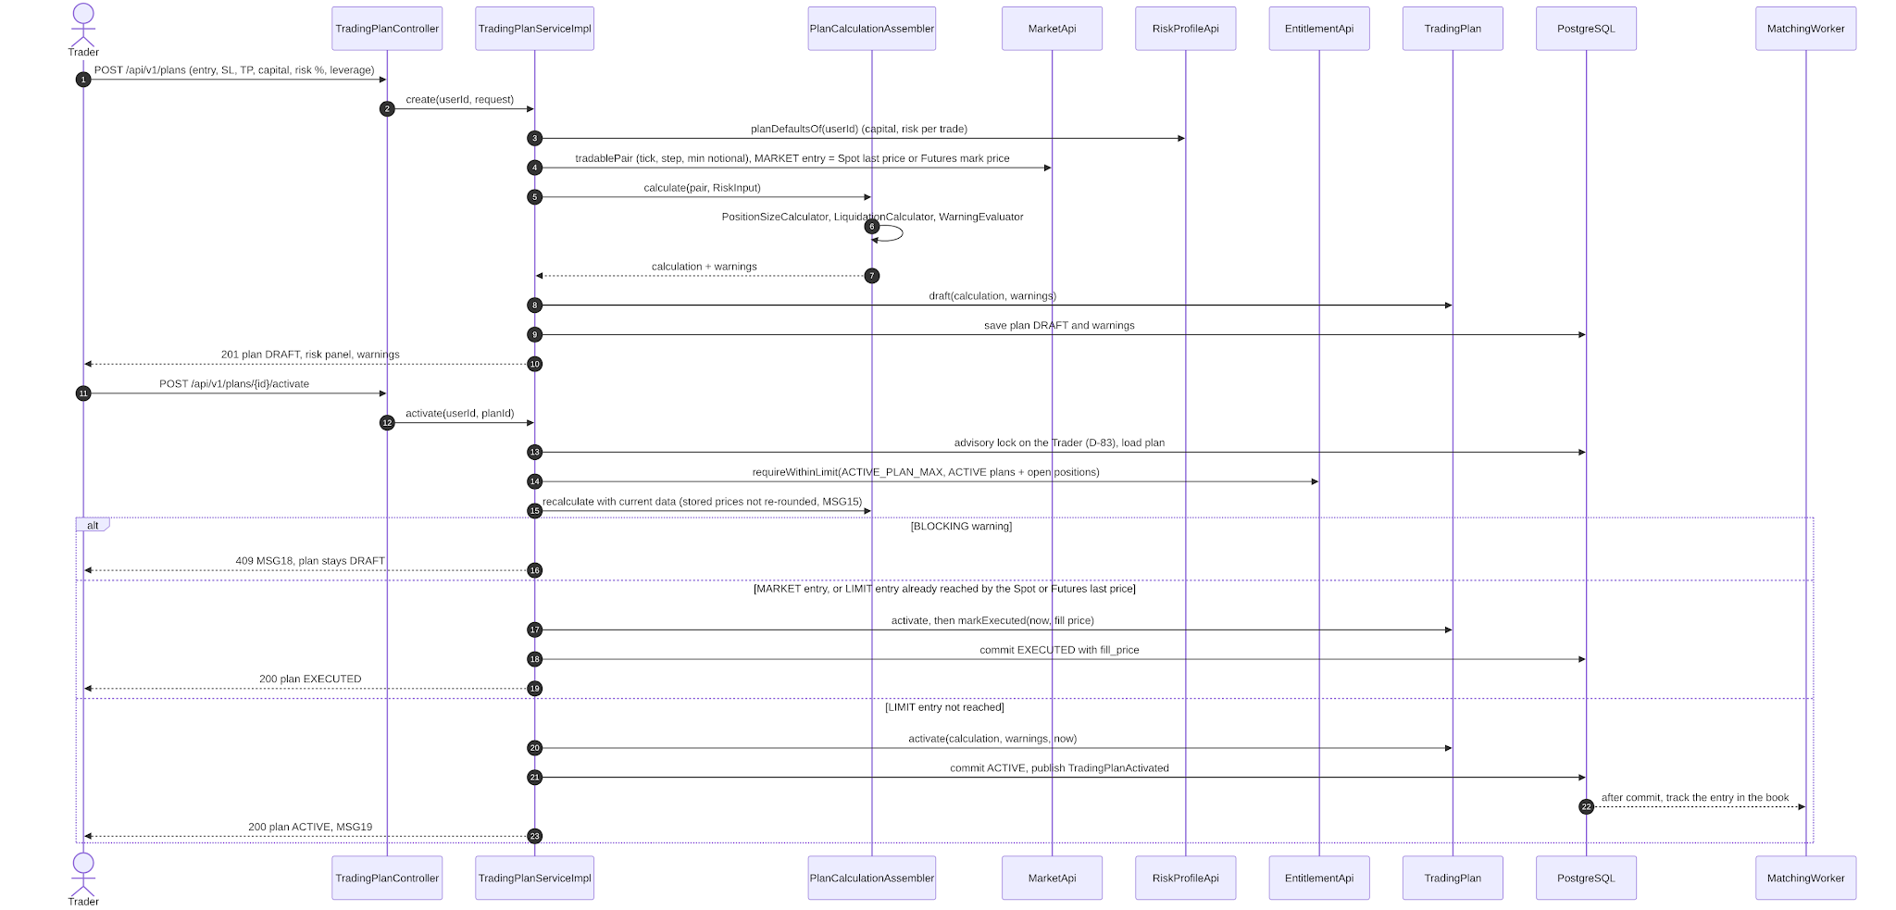
Figure 12: Sequence – create and activate a plan

3.2.3 Sequence – simulated entry fill
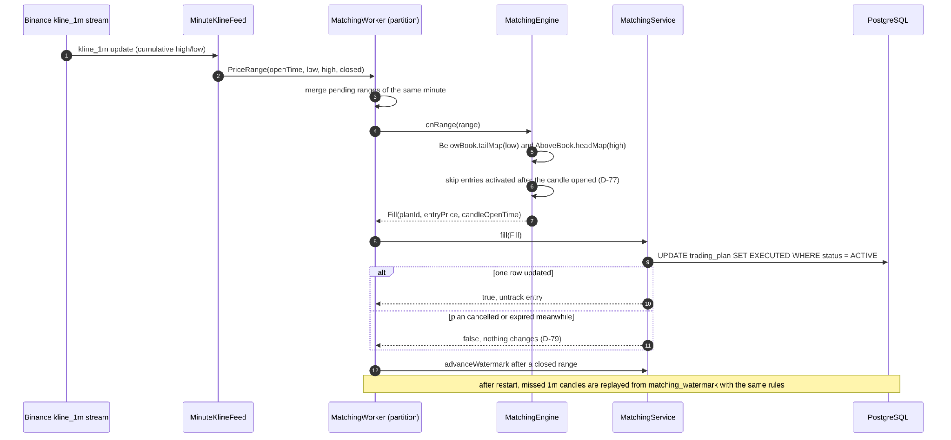
Figure 13: Sequence – simulated entry fill

3.2.4 Sequence – exit and journal record (designed)
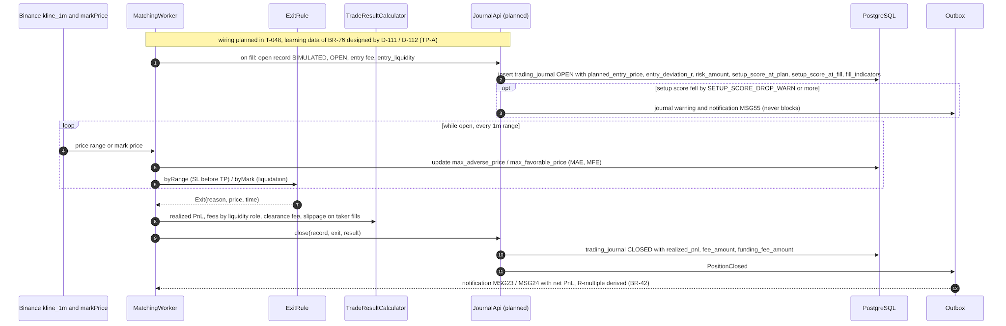
Figure 14: Sequence – exit and journal record (designed)

3.2.5 Sequence – activate a plan with validity and entry deviation (designed)
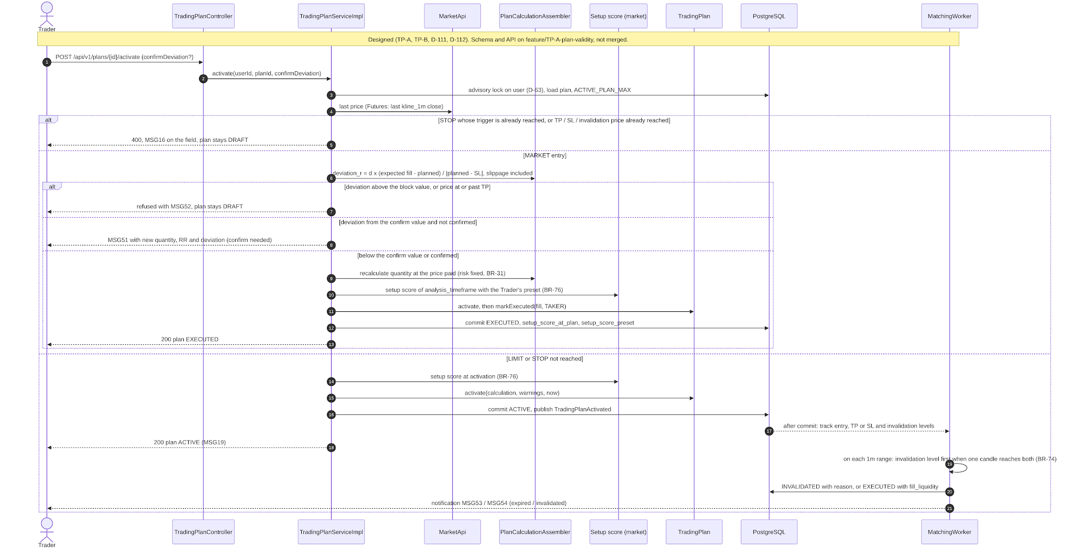
Figure 15: Sequence – activate a plan with validity and entry deviation (designed)

3.3 Watchlist, Alerts and Notifications
Status: Implemented: watchlist, alert API, price/indicator/funding/open-interest engines, outbox, account emails, in-app notification centre for community events (V29). Designed: notifications of alerts, plans and subscriptions, email and push alert channels (RF-12). Owner: Đoàn Trung Trực (in-app notification centre: Lưu Trần Quốc Vũ, PR #64).

3.3.1 Class Diagram
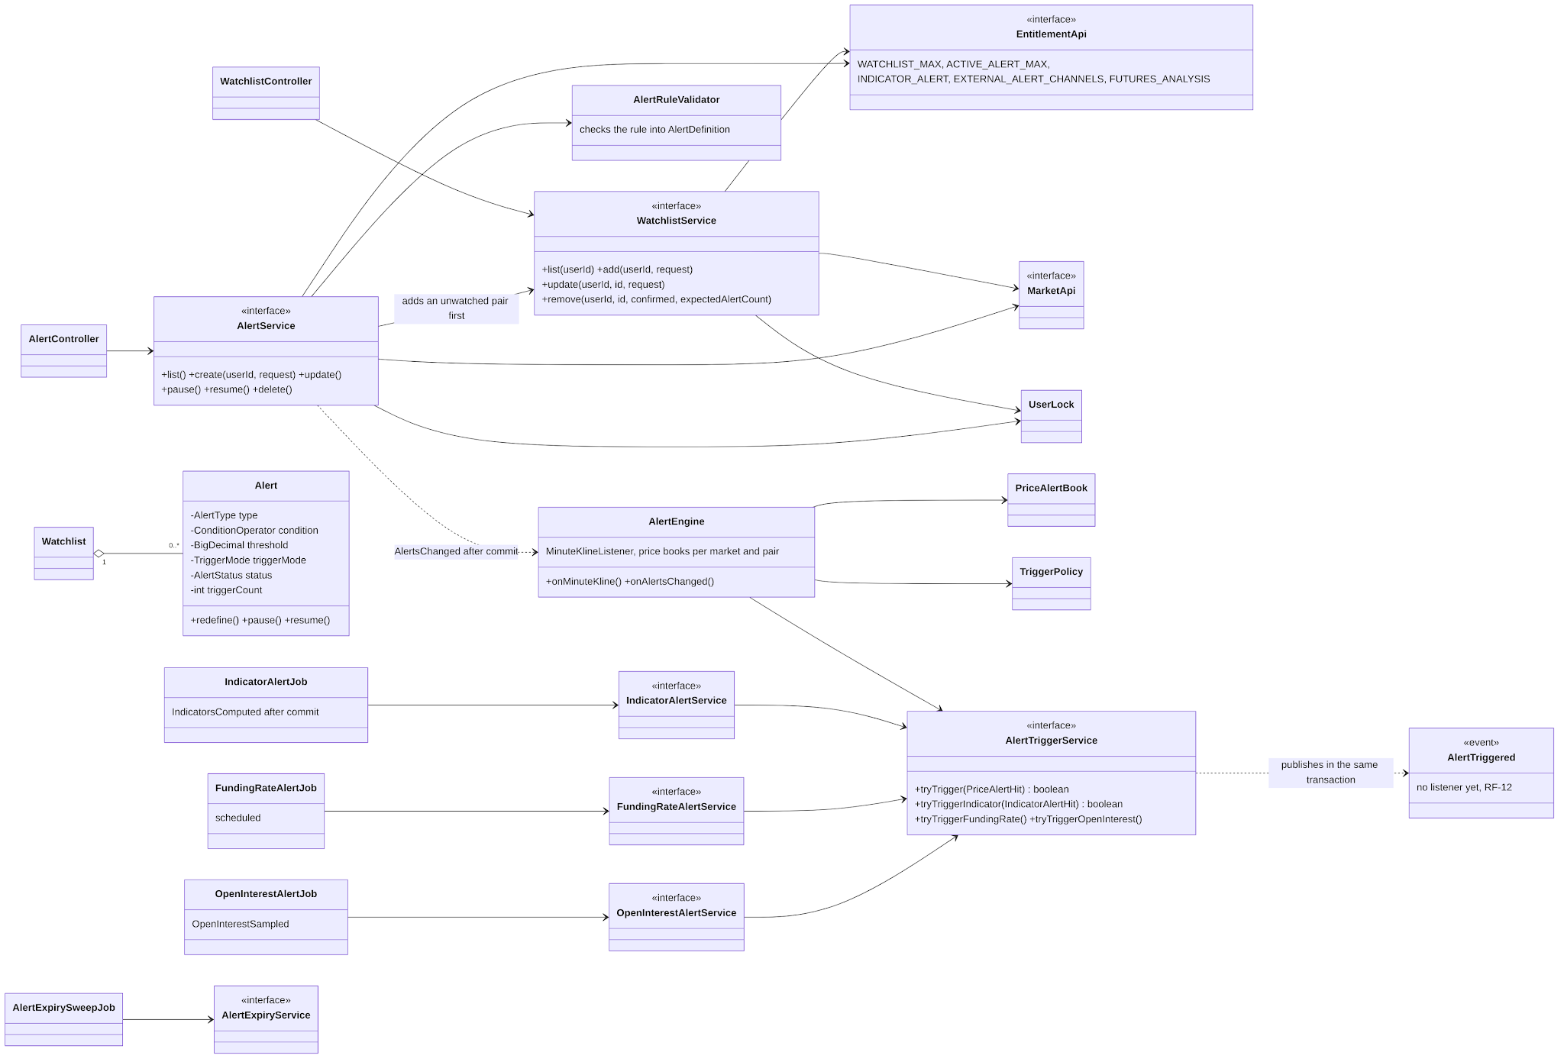
Figure 16: Class diagram – watchlist and alerts
Table 14: Class specifications – Watchlist, Alerts and Notifications
No | Class | Responsibility
01 | WatchlistService / AlertService | Manage the watched pairs and alert rules within the plan limits; an alert always belongs to a watched pair, and creating an alert on a pair not yet watched adds it first in the same transaction (BR-16).
02 | AlertEngine / PriceAlertBook | In-memory sorted thresholds per market and pair, fed by 1m closes; crossing semantics of BR-20.
03 | IndicatorAlertJob, FundingRateAlertJob, OpenInterestAlertJob | Evaluate indicator, funding and open interest alerts after their data is computed.
04 | AlertTriggerService | Confirms a trigger with a conditional UPDATE at the version the engine read, then publishes AlertTriggered in the same transaction (D-89); no module consumes it yet, alert notifications by in-app, email and push are designed (RF-12).
05 | OutboxProcessorJob | Resubmits incomplete event publications so that no notification is lost (ADR-010).
06 | NotificationController / NotificationService | Notification centre: list (all or unread), unread count, mark one or all read; a Trader sees only their own notifications (UC-15).
07 | CommunityNotificationListener / NotificationWriter | After commit, turn PostCommented and PostModerated into notifications for the author and the reporters; one row per source key, then push on /user/queue/notifications (NSF-15).
08 | NotificationSweepJob | Deletes notifications older than 90 days, daily (NSF-17).

3.3.2 Sequence – create an alert and trigger it
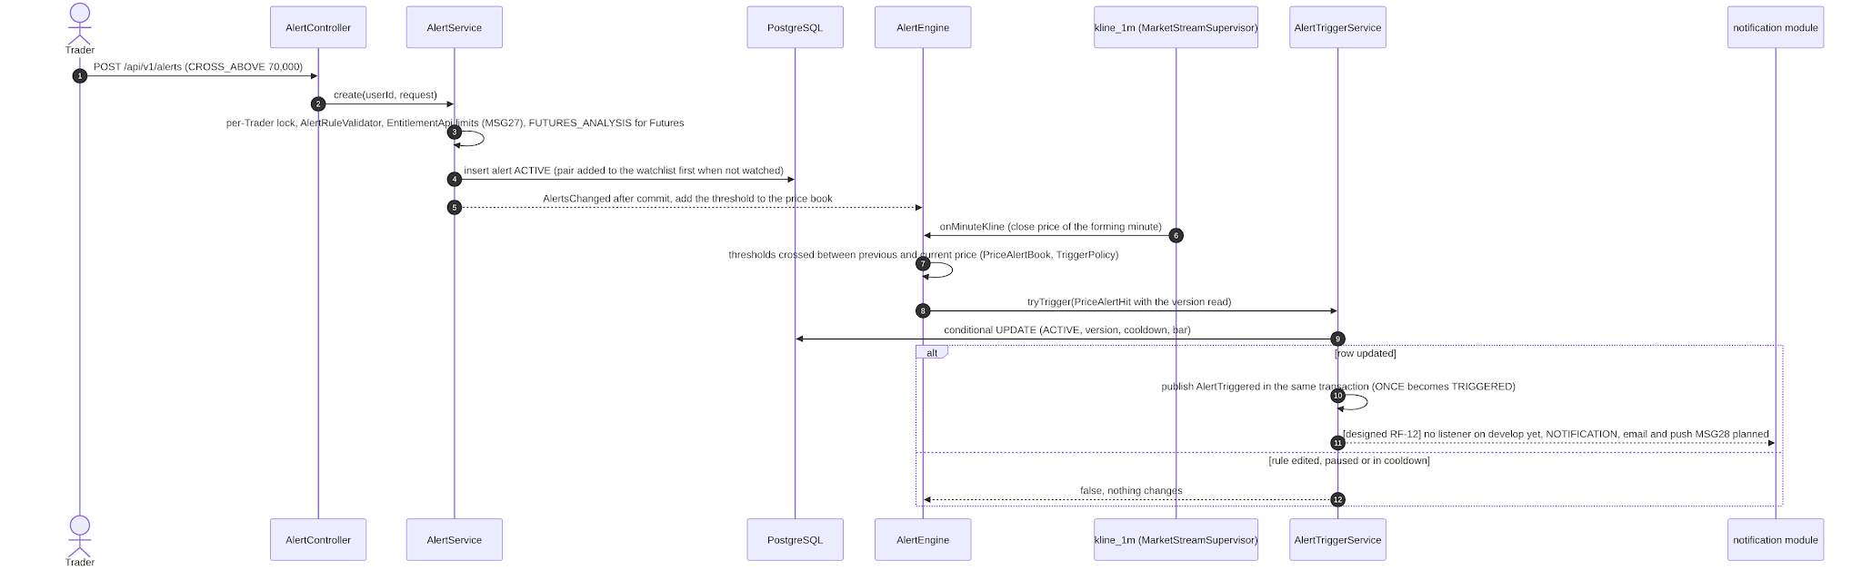
Figure 17: Sequence – create an alert and trigger it (notification step designed)

3.3.3 Class diagram – in-app notifications
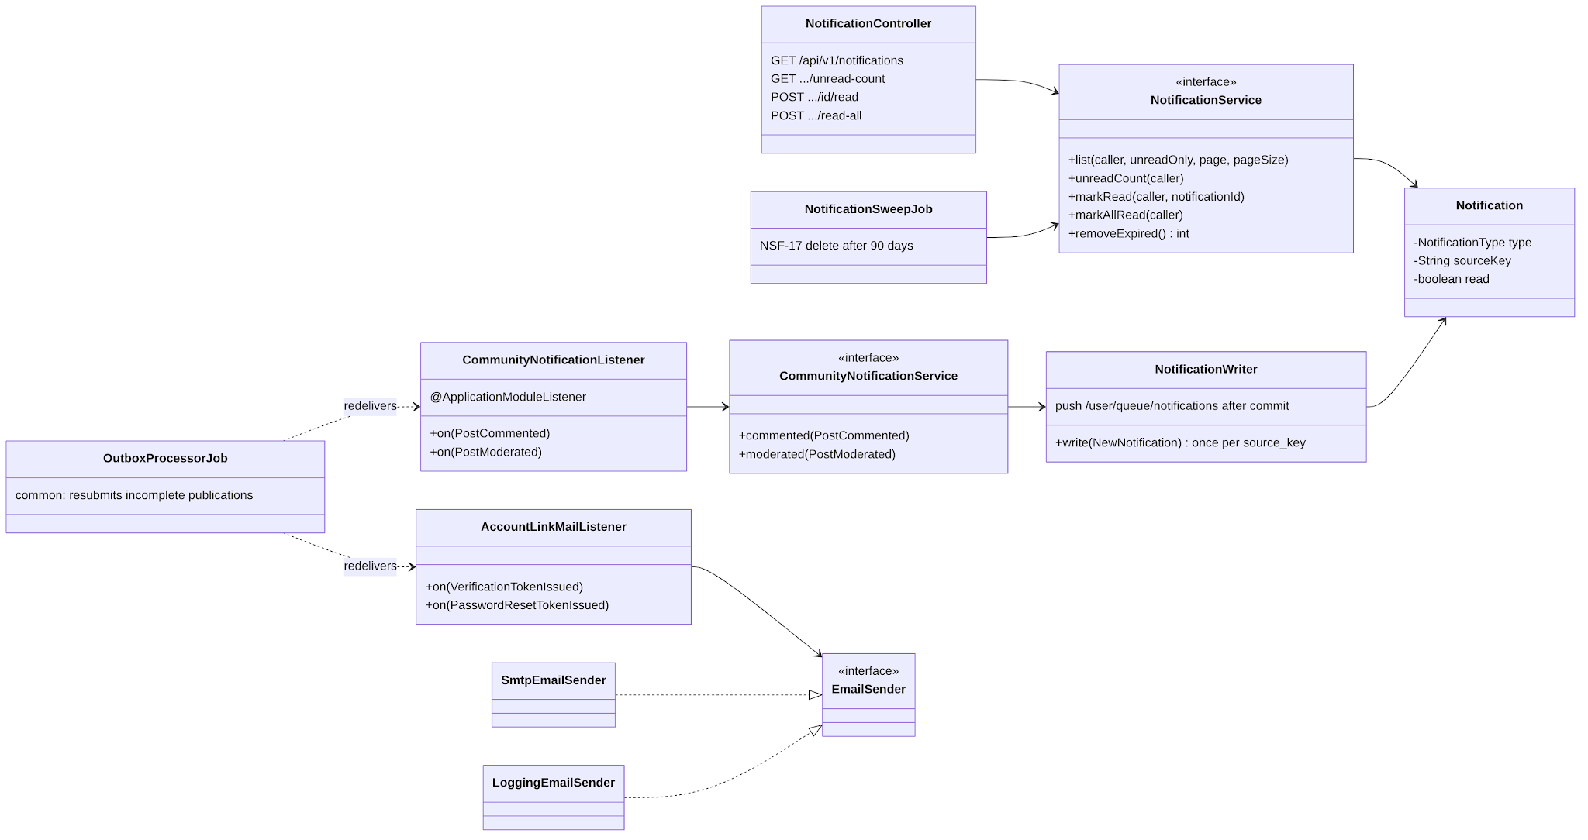
Figure 18: Class diagram – in-app notifications

3.4 Paper Trading
Status: Implemented: account, wallets, transfers, Spot orders (MARKET, LIMIT, LIMIT_MAKER, stop, trailing, OCO/OTO/OTOCO), matching, PnL, equity. Designed: Futures orders and positions. Owner: Lưu Trần Quốc Vũ (PnL fixes PT-F1a and PT-F2: Đoàn Trung Trực, PR #59, #60).

3.4.1 Class Diagram
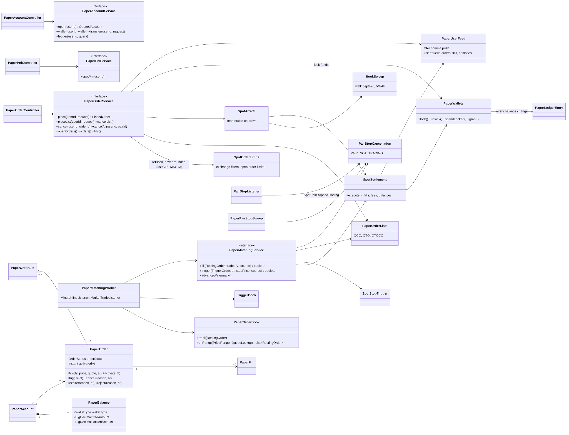
Figure 19: Class diagram – paper trading
Table 15: Class specifications – Paper Trading
No | Class | Responsibility
01 | PaperAccountService | Opens the account with the initial grant, shows wallets, moves funds between wallets, lists the ledger.
02 | PaperOrderService / PaperOrderLists | Places, cancels and groups orders under a per-account lock; checks the pair is still trading and the Spot symbol filters and order limits (SpotOrderLimits, V30), refusing instead of rounding (MSG15, MSG43); a repeated clientOrderId returns the order already placed; locks funds.
03 | SpotArrival / BookSweep | Executes a marketable order on arrival against depth20 (VWAP) or best bid/ask (D-92).
04 | PaperMatchingWorker / PaperOrderBook / TriggerBook | Fills resting orders on each market trade in queue order (D-91); triggers stop and trailing orders.
05 | SpotSettlement / PaperWallets | Applies a fill to balances and writes ledger rows; balance always equals the ledger sum.
06 | PaperOrder | Order with its status transitions (section 4.5).
07 | PairStopCancellation / PairStopListener / PaperPairStopSweep | When Binance stops trading a Spot pair, cancels its open and pending orders with reason PAIR_NOT_TRADING and unlocks their funds (NSF-01).

3.4.2 Sequence – place and fill a LIMIT order
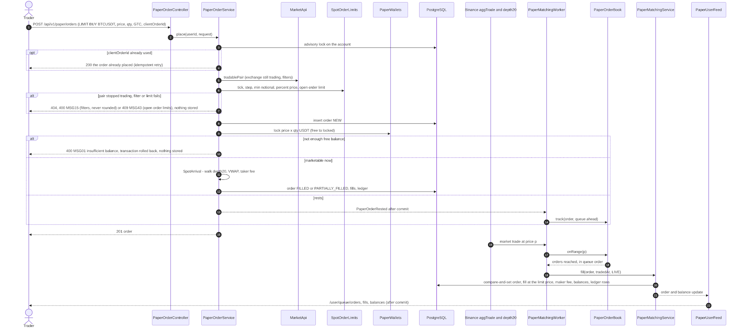
Figure 20: Sequence – place and fill a LIMIT order

3.5 Authentication and Account
Status: Implemented (UC-01…08). Owner: Nguyễn Đình Lực.

3.5.1 Class Diagram
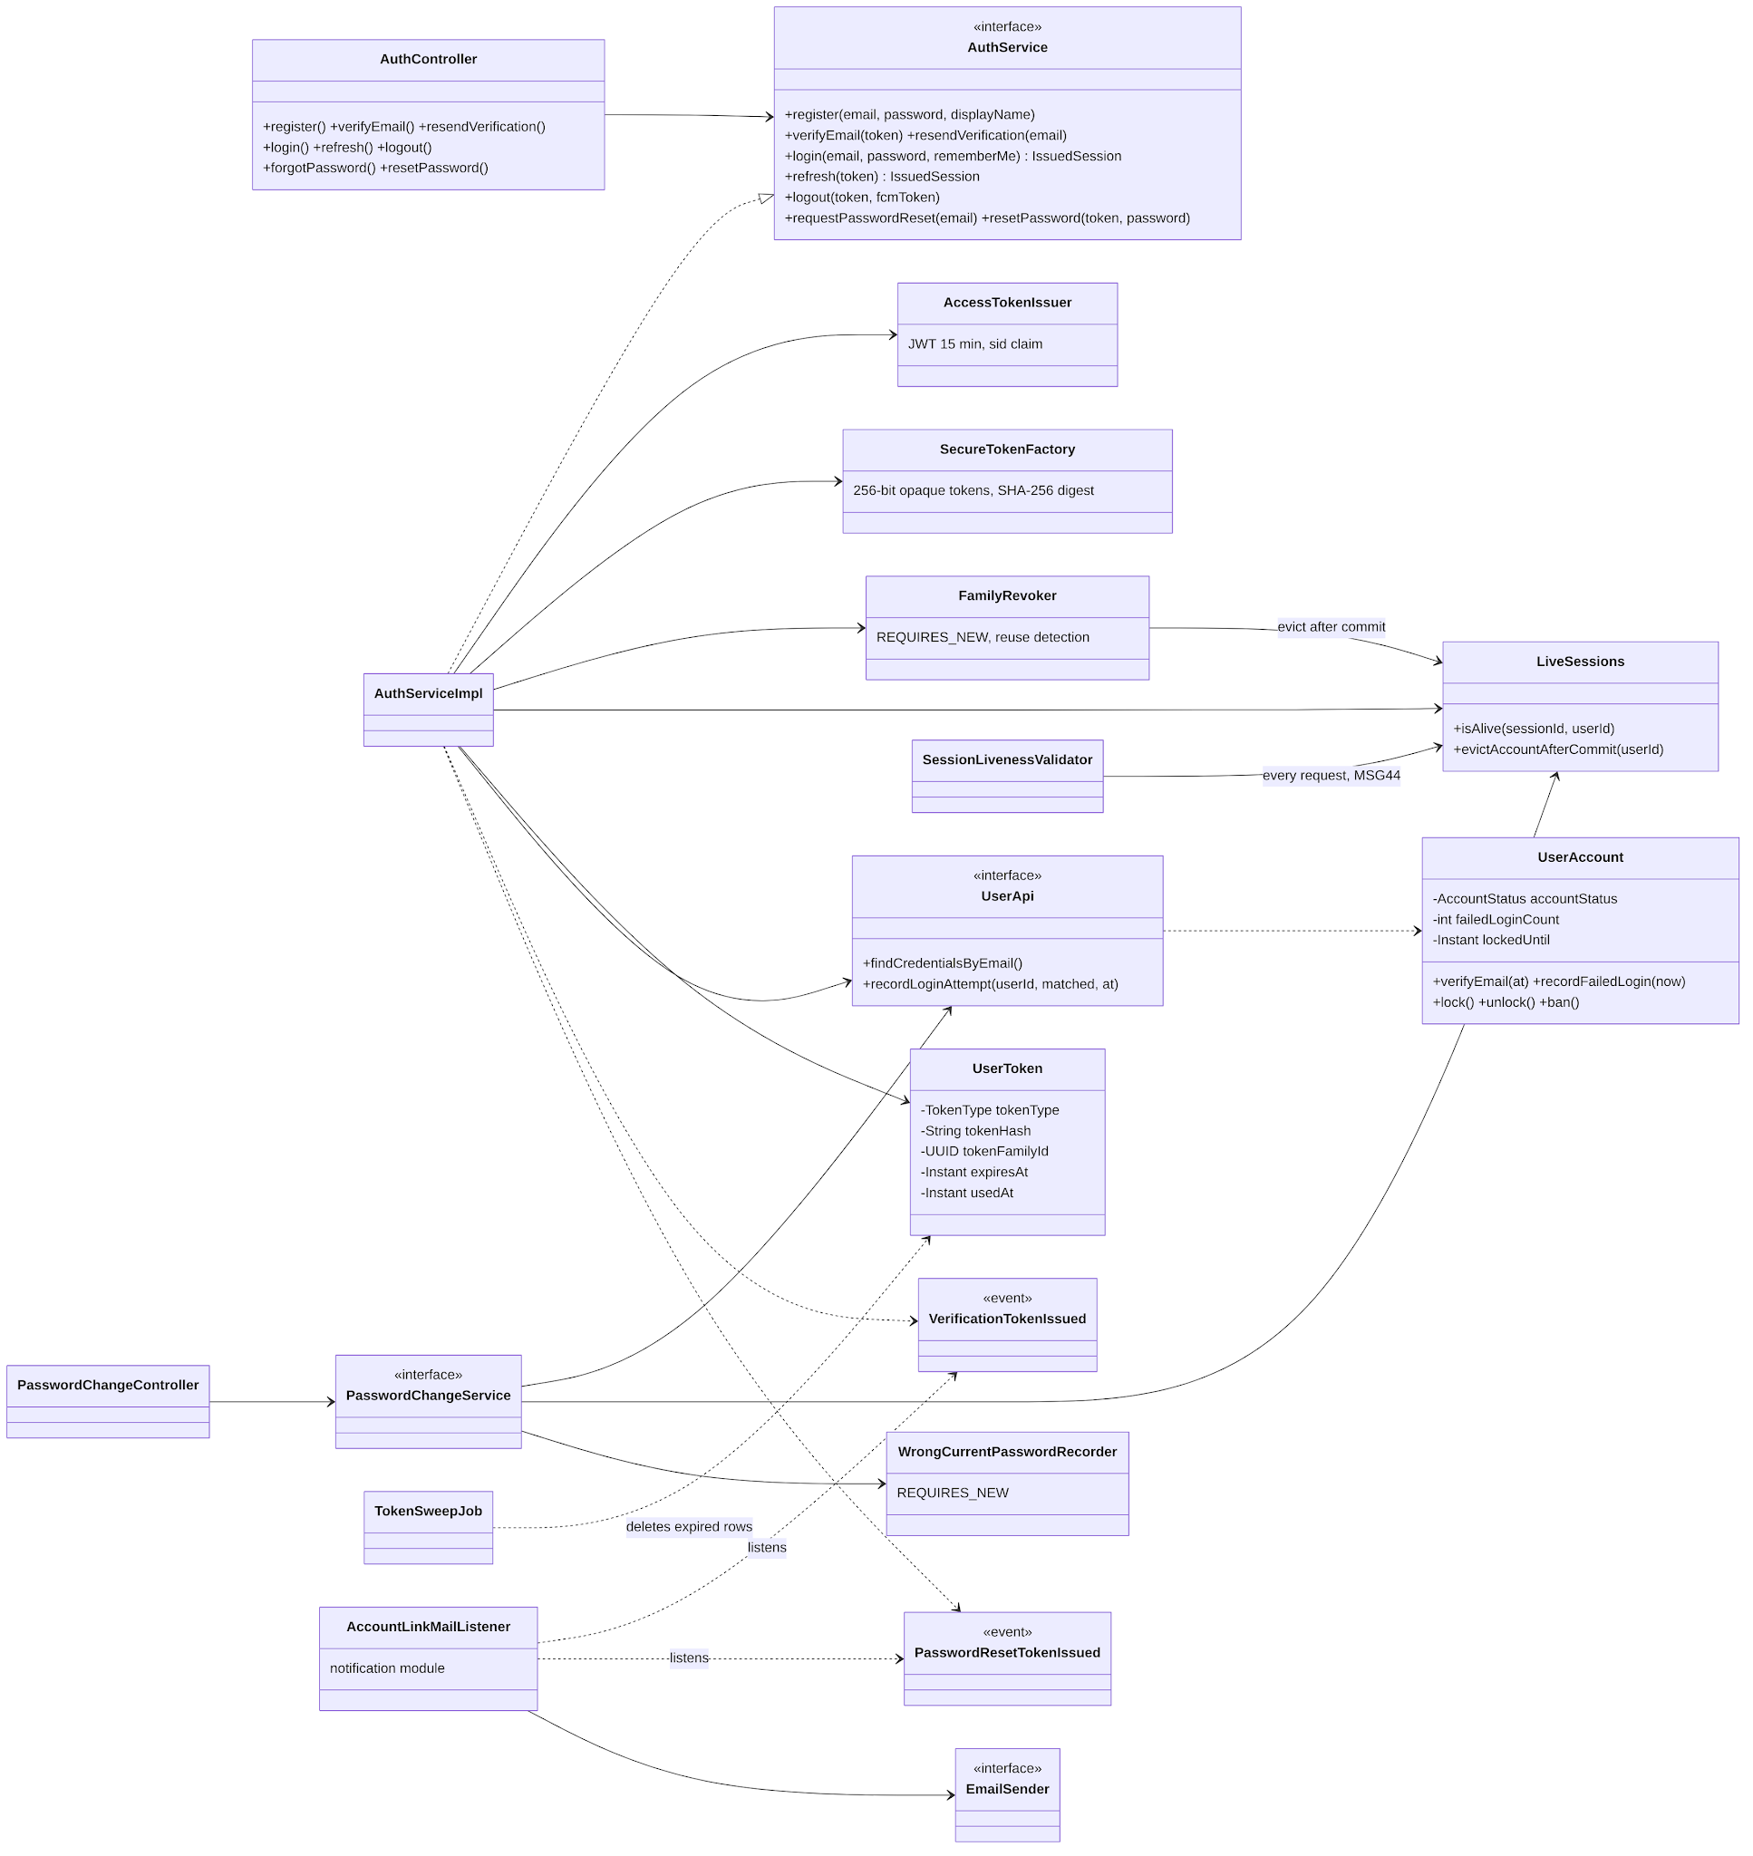
Figure 21: Class diagram – authentication
Table 16: Class specifications – Authentication and Account
No | Class | Responsibility
01 | AuthServiceImpl | Registration, verification, login with lockout (BR-03; the failed attempt is counted by UserApi.recordLoginAttempt in its own transaction), refresh rotation with reuse detection, logout, password reset.
02 | AccessTokenIssuer | 15-minute JWT with a sid claim naming the session family (D-33).
03 | SecureTokenFactory | 256-bit opaque tokens stored as SHA-256 digests.
04 | FamilyRevoker / LiveSessions | Revoke a session family and evict cached session liveness after commit.
05 | UserAccount | Account with status transitions (section 4.1).
06 | AccountLinkMailListener / EmailSender | Sends verification and reset links after commit over SMTP.

3.5.2 Sequence – login and token refresh
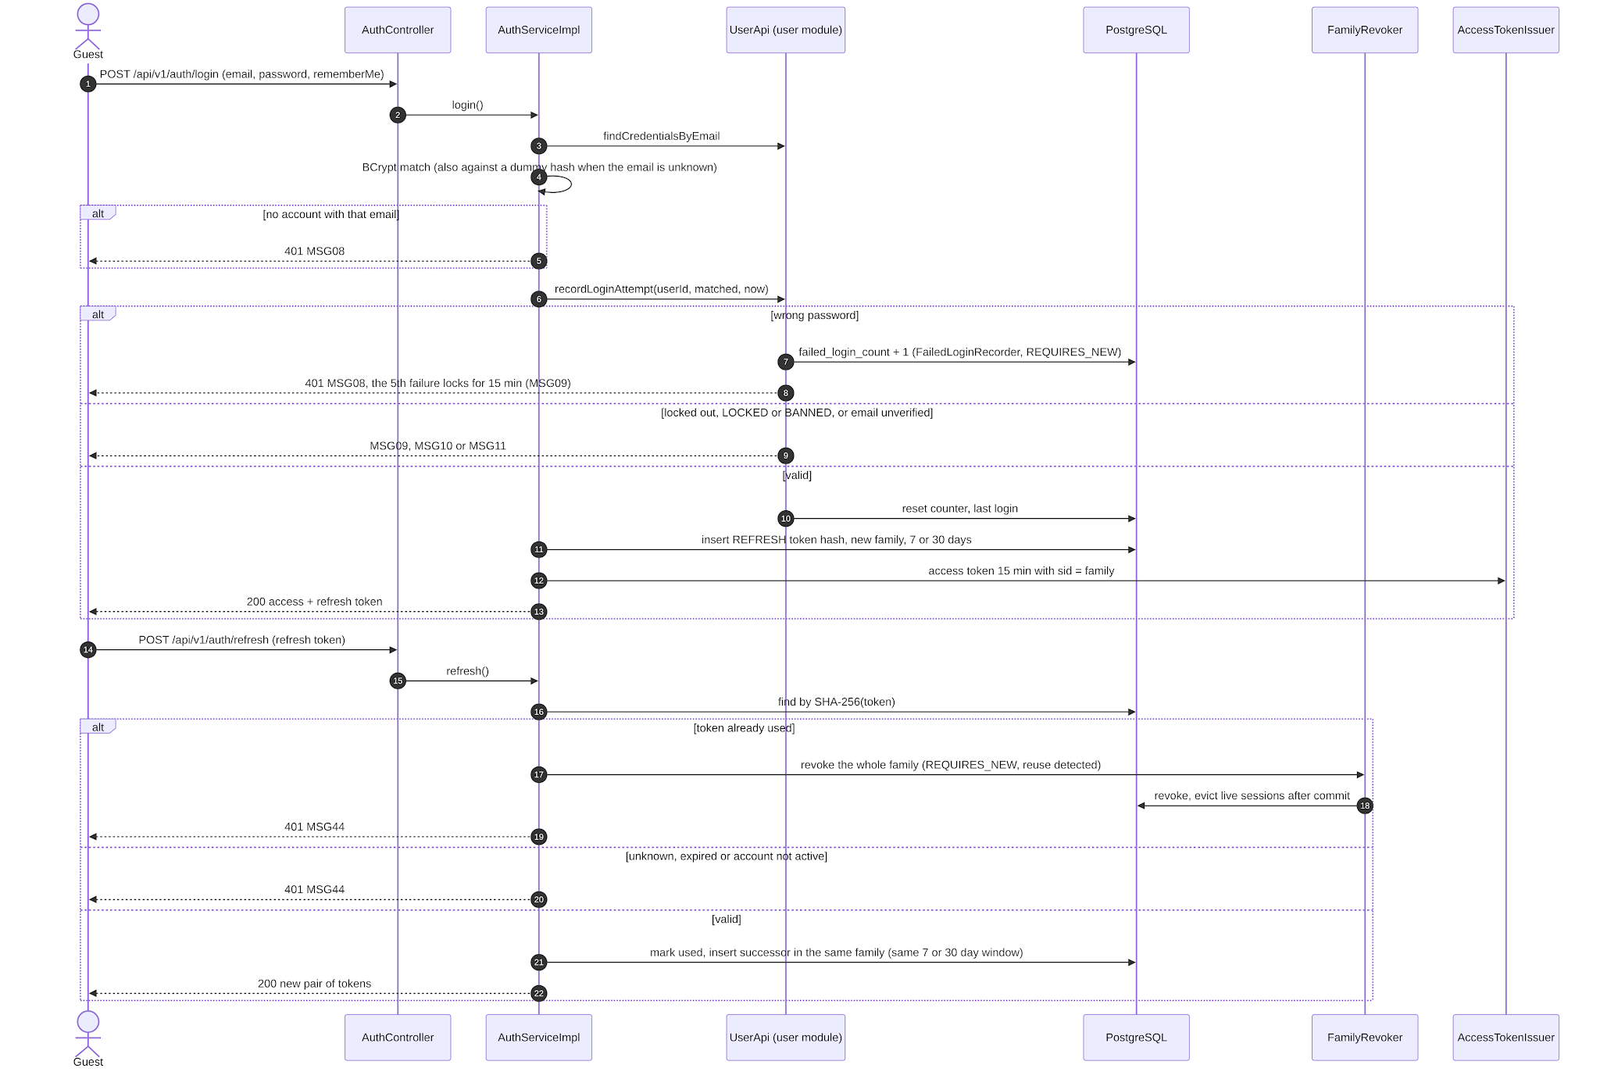
Figure 22: Sequence – login and token refresh

3.6 Subscription Packages and Payment
Status: Implemented: packages and entitlement checks. Designed: orders, VNPay/MoMo, IPN, reconciliation, subscriptions. Implemented part: Nguyễn Đình Lực (plan tiers and entitlements T-106, T-104) and Đoàn Trung Trực (package seed and demo accounts T-007, T-108). Designed part: Hoàng Văn Huy (with Lưu Trần Quốc Vũ).

3.6.1 Class Diagram
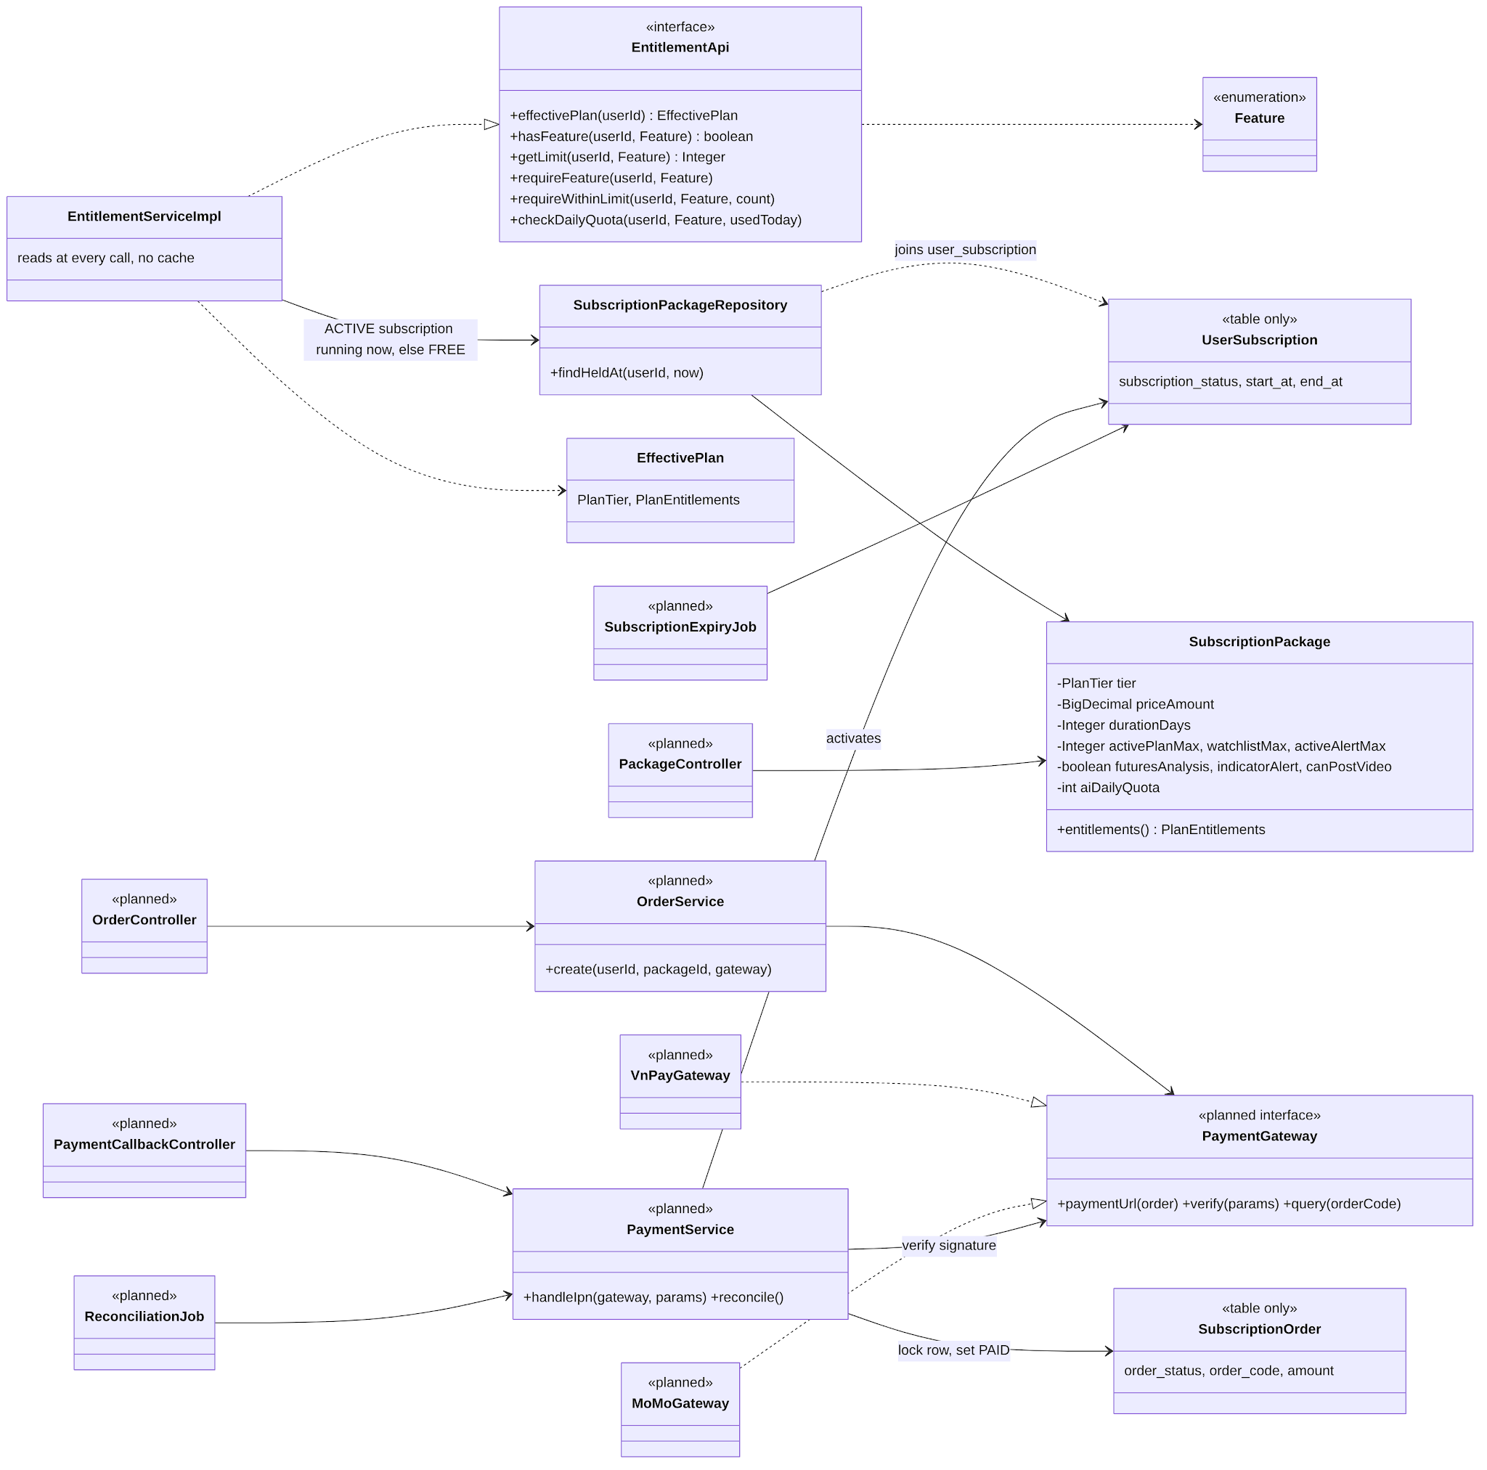
Figure 23: Class diagram – billing (payment part designed)
Table 17: Class specifications – Subscription Packages and Payment
No | Class | Responsibility
01 | EntitlementApi / EntitlementServiceImpl | Effective plan of a Trader (the package of the ACTIVE subscription running now, else FREE) and feature, limit and daily quota checks; MSG29, MSG27 and MSG30 on refusal. Implemented.
02 | OrderService | Creates an order PENDING with a unique code, the package price and an expiry (BR-54, BR-56). Designed.
03 | PaymentGateway, VnPayGateway, MoMoGateway | Strategy per gateway: payment URL, signature verification (HMAC-SHA512 / SHA256), status query. Designed.
04 | PaymentService | Idempotent IPN handling under a row lock; activates or schedules the subscription (BR-53, BR-55). Designed.
05 | ReconciliationJob, SubscriptionExpiryJob | Query pending orders every 5 min; expire and activate subscriptions hourly (NSF-13, NSF-14). Designed.

3.6.2 Sequence – purchase and IPN
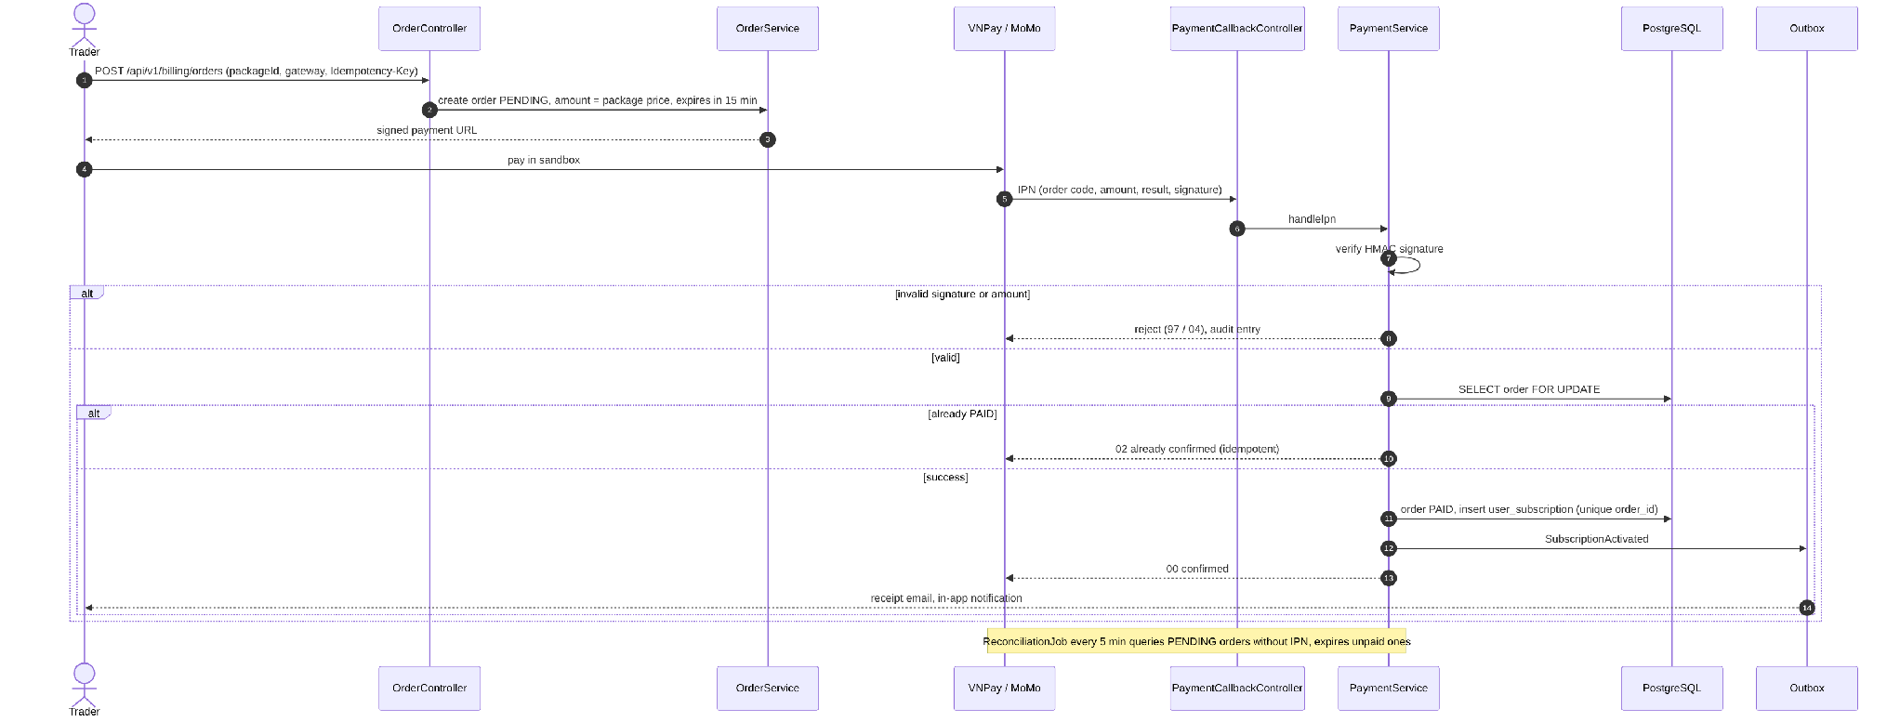
Figure 24: Sequence – purchase and IPN (designed)

3.7 AI Trading Assistant
Status: Designed (UC-35, UC-36, UC-50, NSF-16). Owner: Hoàng Văn Huy.

3.7.1 Class Diagram
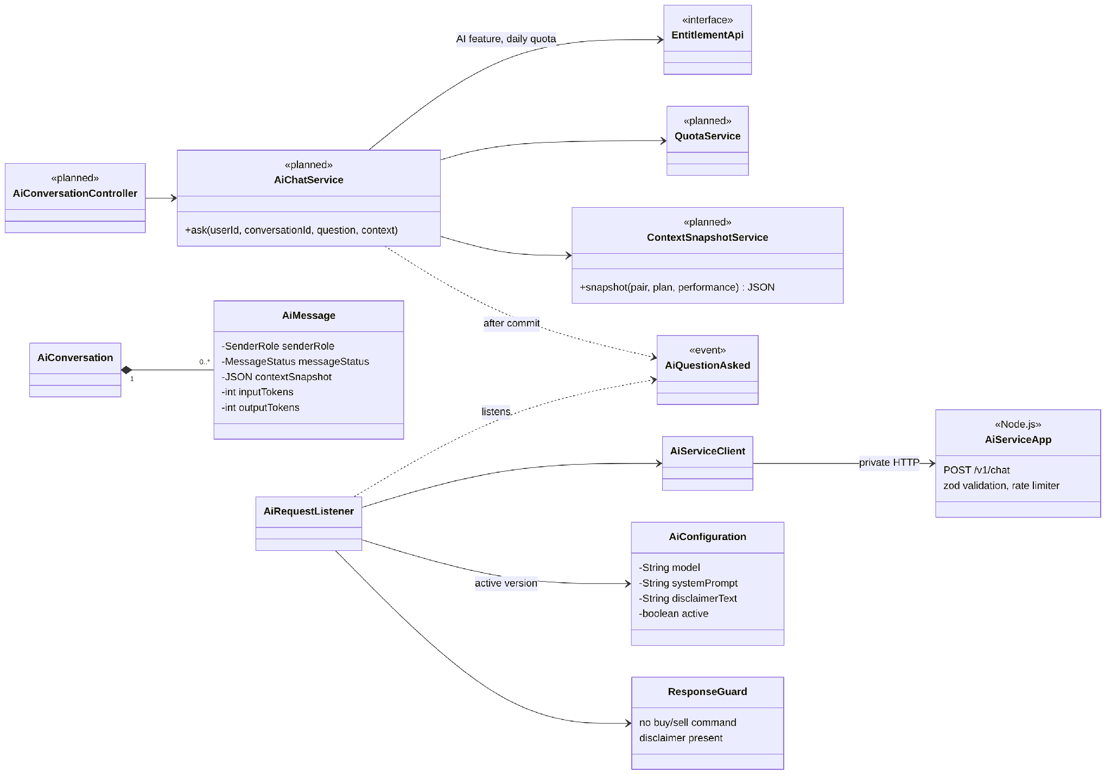
Figure 25: Class diagram – AI Assistant (designed)
Table 18: Class specifications – AI Trading Assistant
No | Class | Responsibility
01 | AiChatService | Checks package and quota under a per-user lock, stores the question with a context snapshot.
02 | ContextSnapshotService | Builds the snapshot from data already processed by the system: indicators, setup score, plan, performance.
03 | AiRequestListener / AiServiceClient | After commit, sends the request to the AI Service with the active configuration and stores the answer.
04 | ResponseGuard | Blocks buy/sell commands and makes sure the disclaimer is present (BR-51).
05 | AI Service (Node.js) | Validates input, rate-limits, calls the LLM with a 60 s timeout and one retry.

3.7.2 Sequence – ask the AI Assistant
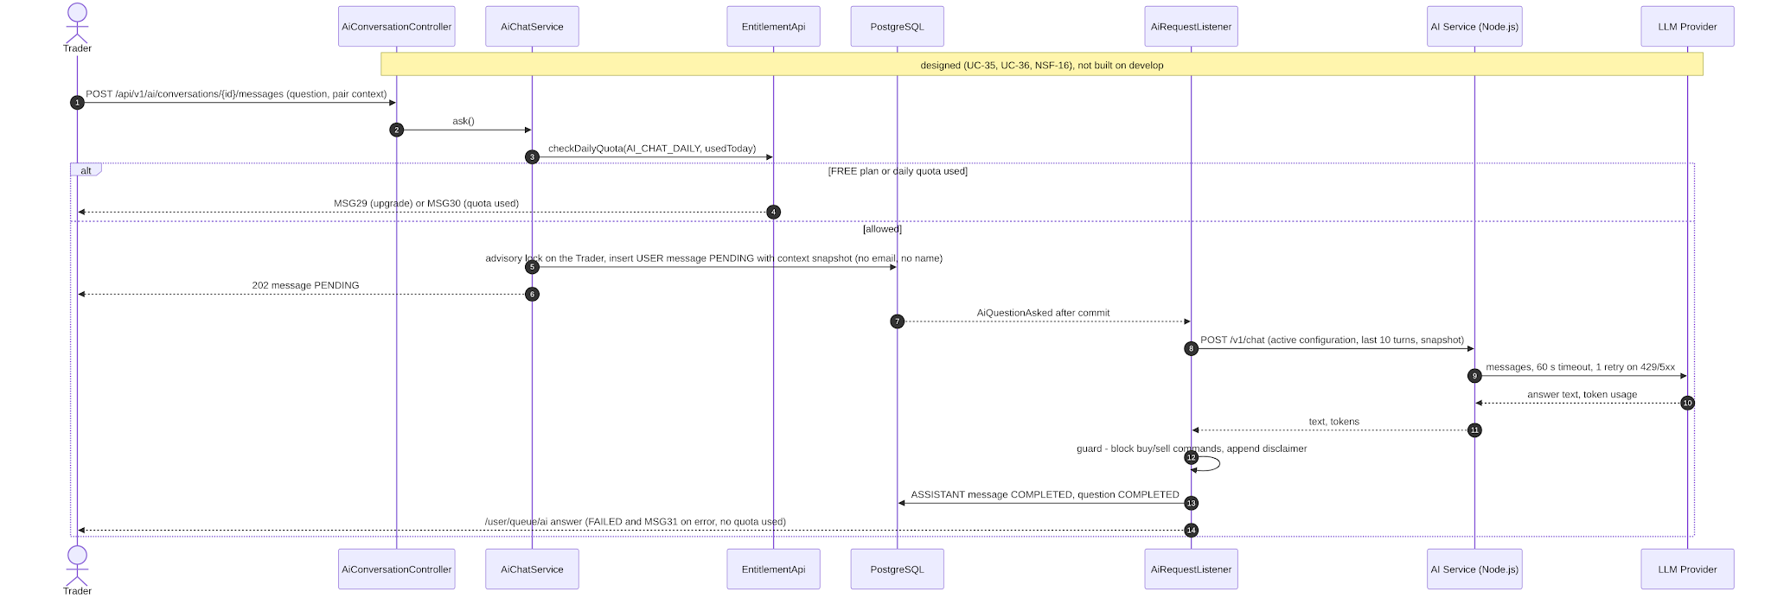
Figure 26: Sequence – ask the AI Assistant (designed)

3.8 Community Forum and Moderation
Status: Implemented (T-060…T-064, T-084, CF-01…CF-07; merged into develop by PR #64 on 22/10/2026). Owner: Lưu Trần Quốc Vũ (PR #63, #64).

3.8.1 Class Diagram
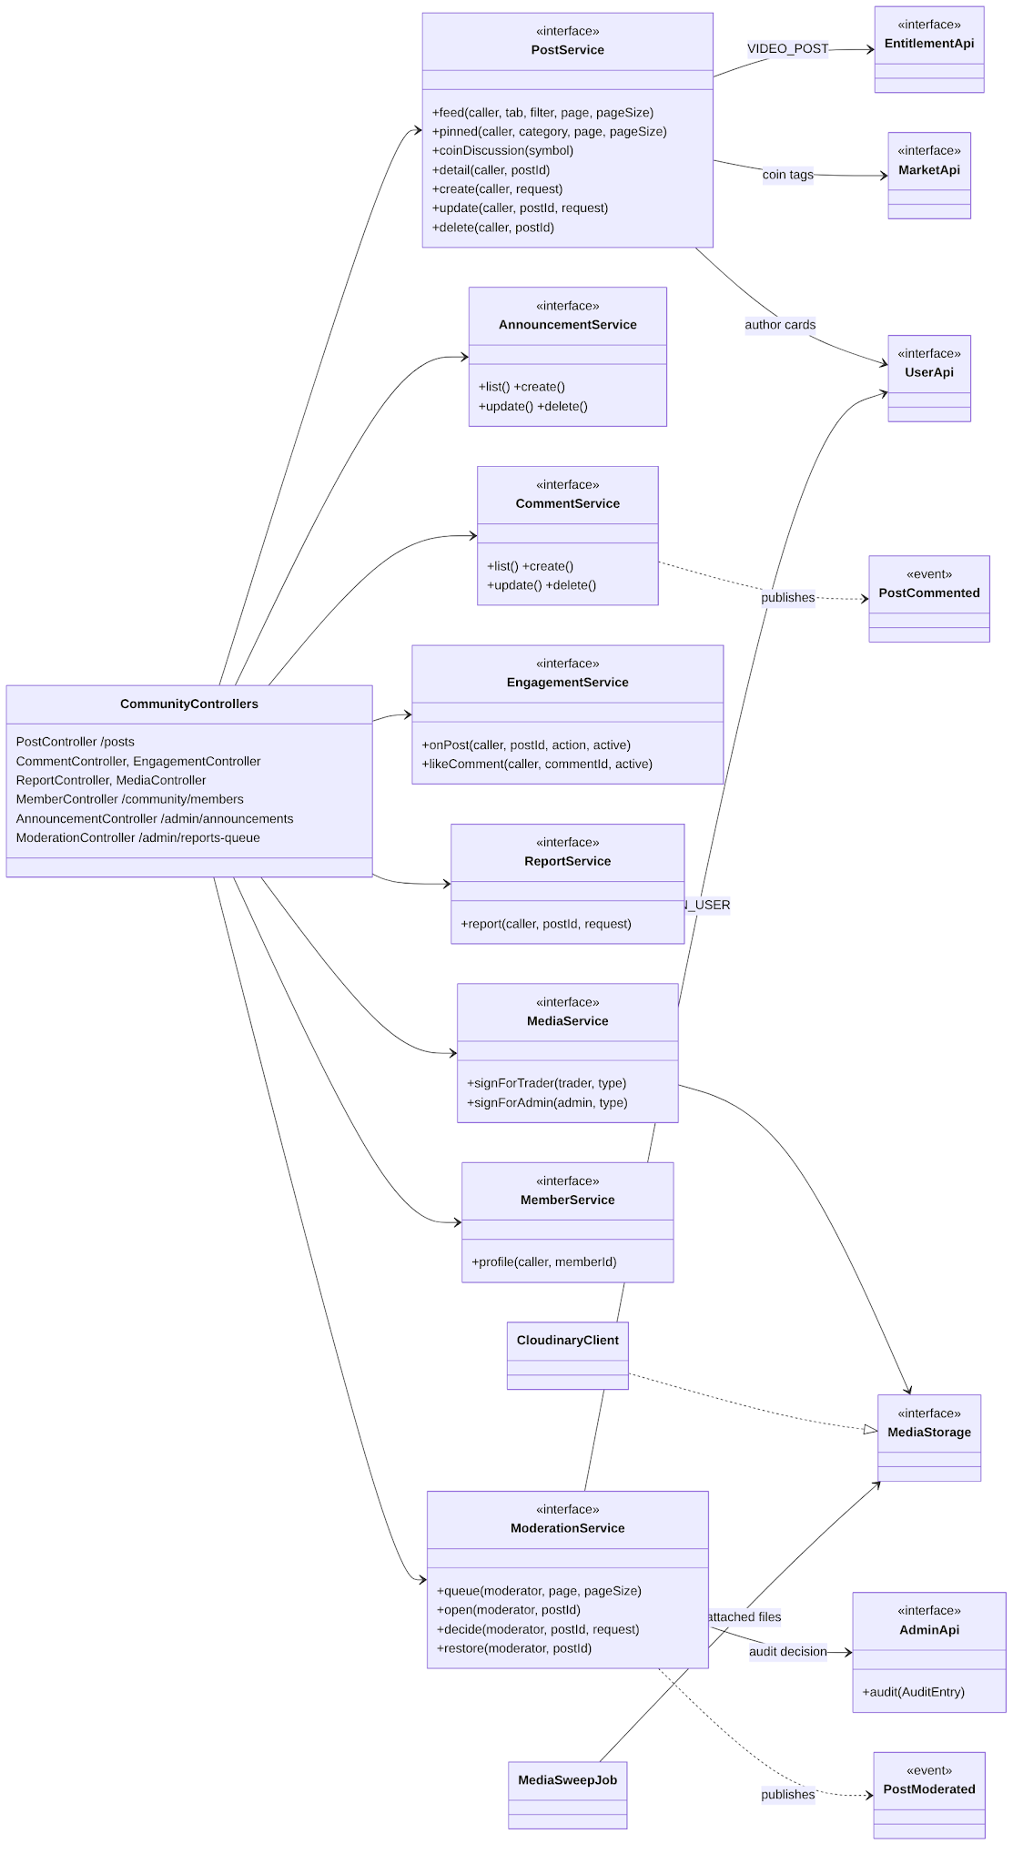
Figure 27: Class diagram – community
Table 19: Class specifications – Community Forum and Moderation
No | Class | Responsibility
01 | PostService / CommentService / EngagementService / AnnouncementService / MemberService | Feed tabs (latest, most liked, saved, mine), pinned official posts with a category, coin discussion, posts with coin tags and market type, comments one level deep, likes and saves, member pages; Guests read published posts (D-99).
02 | MediaService / CloudinaryClient / MediaSweepJob | Signs direct uploads to Cloudinary and checks the stored file through its Admin API; video only with an active PRO or PREMIUM package (VIDEO_POST, V28); daily sweep of unattached files.
03 | ReportService | One report per Trader and post (MSG34); a description is required for OTHER.
04 | ModerationService | Queue grouped by post; opening a case moves its reports to REVIEWING; decisions HIDE_POST, REMOVE_POST (media kept as evidence), DISMISS, WARN_USER, BAN_USER (hides the post and bans the author, ending every session); audit entry in the same transaction; PostModerated notifies the author and the reporters; a hidden post can be restored.

3.8.2 Sequence – report and moderate a post
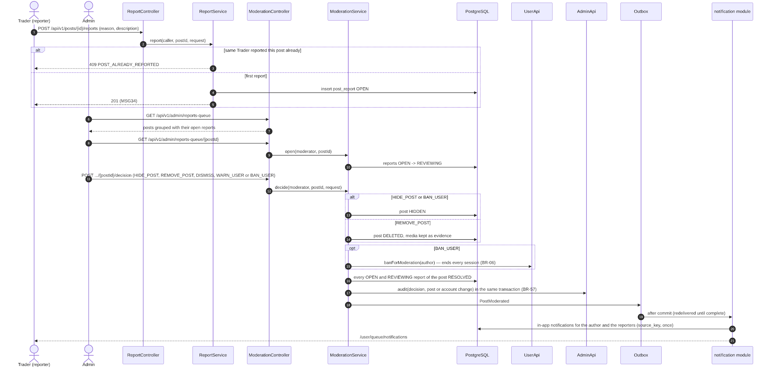
Figure 28: Sequence – report and moderate a post

3.9 News Aggregation, Journal and Administration
These features follow the structure of section 3.6 (controller → service → repository, a job for the background part) and reuse its diagrams. Their classes are:
Table 20: Classes of the remaining features
No | Feature | Classes | Status
01 | News aggregation (UC-34, UC-49, NSF-10, NSF-11) | NewsController, AdminNewsSourceController, NewsService, NewsSourceService, CrawlService, RssClient, UrlNormalizer, TitleNormalizer, CoinTagger, NewsCrawlJob, NewsSummaryJob | Designed
02 | Journal and performance (UC-22…25) | JournalController, PerformanceController, JournalService, PerformanceService, TradingJournalRepository, PerformanceQueryRepository, JournalApi | Designed
03 | Administration (UC-40…52) | AdminApi (audit log T-081, done, Đoàn Trung Trực), SystemSettingApi (done), moderation queue and announcements (done, community module, Lưu Trần Quốc Vũ); pairs and leverage brackets, system settings, user management and reports built on local branches by Lưu Trần Quốc Vũ (T-085, T-082, T-083, T-086, not pushed); packages, orders, news sources, AI configurations, dashboard planned | Partly implemented

4. State Machine Diagrams
Every main entity with a lifecycle has a state machine. Each transition names the use case or non-screen function that triggers it; every non-final state has an exit. The transitions in code are enforced by transition tables (PlanStatus, AlertStatus), guarded entity methods (UserAccount, PaperOrder, ForumPost, PostReport) and conditional updates.

4.1 USER (account_status)
Module user. Status: Implemented.
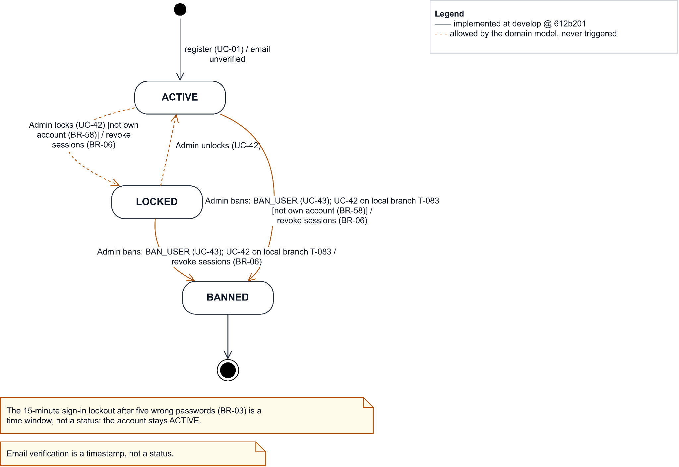
Figure 29: State machine – USER (account_status)

4.2 TRADING_PLAN (plan_status)
Module trading. Status: Implemented; expiry job RF-11. INVALIDATED (shaded) is designed by D-111 (TP-A, TP-B).
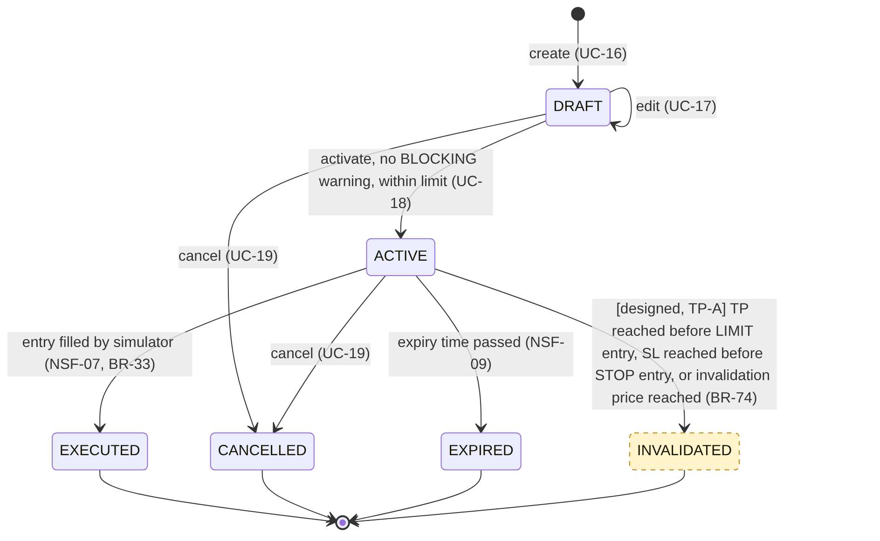
Figure 30: State machine – TRADING_PLAN (plan_status)

4.3 TRADING_JOURNAL (trade_status)
Module journal. Status: Designed.
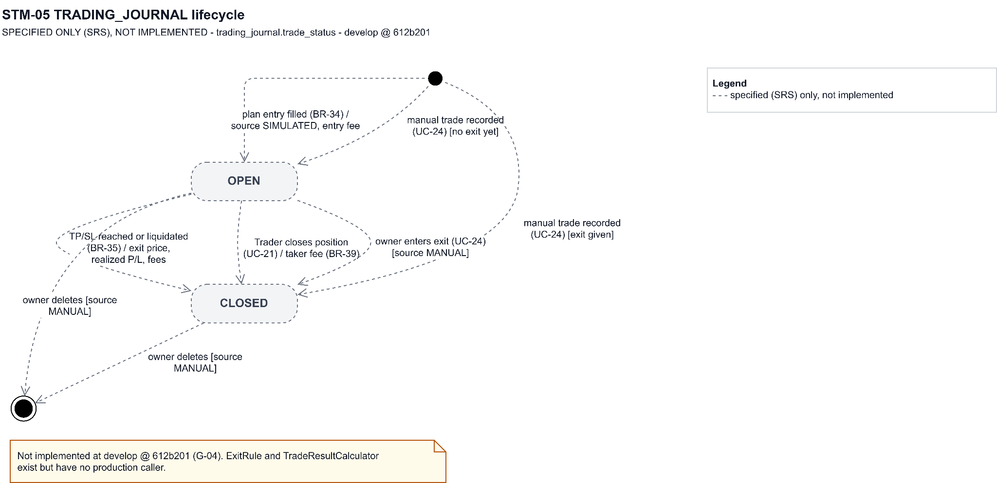
Figure 31: State machine – TRADING_JOURNAL (trade_status)

4.4 ALERT (alert_status)
Module watchlist. Status: Implemented.
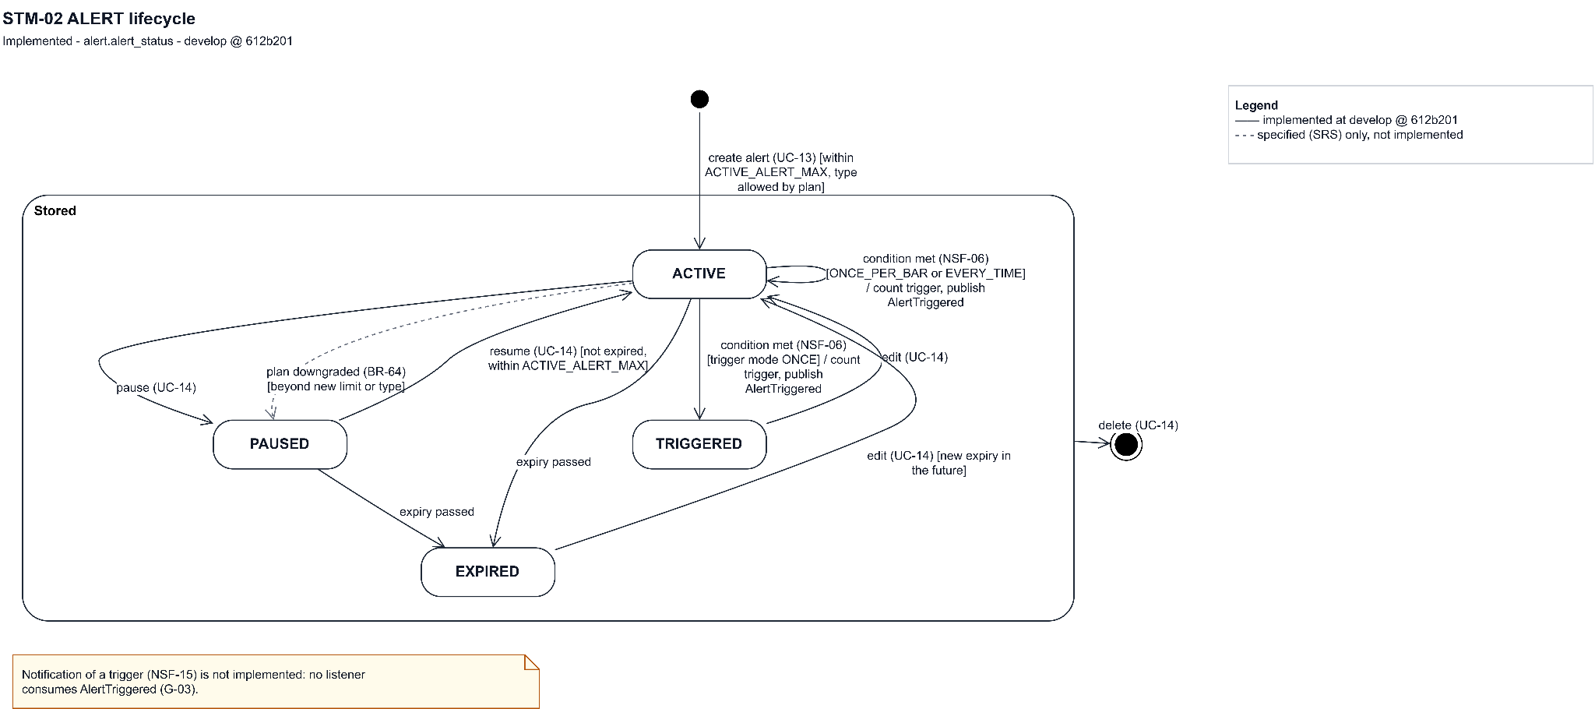
Figure 32: State machine – ALERT (alert_status)

4.5 PAPER_ORDER (order_status)
Module paper. Status: Implemented (Spot).
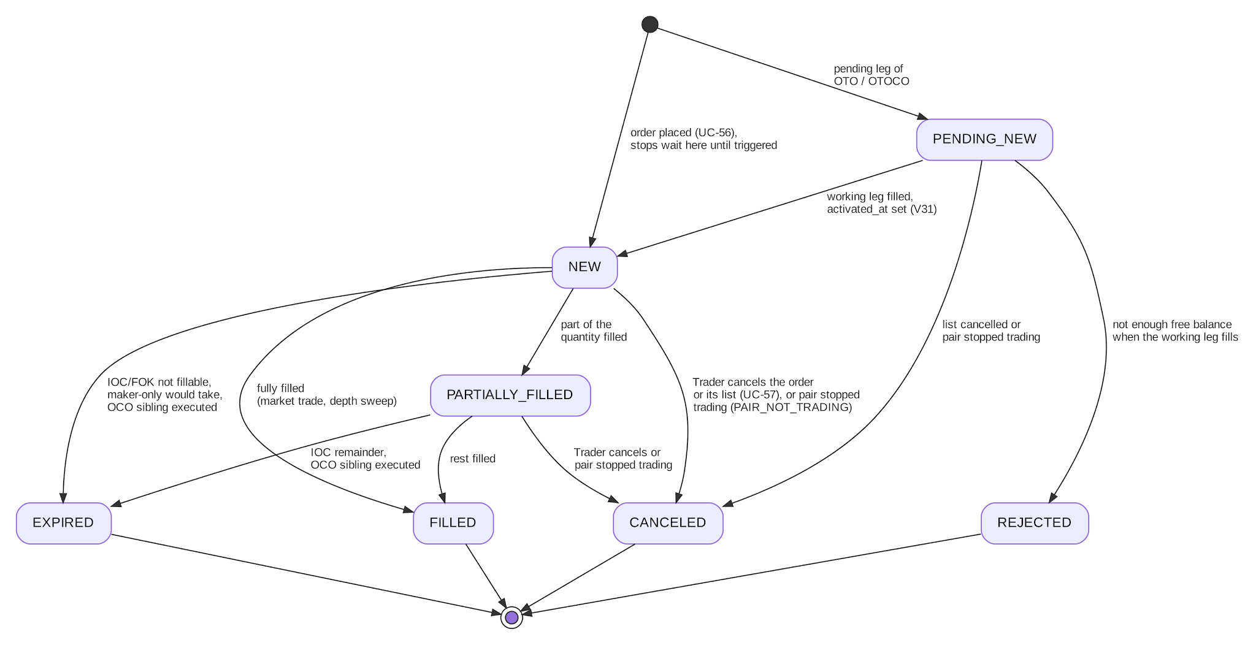
Figure 33: State machine – PAPER_ORDER (order_status)

4.6 PAPER_POSITION (position_status)
Module paper. Status: Schema only (Futures planned).
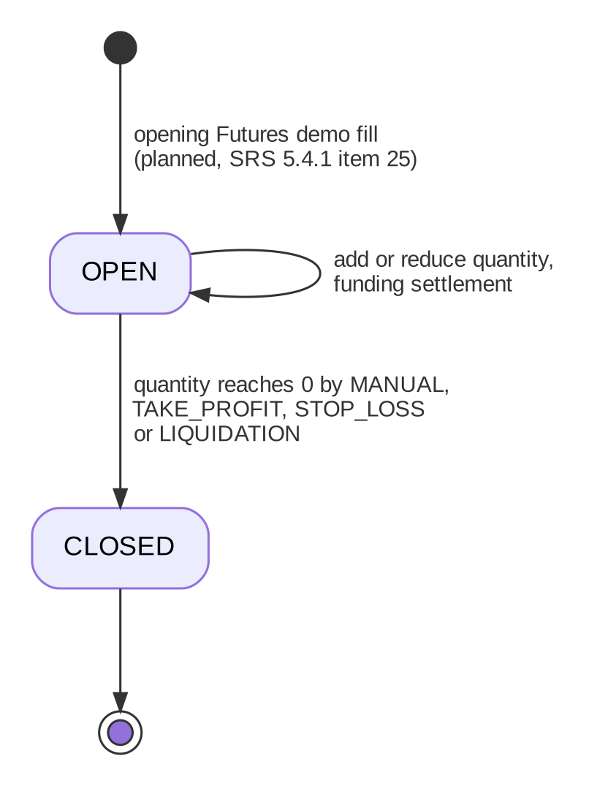
Figure 34: State machine – PAPER_POSITION (position_status)

4.7 SUBSCRIPTION_ORDER (order_status)
Module billing. Status: Designed.
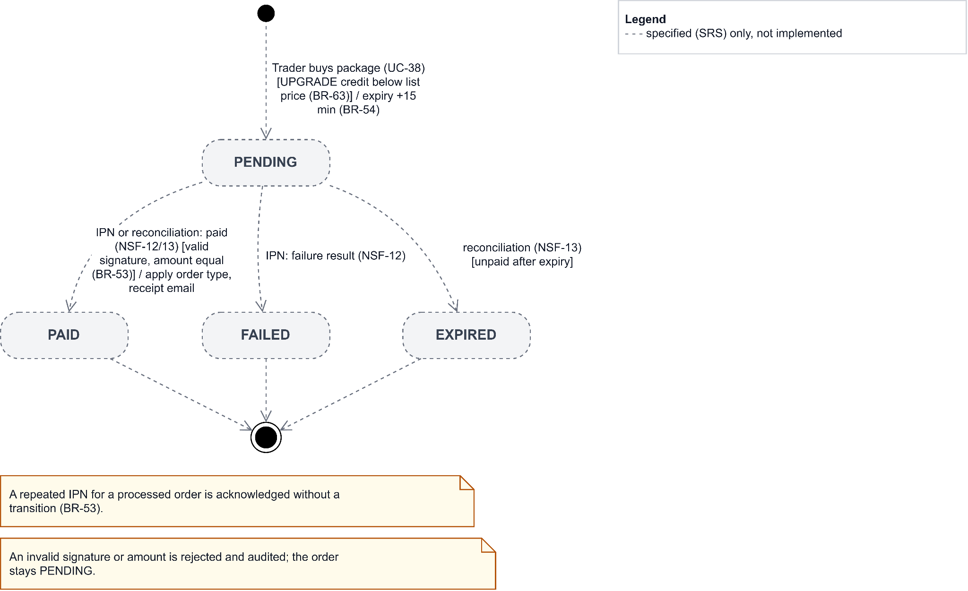
Figure 35: State machine – SUBSCRIPTION_ORDER (order_status)

4.8 USER_SUBSCRIPTION (subscription_status)
Module billing. Status: Designed; script RF-08.
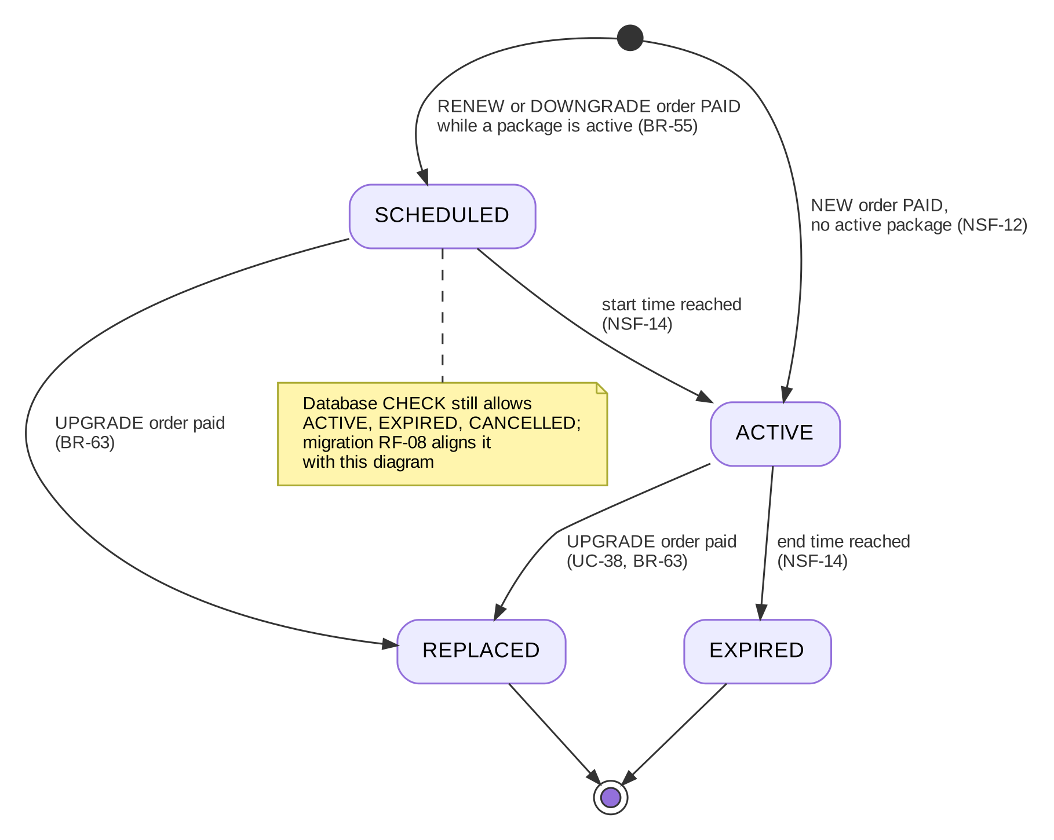
Figure 36: State machine – USER_SUBSCRIPTION (subscription_status)

4.9 AI_MESSAGE (message_status)
Module ai. Status: Designed.
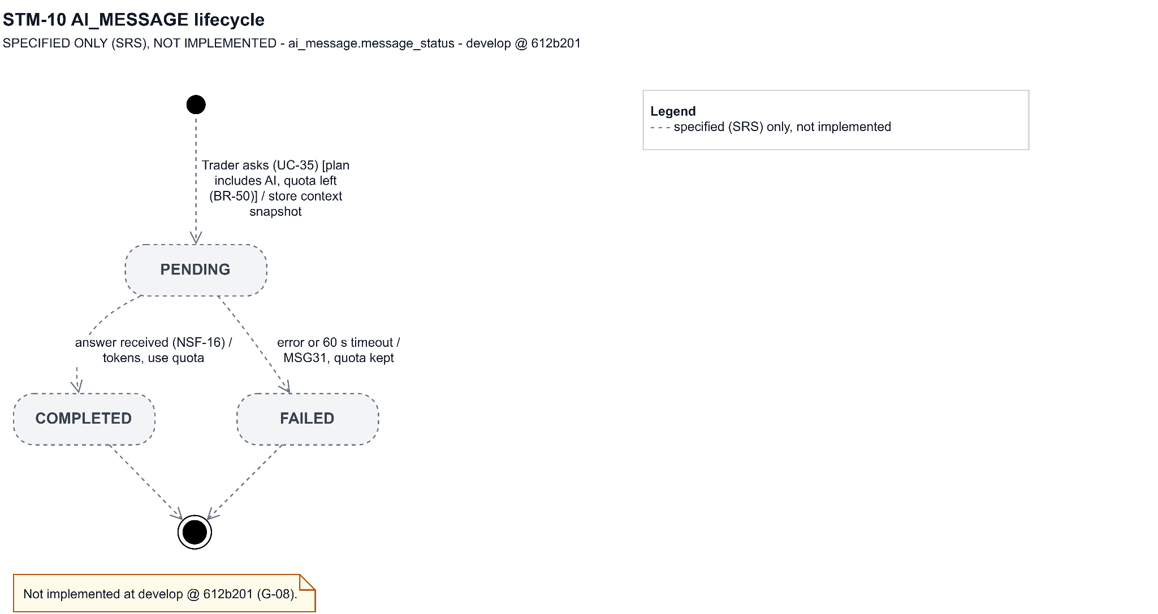
Figure 37: State machine – AI_MESSAGE (message_status)

4.10 FORUM_POST (post_status)
Module community. Status: Implemented.
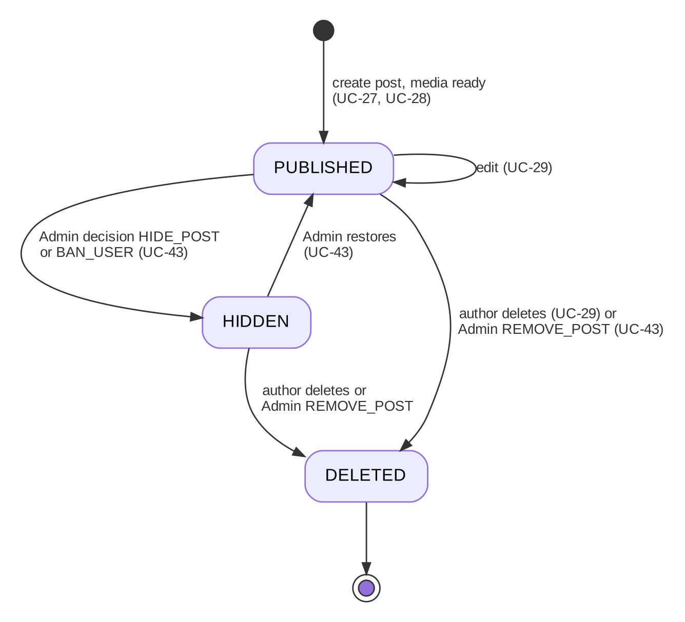
Figure 38: State machine – FORUM_POST (post_status)

4.11 POST_REPORT (report_status)
Module community. Status: Implemented.
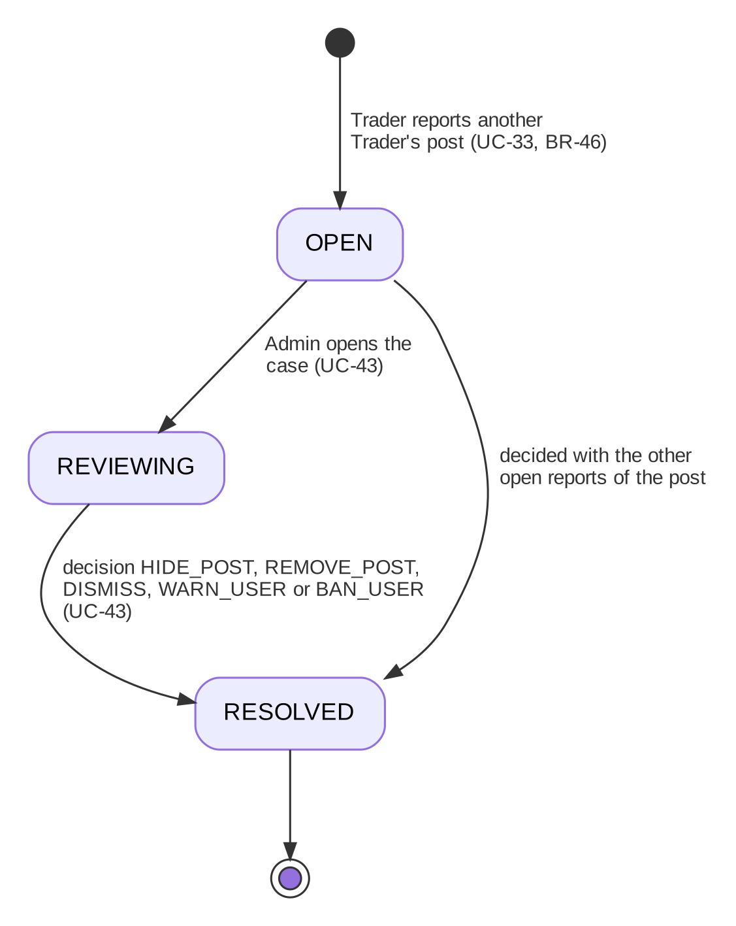
Figure 39: State machine – POST_REPORT (report_status)

5. Activity Diagrams of the Main Workflows
The five main workflows of the Defense 1.1 targets (Design Brief, Appendix A). Each diagram shows the actors as lanes and the business steps; internal processing is shown in sections 3 and 4.

5.1 WF-01 – Plan a trade and review it
Item | Value
Actors | Trader, Binance Market Data API
Trigger | Trader opens a pair's analysis and creates a trading plan
Business outcome | Plan executed by the simulator, or invalidated before its entry (designed), position closed at TP, SL or liquidation, closed trade with net PnL and learning data in the journal and dashboard
Features | F-04, F-05, F-08, F-09, F-11, F-12
Entity states | TRADING_PLAN DRAFT → ACTIVE → EXECUTED (or INVALIDATED, designed); TRADING_JOURNAL OPEN → CLOSED
Owner | Nguyễn Đình Lực

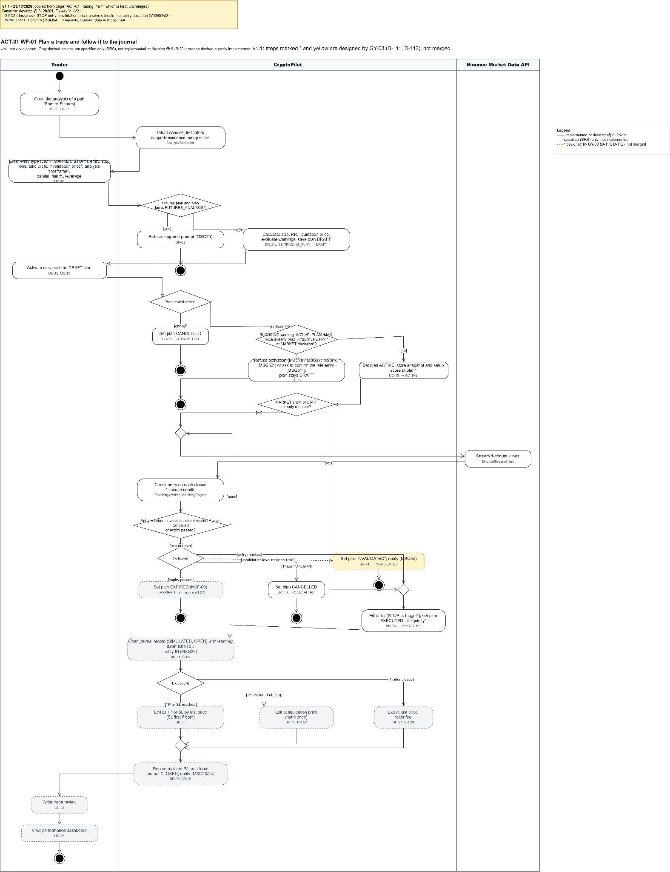
Figure 40: Activity diagram – WF-01 Plan a trade and review it (* designed, D-111, D-112)

5.2 WF-02 – Monitor the market and act on an alert
Item | Value
Actors | Trader, Binance Market Data API, Email / Push Service, News Source
Trigger | Trader adds a pair to the watchlist and creates an alert
Business outcome | Alert triggered; in-app, email and push notification of the alert designed (RF-12); Trader opens the pair (news planned)
Features | F-06, F-07, F-15
Entity states | ALERT ACTIVE → TRIGGERED (→ ACTIVE on edit)
Owner | Đoàn Trung Trực

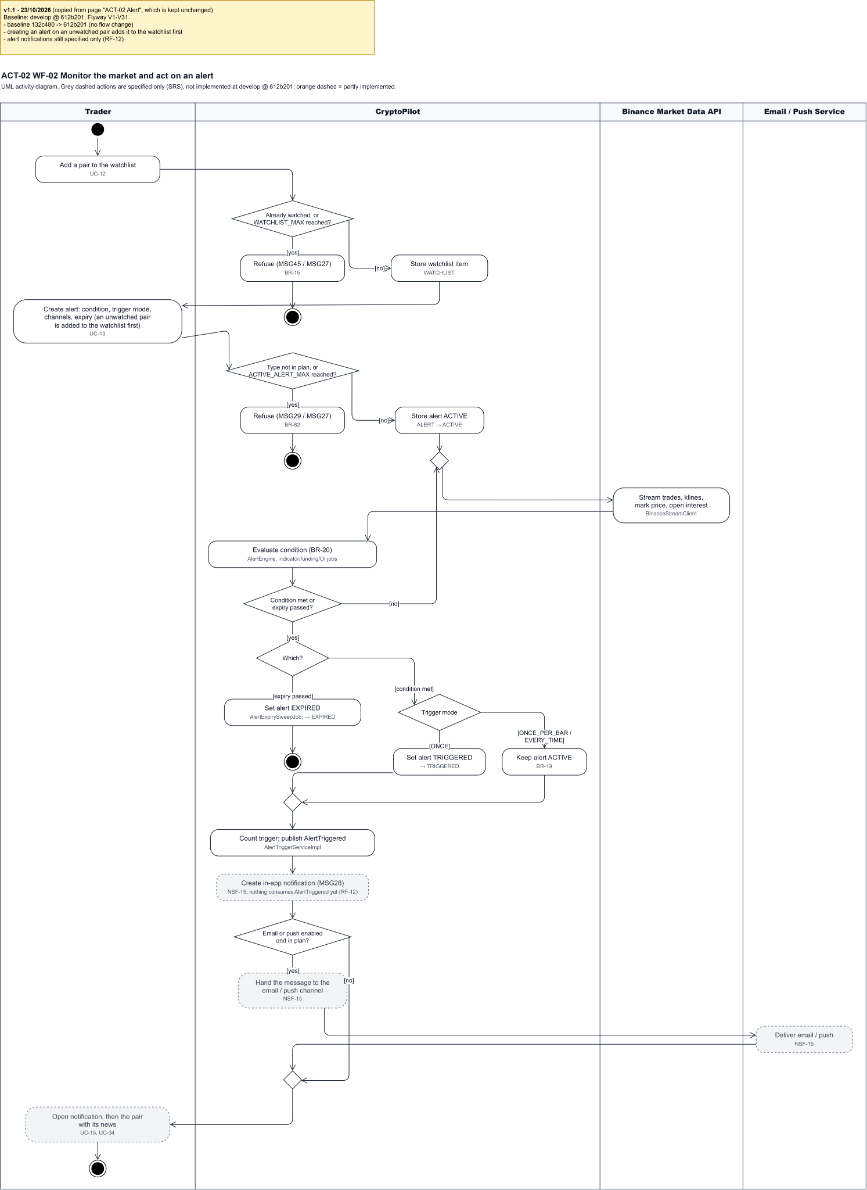
Figure 41: Activity diagram – WF-02 Monitor the market and act on an alert (* designed)

5.3 WF-03 – Practise in the paper exchange
Item | Value
Actors | Trader, Binance Market Data API, Admin
Trigger | Trader opens a paper account and places an order
Business outcome | Order checked against the exchange filters, filled against live trades and depth; balances and PnL updated through the ledger (Spot; Futures positions planned)
Features | F-10, F-19
Entity states | PAPER_ORDER NEW → PARTIALLY_FILLED → FILLED (or CANCELED / EXPIRED; PENDING_NEW → NEW or REJECTED for OTO/OTOCO legs)
Owner | Lưu Trần Quốc Vũ

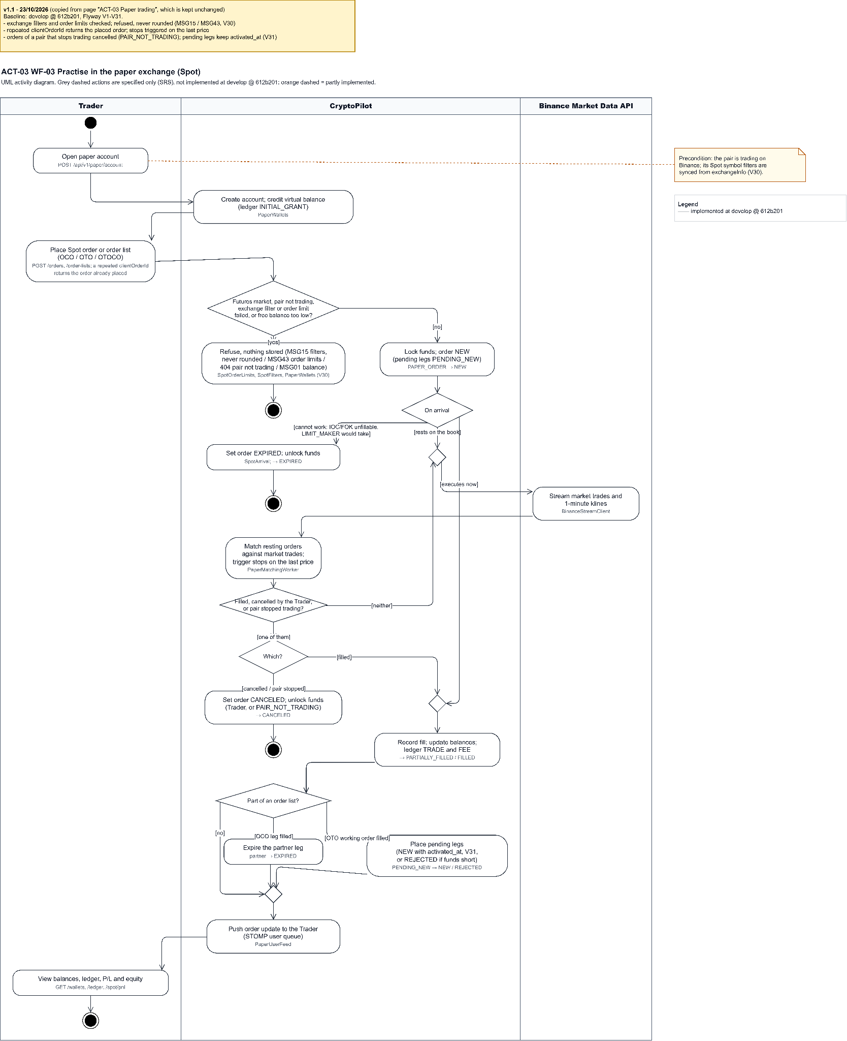
Figure 42: Activity diagram – WF-03 Practise in the paper exchange

5.4 WF-04 – Upgrade and ask the AI Assistant
Item | Value
Actors | Guest / Trader, Payment Gateway, LLM Provider, Email Service
Trigger | A Guest registers; the Trader chooses a package and pays
Business outcome | Package ACTIVE, AI Assistant and video posting unlocked, AI explanation with disclaimer delivered within quota
Features | F-01, F-02, F-03, F-16, F-17, F-21
Entity states | SUBSCRIPTION_ORDER PENDING → PAID; USER_SUBSCRIPTION SCHEDULED/ACTIVE → EXPIRED; AI_MESSAGE PENDING → COMPLETED
Owner | Hoàng Văn Huy

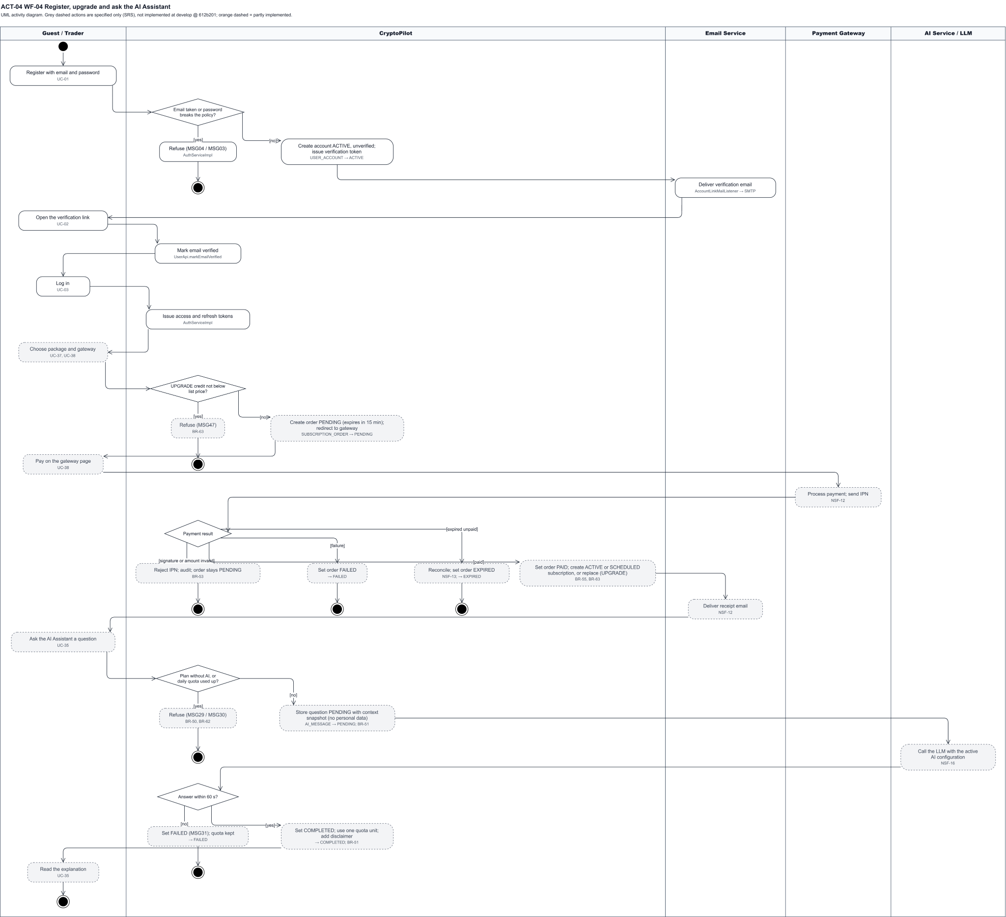
Figure 43: Activity diagram – WF-04 Upgrade and ask the AI Assistant (* designed)

5.5 WF-05 – Publish, report and moderate a post
Item | Value
Actors | Trader (author), Trader (reporter), Admin
Trigger | A Trader publishes a post tagged with a coin
Business outcome | Reported post reviewed; post hidden/removed or report dismissed; author notified; repeat offender locked or banned
Features | F-13, F-14, F-18, F-20
Entity states | FORUM_POST PUBLISHED → HIDDEN / DELETED; POST_REPORT OPEN → REVIEWING → RESOLVED; USER ACTIVE → LOCKED / BANNED
Owner | Lưu Trần Quốc Vũ

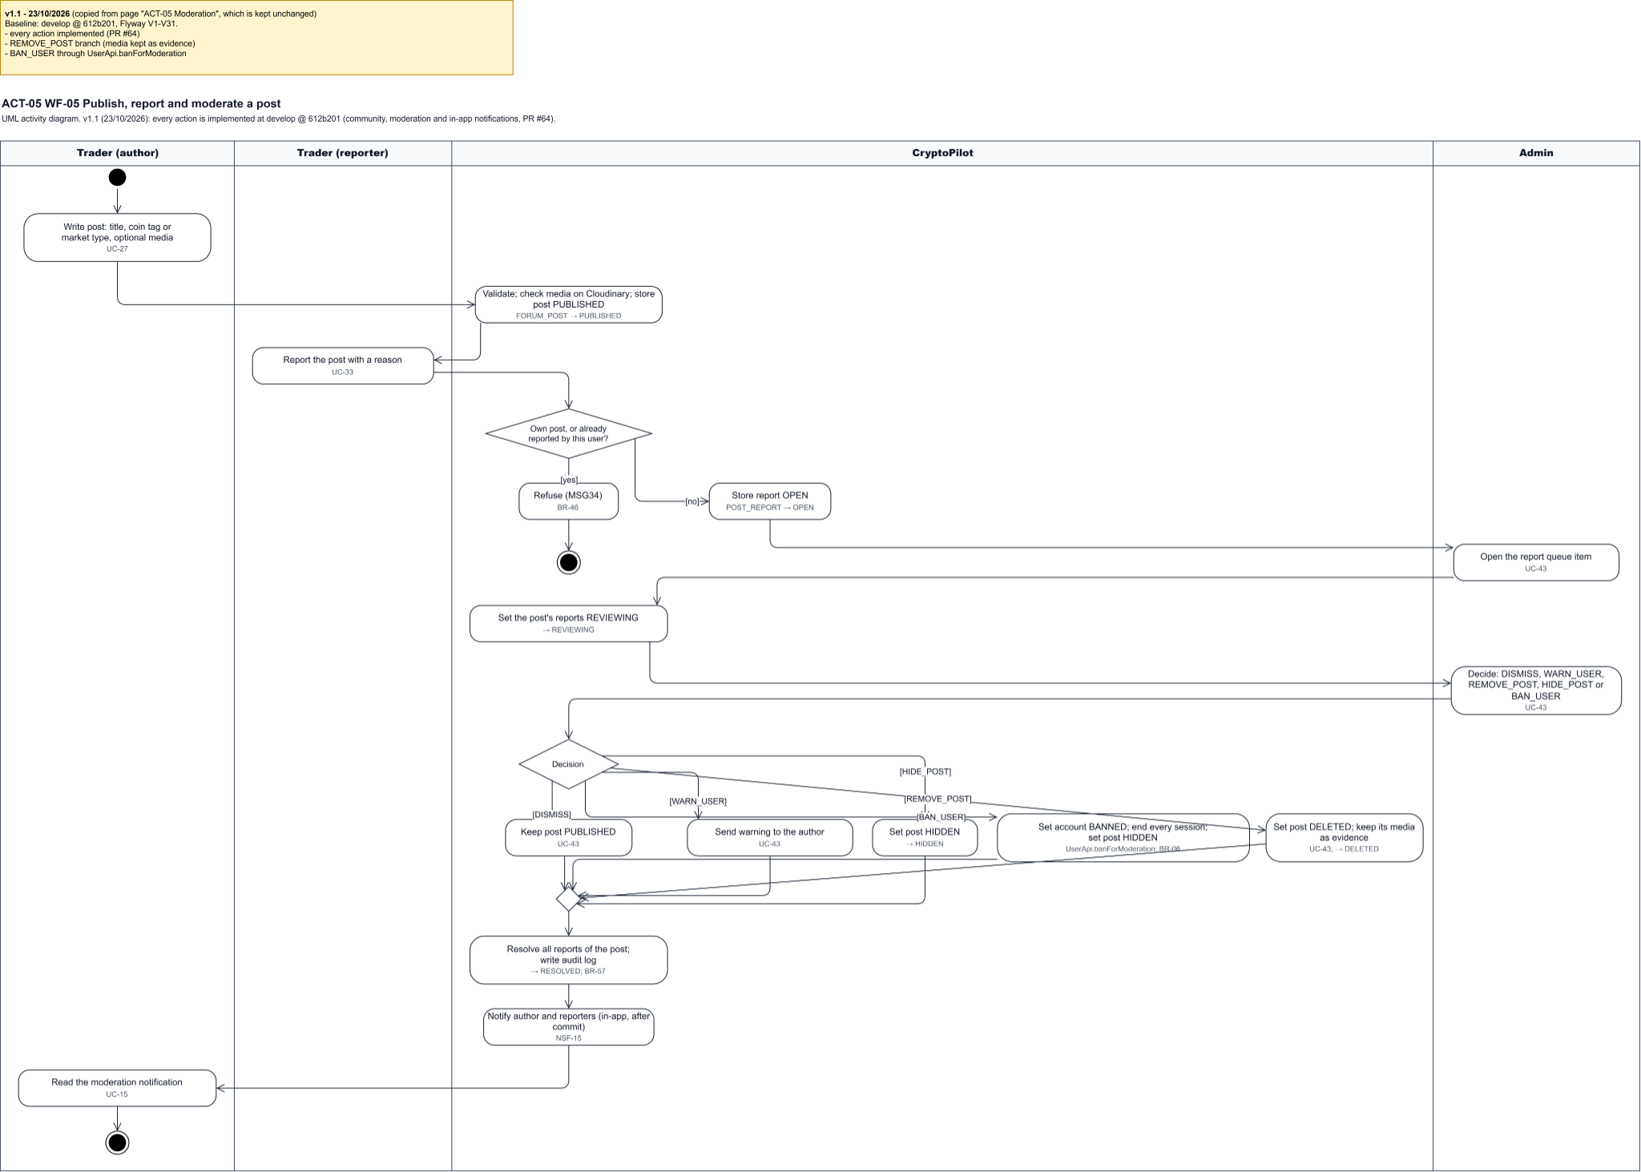
Figure 44: Activity diagram – WF-05 Publish, report and moderate a post

6. Cross-cutting Design
Table 21: Cross-cutting design decisions
No | Concern | Design
01 | API | REST under /api/v1, JSON, camelCase, ISO 8601 UTC, decimals as strings, pages {items, page, pageSize, total} with at most 100 rows; errors as RFC 9457 problem details with a stable code mapped to an SRS message (MSGxx). OpenAPI 3 at /v3/api-docs.
02 | Realtime | STOMP over /ws; public topics /topic/ticker, /topic/kline, /topic/overview, /topic/trades, /topic/depth; user queues /user/queue/notifications and, for the paper exchange, /user/queue/orders, /user/queue/fills, /user/queue/balances (positions and ai planned); ticker coalesced to 1 message per second; clients show Live/Delayed and poll every 10 s when disconnected.
03 | Security | BCrypt cost 12; access token 15 min, rotating refresh token 7 or 30 days stored hashed; roles enforced by the filter chain, ownership and entitlements in services; rate limits per minute: login 10 and other auth calls 20 per address, API 120 per account, Guests 300 per address, and 50 paper orders per 10 s per account (ADR-014); secrets from environment variables.
04 | Precision | BigDecimal for money, prices and quantities; prices rounded to the tick size, quantities floored to the step size; double only inside indicator calculations (ADR-008).
05 | Concurrency | Optimistic version on entities; per-user advisory locks around limit checks; compare-and-set status updates in engines; one consumer per partition owns each in-memory book.
06 | Background work | Schedulers for sync, backfill, metrics, expiry, reconciliation and retention; virtual-thread workers for streams and engines; durable side effects through the event publication registry.
07 | Observability | Structured JSON logs with a correlation id across backend and AI Service; audit log for administrative, security and payment actions (BR-57).

7. Traceability
Table 22: Workflows to design sections
Workflow | Features | Activity | Detailed design | State machines | Owner
WF-01 | F-04, F-05, F-08, F-09, F-11, F-12 | 5.1 | 3.1, 3.2 | 4.2, 4.3 | Nguyễn Đình Lực
WF-02 | F-06, F-07, F-15 | 5.2 | 3.3 | 4.4 | Đoàn Trung Trực
WF-03 | F-10, F-19 | 5.3 | 3.4 | 4.5, 4.6 | Lưu Trần Quốc Vũ
WF-04 | F-01, F-02, F-03, F-16, F-17, F-21 | 5.4 | 3.5, 3.6, 3.7 | 4.7, 4.8, 4.9 | Hoàng Văn Huy
WF-05 | F-13, F-14, F-18, F-20 | 5.5 | 3.8 | 4.1, 4.10, 4.11 | Lưu Trần Quốc Vũ

