Bài 01:

Bài 02:

Bài 03:

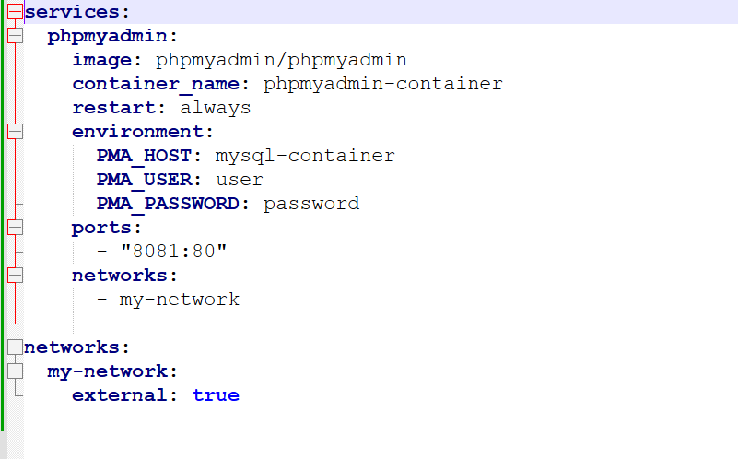

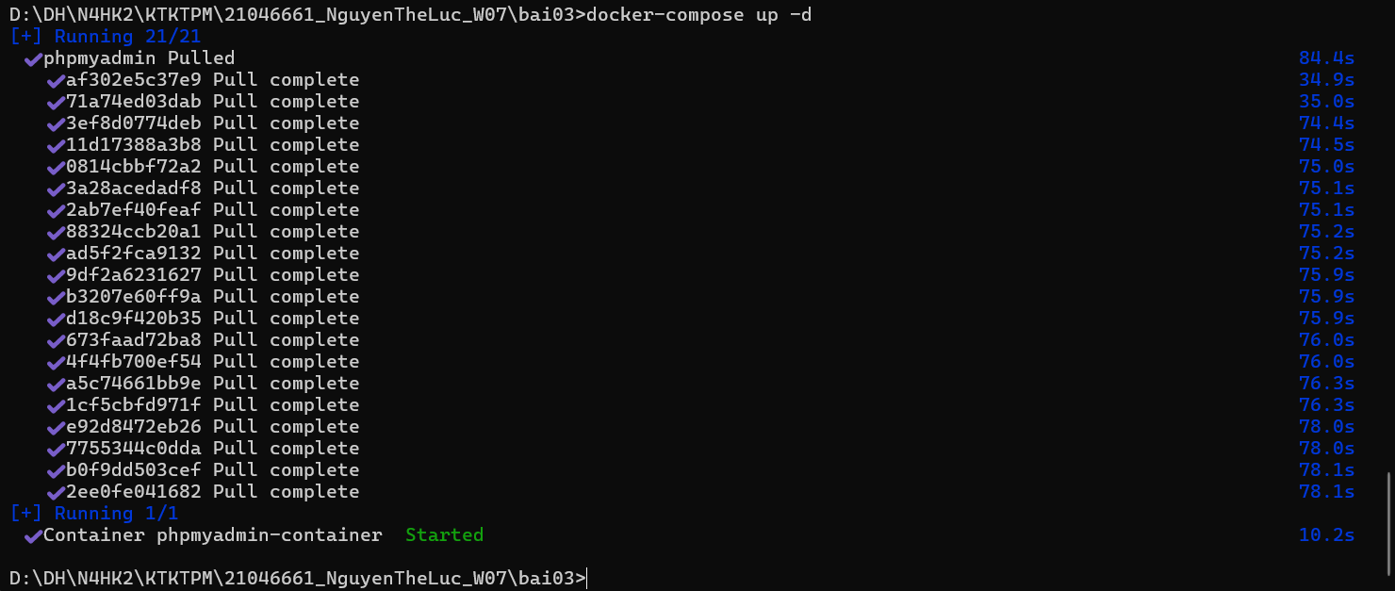

Bài 04:

File index.js  
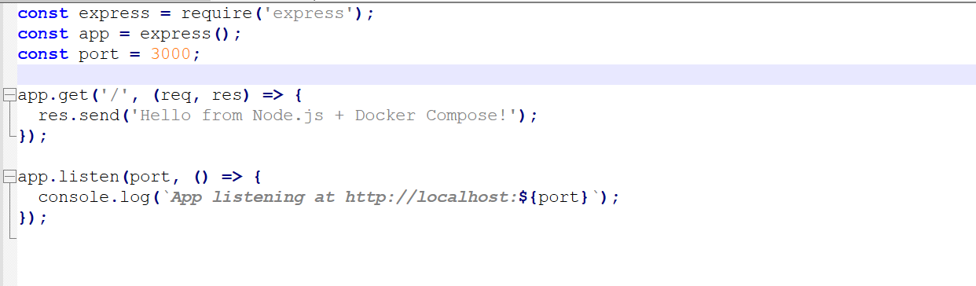

File package.json

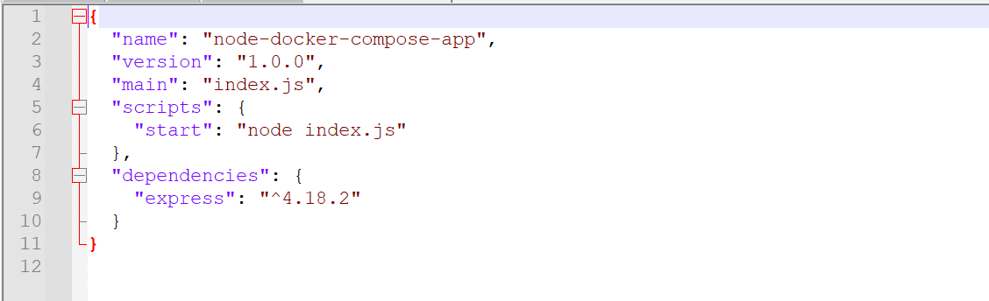

File dockerfile  
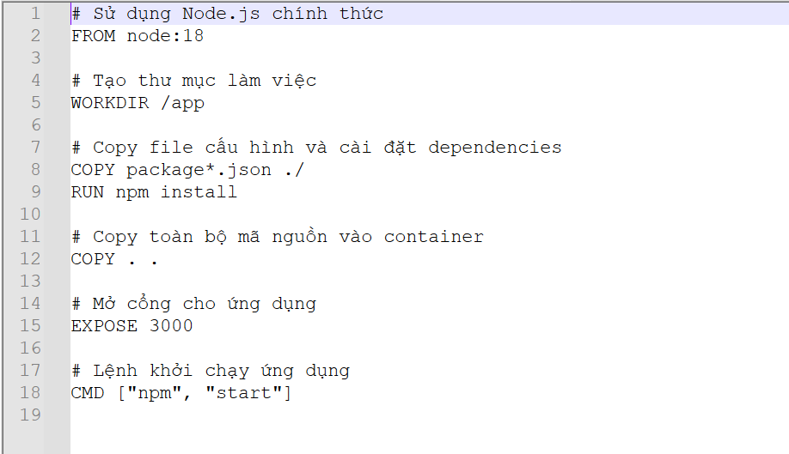

File docker-compose.yml

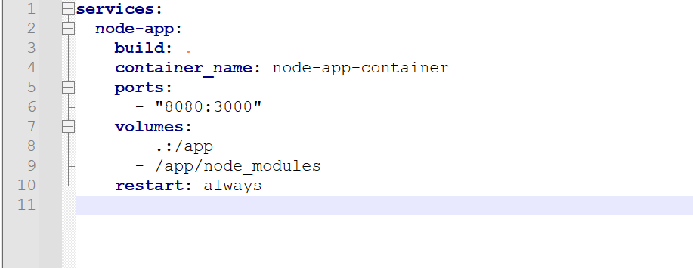

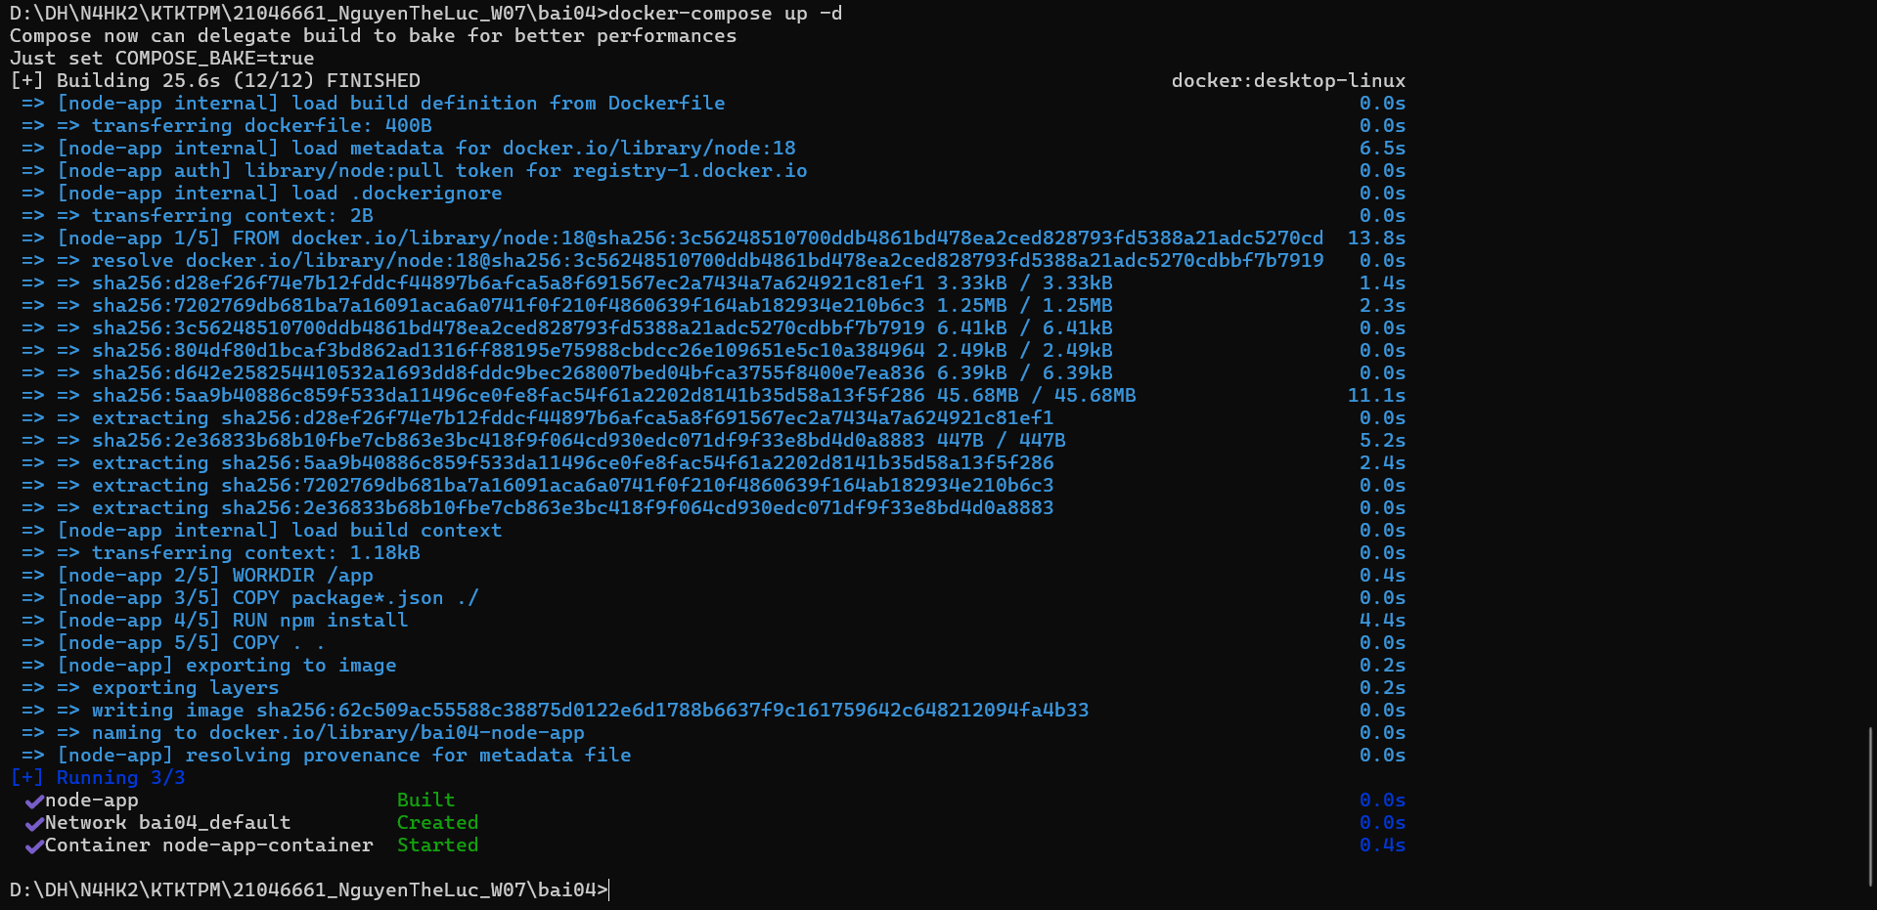

Bài 05:

