CUONG NGUYEN ONLINE EDUCATION SYSTEM

**MC GROUP ENGLISH**

**MID-TERM / FINAL PROJECT FOR SUBJECT………….**

**…topic name…**

*Performed by* : **NGUYEN THI B – MSSV**

**TRAN VAN C – MSSV**

Grade **: IELTS1**

Class code **: ABC 17**

**HO CHI MINH CITY, 2014**

CUONG NGUYEN ONLINE EDUCATION SYSTEM

**MC GROUP ENGLISH**

**MID-TERM / FINAL PROJECT FOR SUBJECT………….**

**…topic name…**

*Performed by* : **NGUYEN THI B – MSSV**

**TRAN VAN C – MSSV**

Grade **: IELTS1**

Class code **: ABC 17**

HO CHI MINH CITY, 2014

**CONFIRM PROJECT COMPLETION**

I hereby certify that this is my/our own project product and is under the guidance of the lecturer ;. The research content and results in this topic are honest and have not been published in any form before. The data in the tables for analysis, comments and evaluation are collected by the author himself from various sources clearly stated in the reference section.

In addition, the project also uses some comments, assessments and data from other authors and organizations, all of which are cited and noted.

**If any fraud is detected, I will take full responsibility for the content of my project.** MC Group English is not related to any copyright violations caused by me during the implementation process (if any).

*Ho Chi Minh City, date month year*

*Author*

*(Sign and print full name)*

*Nguyen Van B*

*Tran Van C*

INSTRUCTOR VERIFICATION AND EVALUATION SECTION

**Confirmation of the instructor**

______________________________________________________________________________________________________________________________________________________________________________________________________________________________________________________________________________________________________________________________________________________________________________________________

Ho Chi Minh City, date month year

(Sign and print full name)

**Teacher's assessment section**

______________________________________________________________________________________________________________________________________________________________________________________________________________________________________________________________________________________________________________________________________________________________________________________________

Ho Chi Minh City, date month year

(Sign and print full name)

INDEX

THANK YOU  i

INSTRUCTOR VERIFICATION AND EVALUATION SECTION  i

SUMMARY  i

TABLE OF CONTENTS  1

LIST OF TABLES, FIGURES, GRAPHS  1

CHAPTER 1 – INTRODUCTION  1

1.1 Sub-item level 1  1

1.1.1 Sub-section level 2  1

1.1.1.1 Level 3 Subsection  1

1.1.1.2 Next level 3 subsection.  1

1.1.2 Next level 2 subsection  1

1.2 Contents of this chapter  1

CHAPTER 2 – OVERVIEW  1

1.1 Presenting mathematical formulas  1

1.2 Present a drawing, diagram  1

CHAPTER 3 – THEORETICAL BASIS / EMPIRICAL RESEARCH  1

3.1 Insert table:  1

3.2 Abbreviations  1

3.3 Quote  1

3.3.1 References and citations  1

3.3.2 Regulations of the Faculty of Information Technology  1

PART A – VOCABULARY AND GRAMMAR

Question 1 Sub-section level 1

Use **Times New Roman (Unicode) font size 13** of Winword editing system; **normal font density** ; do not compress or stretch the space between letters; **line spacing set at 1.5 lines** ; **top margin 3.5 cm** ; **bottom margin 3 cm** ; **left margin 3.5 cm** ; **right margin 2 cm** . Page numbers are typed in the middle, above the top of each page. If there are tables, charts, drawings presented horizontally, the top of the table is the left margin of the page, but this should be limited.

Content of level 1 sub-section, when divided into small sections, must have at least 02 sub-sections (ie if there is 1.1.1 then there must be 1.1.2); maximum should not exceed 05 sub-sections.

Question 1.1 Level 2 sub-section

Detailed content of the subsection.

Question 1.1.1 Level 3 sub-section

- This is the smallest sub-category level, cannot be further divided.

- The ideas in the subsection are presented with bullet points “-“.

- Smaller ideas use bullets as follows:

* Small idea 1.
* Small idea 2.

- Note that this is the deepest level, it is not allowed to be divided into 1.1.1.1.1 .

Sentence 1.1.2 Next level 3 subsection.

The content of the third subsection, when editing, use available Styles, so that when creating a table of contents, it will be automatic and consistent every time we change the format.

Sentence 1.1.2 Next level 2 subsection

It is not always necessary to divide into level 3 sub-sections, if the idea presented is concise.

Question 1.2 Contents of this chapter

This chapter presents the reasons for choosing the topic, the purpose, objects and scope of the research, the scientific and practical significance of the topic ; the scientific basis for choosing the topic ... ;

PART B – READING COMPREHENSION

Sentence 2

Mathematical formulas should be consistent throughout the thesis. Use MS Word tools and number them by chapter, ordinal number within the chapter. For example, the following formula is numbered 2.1.

$x=\frac{-b±\sqrt{b^{2}-4ac}}{2a}$ (2.1)

In a formula, if there are symbols used for the first time, it is necessary to clearly explain which element the symbol represents and what the unit is.

$a^{2}+b^{2}=c^{2}$ (2.2)

In formula 2.2:

* a: length of right angle side of triangle, unit meter ( *m* ).
* b: length of the remaining right angle side of the triangle, unit meter ( *m* ).
* c: length of the hypotenuse of the triangle, unit meter ( *m* ).

Sentence 3

The numbering of tables, figures, and equations must be associated with the chapter number (For example, figure 3.4 means the fourth figure in Chapter 3). All tables and graphs taken from other sources must be fully cited (for example: *Source:* *Page 35, Credit Magazine (2012), No. 15, Finance Publishing House, Ho Chi Minh City* ). Cited sources must be listed accurately in the References List. Table and figure titles are above the table and figure; figure titles are below the figure. Usually, short tables and small graphs must be attached to the content that first refers to them *.* Long tables can be placed on separate pages but must also immediately follow the content that first refers to them.

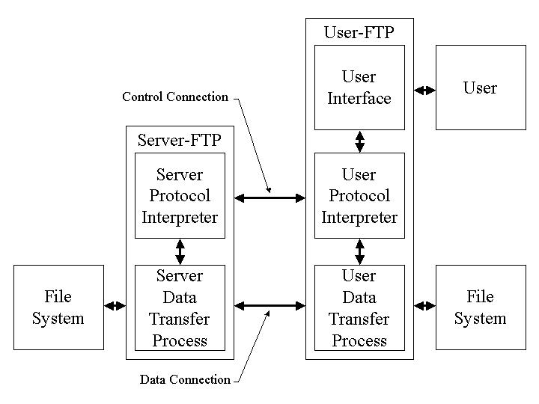

Figure 2. : FTP architecture

Source: (Postel & Reynolds 1985)

PART C – LISTENING SKILLS

|  |  |  |  |  |  |  |  |  |  |
| --- | --- | --- | --- | --- | --- | --- | --- | --- | --- |
| 1C | 2B | 3C | 4D |  |  |  |  |  |  |
|  |  |  |  |  |  |  |  |  |  |

**REFERENCES**

**Vietnamese**

1. Quach Ngoc An (1992), “Looking back at two years of hybrid rice development”, *Applied Genetics* , 98(1), pp. 10-16.
2. Ministry of Agriculture and Rural Development (1996), *Summary report of 5 years (1992-1996) of hybrid rice development,* Hanoi.
3. Nguyen Huu Dong, Dao Thanh Bang, Lam Quang Du, Phan Duc Truc (1997), *Mutation -* *Theoretical and applied basis,* Agricultural Publishing House, Vietnam Academy of Agricultural Science and Technology, Hanoi.
4. Nguyen Thi Gam (1996), *Discovery and evaluation of some heat-induced male sterile lines* *Degree,* Master's thesis in agricultural science, Vietnam Institute of Agricultural Science and Technology Nam, Hanoi.

……….

1. Vo Thi Kim Hue (2000), *Research on diagnosis and treatment of diseases...,* Doctoral thesis in medicine, Hanoi Medical University, Hanoi.

**English**

1. AndersonJE (1985), The Relative Ineffectiveness of Quota, The Cheese Case, *American* *Economic Review* , 75(1), pp. 178-90.
2. Borkakati RP,Virmani SS (1997), Genetics of thermosensitive genic male sterility in Rice, *Euphytica* 88, pp. 1-7.
3. Boulding KE (1955), *Economics Analysis* , Hamish Hamilton, London.
4. Burton GW (1988), “Cytoplasmic male-sterility in pearl millet (penni-setum glaucum L.)”, *Agronomic Journal* 50, pp. 230-231.
5. Central Statistical Organization (1995), *Statistical Year Book* , Beijing.
6. FAO (1971), *Agricultural Commodity Projections (1970-1980)* , Vol. II. Rome.