CUONG NGUYEN ONLINE EDUCATION SYSTEM

**MC GROUP ENGLISH**

**RESEARCH PROJECT – DISCUSSION**

**… name subject ( code) …**

*Performed by* : **NGUYEN THI B – MSSV**

**TRAN VAN C – MSSV**

Grade **: IELTS1**

Code class **: ABC 17**

**HO CHI MINH CITY, 2014**

CUONG NGUYEN ONLINE EDUCATION SYSTEM

**MC GROUP ENGLISH**

**RESEARCH PROJECT – DISCUSSION**

**… name subject ( code) …**

*Performed by* : **NGUYEN THI B – MSSV**

**TRAN VAN C – MSSV**

Grade **: IELTS1**

Code class **: ABC 17**

**HO CHI MINH CITY, 201**

**CONFIRM PROJECT COMPLETION**

I hereby certify that this is my/our own project product and is under the guidance of the lecturer. member ;. The research contents and results in this topic are honest and have not been published in any form before. The data in the tables for analysis, comments and evaluation are collected by the author from various sources clearly stated in the reference section.

In addition, the project also uses some comments, assessments and data from other authors and organizations, all of which are cited and noted.

**If any fraud is detected, I will take full responsibility for the content of my project.** MC Group English is not related to any copyright violations caused by me during the implementation process (if any).

*Ho Chi Minh City, date month year*

*Author*

*(Sign and print full name)*

*Nguyen Van B*

*Tran Van C*

INSTRUCTOR VERIFICATION AND EVALUATION SECTION

**Confirmation of the instructor**

______________________________________________________________________________________________________________________________________________________________________________________________________________________________________________________________________________________________________________________________________________________________________________________________

Ho Chi Minh City, date month year

(Sign and print full name)

**Teacher's assessment section**

______________________________________________________________________________________________________________________________________________________________________________________________________________________________________________________________________________________________________________________________________________________________________________________________

Ho Chi Minh City, date month year

(Sign and print full name)

INDEX

CHAPTER 1 – INTRODUCTION  3

1.1 Problem statement  3

1.1.1 Level 2 Subsection  3

1.1.2 Next level 2 subsection  3

1.2 Research objective  3

1.3 Research Question  4

1.4 Scope and limitations of the topic  4

1.5 Meaning of topic  4

CHAPTER 2 – THEORETICAL BASIS  5

2.1 Concept of market and market regulation  5

2.2 Reasons for government intervention  5

2.3 Theoretical models of the role of government in the economy  6

2.4 Theory of market failure and regulatory tools  6

2.5 Theory of government and models of interaction with the market  6

6 Summary

CHAPTER 3 – GOVERNMENT TOOLS AND POLICIES  7

3.1 Financial regulation tools  7

3.1.1 Competition regulations  7

3.1.2 Regulations on prices and currency  7

3.2 Non-financial regulatory instruments  7

3.2.1 Consumer protection policy  7

3.2.2 Environmental protection  7

3.2.3 Labor regulations  7

3.4 Support and subsidy policies for the market  7

3.3 Anti-monopoly measures  7

CHAPTER 4 – ANALYZING THE IMPACT OF MARKET REGULATION  8

4.1 Positive impacts of market regulation  8

4.1.1 Protecting consumer interests  8

4.1.2 Reducing economic inequality  8

4.2 Negative impacts and limitations of market regulation  8

4.2.1 Bureaucracy and low efficiency  8

4.2.2 Restricting market freedom  8

4.3 Comparison of the market regulatory role of developed and developing countries  8

4.4 Analyze practical examples (e.g. financial markets, energy, healthcare)  8

CHAPTER 5 – DISCUSSION AND RECOMMENDATIONS  9

5.1 Current challenges in market regulation  9

5.2 Suggestions and solutions to improve the regulatory role of the government  9

5.3 Future development direction of market regulation  9

CHAPTER 6 – CONCLUSION  10

**6.1 Summary of key findings from theoretical research**  10

**6.2 Contribution of the study**  10

**6.3 Limitations of the study**  10

**6.4 Recommendations for further research**  10

**REFERENCES**  11

**APPENDIX**  12

CHAPTER 1 – INTRODUCTION

1.1 Place problem subject

History use **type Times New Roman (Unicode) size 13** belong to system compose grass Winword ; **password degree letter jar usually** ; no Okay compress or drag stretch about way between the letter ; **stretch current set in mode** margin **1.5 lines​ over 3.5 cm** ; **margin under 3 cm** ; **margin left 3.5 cm** ; **margin right 2 cm** . Number page Okay hit in the middle , side above head each page paper . If Have table , chart , figure draw program display according to afternoon horizontal suffering paper then head board To be margin left belong to page , but should limit regime program display according to way This .

Contents of pee item level 1, one item when divided​ then dark minimum are 02 sub- items ( ie To be If have 1.1.1 then Right have 1.1.2); dark Multi Are not should more than 05 sub- items .

1.1.1 Sub item level 2

- This To be grant pee item small best , no body next custom share .

- The ideas in pee item Okay program display brick head line “ -“ .

Small ideas than history use bullets like after :

* Small idea 1.
* Small idea 2.

- Need note that​ This To be grant deep best , no Okay division into​ 1.1.1.1.1 .

Contents of pee item rank three , when compose grass let's Use Styles​ available​​ When create item green will on one's own dynamic and copper best each When we replace​ change format

1.1.2 Sub item level 2 next according to

Are not Right at the time any also divided into pee item level 3, if as intended​ display Okay package compact​

1.2 Section pepper research rescue

Chapter This paper presents the reasons for choosing the topic, the purpose, objects and scope of the research, the scientific and practical significance of the topic ; science department​ belong to job select subject resource .. ;​

1.3 Sentence ask research rescue

1.4 Scope and gender limit belong to subject talent

1.5 Meaning subject talent

CHAPTER 2 – THEORETICAL BASIS

2.1 Concept​ think about market school and thing section market school

Recipe​ maths learn need best restaurant in whole set discussion literature . history use labour tool of MS Word and fight number according to chapter , number rank on one's own in chapter . Example example labour awake after This fight is 2.1.

$x=\frac{-b±\sqrt{b^{2}-4ac}}{2a}$ (2.1)

In work wake up , if Have the sign effect To be time head fairy history use , need Right prize prefer clear sign effect there grand area give part death any and single taste To be What .

$a^{2}+b^{2}=c^{2}$ (2.2)

In work Formula 2.2:

* a: degree long edge corner square of triangle , simple​ taste meter ( *m* ).
* b: degree long edge corner square still again of triangle , simple​ taste meter ( *m* ).
* c: degree long edge mysterious of triangle , simple​ taste meter ( *m* ).

2.2 Reasons for need Have interference​​ belong to main cover

Job fight number board figure​​ draw , method program Right attach with number Chapter ( Experiment) example Figure 3.4 has meaning To be image 4th in​ Chapter 3). All board chart​​ market take from the source other Right Okay extract guide full enough ( wallet) Example : *Source :* Page *35 , Trust Magazine ( 2012 ), No. 15, Finance Publishing House , Ho Chi Minh City* ). Source Okay extract guide Right Okay paralysis list main body in Category​ talent whether Reference Reference . Head subject belong to table​​ take note side above table ; top​​ subject belong to image draw take note side below image . normal those board short and thing market small Right Go immediately with part topic content​ access next the board and thing market this time*​ rank most* . The tables long Have body to stay at those page private But also Right next right according to part topic content​ access next board this time​ head first​

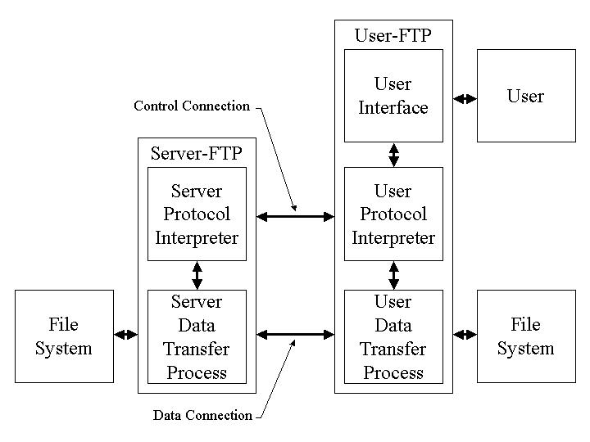

Figure 2.1 FTP structure

Source : (Postel & Reynolds 1985)

2.3 Tissues image reason theory about shoulder game belong to main cover in background terrible economy

2.4 Theory about lost defeat market school and the labour tool thing section

2.5 Theory about main cover and the tissue image work reciprocating​​ with market school

2.6 Summary turn off chapter

…. Items and pee item other link mandarin

CHAPTER 3 – GOVERNMENT TOOLS AND POLICIES

3.1 The works tool about thing section talent main

3.1.1 Regulations about edge painting

3.1.2 Regulations about price chief and money bad

3.2 The works tool thing financial​​ main

3.2.1 Main book tell guard People consumption​

3.2.2 Protection lip school

3.2.3 Regulations about labor dynamic

3.4 The main book support support and support grant give market school

3.3 Measures France against toxic right

….

CHAPTER 4 – ANALYZING THE IMPACT OF MARKET REGULATION

4.1 Author dynamic product pole belong to job thing section market school

4.1.1 Protection profit benefit belong to People consumption​

4.1.2 Reduction minimum any jar class terrible economy

4.2 Author dynamic pepper pole and those limit regime belong to thing section market school

4.2.1 Love status mandarin dose and effect rate short

4.2.2 Limitation regime free market​ school

4.3 Comparison shoulder game thing section market school belong to the water release develop and in progress release develop

4.4 Division product the wallet example real farewell​​ example : market school talent main , energy quantity , health )

…

CHAPTER 5 – DISCUSSION AND RECOMMENDATIONS

5.1 Challenges awake presently in in thing section market school

5.2 Suggestions and​ prize France to reform good shoulder game thing section belong to main cover

5.3 Direction release develop belong to thing section market school in soy sauce hybrid

CHAPTER 6 – CONCLUSION

## **6.1 Summary turn off the release presently main from research rescue reason theory**

## **6.2 Close contribute belong to research rescue**

## **6.3 Limitation regime belong to research rescue**

## **6.4 Topic export give research rescue next according to**

# **REFERENCES**

**Vietnamese​**

1. Quach Ngoc An (1992), “ Look again two year release develop paddy future​*​​ learn application Use* , 98(1), pp. 10-16.
2. Set agriculture Agriculture and Rural Development *(* 1996), *Report total 5 - year (1992-1996) development develop paddy lai ,* Hanoi.
3. Nguyen Huu Dong , Dao Thanh Bang , Lam Quang Du , Phan Duc Truc (1997), *Sudden variable -* *Muscle office reason discussion and application use ,* Home export copy agriculture Industry , Institute of Science Technically technique agriculture Vietnam Industry , Hanoi.
4. Nguyen Thi Gam (1996), *Development presently and fight price one number current any sex male have a cold application heat* *Degree ,* Thesis​ Master scientist​​ agriculture Industry , Institute of Science Technically technique agriculture Vietnamese NamIndustry , Hanoi.

……….

1. Vo Thi Kim Hue (2000), *Research rescue diagnosis guess and thing treat disease …,* Doctor of Medicine Thesis , University of Hanoi Medical University , Hanoi.

**English​**

1. AndersonJE (1985), The Relative Ineffectiveness of Quota, The Cheese Case, *American* *Economic Review* , 75(1), pp. 178-90.
2. Borkakati R. P.,Virmani SS (1997), Genetics of thermosensitive genic male sterility in Rice, *Euphytica* 88, pp. 1-7.
3. Boulding KE (1955), *Economics Analysis* , Hamish Hamilton, London.
4. Burton GW (1988), “Cytoplasmic male-sterility in pearl millet (penni- setum glaucum L.)”, *Agronomic Journal* 50, pp. 230-231.
5. Central Statistical Organization (1995), *Statistical Year Book* , Beijing.
6. FAO (1971), *Agricultural Commodity Projections (1970-1980)* , Vol. II. Rome.