# Overview Panasonic project

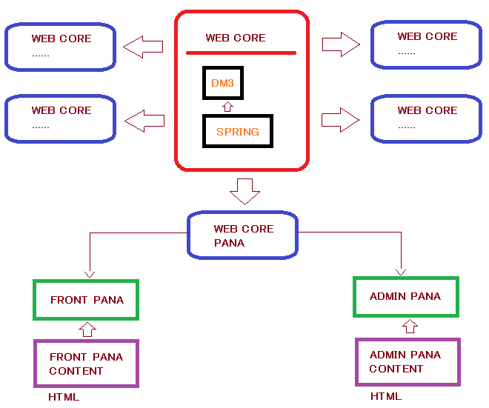

# Git

**Resource**

git clone ssh://git@gitlab.tctav.com:15022/si2-java-team/Panasonic.git

git checkout 20151015_Panasonic_Release_Ver1.1.1

**Document**

git clone ssh://git@gitlab.tctav.com:15022/si2-java-team/SI2-Document.git

# Configuration Database SQL

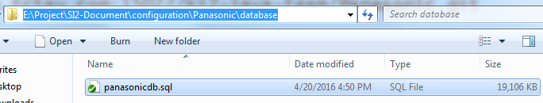

# Configuration Editor Code

**Step 1**: Import project to Spring tool suite / eclipse

**Step 2**: Prepare Server (Tomcat 7) and Java run from jdk-8 (window -> references -> Java)

**Step 3**: add lib mysql-connector to tomcat server (apache tomcat -> lib)

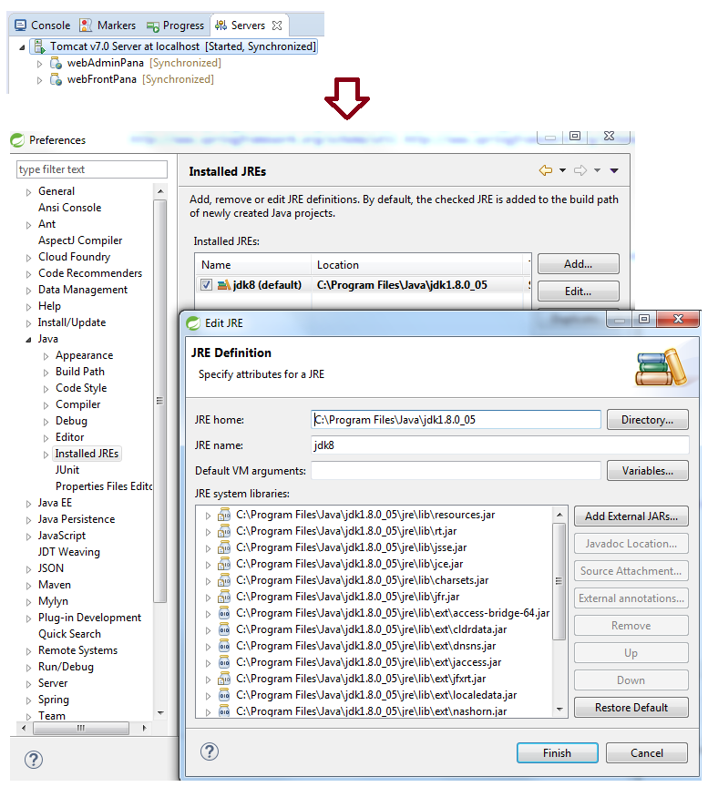

**Step 4**: Install maven for projects (webCore, webCorePana, webFrontPana, webFrontPanaContents, webAdminPana, webAdminPanaContents)

+ *Cách Build maven*

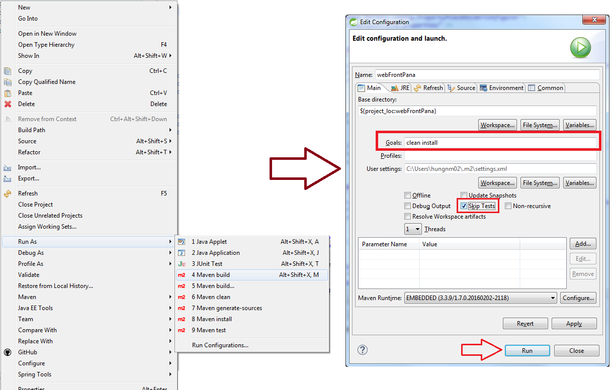

* Thứ tự build maven webCore -> webCorePana -> webFrontPanaContent (Lấy gói .jar trong target copy sang webFrontPana) -> webFrontPana

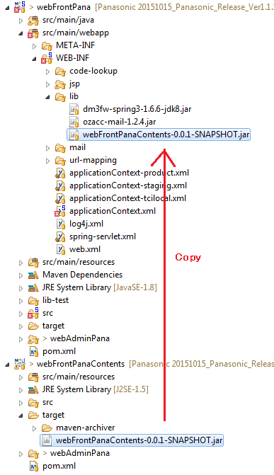

* Thứ tự build maven webCore -> webCorePana -> webAdminPanaContent (Lấy gói .jar trong target copy sang webAdminPana) -> webAdminPana

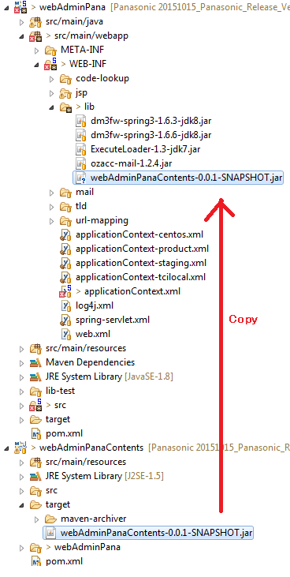

**NOTE: nếu không build được project thì xóa hết file trong thư mục target của webCore.**

**Css: applicationContext.xml : modified**

**<property name="ResourceRootUrl" value="/webAdminPana/admin_rsc/" />**

# Configuration Server local

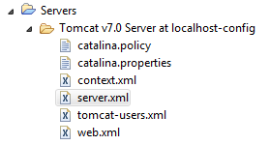

**Server.xml**

Replace:

<Host name=*"localhost"* appBase=*"webapps"*

unpackWARs=*"true"* autoDeploy=*"true"*>

<!-- SingleSignOn valve, share authentication between web applications

Documentation at: /docs/config/valve.html -->

<!--

<Valve className="org.apache.catalina.authenticator.SingleSignOn" />

-->

<!-- Access log processes all example.

Documentation at: /docs/config/valve.html

Note: The pattern used is equivalent to using pattern="common" -->

<Valve className=*"org.apache.catalina.valves.AccessLogValve"* directory=*"logs"*

prefix=*"localhost_access_log."* suffix=*".txt"*

pattern=*"%h %l %u %t &quot;%r&quot; %s %b"* />

</Host>

To:

<Host appBase=*"wtpwebapps"* autoDeploy=*"true"* name=*"pana.com"* unpackWARs=*"true"*>

<Valve className=*"org.apache.catalina.valves.AccessLogValve"* directory=*"logs"* pattern=*"%h %l %u %t &quot;%r&quot; %s %b"* prefix=*"localhost_access_log."* suffix=*".txt"*/>

<Context docBase=*"webFrontPana"* path=*""* source=*"org.eclipse.jst.jee.server:webFrontPana"*/>

</Host>

<Host appBase=*"webapps"* autoDeploy=*"true"* name=*"localhost"* unpackWARs=*"true"*>

<!-- SingleSignOn valve, share authentication between web applications

Documentation at: /docs/config/valve.html -->

<!--

<Valve className="org.apache.catalina.authenticator.SingleSignOn" />

-->

<!-- Access log processes all example.

Documentation at: /docs/config/valve.html

Note: The pattern used is equivalent to using pattern="common" -->

<Valve className=*"org.apache.catalina.valves.AccessLogValve"* directory=*"logs"* pattern=*"%h %l %u %t &quot;%r&quot; %s %b"* prefix=*"localhost_access_log."* suffix=*".txt"*/>

<Context docBase=*"webFrontPana"* path=*"/webFrontPana"* reloadable=*"true"* source=*"org.eclipse.jst.jee.server:webFrontPana"*/><Context docBase=*"webAdminPana"* path=*"/webAdminPana"* reloadable=*"true"* source=*"org.eclipse.jst.jee.server:webAdminPana"*/></Host>

# Configuration Computer

Path: C:\Windows\System32\drivers\etc

Add: 127.0.0.1 pana.com

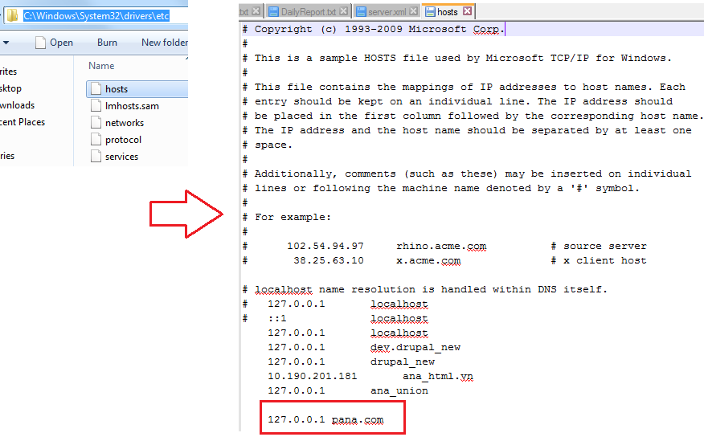

# Run website

**webAdminPana**: <http://localhost:8080/webAdminPana/>



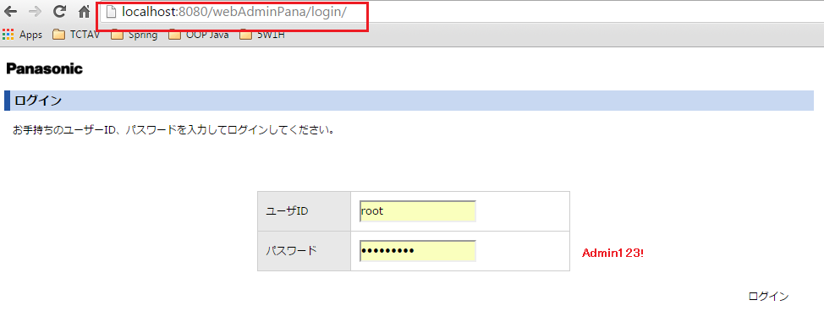

**webFrontPana:** <http://pana.com:8080/buy/special/001/>

