Handle Intercepter

* Mục đích và Cách thức xữ lý tương tự như Filter

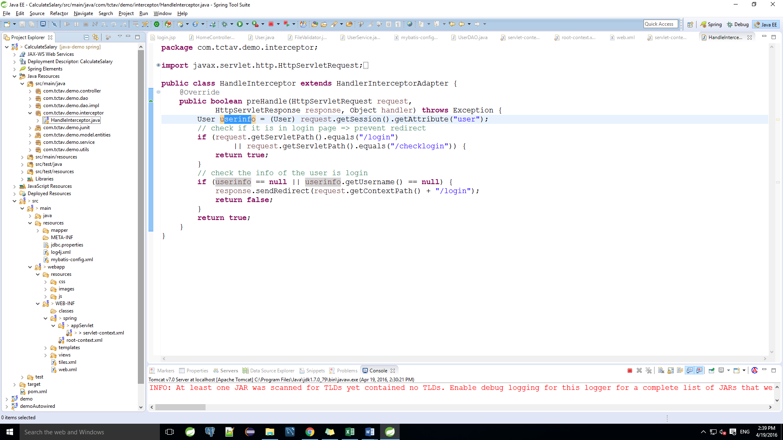

* Khai báo trong servlet-context.xml

<!-- Declare for Interceptor -->

<mvc:interceptors>

<mvc:interceptor>

<mvc:mapping path=*"/**"* />

<bean class=*"com.tctav.demo.interceptor.HandleInterceptor"* />

</mvc:interceptor>

</mvc:interceptors>

* Xử lý trong HandleInterceptor.java

**public** **class** HandleInterceptor **extends** HandlerInterceptorAdapter {

@Override

**public** **boolean** preHandle(HttpServletRequest request,

HttpServletResponse response, Object handler) **throws** Exception {

User userinfo = (User) request.getSession().getAttribute("user");