Local Weather Monitoring, Forecasting System Using Neural Network And Lora Communication Technology

Nguyen Manh Thao, 14520853
Faculty of Computer Engineering, University of Information Technology
Quach The Hao, 14521124
Faculty of Computer Engineering, University of Information Technology
Ph.D Trinh Le Huy
Faculty of Computer Engineering, University of Information Technology

Summary— The thesis research and develops a system of small-scale weather monitoring and forecasting equipment used for the development of weather-related applications. The device is based on machine learning technology to make predictions, which improves the accuracy of predictions for each individual case according to the time spent and adapting to different areas.
Keyword— Weather Forecasting, LoRa, Neural Network

INTRODUCE
Nowadays, along with the development of the Internet of Things models in industries and services, the demand for weather forecasts is increasing. However, there is currently no simple system to meet this need. The current solution to this problem is using National weather forecasting channels. An advantage of this solution is that it is no need for additional hardware. It is entirely free because forecast information is published on media channels. However, there is a disadvantage that the forecast information from National weather forecasting channels is not completely correct for all local areas (where the public measurement devices aren’t installed). The thesis "Local weather forecasting system using neural network" focus on forecasting the weather for a small localized area using a neural network with a reasonable cost, personalizing for users, serving for family and small businesses.

SOLUTION

Artificial Neural Networks for Weather Forecasting
Predicting the weather has long been a common problem for mankind. There have been many advances in meteorological and hydrographic science and invent modern equipment. But local weather forecasting is not popular. Most local weather forecasting devices in the market used to notify the weather state or get weather information from the Internet.
In this project we use Machine Learning, specifically the Back-propagation Neural Network model to solve the problem of small-scale rain forecasting. Utilizing the advantages of the Back-propagation Neural Network model is to improve forecasting accuracy over time.
We examined data sets and analyze problems. By using the examining result, the ANN model was developed with Multi-layer Perceptron, Back-propagation and Dropout algorithms.

Anti-collision algorithms for LoRa bandwidth
Anti-collision is an algorithm for resolving packet collisions including basic protocols such as sending back error packets or error messages, etc. Currently, LoRa has two common anti-collision algorithms which are Pure ALOHA and Slotted ALOHA. However, both aim to minimize latency when resending packets that fail and have the very low bandwidth. Pure ALOHA is 0.184 when G = 1/2 and Slotted ALOHA is 0.368 when G = 1 (G is the expected number of transmission and retransmission per unit time). So, both are inappropriate for weather monitoring systems, which send data every 5 minutes and latency is not important.
We have developed a new algorithm to solve this problem based on the current version of Slotted ALOHA algorithm. In this new algorithm, the transmissions are arranged in slots similar to Slotted ALOHA but have specific cycle time and emergency slots. The length of the cycle and each slot depends on the length of the packet or its time on air. The number of emergency slots usually accounts for about 20% of the total number of slots. Typically, slots will be used for sending the data packet. When a collision occurs, the nodes resend the packet with error information in the emergency slot. In addition, the emergency slot is also used to inform the server about system failure events. A disadvantage of this algorithm is the need for an RTC module on each device and a time synchronization slot.

Related works
The article "Neural Network training model for weather forecasting using Fireworks Algorithm" by Saktaya Suksri and Warangkhana Kimpan, published at the International Computer Science and Engineering Conference (ICSEC) on 14-17 Dec. 2016, presents the method using the Artificial Neural Networks model with the supervised learning paradigm to predict the mean daily temperature values with the input data for the meteorological station located in Bangkok. The Artificial Neural Network model was trained by the Fireworks algorithm - the ANN optimization algorithm developed by the Swarm Intelligence Algorithm. However, the article focuses on algorithm development and research rather than product development.
The article "Neural Network training model for weather forecasting using Fireworks Algorithm" by Saktaya Suksri and Warangkhana Kimpan, published at the International Computer Science and Engineering Conference (ICSEC) on 14-17 Dec. 2016, presents the method using the Artificial Neural Networks model with the supervised learning paradigm to predict the mean daily temperature values with the input data for the meteorological station located in Bangkok. The Artificial Neural Network model was trained by the Fireworks algorithm - the ANN optimization algorithm developed by the Swarm Intelligence Algorithm. However, the article focuses on algorithm development and research rather than product development.
Author Kumar Abhishek with article named "Weather Forecasting Model using Artificial Neural Network", published on Procedia Technology magazine Volume 4, 2012, Pages 311-318, presents considering the possibility of the method that uses ANN with different transmission parameters, different number of hidden layers and neurons in the weather prediction, especially the maximum temperature in a year.

RESULT
Currently, we have completed the monitoring system and collecting environmental data at the roof of Building E, University of Information Technology.
The node is optimized the power consumption by sleeping the MCU and LoRa RFM95W.
In addition, the packet length is reduced from 50 bytes to 15 bytes. The Time on Air of the packet reduced from 1908.74ms to 925.7ms. And the power consumption will be calculated as the following table:
About the Neural Network models, we have examined some popular ANN models/algorithms and give the comparison:
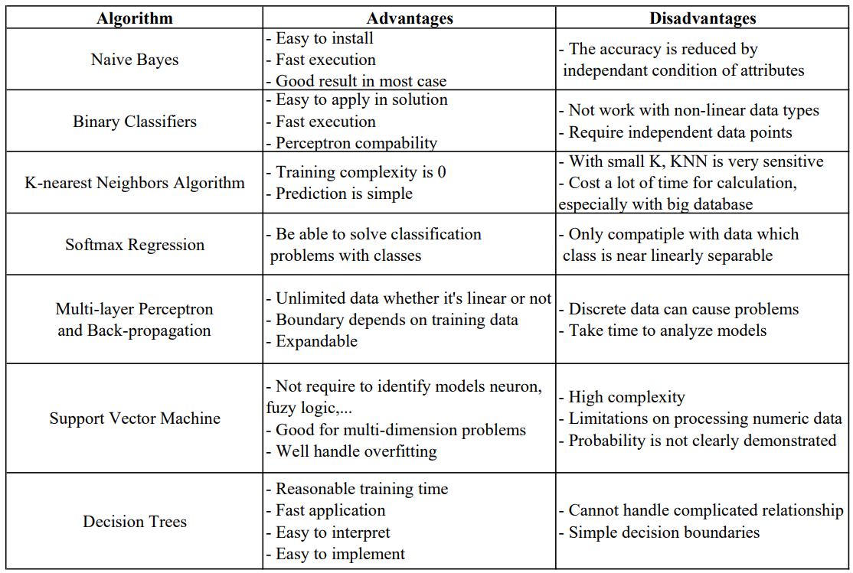
Based on the comparison, an ANN model has been developed and modified through 3 stages and archived up to 80% of forecast accuracy.
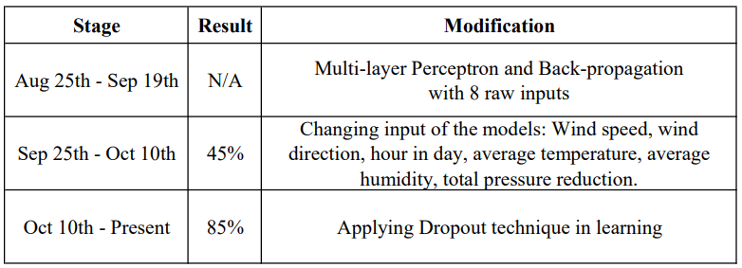
About the simulation of the anti-collision algorithm, we have completed 30 nodes and will be ready for simulation when firmware completed.
Our current setting for the simulation network is SF=8, BW=200kHz, CR=4/5, Explicit Header, Preamble=16.25syms, Header 8syms, Payload=253 bytes, CRC=16Bits, Transmit Power=12.5dBm. With this setting, Time on Air=434.1281ms. So that, every slot should be 1 second in length. Because we need to send the packet every 5 minutes, we will have 300 slots.

CONCLUSION
Currently, the project is about 65% of the completion. In the remaining time of the semester, we would like to complete following tasks:
- Integrating the forecasting module into the system
- Examining the SVM models
- Developing a web interface
- Designing the gateway case
- Examining the anti-collision algorithm

REFERENCES
- Saktaya Suksri and Warangkhana Kimpan, "Neural Network training model for weather forecasting using Fireworks Algorithm", 2016 International Computer Science and Engineering Conference (ICSEC). [Online]. Available: https://ieeexplore.ieee.org/document/7859952/. [Accessed Jul. 14, 2018].
- Andrew Culclasure, "Using Neural Networks to Provide Local Weather Forecasts", Electronic Theses & Dissertations Georgia Southern University Spring 2013. [Online]. Available: https://digitalcommons.georgiasouthern.edu/etd/32/. [Accessed Jul. 14, 2018].
- Kumar Abhishek, "Weather Forecasting Model using Artificial Neural Network", Procedia Technology Volume 4, 2012, Pages 311-318. [Online]. Available: https://www.sciencedirect.com/science/article/pii/S221201731200326X. [Accessed Jul. 14, 2018].

