First, I have to run Server by **java –jar .\jar\chatServer_1.0.jar** **portNumber**, the chat conversation will write to file ChatApp_logfile

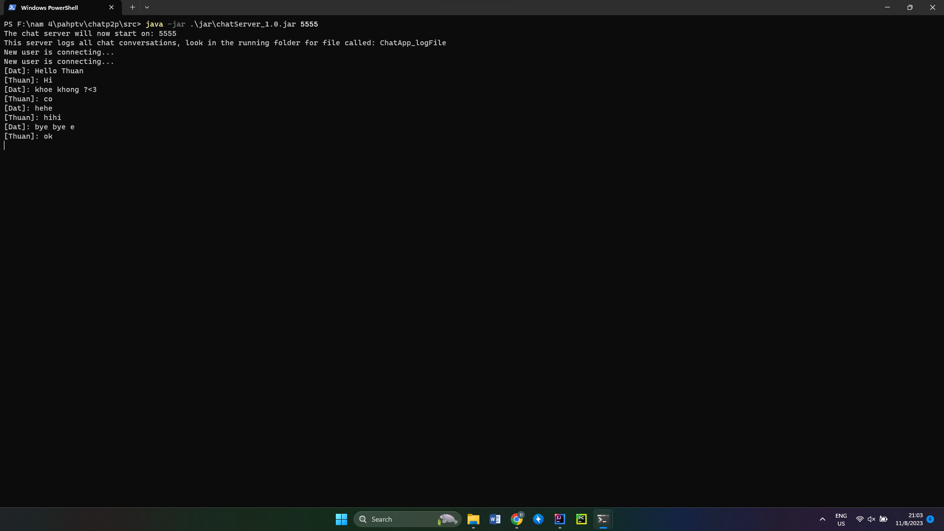

Next, I run 2 client to connect with server and chat via the command:

**java -jar .\jar\chatClient_1.0.jar ipAddress portNumber**

In this, i run in one PC, and I the IP Address = 127.0.0.1 and portNumber is same with Server: 55555

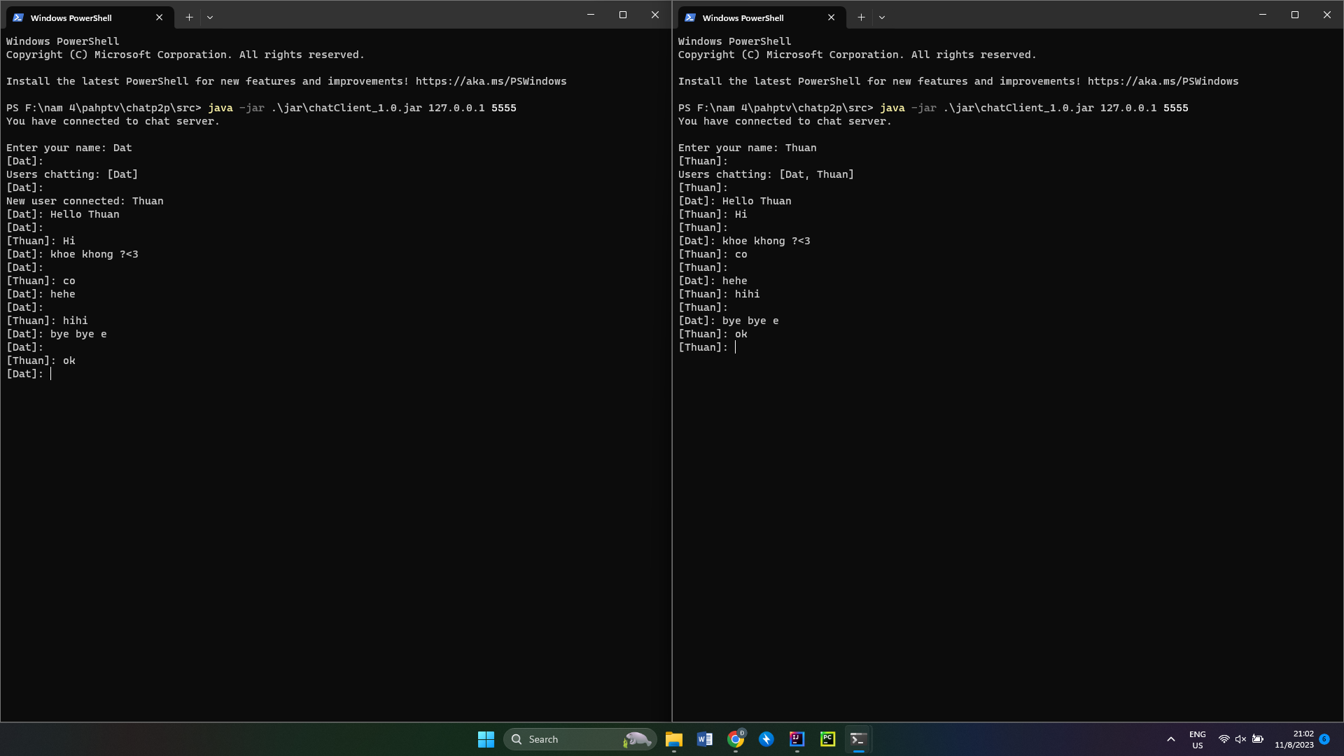

Now, we can chat.

And there is the file to stored chat conversation

