No. 13 | Nguyen Thien Minh | CODE 3

All questions will use the same project for easier management (2 DB in the same Project)

Question 1: Initialize the website (2 points)

- Build single database for student management
use mystudents;
go
INSERT INTO Classes (ClassID, ClassName)
VALUES
('C1701', 'SE1701'),
('C1702', 'SE1702'),
('C1801', 'SA1801'),
('C1901', 'SS1901');
GO

INSERT INTO Students (StudentID, FullName, ClassID)
VALUES
('HE170001', N'Nguyễn Văn An', 'C1701'),
('HE170002', N'Trần Thị Bích', 'C1702'),
('SA180003', N'Lê Hoàng Tùng', 'C1801'),
('SS190004', N'Phạm Thu Hà', 'C1901');
GO
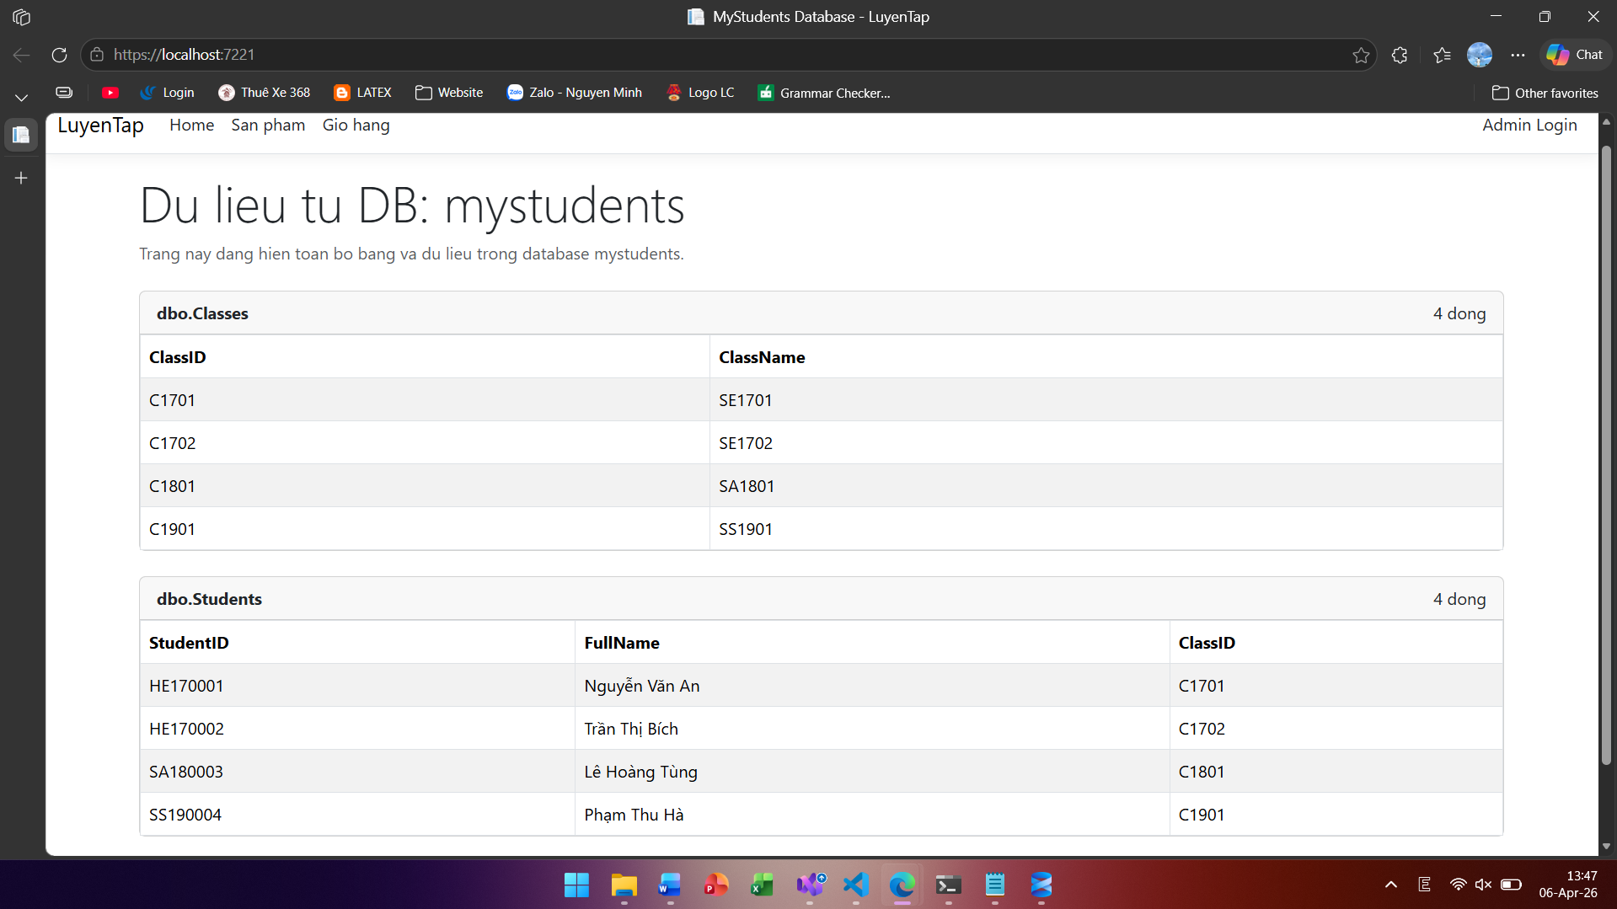
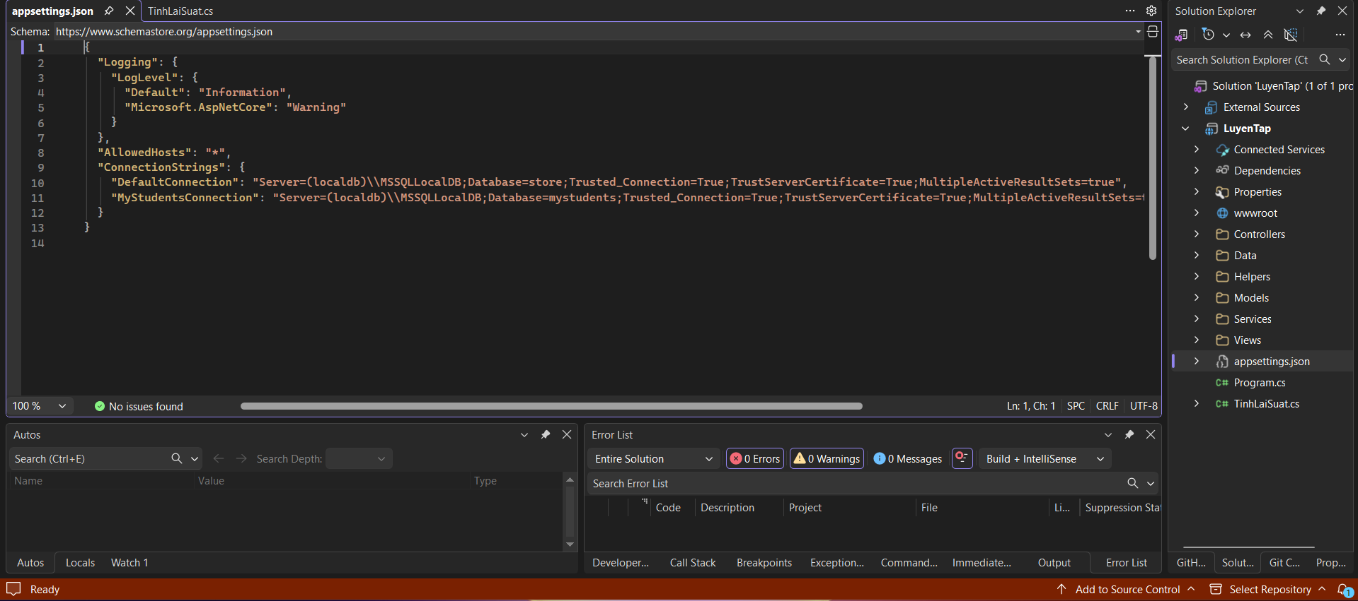
@model LuyenTap.Models.HomeIndexViewModel

@{
ViewData["Title"] = "MyStudents Database";
}

<div class="mb-4">
<h1 class="display-5">Du lieu tu DB: @Model.SourceDatabase</h1>
<p class="text-muted">Trang nay dang hien toan bo bang va du lieu trong database mystudents.</p>
</div>

@if (!string.IsNullOrWhiteSpace(Model.ErrorMessage))
{
<div class="alert alert-danger">@Model.ErrorMessage</div>
}
else if (!Model.Tables.Any())
{
<div class="alert alert-warning">Khong tim thay bang nao trong database mystudents.</div>
}
else
{
@foreach (var table in Model.Tables)
{
<div class="card mb-4">
<div class="card-header d-flex justify-content-between">
<strong>@table.Schema.@table.TableName</strong>
<span>@table.Rows.Count dong</span>
</div>

<div class="card-body p-0">
@if (!table.Columns.Any())
{
<div class="p-3">Bang khong co cot.</div>
}
else if (!table.Rows.Any())
{
<div class="p-3">Bang khong co du lieu.</div>
}
else
{
<div class="table-responsive">
<table class="table table-striped table-bordered mb-0">
<thead>
<tr>
@foreach (var column in table.Columns)
{
<th>@column</th>
}
</tr>
</thead>
<tbody>
@foreach (var row in table.Rows)
{
<tr>
@foreach (var column in table.Columns)
{
<td>@row[column]</td>
}
</tr>
}
</tbody>
</table>
</div>
}
</div>
</div>
}
}

Question 2: Create a search function (3 points)

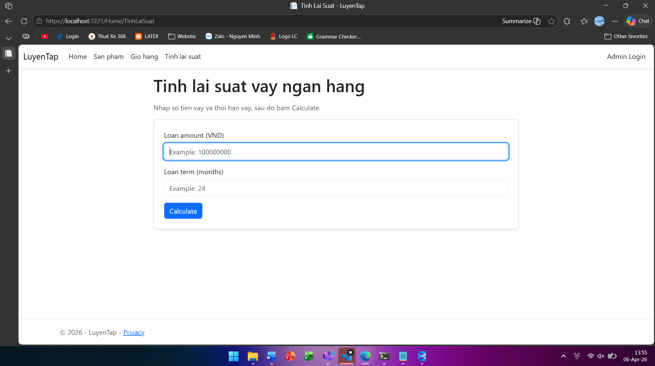
@using System.Globalization
@using LuyenTap
@{
ViewData["Title"] = "Tinh Lai Suat";

var amountText = Context.Request.Query["loanAmount"].ToString();
var termText = Context.Request.Query["loanTermMonths"].ToString();

var hasInput = !string.IsNullOrWhiteSpace(amountText) || !string.IsNullOrWhiteSpace(termText);

decimal loanAmount = 0;
int loanTermMonths = 0;

LoanInterestResult? result = null;
var errorMessage = string.Empty;

if (hasInput)
{
var amountOk = decimal.TryParse(amountText, NumberStyles.Number, CultureInfo.InvariantCulture, out loanAmount)
|| decimal.TryParse(amountText, NumberStyles.Number, CultureInfo.CurrentCulture, out loanAmount);

var termOk = int.TryParse(termText, out loanTermMonths);

if (!amountOk || !termOk)
{
errorMessage = "Invalid input. Please enter numeric values.";
}
else
{
var calculator = new TinhLaiSuat();
if (!calculator.TryCalculate(loanAmount, loanTermMonths, out result, out errorMessage))
{
result = null;
}
}
}
}

<div class="row justify-content-center">
<div class="col-lg-8">
<h1 class="mb-3">Tinh lai suat vay ngan hang</h1>
<p class="text-muted">Nhap so tien vay va thoi han vay, sau do bam Calculate.</p>

<form method="get" asp-controller="Home" asp-action="TinhLaiSuat" class="card p-4 shadow-sm mb-4">
<div class="mb-3">
<label for="loanAmount" class="form-label">Loan amount (VND)</label>
<input id="loanAmount" name="loanAmount" class="form-control" value="@amountText" placeholder="Example: 100000000" />
</div>

<div class="mb-3">
<label for="loanTermMonths" class="form-label">Loan term (months)</label>
<input id="loanTermMonths" name="loanTermMonths" class="form-control" value="@termText" placeholder="Example: 24" />
</div>

<div>
<button type="submit" class="btn btn-primary">Calculate</button>
</div>
</form>

@if (!string.IsNullOrWhiteSpace(errorMessage))
{
<div class="alert alert-danger">@errorMessage</div>
}

@if (result != null)
{
<div class="card p-4">
<h4 class="mb-3">Result</h4>
<p><strong>Interest rate:</strong> @((result.InterestRate * 100).ToString("0.##"))% / year</p>
<p><strong>Interest amount:</strong> @result.InterestAmount.ToString("N2") VND</p>
<p class="mb-0"><strong>Total amount payable:</strong> @result.TotalPayable.ToString("N2") VND</p>
</div>
}
</div>
</div>
namespace LuyenTap
{
public class LoanInterestResult
{
public decimal InterestRate { get; set; }
public decimal InterestAmount { get; set; }
public decimal TotalPayable { get; set; }
}

public class TinhLaiSuat
{
public bool TryCalculate(decimal loanAmount, int loanTermMonths, out LoanInterestResult? result, out string errorMessage)
{
result = null;
errorMessage = string.Empty;

if (loanAmount <= 0)
{
errorMessage = "Loan amount must be greater than 0.";
return false;
}

if (loanTermMonths <= 0)
{
errorMessage = "Loan term must be greater than 0 month.";
return false;
}

var yearlyRate = GetInterestRateByTerm(loanTermMonths);
var interestAmount = loanAmount * yearlyRate * loanTermMonths / 12m;

result = new LoanInterestResult
{
InterestRate = yearlyRate,
InterestAmount = Math.Round(interestAmount, 2),
TotalPayable = Math.Round(loanAmount + interestAmount, 2)
};

return true;
}

private static decimal GetInterestRateByTerm(int loanTermMonths)
{
if (loanTermMonths <= 12)
{
return 0.08m;
}

if (loanTermMonths <= 36)
{
return 0.10m;
}

if (loanTermMonths <= 60)
{
return 0.12m;
}

return 0.135m;
}
}
}

namespace LuyenTap
{
public class LoanInterestResult
{
public decimal InterestRate { get; set; }
public decimal InterestAmount { get; set; }
public decimal TotalPayable { get; set; }
}

public class TinhLaiSuat
{
public bool TryCalculate(decimal loanAmount, int loanTermMonths, out LoanInterestResult? result, out string errorMessage)
{
result = null;
errorMessage = string.Empty;

if (loanAmount <= 0)
{
errorMessage = "Loan amount must be greater than 0.";
return false;
}

if (loanTermMonths <= 0)
{
errorMessage = "Loan term must be greater than 0 month.";
return false;
}

var yearlyRate = GetInterestRateByTerm(loanTermMonths);
var interestAmount = loanAmount * yearlyRate * loanTermMonths / 12m;

result = new LoanInterestResult
{
InterestRate = yearlyRate,
InterestAmount = Math.Round(interestAmount, 2),
TotalPayable = Math.Round(loanAmount + interestAmount, 2)
};

return true;
}

private static decimal GetInterestRateByTerm(int loanTermMonths)
{
if (loanTermMonths <= 12)
{
return 0.08m;
}

if (loanTermMonths <= 36)
{
return 0.10m;
}

if (loanTermMonths <= 60)
{
return 0.12m;
}

return 0.135m;
}
}
}

Question 3: Create a management function (3 points)
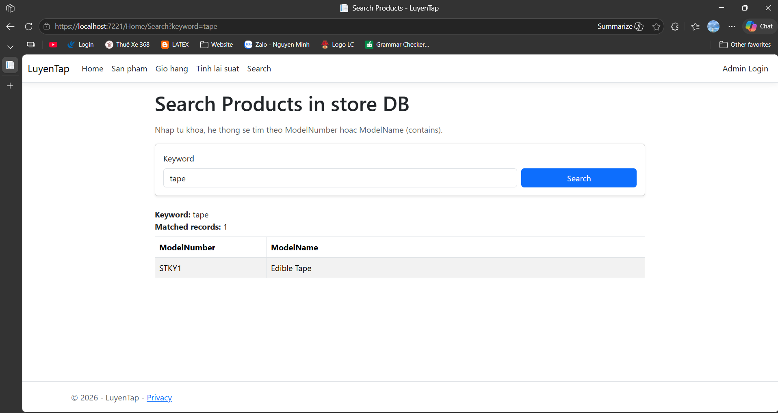

Search.cshtml
@model LuyenTap.Models.SearchProductsViewModel

@{
ViewData["Title"] = "Search Products";
}

<div class="row justify-content-center">
<div class="col-lg-9">
<h1 class="mb-3">Search Products in store DB</h1>
<p class="text-muted">Nhap tu khoa, he thong se tim theo ModelNumber hoac ModelName (contains).</p>

<form method="get" asp-controller="Home" asp-action="Search" class="card p-3 shadow-sm mb-4">
<div class="row g-2 align-items-end">
<div class="col-md-9">
<label for="keyword" class="form-label">Keyword</label>
<input id="keyword" name="keyword" class="form-control" value="@Model.Keyword" placeholder="Example: pro, 1001, samsung" />
</div>
<div class="col-md-3 d-grid">
<button type="submit" class="btn btn-primary">Search</button>
</div>
</div>
</form>

@if (!string.IsNullOrWhiteSpace(Model.ErrorMessage))
{
<div class="alert alert-danger">@Model.ErrorMessage</div>
}
else if (!string.IsNullOrWhiteSpace(Model.Keyword))
{
<div class="mb-2">
<strong>Keyword:</strong> @Model.Keyword<br />
<strong>Matched records:</strong> @Model.Results.Count
</div>

if (!Model.Results.Any())
{
<div class="alert alert-warning">Khong tim thay ban ghi phu hop.</div>
}
else
{
<div class="table-responsive">
<table class="table table-bordered table-striped">
<thead>
<tr>
<th style="width:220px;">ModelNumber</th>
<th>ModelName</th>
</tr>
</thead>
<tbody>
@foreach (var item in Model.Results)
{
<tr>
<td>@item.ModelNumber</td>
<td>@item.ModelName</td>
</tr>
}
</tbody>
</table>
</div>
}
}
</div>
</div>
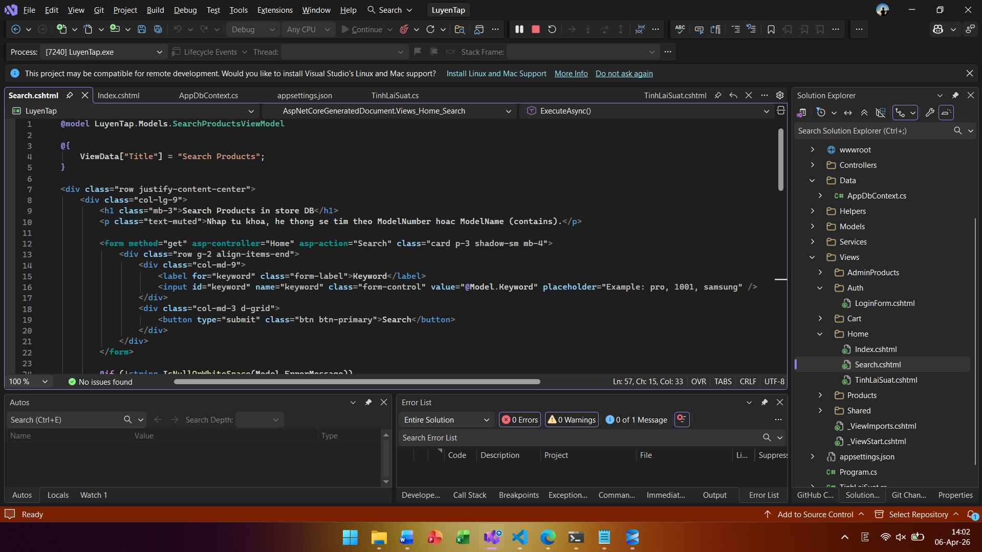
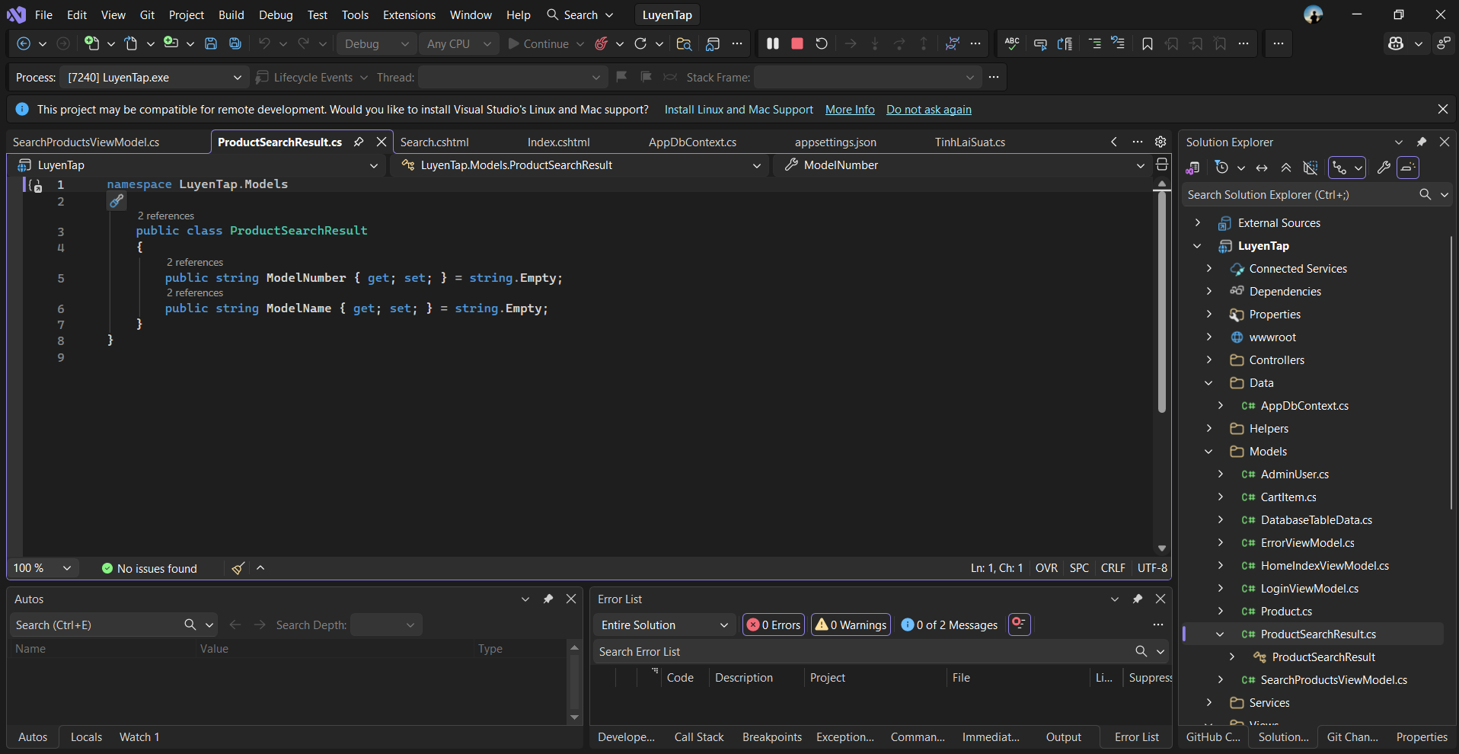
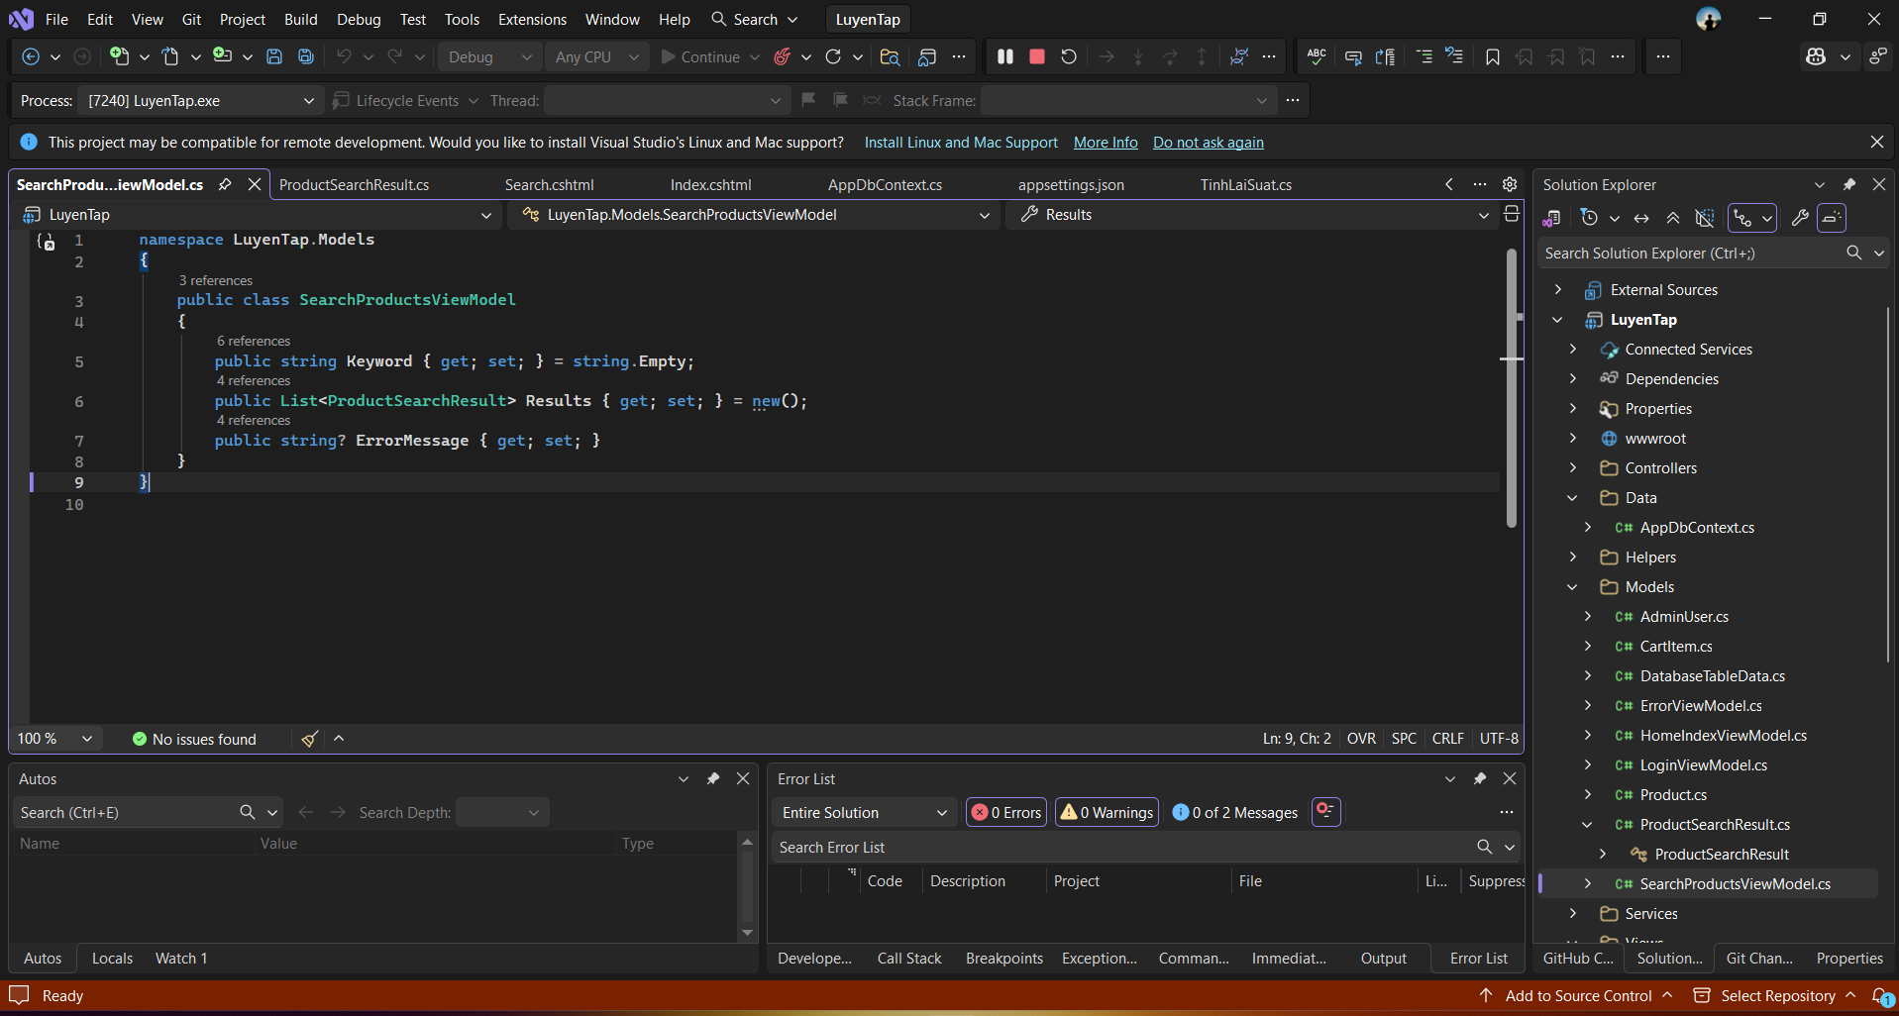

Question 4: Transaction function (2 points)

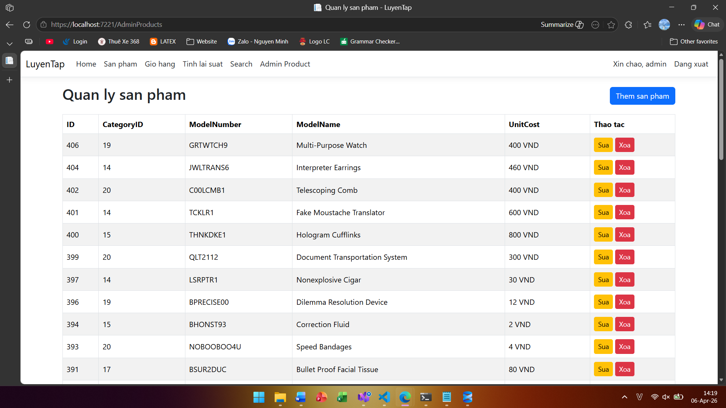
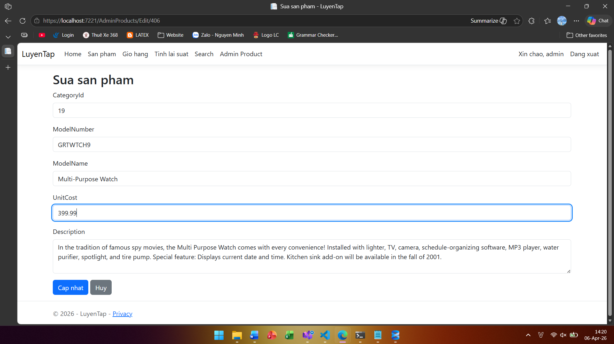

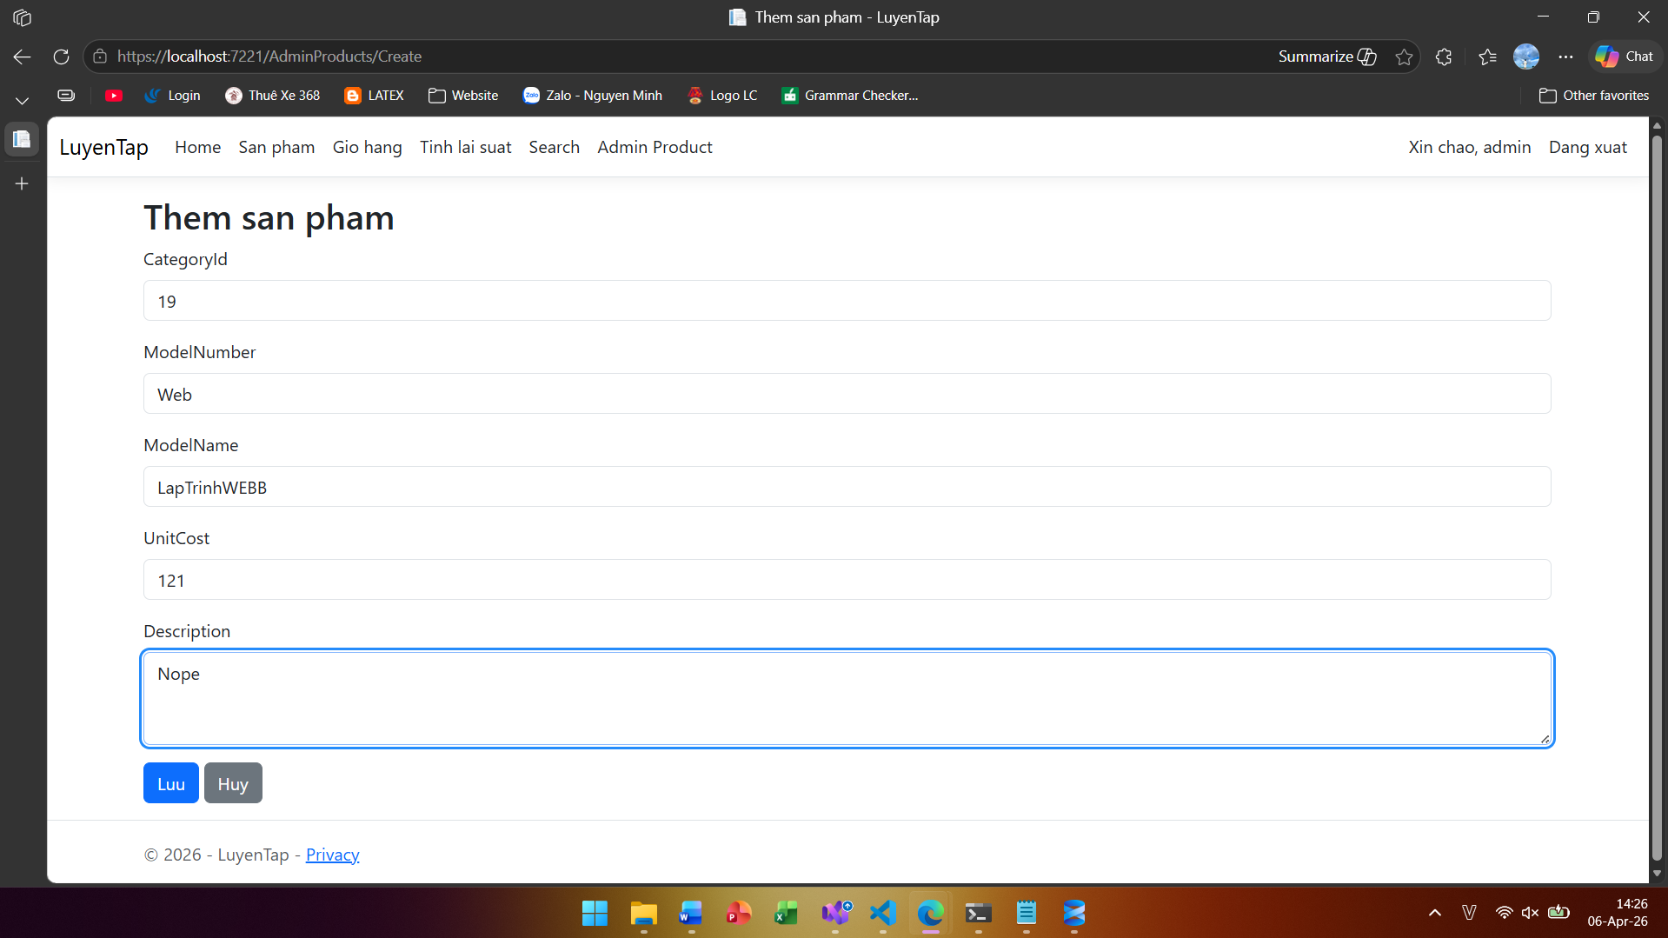

using System.ComponentModel.DataAnnotations;
using System.ComponentModel.DataAnnotations.Schema;

namespace LuyenTap.Models
{
[Table("Products")]
public class Product
{
[Key]
[Column("ProductID")]
public int Id { get; set; }

[Column("CategoryID")]
[Range(1, int.MaxValue, ErrorMessage = "CategoryID phai lon hon 0")]
public int CategoryId { get; set; }

[Column("ModelNumber")]
[StringLength(50)]
public string? ModelNumber { get; set; }

[Column("ModelName")]
[StringLength(100)]
public string? ModelName { get; set; }

[Column("ProductImage")]
[StringLength(255)]
public string? ProductImage { get; set; }

[Column("UnitCost", TypeName = "money")]
[Range(0.01, 999999999, ErrorMessage = "Unit cost phai lon hon 0")]
public decimal UnitCost { get; set; }

[Column("Description")]
[StringLength(1000)]
public string? Description { get; set; }
}
}

