CAN BOARD PRACTICE – CAN COMMUNICATION

Benefit
After this practice, the students will have experience how to implement CAN communication protocol to receive and transmit data.
The student will understand how CAN nodes are connected in a physical layer.
Also, the students will understand how requirement for CAN protocol looks like.
Moreover, the students understand the application checksum.

Overview
CAN node 1 (Practice Board) <-> CAN node 2 (Verification board)

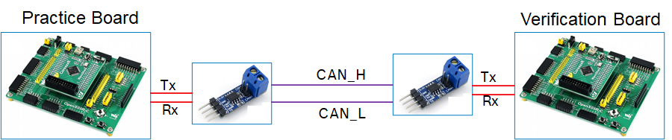

The student has to implement CAN read and CAN write method in CAN node 1 to communication with CAN node 2 on Data frame as BOSCH CAN spec 2.0
Assuming that CAN controller and CAN Transceiver are available in CAN node 1 and CAN node 2
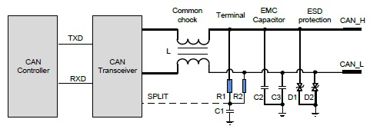
System requirement:
- CAN communication should use the 11-bit ID format standard frame

Bit timing parameters:
Parameter | Symbol | Minimum value | Nominal value. | Maximum value | Unit | Remarks
Bit timing | tBit | 1992 | 2000 | 2008 | ns | fHSCAN = 500kbps (± 0.4 %)
Tq quantity | NBT | 10 | 16 | 20 | Tq
Sampling position | tSP | 75 | - | 82 | %
Synchronisation jump width | SJW | 2 | 2 | 3 | Tq
Sampling amount | NSP | - | 1 | -

Byte order of signal value should be transmitted and received in the Motorola format (big endian format). The start bit of the signal starts from the least significant bit (lsb) of the least significant byte (LSB).
Example, as shown in Figure 1, a data field contains a 10-bit-signal message in the Motorola format, whose start bit is 28 bit.

Figure 1 10-bit-signal message configuration (Motorola format)
The unused bits in the message must be set to 0, and the unused bytes must be set to 0x00.

CAN node 1:
TX message: 0x012
RX message: 0x0A2

CAN node 2:
TX message: 0x0A2
RX message: 0x012

CAN node 2 (Verification board) will send out 0x0A2 with data in byte 0 and byte 1 (0x0A2), the byte 6 will be message counter from (0x0 ~ 0xF)
CAN node 1 needs to receive 0x0A2 data, extract the latest data from 0x0A2 (excluding the message counter information), copy the value to byte 0 and byte 1 and sum (byte 0 + byte 1) then set the result to byte 2 of 0x012. Byte 6 of 0x012 will be the checksum byte of data from byte 0 – byte 5, byte 7 is 0x0. Checksum algorithm will follow CRC 8 SAE J1850:
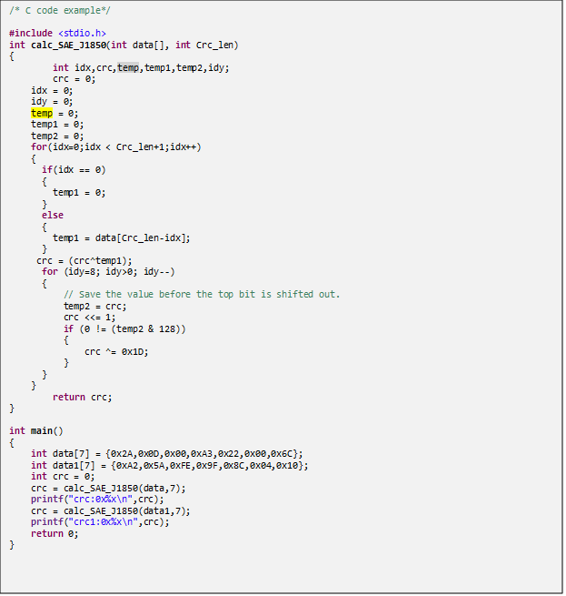
Node 2 will send out 0x012 with cycle 50ms.

Summary:
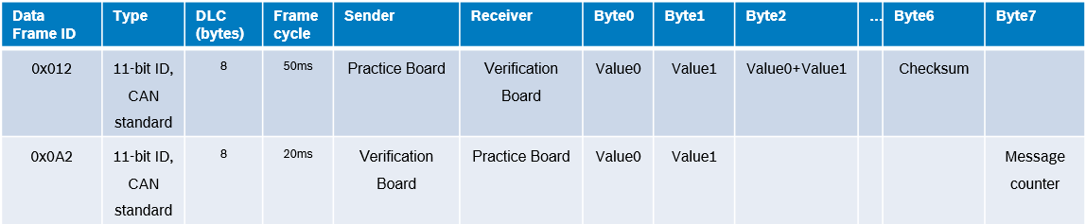
Additional requirement:
CAN Node 1 can display on LCD to show receiving values of 0x0A2
CAN node 2 (Verification board) will acknowledge the receiving of 0x012 and valid CRC on LCD/LED.

Assessment:
Node 1 can send 0x012 (1 point)
Node 1 can send 0x012 on time (+- 1 millisecond) (1 point)
Node 1 can send correct data in byte 0, 1 (1 point)
Node 1 can send correct data in byte 2 (1 point)
Node 1 can send correct checksum in byte 7 (1 point)
Node 1 can display the value via UART and display in the computer (2 point)
The student can answer all the question (2 point)
LCD can display the log recording (1 point) – Watch out: Allow to re-init GPIO to switch between CAN transceiver and LCD green connection to STM32.

