Contents
1 Introduction 2
2 STM32CubeIDE 3
3 FLASHER-STM32 6
4 Hercules 13
5 Others tools 14

Introduction
This document aims to assist student in successfully installing the required tools for their practical.
It outlines the purpose, download source, step-by-step instructions for installing a specific tool. The guide may include information on troubleshooting common issues.
By following the instructions provided in the guide, students will be able to successfully install the tool on their personal computer and getting started with its usage

STM32CubeIDE
Purpose: Development tool with peripheral configuration, code generation, code compilation, and debug features for STM32 microcontrollers.
Download source: STM32CubeIDE - Integrated Development Environment for STM32 - STMicroelectronics
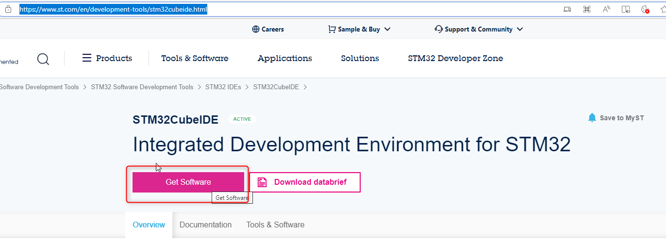
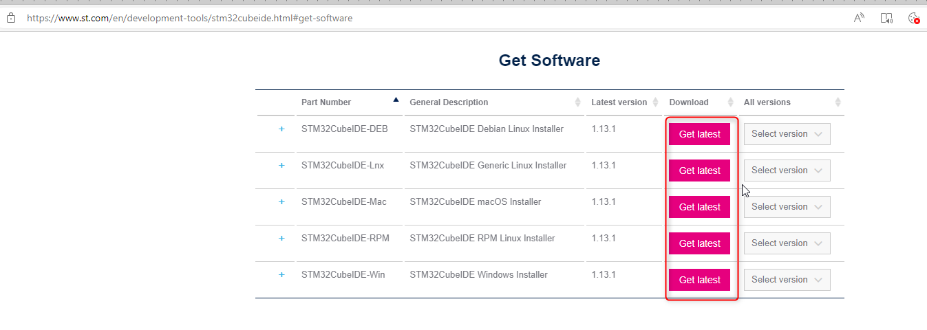
Installation: this link

Usage:
GUI when start the tool:
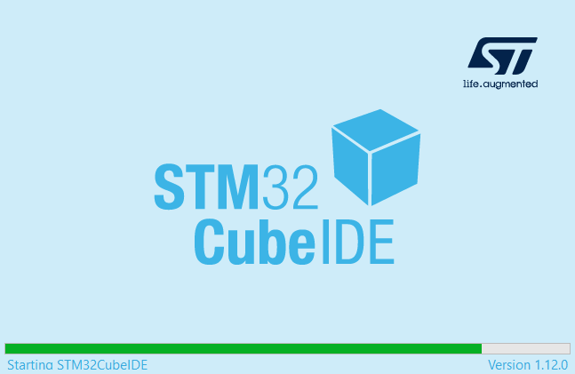
Tool when opened looks like below UI:
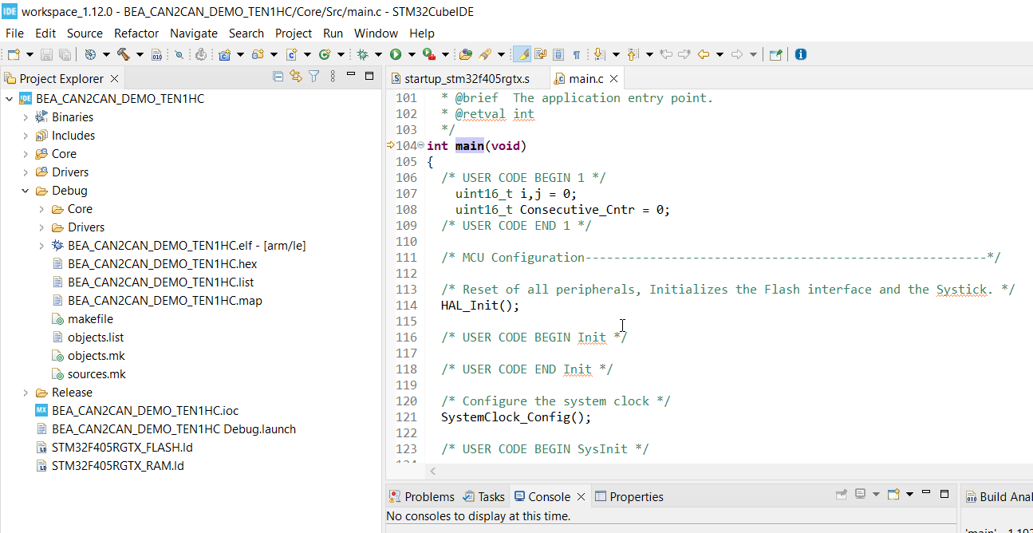
Basic steps using tool (import project, code generation, build project):
Troubleshooting:
When open project bellow notification appears:
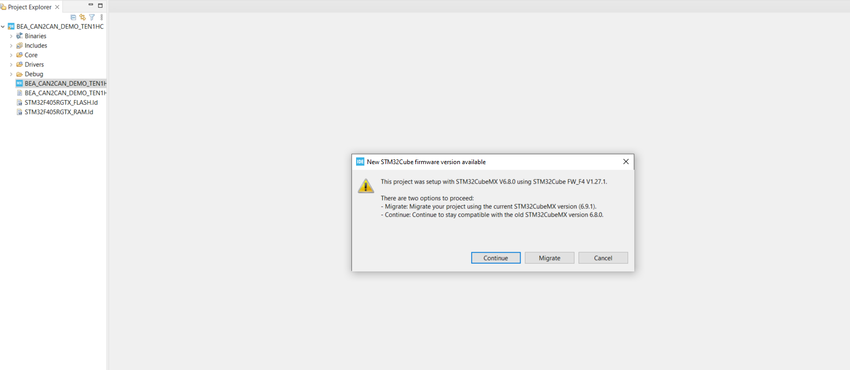
This due to the project was setup using firmware older than current version using in STM32CubeIDE.
Select “Migrate” to migrate the firmware version of base project to current version of STM32CubeIDE


FLASHER-STM32
Purpose: Used for flashing or programming the firmware/hex file onto STM32 microcontrollers.
Download source: FLASHER-STM32 - STM32 Flash loader demonstrator (UM0462) (replaced by STM32CubeProgrammer) - STMicroelectronics
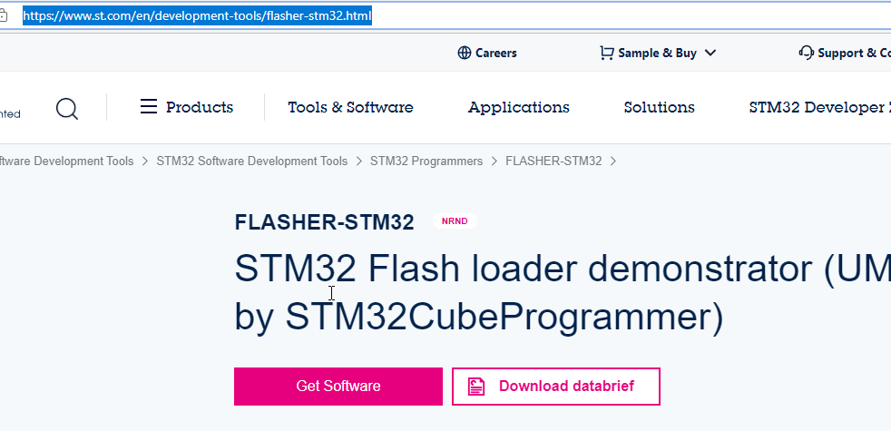
Installation:
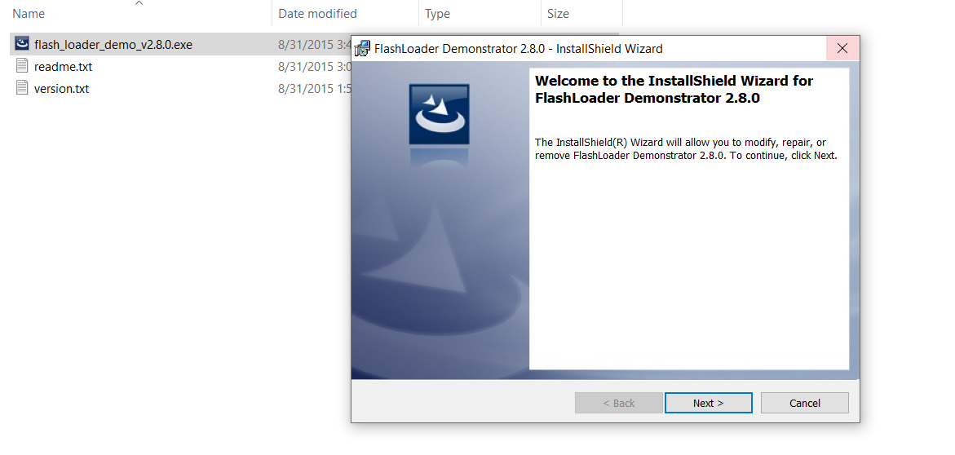
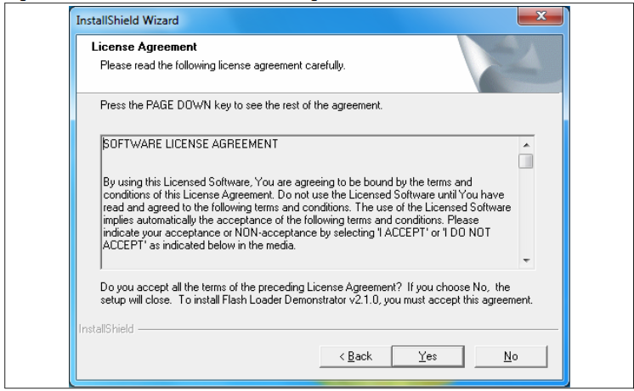
Usage: How to reprograming/flash firmware/hex file to STM32 microcontrollers via FLASHER-STM32
- Step 1: switch BOOT 0 pin on Open405R-C board to “High”. (BOOT 1 = 0. Note that no need to care about BOOT 1 pin when use Open405R-C board )
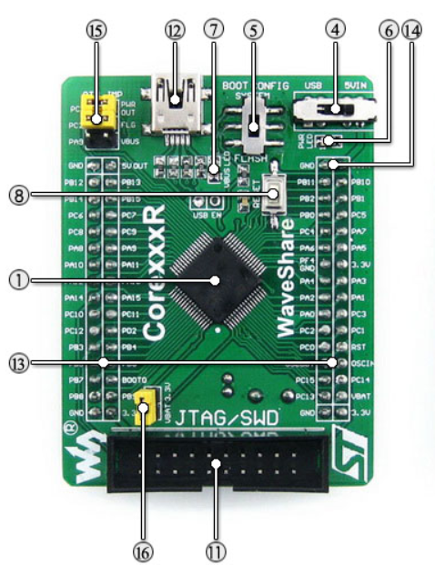
Switch BOOT 0 pin to “High”
- Step 2: Reset board. Then board will go to boot mode

Reset button
- Step 3: Connect PC with UART3 interface on mother board via USB to UART Converter device
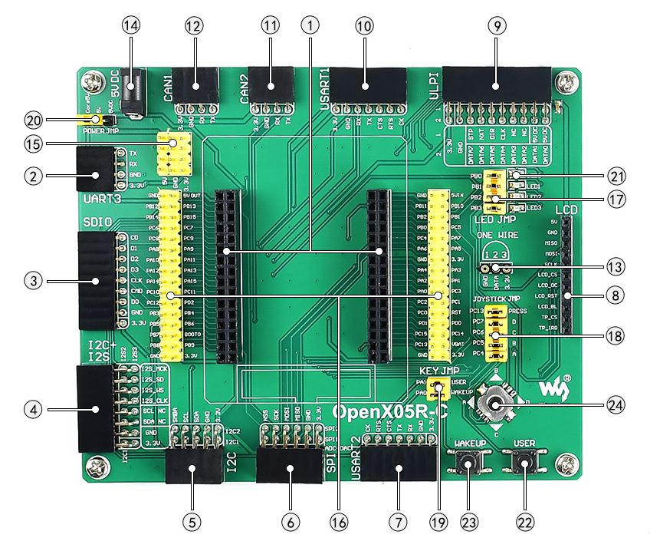
UART3 interface
- Step 4: Open “Flash Loader Demonstrator (FLASHER-STM32)” choose the configuration as bellow figure, then click Next 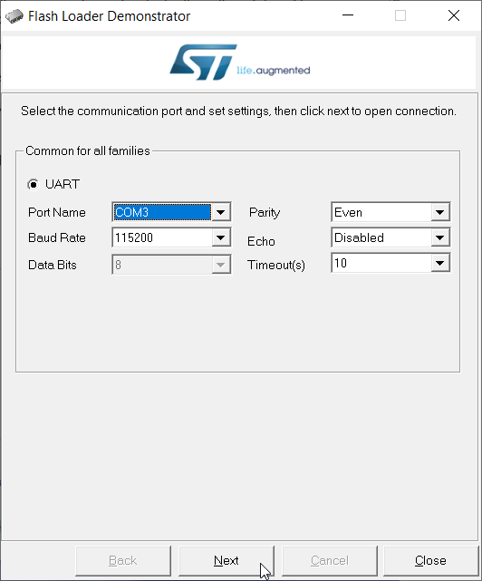
Port name may be different on each PC

- Step 5: After load hex file successfully (as figure bellow). Switch BOOT0 pin on Open405R-C board to “Low”, then reset board. After that the application will run normally.
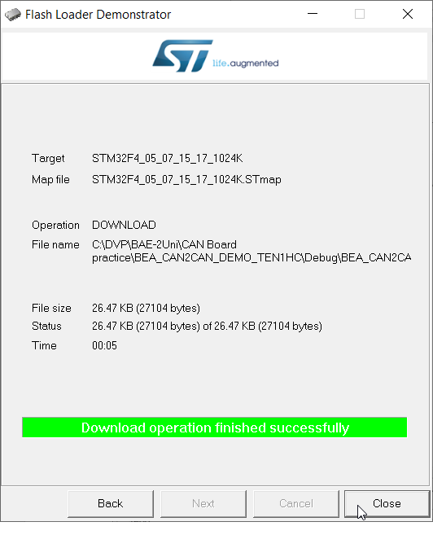

Hercules
Purpose: Used as Serial port terminal (RS-232 terminal), In this practical this tool used for transmitting and receiving data between PC and STM312 Microcontroller via USART3
Download source: Hercules SETUP utility | HW-group.com
Installation: Not required, open directly .exe file to use
Configure as bellow then “Open port”
Note: Port name may be different on each PC
Usage:
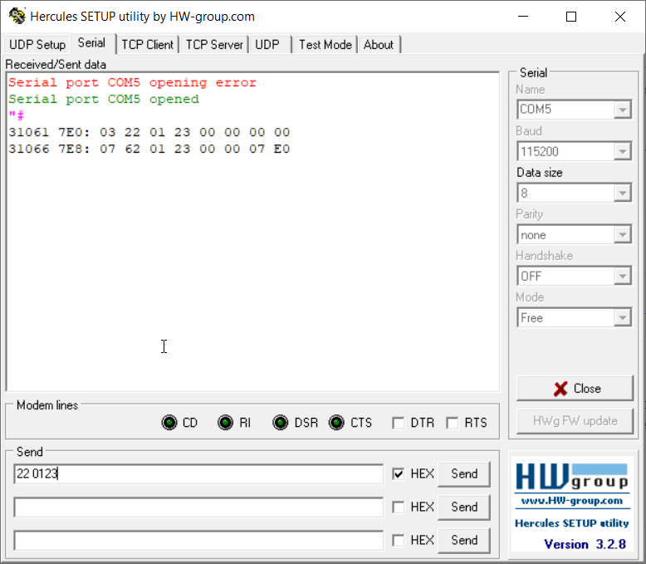
Transmitting and receiving data

Others tools
- USB-Serial port driver:
Purpose: software that helps your operating system to communicate with USB Serial Port devices
Download source: this link

Installation: on Windows 10
