**ETL Project Proposal**

**Group:**

Arian Sadri

Nguyen Nguyen

Ozkar Agoz

**ASTHMA ER VISITS VS AIR QUALITY INDEX**

**BY COUNTY IN CALIFORNIA IN 2012**

1. Extract: Data Sources:

<https://data.world/healthdata/asthma-ed-visit-rates-by-zip>

* Get Number of Visits for Children group by COUNTY

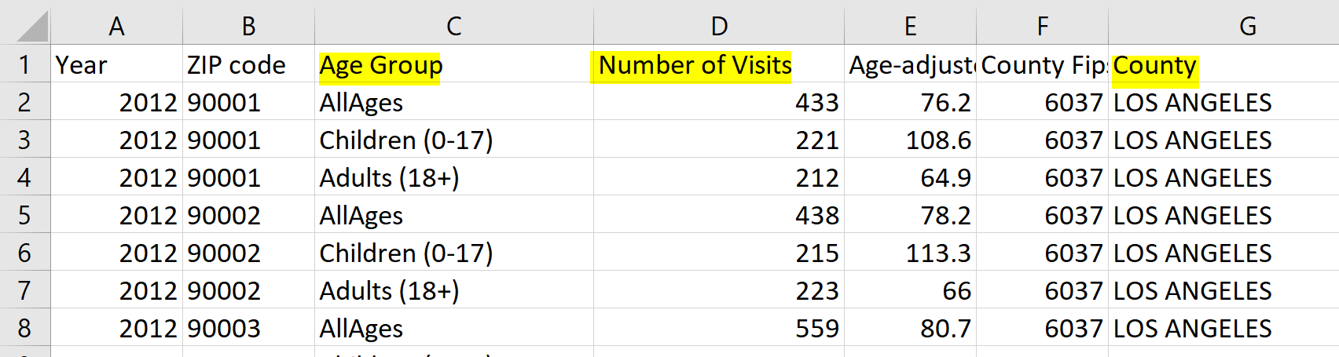

<https://www.epa.gov/outdoor-air-quality-data/download-daily-data>

* Get Daily AQL Value by County
* 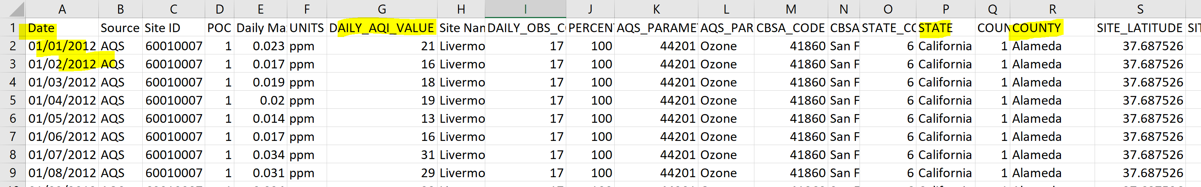

1. Transformation:

* Clean, merge two tables by county
* Manipulate date section on table of Daily AQL to uniform it with year 2012 on the other dataset
* Clean dataset if needed

1. Load:

* Use Relational Database: Join, load to Postgres.