Tạo table + quan hệ

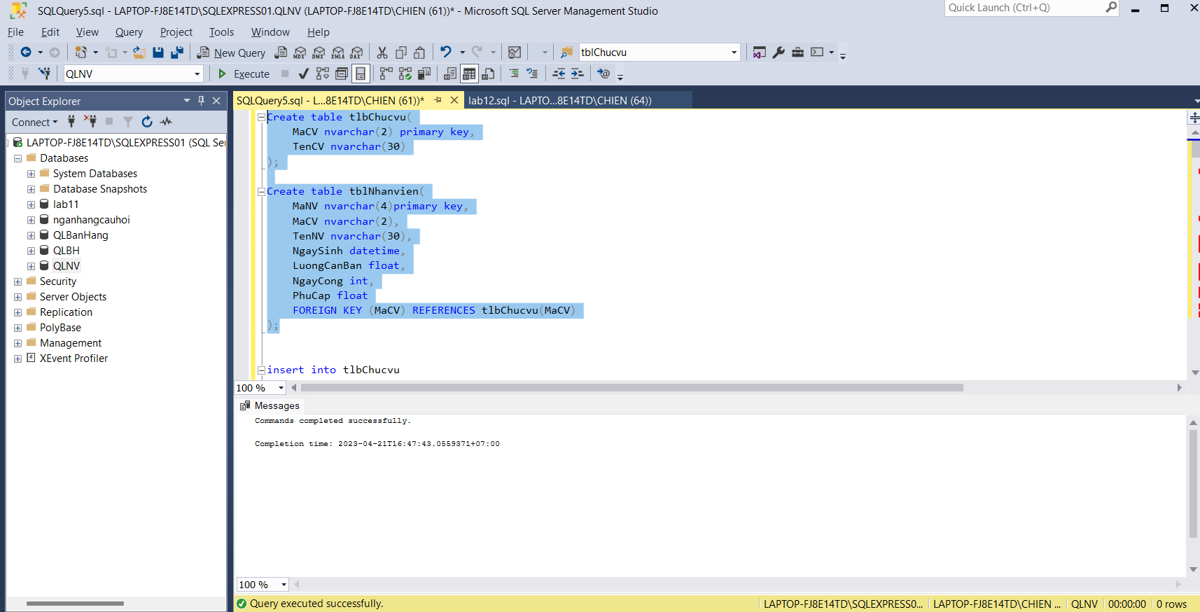

Insert

Yêu cầu :

A:

B:

C:

D:

1,

3.

4.

