----Cau 1---------

INSERT INTO NhanVien (manv, tennv, gioitinh, diachi, sodt, email, phong)

VALUES ('NV11', 'Nguyen Ngoc Hai Anh ', 'Nam', 'HCM', '0931135334', 'nva@example.com', N'thu ngan')

----Thực hiện full back up

BACKUP DATABASE thuchanh TO DISK = 'D:thuchanh\QLBH.bak' WITH INIT

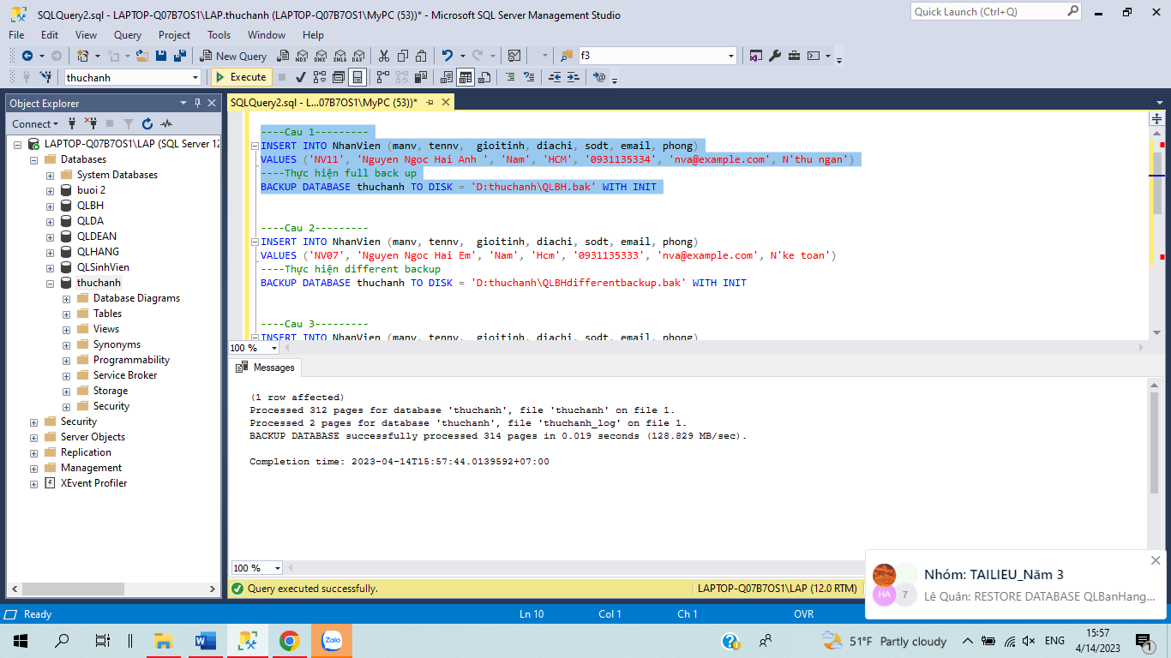

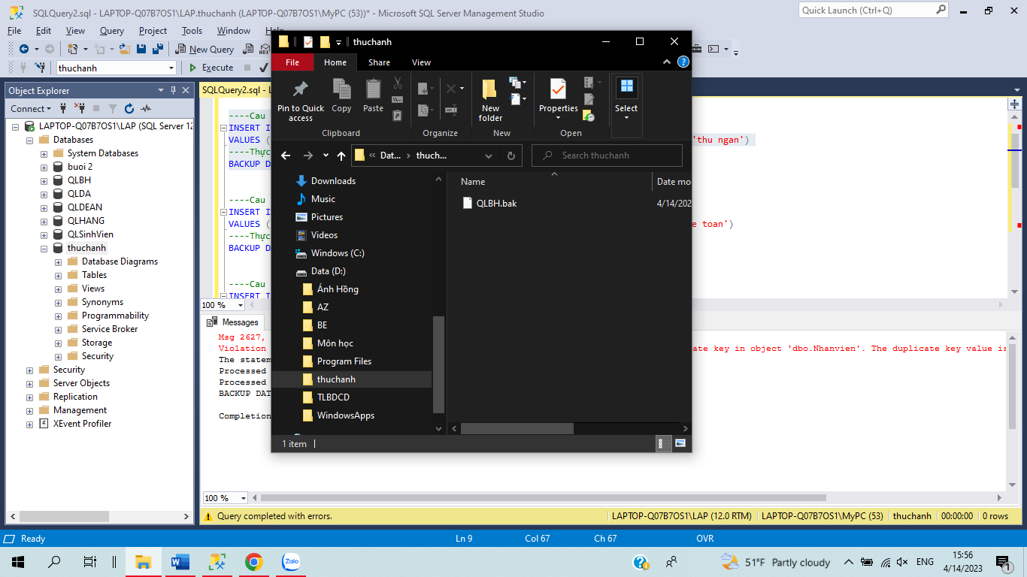

----Cau 2---------

INSERT INTO NhanVien (manv, tennv, gioitinh, diachi, sodt, email, phong)

VALUES ('NV12', 'Nguyen Ngoc Hai Em', 'Nam', 'Hcm', '0931135333', 'nva@example.com', N'ke toan')

----Thực hiện different backup

BACKUP DATABASE thuchanh TO DISK = 'D:thuchanh\QLBHdifferentbackup.bak' WITH INIT



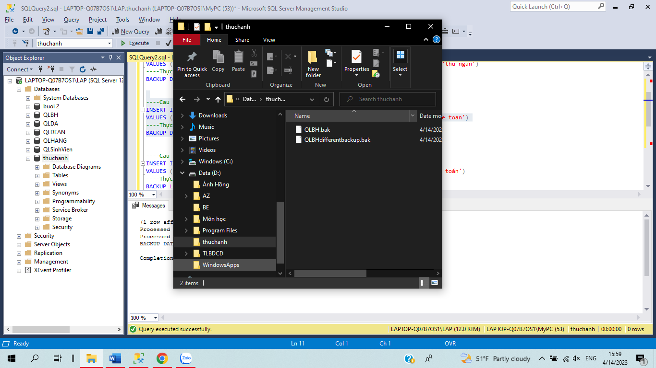

----Cau 3---------

INSERT INTO NhanVien (manv, tennv, gioitinh, diachi, sodt, email, phong)

VALUES ('NV9', 'Nguyen Ngoc Em ', 'Nu', 'Ha Noi', '0931135336', 'nva@example.com', N'Kế toán')

----Thực hiện BACKUP LOG

BACKUP LOG thuchanh TO DISK = 'D:thuchanh\QLBH.trn' WITH FORMAT;

ALTER DATABASE thuchanh SET RECOVERY FULL

Backup database thuchanh To Disk = 'D:thuchanh\QLBH.bak';

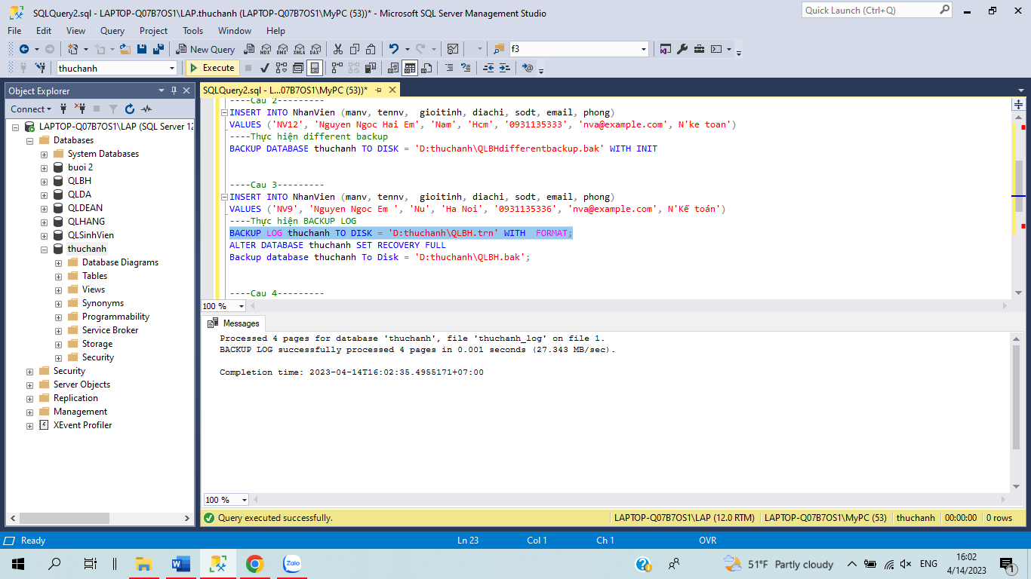

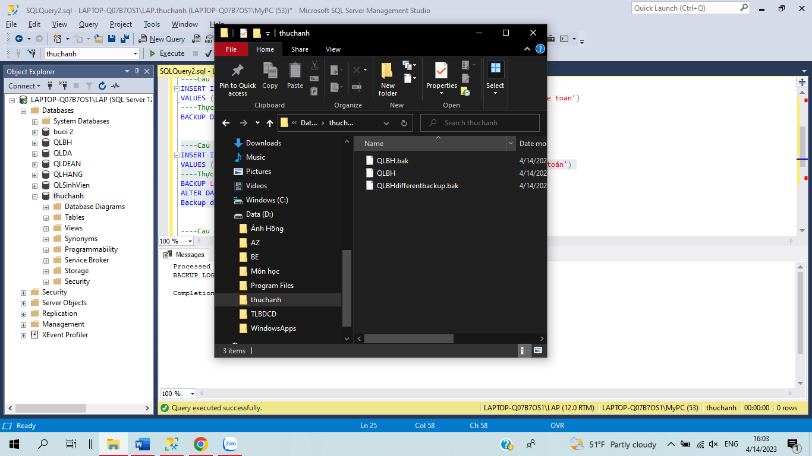

----Cau 4---------

INSERT INTO NhanVien (manv, tennv, gioitinh, diachi, sodt, email, phong)

VALUES ('NV16', 'Nguyen Ngoc Anh', 'Nu', 'Ha Noi', '0931135337', 'nva@example.com', N'Giam doc')

----Thực hiện BACKUP LOG

BACKUP LOG thuchanh TO DISK = 'D:thuchanh\QLBH.trn' WITH NOINIT;

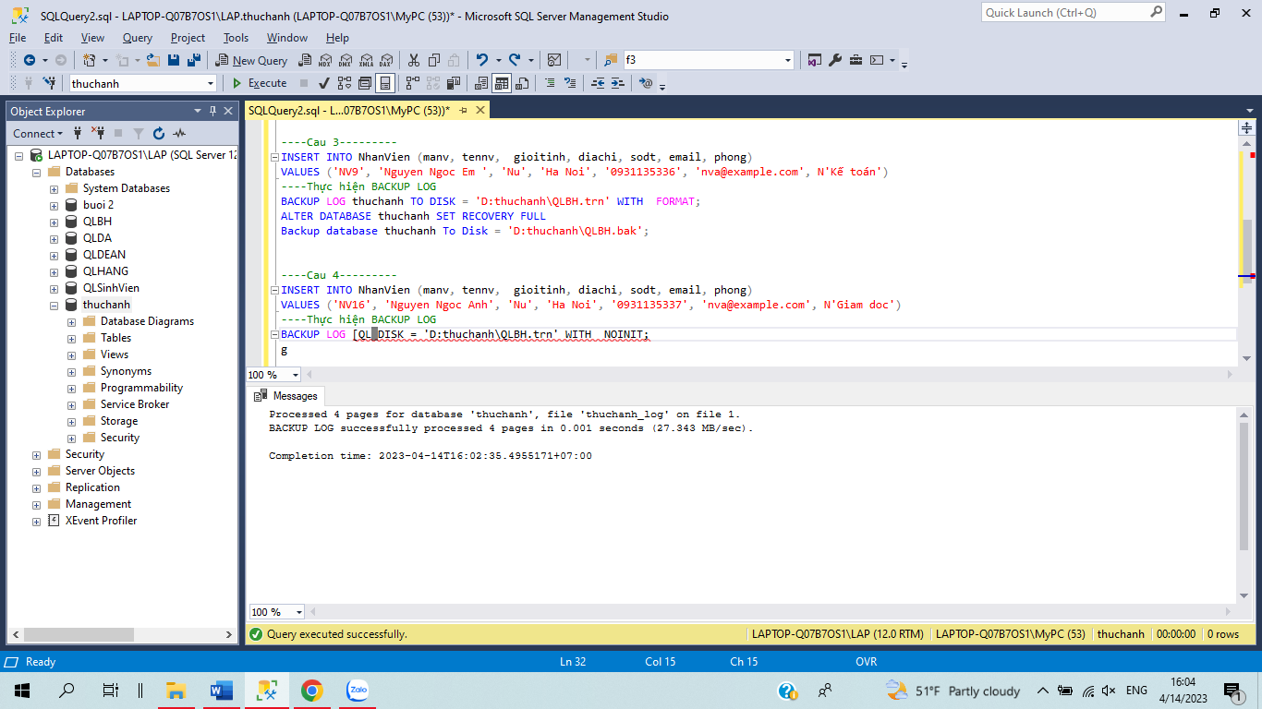

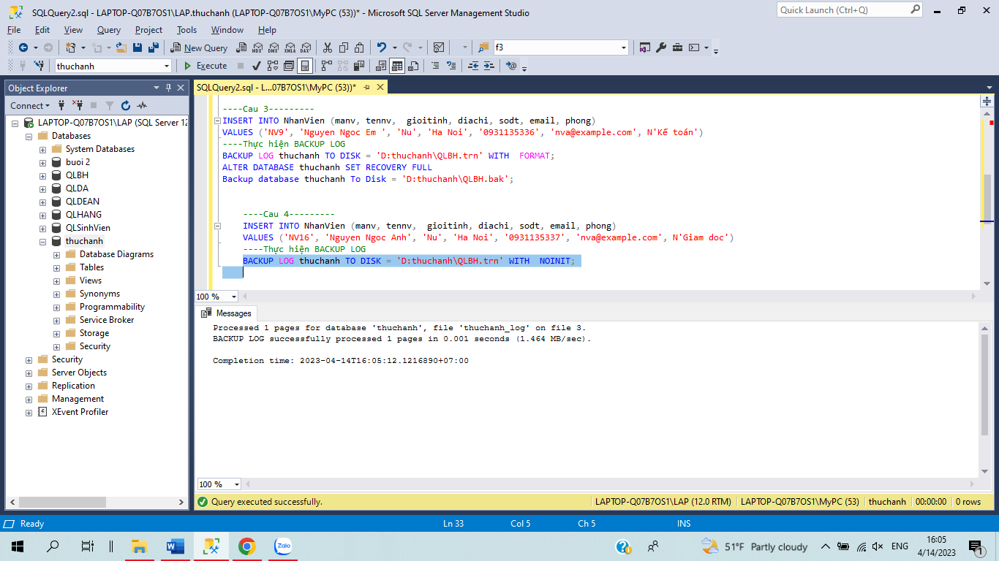

---cau 2---

RESTORE DATABASE thuchanh

FROM DISK = 'D:\thuchanh\QLBH.bak'

WITH STANDBY = 'D:\thuchanh\QLBH_undoFile.undo';

2a drop database thuchanh

