Information Technology Service Agreement
Protocol Specification (FIX)

for Trading System

Release/Revisionhistory
No | Version | Date | Release/Revision Description | Author
1 | 0.1 | 2017.05.26 | New | Sungsoo Bae
2 | 0.11 | 2017.07.28
3 | 0.11 | 2017.08.17
4 | 0.12 | 2017.09.28
5 | 0.98 | 2017.10.27 | - List messages different with the FIX standard  - Delete Appendix of TestCase  - Add description of message ‘Notify MM Duty Occurred’  - Add message flow  (ex, Business reject message, IOI and so on)  - Add description of messages on Trading/Securiry status Info  - Add MsgType : Foreign Ownership Change[K17]  - 4.5, 4.7 Message flow Updated  - 5.5.1~5.5.6 Added description.  - Add more detail description of how to implement the protocol (Router, Server, OS, Middleware, Application).
6 | 0.992 | 2017.11.08 | - Add more detail description and flow on Trading/Securitystatus information
7 | 0.993 | 2017.12.10 | - Tags (>= 8000) are changed to 20000~ Tags (Glossary sheet)  - 5.2.3 IOI Status Info [K16] : Add values of IOIStatusCode(#20061) entry  - 5.2 IOI [6], IOI Report [K15]  : Delete "replace" word in the comment of IOIRefID[#26] entry  - 5.4 Execution Report in the Put-Through(Nego) flow  : Delete "partial filled" words in the Execution Report.  : Add "orderID" in the Execution Report.  : Add description "ClordID"QuoteMsgID  - 5.3.1 Kquote[K01] : Add Replace case example  - 5.6.1 Order Check Request[K10]  : Add description "ClordID" could be QuoteMsgID  - 5.5.1 Ktrading Session Status[K04]  : Add more detail description of market controller’s function.  : Add description about case that member connects after the start of the session.  - 5.5.2 Stock Info Disclosure[K05]  : Update values of ExClassType[#20018],  : Delete entry : ParValueChxType[#20019]  - 5.5.3 Member Restrction/Desgnation Disclosure[K06]  : Add more detail description of market controller’s function  - 5.5.4 Foreign Ownership Change[K17]  : Delete entry : PreHourChxActionType[#20022]  - 5.1.2 New Order Single [D] / 5.1.3 Replace Request  : Add "MTL" value / Delete "GTD" value of Timeinforce[#59] entry  : Delete entry : Expiredate[#432], OrderAmt[#8002], OrderExecPrice[#8038]  - 5.1.5 Execution Report [8]  : Add more description about function of this message.  : Delete entry : Expiredate[#432], OrderAmt[#8002]  5.1.6 Order Cancel Reject[9] : Modify word of flow image  3.3 Header : Update value of PossResend[#97] only "N" possible
8 | 0.994 | 2017.12.20 | Update and modify comments of fields
9 | 0.995 | 2017.12.29 | Update and modify comments of fields.  Symbol Closing Info[K08] : Delete entry : OffHoursHighLimitPrice[#20028], OffHoursLowLimitPrice[#20029].  Update InvestCode values :  (1=>1000) Securities company  (2=>4000) Bank  (3=>3200) Fund  (4=>3000) Asset management company and Investment company  (5=>2000) Insurance company  (6=>6000) Pension Fund  (7=>7000) Government representation  (8=>7030) International organization  (9=>5000) General finance company  (10=>7100) Misc corporation  (11=>8000) Indivisual  Deleted redundant tags such as CrossID, CrossType, CrossPrioritization, NoSides at 'Appendix A’.
10 | 0.996 | 2018.01.12 | Update and modify comments of fields.  Update comments of Country[#421], TargetCompID[#56] fields  Delete tag HaltReason
11 | 0.997 | 2018.02.09 | Updated comments of user defined tags (20000 and above) for better understanding.  Added order validation logic for InvestCode[#20000].  Deleted IsMarketEvalPrice[#20017]: duplicated with #20049.  Deleted ArranTndYN[#20021]: this field is not used by any message.  Deleted BranchNo[#20024]: duplicated with #20050.  Updated possible values for MemberTRScope[#20025].  Added explanation of Bitwise scheme for MemberTRScope[#20025].  Corrected typo: Broad ->Board  Modify Tag name : ClassID[#20009] -> ProductID[#20009].  Add Entry : Execution Report [8] - TradingValue[#20002].  Add Entry : Order Cancel/Replace Request [G] - OpenCloseCode[#20064]
12 | 0.998 | 2018.02.20 | Update “Nego(Put Through) (2/2)” Flow.  Modify Interface Name : VI ->Volatility Interruption.  DeleteEntry : Execution Report [8] - TradingValue[#20002].  Add Entry : Execution Report [8] - NetMoney[#118].  Delete Entry : Stock Info Disclosure [K05] - ProductGrpID[#20003]  Delete Entry - ( BoardID[#20004] )  : KTrading Session Status [K04]  : Foreign Ownership Change [K17]  : Reference Price Determination [K07]  : Symbol Closing Info [K08]  : Volatility Interruption [K09]  Update length of ‘Price / Float” format
13 | 0.999 | 2018.02.27 | Update Appendix B - Data representation.  Update comments of QuoteID[#117], ClOrdID[#11] fields  Update comments of OrdStatus[#39] in "OrderCancelReject" message  Delete the "ProductGrpID[#20003]" field in the" Foreign ownership change" message  Modify the length of the RepoHaircutRatio: "6 (5.2)" -> "8 (5.2)"
14 | 0.9991 | 2018.03.09 | Update length of ‘Price” format  Corrected typo: SymblCloseInfoPxType → SymbolCloseInfoPxType  Recover comment of ClOrdID[#11] field
15 | 0.9992 | 2018.03.23 | 5.5.5 Reference Price Determination [K07] : Add Explanation  Modify the length of StaticVIDispartiyRatio, DynamicVIDispartiyRatio : "15 (9.4)" -> "8 (3.3)"  Update comments of ProductID[#20009], MemberNo[#20023], SymbolCloseInfoPx[#20026], SymbolCloseInfoPxType[#20027] fields
16 | 0.9993 | 2018.04.13 | Modifythe length and comment of FornInvestTypeCode[#20054] field.  Delete Entry : Kquote [K01] - FornInvestTypeCode[#20054].  Quote Response [AJ], KQuote Cancel [K02]  - Add Entry : IOIID(#23)  Update comments of Symbol and so on.
17 | 0.9994 | 2018.04.19 | Modifythe length and comment of FornInvestTypeCode[#20054] field.  RollbackEntry : Kquote [K01] - FornInvestTypeCode[#20054].  Quote Response [AJ], KQuote Cancel [K02]  - Add Entry : IOIID(#23)  Apply VN's feedback :  - Modify field : RepoHaircutRatio[#20059] , QuoteMsgID[#1166]  - Modify "5.4.4 Kquote Cancel(MsgType=K02)"
18 | 0.9995 | 2018.05.03 | Update comment of BoardEvtAppGrpCode [#20007]
19 | 0.9996 | 2018.05.09 | Update comment about Iceberg Order
20 | 0.9997 | 2018.05.17 | Add Entry : FornNegoClassfyCode(#20066)  - Quote [S], Quote Response [AJ]  Add Entry : CashMargin(#544)  - KQuote [K01]
21 | 0.9998 | 2018.05.25 | Add Entry : TreasuryStockTradingCode(#20068)  - New Order Single [D]  Add Entry : AskTypeCode(#20067)  - KQuote [K01]  Update value of TradingSessionID [#336]
22 | 0.9999 | 2018.06.05 | Synchronise the term to Bitwise operation ( [#20007], [#20025] )
23 | 0.99991 | 2018.06.28 | Modify comment of CashMargin[#544] field  - Kquote [K01]  Delete Entry : TreasuryStockTradingCode(#20068)  - New Order Single [D]  Add comment of UTF-8 in “1. Introduction” chapter
23 | 0.99992 | 2018.07.05 | Modify the comment of UTF-8 in “1. Introduction” chapter  Update comment of AskTypeCode[#20067] field  Add Entry : VIReleaseTime(#20068)  - Volatility Interruption [K09]
24 | 0.99993 | 2018.07.16 | Add Entry : VIActivatedTime[#20069], VIReleaseTime[#20068]  - Volatility Interruption [K09]  Add Entry : AskTypeCode[#20067] field  - KQuote Status Report [K03]  Modify Entry : TradingSessionID[#336] field  - Ktrading Session Status [K04]
25 | 0.99994 | 2018.07.19 | Add Entry : CashMargin[#544]  - Quote Status Report [AI]  - KQuote Status Report [K03]
26 | 0.99995 | 2018.08.03 | Add Entry : Yield[#236]  - Execution Report [8]  - Quote Status Report [AI]  Add Entry : BidYield[#632], OfferYield[#634]  - KQuote Status Report [K03]
27 | 0.99996 | 2018.08.10 | Update Nego(Put Through) flow of Nego(Put_Through) Scenarios.
28 | 0.99997 | 2018.12.20 | Update Appendix D - ErrorCode.
29 | 0.99998 | 2019.02.12 | Update Entry : TradingSessionID[#336] field  - Ktrading Session Status [K04]
30 | 0.99999 | 2019.04.23 | Update Entry : TradingSessionID[#336] field  - Ktrading Session Status [K04]  Title Update
31 | 0.999991 | 2019.06.05 | Update comment of MarketID, BoardID, ProductGrpID
32 | 0.999992 | 2019.07.03 | Update comment of BoardEvtID
33 | 0.999993 | 2019.07.17 | - Add Market (HCX)  : Update comment of OnBehalfOfCompID , ProductGrpID, DeliverToCompID  -TAG update  1. Header : #8, 115, 128  2. Execution Report [8] : #336  3. Kquote Cancel [K02] : #117  4. Kquote Status Report [K03] : #54, 133, 135  5. Quote [S] : #117, 421  6. Quote Response [AJ] : #421  7. Quote Status Report [AI] : #117  8. Ktrading Session Status [K04] : #20009, #20010, #20003  9. Order Check Request [K10] : #60  10. Order Check Response [K11] : #60
34 | 0.999994 | 2019.10.25 | - 5.3.2 Kquote Cancel  : Flow is updated
35 | 0.999995 | 2019.10.30 | Match with System interface specification documents contents  2.2 VI -> Volatility Interruption  2.1 Message lists NOT exist in the FIX standard -> 2.3. Message lists NOT exist in the FIX standard  5.1.1 Good for day -> Day  5.5.1 TradingHaltReasonInt -> TradingHaltReasson String  TradingHaltOccType Int -> TradingHaltOccType String  5.5.2 HighLimitPrce -> HighLimitPrice  5.5.5 SymbolCloseInfoPxType Y -> SymbolCloseInfoPxType N  5.5.6 20068 VIActivatedTime -> 20069 VIActivatedTime  20069 VIReleaseTime -> 20068 VIReleaseTime  5.6.2 Account Y -> Account N  7. Appendix A is updated.
36 | 0.999996 | 2019.11.21 | Apply VN's feedback  5.1.1 Good for day -> Day  5.5.4 HighLimitPrce -> HighLimitPrice  KOrder Check Request ->Order Check Request  KOrder Check Response ->Order Check Response
37 | 0.999997 | 2020.01.14 | Update comment of OnBehalfOfSubID[#116] field  Update comment of DelivertosubID[#129] field
38 | 0.999998 | 2020.02.18 | Update comment of RepoHaircutRatio[#20059] and CollateralValue[#20062] field
39 | 0.999999 | 2020.05.15 | Quote status report description is modified  Description of QuoteID on appendix chatper is modified
40 | 0.9999991 | 2020.05.20 | Description of the exception for DeliverToCompID[#128] and DeliverToSubID[#129] is added in 3.3 chapter.
41 | 0.9A02 | 2021.07.22 | Update description of UTCTimestampformat which is described at  8.1.Data Representation  YYYYMMDDHH:MM:SS ->YYYYMMDD-HH:MM:SS  - TargetCompID  - UnitOfMeasureQty
42 | 0.9A03 | 2021.10.08 | 5.4.2 Quote Response(MsgType = AJ)  Update comment of TradeDate[#75]
43 | 0.9A04 | 2021.10.13 | 5.3.1 Kquote (MsgType = K01)  Add description about Replace Kquote message  (Symbol related about ‘Quote with replace’ for ‘Market making’)  5.1.3 Order Cancel/Replace Request (MsgType = G)  Add description about Cancel/Replace message  (One amend order can amend only one field)
44 | 0.9A05 | 2021.11.18 | 5.3.3 Kquote Status Report(MsgType=K03)  Add new field ( FornInvestTypeCode [#20054])  5.1.5 Execution Report(MsgType=8)  Update comment of LeavesQty[#151] field  (This Tag is not required in case of Nego(Put_Through) Execution Report.)  5.4.2 Quote Response(MsgType = AJ)  Update Req'd cell of TradeDate[#75]to required(Y)
45 | 0.9A06 | 2021.12.03 | 5.4 Nego (Put through)  Update second flow diagram (Add 1 Quote Status Report message before Execution Report)
46 | 0.9A07 | 2022.01.17 | Update comment of OrdStatus[#39] and ExecType[#150]  (Delete value “C = Expired“)  Update comment of ExecID[#17]  (Add details of ExecID: Market ID(3)+BoardID(2)+TradeSendSeq(10))
47 | 0.9A08 | 2022.03.11 | 5.1.5 Execution Report(MsgType=8)  Update comment of ExecRestatement[#378]  (Add value “8 = Market(Exchange) Option“)  3.3.Message Header  Add description of SenderSubID[#50]  (This tag is not required for session messages, but is required for trading-releated messages)
48 | 0.9A09 | 2022.03.14 | Update comment of OnBehalfOfSubID[#116], DeliverToSubID[#129] (Description of "AL" code is updated)
49 | 0.9A10 | 2022.04.06 | Update comment(Value) of ExrcType[#150], add “MTL”  (Before : D = Restated( GTC Open Session)  After : D = Restated( GTC Open Session, MTL))
50 | 0.9A11 | 2022.04.13 | - Update comment(Value) of FornNegoClassfyCode[#20066]  Before :  0 : Not negotiation trading between foreigner  1 : Negotiation trading between foreigner  After :  0 : Not negotiation trading between foreigner  1 : Negotiation trading between foreigner  * if #20054 is "10" then #20066 must be sent as "1"  - Update length of HeartBtInt[#108]  Before : 3  After : -  - Update comment of OrderID[#37]  - Update comment of QuoteMsgID[#1166]
51 | 0.9A12 | 2022.06.13 | - Rollback length of HeartBtInt[#108]  Before : -  After : 3  - 5.1.5 Execution Report(MsgType=8)  Add ExecRestatement[#378], ExrcType[#150] description
52 | 0.9A13 | 2022.06.29 | - Update comment(Value) of FornNegoClassfyCode[#20066]  Before :  0 : Not negotiation trading between foreigner  1 : Negotiation trading between foreigner  * if #20054 is "10" then #20066 must be sent as "1"  After :  0 : Not negotiation trading between foreigner  1 : Negotiation trading between foreigner  * if #20066 is "1" then #20054 must be sent as "10"
53 | 0.9A14 | 2022.11.30 | TradingHaltReason[#20051] description is updated
53 | 0.9A15 | 2022.12.16 | 5.3.3 Kquote Status Report (K03) Tag(297) comments updated  - 16= Replaced is removed.
54 | 0.9A16 | 2023.02.22 | 5.4 below diagram following comments added  - Though member uses multi-ports, All Nego FIX msgs to Respondent is sent by only Port-1. So, Port-1 is mandatory for Nego Order.
55 | 0.9A17 | 2023.3.29 | 5.3.3 Kquote Status Report (K03) Tag(297) comments updated  - 16= Replaced is added.
56 | 0.9A18 | 2023.4.12 | 5.5.1.Ktrading Session Status (MsgType = K04) Tags(20070,20071,20072) added  20070(PLE Phase),20071(PLE Direction),20072(PLE Time)
57 | 0.9A19 | 2023.4.19 | 5.3.3 KQuote Status Report(MsgType=K03) Tag(20067) updated  00:Default(If not placed) value added
58 | 0.9A20 | 2023.6.07 | 5.1.5 Execution Report(MsgType=8) Tags(20073,20074), added  20073: Short Term Leg Filled Price of Spread Instrument  20074: Long Term Leg Filled Price of Spread Instrument

Agenda
Release/Revisionhistory 2
Agenda 9
1. Introduction 11
1.1. FIX Session initiator & acceptor 11
1.2. Message Routing 11
1.3. Session Recovery 11
1.4. Restriction on Use and Disclosure of information and Data 12
2. Summary of messages 13
2.1. Administrative messages 13
2.2. Application message 13
2.3. Message lists NOT existin the FIX standard 14
3. Message structure 15
3.1. Message format 15
3.2. Ordered Message Processing 15
3.3. Message Header 15
3.4. Message Trailer 17
3.5. Possible Duplicates 18
3.6. Required Fields 18
3.7. Message Acknowledgment 18
3.8. User Defined Fields 18
4. Administrative message 19
4.1. Overview 19
4.1.1. Connection Workflow Diagrams 19
4.2. Logon (MsgType = A) 20
4.3. Heartbeat (MsgType = 0) 20
4.4. Test Request (MsgType = 1) 21
4.5. Resend Request (MsgType = 2) 22
4.6. Session Reject (MsgType = 3) 24
4.7. Sequence Reset (MsgType = 4) 25
4.8. Logout (MsgType = 5) 27
5. Application messages 28
5.1. General Trading 28
5.1.1. Order Entry 28
5.1.2. New Order Single(MsgType = D) 29
5.1.3. Order Cancel/Replace Request (MsgType = G) 31
5.1.4. Order Cancel Request(MsgType=F) 33
5.1.5. Execution Report(MsgType=8) 35
5.1.6. Order Cancel Reject(MsgType = 9) 39
5.2. Indications of interest 41
5.2.1. IOI(MsgType = 6) 42
5.2.2. IOI Report(MsgType = K15) 43
5.2.3. IOI Status Info(MsgType=K16) 44
5.3. Market maker 44
5.3.1. Kquote(MsgType = K01) 45
5.3.2. Kquote Cancel(MsgType = K02) 47
5.3.3. Kquote Status Report(MsgType=K03) 49
5.3.4. Notify MM Duty Occurred (MsgType =K14) 50
5.4. Nego(Put through) 51
5.4.1. Quote(MsgType = S) 53
5.4.2. Quote Response(MsgType = AJ) 56
5.4.3. Quote Status Report(MsgType = AI) 58
5.4.4. Kquote Cancel(MsgType=K02) 60
5.4.5. Execution Report(MsgType = 8) 60
5.5. Trading/Securitystatus information 61
5.5.1. Ktrading Session Status (MsgType = K04) 61
5.5.1.1. Stock Info Disclosure (MsgType = K05) 63
5.5.2. Member Restrction/Desgnation Disclosure (MsgType = K06) 65
5.5.3. Foreign Ownership Change (MsgType = K17) 66
5.5.4. Reference Price Determination (MsgType=K07) 67
5.5.5. Symbol Closing Info (MsgType = K08) 67
5.5.6. Volatility Interruption (MsgType = K09) 68
5.6. Order verification 69
5.6.1. Order CheckRequest (MsgType = K10) 70
5.6.2. Order CheckResponse (MsgType = K11) 70
5.7. Bussiness reject 71
6. Server inormation 73
6.1. Access Point Server details 73
7. Appendix A – Summary of fields 74
8. Appendix B – Specific information 85
8.1. Data representation 85
9. Appendix C – Checksum calculation 86
10. Appendix D – Reject code 87
11. Appendix E – Trading Halt Reason 90
End of Document 91

- Introduction
This document describes the FIX specification that HOSE provides for interchanging the data with the external institutions. The official FIX specification is available on the Financial Information eXchange Protocol Committee (www.fixprotocol.org).

This document also uses the term “message” to describe information that is exchanged between HOSE and the external nodes.Only the relevant messages are included in this document. Each message describes the required fields and supported values. Unsupported optional field will be ignored. Unsupported value will be rejected. UTF-8 encoding method is used.

  - FIX Session initiator & acceptor
- Session acceptor: HOSE
- Session initiator: External firms

- Interface uses TCP/IP sockets. The TCP/IP protocol was chosen for its flexibility:
it supports differents types of network equipment such as point-to-point lines and Ethernet. It is available for all types of platforms.

  - Message Routing
The fields CompIDs in FIX Header are used to route messages between HOSE and market participants.

Tag | Field Name | In to Market | Out from Market | comment
49 | SenderCompID | Member firm CompID | HOSE FIX Gateway
50 | SenderSubID | Broker ID | - | Conditional
56 | TargetCompID | HOSE FIX Gateway | Member firm No
57 | TargetSubID | - | Broker ID | Conditional
115 | OnBehalfOfCompID | - | Market ID
116 | OnBehalfOfSubID | - | Board ID
128 | DeliverToCompID | Market ID | -
129 | DeliverToSubID | Board ID | -

- HOSE FIX Gateway-Trading Session : "VOTGW", Market Session : "VOMGW"
- HNX FIX Gateway- Trading Session : "VXTGW", Market Session : "VXMGW"

  - Session Recovery
In the event that a FIX session is lost, it should be recovered using the standard methods described in the FIX protocol specifications. In summary the sequence of events is:

- Logon
- Gap-fill
- Resend request and
- Sequence reset negotiation (note that we can only negotiate sequence numbers up through the messaging interface, not down)

For detailed information about session recovery, please refer to the FIX 4.4 Session Protocol.

  - Restriction on Use and Disclosure of information and Data
The information contained in this document constitutes a trade secret and/or information that are commercial or financial and confidential or privileged. It is furnished in confidence with the understanding that it will not, without the prior written permission of HOSE, be used or disclosed for other than evaluation purposes.

- Summary of messages
  - Administrative messages
The administractive messages address the utility needs of the protocol. These messages will be generated from both sides of the connection except the Session reject message in HOSE system.

MsgType | Message | Direction | Service
A | Logon | Bi-directional | Online
0 | HeartBeat | Bi-directional | Online
1 | Test Request | Bi-directional | Online
2 | Resend Request | Bi-directional | Online
3 | Session Reject | Out fromMarket | Online
4 | Sequence Reset/Gap Fill | Bi-directional | Online
5 | Logout | Bi-directional | Online

  - Application message
MsgType | Message | Direction | Service
D | New Order Single | In to Market | Trade
G | Order Cancel/Replace Request | In to Market | Trade
F | Order Cancel Request | In to Market | Trade
8 | Execution Report | Out from Market | Trade/Nego/Quote
9 | Order Cancel Reject | Out from Market | Trade
6 | IOI | In to Market | IOI
K15 | IOI Report | Out from Market | IOI
K16 | IOI Status Info | Out from Market | IOI
S | Quote | Bi-directional | Nego
AJ | Quote Response | In to Market | Nego
AI | Quote Status Report | Out from Market | Nego
K02 | Kquote Cancel | In to Market | Nego/Quote
K01 | Kquote | In to Market | Quote
K03 | Kquote Status Report | Out from Market | Quote
K14 | Notify MM Duty Occurred | Out from Market | Quote
K04 | KTrading Session Status | Out from Market | Trading Status Info
K05 | Stock Info Disclosure | Out from Market | Trading Status Info
K06 | Member Restrction /Desgnation Disclosure | Out from Market | Trading Status Info
K17 | Foreign Ownership Change | Out from Market | Trading Status Info
K07 | Reference Price Determination | Out from Market | Security Status Info
K08 | Symbol Closing Info | Out from Market | Security Status Info
K09 | Volatility Interruption | Out from Market | Security Status Info
K10 | Order CheckRequest | In to Market | Order Verification
K11 | Order CheckResponse | Out from Market | Order Verification
j | Business Message Reject | Out from Market | Biz Reject

  - Message lists NOT existin the FIX standard
MsgType | Message | Direction | Service
K15 | IOI Report | Out from Market | IOI
K16 | IOI Status Info | Out from Market | IOI
K02 | Kquote Cancel | In to Market | Nego/Quote
K01 | Kquote | In to Market | Quote
K03 | Kquote Status Report | Out from Market | Quote
K14 | Notify MM Duty Occurred | Out from Market | Quote
K04 | KTrading Session Status | Out from Market | Trading Status Info
K05 | Stock Info Disclosure | Out from Market | Trading Status Info
K06 | Member Restrction / Desgnation Disclosure | Out from Market | Trading Status Info
K17 | Foreign Ownership Change | Out from Market | Trading Status Info
K07 | Reference Price Determination | Out from Market | Security Status Info
K08 | Symbol Closing Info | Out from Market | Security Status Info
K09 | Volatility Interruption | Out from Market | Security Status Info
K10 | Order CheckRequest | In to Market | Order Verification
K11 | Order CheckResponse | Out from Market | Order Verification

- Message structure
  - Message format
The general format of a FIX message is a standard header followed by the message body fields and terminated with a standard trailer.

Each message is constructed of a stream of <tag>=<value> fields with a field delimiter between fields in the stream. Tags are of data type TagNum. All tags must have a value specified. Optional fields without values should simply not be specified in the FIX message. A Reject message is the appropriate response to a tag with no value.

All fields in a FIX message are terminated by a delimiter character. The non-printing, ASCII "SOH" (#001, hex: 0x01), is used for field termination. Messages are delimited by the “SOH” character following the CheckSum field. All messages begin with the “8=FIX.x.y<SOH>” string and terminate with “10=nnn<SOH>“.
The order of 8,9,35 Tag is fixed.(The order of other Tag is meaningfulness).

In order to provide maximum flexibility for its users, the FIX protocol accommodates User Defined Fields. This document introduces user-defined fields needed to accommodate HOSE fields not handled in FIX. This document also has semantic modifications to specific FIX field for use with HOSE. A list of user-defined fields can be found in Appendix A.

In the following discussion, the column “Req’d”, which describes whether a field is mandatory or optional in each message adheres strictly to FIX 4.4 convention. Any exception to the field requirement will be highlighted separately.

  - Ordered Message Processing
The FIX protocol assumes complete ordered delivery of messages between parties. Implementers should consider this when designing message gap fill processes. Two options exist for dealing with gaps, either request all messages subsequent to the last message received or ask for the specific message missed while maintaining an ordered list of all newer messages.
For example, if the receiver misses the second of five messages, the application could ignore messages 3 through 5 and generate a resend request for messages 2 through 5, or, preferably 2 through 0 (where 0 represents infinity). Another option would involve saving messages 3 through 5 and resending only message 2. In both cases, messages 3 through 5 should not be processed before message 2.

  - Message Header
Each administrative or application message is preceded by a standard header. The header identifies the message type, length, destination, sequence number, origination point, time and etc.

The MsgType field lists all messages that are supported. Unsupported messages and field values will be rejected using the Reject message with explanatory text.

Tag | Field Name | Req'd | Format | Length | Comments
8 | BeginString | Y | String | 7 | FIX.4.4
9 | BodyLength | Y | Int | 6 | Length filed
35 | MsgType | Y | String | 3 | Administration Messages  A = Logon  0 = Heartbeat  1 = Test Request  2 = Resend Request  3 = Session Reject  4 = Sequence Reset  5 = Logout  Application Messages  D = New Order Single  G = Order Cancel/Replace Request  F = Order Cancel Request  8 = Execution Report  9 = Order Cancel Reject  6 = IOI  S = Quote  AJ = Quote Response  AI = Quote Status Report  K01 = KQuote  K02 = KQuote Cancel  K03 = KQuote Status Report  K04 = KTrading Session Status  K05 = Stock Info Disclosure  K06 = Member Restrction/Desgnation Disclosure  K07 = Reference Price Determination  K08 = Symbol Closing Info  K09 = VI  K10 = Order Check Request  K11 = Order Check Reponse  K14 = Notify MM Duty Occurred  K15 = IOI Report  K16 = IOI Status Info  K17 = Foreign Ownership Change  j = Biz message reject
49 | SenderCompID | Y | String | 16 | Sender(Member CompID)
50 | SenderSubID | N | String | 16 | SubID(Member TraderID)  This tag is not required for session messages, but is required for trading-releated messages
56 | TargetCompID | Y | String | 16 | Target(Counter Member CompID)  * Member side,  VOTGW = HOSE FIX gateway (Trading Session)  VOMGW = HOSE FIX gateway (Market Session)  VXTGW = HNX FIX gateway (Trading Session)  VXMGW = HNX FIX gateway (Market Session)
57 | TargetSubID | N | String | 16 | SubID(Counter Member TraderID)
115 | OnBehalfOfCompID | N | String | 3 | MarketID  STO : HoSE Stock Market  BDO : HoSE Bond Market  RPO : HoSE Repo Market  STX : HNX Listed Stock Market  UPX : HNX UPCOM Stock Market  BDX : HNX Government Bond Market  DVX : HNX Derivatives Market  HCX: HNX Corporate Bond Market
116 | OnBehalfOfSubID | N | String | 2 | BoardID  G1 : Main  G2 : Pre open  G3 : Post closing  G4 : Odd lot  G7 : Buy-in  G8 : Sell-out  T1 : Negotiation (regular)  T4 : Negotiation (regular for Odd lot)  T2 : Negotiation (pre)  T3 : Negotiation (post)  T6 : Negotiation (post for Odd lot)  R1 : Negotiation (Repo)  AL : All Boards  * "AL" code is only used when Exchange sends a meesage to members.
128 | DeliverToCompID | Y | String | 3 | MarketID  STO : HoSE Stock Market  BDO : HoSE Bond Market  RPO : HoSE Repo Market  STX : HNX Listed Stock Market  UPX : HNX UPCOM Stock Market  BDX : HNX Government Bond Market  DVX : HNX Derivatives Market  HCX: HNX Corporate Bond Market
129 | DeliverToSubID | Y | String | 2 | BoardID  G1 : Main  G2 : Pre open  G3 : Post closing  G4 : Odd lot  G7 : Buy-in  G8 : Sell-out  T1 : Negotiation (regular)  T4 : Negotiation (regular for Odd lot)  T2 : Negotiation (pre)  T3 : Negotiation (post)  T6 : Negotiation (post for Odd lot)  R1 : Negotiation (Repo)  AL : All Boards  * "AL" code is only used when Exchange sends a meesage to members.
34 | MsgSeqNum | Y | Int | 11 | Session sequence number
43 | PossDupFlag | N | Boolean | 1 | Y = Possible Duplicate  N = Original Transmission
97 | PossResend | N | Boolean | 1 | N = Original transmission
52 | SendingTime | Y | UTCTime | 21 | Time of message transmission
122 | OrigSendingtime | N | UTCTime | 21 | Original time of message transmission

- HOSE FIX interface doesn’t support PossResend(97)=Y in the message from Member firm to Marketplace.
- DeliverToCompID(Tag=128) and DeliverToSubID(Tag=129) are not used in Logon(MsgType=A) message.

  - Message Trailer
Each message, administrative or application, is terminated by a standard trailer. The trailer is used to segregate messages and contains the three digit character representation of the Checksum value.

Tag | Field Name | Req'd | Format | Length | Comments
10 | CheckSum | Y | String | 3 | Reference: Appendix C – Checksum Calculation

  - Possible Duplicates
When a FIX engine is unsure if a message was successfully received at its intended destination or when responding to a resend request, a possible duplicate message is generated. The message will be a retransmission (with the same sequence number) of the application data in question with the PossDupFlag included and set to ”Y” in the header. It is the receiving application’s responsibility to handle the message (i.e. treat as a new message or discard as appropriate). All messages created as the result of a resend request will contain the PossDupFlag field set to ”Y”, messages lacking the PossDupFlag field or with the PossDupFlag field set to ”N” should be treated as original transmissions. Note: When retransmitting a message with the PossDupFlag set to Y, it is always necessary to recalculate the CheckSum value. The only fields that can change in a possible duplicate message are the CheckSum, OrigSendingTime, SendingTime, BodyLength and PossDupFlag.

  - Required Fields
Each message within the protocol is comprised of required(Y), exchange required(Y*), optional and conditionally required(N) (fields which are required based on the presence or value of other fields) fields. Systems should be designed to operate when only the required, andconditionally required fields are present.

  - Message Acknowledgment
The FIX session protocol is based on an optimistic model; normal delivery of data is assumed (i.e. no acknowledgment of individual messages) with errors in delivery identified by message sequence number gaps. Each message is identified by a unique sequence number. It is the receiving application’s responsibility to monitor incoming sequence numbers to identify message gaps for response with resend request messages.
The FIX protocol does not support individual message acknowledgment. However, a number of application messages require explicit application level acceptance or rejection. Orders, cancel requests, cancel/replace requests.

  - User Defined Fields
In order to provide maximum flexibility for its users, the FIX protocol accommodates User Defined Fields. These fields are intended to be implemented between consenting trading partners and should be used with caution to avoid conflicts, which will arise as multiple parties begin implementation of the protocol. It is suggested that if trading partners find that particular User Defined Fields add value, they should be recommended to the FIX Technical Committee for inclusion in a future FIX version.

The user tags defined for the KRX Exture+ trading interface are >= 20000.

- Administrative message
  - Overview
The administrative messages address the utility needs of the protocol. Administrative messages will be generated from both sides of the connection.

    - Connection Workflow Diagrams

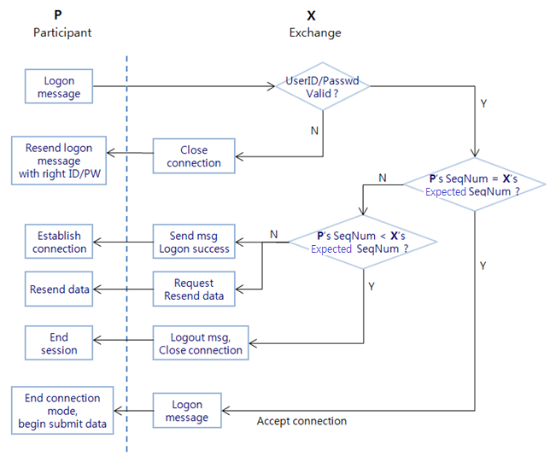

  - Logon (MsgType = A)
The logon message authenticates a user establishing a connection to HOSE exchange system. The logon message must be the first message sent by the application requesting to initiate a FIX session. Heartbeat interval is determined via this message.

Refer to the below flow.

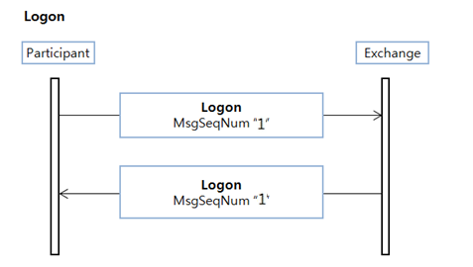

Upon receipt of a Logon message, the session acceptor will authenticate the party requesting connection and issue a Logon message as acknowledgment that the connection request has been accepted. The acknowledgment Logon can also be used by the initiator to validate that the connection was established with the correct party.

Tag | Field Name | Req'd | Format | Length | Comments
 | Standard Header | Y |  |  | MsgType=A
98 | EncryptMethod | Y | Int | 1 | Method of encryption.  Valid values:  0 = None
108 | HeartBtInt | Y | Int | 3 | Heartbeat interval (seconds)  A value of 30 seconds is recommended
553 | Username | N | String | 32 | User ID
554 | Password | N | String | 32 | User password
 | Standard Trailer | Y

- The HeartBtInt(#108) field is used to declare the timeout interval for generating heartbeats. 30 is recommended as the value of HeartBtInt(#108).
- Username(#553), Password(#554) used to certify the trial session counter party

  - Heartbeat (MsgType = 0)
The Heartbeat monitors the status of the communication link and identifies when the last of a string of messages was not received.

Refer to the below flow.

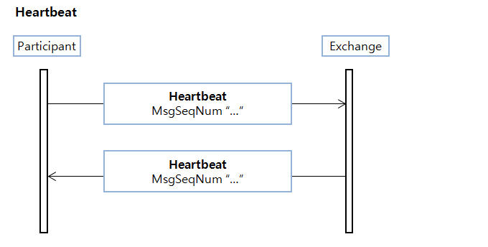

When either end of a FIX connection has not sent any data for [HeartBtInt] seconds, it will transmit a Heartbeat message. When either end of the connection has not received any data for (HeartBtInt + “some reasonable transmission time”) seconds, it will transmit a Test Request message. If there is still no Heartbeat message received after (HeartBtInt + “some reasonable transmission time”) seconds then, the connection should be considered lost and corrective action be initiated.

- Some reasonable transmission time : 20% of HeartBtInt.

Tag | Field Name | Req'd | Format | Length | Comments
 | Standard Header | Y |  |  | MsgType = 0
112 | TestReqID | N | String | 32 | Required when the heartbeat is the result of a Test Request message.
 | Standard Trailer | Y

- Heartbeat(MsgType=0) message which the response message for the request of TestRequest(MsgType=1) should contain the value of TestReqID(#112) at the previous message.

  - Test Request (MsgType = 1)
The test request message forces a heartbeat from the opposing application. The test request message checks sequence numbers or verifies communication line status.

Refer to the below flow.

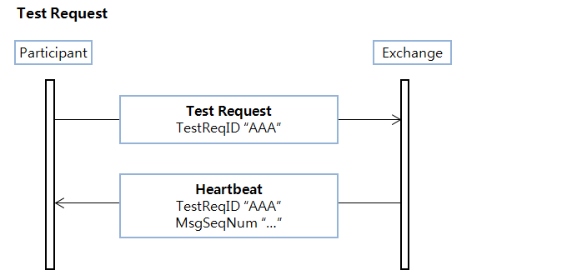

Tag | Field Name | Req'd | Format | Length | Comments
 | Standard Header | Y |  |  | MsgType = 1
112 | TestReqID | Y | String | 32 | Required when the heartbeat is the result of a Test Request message.
 | Standard Trailer | Y

- The opposite application responds to the Test Request with a Heartbeat containing the TestReqID(#112).

  - Resend Request (MsgType = 2)
The resend request is sent by the receiving application to initiate the retransmission of messages. This function is utilized if a sequence number gap is detected, if the receiving application lost a message, or as a function of the initialization process.

Refer to the below flow.

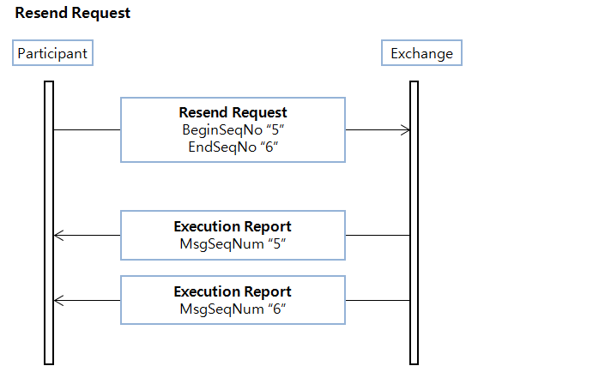

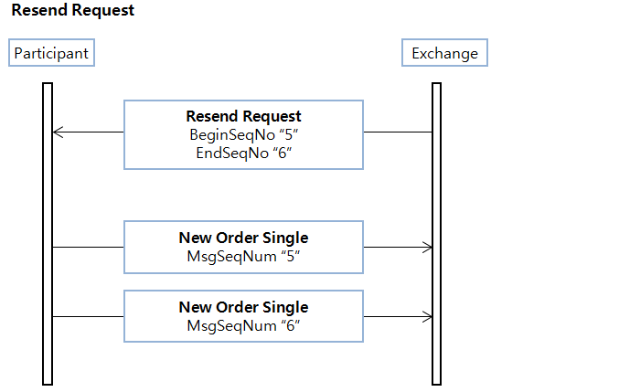

The resend request can be used to request a single message, a range of messages or all messages subsequent to a particular message.

Tag | Field Name | Req'd | Format | Length | Comments
 | Standard Header | Y |  |  | MsgType = 2
7 | BeginSeqNo | Y | Int | 11 | Message sequence number of first message in range to be resent
16 | EndSeqNo | Y | Int | 11 | Message sequence number of last message in range to be resent
 | Standard Trailer | Y
- To request a single message : BeginSeqNo = EndSeqNo
- To request a range of messages: BeginSeqNo = first message of range, EndSeqNo = last message of range
- To request all messages subsequent to a particular message: BeginSeqNo = first message of range, EndSeqNo = 0 (represents infinity)

  - Session Reject (MsgType = 3)
Sent when the message received is unsupported, invalid or cannot be parsed.

Refer to the below flow.

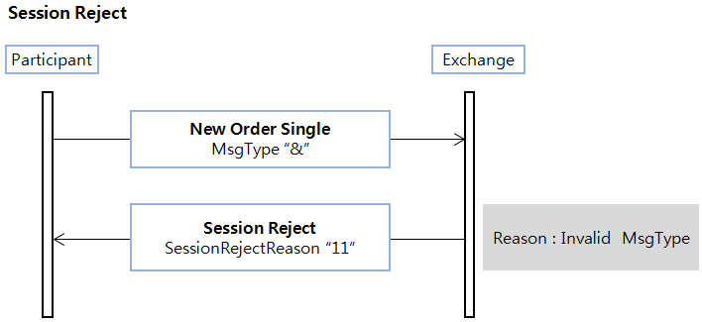

The reject message should be issued when a message is received but cannot be properly processed due to a session-level rule violation. An example of when a reject may be appropriate would be the receipt of a message with invalid basic data (e.g. MsgType=&) which successfully passes de-encryption, CheckSum and BodyLength checks. As a rule, messages should be forwarded to the trading application for business level rejections whenever possible. Rejected messages should be logged and the incoming sequence number incremented.

Note: The receiving application should disregard any message that is garbled, cannot be parsed or fails a data integrity check. Processing of the next valid FIX message will cause detection of a sequence gap and a Resend Request will be generated. Logic should be included in the FIX engine to recognize the possible infinite resend loop, which may beencountered in this situation. Generation and receipt of a Reject message indicates a serious error that may be the result of faulty logic in either the sending or receiving application.

Tag | Field Name | Req'd | Format | Length | Comments
 | Standard Header | Y |  |  | MsgType = 3
45 | RefSeqNum | Y | Int | 11 | MsgSeqNum of rejected message
373 | SessionRejectReason | N | Int | 2 | Session-level Reject Session  Valid values:  0 = Invalid tag number  1 = Required tag missing  2 = Tag not defined for this message type  3 = Undefined Tag  4 = Tag specified without a value  5 = Value is incorrect (out of range) for this tag  6 = Incorrect data format for value  7 = Decryption problem  8 = Signature problem  9 = CompID problem  10 = SendingTime accuracy problem  11 = Invalid MsgType  12 = XML Validation error  13 = Tag appears more than once  14 = Tag specified out of required order  15 = Repeating group fields out of order  16 = Incorrect NumInGroup count for repeating group  17 = Non “data” value includes field delimiter(SOH character)  99 = Other
58 | Text | N | String | 256 | Free format text string
 | Standard Trailer | Y

  - Sequence Reset (MsgType = 4)
The Sequence Reset message has two modes: Gap Fill mode and Reset mode.

Gap Fill mode is used in response to a Resend Request when one or more messages must be skipped over for the following reasons:

- During normal resend processing, the sending application may choose not to send a message. The Sequence Reset can be used to mark the place of that message.

- During normal resend processing, a number of administrative messages are skipped and not resent (such as Heart Beats, Test Requests). The Sequence Reset message is used to fill the sequence gap created.

- In the event of an application failure, it may be necessary to force synchronization of sequence numbers on the sending and receiving sides.

Gap Fill mode is indicated by GapFillFlag (#123) field = "Y".

Refer to the below flow.

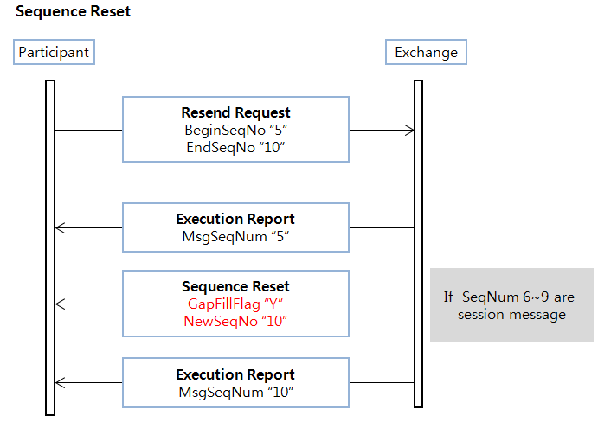

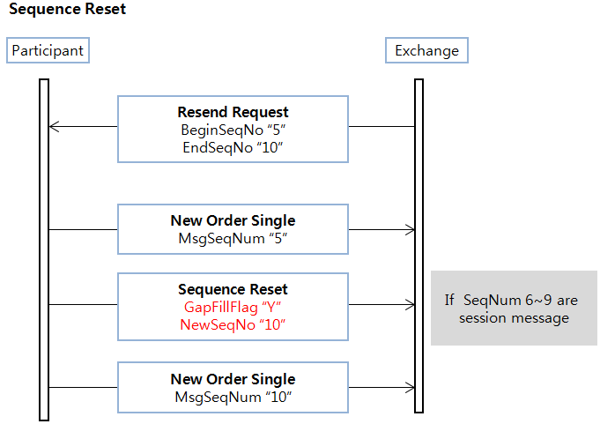

Reset mode involves specifying an arbitrarily higher new sequence number to be expected by the receiver of the Sequence Reset-Reset message, and is used to reestablish a FIX session after an unrecoverable application failure.
Reset mode is indicated by the GapFillFlag (#123) field = "N" or if the field is omitted.

Tag | Field Name | Req'd | Format | Length | Comments
 | Standard Header | Y |  |  | MsgType = 4
123 | GapFillFlag | N | Boolean | 1 | Indicates that the Sequence Reset message is replacing administrative or application messages which will not  be resent. Valid values:  Y = Gap Fill message, MsgSeqNum field valid  N = Sequence Reset, ignore MsgSeqNum
36 | NewSeqNo | Y | Int | 11 | New sequence number
 | Standard Trailer | Y

  - Logout (MsgType = 5)
The logout message initiates or confirms the termination of a FIX session. Disconnection without the exchange of logout messages should be interpreted as an abnormal condition.

Refer to the below flow.

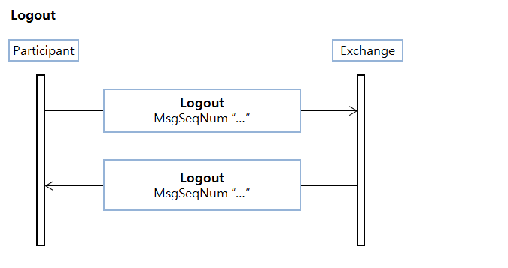

Tag | Field Name | Req'd | Format | Length | Comments
 | Standard Header | Y |  |  | MsgType = 5
58 | Text | N | String | 256 | Free format text string
 | Standard Trailer | Y

- Application messages
  - General Trading
HOSE FIX interface supports the following order handling functionality:

- Entering an order

- Deleting a single order

- Modifying an order

Order Entry
FIX Message | Function | Direction
NewOrderSingle(D) | Enter Order | In to Market
ExecutionReport(8) | Order Ack / Reject | Out from Market
ExecutionReport(8) | Execution(Partial Fill/Filled) | Out from Market

Order Cancel/Expire
FIX Message | Function | Direction
OrderCancelRequest(F) | Cancel Order | In to Market
OrderCancelReject(9) | Reject Cancel Order | Out from Market
ExecutionReport(8) | Order Deleted/Expired | Out from Market

Order Modification
FIX Message | Function | Direction
OrderCancel/ReplaceRequest(G) | Modify Order | In to Market
OrderCancelReject(9) | Reject Modify Order | Out from Market
ExecutionReport(8) | Order Modified | Out from Market

    - Order Entry
The Exchange supports the following order types, refer to OrdType(40) values;
Value | Description
1 | Market Order
2 | Limit Order
3 | Stop Order
4 | Stop Limit Order
X | Sameside best Order
Y | Contraryside best Order
- Iceberg orders are entered as Limit orders including MaxFloor(111) field.

Each order uses the TimeInForce (59) field to control when it is valid

Value | Description
0 | Day
1 | Good Till Cancel (GTC)
2 | At the Opening (ATO)
3 | Fill and Kill (IOC)
4 | Fill or Kill (FOK)
7 | At the Close(ATC)
9 | Market to Limit (MTL)

AccountType (581) is used to define the Settlement Account Type of an order.
Value | Description
1 | Customer
3 | House

CashMargin(544) is used to define the margin or cash for settlement. Absence this field indicates Cash.
Value | Description
1 | Cash
2 | Margin Open

    - New Order Single(MsgType = D)
The FIX client used this message to send orders to the HOSE Gateway. Posssible G/W response messages: ExecutionReport(MsgType=8), Session Reject(MsgType=3) or Business Reject Message(MsgType=j).

Refer to the below flow.

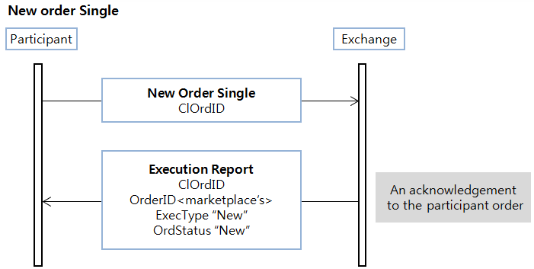

Tag | Field Name | Req'd | Format | Length | Comments
 | Standard Header | Y |  |  | MsgType = D
11 | ClOrdID | Y | String | 17 | Unique identifier for order as assigned by client
1 | Account | Y* | String | 13 | Executing account mnemonic as agreed between the broker and client
581 | AccountType | N | Int | 1 | 1 = Customer  3 = House
21 | HandlInst | Y | Char | 1 | Handling instructions for order  * Valid value only "1" is used.  Valid values:  1 = Automated execution order, private, no Broker intervention
111 | MaxFloor | N | Int | 10 | Show number of shares whinin an Iceberg order
55 | Symbol | Y | String | 12 | The unique code of an issue (a.k.a. instrument or symbol). Generally it is ISIN code but in case of Repo market it is defined as the exchange staffs want
54 | Side | Y | Char | 1 | Side of order  Valid values:  1 = Buy  2 = Sell  5 = Sell short
544 | CashMargin | N | Char | 1 | Indicaties if an order is a margin or non-margin order.  Absence this field indicates Cash.  If side = 2 or 5, no need this field.  If side = 1, possilbe to choose 1 or 2.  Valid values:  1 = Cash  2 = Margin Open
60 | TransactTime | Y | UTCTime | 21 | Time of execution/order creation
38 | OrderQty | Y | Int | 10 | Quantity ordered
40 | OrdType | Y | Char | 1 | Order type  Valid values:  1 = Market  2 = Limit  3 = Stop  4 = Stop limit  X = Sameside best  Y = Contraryside best  ※ Iceberg orders are entered as Limit orders including MaxFloor(111) field.
44 | Price | N | Price | 15 (9.4) | Price per unit of quantity
99 | StopPx | N | Price | 15 (9.4) | Required for OrdType = "Stop" or "Stop Limit"
59 | TimeInForce | N | Char | 1 | Specifies how long the order remains in effect. Absence of this field is interpreted as DAY.  Valid values:  0 = Day  1 = Good Till Cancel (GTC)  2 = At the Opening (OPG)  3 = Fill and Kill (IOC)  4 = Fill or Kill (FOK)  7 = At the Close  9= Market to Limit (MTL)
75 | TradeDate | Y* | LocalMktDate | 8 | Indicates local date of trade refereneced in this message in YYYYMMDD format.
421 | Country | Y* | String | 3 | ISO country code
20000 | InvestCode | N | String | 4 | This field indicates which category the owner of a given order or quote belongs to. This field is validated against AccountType field as below:  - If AccountType is Customer (1), any value is permitted for this field.  - If AccountType is House (3), this field must be 1000.  Valid values:  1000 = Securities company  2000 = Insurance company  3000 = Asset management company and Investment company  3200 = Fund  4000 = Bank  5000 = General finance company  6000 = Pension Fund  7000 = Goverment representation  7030 = International organization  7100 = Misc corporation  8000 = Indivisual
20054 | FornInvestTypeCode | N | String | 2 | Indicates whether a given order or quote is owned by foreigner.  Valide Value:  00 Domestic(default)  10 Foreigner
20063 | CustodianID | N | String | 5 | CustodianID
20064 | OpenCloseCode | N | String | 1 | This field is used for derivatives market only. The field indicates whether the executed order will cancel out existing position or not.  Valid Value  0 : None(default) : For non-derivatives markets  2 : Close : Position is not cancelled out. Only for non-blocked, omnibus accounts  3 : Depending on account : This value is used for non-blocked, ordinary accounts  4 : Close-out : Position is cancelled out. Only for blocked accounts
 | Standard Trailer | Y

    - Order Cancel/Replace Request (MsgType = G)
The Order cancel/replace request is used to change the parameters of an existing order. More precisely, the Order cancel/replace request is used by the ”ORDER MODIFICATION” function. Do not use this message to cancel the remaining quantity of an outstanding order, use the Cancel Request message for this purpose.One amend order can amend only one field.

Refer to the below flow.

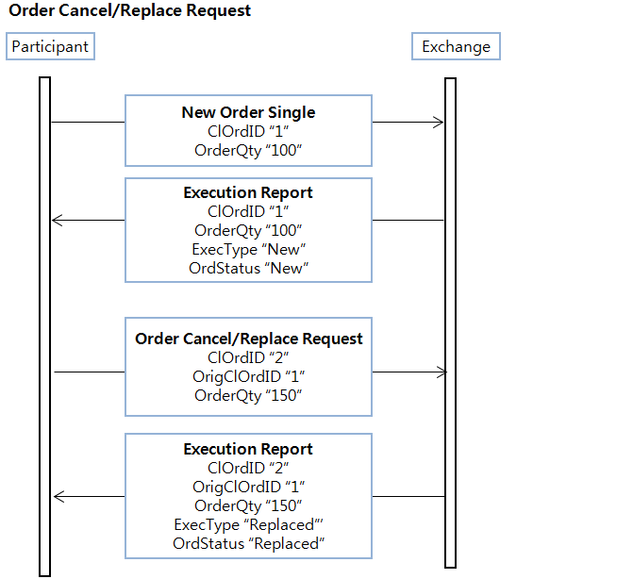

Cancel/Replace will be used to change any valid attribute of an open order (i.e. reduce/increase quantity, change limit price, change instructions, etc.) It can be used to re-open a filled order by increasing OrderQty. The Cancel/Replace request will only be accepted if the order can successfully be pulled back from the exchange floor without executing. Requests which cannot be processed will be rejected using Order cancel reject or the Business Message Reject. It should provide the ClOrdID values which were specified on the Cancel/Replace Request message for identification. Only a limited number of fields can be changed via the cancel/replace request message. All other fields should be retransmitted as sent in the original order. The fields which can be changed via this message are:

Tag Number | FIX Field
38 | OrderQty
40 | OrdType
44 | Price
111 | MaxFloor

A successful modification request that has execution/s occurring in the same processing round as the modification will always have an Order State of Filled or Partial Fill and an Execution Type of replaced. If an order is modified, a new Client Order ID is assigned to the order and the original Client Order ID is sent back to the participant in the OrigClOrdID (41) field. This ‘chaining’ of cancellation and modification messages to the original order message enables a participant to keep track of each order’s history.

Tag | Field Name | Req'd | Format | Length | Comments
 | Standard Header | Y |  |  | MsgType = G
11 | ClOrdID | Y | String | 17 | Unique identifier for order as assigned by client
41 | OrigClOrdID | Y | String | 17 | ClOrdID of the previouse order
21 | HandlInst | Y | Char | 1 | Handling instructions for order  * Valid value only "1" is used.  Valid values:  1 = Automated execution order, private, no Broker intervention
111 | MaxFloor | N | Int | 10 | Show number of shares whinin an Iceberg order
55 | Symbol | Y* | String | 12 | The unique code of an issue (a.k.a. instrument or symbol). Generally it is ISIN code but in case of Repo market it is defined as the exchange staffs want
54 | Side | Y* | Char | 1 | Side of order  Valid values:  1 = Buy  2 = Sell  5 = Sell short
60 | TransactTime | Y | UTCTime | 21 | Time of execution/order creation
38 | OrderQty | Y | Int | 10 | Quantity ordered
40 | OrdType | Y | Char | 1 | Order type  Valid values:  1 = Market  2 = Limit  3 = Stop  4 = Stop limit  X = Sameside best  Y = Contraryside best  ※ Iceberg orders are entered as Limit orders including MaxFloor(111) field.
44 | Price | N | Price | 15 (9.4) | Price per unit of quantity
59 | TimeInForce | N | Char | 1 | Specifies how long the order remains in effect. Absence of this field is interpreted as DAY.  Valid values:  0 = Day  1 = Good Till Cancel (GTC)  2 = At the Opening (OPG)  3 = Fill and Kill (IOC)  4 = Fill or Kill (FOK)  7 = At the Close  9= Market to Limit (MTL)
20064 | OpenCloseCode | N | String | 1 | This field is used for derivatives market only. The field indicates whether the executed order will cancel out existing position or not.  Valid Value  0 : None(default) : For non-derivatives markets  2 : Close : Position is not cancelled out. Only for non-blocked, omnibus accounts  3 : Depending on account : This value is used for non-blocked, ordinary accounts  4 : Close-out : Position is cancelled out. Only for blocked accounts
 | Standard Trailer | Y

    - Order Cancel Request(MsgType=F)
The Order cancel request message requests the cancelation of all of the remaining quantity of an existing order. Note that the Order Cancel/Replace Request should be used to partially cancel (reduce) an order). More precisely, the Order cancel request message is used by the ”ORDER CANCELLATION” function.
The request will only be accepted if the order can successfully be pulled back from the exchange floor without executing.

Refer to the below flow.

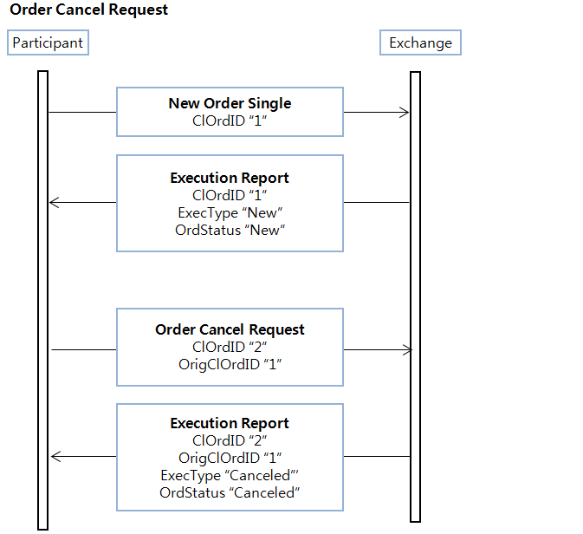

An order can be cancelled using the OrderCancelRequest (35=F) message. The ExecutionReport (35=8) message notifies the participant of the status of a cancellation request as it is processed.

Tag | Field Name | Req'd | Format | Length | Comments
 | Standard Header | Y |  |  | MsgType = F
11 | ClOrdID | Y | String | 17 | Unique identifier for order as assigned by client
41 | OrigClOrdID | Y | String | 17 | ClOrdID of the previouse order
21 | HandlInst | Y | Char | 1 | Handling instructions for order  * Valid value only "1" is used.  Valid values:  1 = Automated execution order, private, no Broker intervention
55 | Symbol | N | String | 12 | The unique code of an issue (a.k.a. instrument or symbol). Generally it is ISIN code but in case of Repo market it is defined as the exchange staffs want
60 | TransactTime | Y | UTCTime | 21 | Time of execution/order creation
 | Standard Trailer | Y

    - Execution Report(MsgType=8)
Orders will be acknowledged on entry by an ExecutionReport message. Subsequent fills will also be sent back in ExecutionReports messages.

Refer to the below flow.

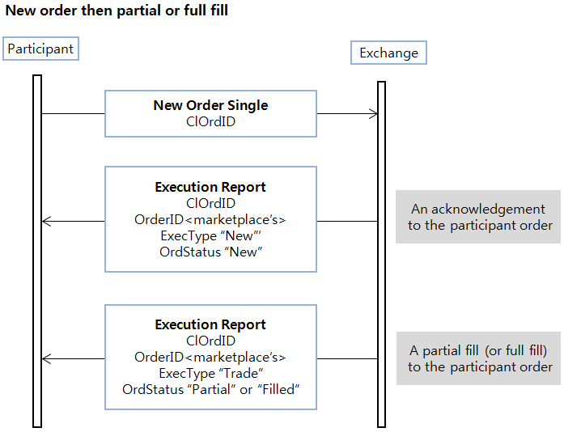

This message is a Status Report, a Fill Notice, or a confirmation or acknowledgment of an order creation, modification, or cancellation. Also, this message is sent in order to reject a New Order Single of client.It is sent by the Gateway in response a Cancel/Replace or New Order Single or as a result of an order matching leading to trade creation. Note that orders expired due to time in force conditions can be reported with OrdStatus either set to 4 (Canceled) or C (Expired). It depends on how exchanges report expiration events and also whether an order was expired by an exchange.

The ExecutionReport message is identified using the ExecID(17). ExecID s not an identifier of trades, it is an identifier assigned to each unique ExecutionReportmessage produced with no duplicate allowed during the entire FIX session.

When the ExecType (150) field = “D”, the ExecRestatement Reason can be “1” (If the Execution Report is GTC-releated information) or “8” (If the Execution Report is MTL-related information).

Tag | Field Name | Req'd | Format | Length | Comments
 | Standard Header | Y |  |  | MsgType = 8
37 | OrderID | Y | String | 32 | Unique identifier for order as assigned by exchange. Uniqssueness must be guaranted on the basis of each board and instrument within a single trading day.
11 | ClOrdID | Y* | String | 17 | Unique identifier for order as assigned by client
41 | OrigClOrdID | N | String | 17 | ClOrdID of the previouse order
17 | ExecID | Y | String | 32 | Unique identifier for execution message as assigned by exchange. Uniqueness must be guaranted within a single trading day.  Market ID(3)+BoardID(2)+TradeSendSeq(10)
150 | ExecType | Y | Char | 1 | Describe the specific execution report  Valid values:  0 = New (Order Ack)  4 = Canceled (Cancel Order Ack)  5 = Replaced (Replace Order Ack)  8 = Rejected  D = Restated( GTC Open Session, MTL)  F = Trade (partial fill or fill)  L = Trigger or Activated by System(STOP)
39 | OrdStatus | Y | Char | 1 | Identifies current status of order  Valid values:  0 = New  1 = Partially filled  2 = Filled  4 = Canceled  5 = Replaced  8 = Rejected
103 | OrdRejReason | N | Int | 4 | Reject code. Refer Appendix.Reject
378 | ExecRestatement  Reason | N | Int | 1 | Required for ExecType = D(Restated)  1 = GT renewal / restatement (no coporate action)  8 = Market(Exchange) Option
1 | Account | N | String | 13 | Executing account mnemonic as agreed between the broker and client
581 | AccountType | N | Int | 1 | Specified type of account. Absence of this field is interpreted as 1(Customer).  1 = Customer  3 = House
55 | Symbol | Y | String | 12 | The unique code of an issue (a.k.a. instrument or symbol). Generally it is ISIN code but in case of Repo market it is defined as the exchange staffs want
54 | Side | Y | Char | 1 | Side of order  Valid values:  1 = Buy  2 = Sell  5 = Sell short
38 | OrderQty | Y | Int | 10 | Quantity ordered
40 | OrdType | N | Char | 1 | Order type  Valid values:  1 = Market  2 = Limit  3 = Stop  4 = Stop limit  X = Sameside best  Y = Contraryside best  ※ Iceberg orders are entered as Limit orders including MaxFloor(111) field.
44 | Price | N | Price | 15 (9.4) | Price per unit of quantity
99 | StopPx | N | Price | 15 (9.4) | Required for OrdType = "Stop" or "Stop Limit"
59 | TimeInForce | N | Char | 1 | Specifies how long the order remains in effect. Absence of this field is interpreted as DAY.  Valid values:  0 = Day  1 = Good Till Cancel (GTC)  2 = At the Opening (OPG)  3 = Fill and Kill (IOC)  4 = Fill or Kill (FOK)  7 = At the Close  9= Market to Limit (MTL)
32 | LastQty | N | Int | 10 | Quantity bought/sold on this fill. Requied if ExecType = Trade.  If ExecType = Stopped, represent the quantity stopped for
31 | LastPx | N | Price | 15 (9.4) | Price of this fill. Required if ExecType = Trade.  If ExecType = Stopped, represent the price stopped at
336 | TradingSessionID | N | String | 2 | 01 = GT Order Load  10 = Opening Call Auction  11 = Opening Call Auction Extension  20 = Call Auction after Halt  21 = Call Auction after Halt Extension  30 = Closing Call Auction  40 = Continuous Auction  50 = VI Call Auction  51 = VI Call Auction Extension  60 = Order Accept Only  80 = Periodic Call Auction  90 = Trading Halt  99 = Board Closing
151 | LeavesQty | Y | Int | 10 | Quantity open for further execution  (This tag is not required in case of Nego(Put_Through) Execution Report.)
14 | CumQty | Y | Int | 10 | Currently executed quantity
6 | AvgPx | N | Price | 15 (9.4) | Calculated average price of all fills on this order
75 | TradeDate | N | LocalMktDate | 8 | Indicates local date of trade refereneced in this message in YYYYMMDD format.
60 | TransactTime | N | UTCTime | 21 | Time of execution/order creation
111 | MaxFloor | N | Int | 10 | Show number of shares whinin an Iceberg order
421 | Country | N | String | 3 | ISO country code
424 | DayOrderQty | N | Int | 10 | For GT orders
425 | DayCumQty | N | Int | 12 | Qauntity on a GT order that has traded today
544 | CashMargin | N | Char | 1 | Indicaties if an order is a margin or non-margin order  Absence this field indicates Cash.  If side = 2 or 5, no need this field.  If side = 1, possilbe to choose 1 or 2.  Valid values:  1 = Cash  2 = Margin Open
117 | QuoteID | N | String | 17 | Unique identifier for quote. Bilateral negotiations ID  * Data Format: BBB^NNNN/MMDDYYYY.  - B: Branch code(2 to 3 alpha characters)  - ^: Space delimiter  - N: Sequence number(up to 4 digits which does not need to be zero prefixed)  - MMDDYYYY: Date
693 | QuoteRespID | N | String | 17 | Unique ID as assigned by the Respondent
20000 | InvestCode | N | String | 4 | This field indicates which category the owner of a given order or quote belongs to. This field is validated against AccountType field as below:  - If AccountType is Customer (1), any value is permitted for this field.  - If AccountType is House (3), this field must be 1000.  Valid values:  1000 = Securities company  2000 = Insurance company  3000 = Asset management company and Investment company  3200 = Fund  4000 = Bank  5000 = General finance company  6000 = Pension Fund  7000 = Goverment representation  7030 = International organization  7100 = Misc corporation  8000 = Indivisual
118 | NetMoney | N | Float | 23 (18.4) | Indicates Trading Amount which is calculated in the trading system.
23 | IOIID | N | String | 17 | Unique identifier for IOI as assigned by client
236 | Yield | N | Float | 13(7.4) | Yield
20041 | Repo2ndLegAmt | N | Float | 23 (18.4) | Monetary value of 2nd leg of a given repo trade. Buyer (money lender) of the repo trade will receive this amount of money from seller (money borrower) on the 2nd leg date.
20054 | FornInvestTypeCode | N | String | 2 | Indicates whether a given order or quote is owned by foreigner.  Valide Value:  00 Domestic(default)  10 Foreigner
20059 | RepoHaircutRatio | N | Float | 8 (5.2) | Haircut ratio for a given repo trade. In the calculation of repo trade value, value of collateral asset is discounted by this ratio. It is also known as Initial margin ratio. This value is used only if Repo Haircut Ratio is not defined by Exchange for the given repo base instrument.
20062 | CollateralValue | N | Float | 23 (18.4) | Value of one unit of collateral security before haircut ratio is applied. This field is only used in repo market. This value is used only if Market Value Price is not defined by Exchange for the given repo base instrument.  * For cancelled order, this field is set to 0 (zero).
20063 | CustodianID | N | String | 5 | CustodianID
20064 | OpenCloseCode | N | String | 1 | This field is used for derivatives market only. The field indicates whether the executed order will cancel out existing position or not.  Valid Value  0 : None(default) : For non-derivatives markets  2 : Close : Position is not cancelled out. Only for non-blocked, omnibus accounts  3 : Depending on account : This value is used for non-blocked, ordinary accounts  4 : Close-out : Position is cancelled out. Only for blocked accounts
20073 | LegNearbyPx | N | Price | 15 (9.4) | Required if ExecType = Trade and for Derivatives Market  Short Term Leg Filled Price of Spread Instrument
20074 | LegDistantPx | N | Price | 15 (9.4) | Required if ExecType = Trade and for Derivatives Market  Long Term Leg Filled Price of Spread Instrument
 | Standard Trailer | Y

    - Order Cancel Reject(MsgType = 9)
This message is sent by the exchange in order to reject a Cancel Request or Cancel Replace Request sent by the member client.

Refer to the below flow.

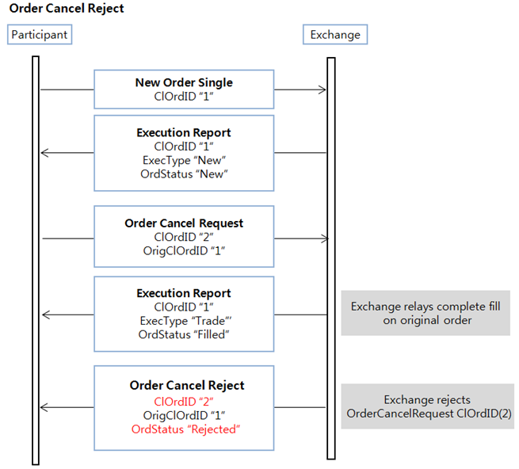

Tag | Field Name | Req’d | Format | Length | Comments
 | Standard Header | Y |  |  | MsgType = 9
37 | OrderID | Y | String | 32 | Unique identifier for order as assigned by exchange. Uniqueness must be guaranted on the basis of each board and instrument within a single trading day.
11 | ClOrdID | Y | String | 17 | Unique identifier for order as assigned by client
41 | OrigClOrdID | Y | String | 17 | ClOrdID of the previous order
39 | OrdStatus | Y | Char | 1 | Identifies current status of order  Valid values:  8 = Rejected
1 | Account | N | String | 13 | Executing account mnemonic as agreed between the broker and client
581 | AccountType | N | Int | 1 | Specified type of account. Absence of this field is interpreted as 1(Customer).  1 = Customer  3 = House
60 | TransactTime | N | UTCTime | 21 | Time of execution/order creation
434 | CxlRejResponseTo | Y | Char | 1 | Identifies the type of request that a Cancel Reject is in response to  Valid values:  1 = Order Cancel Request [F]  2 = Order Cancel/Replace Request [G]
102 | CxlRejReason | N | Int | 4 | Reject code. Refer Appendix-D.Reject code
 | Standard Trailer | Y

  - Indications of interest
Indication of interest messages are used to market merchandise which the broker is buying or selling in either a proprietary or agency capacity. Indications are distributed with the understanding that other firms may react to the message first and that the merchandise may no longer be available due to prior trade.

Refer to the below flow.

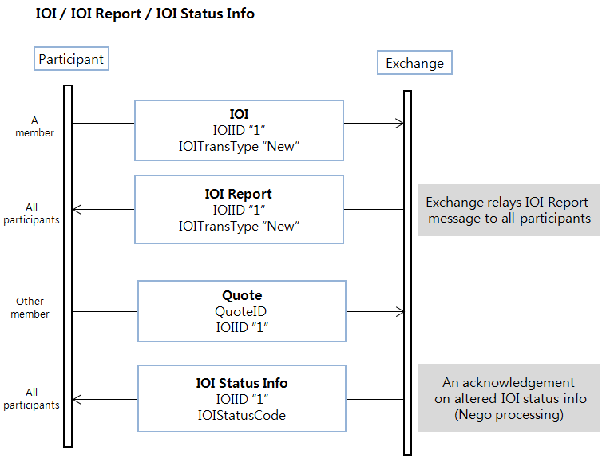

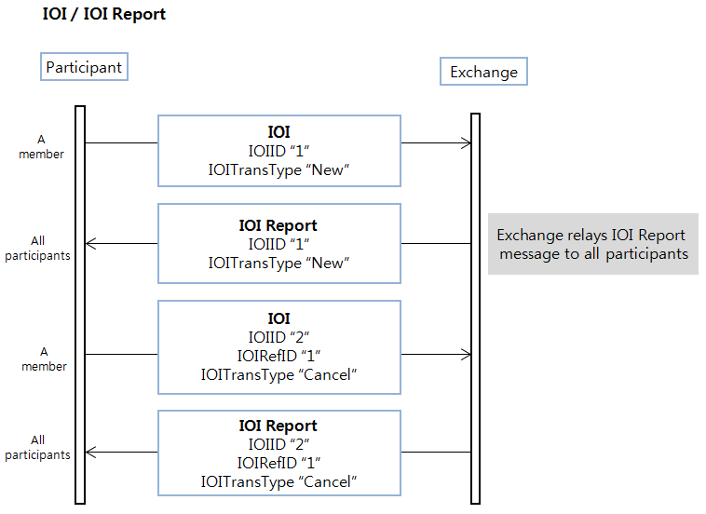

    - IOI(MsgType = 6)
Abroker expresses the interest information using IOImessage.

Indication messages can be transmitted in various transaction types; NEW and CANCEL.
CANCEL transaction type messagecancel the state of the message identified in IOIRefID (26).

Tag | Field Name | Req'd | Format | Length | Comments
 | Standard Header | Y |  |  | MsgType = 6
23 | IOIID | Y | String | 17 | Unique identifier for IOI as assigned by client
26 | IOIRefID | N | String | 17 | Required for Cancel IOITransType messages
28 | IOITransType | Y | Char | 1 | Identifies message transaction type  Valid values:  N = New  C = Cancel
55 | Symbol | Y | String | 12 | The unique code of an issue (a.k.a. instrument or symbol). Generally it is ISIN code but in case of Repo market it is defined as the exchange staffs want
54 | Side | Y | Char | 1 | Side of order  Valid values:  1 = Buy  2 = Sell
27 | IOIQty | Y | Int | 10 | IOI quantity
44 | Price | N | Price | 15 (9.4) | Price per unit of quantity
20057 | ContactNo | N | String | 20 | -
20059 | RepoHaircutRatio | N | Float | 8 (5.2) | Haircut ratio for a given repo trade. In the calculation of repo trade value, value of collateral asset is discounted by this ratio. It is also known as Initial margin ratio. This value is used only if Repo Haircut Ratio is not defined by Exchange for the given repo base instrument.
20062 | CollateralValue | N | Float | 23 (18.4) | Value of one unit of collateral security before haircut ratio is applied. This field is only used in repo market. This value is used only if Market Value Price is not defined by Exchange for the given repo base instrument.  * For cancelled order, this field is set to 0 (zero).
 | Standard Trailer | Y

    - IOI Report(MsgType = K15)
Response of Indication of Interest isrelayedby IOI Report messageto member firms.

Tag | Field Name | Req'd | Format | Length | Comments
 | Standard Header | Y |  |  | MsgType = K15
23 | IOIID | Y | String | 17 | Unique identifier for IOI as assigned by client
26 | IOIRefID | N | String | 17 | Required for Cancel IOITransType messages
28 | IOITransType | Y | Char | 1 | Identifies message transaction type  Valid values:  N = New  C = Cancel
55 | Symbol | Y | String | 12 | The unique code of an issue (a.k.a. instrument or symbol). Generally it is ISIN code but in case of Repo market it is defined as the exchange staffs want
54 | Side | Y | Char | 1 | Side of order  Valid values:  1 = Buy  2 = Sell
103 | OrdRejReason | N | Int | 4 | Reject code. Refer Appendix.Reject
27 | IOIQty | Y | Int | 10 | IOI quantity
44 | Price | N | Price | 15 (9.4) | Price per unit of quantity
20057 | ContactNo | N | String | 20 | Contact Information
20059 | RepoHaircutRatio | N | Float | 8 (5.2) | Haircut ratio for a given repo trade. In the calculation of repo trade value, value of collateral asset is discounted by this ratio. It is also known as Initial margin ratio. This value is used only if Repo Haircut Ratio is not defined by Exchange for the given repo base instrument.
20062 | CollateralValue | N | Float | 23 (18.4) | Value of one unit of collateral security before haircut ratio is applied. This field is only used in repo market. This value is used only if Market Value Price is not defined by Exchange for the given repo base instrument.  * For cancelled order, this field is set to 0 (zero).
60 | TransactTime | N | UTCTime | 21 | Time of execution/order creation
 | Standard Trailer | Y

    - IOI Status Info(MsgType=K16)
Member firms will be acknowledged altered IOI infomation by IOI Status Info message, if some broker submit Quote with the IOIID and the IOI status is alterd.

Tag | Field Name | Req’d | Format | Length | Comments
 | Standard Header | Y |  |  | MsgType = K16
23 | IOIID | Y | String | 17 | Unique identifier for IOI as assigned by client.
20061 | IOIStatusCode | Y | String | 1 | IOI Status Code  Valide Value:  0 : Invalid,  1: Valid,  2: In negotiation
60 | TransactTime | N | UTCTime | 21 | Time of execution/order creation
 | Standard Trailer | Y

  - Market maker
Enables a liquidity provider subscriber to broadcast a quote for a sysmbol for which the subscriber has market making responsibility. Market Makers create prices and provide liquidity by offering dual sided quotes. A quote is a named pair of executable orders used to display a firm two-way offer to trade on an order book. Quotes behave like two independent limit orders and may execute immediately upon entry, or remain on the book to await execution.

HOSE FIX interface supports the following quote handling functionality:

- Entering a Quote using Kquote(MsgType=K01)

- Deleting a single Quote using Kquote Cancel(MsgType=K02)

- Updating a Quote using Kquote(MsgType=K01)

Refer to the below flow.

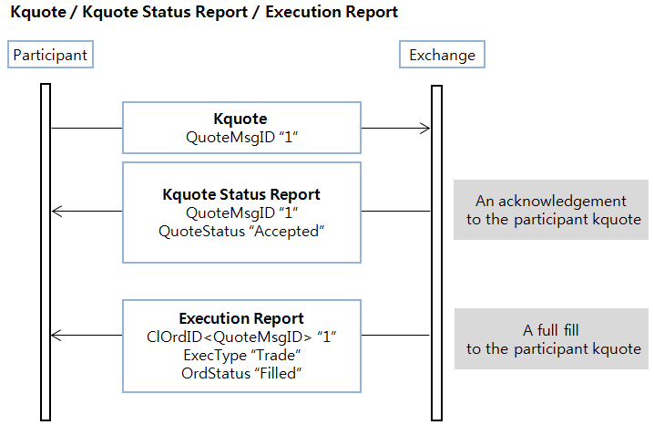

Of course, trade is possible to be “partial filled”

    - Kquote(MsgType = K01)
Enables a liquidity provider subscriber to broadcast a quote for a sysmbol for which the subscriber has market making responsibility.

Provide Kquote and Replace Kquote.

But in case of symbol for ‘Quote with replace for market making’, Replace Kquote is not allowed.
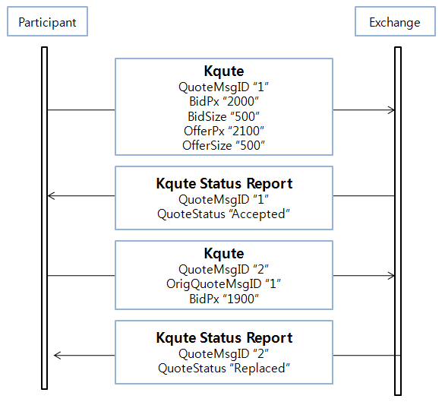

Tag | Field Name | Req’d | Format | Length | Comments
 | Standard Header | Y |  |  | MsgType = K01
1166 | QuoteMsgID | Y* | String | 17 | Unique identifier for quote and KQuote related message.  This field is used the same purpose as ClOrdID[#11] field of New Order Single message.
20001 | OrigQuoteMsgID | N | String | 17 | QuoteMsgID of the original quote that will be replaced or cancelled.
1 | Account | Y* | String | 13 | Executing account mnemonic as agreed between the broker and client
55 | Symbol | Y* | String | 12 | The unique code of an issue (a.k.a. instrument or symbol). Generally it is ISIN code but in case of Repo market it is defined as the exchange staffs want
54 | Side | N | Char | 1 | Required for Counter quotes of single instruments.  * If two side quote, no need this field.  Valid values:  1 = Buy  2 = Sell
544 | CashMargin | N | Char | 1 | Indicaties if an order is a margin or non-margin order.  Absence this field indicates Cash.  If side = 2, no need this field.  If side = 1, possilbe to choose 1 or 2.  Valid values:  1 = Cash  2 = Margin Open
75 | TradeDate | Y* | LocalMktDate | 8 | Indicates local date of trade refereneced in this message in YYYYMMDD format.
60 | TransactTime | Y* | UTCTime | 21 | Time of execution/order creation
132 | BidPx | N | Price | 15 (9.4) | Bid price (Buy)  Required if side(54) = 1
133 | OfferPx | N | Price | 15 (9.4) | Offer price (Sell)  Required if side(54) = 2
134 | BidSize | N | Int | 10 | Quantity of bid (Buy)  Required if side(54) = 1
135 | OfferSize | N | Int | 10 | Quantity of offer (Sell)  Required if side(54) = 2
421 | Country | Y* | String | 3 | ISO country code
20067 | AskTypeCode | N | String | 2 | Indicaties if a kquote(mm) is traded by short-selling  Valid values:  01 : General  02 : Short-selling  * Ask, Ask/Bid : '01'/'02'
20054 | FornInvestTypeCode | N | String | 2 | Indicates whether a given order or quote is owned by foreigner.  Valid values :  00 Domestic(default)  10 Foreigner
20063 | CustodianID | N | String | 5 | CustodianID
20064 | OpenCloseCode | N | String | 1 | This field is used for derivatives market only. The field indicates whether the executed order will cancel out existing position or not.  Valid values:  0 : None(default) : For non-derivatives markets  2 : Close : Position is not cancelled out. Only for non-blocked, omnibus accounts  3 : Depending on account : This value is used for non-blocked, ordinary accounts  4 : Close-out : Position is cancelled out. Only for blocked accounts
 | Standard Trailer | Y

    - Kquote Cancel(MsgType = K02)
Enables a liquidity provider subscriber to cancel apreviousquote for a security for which the subscriber has market making responsibility.

Refer to the below flow.

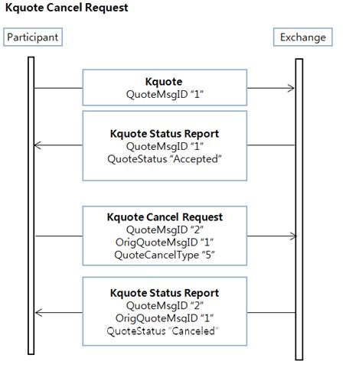

Tag | Field Name | Req’d | Format | Length | Comments
 | Standard Header | Y |  |  | MsgType = K02
1166 | QuoteMsgID | Y* | String | 17 | Unique identifier for quote and KQuote related message.  This field is used the same purpose as ClOrdID[#11] field of New Order Single message.
20001 | OrigQuoteMsgID | Y* | String | 17 | QuoteMsgID of the original quote that will be replaced or cancelled.
298 | QuoteCancelType | Y | Char | 1 | 5 = Cancel quote specified in QuoteID
453 | NoPartyIDs | N | Int | 1 | Number of PartyIDs
→448 | PartyID | N | Char | 5 | MemberID if PartyRole=1, TraderID if PartyRole=12
→447 | PartyIDSouce | N | Char | 1 | Defines the type of identifies used as PartyID.  Valid values:  D = Proprietary / Custom code
→452 | PartyRole | N | Int | 2 | Identfies the type or role of the PartyID(448) specified  Valid values:  1 = Executing Firm, MemberID  12 = Executing Trader
55 | Symbol | Y* | String | 12 | The unique code of an issue (a.k.a. instrument or symbol). Generally it is ISIN code but in case of Repo market it is defined as the exchange staffs want
60 | TransactTime | Y* | UTCTime | 21 | Time of execution/order creation
117 | QuoteID | N | String | 17 | Unique identifier for quote. Bilateral negotiations ID  * Data Format: BBB^NNNN/MMDDYYYY.  - B: Branch code(2 to 3 alpha characters)  - ^: Space delimiter  - N: Sequence number(up to 4 digits which does not need to be zero prefixed)  - MMDDYYYY: Date
23 | IOIID | Y | String | 17 | Unique identifier for IOI as assigned by client
 | Standard Trailer | Y

    - Kquote Status Report(MsgType=K03)
Advisory codes for quote are presented back to the member in Kquote Status Report message; accepted, rejected and canceled.

Tag | Field Name | Req’d | Format | Length | Comments
 | Standard Header | Y |  |  | MsgType = K03
1166 | QuoteMsgID | Y* | String | 17 | Unique identifier for quote and KQuote related message.  This field is used the same purpose as ClOrdID[#11] field of New Order Single message.
20001 | OrigQuoteMsgID | N | String | 17 | QuoteMsgID of the original quote that will be replaced or cancelled.
298 | QuoteCancelType | N | Char | 1 | 5 = Cancel quote specified in QuoteID
1 | Account | N | String | 13 | Executing account mnemonic as agreed between the broker and client
55 | Symbol | N | String | 12 | The unique code of an issue (a.k.a. instrument or symbol). Generally it is ISIN code but in case of Repo market it is defined as the exchange staffs want
54 | Side | N | Char | 1 | Required for Counter quotes of single instruments. If two side quote, no need this field.  Valid values:  1 = Buy  2 = Sell
132 | BidPx | N | Price | 15 (9.4) | Bid price (Buy)  Required if side(54) = 1
133 | OfferPx | N | Price | 15 (9.4) | Offer price (Sell)  Required if side(54) = 2
134 | BidSize | N | Int | 10 | Quantity of bid (Buy)  Required if side(54) = 1
135 | OfferSize | N | Int | 10 | Quantity of offer (Sell)  Required if side(54) = 2
20042 | BidLeavesSize | N | Int | 10 | Remaining bid quantity
20043 | OfferLeavesSize | N | Int | 10 | Remaining offer quantity
20044 | BidCumSize | N | Int | 10 | Executed bid quantity
20045 | OfferCumSize | N | Int | 10 | Executed offer quantity
60 | TransactTime | N | UTCTime | 21 | Time of execution/order creation
20067 | AskTypeCode | N | String | 2 | Indicaties if a kquote(mm) is traded by short-selling  Valid values:  00 :Default(If not placed)  01 : General  02 : Short-selling  * Ask, Ask/Bid : '01'/'02'
544 | CashMargin | N | Char | 1 | Indicaties if an order is a margin or non-margin order.  Absence this field indicates Cash.  If side = 2, no need this field.  If side = 1, possilbe to choose 1 or 2.  Valid values:  1 = Cash  2 = Margin Open
297 | QuoteStatus | N | Int | 2 | Identifies the status of the quote acknowledgement  Valid values:  1 = Accepted  5 = Rejected  16 = Replaced  17 = Canceled
300 | QuoteRejectReason | N | Int | 4 | Reject code. Refer Appendix.Reject
632 | BidYield | N | Float | 13(7.4) | BidYield
634 | OfferYield | N | Float | 13(7.4) | OfferYield
20063 | CustodianID | N | String | 5 | CustodianID
20064 | OpenCloseCode | N | String | 1 | This field is used for derivatives market only. The field indicates whether the executed order will cancel out existing position or not.  Valid Value  0 : None(default) : For non-derivatives markets  2 : Close : Position is not cancelled out. Only for non-blocked, omnibus accounts  3 : Depending on account : This value is used for non-blocked, ordinary accounts  4 : Close-out : Position is cancelled out. Only for blocked accounts
20054 | FornInvestTypeCode | N | String | 2 | Indicates whether a given order or quote is owned by foreigner.  Valid values :  00 Domestic(default)  10 Foreigner
 | Standard Trailer | Y

    - Notify MM Duty Occurred (MsgType =K14)

After a kquote completely filled, exchange relay ‘Notify MM Duty Occurred’ message to market maker.

Refer to the below flow.

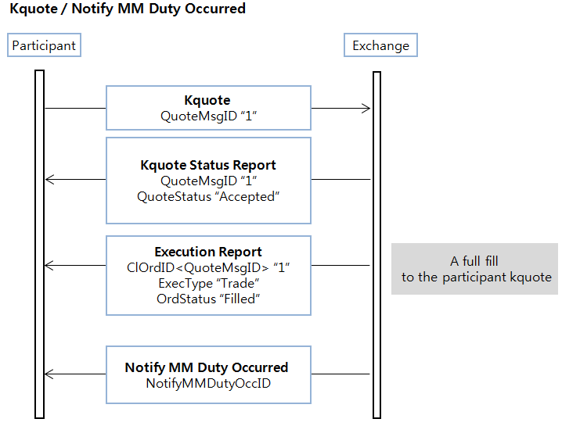

Tag | Field Name | Req’d | Format | Length | Comments
 | Standard Header | Y |  |  | MsgType = K14
20053 | NotifyMMDutyOccID | Y* | String | 32 | Unique identifier for NofifyMMDutyOccurred message as assigned by exchange. Uniqueness must be guaranted within a single trading day.
20050 | TrdrNo | Y* | String | 5 | Trader number
55 | Symbol | Y* | String | 12 | The unique code of an issue (a.k.a. instrument or symbol). Generally it is ISIN code but in case of Repo market it is defined as the exchange staffs want
60 | TransactTime | Y* | UTCTime | 21 | Time of execution/order creation
 | Standard Trailer | Y

  - Nego(Put through)
HOSE FIX interface support the Private Tradeable Quote – “Three-Party matching negotiation model(Put through)”. When the marketplace acts as an intermediary in a private quote negotiation, it may want to control when the trade is created. It would regard a trade to occur when both parties have issued matching firm commitments.

The Three-Party matching model is a model where a third party, often a marketplace, support Quote negotiations including execution. Execution is automated when the terms of a quote and a quote response matches.

Refer to the below flow.

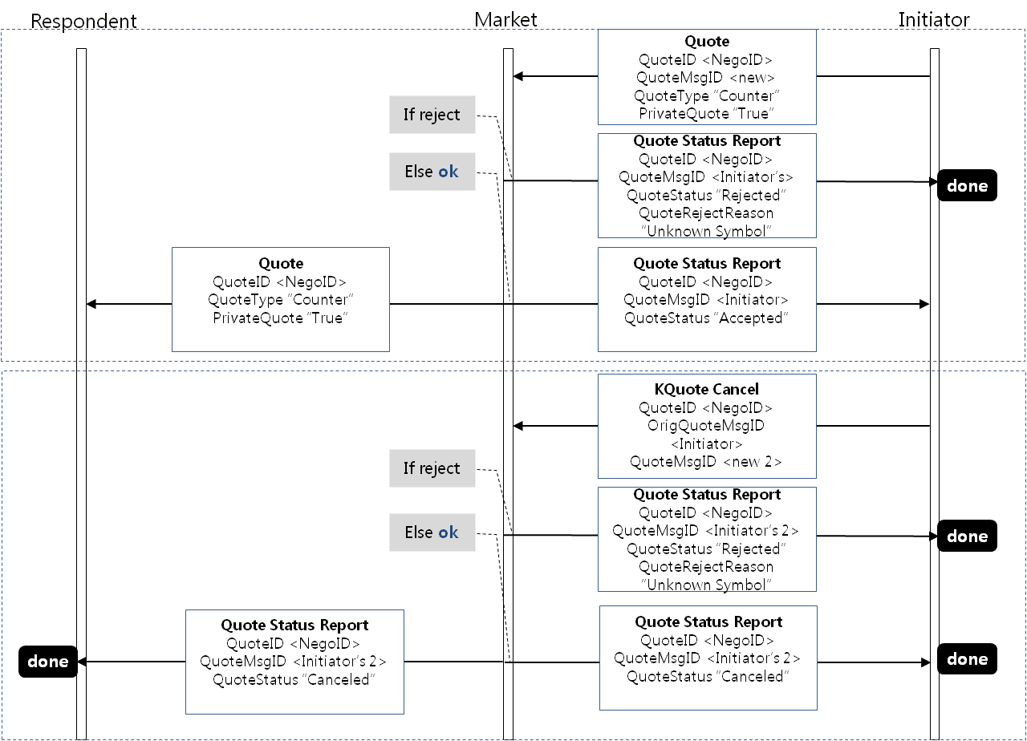

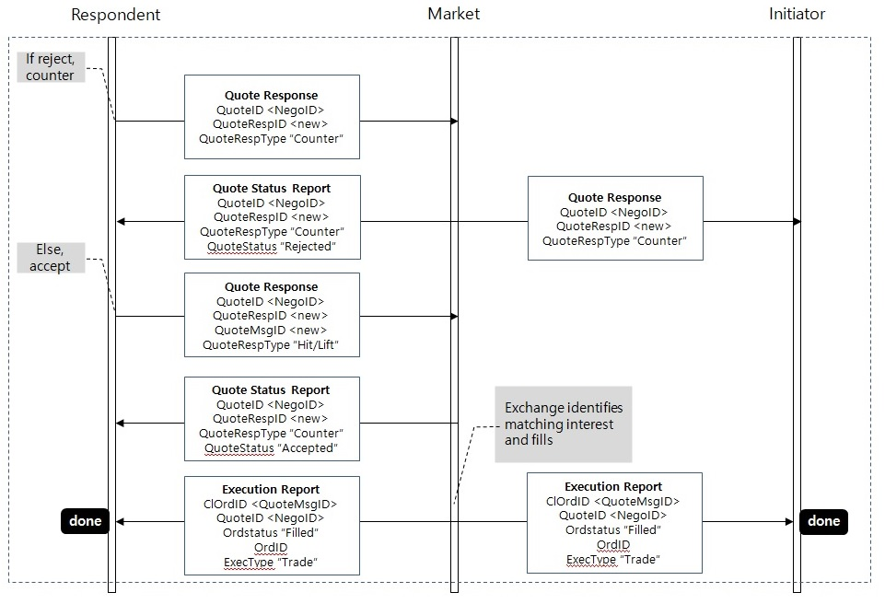

- In the Execution Report, ClOrdID’s value is “QuoteMsgID”.
- In the Execution Report, OrdID is unique identifier for order as assigned by exchange
- Though member uses multi-ports, All Nego FIX msgs to Respondent is sent by only Port-1.
So, Port-1 is mandatory for Nego Order.

    - Quote(MsgType = S)
An initiator submits the nego-deal information using Quote(MsgType=S) message. If the marketplace receives this message from initiator, the exchange fowards this quote information to counterparty specified in Quote’s PartyGroup . The Quote is identified by its QuoteMsgID.

Tag | Field Name | Req’d | Format | Length | Comments
 | Standard Header | Y |  |  | MsgType = S
117 | QuoteID | Y | String | 17 | Unique identifier for quote. Bilateral negotiations ID  * Data Format: BBB^NNNN/MMDDYYYY.  - B: Branch code(2 to 3 alpha characters)  - ^: Space delimiter  - N: Sequence number(up to 4 digits which does not need to be zero prefixed)  - MMDDYYYY: Date
1166 | QuoteMsgID | Y* | String | 17 | Unique identifier for quote and KQuote related message.  This field is used the same purpose as ClOrdID[#11] field of New Order Single message.
537 | QuoteType | Y* | Int | 1 | Identifies the type of quote  * Valid value only "3" is used in the negotiation model.  Valid values:  3 = Counter(tradeable)
1171 | PrivateQuote | Y* | Boolean | 1 | Specifies whether a quote is public or private  * Valid value only "Y" is used  Y = Private Quote
453 | NoPartyIDs | Y* | Int | 1 | Number of PartyIDs  Must be "2"
→448 | PartyID | Y* | Char | 5 | MemberID if PartyRole=1, TraderID if PartyRole=12
→447 | PartyIDSouce | Y* | Char | 1 | Defines the type of identifies used as PartyID.  Valid values:  D = Proprietary / Custom code
→452 | PartyRole | Y* | Int | 2 | Identfies the type or role of the PartyID(448) specified  Valid values:  1 = Executing Firm, MemberID  12 = Executing Trader
55 | Symbol | Y | String | 12 | The unique code of an issue (a.k.a. instrument or symbol). Generally it is ISIN code but in case of Repo market it is defined as the exchange staffs want
54 | Side | Y* | Char | 1 | Side of order  Valid values:  1 = Buy  2 = Sell  5 = Sell short
1 | Account | Y* | String | 13 | Executing account mnemonic as agreed between the broker and client
581 | AccountType | Y* | Int | 1 | Specified type of account. Absence of this field is interpreted as 1(Customer).  1 = Customer  3 = House
544 | CashMargin | N | Char | 1 | Indicaties if an order is a margin or non-margin order.  Absence this field indicates Cash.  If side = 2 or 5, no need this field.  If side = 1, possilbe to choose 1 or 2.  Valid values:  1 = Cash  2 = Margin Open
132 | BidPx | N | Price | 15 (9.4) | Bid price (Buy)  Required if side(54) = 1
133 | OfferPx | N | Price | 15 (9.4) | Offer price (Sell)  Required if side(54) = 2 or 5
134 | BidSize | N | Int | 10 | Quantity of bid (Buy)  Required if side(54) = 1
135 | OfferSize | N | Int | 10 | Quantity of offer (Sell)  Required if side(54) = 2 or 5
60 | TransactTime | Y* | UTCTime | 21 | Time of execution/order creation
40 | OrdType | Y* | Char | 1 | Order type  Valid values:  2= Limit
75 | TradeDate | Y* | LocalMktDate | 8 | Indicates local date of trade refereneced in this message in YYYYMMDD format.
421 | Country | Y* | String | 3 | ISO country code  Valid value:  704 = VN
23 | IOIID | N | String | 17 | Unique identifier for IOI as assigned by client.
20000 | InvestCode | Y* | String | 4 | This field indicates which category the owner of a given order or quote belongs to. This field is validated against AccountType field as below:  - If AccountType is Customer (1), any value is permitted for this field.  - If AccountType is House (3), this field must be 1000.  Valid values:  1000 = Securities company  2000 = Insurance company  3000 = Asset management company and Investment company  3200 = Fund  4000 = Bank  5000 = General finance company  6000 = Pension Fund  7000 = Goverment representation  7030 = International organization  7100 = Misc corporation  8000 = Indivisual
20054 | FornInvestTypeCode | N | String | 2 | Indicates whether a given order or quote is owned by foreigner.  Valide Value:  00 Domestic(default)  10 Foreigner
20059 | RepoHaircutRatio | N | Float | 8 (5.2) | Haircut ratio for a given repo trade. In the calculation of repo trade value, value of collateral asset is discounted by this ratio. It is also known as Initial margin ratio. This value is used only if Repo Haircut Ratio is not defined by Exchange for the given repo base instrument.
20062 | CollateralValue | N | Float | 23 (18.4) | Value of one unit of collateral security before haircut ratio is applied. This field is only used in repo market. This value is used only if Market Value Price is not defined by Exchange for the given repo base instrument.  * For cancelled order, this field is set to 0 (zero).
20063 | CustodianID | N | String | 5
20064 | OpenCloseCode | N | String | 1 | This field is used for derivatives market only. The field indicates whether the executed order will cancel out existing position or not.  Valid Value  0 : None(default) : For non-derivatives markets  2 : Close : Position is not cancelled out. Only for non-blocked, omnibus accounts  3 : Depending on account : This value is used for non-blocked, ordinary accounts  4 : Close-out : Position is cancelled out. Only for blocked accounts
20066 | FornNegoClassfyCode | N | String | 1 | Indicates whether negotiation is traded by foreigner.  Valide Value:  0 : Not negotiation trading between foreigner  1 : Negotiation trading between foreigner  * if #20066 is "1" then #20054 must be sent as "10"
 | Standard Trailer | Y

    - Quote Response(MsgType = AJ)
If the counterparty receive the Quote message from initiator via exchange, it’s possible to enter confirm or reject using Quote Respone(MsgType=AJ).

HOSE FIX interface supports the following Quote Respone handling functionality:

- Confrim means that QuoteRespType(694)=Hit/Lift(1)

- Reject means that QuoteRespType(694)=Counter(2)

Tag | Field Name | Req’d | Format | Length | Comments
 | Standard Header | Y |  |  | MsgType = AJ
693 | QuoteRespID | Y | String | 17 | Unique ID as assigned by the Respondent
117 | QuoteID | Y* | String | 17 | Unique identifier for quote. Bilateral negotiations ID  * Data Format: BBB^NNNN/MMDDYYYY.  - B: Branch code(2 to 3 alpha characters)  - ^: Space delimiter  - N: Sequence number(up to 4 digits which does not need to be zero prefixed)  - MMDDYYYY: Date
1166 | QuoteMsgID | Y* | String | 17 | Unique identifier for quote and KQuote related message.  This field is used the same purpose as ClOrdID[#11] field of New Order Single message.
694 | QuoteRespType | Y* | Int | 1 | Identifies the type of Quote Reponse.  * Value '1' means Confirm, '2' means Reject  Valid values:  1 = Hit/Lift  2 = Counter
537 | QuoteType | Y* | Int | 1 | Identifies the type of quote  * Valid value only "3" is used in the negotiation model.  Valid values:  3 = Counter(tradeable)
453 | NoPartyIDs | Y* | Int | 1 | Number of PartyIDs  Must be "2"
→448 | PartyID | Y* | Char | 5 | MemberID if PartyRole=1, TraderID if PartyRole=12
→447 | PartyIDSouce | Y* | Char | 1 | Defines the type of identifies used as PartyID.  Valid values:  D = Proprietary / Custom code
→452 | PartyRole | Y* | Int | 2 | Identfies the type or role of the PartyID(448) specified  Valid values:  1 = Executing Firm, MemberID  12 = Executing Trader
55 | Symbol | Y | String | 12 | The unique code of an issue (a.k.a. instrument or symbol). Generally it is ISIN code but in case of Repo market it is defined as the exchange staffs want
54 | Side | Y* | Char | 1 | Side of order  Valid values:  1 = Buy  2 = Sell  5 = Sell short
38 | OrderQty | N | Int | 10 | Quantity ordered  * Required if 694(QuoteRespType)=1
1 | Account | N | String | 13 | Executing account mnemonic as agreed between the broker and client  * Required if 694(QuoteRespType)=1
581 | AccountType | N | Int | 1 | Specified type of account.  1 = Customer  3 = House  * Required if 694(QuoteRespType)=1
132 | BidPx | N | Price | 15 (9.4) | Bid price (Buy)  * Required if side(54) = 1 & 694 = 1
133 | OfferPx | N | Price | 15 (9.4) | Offer price (Sell)  * Required if side(54) = 2 or 5 & 694 = 1
134 | BidSize | N | Int | 10 | Quantity of bid (Buy)  * Required if side(54) = 1 & 694 = 1
135 | OfferSize | N | Int | 10 | Quantity of offer (Sell)  * Required if side(54) = 2 or 5 & 694 = 1
60 | TransactTime | Y* | UTCTime | 21 | Time of execution/order creation
40 | OrdType | N | Char | 1 | Valid values:  2= Limit  * Required if 694(QuoteRespType)=1
75 | TradeDate | Y | LocalMktDate | 8 | Indicates local date of trade refereneced in this message in YYYYMMDD format.  * Required if 694(QuoteRespType)=1 or  694(QuoteRespType)=2
421 | Country | Y* | String | 3 | ISO country code  Valid value:  704 = VN
544 | CashMargin | N | Char | 1 | Indicaties if an order is a margin or non-margin order.  Absence this field indicates Cash.  If side = 2 or 5, no need this field.  If side = 1, possilbe to choose 1 or 2.  Valid values:  1 = Cash  2 = Margin Open
23 | IOIID | N | String | 17 | Unique identifier for IOI as assigned by client.
20000 | InvestCode | N | String | 4 | This field indicates which category the owner of a given order or quote belongs to. This field is validated against AccountType field as below:  - If AccountType is Customer (1), any value is permitted for this field.  - If AccountType is House (3), this field must be 1000.  Valid values:  1000 = Securities company  2000 = Insurance company  3000 = Asset management company and Investment company  3200 = Fund  4000 = Bank  5000 = General finance company  6000 = Pension Fund  7000 = Goverment representation  7030 = International organization  7100 = Misc corporation  8000 = Indivisual
20054 | FornInvestTypeCode | N | String | 2 | Indicates whether a given order or quote is owned by foreigner.  Valide Value:  00 Domestic(default)  10 Foreigner
20059 | RepoHaircutRatio | N | Float | 8 (5.2) | Haircut ratio for a given repo trade. In the calculation of repo trade value, value of collateral asset is discounted by this ratio. It is also known as Initial margin ratio. This value is used only if Repo Haircut Ratio is not defined by Exchange for the given repo base instrument.
20062 | CollateralValue | N | Float | 23 (18.4) | Value of one unit of collateral security before haircut ratio is applied. This field is only used in repo market. This value is used only if Market Value Price is not defined by Exchange for the given repo base instrument.  * For cancelled order, this field is set to 0 (zero).
20063 | CustodianID | N | String | 5
20064 | OpenCloseCode | N | String | 1 | This field is used for derivatives market only. The field indicates whether the executed order will cancel out existing position or not.  Valid Value  0 : None(default) : For non-derivatives markets  2 : Close : Position is not cancelled out. Only for non-blocked, omnibus accounts  3 : Depending on account : This value is used for non-blocked, ordinary accounts  4 : Close-out : Position is cancelled out. Only for blocked accounts
20066 | FornNegoClassfyCode | N | String | 1 | Indicates whether negotiation is traded by foreigner.  Valide Value:  0 : Not negotiation trading between foreigner  1 : Negotiation trading between foreigner  * if #20066 is "1" then #20054 must be sent as "10"
 | Standard Trailer | Y

    - Quote Status Report(MsgType = AI)
Quote StatusReport(MsgType=AI) message is used :

- As the response(Accepted or Rejected) to a Quote(MsgType=S) message
- As the response(Canceled or Rejected) to a Kquote Cancel(MsgType=K02) message
- As the response to a Quote Response(MsgType=AJ) message

Tag | Field Name | Req’d | Format | Length | Comments
 | Standard Header | Y |  |  | MsgType = AI
117 | QuoteID | N | String | 17 | Unique identifier for quote. Bilateral negotiations ID  * Data Format: BBB^NNNN/MMDDYYYY.  - B: Branch code(2 to 3 alpha characters)  - ^: Space delimiter  - N: Sequence number(up to 4 digits which does not need to be zero prefixed)  - MMDDYYYY: Date
1166 | QuoteMsgID | N | String | 17 | Unique identifier for quote and KQuote related message.  This field is used the same purpose as ClOrdID[#11] field of New Order Single message.
693 | QuoteRespID | N | String | 17 | Unique ID as assigned by the Respondent
694 | QuoteRespType | N | Int | 1 | Identifies the type of Quote Reponse.  * Value '1' means Confirm, '2' means Reject  Valid values:  1 = Hit/Lift  2 = Counter
537 | QuoteType | N | Int | 1 | Identifies the type of quote  * Valid value only "3" is used in the negotiation model.  Valid values:  3 = Counter(tradeable)
55 | Symbol | N | String | 12 | The unique code of an issue (a.k.a. instrument or symbol). Generally it is ISIN code but in case of Repo market it is defined as the exchange staffs want
54 | Side | N | Char | 1 | Side of order  Valid values:  1 = Buy  2 = Sell  5 = Sell short
38 | OrderQty | N | Int | 10 | Quantity ordered
1 | Account | N | String | 13 | Executing account mnemonic as agreed between the broker and client
581 | AccountType | N | Int | 1 | Specified type of account. Absence of this field is interpreted as 1(Customer).  1 = Customer  3 = House
132 | BidPx | N | Price | 15 (9.4) | Bid price (Buy)  Required if side(54) = 1
133 | OfferPx | N | Price | 15 (9.4) | Offer price (Sell)  Required if side(54) = 2 or 5
134 | BidSize | N | Int | 10 | Quantity of bid (Buy)  Required if side(54) = 1
135 | OfferSize | N | Int | 10 | Quantity of offer (Sell)  Required if side(54) = 2 or 5
60 | TransactTime | N | UTCTime | 21 | Time of execution/order creation
40 | OrdType | N | Char | 1 | Order type  Valid values:  2= Limit
297 | QuoteStatus | N | Int | 2 | Identifies the status of the quote acknowledgement  Valid values:  1 = Accepted  5 = Rejected  17 = Canceled
300 | QuoteRejectReason | N | Int | 4 | Reject code. Refer Appendix.Reject
23 | IOIID | N | String | 17 | Unique identifier for IOI as assigned by client
544 | CashMargin | N | Char | 1 | Indicaties if an order is a margin or non-margin order.  Absence this field indicates Cash.  If side = 2 or 5, no need this field.  If side = 1, possilbe to choose 1 or 2.  Valid values:  1 = Cash  2 = Margin Open
236 | Yield | N | Float | 13(7.4) | Yield
20059 | RepoHaircutRatio | N | Float | 8 (5.2) | Haircut ratio for a given repo trade. In the calculation of repo trade value, value of collateral asset is discounted by this ratio. It is also known as Initial margin ratio. This value is used only if Repo Haircut Ratio is not defined by Exchange for the given repo base instrument.
20062 | CollateralValue | N | Float | 23 (18.4) | Value of one unit of collateral security before haircut ratio is applied. This field is only used in repo market. This value is used only if Market Value Price is not defined by Exchange for the given repo base instrument.  * For cancelled order, this field is set to 0 (zero).
20063 | CustodianID | N | String | 5
20064 | OpenCloseCode | N | String | 1 | This field is used for derivatives market only. The field indicates whether the executed order will cancel out existing position or not.  Valid Value  0 : None(default) : For non-derivatives markets  2 : Close : Position is not cancelled out. Only for non-blocked, omnibus accounts  3 : Depending on account : This value is used for non-blocked, ordinary accounts  4 : Close-out : Position is cancelled out. Only for blocked accounts
 | Standard Trailer | Y

    - Kquote Cancel(MsgType=K02)
An initiator can cancel a submitted deal message using Kquote Cancel(MsgType=K02).
Refer to 5.3.2 Kquote Cancel for more information.

    - Execution Report(MsgType = 8)
After a counterparty send the accept information to exchange, exchange send the deal confirmation message using Execution Report(MsgType=8) to the both initiator and counterparty.
Refer to 5.1.5 Execution Report for more information.

  - Trading/Securitystatus information

    - Ktrading Session Status (MsgType = K04)
When trading schedule is processed at the planned time, and the information of the schedule is published to members. This also includes schedules that is changed by market controller or system. Published information includes market, board, board event, planned time, session information and so on.

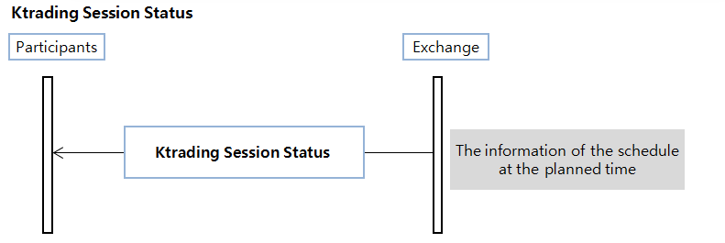

- If member connects after the start of the session, it can receive the previous trading session data sequentially

Tag | Field Name | Req’d | Format | Length | Comments
 | Standard Header | Y |  |  | MsgType = K04
20003 | ProductGrpID | Y* | String | 3 | Indicates Product Group ID which is defined in the trading system. Product Group is a group of Products that share the trading schedule.Valid values:STO : Stock Market Product Group  BDO : Bond Market Product Group  RPO : Repo Market Prodcut Group  STX : Listed Stock Market Product Group  UPX : UPCOM Product Group  BDX : Government Bond Product Group  FIO : Index Future Product Group  FBX : Bond Future Product Group  HCX : HNX Corporate Bond Market
20005 | BoardEvtID | Y* | String | 3 | Indicates Board event ID which is defined in the trading system. Trading schedule is essentially a sequence (list) of Board events, and each event is identified by three-character code or ID.  Valid values:AA1: Opening CA Open  AB1: Cont.A Open  AB2: Board Trading Close  AC2: Closing CA Execution  AD1: Order Reception Start  AD2: CA Excecution  AE1: Market Halt Release  AE8: Market Halt  AF1: CA Open after CB  AF6: CB Notice  AF7: CB Notice Clear  AF8: Suspension by CB  AQ3: Interface Connection Cut-off  AT6: PLE Notice  AW8: Lunch Break  AW9: Open after Lunch Break  AX1: Board Start  BB1: Cont.A Open for Non-PCA Instr.  BC1: Closing CA Open  BE9: Cont.A Open after Market Halt  BF9: Cont.A Open after CB  CC1: Closing PCA Open  CD1: PCA Open  CD3: PCA Execution  DB2: Trading Close for LTD Instr.  DC2: Closing CA Execution for LTD Instr.  EI1: Trading Halt Release by Instr./Product  EI8: Instr./Product Halt  EI9: Cont.A Open after Instr./Product Halt  GT1: GT Order Load
20006 | BoardEvtStartTime | Y* | Time | 9 | Board Event Scheduled(Start) Time
20007 | BoardEvtAppGrpCode | Y* | Int | 5 | Scope of a given Board event  Valid values:  Bitwise operation can be applied to the value of this item  0: Instrument of product specified by market controller  1: General (Not Last Trading Day)  2: Last Trading Day  4: General (Not Periodic Call Auction)  8: Periodic Call Auction
20008 | SessOpenCloseCode | N | String | 2 | Session/Board start & end code  Valid values:  BS : Board Start  BE : Board End  SS : Session Start  SE : Session End  SH : Session Halt  SR : Session Restart
336 | TradingSessionID | N | String | 2 | Trading Session  Valid values:  01 = GT Order Load  10 = Opening Call Auction  20 = Call Auction after Halt  30 = Closing Call Auction  40 = Continuous Auction  60 = Order Accept Only  80 = Periodic Call Auction  90 = Trading Halt  99 = Board Closing
55 | Symbol | N | String | 12 | The unique code of an issue (a.k.a. instrument or symbol). Generally it is ISIN code but in case of Repo market it is defined as the exchange staffs want
20009 | ProductID | N | String | 11 | Product is a layer or unit to define or manage rules of trading, clearing and settlement, instrument creating, calculating statistics, etc. Product ID is assigned to Product ID created by combination of exchange, market, security group, underlying asset and currency  S1STOST : Stock  S2STOST : Stock 2  S1STXST : Stock  S1STXDR : Depositary ReceiptValid values:List of Product (ID and description) will be defined later.
20051 | TradingHaltReason | N | String | 3 | Trading Halt Reason. Refer Appendix.Trading Halt Reason
20010 | TradingHaltOccType | N | String | 1 | In certain cases, trading halt of a given instument is triggered by trading halt of the other related instruments or Market. This field indicates the triggering source of trading halt.Valid values:1 = This instrument is directly suspended (halted) by market operator.  2 = Common stock of this instrument (Subscription warrant) is suspended.  3 = Common stock of this instrument (Subscription certificate) is suspended.  4 = Underlying asset of this instrument (ELW) is suspended.  5 = Issuer of this instrument (ELW) is suspended.  6 = Common stock of this instrument (preferred stock) is suspended.  7 = Underlying Market of this instrument (ELW) is suspended.  A = Issuer of this instrument (Bond) is suspended.  C = Collateral of this instrument (Repo) is suspended.
20070 | PLE Phase | N | String | 2 | PLE Phase  00:Not Occurred  01,02,03..
20071 | PLE Direction | N | String | 1 | PLE Direction  U:Up  D:Down
20072 | PLE Time | N | String | 6 | PLE Time  [hhmmss]
 | Standard Trailer | Y

      - Stock Info Disclosure (MsgType = K05)
In case the information of stock instrument from RDS is wrong, Market Controller can correct it before market opens and corrected information is published to members. Market Controller can correct trading quantity unit, the number of listed shares, reference price and evaluation price.

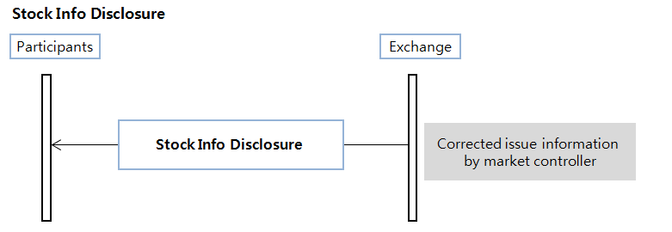

Tag | Field Name | Req’d | Format | Length | Comments
 | Standard Header | Y |  |  | MsgType = K05
20011 | PreHourSymChxType | Y* | String | 3 | Indicates which information is changed for a given instrument.  611 = Reference price is changed  612 = Evaluation price is changed  631 = Number of listed shares is changed  641 = Order quantify unit is changed
55 | Symbol | Y* | String | 12 | The unique code of an issue (a.k.a. instrument or symbol). Generally it is ISIN code but in case of Repo market it is defined as the exchange staffs want
20012 | OpenTime | Y* | String | 9 | The time when the given information is published.
20013 | ReferencePrice | N | Price | 15 (9.4) | Reference price of a given instrument. Price limit is determined based on this price.
1149 | HighLimitPrice | N | Price | 15 (9.4) | Available high limit price for the trading day
1148 | LowLimitPrice | N | Price | 15 (9.4) | Available low limit price for the trading day
20014 | EvaluationPrice | N | Price | 15 (9.4) | Valuation price for a 'Re-Valuation' instrument. For such instrument, price limit is set based on this price until the first execution. Once the first execution is occurred, price limit is set again base on the price of the first execution.
20015 | HgstOrderPrice | N | Price | 15 (9.4) | Higher price limit for a 'Re-Valuation' instrument during the opening call auction (or until the first execution
20016 | LwstOrderPrice | N | Price | 15 (9.4) | Lower price limit for a 'Re-Valuation' instrument during the opening call auction (or until the first execution).
20049 | OpnprcBasPrcYn | N | String | 1 | Indicates whether a given instrument is subject to 'Re-valuation'.
20018 | ExClassType | N | String | 2 | Corporate action type that may affect reference price.  Valid Valus:  00: N/A  01: Stock Dividend/Bonus  02: Cash Dividend  04: Right Offering  03: Stock D/B + Cash D  05: RO + Stock D/B  06: RO + Cash D  07: RO + Stock D/B + Cash D  08: Convertible Bond  16: Treasury Stock Div.  P1: Stock Split  P2: Stock Merge  XX: Etc.
1147 | UnitOfMeasureQty | N | Int | 17 | Minimum unit of quantity (a.k.a. Lot Size) which can be accepted as valid order quantity. In other words, order quantity must be multiples of this value.
20020 | ListedShares | N | Int | 16 | Number of listed shares
 | Standard Trailer | Y

    - Member Restrction/Desgnation Disclosure (MsgType = K06)

If there is some problem to a specific member, exchange have to restrict the trade of the member and after solving the problem, the member needs to be resumed. Exchange can also restrict/release for a specific trader or symbol of a member, if there is some problem in a specific trader or a symbol.
This process is done by market controller and processing result is published immediately.

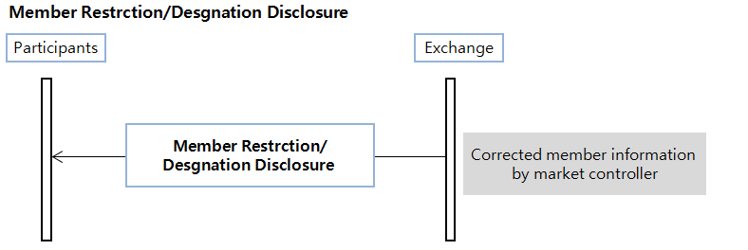

Tag | Field Name | Req’d | Format | Length | Comments
 | Standard Header | Y |  |  | MsgType = K06
20022 | PreHourChxActionType | Y* | String | 3 | Indicates whether trading sanction (to a certain member) is applied.  Code Values:  711 = Member Trade Halt  712 = Member Trade Resumption
55 | Symbol | Y* | String | 12 | The unique code of an issue (a.k.a. instrument or symbol). Generally it is ISIN code but in case of Repo market it is defined as the exchange staffs want
20012 | OpenTime | Y* | String | 9 | The time when the given information is published.
20023 | MemberNo | Y* | String | 5 | ID to identify or distinguish market participants or members with 5-digit numeric characters
20050 | TrdrNo | Y* | String | 5 | Trader number
20025 | MemberTRScope | Y* | Int | 5 | Allowed orders (side and account type) for a given member. Value is represented in Bitwise operation.  In Bitwise operation, each item represents a flag that can be enabled or disabled. When a flag is enabled, the corresponding numeric value is added.  For example, there are four flags 1, 2, 4, 8 and flag 1 and 4 is enabled and 2 and 8 is disabled. This status is represented by number 5 (1+4).  Bitwise operation can be applied to the value of this item  1 = Sell(Put Buy) Client  2 = Sell(Put Buy) House  4 = Buy(Put Sell) Client  8 = Buy(Put Sell) House
 | Standard Trailer | Y

    - Foreign Ownership Change (MsgType = K17)
Exchange need to modify the trading quantity of foreigners(current room). It is instructed by VSD or initial value from RDS might be wrong. In that case, Market Controller modifies the trading quantity of foreigners, and it is published.

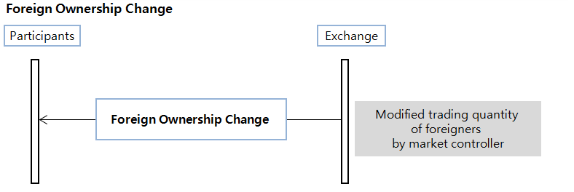

Tag | Field Name | Req’d | Format | Length | Comments
 | Standard Header | Y |  |  | MsgType = K17
55 | Symbol | Y* | String | 12 | The unique code of an issue (a.k.a. instrument or symbol). Generally it is ISIN code but in case of Repo market it is defined as the exchange staffs want
20012 | OpenTime | Y* | String | 9 | The time when the given information is published.
20065 | FornLimitIncDecQty | Y | Int | 10 | Increased or decreased quantity of the current room. Decreasing is indicated by a negative number.
 | Standard Trailer | Y

    - Reference Price Determination (MsgType=K07)
To validate input order price's compatibility and to operate some market actions, security issues need their reference prices. So exchange re-evaluates symbol at the first execution time in the main board, and publishes the results including its high limit price, low limit price and reference price.Reference Price Determination is applied for newlist stock in first trading day with Re-valuation method.”

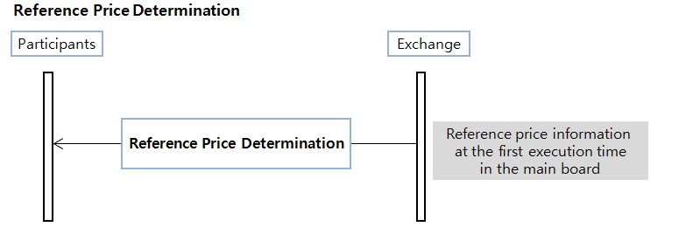

Tag | Field Name | Req’d | Format | Length | Comments
 | Standard Header | Y |  |  | MsgType = K07
55 | Symbol | Y* | String | 12 | The unique code of an issue (a.k.a. instrument or symbol). Generally it is ISIN code but in case of Repo market it is defined as the exchange staffs want
20013 | ReferencePrice | Y* | Price | 15 (9.4) | Reference price of a given instrument. Price limit is determined based on this price.
1149 | HighLimitPrice | Y* | Price | 15 (9.4) | Available high limit price for the trading day
1148 | LowLimitPrice | Y* | Price | 15 (9.4) | Available low limit price for the trading day
 | Standard Trailer | Y

    - Symbol Closing Info (MsgType = K08)
With the closing of the board, exchange publishes the closing information of each symbol. Each symbol's price information, such as its closing price, VWAP, and its closing price type will be included in this publishing message. Closing price indicates that the closing price 1) is Execution Price, 2) is Biased Price, 3) has No Execution, or 4) is Biased Price of Market Re-Evaluated Price Symbol.

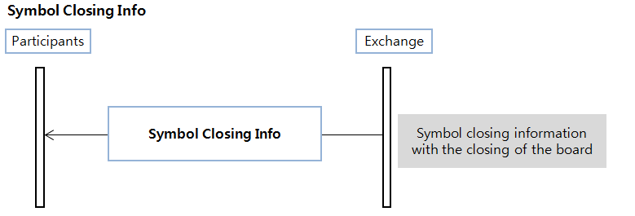

Tag | Field Name | Req’d | Format | Length | Comments
 | Standard Header | Y |  |  | MsgType = K08
55 | Symbol | Y* | String | 12 | The unique code of an issue (a.k.a. instrument or symbol). Generally it is ISIN code but in case of Repo market it is defined as the exchange staffs want
20026 | SymbolCloseInfoPx | Y* | Price | 15 (9.4) | The last execution price of that day. If there is no execution it is replaced with the reference price, and if no reference price is given then it will be 0 (zero)
20027 | SymbolCloseInfoPxType | N | String | 1 | Type of closing price  Valid values:  1: Actual Trade  2: Biased Quotation  3: No Trade  4: Biased Quotation of an Re-Valuation Instr.
 | Standard Trailer | Y

    - Volatility Interruption (MsgType = K09)
VI(Volatility Interruption) is triggered by abnormally deicided trading price exceeding specific threshold, which determined by the VI base price. So, VI message, published by exchange, contains its type(activate/de-activate) code, base price, and triggered price. That information will also includes VI's time period of triggering, changing, and releasing.

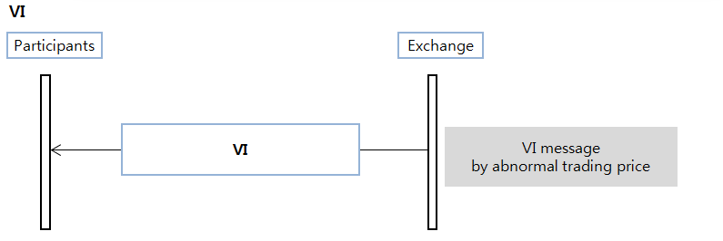

Tag | Field Name | Req’d | Format | Length | Comments
 | Standard Header | Y |  |  | MsgType = K09
55 | Symbol | Y* | String | 12 | The unique code of an issue (a.k.a. instrument or symbol). Generally it is ISIN code but in case of Repo market it is defined as the exchange staffs want
20030 | VITypeCode | Y* | String | 1 | Indicates whether VI is activated or released.  Valide Value:  1 = VI Activated  2 = VI Released
20031 | VIKindCode | Y* | String | 1 | Indicates which kind of VI is activated or released.  Valide Value:  1 = Static VI  2 = Dynamic VI  3 = Static VI + Dynamic VI
20032 | StaticVIBasePrice | Y* | Price | 15 (9.4) | Indicates static VI reference price. Price range for static VI is determined based on this price, and static VI is activated when an order is about to be executed outside the VI price range.
20047 | DynamicVIBasePrice | Y* | Price | 15 (9.4) | Indicates dynamic VI reference price. Price range for dynamic VI is determined based on this price, and dynamic VI is activated when an order is about to be executed outside the VI price range.
20033 | VIPrice | Y* | Price | 15 (9.4) | VI Triggering Price
20034 | StaticVIDispartiyRatio | Y* | Price | 8 (3.3) | Indicates static VI activation ratio expressed in percent. static VI price range is defined as range from static VI reference price plus/minus this ratio. For example, if static VI reference price is 1000 and this ratio is 2.5, then static VI price range is from 975 to 1025.
20048 | DynamicVIDispartiyRatio | Y* | Price | 8 (3.3) | Indicates dynamic VI activation ratio expressed in percent. Dynamic VI price range is defined as range from Dynamic VI reference price plus/minus this ratio. For example, if Dynamic VI reference price is 1000 and this ratio is 2, then Dynamic VI price range is from 980 to 1020.
20069 | VIActivatedTime | N | Time | 9 | VI Activated Time
20068 | VIReleaseTime | N | Time | 9 | VI Release Time
 | Standard Trailer | Y

  - Order verification
HOSE FIX interface support the order verification function to member firms. If member firms want to check the specific order into marketplace, this messages, Order Check Request(MsgType=K10) and Order Check Response(MsgType=K11) will be usefull to resend this order into market or not.

    - Order CheckRequest (MsgType = K10)

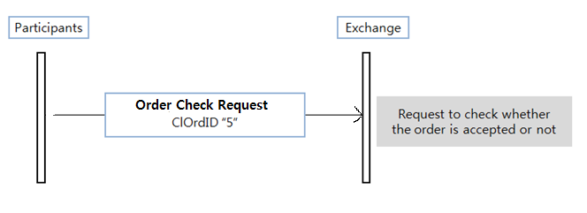

Tag | Field Name | Req’d | Format | Length | Comments
 | Standard Header | Y |  |  | MsgType = K10
11 | ClOrdID | Y* | String | 17 | Possible “QuoteMsgID”
55 | Symbol | Y* | String | 12 | The unique code of an issue (a.k.a. instrument or symbol). Generally it is ISIN code but in case of Repo market it is defined as the exchange staffs want
60 | TransactTime | N | UTCTime | 21 | Time of execution/order creation
 | Standard Trailer | Y

    - Order CheckResponse (MsgType = K11)

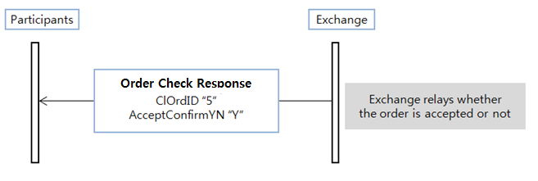

Tag | Field Name | Req’d | Format | Length | Comments
 | Standard Header | Y |  |  | MsgType = K11
11 | ClOrdID | Y* | String | 17 | Unique identifier for order as assigned by client
1 | Account | N | String | 13 | Executing account mnemonic as agreed between the broker and client
55 | Symbol | Y | String | 12 | The unique code of an issue (a.k.a. instrument or symbol). Generally it is ISIN code but in case of Repo market it is defined as the exchange staffs want
54 | Side | N | Char | 1 | Side of order  Valid values:  1 = Buy  2 = Sell  5 = Sell short
20046 | AcceptConfirmYN | Y | String | 1 | Indicates whether a given order is delivered to the matching engine.  Value Y (Delivered) indicates that order was accepted or rejected by the matching engine. In case of rejection, reject reason is specified in the corresponding Execution Report message.  Value N (Not delivered) indicates that order was not delivered to the matching engine. Possible reasons: order was not delivered to the FIX gateway at all, or the order was rejected by FIX gateway.  Valide Value:  Y = Delivered  N = Not delivered
60 | TransactTime | N | UTCTime | 21 | Time of execution/order creation
 | Standard Trailer | Y

  - Bussiness reject
This message is sent by exchange in response to New Order Single, Order Cancel Replace Request, Order Cancel Request and etc. Note this message does not contain ClOrdID(11) field because it is a low level reject and can be sent as an answer to several request types, not only order related. Note in case this message is sent to exchange it will be ignored.

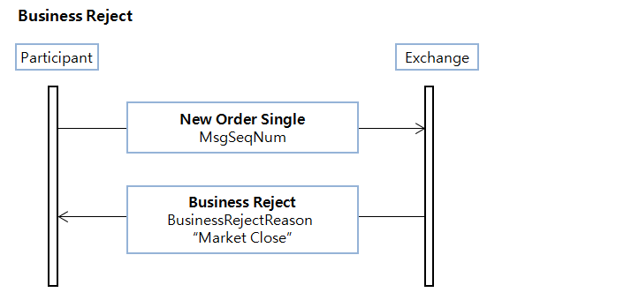
Tag | Field Name | Req’d | Format | Length | Comments
 | Standard Header | Y |  |  | MsgType = j
45 | RefSeqNum | N | Int | 11 | MsgSeqNum of rejected message
372 | RefMsgType | Y | String | 3 | The MsgType of the FIX message being referenced
380 | BusinessRejectReason | Y | Int | 3 | Code to identify reason  Valid values:  0 = Other  1 = Unknown ID  2 = Unknown Security  3 = Unsupported Message Type  4 = Application not available  5 = Conditionally required field missing  6 = Not Authorized  7 = DeliverTo firm not available at this time  100 = Market No Reponse  102 = Market Order Accept Stop  103 = Market Order Accept State Error  104 = Market Close
58 | Text | N | String | 256 | Free format text string
 | Standard Trailer | Y

- Server inormation
  - Access Point Server details
- Server name : Exchange Access Point
- Router : Cisco C6807-XL-S2T-BUN (A device that allows packets of data to be moved efficiently between two points on a network.)
- Server model & spec : Hewlett Packard Enterprise BL460C G9 (CPU : 02 x 3.5Ghz 4C, MEM(GB) : 128)
- OS : RHEL 7.3
- Middleware : XPM
- Application : No application required

- Appendix A – Summary of fields
Tag | Field Name | Format | Length | Comments
1 | Account | String | 13 | Executing account mnemonic as agreed between the broker and client
6 | AvgPx | Price | 15 (9.4) | Calculated average price of all fills on this order
7 | BeginSeqNo | Int | 11 | Message sequence number of first message in range to be resent
8 | BeginString | String | 7 | FIX.4.4
9 | BodyLength | Int | 6 | Length filed
10 | CheckSum | String | 3 | Three byte, simple checksum
11 | ClOrdID | String | 17 | Unique identifier for order as assigned by client
14 | CumQty | Int | 10 | Currently executed quantity
16 | EndSeqNo | Int | 11 | Message sequence number of last message in range to be resent
17 | ExecID | String | 32 | Unique identifier for execution message as assigned by exchange. Uniqueness must be guaranted within a single trading day.  Market ID(3)+BoardID(2)+TradeSendSeq(10)
21 | HandlInst | Char | 1 | Handling instructions for order  * Valid value only "1" is used.  Valid values:  1 = Automated execution order, private, no Broker intervention
23 | IOIID | String | 17 | Unique identifier for IOI as assigned by client
26 | IOIRefID | String | 17 | Required for Cancel IOITransType messages
27 | IOIQty | Int | 10 | IOI quantity
28 | IOITransType | Char | 1 | Identifies message transaction type  Valid values:  N = New  C = Cancel
31 | LastPx | Price | 15 (9.4) | Price of this fill. Required if ExecType = Trade.  If ExecType = Stopped, represent the price stopped at
32 | LastQty | Int | 10 | Quantity bought/sold on this fill. Requied if ExecType = Trade.  If ExecType = Stopped, represent the quantity stopped for
34 | MsgSeqNum | Int | 11 | Session sequence number
35 | MsgType | String | 3 | Administration Messages  A = Logon  0 = Heartbeat  1 = Test Request  2 = Resend Request  3 = Session Reject  4 = Sequence Reset  5 = Logout  Application Messages  D = New Order Single  G = Order Cancel/Replace Request  F = Order Cancel Request  8 = Execution Report  9 = Order Cancel Reject  6 = IOI  S = Quote  AJ = Quote Response  AI = Quote Status Report  K01 = KQuote  K02 = KQuote Cancel  K03 = KQuote Status Report  K04 = KTrading Session Status  K05 = Stock Info Disclosure  K06 = Member Restrction/Desgnation Disclosure  K07 = Reference Price Determination  K08 = Symbol Closing Info  K09 = VI  K10 = Order Check Request  K11 = Order Check Response  K14 = Notify MM Duty Occurred  K15 = IOI Report  K16 = IOI Status Info  K17 = Foreign Ownership Change  j = Biz message reject
36 | NewSeqNo | Int | 11 | New sequence number
37 | OrderID | String | 32 | Unique identifier for order as assigned by exchange. Uniqueness must be guaranted on the basis of each board and instrument within a single trading day. (regardless of message type)
38 | OrderQty | Int | 10 | Quantity ordered
39 | OrdStatus | Char | 1 | Identifies current status of order  Valid values:  0 = New  1 = Partially filled  2 = Filled  4 = Canceled  5 = Replaced  8 = Rejected
40 | OrdType | Char | 1 | Order type  Valid values:  1 = Market  2 = Limit  3 = Stop  4 = Stop limit  X = Sameside best  Y = Contraryside best  ※ Iceberg orders are entered as Limit orders including MaxFloor(111) field.
41 | OrigClOrdID | String | 17 | ClOrdID of the previouse order
43 | PossDupFlag | Boolean | 1 | Y = Possible Duplicate  N = Original Transmission
44 | Price | Price | 15 (9.4) | Price per unit of quantity
45 | RefSeqNum | Int | 11 | MsgSeqNum of rejected message
49 | SenderCompID | String | 16 | Sender(Member CompIF336D)
50 | SenderSubID | String | 16 | SubID(Member TraderID)  This tag is not required for session messages, but is required for trading-releated messages
52 | SendingTime | UTCTime | 21 | Time of message transmission
54 | Side | Char | 1 | Side of order  Valid values:  1 = Buy  2 = Sell  5 = Sell short
55 | Symbol | String | 12 | The unique code of an issue (a.k.a. instrument or symbol). Generally it is ISIN code but in case of Repo market it is defined as the exchange staffs want
56 | TargetCompID | String | 16 | Target(Counter Member CompID)  * Member side,  VOTGW = HOSE FIX gateway (Trading Session)  VOMGW = HOSE FIX gateway (Market Session)  VXTGW = HNX FIX gateway (Trading Session)  VXMGW = HNX FIX gateway (Market Session)
57 | TargetSubID | String | 16 | SubID(Counter Member TraderID)
58 | Text | String | 256 | Free format text string
59 | TimeInForce | Char | 1 | Specifies how long the order remains in effect. Absence of this field is interpreted as DAY.  Valid values:  0 = Day  1 = Good Till Cancel (GTC)  2 = At the Opening (OPG)  3 = Fill and Kill (IOC)  4 = Fill or Kill (FOK)  7 = At the Close  9= Market to Limit (MTL)
60 | TransactTime | UTCTime | 21 | Time of execution/order creation
75 | TradeDate | LocalMktDate | 8 | Indicates local date of trade refereneced in this message in YYYYMMDD format.
97 | PossResend | Boolean | 1 | N = Original transmission
98 | EncryptMethod | Int | 1 | Method of encryption.  Valid values:  0 = None
99 | StopPx | Price | 15 (9.4) | Required for OrdType = "Stop" or "Stop Limit"
102 | CxlRejReason | Int | 4 | Reject code. Refer Appendix.Reject
103 | OrdRejReason | Int | 4 | Reject code. Refer Appendix.Reject
108 | HeartBtInt | Int | 3 | Heartbeat interval (seconds)  A value of 30 seconds is recommended
111 | MaxFloor | Int | 10 | Show number of shares whinin an Iceberg order
112 | TestReqID | String | 32 | Required when the heartbeat is the result of a Test Request message.
115 | OnBehalfOfCompID | String | 3 | MarketID  STO : HoSE Stock Market  BDO : HoSE Bond Market  RPO : HoSE Repo Market  STX : HNX Listed Stock Market  UPX : HNX UPCOM Stock Market  BDX : HNX Government Bond Market  DVX : HNX Derivatives Market  HCX : HNX Corporate Bond Market
116 | OnBehalfOfSubID | String | 2 | BoardID  G1 : Main  G2 : Pre open  G3 : Post closing  G4 : Odd lot  G7 : Buy-in  G8 : Sell-out  T1 : Negotiation (regular)  T4 : Negotiation (regular for Odd lot)  T2 : Negotiation (pre)  T3 : Negotiation (post)  T6 : Negotiation (post for Odd lot)  R1 : Negotiation (Repo)  AL : All Boards  * "AL" code is only used when Exchange sends a meesage to members.
117 | QuoteID | String | 17 | Unique identifier for quote. Bilateral negotiations ID  * Data Format: BBB^NNNN/MMDDYYYY.  - B: Branch code(2 to 3 alpha characters)  - ^: Space delimiter  - N: Sequence number(up to 4 digits which does not need to be zero prefixed)  - MMDDYYYY: Date
118 | NetMoney | Float | 23 (18.4) | Indicates Trading Amount which is calculated in the trading system.
122 | OrigSendingtime | UTCTime | 21 | Original time of message transmission
123 | GapFillFlag | Boolean | 1 | Indicates that the Sequence Reset message is replacing administrative or application messages which will not  be resent. Valid values:  Y = Gap Fill message, MsgSeqNum field valid  N = Sequence Reset, ignore MsgSeqNum
128 | DeliverToCompID | String | 3 | MarketID  STO : HoSE Stock Market  BDO : HoSE Bond Market  RPO : HoSE Repo Market  STX : HNX Listed Stock Market  UPX : HNX UPCOM Stock Market  BDX : HNX Government Bond Market  DVX : HNX Derivatives Market  HCX : HNX Corporate Bond Market
129 | DeliverToSubID | String | 2 | BoardID  G1 : Main  G2 : Pre open  G3 : Post closing  G4 : Odd lot  G7 : Buy-in  G8 : Sell-out  T1 : Negotiation (regular)  T4 : Negotiation (regular for Odd lot)  T2 : Negotiation (pre)  T3 : Negotiation (post)  T6 : Negotiation (post for Odd lot)  R1 : Negotiation (Repo)  AL : All Boards  * "AL" code is only used when Exchange sends a meesage to members.
132 | BidPx | Price | 15 (9.4) | Bid price (Buy)  Required if side(54) = 1
133 | OfferPx | Price | 15 (9.4) | Offer price (Sell)  Required if side(54) = 2 or 5
134 | BidSize | Int | 10 | Quantity of bid (Buy)  Required if side(54) = 1
135 | OfferSize | Int | 10 | Quantity of offer (Sell)  Required if side(54) = 2 or 5
150 | ExecType | Char | 1 | Describe the specific execution report  Valid values:  0 = New (Order Ack)  4 = Canceled (Cancel Order Ack)  5 = Replaced (Replace Order Ack)  8 = Rejected  D = Restated( GTC Open Session, MTL)  F = Trade (partial fill or fill)  L = Trigger or Activated by System(STOP)
151 | LeavesQty | Int | 10 | Quantity open for further execution
236 | Yield | Float | 13(7.4) | Yield
297 | QuoteStatus | Int | 2 | Identifies the status of the quote acknowledgement  Valid values:  1 = Accepted  5 = Rejected  17 = Canceled
298 | QuoteCancelType | Char | 1 | 5 = Cancel quote specified in QuoteID
300 | QuoteRejectReason | Int | 4 | Reject code. Refer Appendix.Reject
336 | TradingSessionID | String | 2 | 01 = GT Order Load  10 = Opening Call Auction  11 = Opening Call Auction Extension  20 = Call Auction after Halt  21 = Call Auction after Halt Extension  30 = Closing Call Auction  40 = Continuous Auction  50 = VI Call Auction  51 = VI Call Auction Extension  60 = Order Accept Only  80 = Periodic Call Auction  90 = Trading Halt  99 = Board Closing
372 | RefMsgType | String | 3 | The MsgType of the FIX message being referenced
373 | SessionRejectReason | Int | 2 | Session-level Reject Session  Valid values:  0 = Invalid tag number  1 = Required tag missing  2 = Tag not defined for this message type  3 = Undefined Tag  4 = Tag specified without a value  5 = Value is incorrect (out of range) for this tag  6 = Incorrect data format for value  7 = Decryption problem  8 = Signature problem  9 = CompID problem  10 = SendingTime accuracy problem  11 = Invalid MsgType  12 = XML Validation error  13 = Tag appears more than once  14 = Tag specified out of required order  15 = Repeating group fields out of order  16 = Incorrect NumInGroup count for repeating group  17 = Non “data” value includes field delimiter(SOH character)  99 = Other
378 | ExecRestatementReason | Int | 1 | Required for ExecType = D(Restated)  1 = GT renewal / restatement (no coporate action)  8 = Market(Exchange) Option
380 | BusinessRejectReason | Int | 3 | Code to identify reason  Valid values:  0 = Other  1 = Unknown ID  2 = Unknown Security  3 = Unsupported Message Type  4 = Application not available  5 = Conditionally required field missing  6 = Not Authorized  7 = DeliverTo firm not available at this time  100 = Market No Reponse  102 = Market Order Accept Stop  103 = Market Order Accept State Error  104 = Market Close
421 | Country | String | 3 | ISO country code  Valid value:  704 = VN
424 | DayOrderQty | Int | 10 | For GT orders
425 | DayCumQty | Int | 12 | Qauntity on a GT order that has traded today
434 | CxlRejResponseTo | Char | 1 | Identifies the type of request that a Cancel Reject is in response to  Valid values:  1 = Order Cancel Request [F]  2 = Order Cancel/Replace Request [G]
447 | PartyIDSouce | Char | 1 | Defines the type of identifies used as PartyID.  Valid values:  D = Proprietary / Custom code
448 | PartyID | Char | 5 | MemberID or TraderID
452 | PartyRole | Int | 2 | Identfies the type or role of the PartyID(448) specified  Valid values:  1 = Executing Firm, MemberID  12 = Executing Trader
453 | NoPartyIDs | Int | 1 | Number of PartyIDs
537 | QuoteType | Int | 1 | Identifies the type of quote  * Valid value only "3" is used in the negotiation model.  Valid values:  3 = Counter(tradeable)
544 | CashMargin | Char | 1 | Indicaties if an order is a margin or non-margin order  Absence this field indicates Cash.  If side = 2 or 5, no need this field.  If side = 1, possilbe to choose 1 or 2.  Valid values:  1 = Cash  2 = Margin Open
553 | Username | String | 32 | User ID
554 | Password | String | 32 | User password
581 | AccountType | Int | 1 | Specified type of account. Absence of this field is interpreted as 1(Customer).  1 = Customer  3 = House
632 | BidYield | Float | 13(7.4) | Bid Yield
634 | OfferYield | Float | 13(7.4) | Offer Yield
693 | QuoteRespID | String | 17 | Unique ID as assigned by the Respondent
694 | QuoteRespType | Int | 1 | Identifies the type of Quote Reponse.  * Value '1' means Confirm, '2' means Reject  Valid values:  1 = Hit/Lift  2 = Counter
1147 | UnitOfMeasureQty | Int | 17 | Minimum unit of quantity (a.k.a. Lot Size) which can be accepted as valid order quantity. In other words, order quantity must be multiples of this value.
1148 | LowLimitPrice | Price | 15 (9.4) | Available low limit price for the trading day
1149 | HighLimitPrice | Price | 15 (9.4) | Available high limit price for the trading day
1166 | QuoteMsgID | String | 17 | Unique identifier for quote and KQuote related message.  This field is used the same purpose as ClOrdID[#11] field of New Order Single message.
1171 | PrivateQuote | Boolean | 1 | Specifies whether a quote is public or private  * Valid value only "Y" is used  Y = Private Quote
20000 | InvestCode | String | 4 | This field indicates which category the owner of a given order or quote belongs to. This field is validated against AccountType field as below:  - If AccountType is Customer (1), any value is permitted for this field.  - If AccountType is House (3), this field must be 1000.  Valid values:1000 = Securities company  2000 = Insurance company  3000 = Asset management company and Investment company  3200 = Fund  4000 = Bank  5000 = General finance company  6000 = Pension Fund  7000 = Government representation  7030 = International organization  7100 = Misc. corporation  8000 = Individual
20001 | OrigQuoteMsgID | String | 17 | QuoteMsgID of the original quote that will be replaced or cancelled.
20003 | ProductGrpID | String | 3 | Indicates Product Group ID which is defined in the trading system. Product Group is a group of Products that share the trading schedule.Valid values:STO : Stock Market Product Group  BDO : Bond Market Product Group  RPO : Repo Market Prodcut Group  STX : Listed Stock Market Product Group  UPX : UPCOM Product Group  BDX : Government Bond Product Group  FIO : Index Future Product Group  FBX : Bond Future Product Group  HCX : HNX Corporate Bond Market
20004 | BoardID | String | 2 | Unique identifier to a Board where a given instrument is traded.Valid values:List of Boards will be defined later.
20005 | BoardEvtID | String | 3 | Indicates Board event ID which is defined in the trading system. Trading schedule is essentially a sequence (list) of Board events, and each event is identified by three-character code or ID.  Valid values:AA1: Opening CA Open  AB1: Cont.A Open  AB2: Board Trading Close  AC2: Closing CA Execution  AD1: Order Reception Start  AD2: CA Excecution  AE1: Market Halt Release  AE8: Market Halt  AF1: CA Open after CB  AF6: CB Notice  AF7: CB Notice Clear  AF8: Suspension by CB  AQ3: Interface Connection Cut-off  AT6: PLE Notice  AW8: Lunch Break  AW9: Open after Lunch Break  AX1: Board Start  BB1: Cont.A Open for Non-PCA Instr.  BC1: Closing CA Open  BE9: Cont.A Open after Market Halt  BF9: Cont.A Open after CB  CC1: Closing PCA Open  CD1: PCA Open  CD3: PCA Execution  DB2: Trading Close for LTD Instr.  DC2: Closing CA Execution for LTD Instr.  EI1: Trading Halt Release by Instr./Product  EI8: Instr./Product Halt  EI9: Cont.A Open after Instr./Product Halt  GT1: GT Order Load
20006 | BoardEvtStartTime | Time | 9 | Scheduled time (start time) of a given Board event
20007 | BoardEvtAppGrpCode | Int | 5 | Scope of a given Board eventValid values:Bitwise operation can be applied to the value of this item  0: Instrument of product specified by market controller  1: General (Not Last Trading Day)  2: Last Trading Day  4: General (Not Periodic Call Auction)  8: Periodic Call Auction
20008 | SessOpenCloseCode | String | 2 | Indicates whether a given Board or Session is started or ended.Valid values:BS : Board Start  BE : Board End  SS : Session Start  SE : Session End  SH : Session Halt  SR : Session Restart
20009 | ProductID | String | 11 | Product is a layer or unit to define or manage rules of trading, clearing and settlement, instrument creating, calculating statistics, etc. Product ID is assigned to Product ID created by combination of exchange, market, security group, underlying asset and currency  S1STOST : Stock  S2STOST : Stock 2  S1STXST : Stock  S1STXDR : Depositary ReceiptValid values:List of Product (ID and description) will be defined later.
20010 | TradingHaltOccType | String | 1 | In certain cases, trading halt of a given instument is triggered by trading halt of the other related instruments or Market. This field indicates the triggering source of trading halt.Valid values:1 = This instrument is directly suspended (halted) by market operator.  2 = Common stock of this instrument (Subscription warrant) is suspended.  3 = Common stock of this instrument (Subscription certificate) is suspended.  4 = Underlying asset of this instrument (ELW) is suspended.  5 = Issuer of this instrument (ELW) is suspended.  6 = Common stock of this instrument (preferred stock) is suspended.  7 = Underlying Market of this instrument (ELW) is suspended.  A = Issuer of this instrument (Bond) is suspended.  C = Collateral of this instrument (Repo) is suspended.
20011 | PreHourSymChxType | String | 3 | Indicates which information is changed for a given instrument.Valid values:611 = Reference price is changed  612 = Evaluation price is changed  631 = Number of listed shares is changed  641 = Order quantify unit is changed
20012 | OpenTime | String | 9 | The time when the given information is published.
20013 | ReferencePrice | Price | 15 (9.4) | Reference price of a given instrument. Price limit is determined based on this price.
20014 | EvaluationPrice | Price | 15 (9.4) | Valuation price for a 'Re-Valuation' instrument. For such instrument, price limit is set based on this price until the first execution. Once the first execution is occurred, price limit is set again base on the price of the first execution.
20015 | HgstOrderPrice | Price | 15 (9.4) | Upper price limit for a 'Re-Valuation' instrument during the opening call auction (or until the first execution).
20016 | LwstOrderPrice | Price | 15 (9.4) | Lower price limit for a 'Re-Valuation' instrument during the opening call auction (or until the first execution).
20017 | IsMarketEvalPrice | String | 1 | Indicates whether a given instrument is subject to 'Re-valuation'.
20018 | ExClassType | String | 2 | Corporate action type that may affect reference price.Valid values:00: N/A  01: Stock Dividend/Bonus (D/B)  02: Cash Dividend  04: Right Offering (RO)  03: Stock D/B + Cash D  05: RO + Stock D/B  06: RO + Cash D  07: RO + Stock D/B + Cash D  08: Convertible Bond  16: Treasury Stock Div.  P1: Stock Split  P2: Stock Merge  XX: Etc.
20020 | ListedShares | Int | 16 | Number of listed shares
20021 | ArranTndYN | String | 1 | Indicates whether a given instrument is subject to Liquidation trading or Warning flag.  The meaning of this field depends on the value of the field [Published information type]. Valid values:1) Published info. type = 621 (Liquidation trading)  N = Terminated  Y = Applied  2) Published info. type = 623 (Warning)  N = Released  Y = Applied
20022 | PreHourChxActionType | String | 3 | Indicates whether trading sanction (to a certain member) is applied.Valid values:711 = Applied  712 = Released
20023 | MemberNo | String | 5 | ID to identify or distinguish market participants or members with 5-digit numeric characters
20024 | BranchNo | String | 5 | Trader number
20025 | MemberTRScope | Int | 5 | Allowed orders (side and account type) for a given member. Value is represented in Bitwise operation.  In Bitwise operation, each item represents a flag that can be enabled or disabled. When a flag is enabled, the corresponding numeric value is added.  For example, there are four flags 1, 2, 4, 8 and flag 1 and 4 is enabled and 2 and 8 is disabled. This status is represented by number 5 (1+4).  Valid values:Bitwise operation can be applied to the value of this item  1 = Sell (Put Buy) Client  2 = Sell (Put Buy) House  4 = Buy (Put Sell) Client  8 = Buy (Put Sell) House
20026 | SymbolCloseInfoPx | Price | 15 (9.4) | The last execution price of that day. If there is no execution it is replaced with the reference price, and if no reference price is given then it will be 0 (zero)
20027 | SymbolCloseInfoPxType | String | 1 | Type of closing priceValid values:1: Actual Trade  2: Biased Quotation  3: No Trade  4: Biased Quotation of an Re-Valuation Instr.
20030 | VITypeCode | String | 1 | Indicates whether VI is activated or released.Valid values:1 = Activated  2 = Released
20031 | VIKindCode | String | 1 | Indicates which kind of VI is activated or released.Valid values:1 = Static VI  2 = Dynamic VI  3 = Static VI + Dynamic VI
20032 | StaticVIBasePrice | Price | 15 (9.4) | Indicates static VI reference price. Price range for static VI is determined based on this price, and static VI is activated when an order is about to be executed outside the VI price range.
20033 | VIPrice | Price | 15 (9.4) | VI Triggering Price
20034 | StaticVIDispartiyRatio | Price | 8 (3.3) | Indicates static VI activation ratio expressed in percent. static VI price range is defined as range from static VI reference price plus/minus this ratio. For example, if static VI reference price is 1000 and this ratio is 2.5, then static VI price range is from 975 to 1025.
20041 | Repo2ndLegAmt | Float | 23 (18.4) | Monetary value of 2nd leg of a given repo trade. Buyer (money lender) of the repo trade will receive this amount of money from seller (money borrower) on the 2nd leg date.
20042 | BidLeavesSize | Int | 10 | Remaining bid quantity
20043 | OfferLeavesSize | Int | 10 | Remaining offer quantity
20044 | BidCumSize | Int | 10 | Executed bid quantity
20045 | OfferCumSize | Int | 10 | Executed offer quantity
20046 | AcceptConfirmYN | String | 1 | Indicates whether a given order is delivered to the matching engine.  Value Y (Delivered) indicates that order was accepted or rejected by the matching engine. In case of rejection, reject reason is specified in the corresponding Execution Report message.  Value N (Not delivered) indicates that order was not delivered to the matching engine. Possible reasons: order was not delivered to the FIX gateway at all, or the order was rejected by FIX gateway.  Valid values:Y = Delivered  N = Not delivered
20047 | DynamicVIBasePrice | Price | 15 (9.4) | Indicates dynamic VI reference price. Price range for dynamic VI is determined based on this price, and dynamic VI is activated when an order is about to be executed outside the VI price range.
20048 | DynamicVIDispartiyRatio | Price | 8 (3.3) | Indicates dynamic VI activation ratio expressed in percent. Dynamic VI price range is defined as range from Dynamic VI reference price plus/minus this ratio. For example, if Dynamic VI reference price is 1000 and this ratio is 2, then Dynamic VI price range is from 980 to 1020.
20049 | OpnprcBasPrcYn | String | 1 | Indicates whether a given instrument is subject to 'Re-valuation'.
20050 | TrdrNo | String | 5 | Trader number
20051 | TradingHaltReason | String | 3 | Trading Halt Reason. Refer Appendix.Trading Halt Reason
20053 | NotifyMMDutyOccID | String | 32 | Unique identifier for NofifyMMDutyOccurred message automatically assigned by the trading system. Uniqueness is guaranteed in a single trading day.
20054 | FornInvestTypeCode | String | 2 | Indicates whether a given order or quote is owned by foreigner.Valid values:00 Domestic(default)  10 Foreigner
20057 | ContactNo | String | 20 | Contact Information
20059 | RepoHaircutRatio | Float | 8 (5.2) | Haircut ratio for a given repo trade. In the calculation of repo trade value, value of collateral asset is discounted by this ratio. It is also known as Initial margin ratio. This value is used only if Repo Haircut Ratio is not defined by Exchange for the given repo base instrument.
20061 | IOIStatusCode | String | 1 | Indicates IOI statusValid values:0: Invalid,  1: Valid,  2: In negotiation
20062 | CollateralValue | Float | 23 (18.4) | Value of one unit of collateral security before haircut ratio is applied. This field is only used in repo market. This value is used only if Market Value Price is not defined by Exchange for the given repo base instrument.  * For cancelled order, this field is set to 0 (zero).
20063 | CustodianID | String | 5 | Custodian ID
20064 | OpenCloseCode | String | 1 | This field is used for derivatives market only. The field indicates whether the executed order will cancel out existing position or not.Valid values:0: None (default): For non-derivatives markets  2: Close: Position is not cancelled out. Only for non-blocked, omnibus accounts  3: Depending on account: This value is used for non-blocked, ordinary accounts  4: Close-out: Position is cancelled out. Only for blocked accounts
20065 | FornLimitIncDecQty | Int | 10 | Increased or decreased quantity of the current room. Decreasing is indicated by a negative number.
20066 | FornNegoClassfyCode | String | 1 | Indicates whether negotiation is traded by foreigner.  Valide Value:  0 : Not negotiation trading between foreigner  1 : Negotiation trading between foreigner  * if #20066 is "1" then #20054 must be sent as "10"
20067 | AskTypeCode | String | 2 | Indicaties if a kquote(mm) is traded by short-sellingValid values:01 : General  02 : Short-selling  * Ask, Ask/Bid : '01'/'02'
20068 | VIReleaseTime | Time | 9 | VI Release Time
20069 | VIActivatedTime | Time | 9 | VI Activated Time
20070 | PLE Phase | String | 2 | PLE Phase  00:Not Occurred  01,02,03..
20071 | PLE Direction | String | 1 | PLE Direction  U:Up  D:Down
20072 | PLE Time | String | 6 | PLE Time  [hhmmss]

- Appendix B – Specific information
  - Data representation
This section documents the range of values used by some of the fields in HOSE.
The range may be widened in the future should the need arise. All data types (with the exception of those of type “data”) are mapped to ASCII strings.

Should the client application send a data field greater than the specified length expected by HOSE, the excess data will not be processed. This is true for all data fields except price and quantity, where they will be rejected by HOSE.

Data Types | Data Comments
Int | Sequence of digits without commas or decimals and optional  sign character (ASCII characters “-” and “0” – “9”).  The sign character utilizes one byte (i.e. positive int is 99999 while negative int is -99999).  Examples: 273 in field 21 would be mapped int as |21=273|  -273 in field 12 would be mapped int as |12=-273|
Float | Sequence of digits with optional decimal point and sign character (ASCII characters “-“ and“0”~”9” and “.”). The absence of the decimal point within the string will be interpreted as the float representation of an integer value
Char | Single character value, can include any alphanumeric character or punctuation except the delimiter. All char fields are case sensitive.
Boolean | Char field. It contains one of two values:  ‘Y’ – True/Yes  ‘N’ – False/No
Price | float field (see definition of “float” above) representing a price. Note the number of decimal places may vary. For certain asset classes prices may be negative values.
Qty | Quantity. Float field. Ranges from 000000001 to 999999999. All FIX fields using the “Qty” format are expected to conform to this convention.
String | Alpha-numeric free format strings can include any character or punctuation except the delimiter. All char fields are case sensitive.
Currency | String field representing a currency type. See Appendix F : Valid Currency Codes.
UTCTimestamp | Time/date combination represented in UTC (Universal Time Coordinated, also known as “GMT”) in either YYYYMMDD-HH:MM:SS (whole seconds) or YYYYMMDD-HH:MM:SSsss (milliseconds) format, colons, dash, and period required.  Valid values:  YYYY = 0000-9999, MM = 01 –12, DD = 01 – 31 HH = 00 – 23, MM = 00 – 59, SS = 00 – 59 (without milliseconds), sss = 000 – 999 (indicating milliseconds)

- Appendix C – Checksum calculation
The checksum of a FIX message is calculated by summing every byte of the message up to but not including the checksum itself. This checksum is then transformed into a modulo 256 number for transmission. It is sent as three ASCII digits during transmission.

For example, if the checksum is calculated to be 271, then the modulo 256 value is 18.
The value would be transmitted as |10=018| where “10=” is the tag for checksum field.
A sample code to generate the checksum field is as follows:

char *GenerateCheckSum( char *buf, long bufLen )
{
static char tmpBuf[ 4 ];
long idx;
unsigned int cks;

for( idx = 0L, cks = 0; idx < bufLen; cks += (unsigned int)buf[ idx++ ] );
sprintf( tmpBuf, “%03d”, (unsigned int)( cks % 256 ) );
return( tmpBuf );
}
- Appendix D – Reject code
Code | Meaning
0101 | Before Trading Hours
0102 | After Trading Hours
0104 | Instrument Order Receiving Halted
0112 | Order ID Format Error
0201 | Instrument Code Error
0202 | Buy/Sell Side Error
0203 | Account No. Error
0204 | Date Error
0206 | Order ID Error
0207 | Order ID Duplicated
0210 | GTD Expiration Date Error
0213 | Order ID Duplicated by Retransmission
0301 | Price Limit Violation
0302 | Price Error
0303 | Price Unit Error
0306 | VI Price Limit Violation
0307 | Conditional Price Error
0401 | Order Qty Limit Error
0402 | Order Qty(Amt) Error
0403 | Disclosed Qty Error
0404 | OpenCloseRequest Error
0501 | Instrument Halted
0502 | Market Halted
0503 | Last Trading Day Instrument Closed
0504 | Amend/Cancel Not Allowed within n Min before EP Execution
0505 | CB Activated
0506 | Spread Instrument Order Not Allowed
0508 | Order Not Allowed for Instrument with No Reference Price
0601 | Client/House Error
0602 | Country Code Error
0603 | Investor Type Error
0604 | Foreign Investor Type Error
0605 | Inter-foreign Nego Code Error
0701 | Order Type Error
0702 | Order Condition Error
0704 | Upper/Lower Limit Order Type Error
0705 | Order Type Error during Auction Extension
0706 | Order Condition Error during Auction Extension
0801 | Amend/Cancel Class Error
0802 | Original Order ID Missing
0803 | Original Order Not Exists
0804 | No Amend/Cancel Remaining Qty
0805 | Amend/Cancel Qty Error
0806 | Amend/Cancel for Cancel Order
0807 | Amend/Cancel for Rejected Order
0808 | Same Price Amend Not Possible
0809 | Amend Not Possible between Specific Order Types
0810 | Original Order ID Error
0811 | Violation of Min Remaining Qty after Cancel
0812 | Buy/Sell Side for Amend Not Matched
0813 | Amend Subject Error
0901 | Member No. Error
0902 | Member/Account Not Allowed For Given Instrument
0907 | Exeeds Foreigners Order Qty Limit
0908 | Member Trading Restricted for Given Instrument
0911 | Member Trading Restricted
0912 | Custodian ID Error
1001 | Trader No. Error
1002 | Amend/Cancel Order Trader No. Error
1006 | Trader Trading Restricted for Given Instrument
1007 | Trader Trading Restricted
1008 | Custodian ID mismatch Error
1102 | Instrument Not Subjected for MM
1103 | Not MM for Given Instrument
1104 | MM Quote Type Error
1105 | MM Quote Condition Error
1107 | MM Quote Min Qty Violation
1108 | MM Quote Spread Violation
1109 | Exceeds No. of issuing Shares
1110 | Exceeds No. of Listed Shares
1111 | Exceeds MM Holding Qty
1115 | MM Quote Allowed Direction Error
1116 | Account No. Error of market making order
1202 | Duplicated Nego Initiator Request
1203 | Nego Initiator Request Cancel Not Possible Session
1204 | Nego Counterparty Approve/Reject Not Possible Session
1206 | Time that negotiation is impossible
1207 | Nego Request/Response Not Matched
1209 | Nego Counterparty No. Input Error
1224 | Nego Initiator Buy/Sell Side Error
1246 | Collateral value Error
1247 | Repo haircut ratio Error
1401 | Trading Not Allowed Instrument
1405 | Off-Hours Trading Not Allowed due to No Execution(or Closing Price Auction RE Activated)
1410 | No application for Buy-In/Sell-Out
1411 | Duplicate Error of Buy-In/Sell-Out order
1412 | Order quantity error of Buy-In/Sell-Out order
1413 | Order price error of Buy-In/Sell-Out order
1501 | Margin Class Error
1502 | Margin Order Not Allowed Instrument
1503 | Margin Order Price Error
1504 | Margin Order Order Type Error
1505 | Margin Order Order Condition Error
1506 | Margin Order Input Restricted
1601 | Treasury Report ID Error
1602 | Treasury Trading Method Error
1603 | Treasury Buy/Sell Side Error
1610 | Treasury Order Not Allowed Session
1612 | Treasury Cancel Order Not Allowed
1613 | Treasury Stock Trading Not Allowed Instrument
1615 | Treasury Order Sell Type Code Error
1616 | Treasury Order Investor Type Error
1801 | Sell Type Code Error
1802 | Short Selling Order Price Error
1803 | Short Selling Order Type Error
1804 | Short Selling Order Condition Error
1805 | Short Selling Order Input Restricted
1806 | Borrowed Securities Short Selling Not Allowed Instrument
2013 | Session that one-side acution order can not be submitted
8000 | Message Type Code Error
8001 | RFQ Code Error
8002 | Quote ID Error
8003 | Order Disclosure Condition Code Error
8004 | Initiator Order Not Exists
8005 | IOI ID Error
8006 | Original IOI ID Error
8007 | missing Original IOI ID
8008 | IOI ID Duplicated
8009 | Original IOI don't exist
8010 | Rejected IOI
8011 | Cancelled IOI
8012 | Invalid IOI
8013 | Buy/Sell Side mismatch error between IOI and put-through order
8014 | Order price mismatch error between IOI and put-through order
8015 | Order quantity mismatch error between IOI and put-through order
8016 | Trader No mismatch error between IOI and put-through order
8017 | Repo haircut ration mismatch error between IOI and put-through order
8018 | collateral value mismatch error between IOI and put-through order
9998 | Individual Instrument Failure

- Appendix E – Trading Halt Reason
Code | Description | HOSE |  |  | HNX
 |  | STO | BDO | RPO | STX | UPX | DVX | BDX | HCX
B10 | The result of the inquiry disclosure for rumor and news |  |  |  |  |  |  | O | O
B11 | Unsubmission of annual/half-yearly/quarterly report |  |  |  |  |  |  | O | O
B21 | Capital is less than 10 billion VND |  |  |  |  |  |  | O | O
B23 | Auditor's Opinion is adverse or disclaimer |  |  |  |  |  |  | O | O
B24 | Issuers default |  |  |  |  |  |  | O | O
B25 | Dissolution |  |  |  |  |  |  | O | O
B26 | Bankruptcy |  |  |  |  |  |  | O | O
B27 | Sanction on Business |  |  |  |  |  |  | O | O
B28 | Suspension by courts decision |  |  |  |  |  |  | O | O
B29 | False information/omission of listing document |  |  |  |  |  |  | O | O
B30 | Accounting standards of violation |  |  |  |  |  |  | O | O
B31 | Investor warning/protection |  |  |  |  |  |  | O | O
B40 | Issues for administration |  |  |  |  |  |  | O | O
B60 | Falsification of securities |  |  |  |  |  |  | O | O
B70 | Investor protection during a workout program |  |  |  |  |  |  | O | O
B80 | Bankruptcy of guarantee institution |  |  |  |  |  |  | O | O
B90 | Other reasons |  |  |  |  |  |  | O | O
B99 | When maturity date will be a holiday |  |  |  |  |  |  | O | O
D11 | Corresponded cash market stop trading |  |  |  |  |  | O
D21 | Investor warning/protection |  |  |  |  |  | O
D22 | Volatile price movement |  |  |  |  |  | O
D23 | Bankruptcy |  |  |  |  |  | O
D24 | Issuers default |  |  |  |  |  | O
D25 | Liquidation |  |  |  |  |  | O
D26 | Sanction on Business |  |  |  |  |  | O
D27 | Suspension by courts decision |  |  |  |  |  | O
D28 | Stock split or reverse stock split |  |  |  |  |  | O
D31 | HNX trading system have problem |  |  |  |  |  | O
D32 | Lot of HNX’s members have problem |  |  |  |  |  | O
D33 | VSD have problem |  |  |  |  |  | O
D41 | Requested by SSC |  |  |  |  |  | O
O01 | Volatile price movement | O | O | O |  |  | O
O02 | Information Disclosure Special Warning | O | O | O |  |  | O
O03 | Stock split or reverse stock split | O | O | O |  |  | O
O04 | Bond Converting | O | O | O |  |  | O
O05 | Capital Decrease | O | O | O |  |  | O
O06 | Investor warning/protection | O | O | O |  |  | O
O07 | Other reasons | O | O | O |  |  | O
O12 | Volatile price movement (Intraday) | O | O | O |  |  | O
O13 | Investor warning/protection (Intraday) | O | O | O |  |  | O
O14 | Other reasons (Intraday) | O | O | O |  |  | O
X01 | Volatile price movement |  |  |  | O | O | O
X02 | Information Disclosure Special Warning |  |  |  | O | O | O
X03 | Stock split or reverse stock split |  |  |  | O | O | O
X04 | Bond Converting |  |  |  | O | O | O
X05 | Capital Decrease |  |  |  | O | O | O
X06 | Investor warning/protection |  |  |  | O | O | O
X07 | Other reasons |  |  |  | O | O | O
X08 | Violation on information disclosure |  |  |  | O | O | O
X09 | Volatile volume movement |  |  |  | O | O | O
X10 | Fault to fix controlled status |  |  |  | O | O | O
X11 | Continue to violate information disclosure when controlled |  |  |  | O | O | O
X12 | Volatile volume movement (Intraday) |  |  |  | O | O | O
X13 | Investor warning/protection (Intraday) |  |  |  | O | O | O
X14 | Other reasons (Intraday) |  |  |  | O | O | O

End of Document

