# Generic template

With your audience in mind, decide what your key message is. Your main heading should capture that message.

## How to structure your document

Planning is important to communicating well. Before you start writing, you should think about how you are going structure your document so that the flow of information is logical.

A reader-friendly structure arranges information in descending order of importance, rather than following a chronological structure. The core message or key points that you want to convey should be prominent and mentioned early. Use headings and subheadings to help you structure your document and keep relevant information together.

## Write to engage your audience

To engage your audience, your writing should be concise and clear, and avoid technical terms and jargon. Engaging writing also uses active verbs (i.e. ‘engaging’ not ‘engagement’, ‘employ’ not ‘the employment of’) and is accountable (‘I/We/FACS’, not ‘it is’).

While you should always use the best word to suit your purpose, use a short word in place of a more complex word when you have the choice. Complicated words may not be understood by people without specialist knowledge or for whom English is their second language.

You will also communicate most effectively if you keep sentences short and clutter-free - aim for sentences of 15 to 20 words.

## How to use this template

This template is laid out in an accessible format and to meet FACS style guidelines. To use this template correctly, please follow these instructions:

### Start your work in this template

Or if you do need to copy text into the template, make sure you clear the formatting first. To do this, select text and click the ‘clear formatting’ symbol.

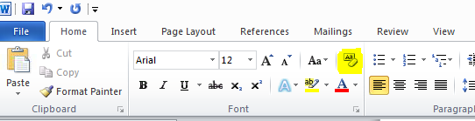

To copy and paste the text by selecting the paste option that keeps destination formatting.

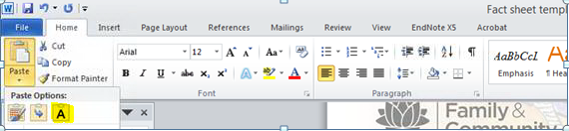

### Use the default styles

Use the default heading styles in this template and do not alter these styles. To apply a default style, highlight the text and click on the appropriate style in the style ribbon (found in the Home tab).

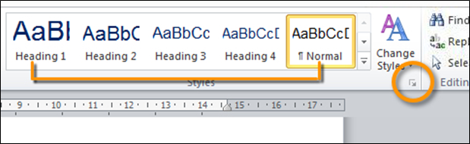

### Review accessibility

Use the accessibility checker to ensure your document meets accessibility requirements. For more guidance on making Word documents accessible, please see [our Word document accessibility page](http://intranet.facs.nsw.gov.au/internal_services/ministerial_and_communication_services/web-and-document-accessibility/word-documents).

Remember, information in headers or footers cannot be read by screen readers. Any information that is included in the header and footer must be replicated within the body text so it is accessible.

## Resources for writing

For support resources on writing, please visit the Ministerial and Communication Services (MACS) [writing guides and resources page](http://intranet.facs.nsw.gov.au/internal_services/ministerial_and_communication_services/writing-guides-and-resources).