**VIET NAM NATIONAL UNIVERSITY HO CHI MINH CITY**

**HO CHI MINH CITY UNIVERSITY OF TECHNOLOGY**

**FACULTY OF MECHANICAL ENGINEERING**

**DEPARTMENT OF MACHINE DESIGN**

**--------------oOo--------------**



**TRANSMISSION SYSTEM PROJECT**

**Topic:**

**Designing mixing drum transmission system**

Instructor: Ph.D Nguyễn Tấn Tiến

Student: Phan Đăng Khôi Nguyên – 1952366

HO CHI MINH CITY, December 14nd 2021

**TRANSMISSION SYSTEM PROJECT**

**(ME3145)**

**SEMESTER 212, 2021 – 2022**

Student: Phan Đăng Khôi Nguyên Student ID: 1952366

Instructor: Ph.D Nguyễn Tấn Tiến Sign:

Start date: 01/09/2021 End date: Defend date:

**Topic:**

**Designing mixing drum transmission system**

**Plan 9**

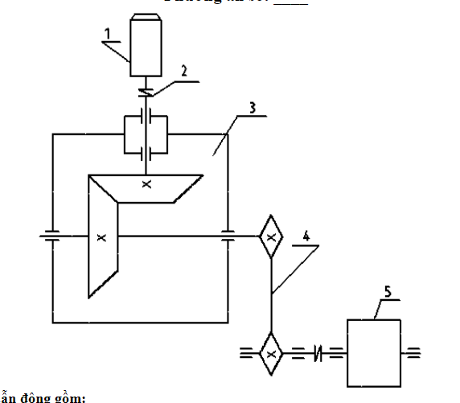

**The transmission system includes:**

1. Motor
2. Flexible coupling
3. Single stage bevel gear reducer
4. Roller chain sprocket system
5. Mixing drum

**Design information:**

* Power of working shaft, P (kW): 2.5
* Number of revolutions per minute of working shaft, n (rpm): 160
* Service life, Lh (hours): 10000
* One – way rotation, works 2 shifts

***INDEX***

***PART 1: MOTOR SELECTION AND TRANSMISSION RATIO***……..6

***PART 2: DESIGNING CHAIN DRIVE***…………………………………….9

**2.1 Initial Information**………………………………………………………...…..9

**2.2 Chain Sprocket Calculations**……………………………………………...….9

**2.3 Durability Check**……………………………………………………………..11

**2.4 Durability of Contact Check**………………………………………………...11

**2.5 Chain Drive Design Summary**………………………………………………12

***PART 3: DESIGNING BEVEL GEAR DRIVE***………………………….13

**3.1 Initial Information**…………………………………………………………...13

**3.2 Reducer Calculations**………………………………………………………...13

***PART 4: DESIGNING SHAFTS AND KEYS***……………………………20

**4.1 Choose material**………………………………………………………………20

**4.2 Preliminary shaft design**……………………………………………………..20

**4.3 Shaft Length Calculations**…………………………………………………...21

**4.3.1 Shaft 1**……………………………………………………………………….21

**4.3.2 Shaft 2**……………………………………………………………………….21

**4.4 Force caused by Coupling and Chain Sprocket Calculations**……………..21

**4.4.1 Force caused by Flexible Coupling**……………………………………..…21

**4.4.2 Force caused by Chain Sprocket**………………………………………….22

**4.5 Shaft Calculations** …………………………………………………………...22

**4.5.1 Shaft 1**……………………………………………………………………....22

**4.5.2 Shaft 2**………………………………………………………………………26

**4.6 Fatigue Strength Check**……………………………………………………..29

**4.7 Static Strength Check**……………………………………………………….32

**4.8 Key Check**……………………………………………………………………32

***PART 5: BEARING AND COUPLING SELECTION***…………………34

**5.1 Bearing Selection**…………………………………………………………….34

**5.1.1 On Shaft 1**………………………………………………………………….34

**5.1.2 On Shaft 2**………………………………………………………………….36

**5.2 Coupling Selection**…………………………………………………………..38

***PART 6: REDUCER CASE DESIGN***…………………………………….40

***PART 7: TOLERANCES***……………………………………………………45

***CONCLUSION & REFERENCE***…………………………………………46

***PART 1: MOTOR SELECTION AND TRANSMISSION RATIO***

Power necessary for motor:

$$P_{dc}=\frac{P_{ct}}{η_{sys}}=\frac{2.5}{0.85}=2.941 \left(kW\right)$$

$$η_{sys}=η_{bg}η_{rb}^{4}η_{c}^{2}η_{rc}= 0.96×{0.99}^{4}×{0.99}^{2}×0.90=0.85$$

Wherein:

* ηsys : general efficiency of the system.
* ηbg : efficiency of bevel gears.
* ηrb : efficiency of roller bearings.
* ηc : efficiency of couplings.
* ηrc : efficiency of roller chain sys.

*(Assuming lubricated working environment, calculated with smallest efficiency)*

General system transmission ratio $u_{sys}$ is:

$$u_{sys}=u_{bg}×u_{rc}= \frac{n_{dc}}{n_{ct}}$$

Wherein:

* usys : transmission ratio of system.
* ubg : transmission ratio of bevel gear single stage reducer (in range 2÷4).
* urc : transmission ratio of roller chain system (in range 2÷5).

We choose: $u_{ch}=3×3=9$ and $n_{dc}=n_{ct}×u_{ch}=160×9=1440 rpm$

Based on table **P1.3** in reference **[1]**, we choose motors with $P=3.0 \left(kW\right)$ so as to satisfy the condition $P{≥P}_{dc}$

**Table 1.1 Motors and Transmision ratios**

|  |  |  |  |  |  |  |
| --- | --- | --- | --- | --- | --- | --- |
| Motor type | Power (*kW*) | Rotational speed (*rpm*) | $$\cos{φ}$$ | $$η \%$$ | $$\frac{T_{max}}{T_{dn}}$$ | $$\frac{T_{k}}{T_{dn}}$$ |
| 4A100S4Y3 | 3.0 | 1420 | 0.83 | 82 | 2.2 | 2.0 |

Transmission ratio of reducer and roller chain system:

$$u_{hgt}=\frac{n}{u_{x}n_{ct}}=\frac{1420}{3×160}=2.958$$

$$u_{rc}=3$$

Working power on each shaft:

$$P_{3}=\frac{P_{ct}}{η_{c}η_{rb}}=\frac{2.5}{0.99×0.99}=2.551 \left(kW\right)$$

$$P_{2}=\frac{P_{3}}{η_{rc}η_{rb}}=\frac{2.551}{0.95×0.99}=2.712 \left(kW\right)$$

$$P_{1}=\frac{P_{2}}{η_{rb}η_{bg}η_{c}}=\frac{2.712}{0.99×0.95×0.99}=2.913 \left(kW\right)$$

Rotational speed on each shaft:

$$n_{dc}=n_{1}=1420 (rpm)$$

$$n_{2}=\frac{n_{1}}{u_{hgt}}=\frac{1420}{2.958}=480.054 \left(rpm\right)$$

$$n_{3}=\frac{n_{2}}{u_{rc}}=\frac{480.054}{3}=160.018 \left(rpm\right)$$

$$n_{ct}=160 \left(rpm\right)$$

Torque on each shaft:

$$T_{dc}=\frac{9.55×{10}^{6}×P_{dc}}{n_{dc}}=\frac{9.55×{10}^{6}×3}{1420}=19779.261 (Nmm)$$

$$T_{1}=\frac{9.55×{10}^{6}×P_{1}}{n_{1}}=\frac{9.55×{10}^{6}×2.913}{1420}=19590.951 (Nmm)$$

$$T_{2}=\frac{9.55×{10}^{6}×P_{2}}{n_{2}}=\frac{9.55×{10}^{6}×2.863}{480.054 }=56955.363 \left(Nmm\right)$$

$$T_{3}=\frac{9.55×{10}^{6}×P_{3}}{n_{3}}=\frac{9.55×{10}^{6}×2.551}{160}=152245.685 \left(Nmm\right)$$

$$T_{ct}=\frac{9.55×{10}^{6}×P_{ct}}{n_{ct}}=\frac{9.55×{10}^{6}×2.5}{160}=149218.750 \left(Nmm\right)$$

**Table 1.2 Technical specifications of transmission system table**

|  |  |  |  |  |  |  |  |  |
| --- | --- | --- | --- | --- | --- | --- | --- | --- |
| **Shaft**  **Parameters** | Motor | Shaft 1 | | Shaft 2 | | Shaft 3 | | Working shaft |
| Transmission ratio | 1 | | 2.958 | | 3 | | 1 | |
| Rotational speed (*rpm*) | 1420 | 1420 | | 480.054 | | 160.018 | | 160 |
| Power (*kW*) | 2.941 | 2.913 | | 2.712 | | 2.551 | | 2.5 |
| Torque (*Nmm*) | $$19779.26$$ | $$19590.951$$ | | $$56955.363$$ | | $$152245.685$$ | | 149218.750 |

***PART 2: DESIGNING CHAIN DRIVE***

**2.1 Initial Information**

|  |  |
| --- | --- |
| Transmission Power $P_{1}$ (*kW*) | 2.551 |
| Rotational speed $n_{1}$ (*rpm*) | 160.018 |
| Transmission Ratio $u_{rc}$ | 3 |

**2.2 Chain Sprocket Calculations**

Calculate number of teeth for driving sprocket gear:

$$z_{1}=29-2u=29-2×3=23 (teeth)$$

Calculate number of teeth for driven sprocket gear:

$z_{2}=u× z_{1}=3×23=69 (teeth)$ (so that $z_{2}<z_{max}=120 teeth$)

Calculating the power:

$$P_{t}=P_{3}× K× K_{Z}× K_{n}≤\left[P\right]$$

With:

$K_{Z}$: gear tooth factor.

$$K_{z}=\frac{25}{z_{1}}=\frac{25}{23}=1.087$$

$K_{n}$: rotational factor.

$$K_{n}=\frac{n_{01}}{n_{1}}=\frac{200}{160.018}=1.25$$

Calculating operational factor $K$:

$$K=K_{0}×K_{a}×K_{dc}×K_{d}×K_{c}×K_{bt}=1×1×1×1×1.25×1=1.25$$

Wherein:

* Factor taking into account the position of the system $K_{0}=1$ (line connecting two centers of the gear comparing to horizontal line, up to $60°$).
* Factor taking into account shaft distance and chain length $K_{a}=1$ (shaft distance $a=30÷50$).
* Factor taking into account adjustments of the tensile force on chain $K_{dc}=1$.
* Factor taking into account load conditions $K_{d}=1$ (static load).
* Factor taking into account working conditions $K_{c}=1.25$ (working 2 shifts).
* Factor taking into account lubrication $K_{bt}=1$

Calculating power:

$$P_{t}= P_{3}×K×K_{Z}×K_{n}=4.333 kW$$

Based on table **5.5** in reference **[1]**, choose:

$$P_{t}≤\left[P\right]=4.8 kW$$

Chain pitch $p_{c}=19.05 mm$

Shackle stud diameter $d_{c}=5.96 mm$

Tube length $B=17.75 mm$

Mean chain velocity:

$v=\frac{z_{1}×n_{1}×p_{c}}{60000}=1.169 m/s$

Calculating shaft distance:

$$a=40p_{c}=40×19.05=762.4$$

Number of chain link:

$$X=\frac{2a}{p_{c}}+\frac{z_{1}+z_{2}}{2}+\frac{{\left(z_{2}-z_{1}\right)}^{2}p_{c}}{4π^{2}×a }=127.34$$

Choose $X=128 links$

Recalculating shaft distance:

$$a=0.25p_{c}\left[X-\frac{\left(z_{1}+z_{2}\right)}{2}+\sqrt{{\left(X-\frac{z_{1}+z_{2}}{2}\right)}^{2}-8{\left(\frac{z_{2}-z_{1}}{2π}\right)}^{2}}\right]$$

$$a=0.25×19.06×\left[128-\frac{\left(23+69\right)}{2}+\sqrt{{\left(128-\frac{23+69}{2}\right)}^{2}-8{\left(\frac{69-23}{2π}\right)}^{2}}\right]=768.796 mm$$

To reduce the tensile force on chain, the shaft distance is reduced by

$$∆a=\left(0.002÷0.004\right), a=\left(1.538÷3.075\right)$$

Choose $a=767 mm$

Checking times of impact $i$ on chain hinge in 1 second:

$i=z_{1}×\frac{n_{1}}{15X}≤\left[i\right]$ với $\left[i\right]=35$ (Corresponding to chain pitch 19.05)

$i=232×\frac{160.018}{15×128}=1.917≤$ 35

**2.3 Durability Check**

Safety factor:

$$s=\frac{Q}{\left(k_{đ}F_{t}+F_{0}+F_{v}\right)}≥[s]$$

Wherein:

* Destroying load $Q=31.8 kN$ (based on table **5.2** in reference **[1]**).
* Dynamic load factor $k_{d}=1.2$ (average working conditions).
* Useful peripheral force: $F_{t}=\frac{1000P}{v}=\frac{1000×2.551}{1.169}=2182.21 N$.
* Tensile force caused by centrifugal force: $F_{v}= qv^{2}=1.9×1.169=2.2211 N$ ($q$: weight of 1 meter chain, based on table **5.2** in reference **[1]**).
* Tensile force caused by passive chain link $F_{0}=9.81k_{f}qa=9.81×6×1.9×768.796×{10}^{3}=85.978N$
* Allowable safety factor $\left[s\right]=8.2$ (based on table **5.10** in reference **[1]**).

We have:

$s=\frac{Q}{\left(k_{đ}F_{t}+F_{0}+F_{v}\right)}=\frac{31.8×{10}^{3}}{\left(1.2×2182.21+85.978+2.2211\right)}=11.753≥8.2$

Conclusion: chain drive system has passed the durability check.

**2.4 Durability of Contact Check**

$$σ_{H1}=0.47\sqrt{\frac{k_{r}\left(F_{t}k_{d}+F_{vd}\right)E}{AK_{d}}}≤\left[σ\right]$$

Wherein:

* Impact force on chain: $F_{vd}=13×{10}^{-7}× n_{1}× p_{c}^{3}=13×{10}^{-7}× 160.018×{19.05}^{3}= 1.438 N$
* Factor taking into account uneven load: $k_{d}=1$ (1 chain)
* Factor taking into account dynamic load: $K_{d}=1$ (tải trọng tĩnh)
* Factor taking into account number of teeth on sprocket gears: $k_{r}=0.44$
* Elastic modulus: $E=\frac{2E_{2}E_{1}}{E_{1}+E_{2}}=2.1×{10}^{5} MPa$
* Area of hinge: $A=106 mm^{2}$ (based on table **5.12** in reference **[1]**).

We have:

$$σ_{H1}=0.47\sqrt{\frac{k_{r}\left(F_{t}k_{đ}+F_{vd}\right)E}{AK_{đ}}}=0.47\sqrt{\frac{0.44\left(2182.21×1+1.438\right)×2.1×{10}^{5}}{106×1}}=648.444 MPa≤650 MPa$$

Choose material gray cast iron C4 28-48 (chilled).

**2.5 Chain Drive Design Summary**

Effective diameter of sprocket gear:

$$d_{1}=\frac{p_{c}}{\sin\left(\frac{π}{z_{1}}\right)}=\frac{19.05}{\sin\left(\frac{π}{23}\right)}=139.902 mm \\ d_{2}=\frac{p_{c}}{\sin\left(\frac{π}{z_{2}}\right)}=\frac{19.05}{\sin\left(\frac{π}{69}\right)}=418.547 mm$$

$$d_{a1}= p_{c}\left[0.5+\cot\left(\frac{π}{z_{1}}\right)\right]= 19.05\left[0.5+\cot\left(\frac{π}{23}\right)\right] =148.124$$

$$d_{a2}= p_{c}\left[0.5+\cot\left(\frac{π}{z_{2}}\right)\right]= 19.05\left[0.5+\cot\left(\frac{π}{69}\right)\right] =427.638$$

$$d_{f1}=d_{1}-2r=139.902-2×6.035=127.832$$

$$d_{f2}=d_{2}-2r=418.638-2×6.035=406.568$$

With $r=0.502{5d}_{1}+0.05=0.5025×11.91+0.05=6.035$

Force acting on shaft:

$$F_{r}=k_{x}F_{t}=1.15×2182.21=2509.54 N$$

With $k_{x}=1.15$ for all chain drive systems up to $40°$.

***PART 3: DESIGNING BEVEL GEAR DRIVE***

**3.1 Initial Information**

|  |  |
| --- | --- |
| Torque on driving shaft 1 $T_{1}$ (*Nmm*) | 19590.951 |
| Rotational speed of driving gear $n_{1}$ (*rpm*) | 1420 |
| Rotational speed of driven gear $n_{2}$ (*rpm*) | 480.054 |
| Transmission Ratio $u_{hr}$ | 2.958 |

**3.2 Reducer Calculations**

1. Choice of material

Since there is no special requirement and reducer works in normal conditions, we choose material for the bevel gear according to table **6.1** in reference **[1]**.

* For the driving gear, we will pick refined C45 steel with stiffness $H_{1}=250 HB$ as our material.
* For the driven gear, we will use refined C40 steel with Brinell hardness of $H_{2}=220 HB$ since it satisfies the following condition $H_{1}≥H_{2}+\left(10÷15\right) HB$.

We are able to extract information about the fatigue contact limits $σ_{OHlim }$ and fatigue stress limit $σ_{OFlim}$ for driving gear:

$$σ_{OHlim1 }=2HB+70=2×250+70=570 (MPa)$$

$$σ_{OFlim1}=1.8HB=1.8×250=450 \left(MPa\right)$$

and for driven gear:

$$σ_{OHlim2}=2HB+70=2×220+70=510 (MPa)$$

$$σ_{OFlim2}=1.8HB=1.8×220=396 \left(MPa\right)$$

1. Determining allowable contact stress $\left[σ_{H }\right]$ and allowable bending stress $\left[σ_{F}\right]$ for preliminary design

We first determine the number of cycles corresponding to the change of the stress-cycle diagram $N_{HO }$ and $N_{FO}$, also called base number of loading cycles on the driving and driven gears:

$$N_{HO1}=30H_{1}^{2.4}=30×{250}^{2.4}=1.71×{10}^{7} \left(cycles\right)$$

$$N_{HO2}=30H_{2}^{2.4}=30×{220}^{2.4}=1.26×{10}^{7} \left(cycles\right)$$

$$N_{FO1}=N_{FO2}=4×{10}^{6} \left(cycles\right)$$

Then we proceed to calculate the cyclic service time of the two gears:

$$N_{HE1}=N_{FE1}=60cn_{2}L_{h}=60×1×480×10000=28.8×{10}^{7}\left(cycles\right)$$

$$N_{HE2}=N_{FE2}=60cn_{3}L_{h}=60×1×160×10000=9.60×{10}^{7}\left(cycles\right)$$

Wherein

* $c=1$ is the number of tooth matings of the wheel per revolution.
* $n_{1}$ and $n_{2}$: each gear’s respective rotational speed.
* Lh: lifetime action period in hours given.

Because $N_{HE1}>N_{HO1}, N_{HE2}>N_{HO2}, N_{FE1}>N_{FO1}, N_{FE2}>N_{FO2}$, we will take $K_{HL1}=K_{HL2}=K_{FL1}=K_{FL2}=1$

From table **6.2** in reference **[1],** we extract factors of safety $s_{H}=1.1$ and $s_{F}=1.75$. With all the calculated values, we can determine the allowable contact and bending stresses:

$$\left[σ_{H1 }\right]=σ_{OHlim1 }\frac{0.9K_{HL1}}{s_{H}}=570×\frac{0.9×1}{1.1}=466.36 \left(MPa\right)$$

$$\left[σ_{H2 }\right]=σ_{OHlim2}\frac{0.9K_{HL2}}{s_{H}}=510×\frac{0.9×1}{1.1}=417.27 \left(MPa\right)$$

$$\left[σ_{F1 }\right]=σ_{OFlim1 }\frac{0.9K_{KL1}}{s_{F}}=450×\frac{0.9×1}{1.75}=231.43 \left(MPa\right)$$

$$\left[σ_{F2 }\right]=σ_{OFlim2 }\frac{0.9K_{FL2}}{s_{F}}=396×\frac{0.9×1}{1.75}=203.66 \left(MPa\right)$$

When overloaded:

$${\left[σ_{F1}\right]}_{max}= {0.8σ}_{ch}= 2.8 x 580 = 464 MPa$$

$${[σ_{F2}]}_{max}= 0.8σ_{ch2}= 2.8 x 450 = 360 MPa$$

For well-lubricated, encased gear drive such as this one, we will do design calculation according to contact stress so as to prevent potential pitting.

1. Selecting allowable contact stress $\left[σ_{H }\right]$

Since we are designing a bevel gear reducer, allowable contact stress is given by:

$$\left[σ_{H}\right]=\min_{1-2}{[σ_{Hi}]}=417.27 MPa$$

When overloaded:

$${[σ_{H}]}_{max}= 2.8σ_{chmin}= 2.8 x 450 = 1260 MPa$$

1. Pitch cone length

$$R_{e}=K_{R}\sqrt{u^{2}+1}×\sqrt[3]{\frac{T_{1}K_{Hβ}}{\left(1-K_{be}\right)×K_{be}×u×{\left[σ_{H}\right]}^{2}}}$$

$$K_{R}=0.5×K_{d}=0.5×100=50 MPa^{\frac{1}{3}}$$

(For straight bevel gearing made of steel $K_{d}=100 MPa^{1/3}$)

$$K_{be}=0.275$$

Based on table **6.21** in reference **[1]** and $\frac{K_{be}×u}{2-K_{be}}=0.48$

Gear shaft is installed on roller bearings, $HB<350$ so that we have: $K_{Hβ}=1.1$

Torque acting on driving gear shaft: $T_{I}=19590.951 Nmm$

$$\left[σ_{H}\right]=417.27 MPa$$

$$R_{e}=50\sqrt{3^{2}+1}×\sqrt[3]{\frac{19590.951×1.1}{\left(1-0.275\right)×0.275×3×{417.27}^{2}}}=93.521 mm$$

1. Gear mating parameters

Preliminary reference diameter for driving gear:

$$d_{e1}=\frac{2R_{e}}{\sqrt{1+u^{2}} }=\frac{2×93.521}{\sqrt{1+3^{2}} }=59.148 mm$$

Based on table **6.22** in reference **[1]**, we choose $z_{1p}=18 teeth$

Since the stiffness of material used to make gears < 350 HB:

$$z_{1}=1.6z_{1p}=1.6×18=28.8 teeth;choose z_{1}=29 teeth$$

Tooth reference angle:

$$δ_{1}=\arctan{\frac{1}{u}}=\arctan{\frac{1}{3}=18.435°}$$

$$δ_{2}=90-δ_{1}=71.565°$$

Number of teeth on equivalent cylindrical gear:

$$z_{vn1}=\frac{z_{1}}{\cos{δ_{1}}}=30.569 teeth$$

Mean diameter:

$$d_{m1}=\left(1-0.5K_{be}\right)d_{e1}=51.015 mm$$

Mean modulus:

$$m_{te}=\frac{d_{m1}}{z_{1}}=\frac{51.015}{29}=1.759$$

Modulus of bevel gear drive:

$$m_{te}=\frac{m_{tm}}{\left(1-0.5K_{be}\right)}=\frac{1.759}{1-0.5×0.275}=2.039$$

1. Recalculating parameters

Choose $m_{te}=2$ according to table **6.8** in reference **[1]**, we recalculate:

$$m_{tm}=m_{te}\left(1-0.5K_{be}\right)=2\left(1-0.5×0.275\right)=1.725 mm$$

Therefore:

$$d_{m1}=m_{tm}z_{1}=1.725×29=50.025 mm$$

Number of teeth on driving gear:

$$z_{2}=u_{br1}×z_{1}=3×29=87 răng$$

Recalculating transmission ratio:

$$u_{br1}=\frac{z_{2}}{z_{1}}=\frac{87}{29}=3$$

Recalculating tooth reference angle:

$$δ_{1}=\arctan{\frac{1}{u}}=\arctan{\frac{1}{3}=18.435°}$$

$$δ_{2}=90-δ_{1}=71.565°$$

Mean diameter:

$$d_{m2}=m_{tm}z_{2}=1.725×87=150.075 mm$$

1. Bevel gear drive geometry parameters summary:

|  |  |  |
| --- | --- | --- |
| **Parameter** | **Driving gear** | **Driven gear** |
| Pitch cone length | $$R_{e}=0.5m_{te}\sqrt{z_{1}^{2}+z_{2}^{2}}=0.5×2\sqrt{{29}^{2}+{87}^{2}}=91.706 mm$$ | |
| Width of face | $${b=K}_{be}R_{e}=0.275×91.706=25.219 mm$$ | |
| Outside ring modulus | $$m_{te}=2 mm$$ | |
| Transmission ratio | $$u_{br1}=3$$ | |
| Reference diameter | $$d_{e1}=m_{te}z_{1}=2×29=58 mm$$ | $$d_{e2}=m_{te}z_{2}=2×87=174 mm$$ |
| Tooth reference angle | $$18.435°$$ | $$71.565°$$ |
| Tooth height | $$h_{e}=2m_{te}+0.2m_{te}=2×2+0.2×2=4.4 mm$$ | |
| Tip tooth height | $$h_{ae1}=m_{te}=2$$ | $$h_{ae2}=2h_{te}m_{te}-h_{ae1}=2$$ |
| Root tooth height | $$h_{fe}=h_{e}-h_{ae}=2.4 mm$$ | |
| Outside tip tooth diameter | $$d_{ae1}=d_{e1}+2h_{ae}\cos{δ_{1}}=61.795 mm$$ | $$d_{ae2}=d_{e2}+2h_{ae}\cos{δ_{2}}=175.265 mm$$ |
| Mean velocity | $$v_{1}=\frac{πn_{1}d_{m1}}{60000}=3.72 m/s$$ | |

1. Contact durability check

Contact durability must satisfies:

$$σ_{H}=Z_{H}Z_{M}Z_{ε}\sqrt{\frac{{2T}_{1}K_{H}\sqrt{u^{2}+1}}{0.85×b×u×d_{m1}^{2}}}$$

Based on table **6.12** in reference **[1]**, we have:

$$Z_{H}=1.76 \left(extension x_{1}+x_{1}=0\right)$$

Based on table **6.5** in reference **[1]**, we have:

$$Z_{M}=274 MPa^{\frac{1}{3}} \left(material used to make gear is steel\right)$$

Horizontal mating factor:

$$ε_{a}=1.8-3.2\left(\frac{1}{z_{1}}+\frac{1}{z_{2}}\right)=1.653$$

$$Z_{ε}=\sqrt{\frac{4-ε_{a}}{3}}=0.884$$

Load factor: $K_{H}=K_{Hβ}×K_{Hα}×K_{Hv}$

Wherein:

$$K_{Hα}=1 \left(straight-tooth\right)$$

$$K_{Hβ}=1.1$$

$$K_{Hv}=1+\frac{v_{H}bd_{m1}}{{2T}_{1}K_{Hα}K_{Hβ}}$$

Based on table **6.13** in reference **[1]**, using precision level 8.

$$v_{H}=δ_{H}g_{0}v\sqrt{\frac{d_{m1}\left(u+1\right)}{u}}=0.006×56×3.72×\sqrt{\frac{50.025×4}{3}}=10.208\frac{m}{s}$$

Based on table **6.15** and **6.16** in reference **[1]**: $δ_{H}=0.006, g_{0}=56$

Tooth width ${b=K}_{be}×R_{e}=25.718 mm$

$${→K}_{Hv}=1+\frac{10.208×25.718×50.025}{2×19590.951×1×1.1}=1.305$$

Therefore $K_{H}=1.1×1×1.305=1.436$

$${→σ}_{H}=1.76×274×0.884×\sqrt{\frac{2×19590.951×1.436×\sqrt{3^{2}+1}}{0.85×25.718×3×{50.025}^{2}}=443.874 MPa}$$

$$σ_{H}>\left[σ_{H}\right]=417.27 MPa$$

Since the difference is negligible, we can adjust width of face:

$$b=25.718×{\left(\frac{443.874}{417.27}\right)}^{2}=29.102 mm; Choose b=30 mm$$

We have: $σ_{H}=410.977<\left[σ_{H}\right]=417.27$

Conclusion: bevel gear drive has passed the contact durability check.

1. Bending durability check

Bending durability must satisfies:

$$σ_{F1}=\frac{2T_{1}K_{F}Y_{ε}Y_{β}Y_{F1}}{0.85×b×m_{tm}×d_{m1}}$$

Load factor: $K_{F}=K_{Fβ}×K_{Fα}×K_{Fv}$

Wherein:

$$K_{Fα}=1 \left(straight-tooth\right)$$

Based on table **6.21** in reference **[1]** and $\frac{K_{be}×u}{2-K_{be}}=0.48$, we have $K_{Fβ}=1.2$

Based on table **6.15** in reference **[1], $δ_{F}=0.016$**

Based on table **6.16** in reference **[1], $g_{0}=56$**

$$v_{F}=δ_{F}g_{0}v\sqrt{\frac{d_{m1}(u+1)}{u}}=0.016×56×3.72×\sqrt{\frac{50.025×4}{3}}=27.222 m/s$$

$$K_{Hv}=1+\frac{v_{F}bd_{m1}}{{2T}_{1}K_{Fα}K_{Fβ}}=1+\frac{27.222×30×50.025}{2×19590.951×1×1.2}=1.869$$

Therefore: $K_{F}=1.2×1×1.869=2.243$

We have:

$$Y_{β}=1 \left(straight-tooth\right)$$

$$Y_{ε}=\frac{1}{ε_{a}}=\frac{1}{1.653}=0.605$$

Equivalent number of teeth:

$$z_{vn1}=\frac{z_{1}}{\cos{δ_{1}}}=\frac{29}{\cos{18.435°}}=30.569$$

$$z_{vn2}=\frac{z_{2}}{\cos{δ_{2}}}=\frac{87}{\cos{71.565°}}=275.117$$

Factor of tooth type:

$$Y_{F1}=3.47+\frac{13.2}{z_{vn1}}=3.902$$

$$Y_{F2}=3.47+\frac{13.2}{z_{vn2}}=3.518$$

Therefore:

$$σ_{F1}=\frac{2×19590.951×2.241×0.605×1×3.902}{0.85×30×1.725×50.025}=94.201 MPa$$

$$σ_{F1}<\left[σ_{F1}\right]=231.43 MPa$$

$$σ_{F2}=\frac{σ_{F1}×Y_{F2}}{Y_{F1}}=84.931 MPa$$

$$σ_{F2}<\left[σ_{F2}\right]=203.66 MPa$$

Conclusion: bending stress condition is satisfied, we can adjust the width of tooth to 30 *mm.*

1. Calculate force acting on gear shaft

Centripetal force:

$$F_{t1}=F_{t2}=\frac{2T_{1}}{d_{m1}}=\frac{2×19590.951}{50.025}=783.246 N$$

Centrifugal force:

$$F_{r1}=F_{a2}=F_{t1}×tan{α}×\cos{δ_{1}}=783.246××tan{20°}×\sin{18.435°}=270.449 N$$

Axial force:

$$F_{a1}=F_{r2}=F_{t1}×tan{α}×\sin{δ_{1}}=783.246××tan{20°}×\sin{18.435°}=90.150 N$$

*For the bevel gear drive, we don’t have to do overload check since the system is under static load. Rotational speed is constant and the probability of overloading is low.*

*Therefore, in the scope of this project, we don’t take into account the overload conditions of bevel gear drive.*

***PART 4: DESIGNING SHAFTS AND KEYS***

**4.1 Choose material**

We use refined C45 steel as material.

* Stiffness: 200HB
* Tensile strength: $σ_{b}=600 MPa$
* Yield strength: $σ_{ch}=340 MPa$
* Allowable stress: $\left[σ\right]=65 MPa;\left[τ\right]=20 MPa$

**4.2 Preliminary shaft design**

Torque parameters:

|  |  |
| --- | --- |
| **Torque** | **Magnitude (*Nmm*)** |
| $$T_{1}$$ | $$19590.951$$ |
| $$T_{2}$$ | $$56955.363$$ |
| $$T_{3}$$ | $$152245.685$$ |

With this information we proceed to calculate each of the shafts’ preliminary diameter:

$$d_{1}=\sqrt[3]{\frac{5T_{1}}{[τ]}}=\sqrt[3]{\frac{5×19590.951}{20}}=16.982 mm$$

Choose $d_{1}=20 mm$

$$d_{2}=\sqrt[3]{\frac{5T_{2}}{[τ]}}=\sqrt[3]{\frac{5×56955.363}{20}}=24.238 mm$$

Choose $d_{2}=25 mm$

$$d_{3}=\sqrt[3]{\frac{5T_{3}}{[τ]}}=\sqrt[3]{\frac{5×152245.685}{20}}=33.638 mm$$

Choose $d_{3}=40 mm$

**4.3 Shaft Length Calculations**

Based on table **10.3** in reference **[1]**, we choose lengths:

* Distance from rotating element to wall: $k_{1}=5…15 mm$
* Distance from bearing to wall $k_{2}=5…15 mm$
* Distance from rotating element to cover plate $k_{3}=10…20 mm$
* Height of cover plate plus screw: $h_{n}=15…20 mm$
* Bearing width, chosen according to preliminary diameter (table **10.2** in reference **[1]**)

$$k_{1}=5 mm; k_{2}=5 mm;k_{3}=6 mm$$

$$b_{1}=17 ;b_{2}=21$$

Parameters of coupling are based on table **16-10a** in reference **[2]**

**4.3.1 Shaft 1**

Length of coupling: $l_{m11}=40 mm$

Length of driving gear hub: $l_{m12}=25 mm$

Width of bearing: $b_{1}=17 mm$

Distance between two bearings: $l_{11}=60 mm$

Length of shaft 1: $l_{1}=l_{m11}+k_{1}+k_{2}+k_{3}+2b_{1}+l_{11}+k_{2}+k_{1}+l_{m12}=40+5+5+6+2×17+60+5+5+25=198 mm$

**4.3.2 Shaft 2**

Length of driven gear hub: $l_{m21}=40 mm$

Length of chain sprocket hub: $l_{m22}=40 mm$

Width of bearing: $b_{2}=21 mm$

Diameter of tip ring of driven gear: $d_{ae1}=61.795 mm$

Length of shaft 2: $l_{2}=l_{m21}+d_{ae1}+{3(k}_{1}+k_{2})+k_{3}+l_{m22}+{2b}_{2}=40+62+3\left(5+5\right)+6+40+2×(21)=218 mm$

**4.4 Force caused by Coupling and Chain Sprocket Calculations**

**4.4.1 Force caused by Flexible Coupling**

Force caused by flexible coupling is centrifugal. Direction of this force has the tendency to increase stress and deformation caused by centripetal force of driving bevel gear acting on shaft.

$$F_{nt}=0.25×\frac{2T_{1}}{D_{t}}=0.25×2×\frac{19590.951}{63}=155.484 N$$

**4.4.2 Force caused by Chain Sprocket**

Force acting on shaft caused by chain drive system is tensile force towards center, with direction from driving chain sprocket to driven chain sprocket.

$$F_{r}=2329.1 N$$

**4.5 Shaft Calculations**

**4.5.1 Shaft 1**

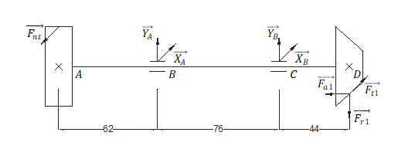

Moment caused by axial force: ${M=F}_{a1}× d_{m1}/2=90.150×50.025/2=2254.877 Nmm$

Force equations:

$$\sum{F_{X}}=X_{A}+X_{B}-F_{nt}+F_{t1}=0$$

$${↔X}_{A}+X_{B}=F_{nt}-F_{t1}=155.484-783.246=-627.762 N$$

$$\sum{F_{Y}}=Y_{A}+Y_{B}-F_{r1}=0$$

$${↔Y}_{A}+Y_{B}=F_{r1}=270.449 N$$

$$\sum{M_{Y/A}}={62F}_{nt}+120F_{t1}+76X_{B}=0$$

$$↔62×155.484+120×783.246+76X_{B}=0$$

$$→X_{B}=-1363.546 N→X_{A}=735.784 N$$

$$\sum{M_{X/A}}=M+{120F}_{r1}-{76Y}_{B}=0$$

$↔2254.877+120×270.449-{76Y}_{B}=0$

$$→Y_{B}$$

$$=456.694 N→Y_{A}=-186.245 N$$

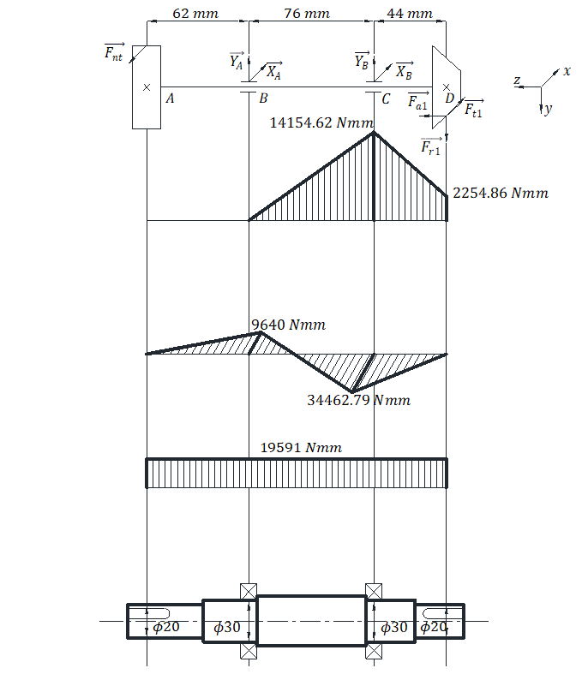

*Figure 4.5.1 Bending Moment and Torque diagram for shaft 1*

Allowable stress $\left[σ\right]=65 MPa$

Equivalent moment at cross section j:

$$M_{tđ}=\sqrt{M_{j}^{2}+0.75T_{j}^{2}}; M_{j}=\sqrt{M_{xj}^{2}+M_{yj}^{2}}$$

Shaft diameter at cross section j:

$$d_{j}=\sqrt[3]{\frac{M_{tđj}}{0.1[σ]}}$$

Calculating shaft diameter at cross section j:

$$d_{j}=\sqrt[3]{\frac{\sqrt{M_{xj}^{2}+M_{yj}^{2}+0.75T_{j}^{2}}}{0.1[σ]}}$$

$$d_{A}=\sqrt[3]{\frac{\sqrt{M_{xA}^{2}+M_{yA}^{2}+0.75T_{A}^{2}}}{0.1[σ]}}=\sqrt[3]{\frac{\sqrt{0+0+0.75×{19591}^{2}}}{0.1×65}}=13.769 mm$$

Choose $d_{A}=20 mm$

$$d_{B}=\sqrt[3]{\frac{\sqrt{M_{xB}^{2}+M_{yB}^{2}+0.75T_{B}^{2}}}{0.1[σ]}}=\sqrt[3]{\frac{\sqrt{{9640}^{2}+0+0.75×{19591}^{2}}}{0.1×65}}=14.426 mm$$

Choose $d_{B}=30 mm$

$$d_{C}=\sqrt[3]{\frac{\sqrt{M_{xC}^{2}+M_{yC}^{2}+0.75T_{C}^{2}}}{0.1[σ]}}=\sqrt[3]{\frac{\sqrt{{34462.79}^{2}+{14154.62}^{2}+0.75×{19591}^{2}}}{0.1×65}}=18.467 mm$$

Choose $d_{c}=30 mm$

$$d_{D}=\sqrt[3]{\frac{\sqrt{M_{xD}^{2}+M_{yD}^{2}+0.75T_{D}^{2}}}{0.1[σ]}}=\sqrt[3]{\frac{\sqrt{0+{2254.864}^{2}+0.75×{19591}^{2}}}{0.1×65}}=13.81 mm$$

Choose $d_{D}=20 mm$

**4.5.2 Shaft 2**

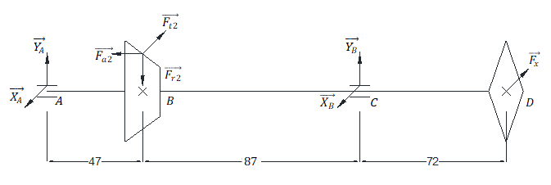

Moment caused by axial force: ${M=F}_{a2}× d_{m2}/2=270.449×150.075/2=20293.82 Nmm$

Force equations:

$$\sum{F_{X}}={-X}_{A}-X_{B}+F_{x}+F_{t2}=0$$

$${↔X}_{A}+X_{B}=F_{x}+F_{t2}=2509.54+783.246=3292.786 N$$

$$\sum{F_{Y}}=Y_{A}+Y_{B}-F_{r2}=0$$

$${↔Y}_{A}+Y_{B}=F_{r2}=90.150 N$$

$$\sum{M_{Y/A}}={47F}_{t2}-154X_{B}+226F_{x}=0$$

$$↔47×783.246-154X_{B}+226×2509.54=0$$

$$→X_{B}=3921.87 N→X_{A}=-629.08 N$$

$$\sum{M_{X/A}}=M-{47F}_{r2}+154Y_{B}=0$$

$$↔20293.82-47×90.150+154Y_{B}=0$$

$$→Y_{B}=-104.265 N→Y_{A}=194.415 N$$

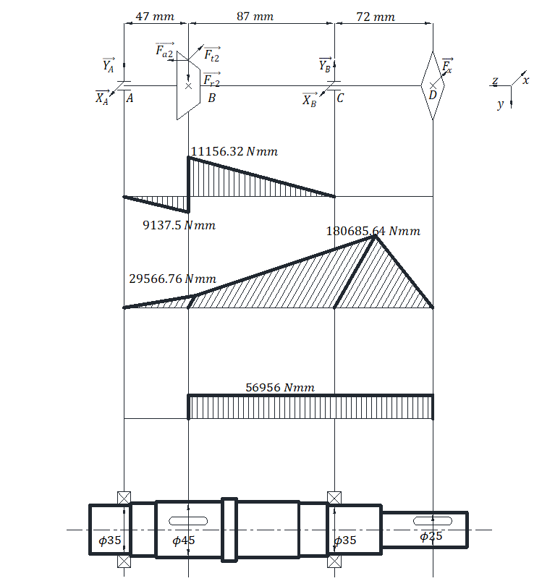

*Figure 4.5.2 Bending Moment and Torque diagram for shaft 2*

Allowable stress $\left[σ\right]=65 MPa$

$$d_{A}=\sqrt[3]{\frac{\sqrt{M_{xA}^{2}+M_{yA}^{2}+0.75T_{A}^{2}}}{0.1[σ]}}=\sqrt[3]{\frac{\sqrt{0+0+0.75×0^{2}}}{0.1×65}}=0 mm$$

$$d_{B}=\sqrt[3]{\frac{\sqrt{M_{xB}^{2}+M_{yB}^{2}+0.75T_{B}^{2}}}{0.1[σ]}}=\sqrt[3]{\frac{\sqrt{{29566.76}^{2}+{11156.32}^{2}+0.75×{56956}^{2}}}{0.1×65}}=20.81 mm$$

Choose $d_{B}=45 mm$

$$d_{C}=\sqrt[3]{\frac{\sqrt{M_{xC}^{2}+M_{yC}^{2}+0.75T_{C}^{2}}}{0.1[σ]}}=\sqrt[3]{\frac{\sqrt{{180685.64}^{2}+0+0.75×{56956}^{2}}}{0.1×65}}=30.66 mm$$

Choose $d_{A}=d_{c}=35 mm$

$$d_{D}=\sqrt[3]{\frac{\sqrt{M_{xD}^{2}+M_{yD}^{2}+0.75T_{D}^{2}}}{0.1[σ]}}=\sqrt[3]{\frac{\sqrt{0+0+0.75×{56956}^{2}}}{0.1×65}}=19.65 mm$$

Choose $d_{D}=25 mm$

**4.6 Fatigue Strength Check**

We will conduct check on safety factor:

$$s_{j}=\frac{s_{σj}s_{τj}}{\sqrt{s_{σj}^{2}+s_{τj}^{2}}}≥[s]$$

Wherein:

$s_{σj}=\frac{σ_{-1}}{K_{σdj}σ_{aj}+ψ_{σ}σ_{mj}}$

$s_{τj}=\frac{τ_{-1}}{K_{τdj}τ_{aj}+ψ_{τ}τ_{mj}}$

$[s]$ is the value for allowable safety factor, choosing it to be 3 so that we don’t need to check on shaft stiffness.

On the other hand, we have:

Fatigue strength of Cacbon steel (material of shaft) is:

$$σ_{-1}=0.436σ_{b}=0.436×600=261.6 MPa$$

Torsional strength is:

$$τ_{-1}=0.58σ_{b}=0.58×261.6=151.73 MPa$$

Since shaft rotates, bending stress changes in symmetrical cycle:

Mean value of normal stress at cross section j: $σ_{mj}=0$

Magnitude of normal stress at cross section j: $σ_{aj}=σ_{maxj}=M_{j}/W_{j}$

Where $M_{j}$ is bending moment $M_{j}=\sqrt{M_{xj}^{2}+M_{yj}^{2}}$

$W_{j}$ is induced bending moment, according to table **10.6** in reference **[1]**, for shaft with one keyway:

$W_{j}=\frac{πd_{j}^{3}}{32}-\frac{bt_{1}{\left(d_{j}-t_{1}\right)}^{2}}{2d_{j}}$

The system is designed for one-way rotation:

Mean value of stress at cross section j: $τ_{mj}=0$

Magnitude of normal stress at cross section j: $τ_{aj}=τ_{maxj}=T_{j}/2W_{oj}$

Where $T_{j}$ is torsional moment at cross section j

$W_{oj}$ is torsional moment, according to table **10.6** in reference **[1]**, for shaft with one keyway:

$W_{oj}=\frac{πd_{j}^{3}}{16}-\frac{bt_{1}{\left(d_{j}-t_{1}\right)}^{2}}{2d_{j}}$

Factors $ψ_{σ}, ψ_{τ}$ take into account mean stress value on fatigue strength, based on table **10.7** in reference **[1]**, we have: $ψ_{σ}=0.05, ψ_{τ}=0$

Factors $K_{σdj},K_{τdj}$ are calculated by formuli **10.25** and **10.26** in reference **[1]**:

$$K_{σdj}=\frac{\frac{K_{σ}}{ε_{σ}}+K_{X}-1}{K_{γ}}$$

$$K_{τdj}=\frac{\frac{K_{τ}}{ε_{τ}}+K_{X}-1}{K_{γ}}$$

Factor taking into concentrated stress caused by surface condition $K_{X}=1.06$ since shaft is manufactured by lathe machine with roughness factor $R_{a}=2.5÷0.63$, correlates to strength factor $σ_{b}=600 MPa$

Factor taking into incremental strength $K_{γ}=2$, shaft surface is case-hardened.

Dimension parameters: $ε_{σ}, ε_{τ}$ according to table **10.10** in reference **[1]**

Parameteres $K_{σ}, K_{τ}$ according to table **10.12** in reference **[1]**, correlates to keyway produced by milling cutter: $K_{σ}=1.76, K_{τ}=1.54$

We can summarize parameters of fatigue strength check on shafts:

|  |  |  |  |  |  |  |  |  |  |  |  |
| --- | --- | --- | --- | --- | --- | --- | --- | --- | --- | --- | --- |
| Shaft | Position (cross section) | Key ${b×h×t}_{1}$ | $$W_{j}$$ | $$W_{oj}$$ | $$ε_{σ}$$ | $$ε_{τ}$$ | $$σ_{a}$$ | $$τ_{a}$$ | $$s_{σ}$$ | $$s_{τ}$$ | $$s$$ |
| **1** | A (20) | $$6×6×3$$ | 655.35 | 1440.75 | 0.92 | 0.89 | 0 | 6.8 | x | 24.93 | x |
| D (20) | $$6×6×3$$ | 655.35 | 1440.75 | 0.92 | 0.89 | 3.44 | 6.8 | 77.06 | 24.93 | 23.72 |
| B, C (30) | x | 1533.98 | 3067.96 | 0.9 | 0.85 | 23.33 | 3.19 | 11.13 | 30.82 | 10.47 |
| **2** | A (35) | x | 4209.24 | 8418.49 | 0.865 | 0.795 | 0 | 0 | x | x | x |
| C (35) | x | 4209.24 | 8418.49 | 0.865 | 0.795 | 42.93 | 6.77 | 5.82 | 22.44 | 5.63 |
| B (45) | $$10×8×5$$ | 3566.39 | 7775.63 | 0.865 | 0.795 | 8.86 | 3.66 | 28.19 | 41.52 | 23.32 |
| D (25) | $$8×7×4$$ | 1133.98 | 2667.96 | 0.9 | 0.85 | 0 | 10.67 | x | 15.19 | x |

Conclusion: all safety factors on table is larger than $\left[s\right]=3$. Therefore all shafts have passed fatigue strength check.

**4.7 Static Strength Check**

$$σ_{td}=\sqrt{σ^{2}+3τ^{2}}≤[σ]$$

Wherein:

$$σ=M_{max}/(0.1d^{3})$$

$$τ=T_{max}/(0.2d^{3})$$

$$\left[σ\right]=0.8σ_{ch}=0.8×340=272 MPa$$

Shaft 1:

$$σ=\frac{M_{max}}{0.1d^{3}}=\frac{\sqrt{{9644.86}^{2}+{34462.79}^{2}}}{0.1×{25}^{3}}=22.9$$

$$τ=\frac{T_{max}}{0.2d^{3}}=\frac{19591}{0.2×{20}^{3}}=12.24$$

Shaft 2:

$$σ=\frac{M_{max}}{0.1d^{3}}=\frac{\sqrt{{180685.64}^{2}}}{0.1×{35}^{3}}=42.14$$

$$τ=\frac{T_{max}}{0.2d^{3}}=\frac{56956}{0.2×{25}^{3}}=18.23$$

$$σ_{td}=\sqrt{σ^{2}+3τ^{2}}=\sqrt{{42.14}^{2}+3×{18.23}^{2}}=52.66≤[σ]$$

Conclusion: all shafts have passed static strength check.

**4.8 Key Check**

Parameteres of keys are based on table **9.1a** in reference **[1]**.

Conditions of impact and shearing strength:

$$σ_{d}=\frac{2T}{\left[dl_{t}\left(h-t_{1}\right)\right]}≤\left[σ_{d}\right]=150 MPa$$

$$τ_{c}=\frac{2T}{dl_{t}b}≤\left[τ_{c}\right]=60 MPa$$

Wherein:

* $T$: Torsional moment on shaft (*Nmm*).
* $d$: diameter of shaft at cross section with key.
* $l_{t}$: length of key.
* $h$: height of key.
* $t_{1}$: depth of keyway

We have key checking table:

|  |  |  |  |  |  |
| --- | --- | --- | --- | --- | --- |
| Shaft | Diameter d | $${b×h×t}_{1}$$ | $$l_{t}$$ | $$σ_{d}$$ | $$τ_{c}$$ |
| **1** | 20 | $$6×6×3$$ | 35 | 32.65 | 16.33 |
| 20 | $$6×6×3$$ | 20 | 32.65 | 16.33 |
| **2** | 45 | $$10×8×5$$ | 30 | 30.14 | 9.04 |
| 25 | $$8×7×4$$ | 35 | 30.38 | 9.11 |

Conclusion: all stress values on key satisfy.

***PART 5: BEARING AND COUPLING SELECTION***

**5.1 Bearing Selection**

**5.1.1 On Shaft 1**

$$n=1420 rpm$$

Working time: $L=10000 hours$

Inner diameter of bearing: $d=30 mm$

Since driving bevel gear is installed on input shaft, axial force acting on shaft is . Therefore, we choose roller bearing on input shaft, distributed in round shape.

Choose bearing with respect to dynamic load:

Based on table **P 2.11** in reference **[1]**

|  |  |  |  |  |  |  |  |  |
| --- | --- | --- | --- | --- | --- | --- | --- | --- |
| Designation | $$d (mm)$$ | $$D (mm)$$ | $$B (mm)$$ | $$T (mm)$$ | $$r (mm)$$ | $$α (°)$$ | $$C (KN)$$ | $$C_{0} (KN)$$ |
| 7206 | 30 | 62 | 16 | 17.25 | 1.5 | 13.67 | 29.8 | 22.3 |

Force distribution:

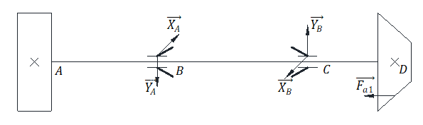

Centrifugal force at roller bearings:

$$F_{RB}=\sqrt{Y_{A}^{2}+X_{A}^{2}}=\sqrt{{126.906}^{2}+{735.784}^{2}}=746.65 N$$

$$F_{RC}=\sqrt{Y_{B}^{2}+X_{B}^{2}}=\sqrt{{397.355}^{2}+{1363.546}^{2}}=1420.28 N$$

Where: $e=1.5\tan{α}=1.5\tan{13.67=0.36}$

Axial force at B: $\sum{F_{aB}}=F_{sC}+F_{a1}=0.83e×F_{rB}+F_{a1}=0.83×0.36×1420.28+90.15=514.53 N$

Since $\sum{F_{aB}}>F_{sB}=0.83×0.36×746.65=223.1→F_{aB}=\sum{F_{aB}}=514.53$

Axial force at C: $\sum{F_{aC}}=F_{sB}+F_{a1}=0.83e×F_{rB}-F_{a1}=0.83×0.36×746.65-90.15=132.95 N$

Since $\sum{F_{aC}}>F_{sC}=0.83×0.36×1420.28=424.38→F_{aC}=F_{sC}=424.38$

We have:

$$\frac{F_{aB}}{VF_{RB}}=\frac{514.53}{1×746.65}=0.689>e$$

Based on table **11.4** in reference **[1]**:

$$X=0.4;Y=0.4\cot{α}=1.666$$

$$\frac{F_{aB}}{VF_{RB}}=\frac{424.38}{1×1420.28}=0.299<e$$

$$X=1;Y=0$$

Convention load on bearing:

$$Q_{B}=\left(XVF_{rB}+YF_{aB}\right)K_{t}K_{đ}=\left(0.4×1×746.65+1.666×514.53\right)×1×1.2=1387.04 N$$

$$Q_{C}=\left(XVF_{rC}+YF_{aC}\right)K_{t}K_{đ}=1×1×1420.28×1×1.2=1704.34 N$$

Wherein:

$V=1$ rotating inner ring

factor taking into account heat ()

applied to minimal impact conditions, short-term overload according to table **11.3** in reference **[1]**

Since we recalculate with respect to parameters at C.

Life of bearing in million revolutions:

Static load rating:

using roller bearing

Real life cycle of bearing:

For roller bearing, we have: $X_{0}=0.5, Y_{0}=0.22\cot{α}=0.22\cot{13.5}=0.916$

Based on formula **11.19** in reference **[1]**

$$Q_{0C}=X_{0}F_{rC}+Y_{0}F_{aC}=0.5×1420.28+0.916×132.95=831.92 N<F_{rC}$$

$$→Q_{0C}=F_{rC}=831.92 N≪C_{0}=29800 N$$

Conclusion: bearing satisfies static load ratings.

**5.1.2 On Shaft 2**

$$n=480.054 rpm$$

Working time: $L=10000 hours$

Inner diameter of bearing: $d=35 mm$

Since driving bevel gear is installed on input shaft, axial force acting on shaft is . Therefore, we choose roller bearing on input shaft, distributed in round shape.

Choose bearing with respect to dynamic load:

Based on table **P 2.11** in reference **[1]**

|  |  |  |  |  |  |  |  |  |
| --- | --- | --- | --- | --- | --- | --- | --- | --- |
| Designation | $$d (mm)$$ | $$D (mm)$$ | $$B (mm)$$ | $$T (mm)$$ | $$r (mm)$$ | $$α (°)$$ | $$C (KN)$$ | $$C_{0} (KN)$$ |
| 7207 | 35 | 72 | 17 | 18.25 | 2.0 | 13.83 | 35.2 | 26.3 |

Force distribution:

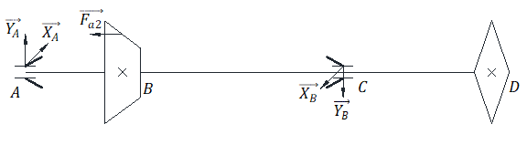

Centrifugal force at roller bearings:

$$F_{RA}=\sqrt{Y_{A}^{2}+X_{A}^{2}}=\sqrt{{194.415}^{2}+{629.08}^{2}}=658.44 N$$

$$F_{RC}=\sqrt{Y_{B}^{2}+X_{B}^{2}}=\sqrt{{104.265}^{2}+{3921.87}^{2}}=3923.26 N$$

Where: $e=1.5\tan{α}=1.5\tan{13.83=0.37}$

Axial force at A: $\sum{F_{aA}}=F_{sC}+F_{a2}=0.83e×F_{rC}+F_{a2}=0.83×0.37×3923.26+270.449=1475.28 N$

Since $\sum{F_{aA}}>F_{sA}=0.83×0.37×658.44=202.211→F_{aA}=\sum{F_{aA}}=1475.28$

Axial force at C: $\sum{F_{aC}}=F_{sA}-F_{a2}=0.83e×F_{rA}-F_{a2}=0.83×0.37×658.44-270.449=-68.24 N$

Since $\sum{F_{aC}}<F_{sC}=0.83×0.36×3923.26=1172.27→F_{aC}=F_{sC}=1172.27$

We have:

$$\frac{F_{aA}}{VF_{RA}}=\frac{1475.28}{1×658.44}=2.24>e$$

Based on table **11.4** in reference **[1]**:

$$X=0.4;Y=0.4\cot{α}=1.625$$

$$\frac{F_{aC}}{VF_{RC}}=\frac{68.24}{1×3923.26}=0.017<e$$

$$X=1;Y=0$$

Convention load on bearing:

$$Q_{A}=\left(XVF_{rA}+YF_{aA}\right)K_{t}K_{đ}=\left(0.4×1×658.44+1.625×1475.28\right)×1×1.2=3192.85 N$$

$$Q_{C}=\left(XVF_{rC}+YF_{aC}\right)K_{t}K_{đ}=1×1×3923.26×1×1.2=4707.91 N$$

Wherein:

$V=1$ rotating inner ring

factor taking into account heat ()

applied to minimal impact conditions, short-term overload according to table **11.3** in reference **[1]**

Since we recalculate with respect to parameters at C.

Life of bearing in million revolutions:

Static load rating:

using roller bearing

Real life cycle of bearing:

For roller bearing, we have: $X_{0}=0.5, Y_{0}=0.22\cot{α}=0.22\cot{13.83}=0.868$

Based on formula **11.19** in reference **[1]**

$$Q_{0C}=X_{0}F_{rC}+Y_{0}F_{aC}=0.5×3923.26+0.868×68.24=2020.86 N<F_{rC}$$

$$→Q_{0C}=F_{rC}=2020.86 N≪C_{0}=26300 N$$

Conclusion: bearing satisfies static load ratings.

**5.2 Coupling Selection**

We will use flexible coupling since its advantages are simple mechanism, easy to manufacture, easy to replace and reliability.

Torsional moment at input shaft: $T_{1}=19590.951 Nmm=19.59 Nm$

Based on table **16.10a** in reference **[2]**, we have parameters for coupling:

|  |  |  |  |  |  |  |  |  |  |  |  |
| --- | --- | --- | --- | --- | --- | --- | --- | --- | --- | --- | --- |
| $$T$$ | $$d$$ | $$D$$ | $$d_{m}$$ | $$L$$ | $$l$$ | $$d_{1}$$ | $$D_{0}$$ | $$Z$$ | $$n_{max}$$ | $$d_{c}$$ | $$l_{3}$$ |
| $$Nm$$ | $$mm$$ | $$mm$$ | $$mm$$ | $$mm$$ | $$mm$$ | $$mm$$ | $$mm$$ | $$mm$$ | $$rpm$$ | $$mm$$ | $$mm$$ |
| 250 | 20 | 125 | 65 | 168 | 83 | 40 | 90 | 4 | 65000 | 14 | 75 |

Checking impact strength:

$$σ_{d}=\frac{2kT}{ZD_{0}d_{c}l_{3}}≤[σ_{d}]$$

Where $\left[σ_{d}\right]=3 MPa$, allowable impact stress of rubber

$k$: factor taking into account working condition, choose 1.35 for mixing drum system

$$σ_{d}=\frac{2kT}{ZD_{0}d_{c}l_{3}}=\frac{2×1.35×19590.951}{4×90×14×75}=1.399 MPa$$

Conclusion: shaft has passed impact strength check.

Checking strength of pin:

$$σ_{u}=\frac{kTl_{0}}{0.1ZD_{0}d_{c}^{3}}≤[σ_{u}]$$

With $\left[σ_{u}\right]=70 MPa$, allowable stress of pin

$$l_{0}=l_{1}+\frac{l_{2}}{2}=20+\frac{10}{2}=25 mm$$

We have:

$$σ_{u}=\frac{kTl_{0}}{0.1ZD_{0}d_{c}^{3}}=\frac{1.35×19590.951×30}{0.1×4×90×{14}^{3}}=26.238 MPa$$

Conclusion: pin has passed strength check.

***PART 6: REDUCER CASE DESIGN***

Reducer case takes the responsibility of maintaining relative position between components, receiving load from elements installed on the outside, containing lubrication oil and covering inside components.

The material used to produce this case is cast iron GX15-32.

The reducer’s basic dimensions are given in the table below:

|  |  |
| --- | --- |
| **Parameters meaning** | **Parameters** |
| Thickness:  Case body $δ$ Case top $δ_{1}$ | $$δ=8 mm$$ $$δ_{1}=5 mm$$ |
| Stiffening rib:  Thickness $e$ | $$e=8 mm$$ |
| Diameter:  Foundation bolt $d_{1}$ Bearing side bolt $d_{2}$ Connecting top and body bolt $d_{3}$ Cover plate screw ${ d}_{4}$ Observation cap screw $d_{5}$ | $$d_{1}=18 mm$$ $$d_{2}=12 mm$$ $$d_{3}=10 mm$$ $$d_{4}=8 mm$$ $$d_{5}=8 mm$$ |
| Top and body flange:  Body thickness $S_{3}$ Top thickness $S_{4}$ Width of top and body $K_{3}$ | $$S_{3}=12 mm$$ $$S_{4}=12 mm$$ $$K_{3}=36 mm$$ |
| Width of flange at bearing side $K_{2}$ Center of bolt at bearing side $E_{2}$ và $C$ Distance from bolt center to hole $k$ | $$E_{2}=20 mm$$ $$R_{2}=16 mm$$ $$K_{2}=40 mm$$ $$k>14.4 mm$$ |
| Bottom flange:  Thickness $S_{1}$ Width $K_{1}$ | $$S_{1}=12 mm$$ $$S_{2}=20 mm$$ $$K_{1}=42 mm$$ $$q=65 mm$$ |
| Cleft between elements:  Gear and wall  Larger gear and bottom wall | $$∆=5$$ $$∆_{1}=24$$ |
| Number of foundation bolt | $$Z=4$$ |

**Table 6.1 Reducer’s basic dimensions**

There are a total of 3 bearing cover plates, all of which are made of cast iron GX15-32. In figure 6.1 below, the cover plate on the left is a through hole cover plate which has an oil seal attached to prevent outside contaminants such as dust from coming in and inside lubricant from leaking out. The one on the right is a blind hole cover plate. Basic dimensions of these plates are given in table 6.2.

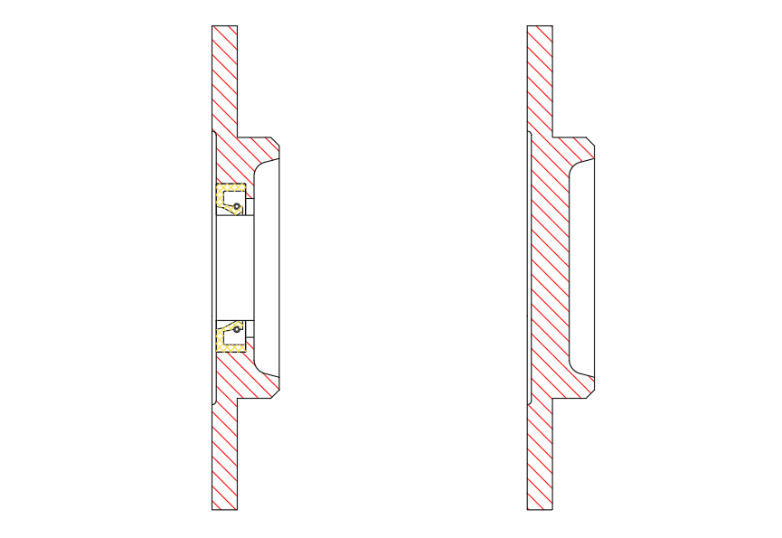*Figure 6.1 Bearing Cover Plates (through hole – left; blind hole – right)*

**Table 6.2 Bearing Cover Plates**

|  |  |  |  |  |  |  |  |
| --- | --- | --- | --- | --- | --- | --- | --- |
| **Shaft** | $$D$$ | $$D_{2}$$ | $$D_{3}$$ | $$D_{4}$$ | $$h$$ | $$d_{4}$$ | $$Z$$ |
| 1 | 74 | 90 | 115 | 65 | 10 | M8 | 4 |
| 2 | 74 | 90 | 115 | 65 | 10 | M8 | 4 |

Observation cap is a plate/lid on top of the reducer through which can inspect the inside of the machine. In this model, the ventilation plug is mounted onto the observation cap. Figure 6.2 below illustrates a set of observation cap – ventilation plug and table 6.3 – 6.4 give dimensions of these parts. The cap is made of cast iron GX15-32 (shown in red hatch) while the vent plug is made of steel CT3 (shown in yellow hatch).

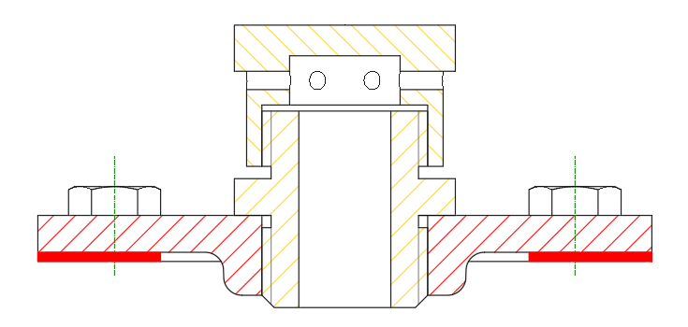

*Figure 6.2 Set of observation cap – ventilation plug*

**Table 6.3 Observation Cap**

|  |  |  |  |  |  |  |
| --- | --- | --- | --- | --- | --- | --- |
| A1 | B1 | C | K | R | Screw | Quantity |
| 100 | 80 | 75 | 30 | 3 | M8x12 | 4 |

**Table 6.4 Ventilation Plug**

|  |  |  |  |  |  |  |  |  |  |  |  |  |  |  |  |  |
| --- | --- | --- | --- | --- | --- | --- | --- | --- | --- | --- | --- | --- | --- | --- | --- | --- |
| A | B | C | D | E | G | H | J | $$l$$ | K | L | M | N | O | Q | P | R |
| M27 $×$ 2 | 15 | 30 | 15 | 45 | 36 | 32 | 6 | 4 | 10 | 8 | 22 | 6 | 32 | 18 | 36 | 32 |

The oil dipstick is used to check the oil level inside the reducer. The highest oil level and the lowest oil level are 14 (*mm*) apart. Note that the oil level does not go above the center of the roller/ball of the ball bearing; consequently, we install oil splasher to help splash the lubricant on to the working gears.

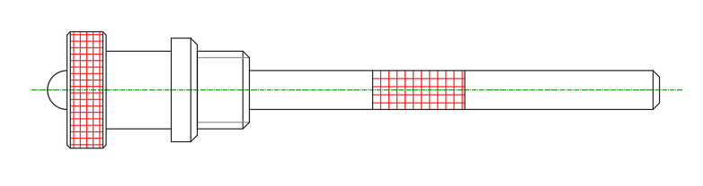

*Figure 6.3 Oil Dipstick*

**Table 6.5 Oil Dipstick**

|  |  |  |  |  |  |  |  |  |
| --- | --- | --- | --- | --- | --- | --- | --- | --- |
| $$d$$ | $$d_{1}$$ | $$d_{2}$$ | $$D$$ | $$D_{1}$$ | $$L_{1}$$ | $$l$$ | $$l_{1}$$ | $$b$$ |
| M12 $×$ 1.25 | 5 | 6 | 18 | 12 | 30 | 12 | 6 | 3 |

The drain plug empties out the oil bath. Its dimension is given in table 6.6

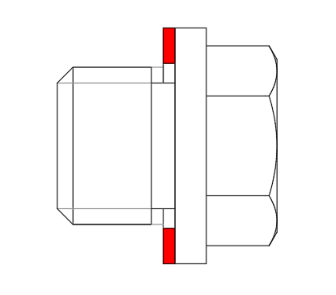

*Figure 6.4 Drain Plug*

**Table 6.6 Drain Plug**

|  |  |  |  |  |  |  |  |  |  |  |
| --- | --- | --- | --- | --- | --- | --- | --- | --- | --- | --- |
| $$d$$ | $$D$$ | $$D_{1}$$ | $$L$$ | $$l$$ | $$b$$ | $$s$$ | $$t$$ | $$d_{2}$$ | $$D_{2}$$ | $$B_{2}$$ |
| M20 $×$ 1.5 | 25 | 25.4 | 30 | 15 | 4 | 22 | 2.5 | 20 | 32 | 3 |

Eye bolt for lifting and transportation

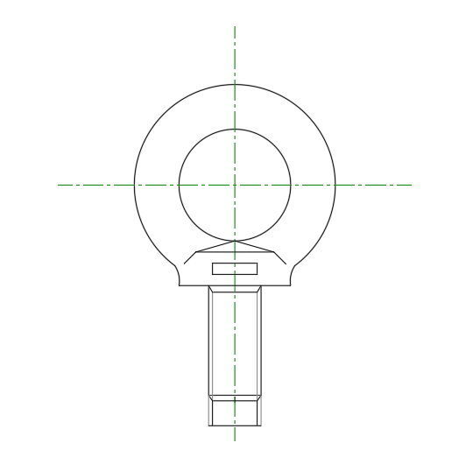

*Figure 6.5 Eye Bolt*

**Table 6.7 Eye Bolt**

|  |  |  |  |  |  |  |  |  |  |
| --- | --- | --- | --- | --- | --- | --- | --- | --- | --- |
| $$d$$ | $$d_{1}$$ | $$d_{2}$$ | $$d_{3}$$ | $$d_{4}$$ | $$b$$ | $$h$$ | $$h_{1}$$ | $$l$$ | $$l_{1}$$ |
| M8 | 36 | 20 | 8 | 20 | 10 | 12 | 6 | 18 | 20 |

Alignment pins are used to ensure relative positions of top and body cases so as to reduce the chance of deformation at the outside ring of bearings

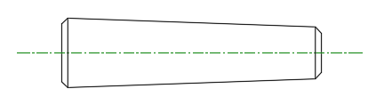

*Figure 6.6 Alignment Pin*

**Table 6.8 Alignment Pin**

|  |  |  |
| --- | --- | --- |
| $$d$$ | $$c$$ | $$l$$ |
| 6 | 1 | 30 |

***PART 7: TOLERANCES***

All fits on the two shafts are hole – basis. In a hole-basis system, the size of the hole remains constant and the diameter of the shaft is varied to determine the fit; conversely, in a shaft-basis system the size of shaft remains constant and the hole diameter is varied to determine the fit. The ISO system uses an alpha-numeric code to illustrate the tolerance ranges for the fit, with the upper-case representing the hole tolerance and lower-case representing the shaft.

**Table 7.1 Tolerances in Gear Assembly**

|  |  |  |  |  |  |  |  |
| --- | --- | --- | --- | --- | --- | --- | --- |
| Parts | Code allocated with fit | $$es (μm)$$ | $$ei \left(μm\right)$$ | $$ES \left(μm\right)$$ | $$EI (μm)$$ | Max excess | Max clearance |
| Driving gear | $$ϕ25\frac{H7}{k6}$$ | $$+15$$ | $$+2$$ | $$+21$$ | $$0$$ | $$15$$ | $$19$$ |
| Driven gear | $$ϕ45\frac{H7}{k6}$$ | $$+15$$ | $$+2$$ | $$+21$$ | $$0$$ | $$15$$ | $$19$$ |

**Table 7.2 Tolerances in Bearing Assembly**

|  |  |  |  |  |  |  |
| --- | --- | --- | --- | --- | --- | --- |
| Code allocated with fit | $$es (μm)$$ | $$ei \left(μm\right)$$ | $$ES \left(μm\right)$$ | $$EI (μm)$$ | Max excess | Max clearance |
| $$ϕ30k6$$ | $$+15$$ | $$+2$$ | $$0$$ | $$-10$$ | $$25$$ | $$-$$ |
| $$ϕ35k6$$ | $$+18$$ | $$+2$$ | $$0$$ | $$-12$$ | $$30$$ | $$-$$ |
| $$ϕ62H7$$ | $$0$$ | $$-15$$ | $$+30$$ | $$0$$ | $$-$$ | $$45$$ |
| $$ϕ72H7$$ | $$0$$ | $$-15$$ | $$+30$$ | $$0$$ | $$-$$ | $$45$$ |

**Table 7.3 Tolerances in Key Assembly**

|  |  |  |
| --- | --- | --- |
| Key dimensions $$b×h$$ | Keyway width P9 | Depth of keyway $t_{1}$ |
| $$6×6$$ | $$-0.042$$ | $$0.1$$ |
| $$8×7$$ | $$-0.015$$ | $$0.2$$ |
| $$10×8$$ | $$-0.015$$ | $$0.2$$ |

***CONCLUSION:***

Through the time of doing this project on designing a mechanical transmission system, I now have a better understanding of how to analyze the problem of designing.

Since the characteristics of this project is to calculate the transmission system, it has encouraged students to be more observant and apply previous theoretical knowledge to find optimal solution for the design.

Although I have finished this project on my own in due time, with thorough guidance and helps of **Mr. Nguyễn Tấn Tiến** from the mechanical engineering faculty, there are undoubtedly still many shortcomings and mistakes due to my naivety and lack of practical knowledge. Therefore, I’m looking forward to your corrections and comments so that I can gain experience and add them to my knowledge.

I would like to sincerely thank **Mr. Nguyễn Tấn Tiến** for your help and dedicated guidance.

Student:

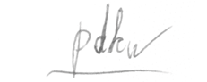

Phan Đăng Khôi Nguyên

***REFERENCE:***

[1]. Trịnh Chất – Lê Văn Uyển: Tính toán thiết kế hệ dẫn động cơ khí tập 1.

[2]. Trịnh Chất – Lê Văn Uyển: Tính toán thiết kế hệ dẫn động cơ khí tập 2.