|  |  |
| --- | --- |
|  | **FPT ACADEMY INTERNATIONAL**  **FPT – APTECH COMPUTER EDUCATION** |

**Centre Name: ACE-THUDUC-1-FPT.**

**Address: 590 Cach Mang Thang 8, District 3, Ho Chi Minh City, Viet Nam.**

**FANoFAN**

|  |  |  |
| --- | --- | --- |
| **Supervisor.** | Mr. Nguyen Phat Tai | |
| **Batch.** | T1.2306.M0 | |
| **Group.** | Group 4 | |
| **Serial No.** | **Enrollment Number** | **Student Name** |
| 1. | Student1470107 | Tran Thi Ngoc Tram |
| 2. | Student1477169 | Nguyen Thanh Nghia |
| 3. | Student1470284 | Vo Nguyen Thien An |
| 4. | Student1479461 | Le Anh Kiet |

Month 09 Year 2023

**This is to certify that**

**Mr./Miss:**

Tran Thi Ngoc Tram

Nguyen Thanh Nghia

Vo Nguyen Thien An

Le Anh Kiet

**has successfully designed & developed**

eProject: FANoFAN website

**Submitted by: Tran Thi Ngoc Tram**

**Date of issue: 16-Oct-2023**

**Authorized Signature: Tram**

**TABLE OF CONTENTS**

ACKNOWLEDGEMENT 3

SYNOPSIS 3

PROBLEM DEFINITION 3

CUSTOMER'S REQUIREMENTS SPECIFICATIONS (CRS) 3

Business/Project Objective: 3

Hardware/ Software Requirements: 4

SCOPE OF THE WORK (IN BRIEF) 5

Architecture and design of the system 6

Diagram of the website 7

TASK SHEET REVIEW 1 8

***SITE MAP………………………………………………………………………………………………………………………….......................9***

***MOCK OF WEBSITE…………………………………………………………………………………………………………………………………9***

***1.HOMEPAGE…………………………………………………………………………………………………………………………...10***

***2.PRODUCTS…………………………………………………………………………………………………….……………………...11***

***3.CATEGORIES………………………………………………………………………………………………………………………....12***

***4.BRANDS…………………………………………………………………………………………………………………………..……13***

***5.GALLERY………………………………………………………………………………………………………………………..……..14***

***6.FEEDBACK………………………………………………………………………………………………...............................15***

***7.CUSTOMER SERVICE………………………………………………………………………………….............................15***

***8.CONTACTUS……………………………………………………………………………………………………………….…………16***

***9.ABOUTUS………………………………………………………………………………………………………………………….....16***

TASK SHEET REVIEW 2 17

# ACKNOWLEDGEMENT

Regarding to the FANoFAN project, we Group 4 would like to express our deepest appreciation to our teacher, Mr. Nguyen Phat Tai for his support and enthusiasm. It would not have been completed without his wise advices throughout the process of doing it. The outcome is also the proof of the hard work and effort of all the members of the group. We believe that it still needs to be improved since this is the very first project that we have participated so far and we are looking forward to receiving all the comments. FANoFAN website project is certainly a remarkable milestone in our carriers of pursuing the dream of becoming professional developpers. Last but not least, we share this goal with our families for all the unconditional love and motivation that they have given to us.

# SYNOPSIS

FANoFAN Company is into manufacturing and selling on Fans. They manufacture fans for various needs of customers. From Ceiling Fans to Table Fans to Exhaust Fans, they are into all types of Fan Manufacturing.

They are looking to come up with their own website and display all the products available with them. They want to provide a detailed information about all their products.

The website is to be developed for the Windows Platform using HTML5, JavaScript and Geolocation. The site should work well in all leading browsers including Chrome, IE, Firefox etc.

# PROBLEM DEFINITION

The Web site is to be created based on the following requirements.

1. The Home Page should be created making use of Sections with a suitable logo, the header section can be added which will show images Fans.
2. The site must contain the links to navigate through any category for the information.
3. Links of bottles can be categorized like (Ceiling Fans, Table Fans, Exhaust etc.)
4. Specification and Pricing of Fans can be added along with the images.
5. Gallery section can be added for viewing different images.
6. Feedback must be allowed to enter by the viewer
7. Site map, Gallery, about us, Queries link, Contact us link must be added. Address of the Company should be displayed using GeoLocation API (eg. GoogleMaps).
8. The complete description must be allowed to get download as pdf or doc file.
9. The advertise section with various facilities provided should be mentioned.

# CUSTOMER'S REQUIREMENTS SPECIFICATIONS (CRS)

**Client: FANoFAN**

### Business/Project Objective:

The Objective of this program is to give a sample project to work on real life projects. These applications help you build a larger more robust application.

The objective is not to teach you HTML/JavaScript/Dreamweaver but to provide you with a real life scenario and help you create basic applications using the tools.

You can revise the chapters before you start with the project.

This project is meant for students who have completed the module of ***HTML5***. These programs should be done in the Lab sessions with assistance of the faculty if required.

It is very essential that a student has a clear understanding of the subject. Students should go through the project and solve the assignments as per requirements given.

Kindly get back @ [eprojects@aptech.ac.in](mailto:eprojects@aptech.ac.in) in case of any doubts regarding the application or its objectives.

**Input to the system:**

* + - * Browsing products based on brands, type of appliances..

**Output from the system:**

* A menu that will categorize all the functions of the site.
* Display the list of available albums category wisely.
* Site should be able to provide brief introduction/history about the company under About Us page.
* The location of the company is in Contact Us page.
* Besides the above requirements, the site should have look and feel as per the industry standards.

**Expected delivery date:** 16-Oct-2023.

**List of deliverables:**

* + - * Document Word.
      * User Guide.
      * Source code.

### Hardware/ Software Requirements:

**Hardware**

* A minimum computer system that will help you access all the tools in the courses is a Pentium 166 or better
* 64 Megabytes of RAM or better

**Software *[Either or Combination as per Course/Sem]***

* Notepad/HTML editor/CoffeeCup/Visual Studio Code
* Angular / Angular JS / React / BootStrap
* Dreamweaver / Figma
* MS IE / Chrome / FireFox / Netscape /MS Edge

# SCOPE OF THE WORK (IN BRIEF)

**The team has discussed and has agreed about the website layout as shown briefly below:**

1. **Homepage**: Includes logo, main menu, slideshow and content of some outstanding products
2. **Products**: Containing all products with their details and images of FANoFAN.
3. **Categories**: Containing its products with their details and images categorized by type.
4. **Brands:** Containing products categorized by major brands in fans
5. **Gallery** : Containing all images of all products
6. **Feedback** : Displays a form to collect feedback from users
7. **Customer Service** : Advise customers on purchasing and placing orders
8. **Contact Us**: Showing the contact information of the company such as address, location map, mobile, fax, email.
9. **About Us**: Introducing the history, archivements and further information about the company.

# Architecture and design of the system

Figma

# Diagram of the website

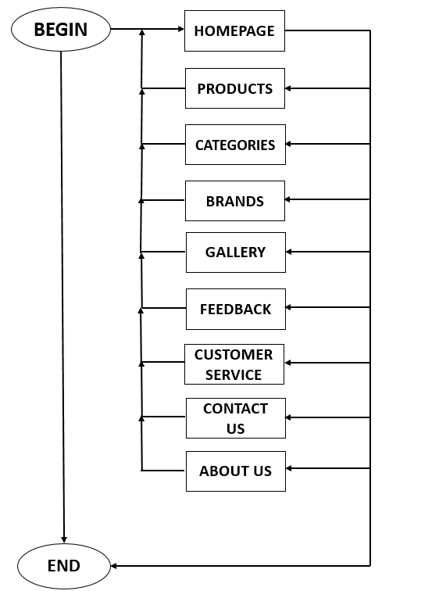



# TASK SHEET REVIEW 1

|  |  |  |  |  |  |  |  |
| --- | --- | --- | --- | --- | --- | --- | --- |
| **Project Ref. No.:**  **eP/Advertisement Portal Management**  **System/01** | | **Project Title:** | **Activity Plan Prepared By:** | **Date of Preparation of Activity Plan:** | | | |
| **Sr.**  **No.** | **Task** | **Actual**  **Start Date** | **Actual Days** | **Team**  **Mate Names** | **Status** |
| 1 | Problem Statement | FANoFAN | Tram | 16-Sep-2023 | 1 | An, Nghia | Completed |
| 2 | Analysis of the requirements about the website | 16-Sep-2023 | 1 | An,  Nghia | Completed |
| 3 | The scope of the work (in brief) | 16-Sep-2023 | 1 | Tram | Completed |
| 4 | Architecture and design of the system | 16-Sep-2023 | 1 | Nghia, Tram | Completed |
| 5 | Diagram of the website | 16-Sep-2023 | 1 | An | Completed |
| 6 | Task Sheet | 16-Sep-2023 | 1 | Tram | Completed |

|  |  |
| --- | --- |
| **Date: 22/09/2023** | |
| Signature of Instructor:  **Mr. Nguyen Phat Tai** | Signature of Team Leader:    **Miss. Tran Thi Ngoc Tram** |

**SITE MAP**

**MOCK OF THE WEBSITE**

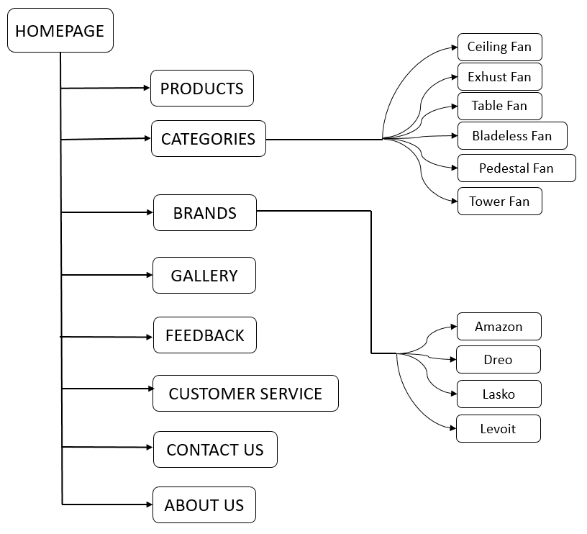

1. **HOMEPAGE**

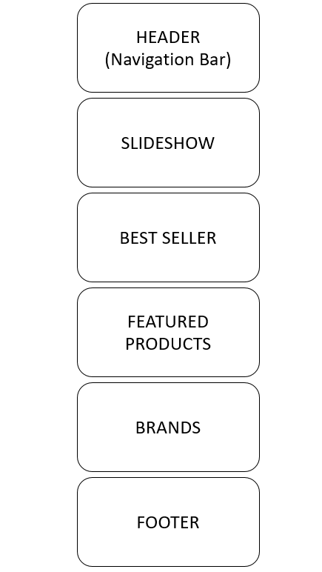

1. **PRODUCTS:**

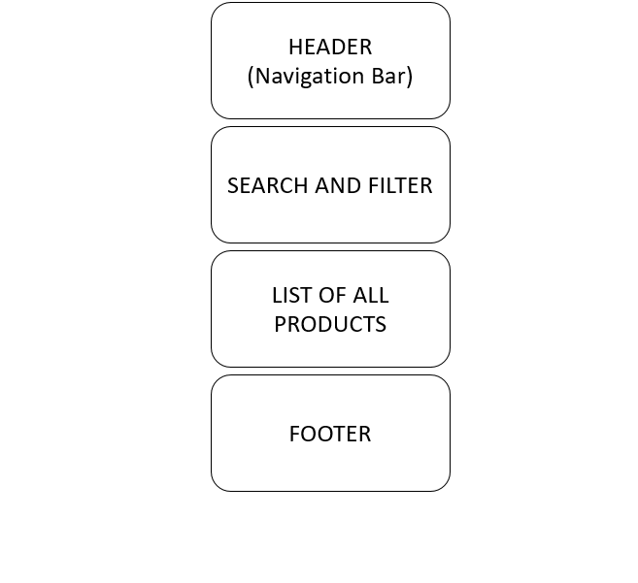

1. **CATEGORIES**

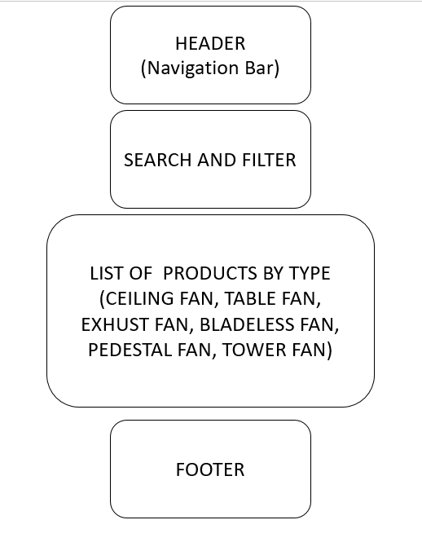

1. **BRANDS**

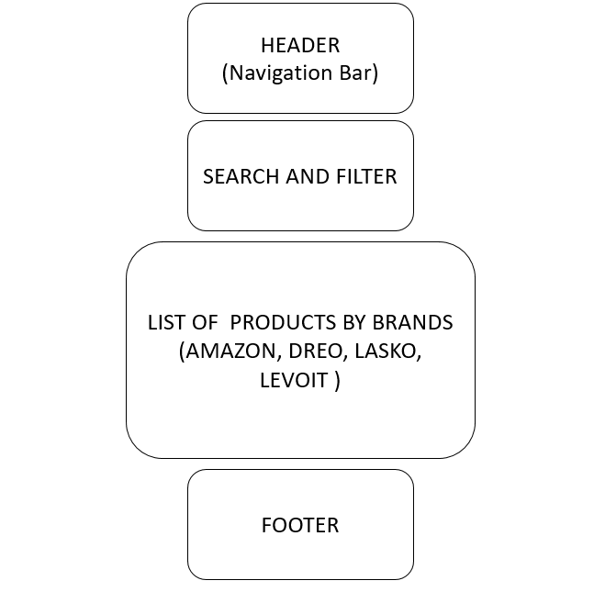

1. **GALLERY**

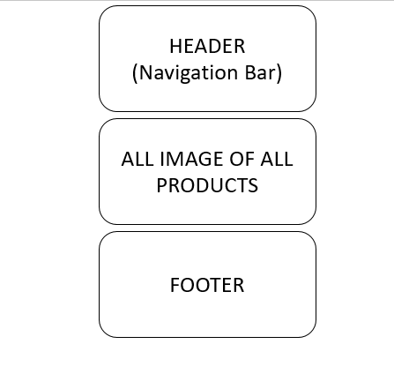

1. **FEEDBACK**

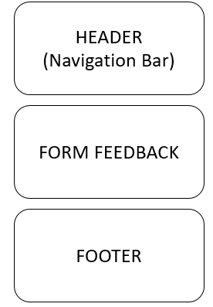

1. **CUSTOMER SERVICE**

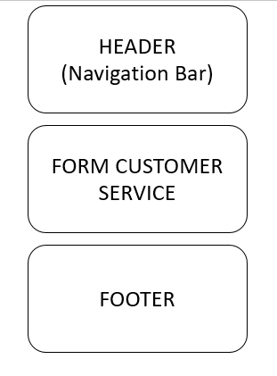

1. **CONTACT US**

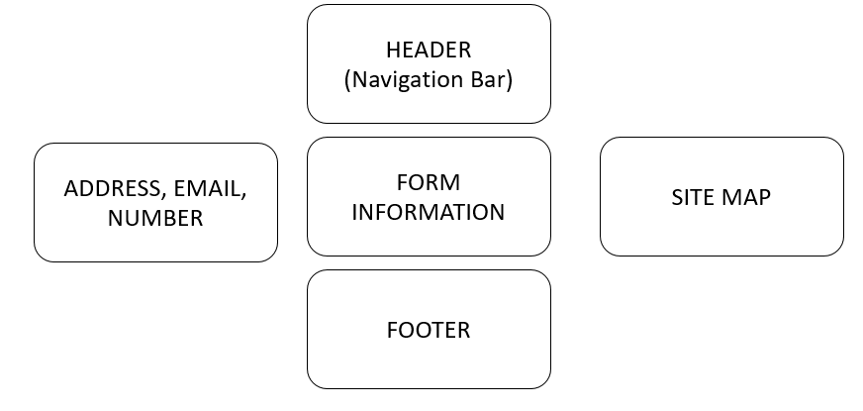

1. **ABOUT US**

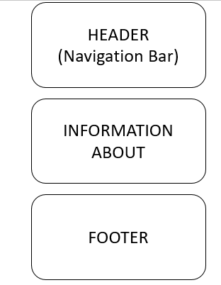

# TASK SHEET REVIEW 2

|  |  |  |  |  |  |  |  |
| --- | --- | --- | --- | --- | --- | --- | --- |
| **Project Ref. No.:**  **eP/Advertisement**  **Portal Management System/01** | | **Project Title:** | **Activity Plan Prepared By:** | **Date of Preparation of Activity Plan:** | | | |
| **Sr.**  **No.** | **Task** | **Actual**  **Start Date** | **Actual Days** | **Team**  **Mate Names** | **Status** |
| 1 | Site map | La Imperial | Thinh | 29-Sep-2023 | 1 | Nghia | Completed |
| 2 | Mock of the website | 29-Sep-2023 | 1 | Tram, Nghia, An | Completed |
| 3 | Task Sheet | 29-Sep-2023 | 1 | An | Completed |

|  |  |
| --- | --- |
| **Date: 29/09/2023** | |
| Signature of Instructor:  **Mr. Nguyen Phat Tai** | Signature of Team Leader:  **Ms. Tran Thi Ngoc Tram** |