* php artisan make:controller FileController --resource
  + –resource là để tạo ra function: add, create,…

create file in controller image

* php artisan make:seeder CountryTableSeeder

create file seeder

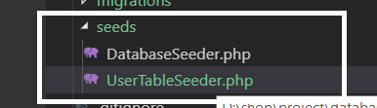

* php artisan make:migration create_table_banking --create=banking

create file migration

* php artisan make:factory CustomerFactory --model="App\Customer"

create file factory

* php artisan make:middleware RoleMiddleware

create file middleware

in folder **app/Http/Middleware/RoleMiddleware.php.**

* php artisan make:auth
  + để tạo ra các auth như login, resetpw, register,…