* php artisan make:controller FileController --resource

create file in controller image

* php artisan make:seeder CountryTableSeeder

create file seeder

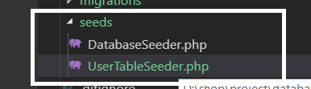

* php artisan make:migration create_table_banking --create=banking

create file migration

* php artisan make:factory CustomerFactory --model="App\Customer"

create file factory

