Name: Nguyen Phuong Le

ID: 104178943

**Week 1**

**Task 1:**

**public** **class** task1 {

**public** **static** **void** main(String[] args) {

System.***out***.print("Welcome to Java Programming");

}

}

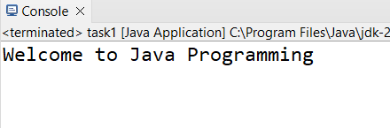

**Task 1.2:**

**import** java.util.Scanner;

**public** **class** task2 {

**public** **static** **void** main(String[] args) {

Scanner input = **new** Scanner(System.***in***);

**int** posi_Sum = 0, nega_Sum = 0, currentInput;

System.***out***.print("Enter 10 inteher values:");

**for** (**int** i = 0; i < 10; i++) {

currentInput = input.nextInt();

**if** (currentInput > 0) {

posi_Sum += currentInput;

}

**else** {

nega_Sum += currentInput;

}

}

System.***out***.println("Sum of positive: " + posi_Sum);

System.***out***.println("Sum of negative: " + nega_Sum);

}

}

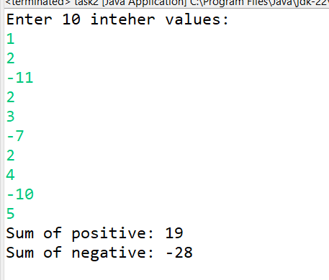

**Task 1.3:**

**public** **class** task3 {

**public** **static** **void** main(String[] args) {

**int** throwsNeeded = 1;

**while** (**true**)

{

// Get random value between 1-6

**int** dice1 = ((**int**) (Math.*random*() * 6) + 1);

**int** dice2 = ((**int**) (Math.*random*() * 6) + 1);

System.***out***.println("Dice thows: " +dice1 + " and " +dice2);

**if** (dice1 == dice2) {

System.***out***.println("Dice match!");

System.***out***.println("Throws needed: " + throwsNeeded);

**break**;

}

**else** {

System.***out***.println("Dice not matched");

throwsNeeded++;

}

}

}

}

**Task 1.4:**

**import** java.util.*;

**public** **class** task1_4 {

**public** **static** **void** main(String[] args) {

Scanner input = **new** Scanner(System.***in***);

**int** i;

String [] colors= {"Red","Orange","Yellow","Green","Blue","Indigo","Violet"};

**do**

{

System.***out***.println("Please enter form (1-7). And enter -1 to exit: ");

i = input.nextInt();

**if** (i >= 1 && i <= 7)

{

System.***out***.println("Color is: " + colors[--i]);

}

}**while**(i != -1);

}

}

