Name: Nguyen Phuong Le

ID: 104178943

**Week 2**

**Task 2.1:**

package week2;

class Employee {

String Emloyee_ID, First_Name, Last_name;

double Salary;

}

public class task2_1 {

public static void main(String[] args) {

Employee employee1 = new Employee();

employee1.Emloyee_ID = "E101011";

employee1.First_Name = "John";

employee1.Last_name = "Matthew";

employee1.Salary = 1500.00;

System.***out***.println("Employee Details:");

System.***out***.println("ID: " + employee1.Emloyee_ID + ", First Name: " + employee1.First_Name + ", Last Name: " + employee1.Last_name + ", Salary: $" + employee1.Salary);

}

}

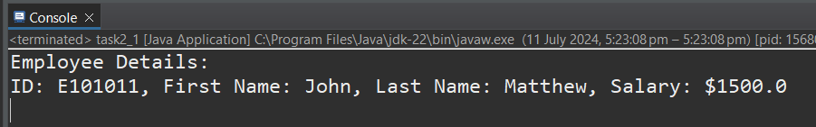

**Task 2.2:**

package week2;

class Employeee {

String Emloyee_ID, First_Name, Last_name;

double Salary;

public Employeee (String Emloyee_ID, String First_Name, String Last_name, double Salary)

{

this.Emloyee_ID = Emloyee_ID;

this.First_Name = First_Name;

this.Last_name = Last_name;

this.Salary = Salary;

}

}

public class tassk2_2 {

public static void main(String[] args) {

Employeee employee1 = new Employeee("E101011", "John", "Matthew", 1500.00);

System.***out***.println("Employee Details:");

System.***out***.println("ID: " + employee1.Emloyee_ID + ", First Name: " + employee1.First_Name + ", Last Name: " + employee1.Last_name + ", Salary: $" + employee1.Salary);

}

}

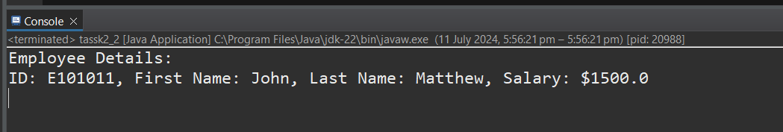

**Task 2.3:**

Print the Employee values in a formatted output: Use the accessor methods to print the member variables values:

package week2;

import java.util.Scanner;

class Employee1 {

String Emloyee_ID, First_Name, Last_name;

double Salary;

public Employee1 (String Emloyee_ID, String First_Name, String Last_name, double Salary)

{

this.Emloyee_ID = Emloyee_ID;

this.First_Name = First_Name;

this.Last_name = Last_name;

this.Salary = Salary;

}

String getEmployeeID() {

return this.Emloyee_ID;

}

String getFirstname() {

return this.First_Name;

}

String getLastname() {

return this.Last_name;

}

double getSalary() {

return this.Salary;

}

public void setSalary (double newSalary) {

this.Salary = newSalary;

}

public String Employee2() {

return "ID: " + Emloyee_ID + ", First Name: " + First_Name + ", Last Name: " + Last_name + ", Salary: $" + Salary;

}

}

public class task2_3 {

public static void main(String[] args) {

Scanner input = new Scanner(System.***in***);

System.***out***.println("Enter Employee Details");

System.***out***.print("Employee ID: ");

String Emloyee_ID = input.nextLine();

System.***out***.print("First Name: ");

String First_Name = input.nextLine();

System.***out***.print("Last Name: ");

String Last_name = input.nextLine();

System.***out***.print("Salary: $");

double Salary = input.nextDouble();

System.***out***.println("ID:"+Emloyee_ID+", First Name: "+First_Name+", Last Name: "+Last_name+", Salary:$"+Salary);

}

}

Print the Employee values in a formatted output. Use the accessor methods to print the member variables values:

package week2;

import java.util.Scanner;

class Employee1 {

String Emloyee_ID, First_Name, Last_name;

double Salary;

public Employee1 (String Emloyee_ID, String First_Name, String Last_name, double Salary)

{

this.Emloyee_ID = Emloyee_ID;

this.First_Name = First_Name;

this.Last_name = Last_name;

this.Salary = Salary;

}

String getEmployeeID() {

return this.Emloyee_ID;

}

String getFirstname() {

return this.First_Name;

}

String getLastname() {

return this.Last_name;

}

double getSalary() {

return this.Salary;

}

public void setSalary (double newSalary) {

this.Salary = newSalary;

}

public String Employee2() {

return "ID: " + Emloyee_ID + ", First Name: " + First_Name + ", Last Name: " + Last_name + ", Salary: $" + Salary;

}

}

public class task2_3 {

public static void main(String[] args) {

Scanner input = new Scanner(System.***in***);

System.***out***.println("Enter Employee Details");

System.***out***.print("Employee ID: ");

String Emloyee_ID = input.nextLine();

System.***out***.print("First Name: ");

String First_Name = input.nextLine();

System.***out***.print("Last Name: ");

String Last_name = input.nextLine();

System.***out***.print("Salary: $");

double Salary = input.nextDouble();

//new Salary

Employee1 employee3 = new Employee1(Emloyee_ID, First_Name, Last_name, Salary);

System.***out***.println("Employee Details:");

System.***out***.println(employee3.Employee2());

System.***out***.print("Enter the new Salary: $");

double newSalary = input.nextDouble();

employee3.setSalary(newSalary);

System.***out***.println("Employee Details:");

System.***out***.println("ID:"+employee3.getEmployeeID()+", First Name: "+employee3.getFirstname()+", Last Name: "+employee3.getLastname()+", Salary:$"+employee3.getSalary());

}

}

**Task 2.4:**

Print the Business values in a formatted output. Use the accessor methods to print the member variables values:

package week2;

import java.util.Scanner;

class Business {

String Name;

String Model;

String Address;

String Email;

public Business (String Name, String Model, String Address, String Email) {

this.Name = Name;

this.Model = Model;

this.Address = Address;

this.Email = Email;

}

String getName () { return this.Name;}

String getModel() {return this.Model;}

String getAddress () {return this.Address;}

String getEmail () {return this.Email;}

public void setEmail (String newEmail) {this.Email = newEmail;}

}

public class task2_4 {

public static void main(String[] args) {

Scanner input = new Scanner(System.***in***);

System.***out***.println("Enter Business Details");

System.***out***.print("Business Name: ");

String Name = input.nextLine();

System.***out***.print("Business Model: ");

String Model = input.nextLine();

System.***out***.print("Business Address: ");

String Address = input.nextLine();

System.***out***.print("Business Email: ");

String Email = input.nextLine();

System.***out***.println("Name: " + Name + ", Model: " + Model + ", Address: " + Address + ", Email: " + Email);

}

}

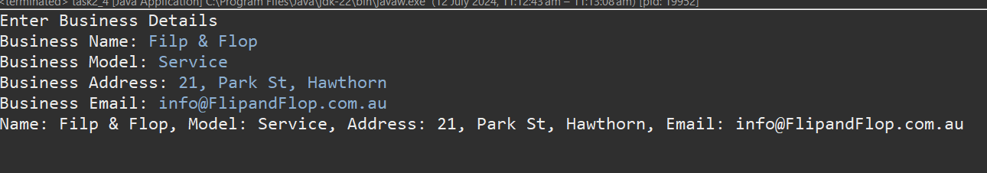

Print the Employee values in a formatted output. Use the accessor methods to print the member variables values:

package week2;

import java.util.Scanner;

class Business {

String Name;

String Model;

String Address;

String Email;

public Business (String Name, String Model, String Address, String Email) {

this.Name = Name;

this.Model = Model;

this.Address = Address;

this.Email = Email;

}

String getName () { return this.Name;}

String getModel() {return this.Model;}

String getAddress () {return this.Address;}

String getEmail () {return this.Email;}

public void setEmail (String newEmail) {this.Email = newEmail;}

public void busines2() {

System.***out***.println( "Name: " + Name + ", Model: " + Model + ", Address: " + Address + ", Email: " + Email);

}

}

public class task2_4 {

public static void main(String[] args) {

Scanner input = new Scanner(System.***in***);

System.***out***.println("Enter Business Details");

System.***out***.print("Business Name: ");

String Name = input.nextLine();

System.***out***.print("Business Model: ");

String Model = input.nextLine();

System.***out***.print("Business Address: ");

String Address = input.nextLine();

System.***out***.print("Business Email: ");

String Email = input.nextLine();

// new Email

Business busin = new Business(Name, Model, Address, Email);

System.***out***.println("Business Details:");

busin.busines2();

System.***out***.print("Enter the new Email: ");

String newEmail = input.nextLine();

busin.setEmail(newEmail);

System.***out***.println("Business Details:");

busin.busines2();

}

}

