**Name:** Phạm Thanh Nguyên

**ID:** 17141017

**Assignment 1**

Given an image f(x, y) as bellow

1. What is the image f called? Why?
2. Assume that the image f is in the domain space, so after using Fourier transform, what domain is it?
3. Transform the image f using Fourier transform. Notice that you must use formula for calculating it.
4. Write Matlab code to transform the image f in the frequency domain
5. Calculate the amplitude of pixel at the coordinate axis (1, 1) of the output image g.

$$f=\begin{matrix}0 & 1 & 0 & 0 \\ 1 & 0 & 1 & 0 \\ 0 & 1 & 0 & 0 \\ 0 & 0 & 0 & 0\end{matrix}$$

**Solution**

1. F is pixel value at position (x, y).

Because: Within a two-dimensional image frame, each pixel corresponds to a pair of coordinates (x, y). Definition: A pixel (pixel) is an element of a digital image at the coordinates (x, y) with a certain level of gray or color. The size and distance between those pixels is appropriately chosen so that the human eye perceives the spatial continuity and the gray (or color) level of the digital image is close to the actual image. Each element in the matrix is called an image element.

1. After using Fourier transform, the domain is frequency domain. This is the final result is transferred back to the spatial domain thanks to inverse transforms.

* On the matrix has the row M=4 and column N=4
* Transform matrix U(x, u) and V(y, v) and $F\left(u,v\right)=U×f×V$
$$F(u,v)=\sum_{x=0}^{M-1}{\sum_{y=0}^{N-1}{f\left(x, y\right)}}×e^{-\frac{j2π\left(ux\right)}{M}}×e^{-\frac{j2π\left(vy\right)}{N}}$$

* With $U\left(x,u\right)=e^{-\frac{j2π\left(ux\right)}{M}}$

$$U=\left[\begin{matrix}e^{-\frac{j2π×0×0}{4}} & e^{-\frac{j2π×0×1}{4}} & e^{-\frac{j2π×0×2}{4}} & e^{-\frac{j2π×0×3}{4}} \\ e^{-\frac{j2π×1×0}{4}} & e^{-\frac{j2π×1×1}{4}} & e^{-\frac{j2π×1×2}{4}} & e^{-\frac{j2π×1×3}{4}} \\ e^{-\frac{j2π×2×0}{4}} & e^{-\frac{j2π×2×1}{4}} & e^{-\frac{j2π×2×2}{4}} & e^{-\frac{j2π×2×3}{4}} \\ e^{-\frac{j2π×3×0}{4}} & e^{-\frac{j2π×3×1}{4}} & e^{-\frac{j2π×3×2}{4}} & e^{-\frac{j2π×3×3}{4}}\end{matrix}\right]$$

Similarly, one has the matrix:

$$U=\left[\begin{matrix}1 & 1 & 1 & 1 \\ 1 & -j & -1 & j \\ 1 & -1 & 1 & -1 \\ 1 & j & -1 & -j\end{matrix}\right]$$

$F\left(u,v\right)=U×f×V$**= $\left[\begin{matrix}4 & -2j & 0 & 2j \\ -2j & 0 & -2j & 0 \\ 0 & -2j & -4 & 2j \\ 2j & 0 & 2j & 0\end{matrix}\right]$**

1. Matlab codeto transform the image f in the frequency domain:

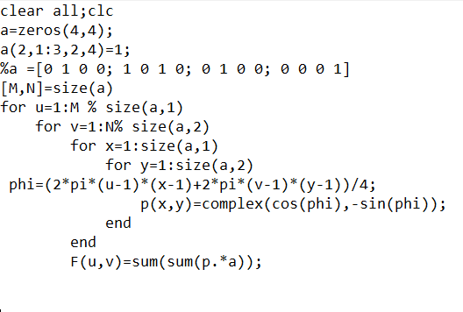

$\left|F(u,v)\right|=\sqrt{R^{2}\left(u,v\right)+I^{2}\left(u,v\right)}$

$\left|F(1,1)\right|=\sqrt{R^{2}\left(1,1\right)+I^{2}(1,1)}=\sqrt{4^{2}+0^{2}}=4$