User guide for Spring MVC Example 1

1. Create MYSQL Database named demodb1, and run the content in demo1_db1.sql.

2. Controller with JSTL

URL: http://localhost:8080/SpringMVCDemo/Specialization

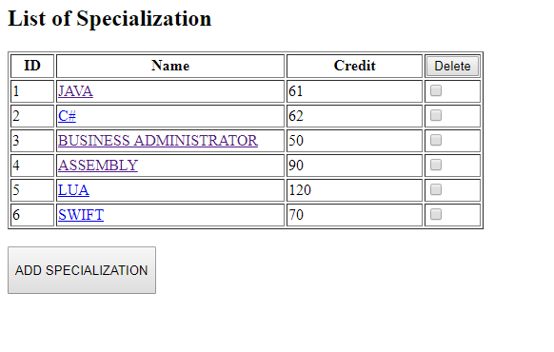

3. REST Controller

Get All Specialization

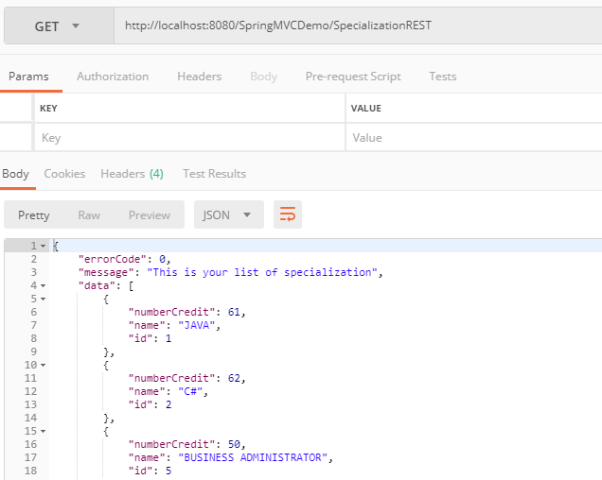

Get specialization by ID

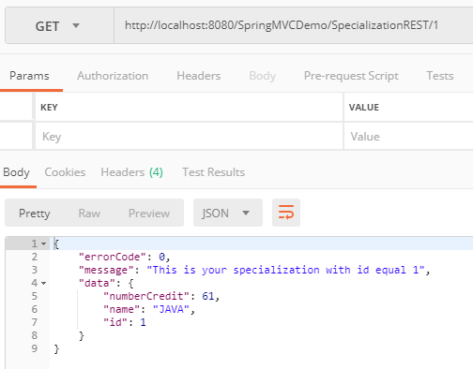

Add a specialization

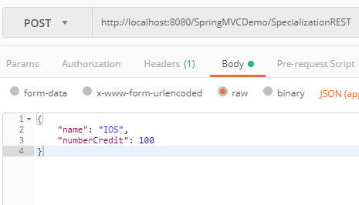

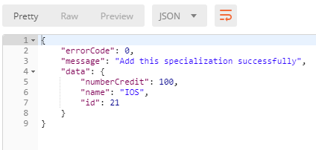

Delete a specialization

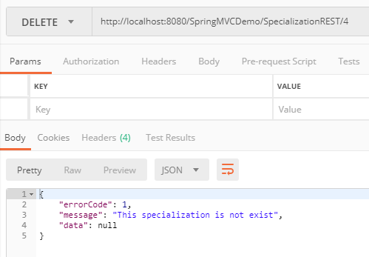

Update a specialization

