

USER GUIDE

**DATASSISTANT**

|  |  |
| --- | --- |
| Code |  |
| Version | 1.0 |
| Effective date | 01 Aug 2022 |
| Owner | FSG.FIV |

Contents

INTRODUCTION 3

Purpose 3

Application Scope 3

INSTALL & RUN 3

Install Python 3

DATASSISTANT 4

How it work 4

# INTRODUCTION

## Purpose

* The document provides an overview guideline how to install & run Datassistant so that you can create meaningful, clean and exact data as your expectation and for your work. Let’s enjoy!

## Application Scope

* Generated data can be used for many purposes: automation & manual testing & functional testing, import directly into DB, data customization based on user’s expectations. This tool can help you in huge data need cases, up to millions of records.
* File format can be exported: jSON, CSV, EXCEL, SQL, XML.

# INSTALL & RUN

* After extracting datassistant.zip from download folder, see the following folder:

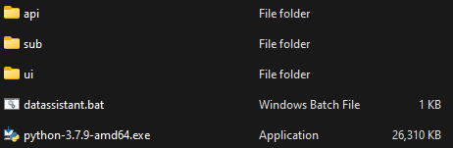

## Install Python

*\*Note: The recommended python version is python 3.7. The python installer is saved in the download folder. (If you already have python installed in higher versions, please skip this step).*

* STEP 1: Run Python-3.7.9-amd64.exe.
* STEP 2: Click “Add Python 3.7 to PATH” checkbox.
* STEP 3: Click “Install Now”. The installation is completed when the screen above appeared. Click “Close” to complete setup.

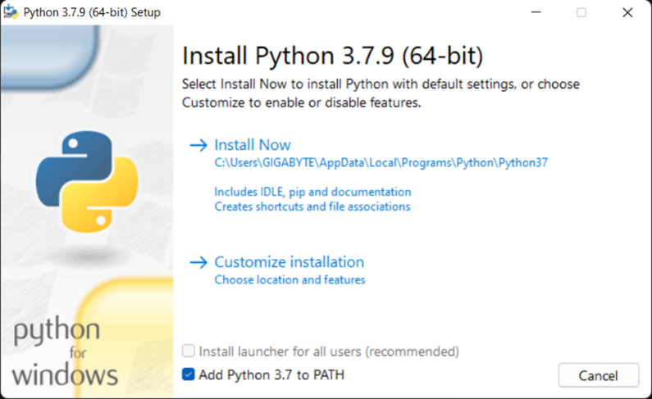

* CHECK PYTHON VERSION and make sure your Python work correctly:
  + Open CMD and run “python” command.



# DATASSISTANT

## How it work

* After installed python successfully, execute **datassistant.bat** in Datassistant.

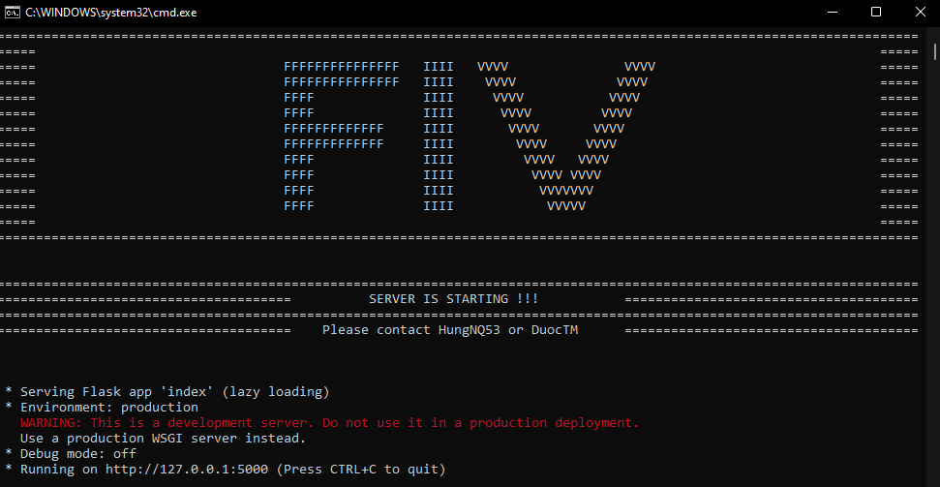

Figure 1: Server is running

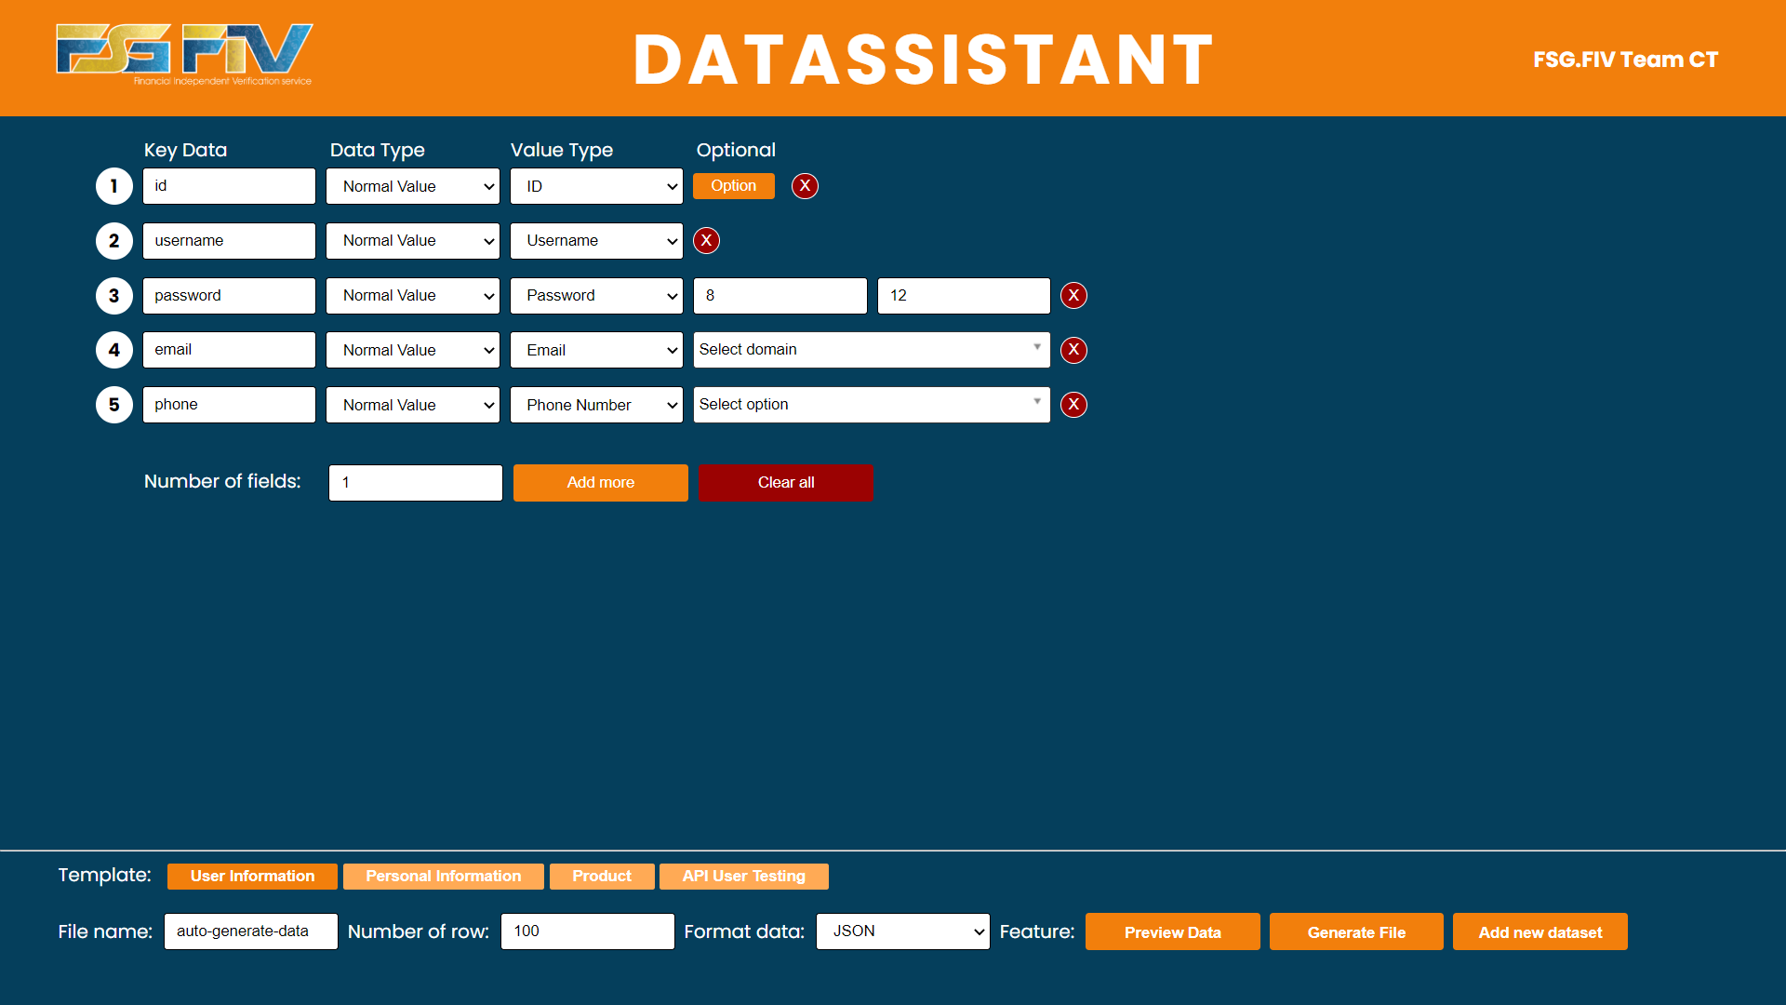

Figure 2: User Interface

* **Key Data:** Key name.
* **Data Type:** Contribute structure format.
  + Normal Value: The simple string of characters.
  + Array: The array of strings with a specified number of elements.
  + Object: Same format of a JSON file as follows:  
     key:{key1:value1,   
     key2:value2  
     ,...}.
  + Array Object: An advanced object that allows to create arrays of objects with the same structure.
* **Value Type:** Expected output data. Only fields have data type are “**Normal Value**”or “**Array”** allows you to customize its value type.
* **Optional:** Some value types allow you to customize the output data. The Optional can be left as blank.
* **Preview Data Button:** for preview before export.
* **Generate File Button:** for export as download file.
* **Add New Dataset**: allow you to data (.xlsx) file from your local and import into Tool. In case you didn’t have file format, can use “Download file example” button and edit before using.

|  |  |
| --- | --- |
|  |  |

Figure 3: Add New Dataset – uploaded file successfully

If you have any questions or queries, please let us know.

*THANK YOU!*

HungNQ53 & DuocTM from FSG.FIV Team