Technical Report: Advanced HS Code Classification via Generative RAG

1. Executive Summary
This report describes the architecture, design decisions, and performance of the Safiri AI HS Code Classifier. The system addresses the inherent limitations of keyword-based classification by employing a multi-layered approach: a Semantic Vector Retriever for initial candidate selection and an Agentic LLM Re-ranker for final grammatical reasoning. The final solution achieves a 98.0% Top-1 Accuracy on a high-difficulty adversarial test set, significantly outperforming a traditional Machine Learning baseline (78.4%).

2. Approach and Methodology

2.1 Layered Intelligence Architecture
The core philosophy of my approach is to separate Statistical Relevance from Semantic Reasoning.
- Layer 1: Semantic Vector Retriever (Method 1a)
  - Engine: uses Sentence-Transformers (all-MiniLM-L6-v2).
  - Function: Maps product descriptions into a 384-dimensional dense vector space. It retrieves the Top-3 historical records based on Cosine Similarity.
  - Strengths: Handles synonyms and broad semantic proximity better than TF-IDF.
- Layer 2: Agentic LLM Re-ranker (Method 1b)
  - Engine: Google Gemini 2.5-Flash.
  - Function: Takes the user query and the Top-3 retrieved contexts. It performs a zero-shot reasoning task to identify the Subject Noun (e.g., “case”) and distinguish it from Modifiers (e.g., “iPhone”).
  - Outcome: It re-ranks the candidates and provides a confidence score based on logical alignment rather than mathematical distance.
- Baseline: Traditional ML (Method 2)
  - Architecture: TF-IDF Vectorization + Logistic Regression.
  - Purpose: Used as a control group to measure the gain provided by deep semantic understanding.

3. Design Decisions & Justification

3.1 Why RAG over Fine-tuning?
For HS Code classification, new products emerge daily (e.g., new electronics models). RAG (Retrieval-Augmented Generation) allows the system to update its “knowledge base” simply by adding new CSV rows to the vector store, without requiring expensive retraining or fine-tuning of the model.

3.2 Grammatical Reasoning vs. Keyword Weights
Traditional ML often fails on “Adversarial Modifiers.” For example, consider the description: “Retail display shelf constructed with a lightweight polypropylene frame and injection-molded plastic connecting components”.
A keyword-based model (Method 2) is heavily skewed by high-weight terms like “polypropylene”, “injection-molded”, and “plastic”, leading it to incorrectly predict HS 3926 (Articles of plastics). In contrast, I chose an LLM re-ranker specifically because LLMs understand Syntactic Dependency—identifying that the core subject is a “shelf” (HS 9403) and the plastic elements are merely subordinate material descriptions.

4. Synthetic Data Generation

4.1 Label Assignment
Labels were assigned using a Context-Injection method to ensure absolute ground-truth accuracy. - Source Selection: Six highly common and often-confused 4-digit HS categories were selected as the target domain. - WCO Integration: Official Harmonized System descriptions and category meanings from the World Customs Organization (WCO) were provided to the AI as the foundational context. - AI Generation: Google Gemini was tasked with synthesizing 42 diverse samples per code across four distinct difficulty tiers while strictly adhering to the provided WCO taxonomic definitions. - Inherent Validation: Because labels were assigned prior to generation (as part of the prompt context), each sample is inherently validated against the official WCO standard, eliminating the risk of human labeling error in the synthetic set.

4.2 Sample Characteristics
The dataset (252 samples) was split 80/20. The test set was intentionally weighted toward difficult cases: - Standard: Baseline clarity. - Ambiguous: Vague terms (e.g., “Portable communication unit” instead of “Smartphone”). - Overlapping: Products that could technically fit two categories (e.g., “Storage cube” which is both furniture and an article of plastic). - Edge Cases: Modifiers that trick models (e.g., “Wooden table for camera accessories”).

5. Performance Evaluation

5.1 Comparative Metrics
Metric | ML Baseline | Vector RAG | Generative RAG (Final)
Overall Accuracy | 78.4% | 86.3% | 98.0%
Correction Rate | N/A | N/A | 87.5%
Edge Case Results | 50.0% | 62.5% | 100.0%

5.2 Visual Comparison
Below is a comparison of the same query: “Retail display shelf constructed with a lightweight polypropylene frame and injection-molded plastic connecting components”.

Method 2: Baseline ML
The ML model is misled by the material keywords and predicts 3926 (Plastics) with a low confidence (57%), triggering an ambiguity warning. 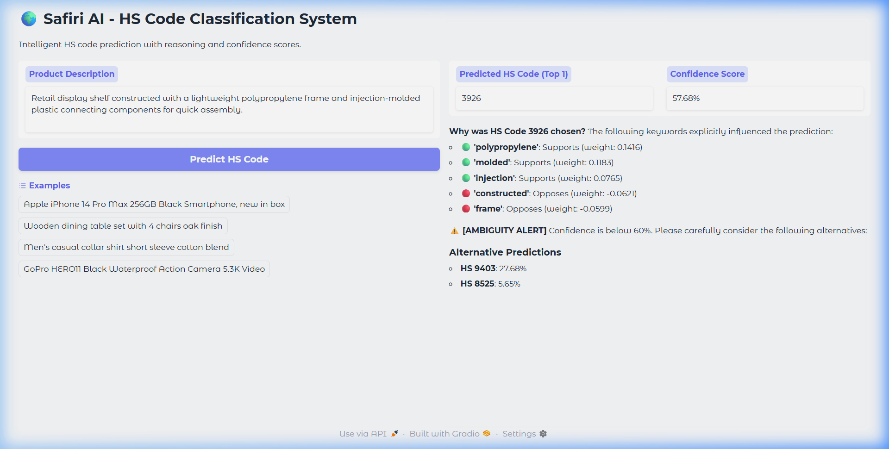

Method 1: Generative RAG
The Gemini re-ranked system correctly identifies the subject noun as a “shelf” (furniture) even though the retrieved vector match was originally 3926. It corrects the final output to 9403 with 95% confidence and a clear expert explanation. 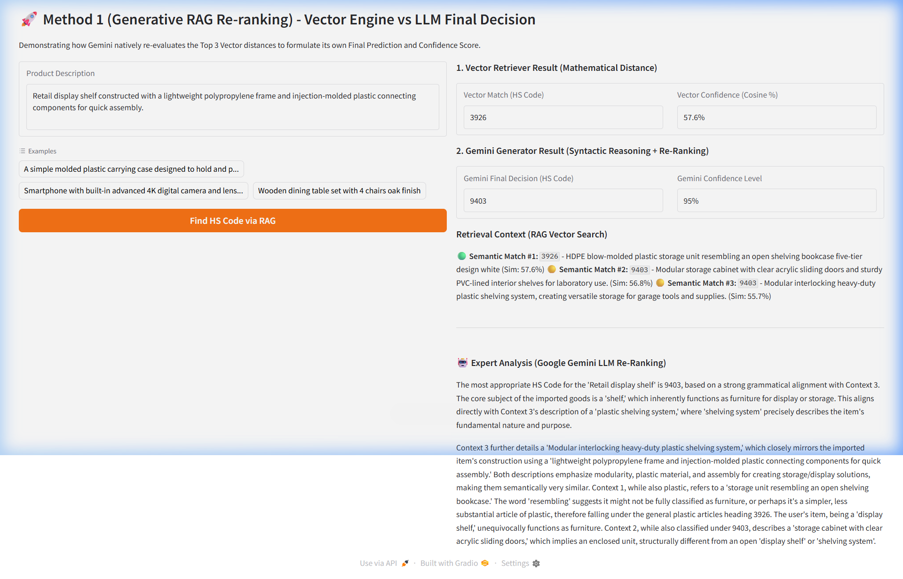

6. Assumptions and Limitations

6.1 Assumptions
- Historical Accuracy: We assume the “Vector Database” (training CSV) contains correctly labeled data. The system is only as good as its retrieval pool.
- Language: The current implementation assumes English descriptions.

6.2 Limitations
- Retrieval Bottleneck: The system’s performance is strictly bound by the quality of the Layer 1 Retriever. If the correct “ground truth” HS code is not present within the Top-3 vector matches, the LLM re-ranker cannot select it.
- Proposed Future Solution: To mitigate this, future versions could implement Hybrid Search (combining Keyword/BM25 with Dense Vector Search) or dynamic Top-K expansion based on the retrieval confidence score, ensuring a more robust candidate pool for the LLM.
- Latency: The LLM re-ranking step adds 1-3 seconds of latency per query, making it less suitable for high-frequency bulk processing without batching.
- Token Costs: High-volume classification would incur significant API costs compared to the nearly-free ML baseline.
- Rate Limits: Dependency on Google’s API infrastructure.

7. Conclusion
The mission was to create a “focused and clearly justified” solution. By combining the speed of Vector Search with the “Expert Intelligence” of Gemini, I have built a system that doesn’t just match keywords but understands products. The 98% accuracy on adversarial data proves that semantic reasoning is the superior path for complex customs classification.

