**Starbucks-orders-dynamodb project**

**Steps to start local dynamodb**

**How to start dynamodb:**

go to the folder were local dynamodb is installed and run this command:

java -Djava.library.path=./DynamoDBLocal_lib -jar DynamoDBLocal.jar -sharedDb

How to see the tables in the dynamodb:

aws dynamodb list-tables --endpoint-url http://localhost:8000

**How to create the Order table**

aws dynamodb create-table --table-name Order --attribute-definitions AttributeName=Id,AttributeType=S --key-schema AttributeName=Id,KeyType=HASH --provisioned-throughput ReadCapacityUnits=1,WriteCapacityUnits=1 --endpoint-url http://localhost:8000

**how to delete table in the dynamodb:**

aws dynamodb delete-table --table-name Order --endpoint-url <http://localhost:8000>

**how to display items in the dynamodb table**

aws dynamodb scan --table-name Order --endpoint-url http://localhost:8000

**Save orders:**

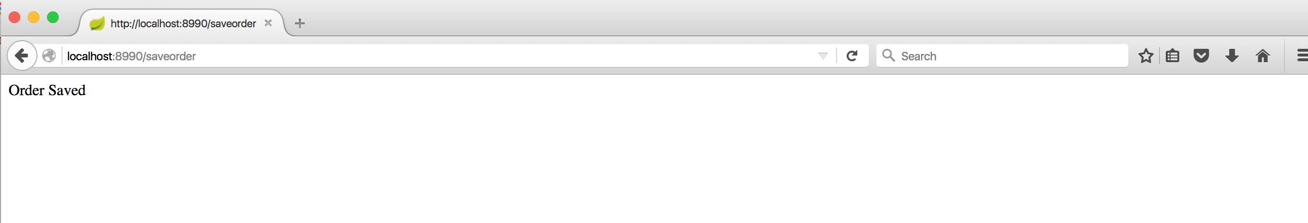

**show all orders:**

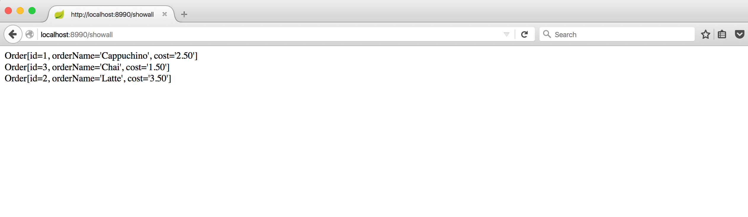

**show orders by id**

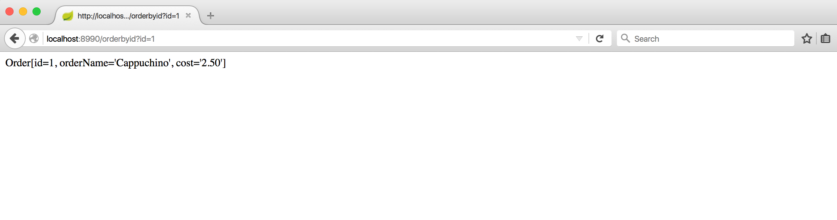

**deleting all orders:**

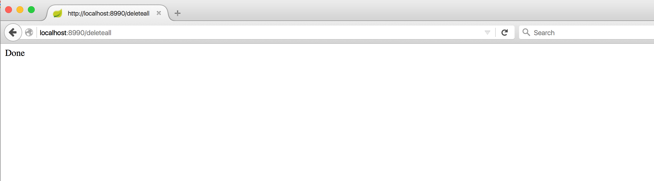

**show empty list as all orders are deleted:**

