VIETNAM NATIONAL UNIVERSITY – HO CHI MINH CITY INTERNATIONAL UNIVERSITY
SCHOOL OF COMPUTER SCIENCE & ENGINEERING


Web-based Boarding House Management System
By
Nguyen Sy Phi– ITITIU19178
A thesis submitted to the School of Computer Science and Engineering in partial fulfillment of the requirements for the degree of Bachelor of Computer Science

Ho Chi Minh City, Vietnam
2025

Web-based Boarding House Management System
APPROVED BY: ________________________________ ,
Ly Tu Nga, Ph.D

________________________________

THESIS COMMITTEE
(Whichever applies)

ACKNOWLEDGMENTS

First and foremost, I would like to express my deepest gratitude to Dr. Ly Tu Nga for her invaluable guidance, support, and encouragement throughout my thesis journey.
To Dr. Ly Tu Nga, thank you for your dedication, insightful feedback, and constant motivation, which have been instrumental in shaping the direction of my work. Your expertise and thoughtful advice have not only enriched my research but also inspired me to strive for excellence.
Without your mentorship and belief in my abilities, this thesis would not have been possible. I am profoundly grateful for the time and effort you devoted to helping me achieve this milestone.

TABLE OF CONTENTS

ACKNOWLEDGMENTS 3
TABLE OF CONTENTS 4
LIST OF FIGURES 6
ABSTRACT 9
CHAPTER 1. INTRODUCTION 10
1.1. Background 10
1.2. Problem Statement 10
1.3. Scope and Objectives 11
1.3.1. Scope 11
1.3.2. Objective 12
1.4. Assumption and Solution 12
1.4.1. Assumption 12
1.4.2. Solution 13
1.5. Structure of thesis 15
CHAPTER 2. LITERATURE REVIEW 17
2.1. Room Rental Websites 17
2.1.1. History of Online Rental Platforms 17
2.1.2. How the efficiency of Room Rental Websites has been improved 17
2.2. Techniques 18
2.2.1. Frontend Technology 18
2.2.2. Backend Technology 19
2.2.3. Database Technology 20
2.3. Summarize 20
CHAPTER 3. METHODOLOGY 22
3.1. System Designs 22
3.1.1. Overview 22
3.1.2. User requirement analysis 23
3.1.3. Use case diagram 26
3.1.4. Sequence diagram 34
3.1.5. Database 38
CHAPTER 4. IMPLEMENT AND RESULTS 48
4.1. Implement 48
4.1.1. Code 48
4.2. Result 55
4.2.1. General interface 55
2.3.1. Login and Forgot Password 66
4.2.2. Tenant 67
4.2.3. Landlord 81
4.2.4. Admin 89
CHAPTER 5. DISCUSSION AND EVALUATION 93
4.3. Discussion 93
4.4. Comparison 93
4.5. Evaluation 94
CHAPTER 6. CONCLUSION AND FUTURE WORK 96
4.6. Conclusion 96
4.7. Future work 96
REFERENCES 97

LIST OF FIGURES

Figure 1: Architecture Diagram for Rental Accommodations Website ................................. 23
Figure 2: Use Case Diagram for Rental Accommodations Website ..................................... 26
Figure 3: Sequence diagram of use case: Register ............................................................. 34 Figure 4: Sequence diagram of use case: Login ................................................................. 35
Figure 5: Sequence diagram of use case: Room’s Information ........................................... 36
Figure 6: Sequence diagram of use case: Update Information ............................................ 37
Figure 7: Sequence diagram of use case: Sent Email ......................................................... 38
Figure 8: Database diagram number 1 Entire website ......................................................... 39
Figure 9: Database diagram number 2 Comments .............................................................. 40
Figure 10: Database diagram number 3 Expireds ............................................................... 41
Figure 11: Database diagram number 4 News .................................................................... 42
Figure 12: Database diagram number 5 Orders .................................................................. 43
Figure 13: Database diagram number 6 Payments ............................................................. 44
Figure 14: Database diagram number 7 Posts .................................................................... 45
Figure 15: Database diagram number 8 Ratings ................................................................. 46
Figure 16: Database diagram number 8 Users ................................................................... 47
Figure 17: Frontend folders ................................................................................................. 49
Figure 18: Frontend components folders ............................................................................. 50
Figure 19: Frontend routes .................................................................................................. 51
Figure 20: Frontend packages ............................................................................................ 52
Figure 21: Backend folders ................................................................................................. 53
Figure 22: Backend package ............................................................................................... 54
Figure 23: Database actor ................................................................................................... 55
Figure 24: Title of the website ............................................................................................. 55
Figure 25: Home of the website .......................................................................................... 56
Figure 26: Boarding room ................................................................................................ 58
Figure 27: Entire house for rent ........................................................................................... 58
Figure 28: Apartment for rent .............................................................................................. 59
Figure 29: News portal ........................................................................................................ 60
Figure 30: Detailed news page ............................................................................................ 60
Figure 31: User Account Menu of Admin ............................................................................. 61
Figure 32: User Account Menu of Landlord ......................................................................... 61
Figure 33: User Account Menu of Tenant ............................................................................ 62
Figure 34: Wishlist .............................................................................................................. 62
Figure 35: Detailed wishlist page ........................................................................................ 63
Figure 36: Posting function ................................................................................................. 64
Figure 37: Register of the website ....................................................................................... 64
Figure 38: Unsatisfying input in part: Register ..................................................................... 65
Figure 39: Login of the Rental Accommodation Website ..................................................... 66
Figure 40: Password recover of the Rental Accommodation Website ................................. 66
Figure 41: Reset password of the Rental Accommodation Website .................................... 67
Figure 42: Search bar ........................................................................................................ 67
Figure 43: Filter by price ..................................................................................................... 68
Figure 44: Filter by area ...................................................................................................... 68
Figure 45: Filter by amenities .............................................................................................. 69 Figure 46: Selected conditions after filtering ........................................................................ 69
Figure 47: List of posts ........................................................................................................ 70
Figure 48: Navigation bar .................................................................................................... 71
Figure 49: Pagination .......................................................................................................... 72
Figure 50: Room detail page ............................................................................................... 72
Figure 51: Room Features and Map .................................................................................... 73
Figure 52: Information page review section ......................................................................... 74
Figure 53: User Dashboard of Tenant ................................................................................. 74
Figure 54: Account upgrade conditions ............................................................................... 75
Figure 55: Notification when upgrade is successful ............................................................. 76
Figure 56: Email update section .......................................................................................... 76
Figure 57: OTP code sent to email ...................................................................................... 77
Figure 58: Page for saved viewed posts.............................................................................. 77
Figure 59: Balance information ........................................................................................... 78
Figure 60: Payment history ................................................................................................. 78
Figure 61: VNPay top-up ..................................................................................................... 79
Figure 62: VNPay gateway ................................................................................................. 79
Figure 63: Payment successful interface ............................................................................. 80
Figure 64: Update balance .................................................................................................. 80
Figure 65: Basic information of the posting page ................................................................. 82
Figure 66: Post information of the posting page .................................................................. 83
Figure 67: Room Information of the posting page ................................................................ 84
Figure 68: Posting package of the posting page .................................................................. 84
Figure 69: Upload images and videos ................................................................................. 85
Figure 70: Contact and Payment information ...................................................................... 86
Figure 71: Post Management section .................................................................................. 87
Figure 72: Notice of successful approval ............................................................................. 87
Figure 73: Bill Management section .................................................................................... 88
Figure 74: Posting success notification ............................................................................... 88
Figure 75: The newly published post appears on the home page ........................................ 89
Figure 76: User dashboard of Admin ................................................................................... 90
Figure 77: Member Management Page ............................................................................... 91
Figure 78: Manage post status ............................................................................................ 91
Figure 79: News article creation page ................................................................................. 92
Figure 80: News management page ................................................................................... 92

LIST OF TABLES

Table 1: Requirement analysis of Tenant ............................................................................ 23
Table 2: Requirement analysis of Landlord ......................................................................... 24
Table 3: Requirement analysis of Admin ............................................................................. 25
Table 4: Use case diagram description of use case: Register ............................................. 26 Table 5: Use case diagram description of use case: Login .................................................. 27
Table 6: Use case diagram description of use case: Post Room’s Information .................... 28
Table 7: Use case diagram description of use case: Manage Post ...................................... 29
Table 8: Use case diagram description of use case: Search for Room Information ............. 29
Table 9: Use case diagram description of use case: Recharge the Account ....................... 30
Table 10: Use case diagram description of use case: Rental Room Rating ......................... 31
Table 11: Use case diagram description of use case: View Room Details ........................... 31
Table 12: Use case diagram description of use case: Manage Profile ................................. 32
Table 13: Use case diagram description of use case: Send Email ...................................... 33

ABSTRACT

In the context of rapid urbanization and accelerating economic growth in Vietnam, the demand for accessible and affordable housing- particularly rental rooms - has intensified, emerging as a critical socioeconomic challenge. This thesis delves into the design and implementation of an advanced room rental platform that bridges the structural gap between landlords and prospective tenants. Drawing inspiration from contemporary real estate portals, this platform delivers an intuitive, mobile-responsive ecosystem where property owners can effortlessly digitalize their listings. At the same time, seekers can navigate available spaces utilizing multifaceted filtering mechanisms and interactive geolocation mapping.

Distinguishing itself through a highly optimized architectural framework, the application empowers property owners to oversee accommodations comprehensively, capturing images, specifying essential amenities, and autonomously managing post-visit visibility through integrated MoMo payment gateways for listing extensions. Beyond basic search functionality, the system enriches user experience by incorporating personalized features such as wishlists, rating and comment sections, and Google OAuth for seamless authentication. Engineered leveraging cutting-edge web technologies, the frontend utilizes ReactJS strictly bundled with Vite for peak rendering performance, whereas the robust backend relies on Express.js and PostgreSQL. This study introduces a reliable, centralized, and feature-rich operational tool that vastly diminishes information asymmetry, elevating the transparency and efficiency of the modern room rental market..

CHAPTER 1. INTRODUCTION

1.1. Background

The residential rental market, inherently characterized by its provision of modest accommodations such as single rooms and shared apartments, forms the backbone of urban housing solutions. In developing economies akin to Vietnam, a massive influx of students, expatriates, and the labor workforce migrating to metropolitan hubs has catalyzed an unprecedented demand for affordable housing. Historically, the methodologies employed in navigating this rental landscape - relying on word-of-mouth recommendations, physical bulletins, or fragmented social media posts - have proven severely archaic. These traditional paradigms inherently breed a lack of transparency, geographical constraints, and significant communication friction between property proprietors and potential occupants.

To counteract these systemic inefficiencies, establishing centralized online rental ecosystems has become paramount. While several digital platforms exist today, a substantial portion suffers from cumbersome user interfaces, inadequate robust search algorithms, or subpar mobile adaptability. Consequently, the contemporary market demands an agile, meticulously structured digital solution tailored for grassroots rental operations, circumventing the heavy reliance on macroscopic property management conglomerates. This project aims to conceptualize and materialize a holistic web application, facilitating seamless interactions where property operators can broadcast vacancies digitally, enabling seekers to pinpoint optimal living spaces through intelligent, parameter-driven searches.

1.2. Problem Statement

The property rental sector across densely populated municipalities routinely grapples with operational bottlenecks. Inherently reliant on antiquated advertising mechanisms, the flow of rental information remains isolated and occasionally misleading. Prospective tenants invariably endure a time-consuming, frustrating endeavor marred by outdated inventory or opaque pricing models. Conversely, individual landlords—often managing localized operations—struggle to amplify their property's exposure to a broader demographic and face administrative fatigue when overseeing multiple decentralized postings manually.

Despite acute market demand, there is a pronounced scarcity of coherent, high-performing platforms that organically pair meticulous listing customization with an unhindered tenant search journey. Many existing alternatives lack granular filtering capabilities, spatial mapping integrations, or straightforward communicative links. This absence of a standardized digital registry results in duplicated efforts and widespread informational asymmetry. Thus, the fundamental problem this project addresses is the urgent necessity for an integrated, highly accessible digital environment. By architecting a refined interface, this initiative endeavors to systematize property publication and streamline intricate search workflows, ultimately fostering trust and transparency for both end-users.

1.3. Scope and Objectives

1.3.1. Scope

The endeavor is strictly bound to the architecture and deployment of a dynamic room rental directory. It encompasses distinct operational tiers: a portal for landlords to publish and curate property portfolios; an explorer module for tenants to conduct targeted inquiries leveraging interactive maps and community feedback; and an overarching administrative dashboard to monitor macro-system metrics. Crucial system augmentations encompass integrated digital payment gateways (MoMo), empowering landlords to automate renewal listing durations. The application is engineered with a mobile-first UI philosophy, prioritizing cross-platform uniformity and robust operational speed over local development constraints..

1.3.2. Objective

The core aspiration of this research is to forge an operational and commercially viable real estate tool. Essential benchmarks include:

Landlord Interface Mastery: Architecting a comprehensive dashboard enabling property owners to inject intricate listing metadata, ranging from spatial dimensions and geographic coordinates to multimodal imagery and safety features.

Empowered Tenant Discovery: Constructing an advanced retrieval system governed by layered filters (price thresholds, vicinity, room typologies) and integrated with Leaflet maps to accelerate the tenant’s spatial decision-making process.

Enhanced User Interactions: Embedding personalized user-centric features, including secure Google OAuth logins, a wishlist mechanism for saving favorite properties, and a transparent comment and rating system to build community trust.

Optimized Structural Design: Utilizing the ReactJS library combined with Vite building procedures to manifest a high-fidelity, high-performance UI tailored universally across both desktop and mobile devices.

Administrative Analytics: Delivering an administrative command center visualizing data-driven insights (utilizing Chart.js) to track listing volumes, revenue streams, and user registrations, alongside an RSS-driven news syndication feature.

Automated Subscription Modalities: Integrating the secure MoMo payment gateway, enabling landlords to execute micro-transactions to artificially extend the chronological visibility of their accommodation postings.

1.4. Assumption and Solution

1.4.1. Assumption

The fundamental premise postulates that the demographic targets (landlords and tenants) inherently desire an expedited, interactive environment for exchanging property parameters. It is assumed that the adopted technology stack exhibits the necessary scalability, concurrency handling, and cryptographic stability to protect user identities and financial transactions, adhering strictly to standard web data security doctrines.

1.4.2. Solution

Aligning with the predefined prerequisites, the system's structural blueprint unfolds sequentially:

Presentation & Exploration Core:

Frontend Elements: Leveraging React paired with Tailwind CSS and Radix UI to forge a responsive, aesthetically pristine visual hierarchy. Interactive Map components (via Leaflet) inject geographical context directly into property listings.

Backend Elements: Express.js operates as the central neurological routing system, interfacing with a PostgreSQL relational database meticulously managed by the Sequelize Object-Relational Mapper (ORM).

Dynamic Querying & Synchronization:

Zustand assumes global state management responsibilities, while Axios (paired with SWR for caching) seamlessly pipes HTTP requests against backend RESTful endpoints to reflect real-time property inventories.

User Engagement & Analytics:

The platform encompasses rating schemas and a post tracking module (View/SeenPost) for continuous engagement. For the administrative echelon, Chart.js interfaced via React-Chartjs-2 projects complex backend aggregations visually.

Listing Administration:

React Hook Form orchestrates bidirectional data binding during the property submission phases, enforcing rigorous structural validation prior to database insertion.

Transactional Listing Extensions:

Landlord payment processing is routed to the MoMo Sandbox APIs constructed within the Express back-end, allowing transactional Webhook/IPN verifications to instantaneously mutate post expiry timestamps dynamically.

Authentication & Cryptography:

Secure access is gated utilizing JSON Web Tokens (JWT) and Google OAuth integrations, with native user credential masking handled algorithmically via bcryptjs to thwart unauthorized infiltrations.

1.5. The subsequent documentation is systematically segmented into the following framework:

Chapter 1 – Introduction: Outlines the socio-economic catalyst driving the research, defines the empirical problem, and articulates the theoretical constraints alongside proposed technological remedies.

Chapter 2 – Literature Review: Critically evaluates existing real estate digital solutions, tracing historical iterations of property listing paradigms, interactive search interfaces, and architecture comparatives.

Chapter 3 – Methodology: Illuminates the procedural lifecycle of the software's conception. This includes requirements elicitation, architectural modelling (Use Cases, Sequence Schematics), and rigorous Entity-Relationship mapping.

Chapter 4 – Implementation and Results: Translates the theoretical architecture into materialized code, documenting crucial module assemblies (such as the MoMo payment flow and Leaflet integration) and highlighting the functional outputs authenticated during local execution.

Chapter 5 – Discussion and Evaluation: Undertakes an analytical appraisal of the deployed prototype, measuring operational latency, responsive experience, and weighing definitive advantages against existing limitations.

Chapter 6 – Conclusion and Future Work: Synthesizes final realizations and charts a prospective trajectory for subsequent functional expansions, solidifying the application's evolutionary roadmap..

CHAPTER 2. LITERATURE REVIEW

2.1. Room Rental Websites

2.1.1. History of Online Rental Platforms

On a global scale, the evolution of digital room rental platforms has achieved significant milestones, transitioning from rudimentary online classifieds to highly sophisticated digital marketplaces. The genesis of this digital transformation is often traced back to 1995 with the launch of VRBO (Vacation Rentals by Owner), the pioneer platform facilitating short-term and vacation accommodations. Initially, VRBO empowered independent property owners to directly showcase their listings to web visitors, effectively centralizing reservations predominantly within the United States market [1]. Concurrently, Craigslist emerged as a decentralized, informal conduit offering both transient and long-term accommodation advertisements [1].

In 1996, the landscape shifted with the establishment of Booking.com in the Netherlands. Although it initially functioned as a hotel aggregator, the platform aggressively diversified to encompass vacation rentals, cementing its status as a colossal industry leader [1]. By continuously investing in frictionless travel technologies, Booking.com successfully bridges millions of users with diverse lodging options—ranging from private homes to corporate hotels. As a premier global travel marketplace, it empowers property managers globally to capture international audiences and scale their enterprises [2].

Within the Vietnamese context, Phongtro123.com is widely recognized as one of the earliest specialized room rental ecosystems, launching circa 2015. The portal disrupted the local market by adopting a hyper-focused approach exclusively on boarding houses and rental rooms, thereby delivering exhaustive and rapidly accessible inventory. By equipping users with robust filtering mechanisms—encompassing price ranges, geolocations, and surrounding amenities—it dramatically accelerated the connection phase between landlords and prospective tenants [3], [4], [5].

2.1.2. How the efficiency of Room Rental Websites has been improved

Contemporary rental portals, both domestically and internationally, continuously refine their operational efficiency, measurable through heightened user engagement, conversion velocity, and robust feedback loops. In Vietnam, domain-specific sites like Phongtro123.com have achieved sustained success by curating highly detailed inventories, implementing granular search constraints, and offering responsive customer relations. By strictly narrowing its niche to room rentals, Phongtro123.com drastically mitigates search fatigue, enabling seekers to locate suitable living arrangements almost instantaneously.

Internationally, Airbnb remains an undisputed paradigm of efficiency, heavily attributed to its expansive portfolio comprising apartments, luxury villas, and authentic homestays. Airbnb’s operational superiority relies fundamentally on fostering ecosystem transparency via a rigorous peer-review and rating methodology, which exponentially elevates user trust. Illustratively, local Vietnamese accommodations such as Ha Long Lily Homestay consistently secure excellent ratings, reflecting profound consumer gratification regarding facility quality, responsive services, and seamless reservation journeys [6]. Furthermore, overarching platforms like Agoda have broadened their strategic horizons beyond mere hotel reservations to include prolonged leasing options engineered for metropolitan hubs in Vietnam. This strategic pivot actively captures diverse socioeconomic segments, catering to both transient tourists and long-term expatriates [7].

Collectively, these case studies highlight that the sustained growth and profitability of contemporary rental ecosystems are deeply dependent on user-centric augmentation, namely, customizable algorithmic searches, stringent rating verifications, and unhindered communicative channels connecting property owners with tenants.

2.2. Techniques

2.2.1. Frontend Technology

ReactJS: A premier JavaScript library dedicated to architecting dynamic user interfaces. It enforces a component-based paradigm, enabling developers to synthesize complex, highly interactive, and reusable UI structures [8].

Vite: An ultra-fast, modern frontend build tool originally conceptualized around the Vue ecosystem to overcome the latency bottlenecks characteristic of legacy bundlers. Engineered in Go, Vite delivers near-instantaneous server starts and Hot Module Replacements (HMR), operating exponentially faster than conventional JavaScript bundlers [9].

Styling and UI Architecture:

Tailwind CSS: A highly customizable, utility-first CSS framework that facilitates the rapid construction of bespoke, modern user interfaces directly within HTML markups, bypassing the necessity for external stylesheet context-switching [10].

Radix UI: A robust, open-source library providing unstyled (headless) UI primitives. It serves as an accessible foundation for engineering high-quality design systems and interactive web elements such as dialog modals, interactive dropdowns, and tooltips [11].

State Management and Complex Handling:

Zustand: An exceptionally lightweight, unopinionated state-management solution engineered by the creators of Jotai and React-spring. It leverages a simplistic, hook-driven API that avoids the boilerplate fatigue typically induced by traditional flux architectures [12].

React Hook Form: A highly performant library designated for managing complex form validations. Boasting minimal re-renders, zero dependencies, and an incredibly light footprint, it integrates flawlessly with UI ecosystems while providing a superior developer experience [13].

Routing, Navigation, and Data Fetching:

React Router DOM: An indispensable routing dependency for React environments, enabling seamless, dynamic client-side navigational structures. It allows applications to transition between unique views smoothly without triggering full document reloads [14].

Axios: A robust, Promise-based HTTP client proficient in both Node.js and browser environments. It facilitates seamless API communications, utilizing the native http module server-side and XMLHttpRequests client-side [15].

SWR (Stale-While-Revalidate): A sophisticated React hook library tailored for remote data fetching. SWR fundamentally accelerates perceived application speed by returning cached (stale) data instantaneously, simultaneously emitting a fetch request to revalidate and update the UI implicitly [16].

Geographic Mapping & Analytics Visualization (System Specific):

Leaflet: An open-source, lightweight JavaScript library pivotal for embedding interactive, mobile-friendly geographic maps. It visualizes property coordinates, vastly improving the spatial awareness of potential tenants during their search.

Chart.js & React-Chartjs-2: An declarative charting library utilized within the administrative tier to render aesthetic, data-rich graphical representations, empowering administrators to track financial and demographic trends accurately.

2.2.2. Backend Technology

Node.js: A ubiquitous, cross-platform JavaScript runtime environment executing JavaScript code outside a web browser, forming the robust engine for scalable network applications [17].

Express.js: The universally acknowledged, minimalist web application framework intrinsic to the Node.js ecosystem. It equips developers with a profound suite of features essential to assemble RESTful APIs and handle intricate routing architectures effortlessly [18].

Cryptography and Access Security:

BcryptJS: A pure JavaScript implementation of the formidable bcrypt password hashing function. It incorporates complex salting mechanics to securely obfuscate user credentials, shielding the database against brute-force cryptographic attacks [19].

JSON Web Token (JWT): An industry-standard (RFC 7519) cryptographic protocol. It formulates concise, digitally signed payloads tailored for secure data transmission, operating as the core mechanism for stateless user authentication and session persistence [20].

Communication Services:

Nodemailer: A highly reliable Node.js middleware engineered to facilitate streamlined, programmatic email transmissions directly from the server runtime [21].

Twilio: An enterprise-grade cloud communications platform. It exposes powerful APIs allowing software architectures to natively ingest and dispatch SMS notifications, bridging the gap between digital interfaces and telecommunication networks [22].

2.2.3. Database Technology

PostgreSQL: An advanced, enterprise-class open-source Relational Database Management System (RDBMS). It is universally acclaimed for its rigid SQL compliance, structural flexibility, and capacity to handle immense, concurrent transactional workloads flawlessly [23].

Sequelize: A modern, highly mature Object-Relational Mapper (ORM) for Node.js and TypeScript ecosystems. It provides robust synchronization with PostgreSQL engines, enabling developers to interact with relational constructs utilizing strongly-typed JavaScript models [24].

2.3. Summarize
Related Work | Features | This Thesis | Description
Le, T. T. V., & Do, P. C.  (2022) [25] | Operational management framework including room inventory, contractual oversight, facility maintenance, landlord-tenant communication conduits, and statistical tracking.. | ☑ | This antecedent system introduces a foundational management matrix for rental operations. Concepts such as room inventory oversight, localized direct communication channels, and monthly administrative analytics heavily inspired the administrative functionalities integrated within this thesis.
Nguyen, M. T.  (2020) [26] | Analysis of factors influencing renting | ☑ | This study examines critical aspects, including price, area,
 | decisions: price, area, and location. |  | and location, that affect students' rental choices, establishing a basis for developing a system that addresses user requirements.
Pham, T. N.  (2019) [27] | Survey of current trends and analysis of factors influencing students' rental choices. | ☑ | This study examines and evaluates the determinants influencing students' rental preferences, assisting in the formulation of suitable attributes for the rental system.
Hoang, D. T., & Tran, A. P.  (2021) [28] | Analysis of factors: price, location, facilities, service quality, security, living environment. | ☑ | This study use statistical analysis to ascertain key elements affecting rental decisions, offering vital data for system design.
Doan, L. T.  (2023) [29] | Analysis of factors affecting the intention to continue renting:  service quality, environment, relationships. | ☑ | This article examines the aspects affecting students' intention to sustain rental housing, with the objective of enhancing attributes to elevate tenant happiness and loyalty.

CHAPTER 3. METHODOLOGY

3.1. System Designs

3.1.1. Overview
The conceptualized platform operates on a robust multi-tier architectural pattern, purposefully engineered to enforce a strict separation of concerns across the presentation (client), application (server), and data (database) layers.

At the presentation tier, the client interface is meticulously constructed utilizing contemporary frontend paradigms. It leverages React.js as the core library, bundled cohesively via Vite to ensure accelerated local development and optimized deployment pipelines. Tailwind CSS acts as the primary stylistic engine, facilitating a highly fluid and mobile-responsive UI design. To handle the complexities of intra-application interactions, global state transitions are orchestrated via Zustand, while sophisticated form validations are delegated to React Hook Form. Client-side navigation is seamlessly dictated by React Router DOM. Furthermore, bidirectional data synchronization between the frontend environment and the backend infrastructure is efficiently managed using Axios, synergized with SWR (Stale-While-Revalidate) to enable instantaneous data fetching and sophisticated local caching strategies.

The application tier is deployed atop a Node.js runtime environment utilizing the Express.js framework. This backend stratum acts as the central hub for exposing RESTful APIs, which systematically process and route diverse client constraints. Security protocol is a paramount focus; thus, the architecture integrates JSON Web Tokens (JWT) for stateless user authentication and employs BcryptJS algorithms for stringent password cryptography. Beyond foundational processing, the server tier is augmented with modular communication services, utilizing Nodemailer for automated email dispatch protocols and Twilio for programmatic SMS notifications.

At the foundational data tier, PostgreSQL is deployed to guarantee highly dependable, ACID-compliant data preservation and structural integrity. This relational database is bridged using Sequelize, a powerful Object-Relational Mapper (ORM) that accelerates complex database querying through dynamic, object-oriented paradigms. Ultimately, this decoupled 3-tier architecture ensures extreme scalability, structural maintainability, and a frictionless user experience, thereby establishing a resilient infrastructural baseline primed for the prospective integration of AI-driven tools, such as ChatGPT-powered functional enhancements..
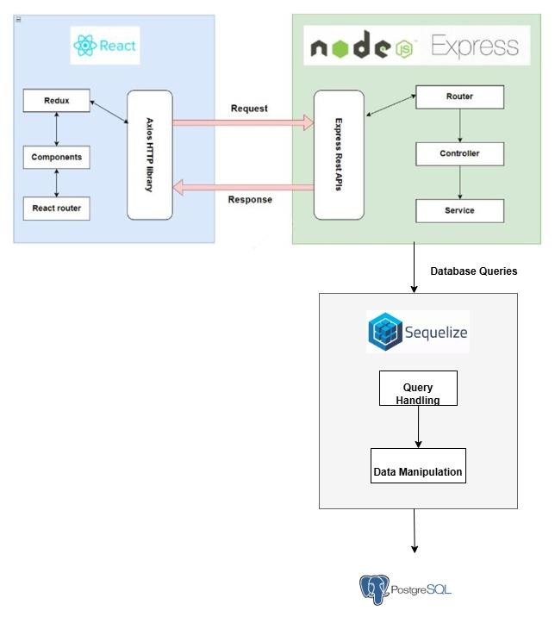
Figure 1: Architecture Diagram for Rental Accommodations Website

3.1.2. User requirement analysis
3.1.2.1. Tenant

Table 1: Requirement analysis of Tenant
Registration | Allow new users to create a secure platform account by submitting basic identity credentials.
Authentication (Login) | Grants’ role-based access to the platform using verified credentials protected by JWT and bcrypt encryption.
Advanced Room Search | Enables tenants to discover available rooms using multi-parameter filters including price range, location, room type, and spatial area.
Profile Management | Allows users to update their personal information such as name, email, phone number, avatar, and password.
Wallet Recharge | Enables users to top-up their internal account balance via the integrated MoMo payment gateway.
Post Modification Payments | Allows users to deduct funds from their wallet balance to pay for listing-related transactions, such as extending post visibility.
Privilege Escalation | Provides a pathway for Tenant accounts to be upgraded to Landlord role, granting access to property listing features.
Financial Ledger Tracking | Allows users to monitor their wallet balance, view transaction history, and track listing renewal records.
Direct Proprietor Communication | Displays verified landlord contact details (phone, email) on listings, enabling tenants to communicate offline directly.
Rating & Feedback Mechanism | Allows tenants to submit a star rating and written review on property listings to promote community transparency.
Wishlist Curation | Enables tenants to bookmark and manage a personal list of favorite property listings for later review.

3.1.2.2. Landlord
Table 2: Requirement analysis of Landlord
roperty Listing Initialization | Allows landlords to publish room details to the platform, including spatial area, pricing, geographic location, amenities, images, and direct contact information.
Listing Lifecycle Management | Provides landlords with an interface to edit existing listing data, manage uploaded images, and toggle real-time room availability status (vacant / rented).
Chronological Listing Extension | Enforces a time-limited visibility model where listings automatically expire after a set period. Landlords must complete a MoMo micro-payment to renew and sustain their listing's public visibility.

3.1.2.3. Admin
Table 3: Requirement analysis of Admin
Global Analytics Dashboard | Provides administrators with a visual overview of platform KPIs, including active listings, revenue statistics, and user demographics to support data-driven decision-making.
User Access Governance | Allows administrators to manage user accounts, including deactivating accounts and adjusting user roles (e.g., promoting a tenant to landlord).
Automated Notifications | Handles scheduled email alerts via cron jobs, automatically notifying landlords when their listings are approaching expiration.
Content Moderation | Enables administrators to review, approve, reject, or remove property listings submitted by landlords to maintain platform content quality.
News Management | Allows administrators to create, edit, and delete editorial news content and RSS-based articles displayed on the platform.
Profile Configuration | Permits administrators to update their own account credentials and personal contact information within the system.

3.1.3. Use case diagram

3.1.3.1. Use case diagram
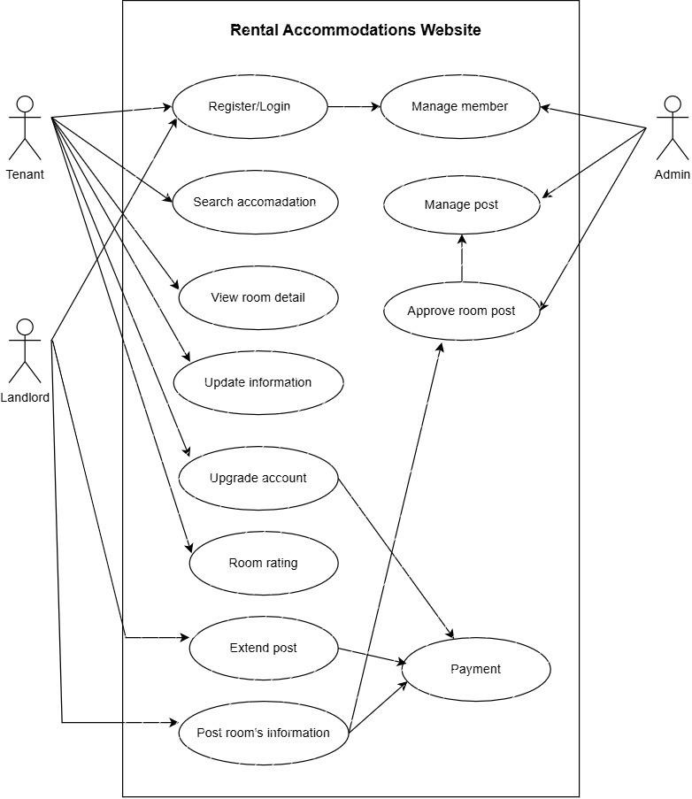

Figure 2: Use Case Diagram for Rental Accommodations Website
3.1.3.2. Use case diagram description

Table 4: Use case diagram description of use case: Register
Use Case Name | UC-1: Account Registration
Actors | Tenant, Landlord
Preconditions | Device has an active internet connection
Rationale | User wishes to create a persistent account on the platform
Postconditions | New account securely created and persisted to the database
Main scenario | 1. User navigates to the platform homepage.  2. User selects the "Register" option.  3. User inputs required credentials (full name, email address, password).  4. User confirms by clicking "Sign Up".  5. System performs input validation checks.  6. System hashes the password and saves credentials to the database.  7. System forwards the new account for administrative review.  8. System renders a success confirmation message to the user.
Alternative Paths | Submitted email already exists in the database → system returns a duplication conflict error..
Extensions

Table 5: Use case diagram description of use case: Login
Use Case Name | UC-2: System Authentication (Login)
Target Actors | Tenant, Landlord, Administrator
Preconditions | User has a registered account
Rationale | User wants to access role-based features
Postconditions | JWT issued; user redirected to appropriate dashboard
Main scenario | 1. User opens the login page and enters credentials.  2. System validates credentials against hashed records.  3. System issues a JWT session token.  4. User is redirected to their role-based dashboard (Tenant / Landlord / Admin).
Alternative Paths | Invalid credentials → system returns authentication error.
Extensions | Forgotten password → reset token sent via registered email.

Table 6: Use case diagram description of use case: Post Room’s Information
Use Case Name | UC-3: Property Listing Publication
Actors | Landlord (initiator), Admin (approver)
Preconditions | Landlord is authenticated with posting privileges
Rationale | Landlord wants to advertise a vacant rental room
Postconditions | Listing approved and visible in public directory
Main scenario | 1. Landlord opens the "Post Room" panel.  2. Landlord fills in property details (price, area, location, images).  3. Listing is submitted and queued with "Pending" status.  4. Admin reviews and approves the submission.  5. System publishes the listing publicly.
Alternative Paths | Admin rejects post → landlord receives rejection notification.
Extensions | Listing expires → system auto-sends email renewal reminder to landlord.

Table 7: Use case diagram description of use case: Manage Post
Use Case Name | UC-4: Listing Lifecycle Management
Actors | Landlord (primary), Admin (moderator)
Preconditions | Landlord is authenticated and owns at least one active listing
Rationale | Landlord wants to modify or remove an existing property post
Postconditions | Updated listing details are validated and persisted to the database
Main scenario | 1. Landlord navigates to the "Manage Post" dashboard.  2. Landlord selects the target listing from their portfolio.  3. Landlord edits metadata (price, description, images) or toggles availability status (vacant / rented).  4. System validates submitted changes and updates the database record.  5. Changes are immediately reflected across the public listing directory.
Alternative Paths
Extensions | Admin retains override authority to forcibly remove any listing that violates platform content guidelines, independent of landlord consent.

Table 8: Use case diagram description of use case: Search for Room Information
Use Case Name | UC-5: Advanced Room Search
Actors | Tenant
Preconditions | Tenant is authenticated with an active session
Rationale | Tenant wants to discover available rental rooms matching personal criteria
Postconditions | System renders a filtered list of matching property listings
Main scenario | 1. Tenant navigates to the search interface.  2. Tenant inputs desired filter parameters (location, price range, room type, area).  3. System queries the database against the submitted filter set.  4. Matching listings are retrieved and displayed as an organized result grid, with geographic context rendered on the integrated Leaflet map.
Alternative Paths | No matching records found → system displays an empty-state notification advising the tenant to broaden search parameters.
Extensions | Tenant may bookmark any displayed listing directly into their personal Wishlist for deferred review.

Table 9: Use case diagram description of use case: Recharge the Account
Use Case Name | UC-6: Wallet Recharge
Actors | Tenant, Landlord
Preconditions | User is authenticated with an active session
Rationale | User wants to deposit funds into their internal wallet to enable platform transactions
Postconditions | Transaction verified; account balance incremented and persisted in the database
Main scenario | 1. User navigates to the "Recharge" section of their account dashboard.  2. User selects or manually inputs the desired top-up amount.  3. User selects MoMo as the payment gateway and confirms the transaction.  4. System generates a secure payment request and redirects the user to the MoMo payment portal.  5. Upon successful payment, MoMo dispatches an IPN (Instant Payment Notification) callback to the backend.  6. System validates the IPN signature and increments the user's wallet balance accordingly.
Alternative Paths | Payment fails or IPN returns error status → system rolls back the transaction and notifies the user of the failure.
Extensions

Table 10: Use case diagram description of use case: Rental Room Rating
Use Case Name | UC-7: Rental Room Rating & Review
Actors | Tenant
Preconditions | Tenant is authenticated with an active session
Rationale | Tenant wants to submit qualitative and quantitative feedback on a rental property
Postconditions | Review record persisted to database and rendered publicly on the listing page
Main scenario | 1. Tenant navigates to the target property listing page.  2. Tenant triggers the "Rate Room" interaction element.  3. Tenant assigns a quantitative star rating (1–5) and composes a written review comment.  4. Tenant submits the feedback form.  5. System validates and persists the rating and comment records to the database.  6. The review is immediately rendered within the listing's public feedback section.
Alternative Paths
Extensions

Table 11: Use case diagram description of use case: View Room Details
Use Case Name | UC-8: Property Detail View
Actors | Tenant
Preconditions | Tenant has accessed the listing directory via search or browsing
Rationale | Tenant wants to inspect comprehensive details of a specific rental property before making contact
Postconditions | Full property record rendered on a dedicated detail page; view count incremented in database
Main scenario | 1. Tenant selects a listing card from the search results or directory.  2. System fetches and renders the complete property profile (images gallery, pricing, spatial area, geographic map, amenities, and landlord contact details).  3. Tenant reviews the information and may directly contact the landlord via the displayed phone number or email.
Alternative Paths | Property record is incomplete or unavailable → system renders an error state notifying the tenant of the data retrieval failure.
Extensions | Tenants can scroll to the community feedback panel to inspect aggregated star ratings and written reviews submitted by previous occupants. Tenant may also save the listing to their personal Wishlist.

Table 12: Use case diagram description of use case: Manage Profile

Use Case Name | UC-9: Profile Management
Actors | Tenant, Landlord
Preconditions | User is authenticated with an active session
Rationale | User wants to update personal identity data stored within the system
Postconditions | Updated profile data validated, persisted to database, and reflected on the UI
Main scenario | 1. User navigates to the "My Profile" section.  2. User modifies desired fields (full name, email, phone number, or password).  3. System dispatches a One-Time Password (OTP) verification code to the user's registered email or phone number.  4. User enters the OTP to confirm identity and clicks "Save Changes".  5. System validates the OTP, persists the updated records, and refreshes the displayed profile data.
Alternative Paths | Required fields left blank or OTP mismatch → system prompts the user with targeted validation error messages.
Extensions | Users may upload or replace their profile avatar image, which is stored and rendered across all platform interactions.

Table 13: Use case diagram description of use case: Send Email
Use Case Name | UC-10: Automated Email Notification
Actors | System (automated, no human initiator)
Preconditions | System has valid email templates configured and recipient data accessible in the database
Rationale | System must dispatch contextual automated notifications to users upon specific trigger events
Postconditions | Email successfully delivered to recipient; transmission status logged in the system
Main scenario | 1. System detects a predefined trigger event (e.g., payment confirmation, listing expiry warning, OTP request).  2. System selects and populates the appropriate email template with dynamic recipient-specific data.  3. System retrieves the target recipient's registered email address from the database.  4. System dispatches the email via the Nodemailer SMTP service.  5. System records the transmission outcome (success / failure) in the activity log.
Alternative Paths
Extensions | If all delivery retry attempts are exhausted, the system flags the failure in the error log and escalates an internal alert to the Administrator.

3.1.4. Sequence diagrams
These diagrams show the main function of the system.

UC-1: Register
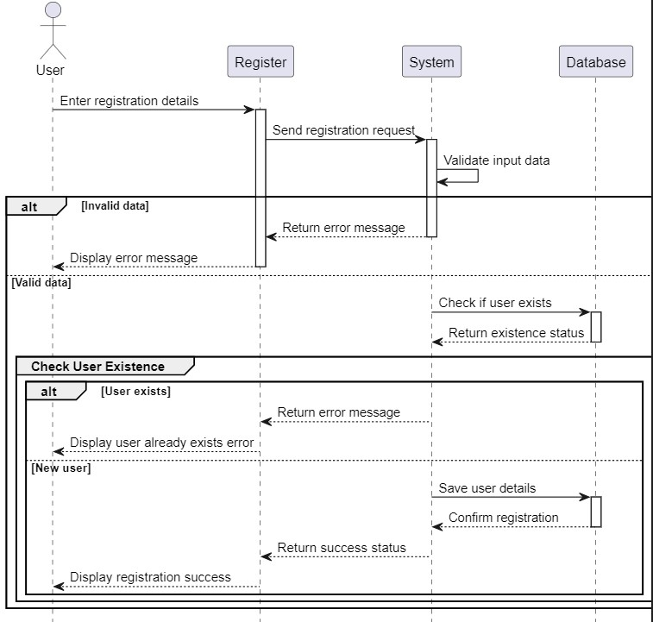

Figure 3: Sequence diagram of use case: Register

The sequence diagram illustrating the account registration workflow captures the full interaction chain between the user, the frontend interface, the backend server, and the database. The process is initiated when the user selects the "Register" entry point on the platform, prompting the system to render the registration form. Upon completing the required fields, the user submits the credential package, triggering a series of server-side validation checks. If all submitted inputs conform to the predefined business rules and format constraints, the backend proceeds to hash the user's password via bcryptjs and securely persist the new account record to the PostgreSQL database. A confirmation notification is subsequently dispatched to the user's interface, affirming successful account creation. Conversely, should any submitted field fail validation - whether due to a duplicate email address, malformed input, or missing mandatory data - the backend returns a descriptive error response, and the frontend surfaces an inline error prompt instructing the user to rectify the identified discrepancies before resubmission.

UC-2: Login
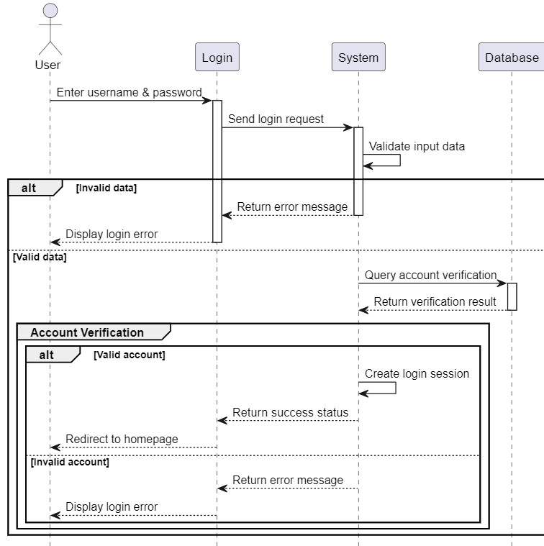
Figure 4: Sequence diagram of use case: Login

The sequence diagram for the authentication workflow illustrates the complete interaction chain triggered when a user initiates the login process. Upon selecting the "Login" entry point, the system renders the credential input interface, prompting the user to supply their registered email address and password. Once submitted, the frontend dispatches the credential payload to the backend authentication controller via a secured HTTP request. The server then extracts the submitted email to retrieve the corresponding user record from the PostgreSQL database. If a matching record is located, the backend invokes bcryptjs to compare the submitted plaintext password against the stored cryptographic hash. Upon successful verification, the server generates and returns a signed JSON Web Token (JWT), which the frontend persists to maintain the session state. The system subsequently determines the user's assigned role (Tenant, Landlord, or Administrator) and programmatically redirects the actor to their respective privilege-scoped dashboard. Conversely, should the credentials fail to match any existing database record, or should the hash comparison yield a mismatch, the backend terminates the authentication pipeline and returns an explicit error response, which the frontend surfaces as an inline notification to prompt corrective action by the user.

UC-3: Post Room’s Information
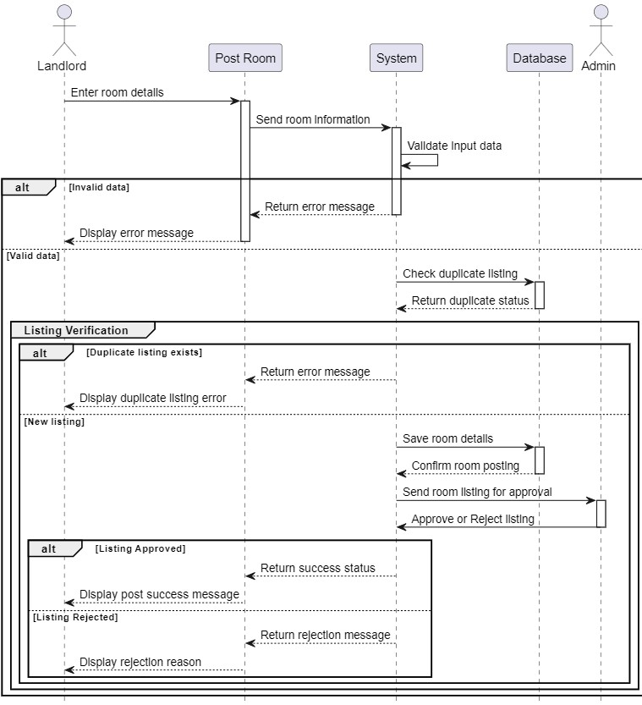
Figure 5: Sequence diagram of use case: Post Room’s Information

The sequence diagram for the property listing publication workflow delineates the complete interaction pipeline initiated when an authenticated landlord selects the "Post Room" option from their dashboard. The system responds by rendering a structured submission form, prompting the landlord to populate all mandatory metadata fields, encompassing room dimensions, pricing parameters, geographic coordinates, amenity descriptors, and multimodal image assets. Upon form submission, the frontend dispatches the complete payload to the backend listing controller, which executes a series of server-side validation checks against predefined business rules and schema constraints. If all submitted data conforms to the required criteria, the backend persists the listing record to the PostgreSQL database with an initial status of "Pending Review" and simultaneously routes an administrative notification to the admin panel queue. The Administrator subsequently intercepts the queued submission, conducts a content compliance audit, and formally approves the listing. Upon receiving an approval signal, the system transitions the listing's status to "Active," rendering it publicly accessible across the platform's property directory, and dispatches a confirmation notification to the landlord's interface. Conversely, should any submitted field fail the validation pipeline - whether due to missing mandatory data or constraint violations - the backend returns descriptive error messages, which the frontend surfaces as targeted inline prompts, directing the landlord to identify and resolve the specific discrepancies prior to resubmission.

UC-5: Search for Room Information
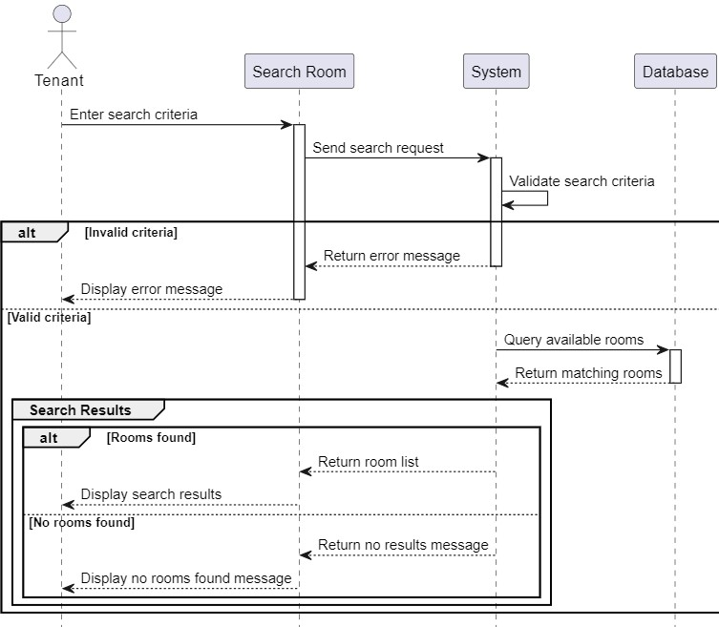
Figure 6: Sequence diagram of use case: Search for Room Information

The sequence diagram for the room search workflow captures the complete interaction chain initiated when a tenant triggers the search functionality. Upon activating the "Search" interface, the system renders a dynamic filtering panel, enabling the tenant to define a precise set of discovery parameters including geographic location, price range, room type, and spatial area. The frontend aggregates the submitted filter criteria and dispatches a structured query request to the backend search controller via an HTTP GET request. The backend constructs and executes a parameterized database query against the PostgreSQL property repository, applying all submitted constraints to retrieve only conforming records. If matching listings are identified, the server returns the result set to the frontend, which renders the properties as an organized listing grid alongside their geographic coordinates visualized on the integrated Leaflet interactive map, providing tenants with both structural and spatial context to inform their decision. Conversely, should the submitted filter combination yield no corresponding records within the database, the backend returns an empty result set, and the frontend surfaces a contextual empty-state notification, advising the tenant to broaden or modify their search parameters to expand the potential discovery scope.

UC-10: Send Email
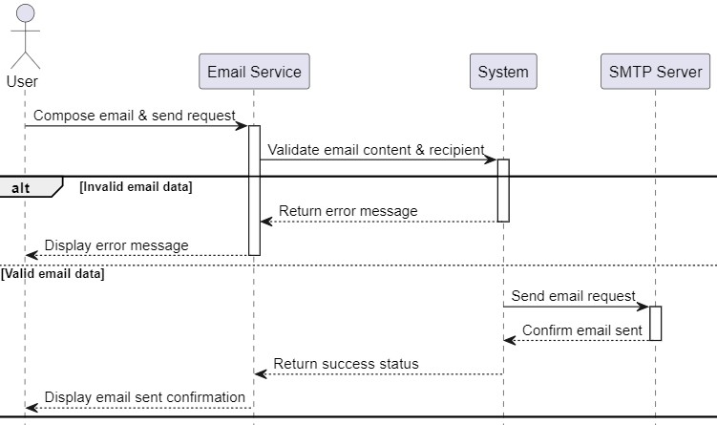

Figure 7: Sequence diagram of use case: Sent Email

The sequence diagram for the automated email notification workflow illustrates the system-driven process triggered by predefined internal events, operating independently of direct user interaction. Trigger events may encompass scenarios such as successful payment confirmations, imminent listing expiration thresholds, OTP verification requests, or administrative status change notifications. Upon detecting a qualifying trigger, the system's backend notification module—governed by scheduled cron jobs or event-driven callbacks—retrieves the target recipient's registered email address and associated contextual data from the PostgreSQL database. The backend subsequently populates the appropriate predefined email template with recipient-specific dynamic parameters and dispatches the compiled message via the Nodemailer SMTP service. Should the transmission complete successfully, the system records the delivery outcome in the activity log, confirming successful notification. Conversely, if the SMTP service returns a transmission failure—attributable to network interruptions, invalid recipient addresses, or server-side errors—the system captures the exception, logs the failure event to the error registry, and escalates an internal alert notification to the Administrator, enabling timely manual intervention to diagnose and remediate the underlying delivery issue.

3.1.5. Database
The website's database structure is represented in the graphic below. It
demonstrates how data is maintained by each actor and the interactions built among them.
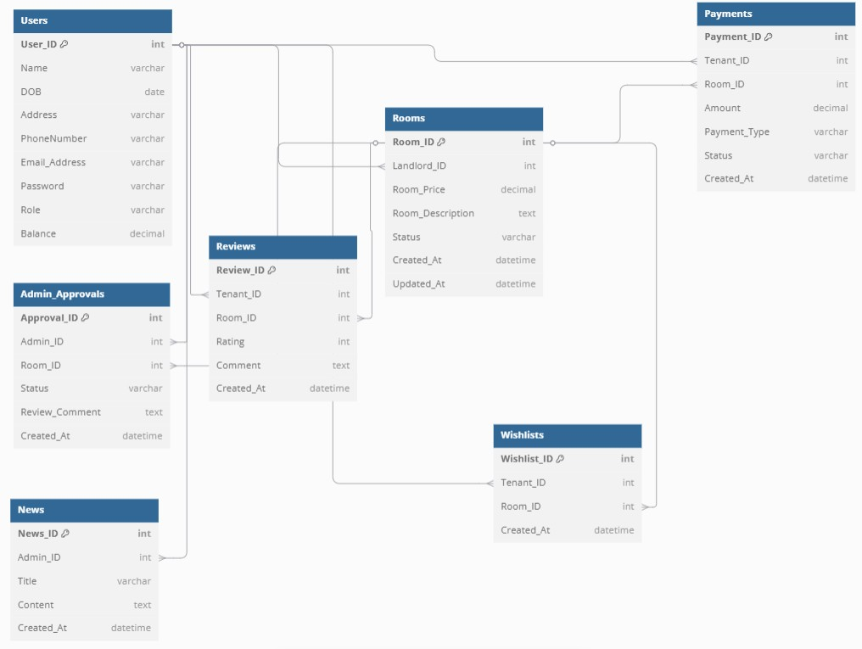
Figure 8: Database diagram number 1 Entire website

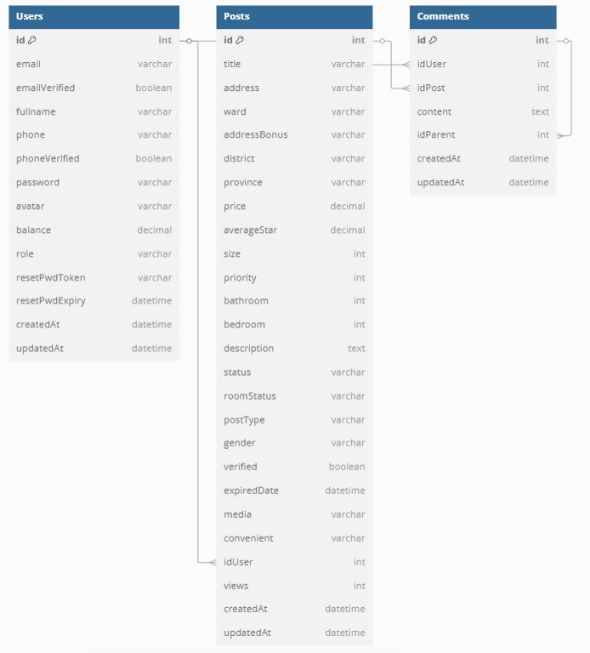

Figure 9: Database diagram number 2 Comments

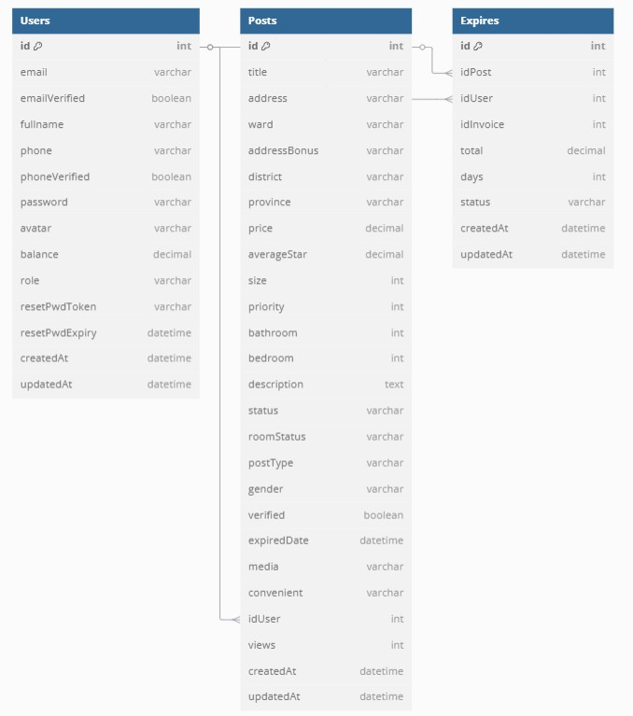

Figure 10: Database diagram number 3 Expireds

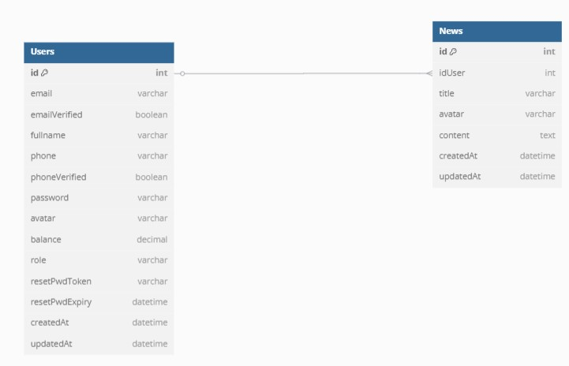
Figure 11: Database diagram number 4 News

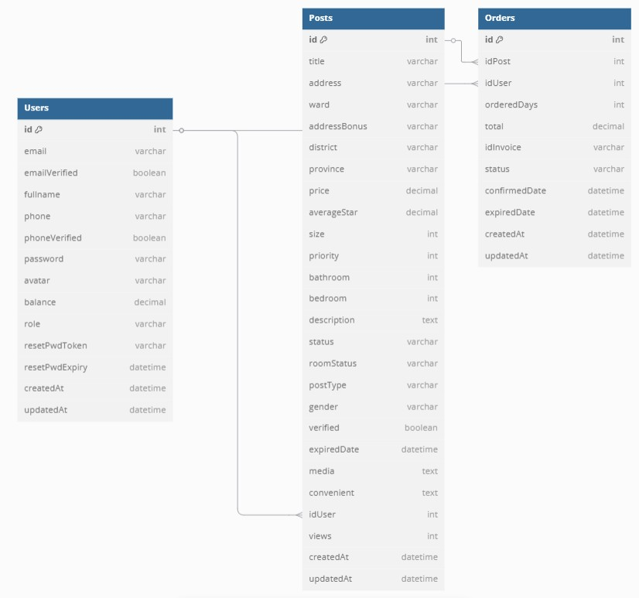

Figure 12: Database diagram number 5 Orders

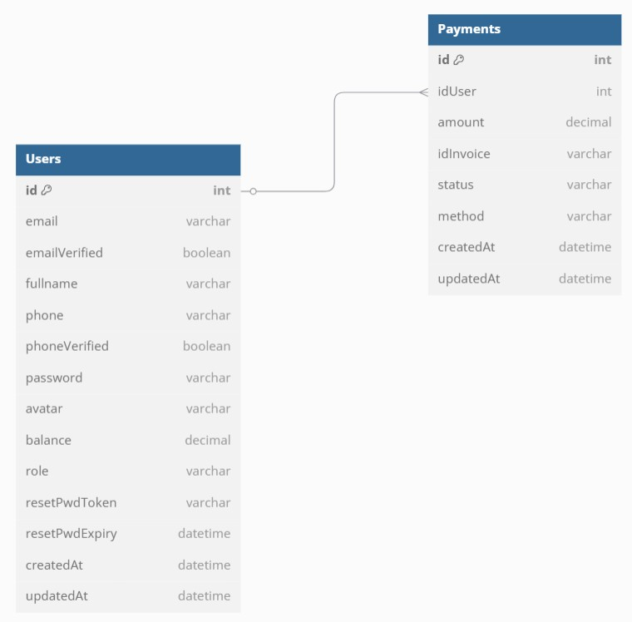

Figure 13: Database diagram number 6 Payments

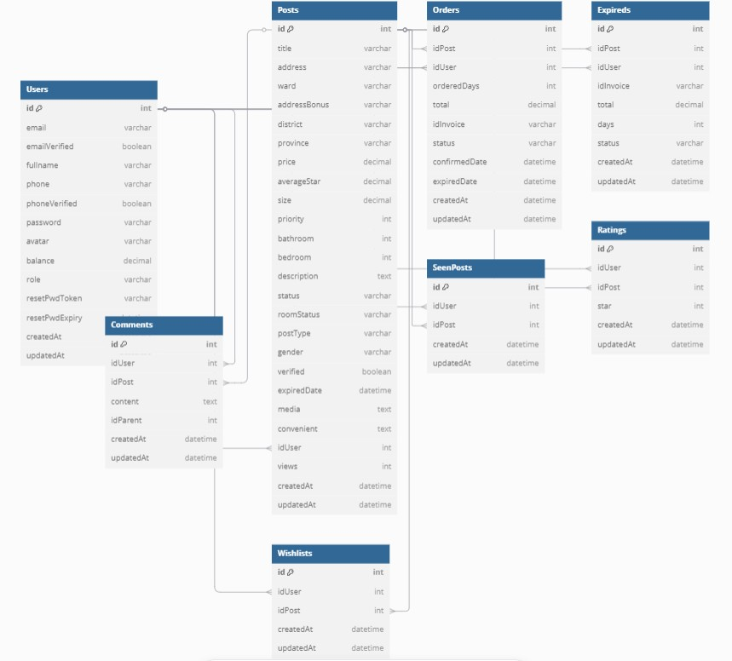

Figure 14: Database diagram number 7 Posts

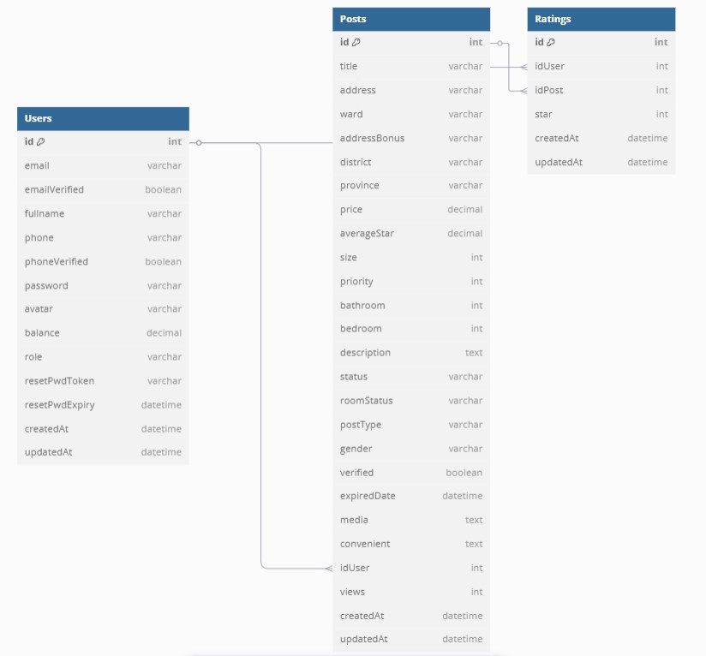

Figure 15: Database diagram number 8 Ratings

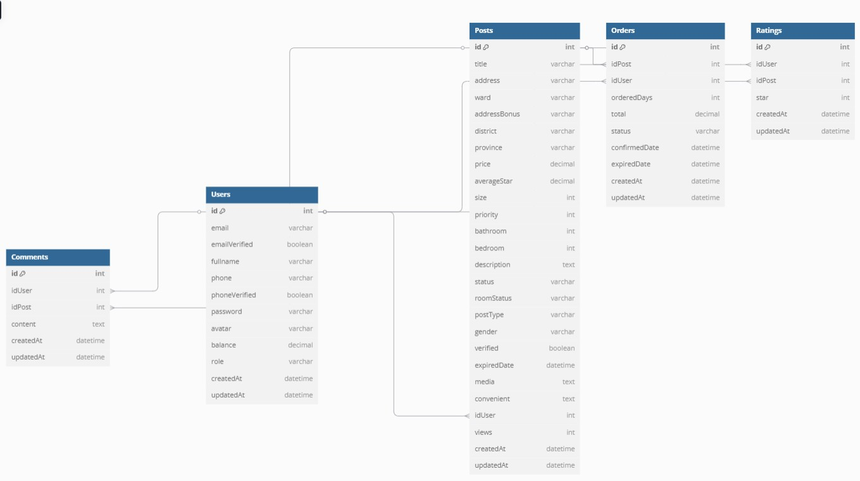
Figure 16: Database diagram number 8 Users

CHAPTER 4. IMPLEMENTS AND RESULTS

4.1. Implement
The implementation of the TroHub rental accommodation platform encompasses the systematic design, construction, and integration of all architectural components - spanning the frontend presentation layer, backend application logic, and persistent database tier - executed within a local development environment. The solution adopts a rigorously selected, modern technology stack engineered to deliver scalability, maintainability, and high operational performance across all system tiers.
Frontend Layer. The client-side interface is architected using React.js, bundled and served through Vite to achieve accelerated module compilation and instantaneous Hot Module Replacement (HMR) during development. Tailwind CSS provides the foundational styling paradigm, enabling the rapid construction of a mobile-first, responsive UI, while Radix UI contributes a suite of accessible, headless component primitives (dialogs, dropdowns, tooltips) to ensure interface consistency. Global application state is orchestrated via Zustand, and complex form lifecycle management - including validation and input binding - is delegated to React Hook Form. Client-side navigation is governed by React Router DOM, enabling seamless role-based routing across tenant, landlord, and administrator views. Data synchronization between client and server is facilitated through Axios for imperative HTTP requests, complemented by SWR for declarative data fetching with built-in caching and revalidation strategies. Geographic property visualization is rendered through the Leaflet mapping library, while administrative analytics are presented via Chart.js integrated with React-Chartjs-2.
Backend Layer. The server-side application is engineered atop a Node.js runtime utilizing the Express.js framework to expose a suite of RESTful API endpoints governing all core business logic. User credential security is enforced through a dual-layer mechanism: bcryptjs performs adaptive password hashing prior to database persistence, while JSON Web Tokens (JWT) maintain stateless, cryptographically signed session integrity across all protected routes. Transactional payment processing for listing extensions is handled through the integrated MoMo payment gateway, with IPN (Instant Payment Notification) callbacks employed to verify and finalize transaction outcomes. Outbound communication services leverage Nodemailer for automated SMTP email dispatches and Twilio for programmatic SMS notifications, supporting workflows such as OTP verification, expiry alerts, and account status updates.
Database Layer. Data persistence is managed by a PostgreSQL relational database, selected for its ACID compliance, structural integrity guarantees, and capacity to handle concurrent transactional workloads reliably. All database interactions are abstracted through Sequelize, a mature ORM that maps relational schema constructs to JavaScript object models, streamlining data insertion, retrieval, modification, and deletion operations across the platform's twelve core entity models.

4.1.1. Code

4.1.1.1. Frontend
The frontend folder comprises the following folders and files:

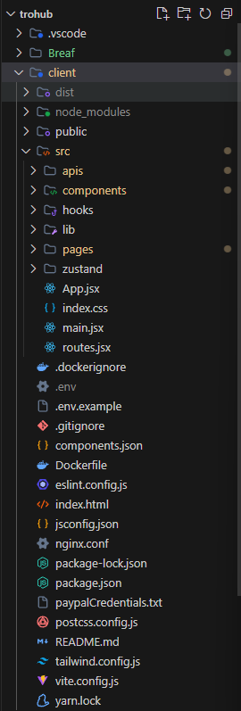

Figure 17: Frontend folders
Frontend components is divided into smaller parts to manage based on route like header, navigation, search, charts, etc

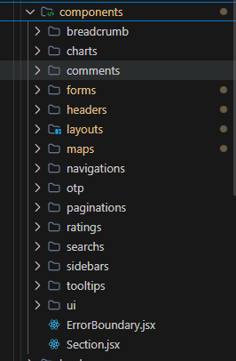

Figure 18: Frontend components folders

To get a clear view of all the routes of the project, go to the routes.jsx file.
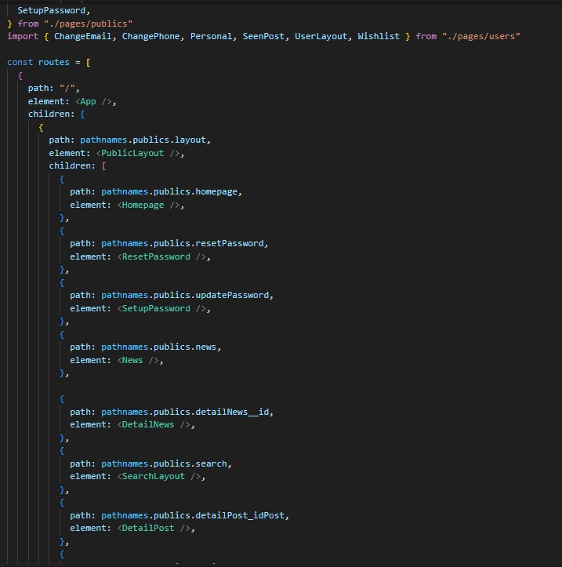
Figure 19: Frontend routes

All packages installed for the client side are clearly reflected in the package.json file.

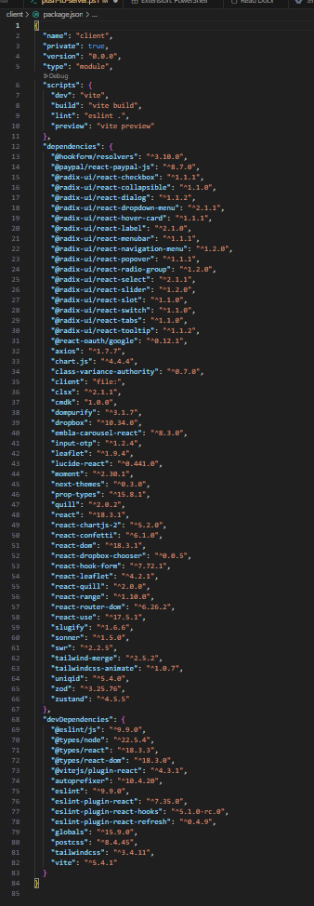

Figure 20: Frontend packages

4.1.1.2. Backend
Express is set up. The structure of folders can be seen in Figure 26.

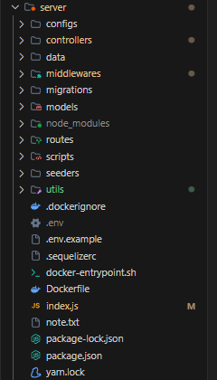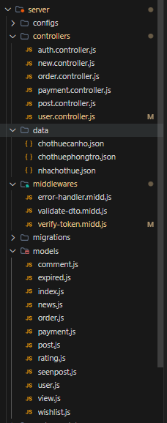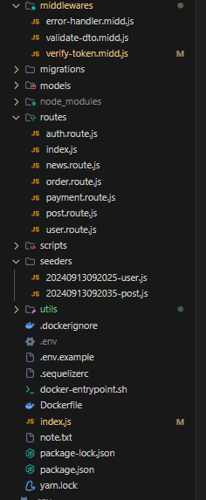
Figure 21: Backend folders

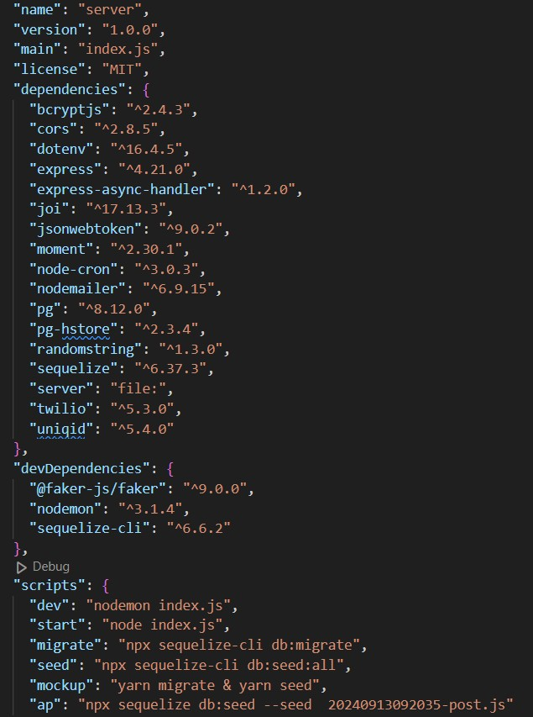

Figure 22: Backend package

4.1.1.3. Database
A collection in PostgreSQL is setup with desired fields
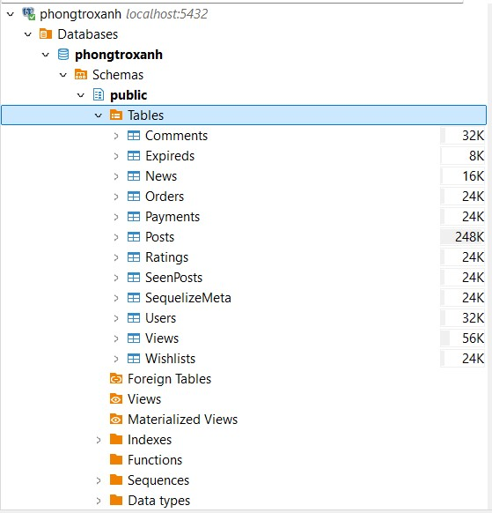
Figure 23: Database actor

4.2. Result
The webpage is handled via the "yarn dev" command. When a visitor accesses the web, the first screen they view is called "Home." Sections of the Home Section can be classified into seven groups. They'll be presented below:

4.2.1. General interface

4.2.1.1. Title

Figure 24: Title of the website

Sections are presented at the top of each page on the website. The following sections are available: Home, Types of rental rooms (rooms, houses for rent, flats), News, User Account Menu, Wishlist, Posting feature. The layout is carefully structured to allow users to simply reach each part and use it.
4.2.1.2. Home
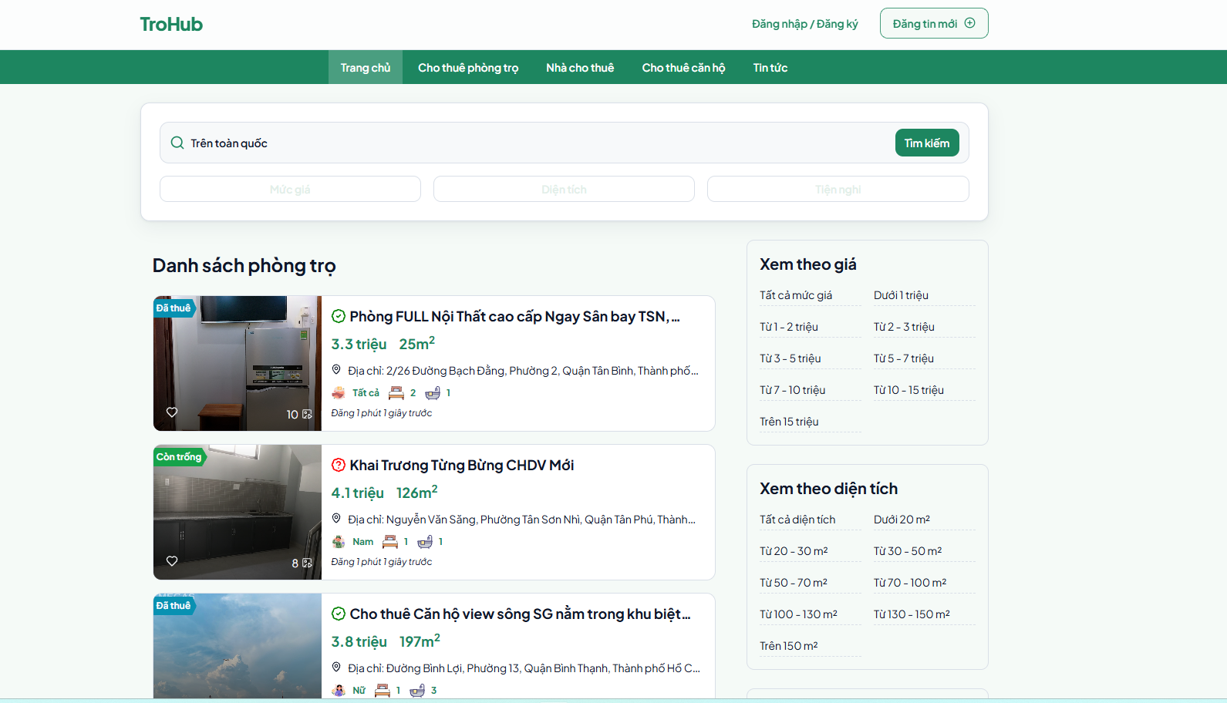
Figure 25: Home of the website
Upon accessing the TroHub rental accommodation platform, the interface redirects users to the Home Page, which serves as the primary gateway designed with an emphasis on usability and intuitive navigation (UX/UI). The architectural layout is anchored by a high-performance search module situated at the top of the interface. This component facilitates multi-parameter inquiries, allowing potential tenants to filter the repository by keywords, price thresholds, spatial dimensions, and specific facility requirements. By centralizing these discovery tools, the platform effectively streamlines the initial phase of the residential search process.

The content hierarchy continues with a systematic rendition of available listings positioned beneath the main search vector. Each property entry is presented as a data-rich entity, surfacing essential decision-making metadata such as rental valuation, spatial area in square meters, and localized descriptors. To bridge the gap between digital listings and physical reality, each card incorporates high-fidelity imagery, providing a visual verification layer that assists users in conducting immediate suitability assessments. Furthermore, the inclusion of interactive engagement metrics- namely real-time view counts and favoriting functionalities - allows seekers to identify high-demand properties and curate a personalized inventory for future evaluation.

To enhance the precision of the search journey, the platform integrates a faceted sidebar on the right-hand portion of the layout. This module allows for the stratification of search results based on specific fiscal brackets (e.g., accommodations under 2 million VND), minimum volumetric thresholds (e.g., properties exceeding 50m²), or geographic targeting of high-demand metropolitan hubs such as Ho Chi Minh City, Hanoi, and Da Nang. This secondary filtering layer is designed to minimize cognitive load, allowing users to align their searches with specific budgetary and lifestyle constraints.

Finally, to manage the extensive data corpus without overwhelming the end-user, the interface employs a bottom-anchored pagination logic. This ensures a fluid navigational flow through large datasets while maintaining system performance. Overall, the Home Page functions as a sophisticated nexus that synergizes structured data with a mobile-responsive design, establishing a centralized and efficient environment for navigating the competitive rental market in Vietnam.

4.2.1.3. Types of rental rooms
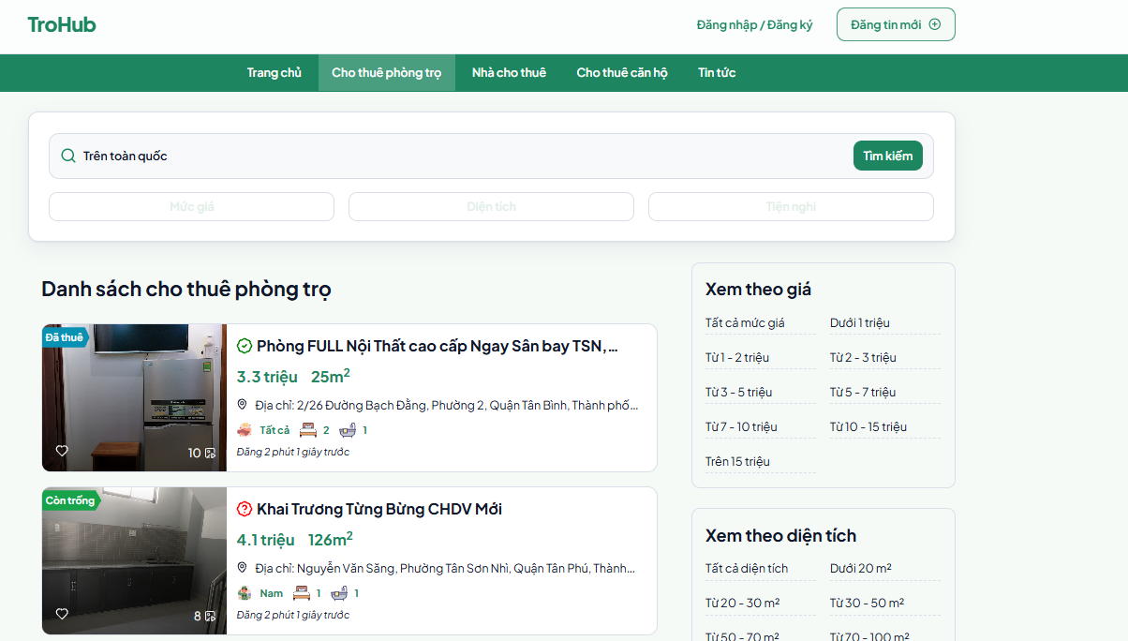
Figure 26: Boarding room

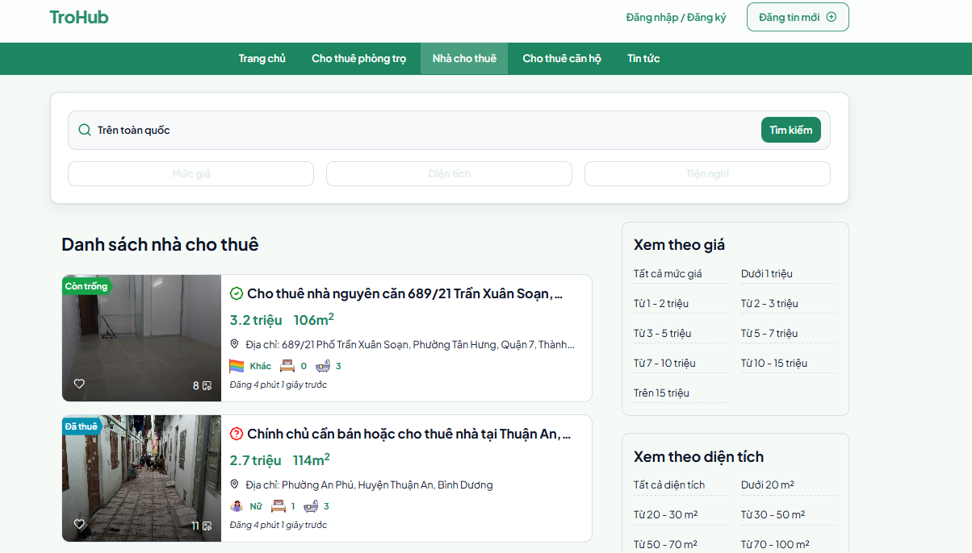
Figure 27: Entire house for rent

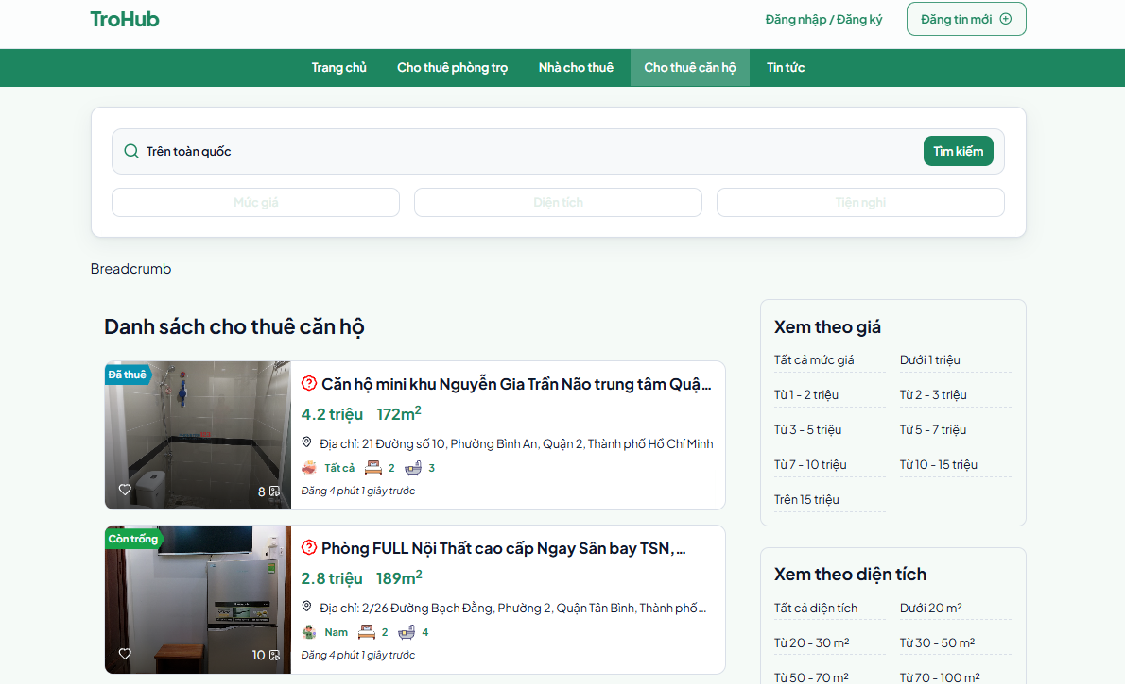
Figure 28: Apartment for rent

In the tab types of rental rooms, the website is designed to divide each article into each type of room so that users can easily search for the type of room they are looking for, thereby saving search time.

4.2.1.4. News
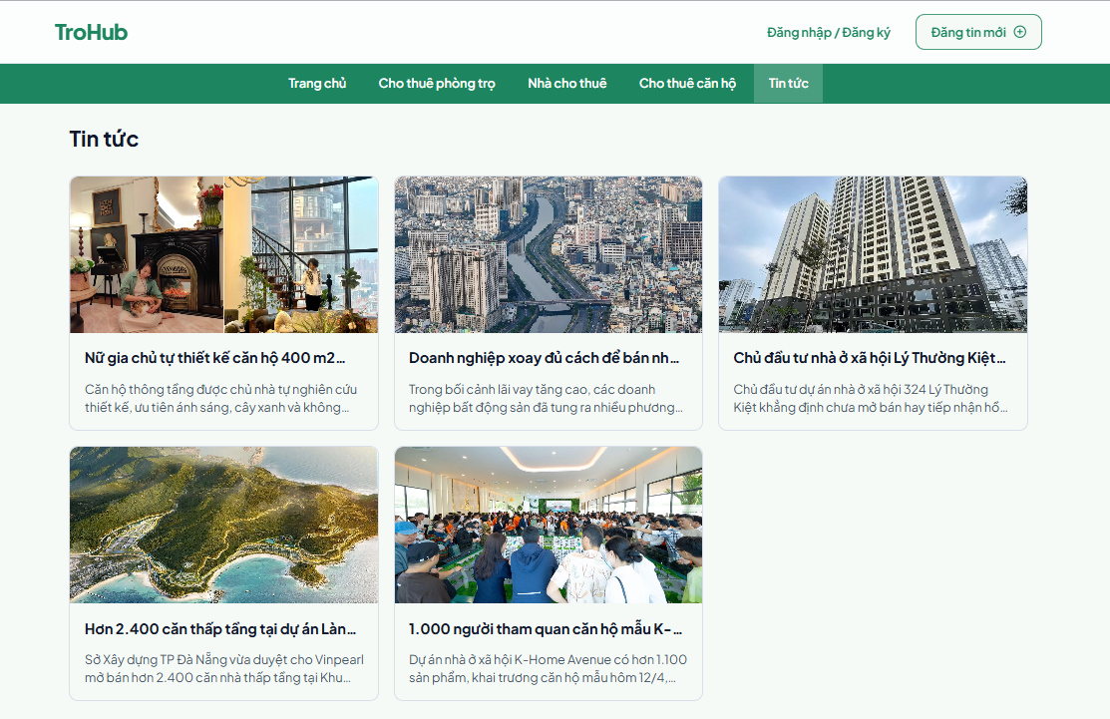
Figure 29: News portal

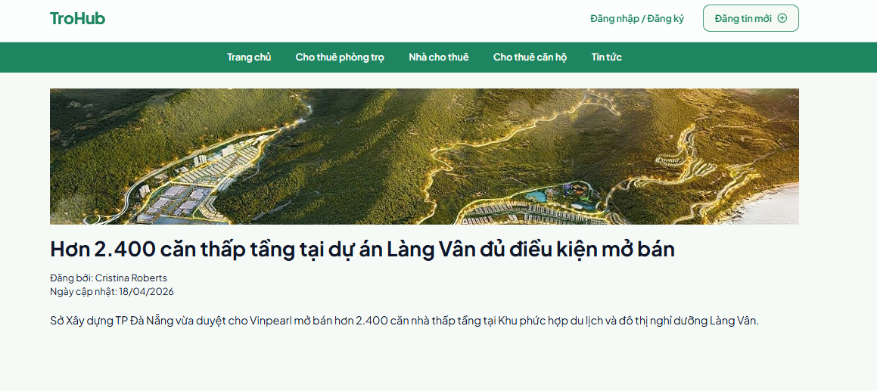
Figure 30: Detailed news page
The "News" area lets users remain current with the newest information, events, or key changes in the industry, company, or field the website works in. It also boosts engagement by delivering engaging articles or information, motivating visitors to return to the website often to prevent losing out on fresh updates. Furthermore, the admin can post announcements, promotions, new items, special deals, events, or other vital news relating to the website.

4.2.1.5. User Account Menu, Wishlist, Posting Function
In addition to the main components above, the website has 3 other components: User Account Menu, Wishlist, Posting Function.

- User account menu
The User Account Menu is a common feature on websites or applications, helping users manage their personal settings and information. And for each different role, users will have limited access to:
- As an Admin, the User Account Menu section allows users to have all the rights/functions of the website such as: Overview, Personal, Balance Management, Member Management, Ad Management, News, Account
Logout

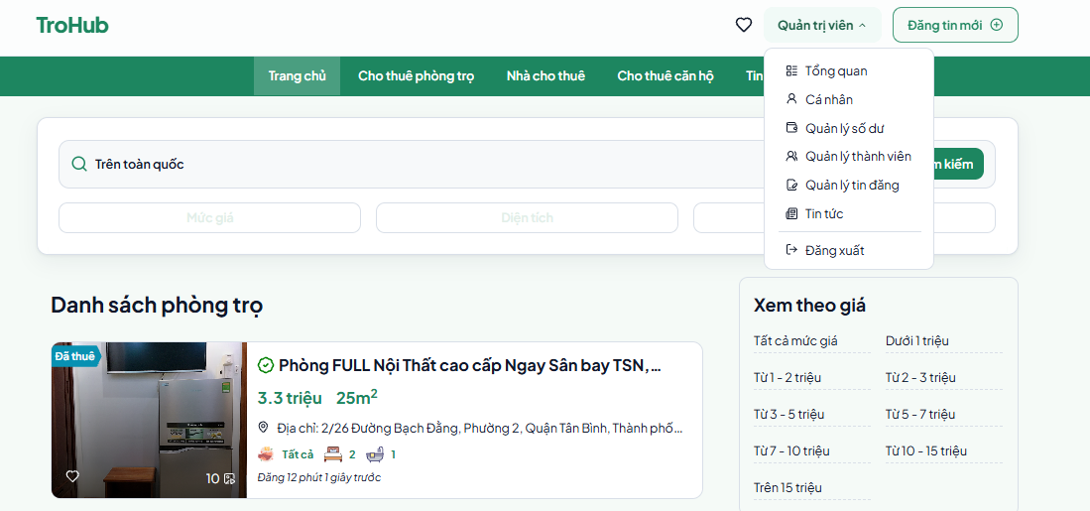

Figure 31: User Account Menu of Admin

Similar to the Admin role, the Landlord and Tenant also have some basic functions but will be limited and not as complete as the Admin role.

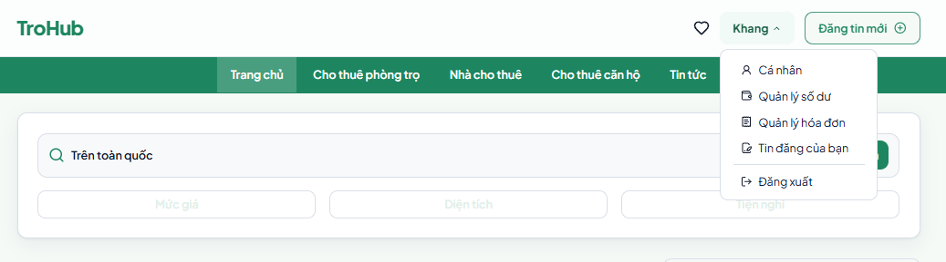
Figure 32: User Account Menu of Landlord

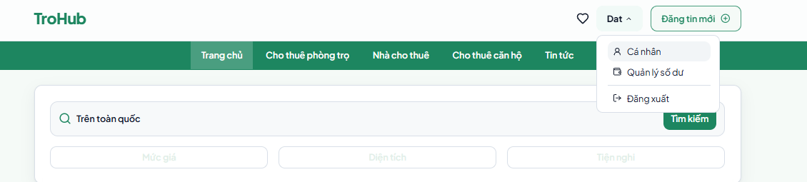
Figure 33: User Account Menu of Tenant

Wishlist
A wishlist on a website is a method that offers consumers numerous vital purposes:
- Store favorite rooms: Tenants can store the rooms they find acceptable for their requirements in the wishlist. This makes it simpler for them to revisit and compare with alternative possibilities after more consideration.
- Organize and manage room choices: With a wishlist, Tenants may organize rooms based on preferences or criteria (e.g., rooms near schools, rooms with full facilities, rent within a specified budget…). This helps them track and make judgments more rapidly.
- Discuss with friends or family: If a Tenant is looking for a room for a group or wants to discuss alternatives with friends, they can easily post their wishlist for everyone to evaluate and decide together.
- Save rooms to rent later: If the Tenant is not ready to decide immediately, the wishlist allows them to save rooms and come back to them when they have more time or financial preparedness to rent.


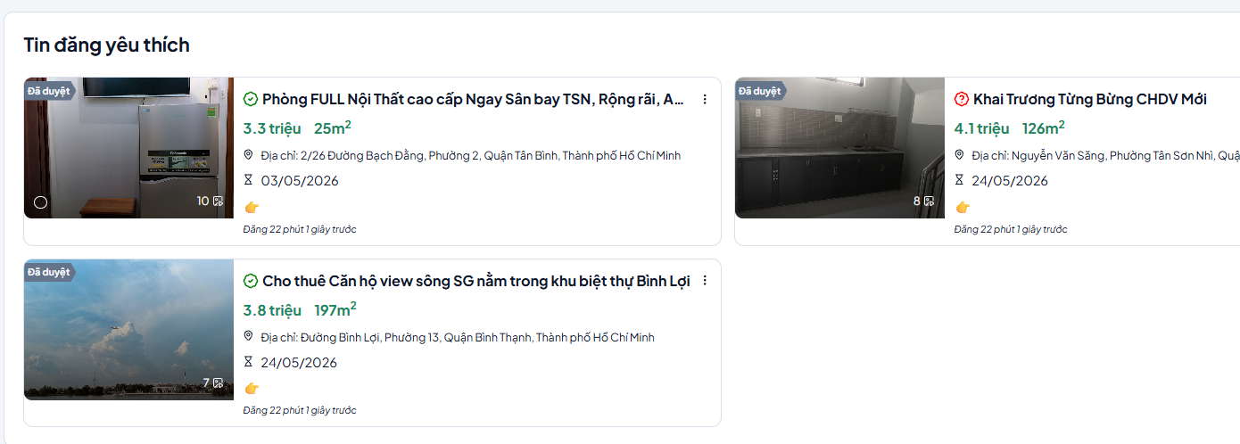
Figure 34: Wishlist

Figure 35: Detailed wishlist page

Posting Function
The posting function on the room rental platform allows the landlord to upload specific information about the rooms they want to rent. This function enables the landlord quickly produce and distribute room information with Tenants, including room descriptions, amenities, rates, images, and other key elements that tenants need to know. The posting feature plays a key role in helping landlords contact with Tenants and give thorough and accurate information about the rooms. Details concerning the posting function will be detailed more extensively in section
4.2.3.2.

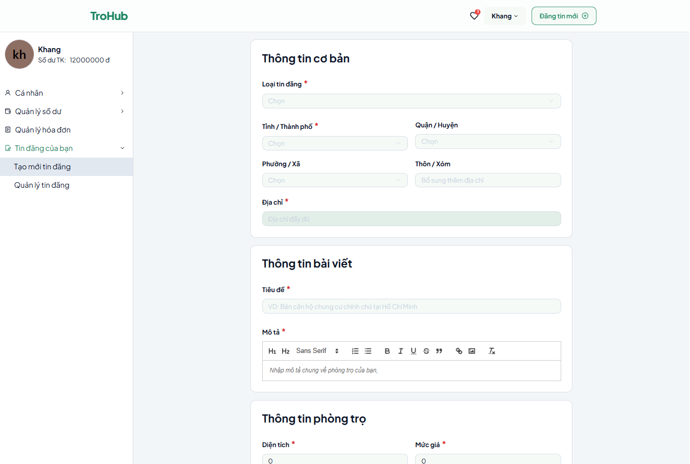
Figure 36: Posting function


4.2.1.6. Register
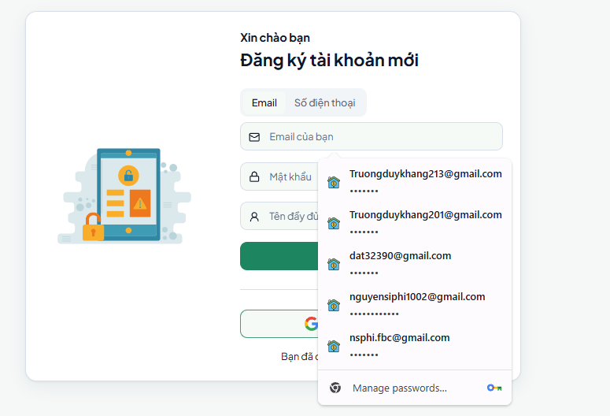

Figure 37: Register of the website
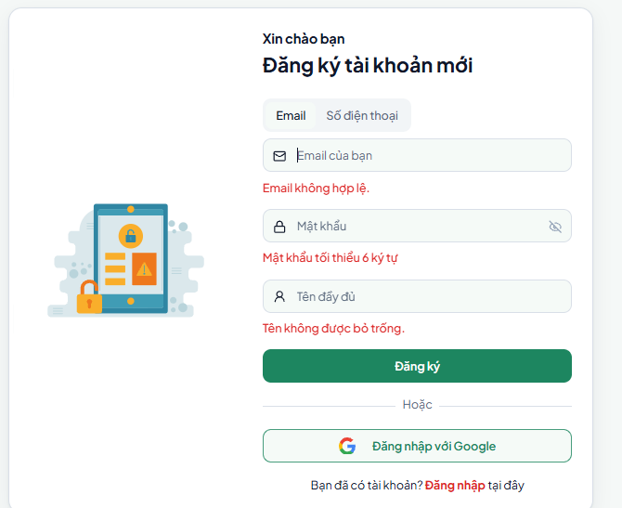
The register function allows users to create an account on the room rental website. When registration, users submit personal information such as name, email, phone number, and establish a username and password. By default, users establish an account as a Tenant. After registration, users may access services such as searching for rooms, storing favorite rooms, and receiving notifications. If desired, users can subsequently upgrade their account to a landlord account to publish rental listings. And they may also sign in using a Google account

Figure 38: Unsatisfying input in part: Register
The registration data must meet the specified requirements. The website will highlight errors in bright red to alert users, making it easy for them to identify and correct any mistakes.

2.3.1. Login and Forgot Password



Figure 39: Login of the Rental Accommodation Website

The site offers the normal login way of creating an account and logging in (by email or phone number) as well as the possibility to connect in using Google.

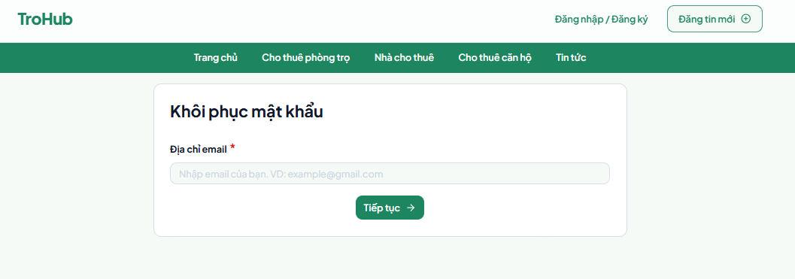

Figure 40: Password recover of the Rental Accommodation Website

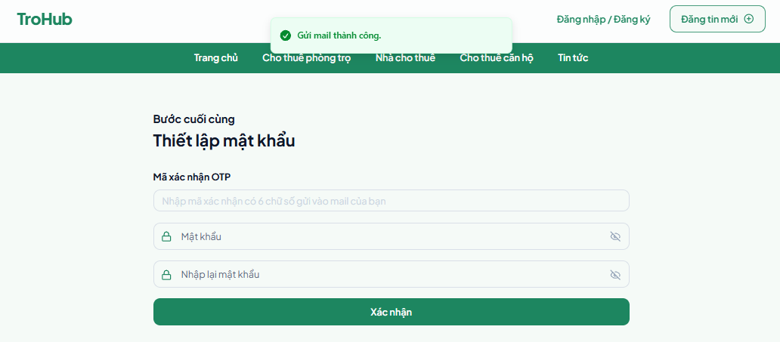
Figure 41: Reset password of the Rental Accommodation Website

In addition, when users forget their password, they may recover their password by heading to the Forgot Password area, here they will input the email they registered previously, the system will send an OTP code to their email. They merely need to input the OTP then enter the new password

4.2.2. Tenant
4.2.2.1. Display

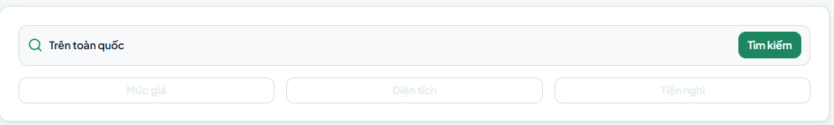

Figure 42: Search bar
After logging in, the tenant will be directed to the Homepage, highlighted by the search bar at the top of the page including the following components:
- Keyword search box: Allows entering keywords to search for a room.
- Price: Limits results based on the desired room price range.
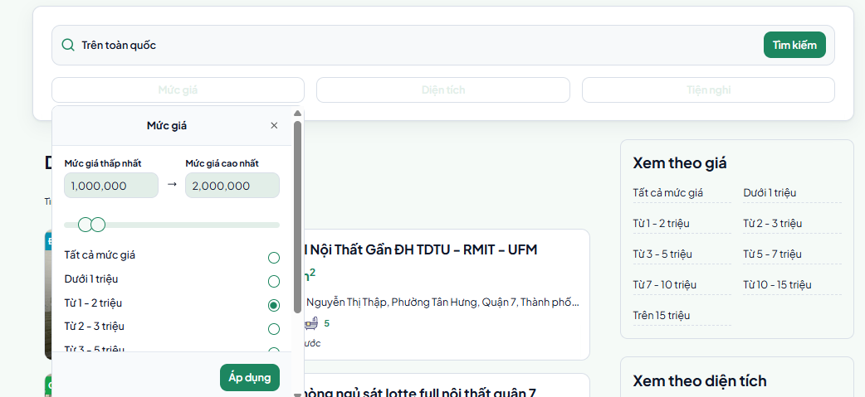

Figure 43: Filter by price

• Area: Filter rooms by specific area (m²).
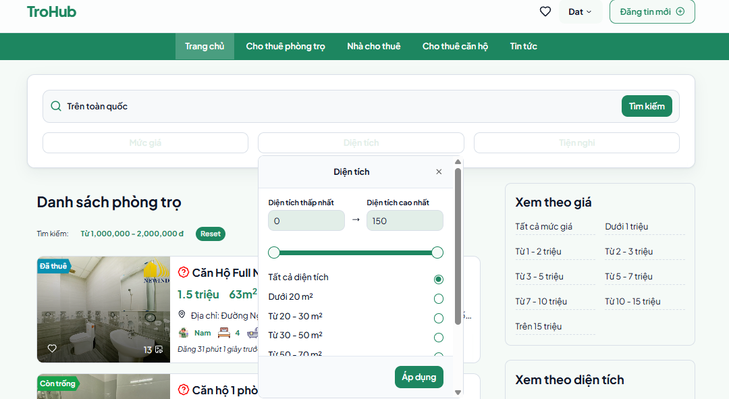

Figure 44: Filter by area
- Amenities: Filter rooms by amenities such as furniture, air conditioning, kitchen, etc.
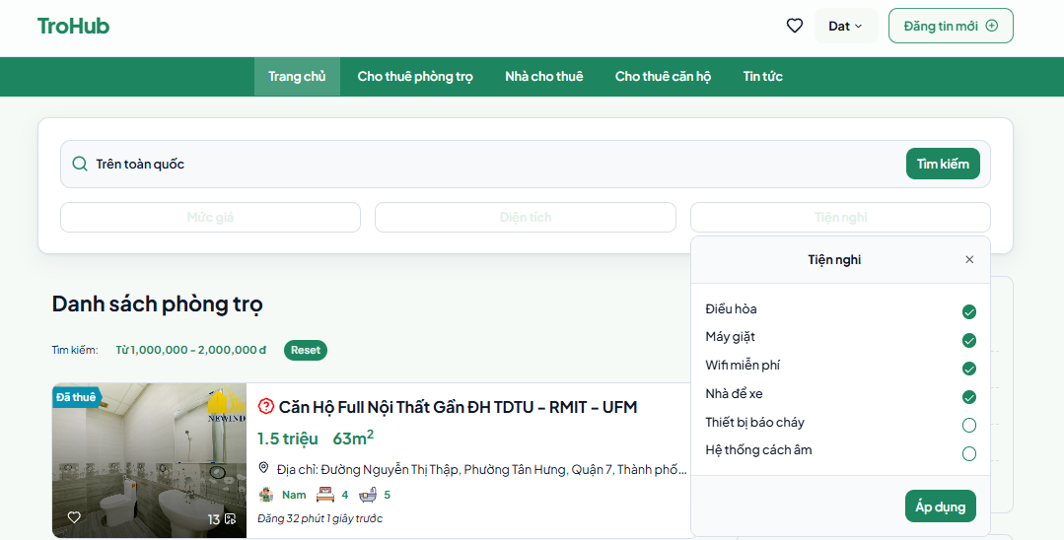
Figure 45: Filter by amenities

- The green "Search" button to submit a filter query. After clicking "Search", the filtered conditions above will appear immediately on the list of posting
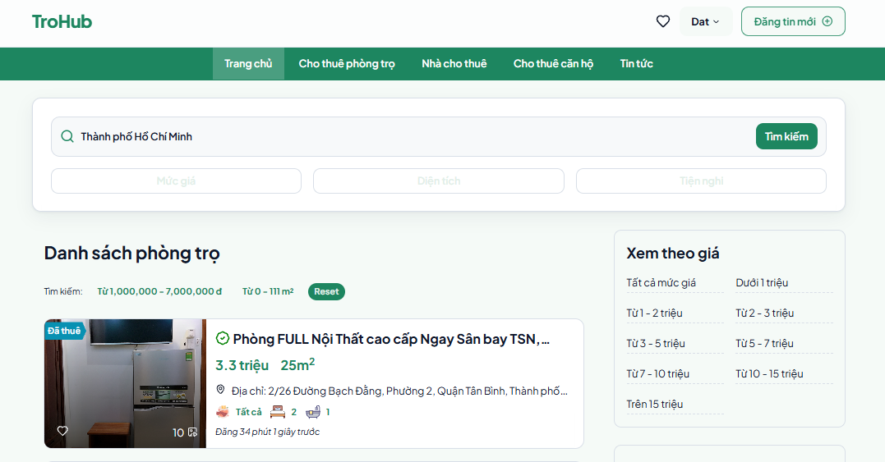

Figure 46: Selected conditions after filtering

Next is the list of rooms, the rooms are displayed as information cards with the following details:
- Room image: Helps tenants have a visual view.
- Status: The "Rented" label appears on rooms that are no longer available for rent.
- Room title: Briefly describe the room (eg: "Newly built, unused apartment").
- Rent price: Clearly displayed (eg: 2.7 million, 4.9 million).
- Area: Exact area (eg: 168m², 124m²).
- Address: Clearly state the district and city for easy locating.
- Amenities: Icons showing the room's amenities such as: Bed, suitable number of people, parking space, etc.
- Likes (hearts): Displays the number of people who have liked the room.
- Posting date: Displays the posting time to evaluate the newness of the post.

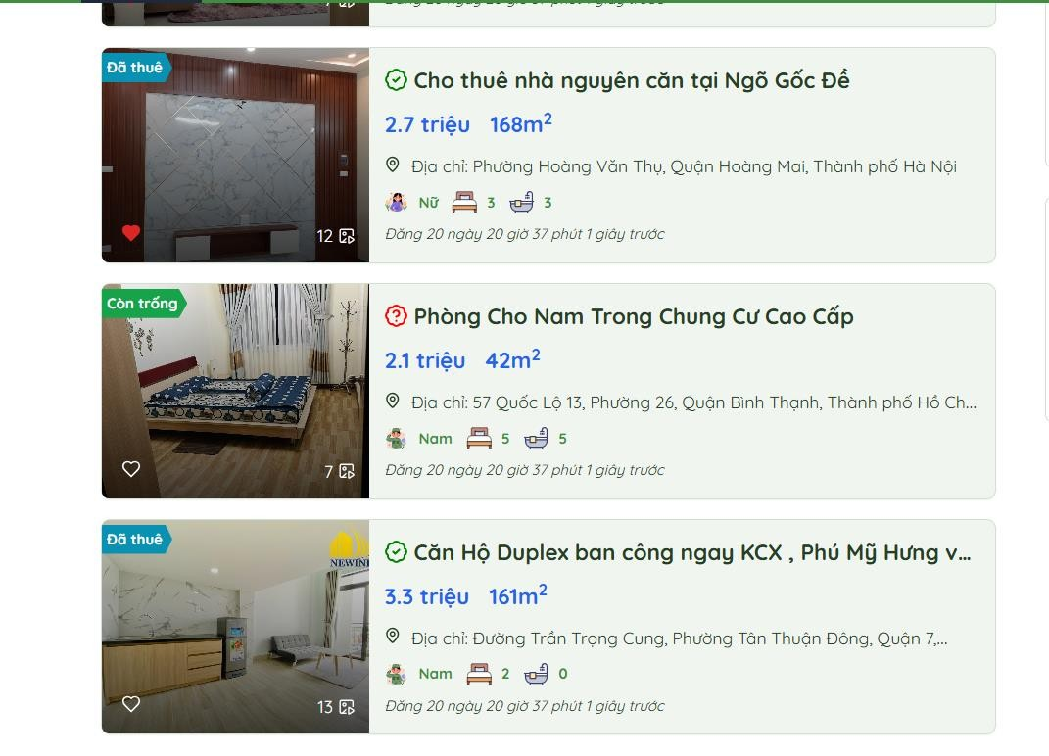
Figure 47: List of posts

The room listing page is equipped with a navigation bar on the right with three primary filtering options, enabling Tenants rapidly search for rooms according to their needs. The pricing filter splits rooms into particular price groups such as under 1 million, 2 - 3 million, 5 - 7 million and over 15 million, enabling consumers quickly pick a price that meets their budget. Next is the area filter, allowing the choice to filter rooms based on size such as under 20m², 30 - 50m², 70 - 100m² and over 150m², assuring to satisfy the different space demands of Tenants. In addition, the area filter allows users to rapidly pick important cities like Vietnam Hanoi, Ho Chi Minh City, Da Nang, Binh Duong, Nha Trang and Dong Nai, making searching by geographic location more accessible.
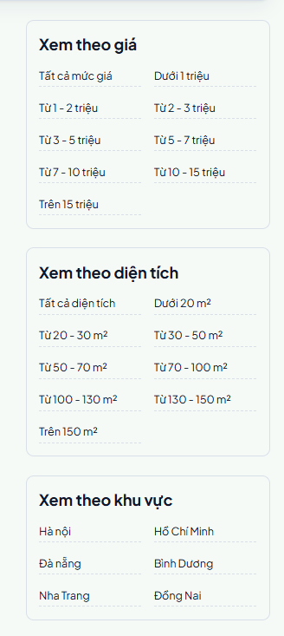
Figure 48: Navigation bar

Below the room list is the pagination, created with sequential page numbers such as 1, 2, 3..., allowing tenants to simply move between result pages. In addition, each room card is incorporated with a heart icon, allowing users to save the room to their favorites list for further inspection. In particular, the system always updates the status of the listing, with clear information about the posting date and the "Rented" designation for rooms that are no longer available. This lets tenants focus on the latest postings and avoid spending time going through outdated or expired listings.

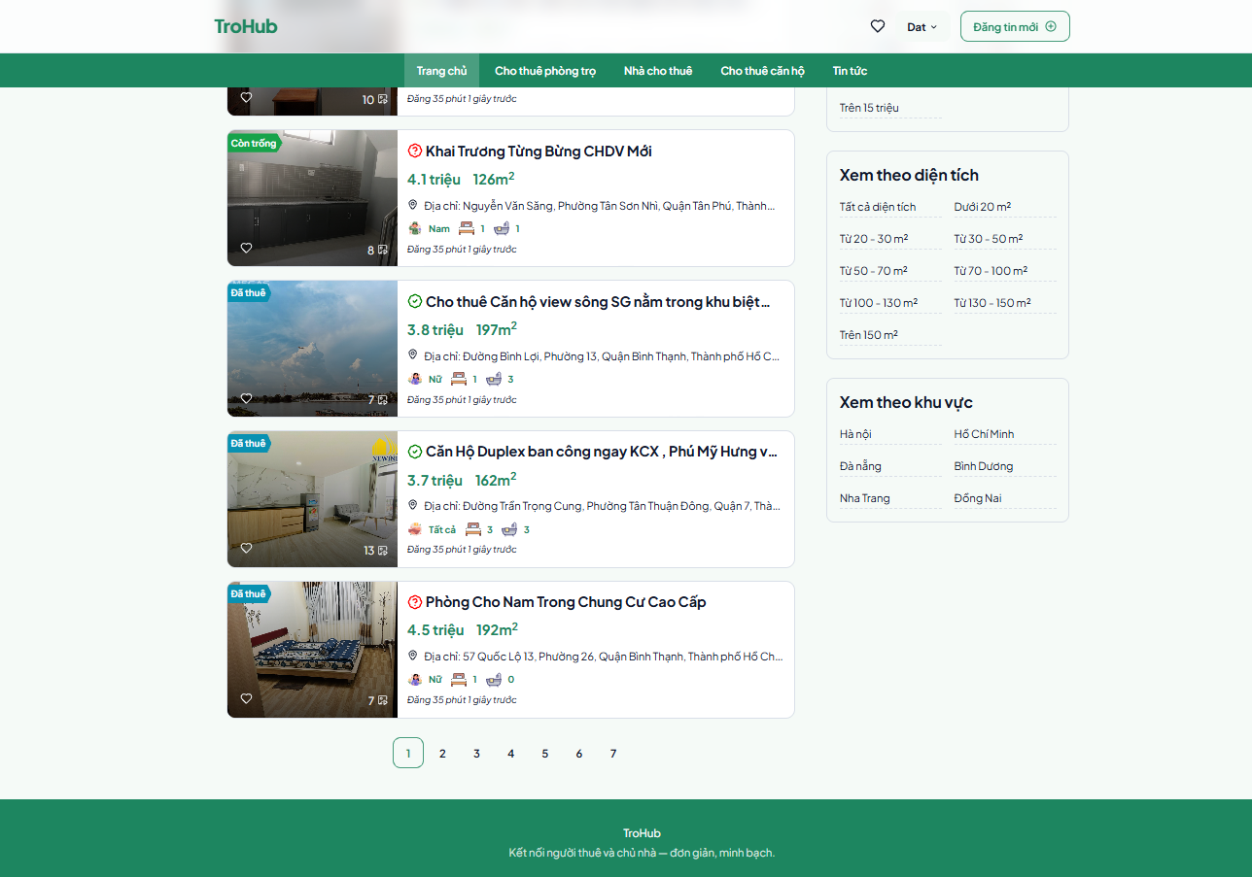

Figure 49: Pagination

When clicking to read any post in the room list, the Tenant will be routed to the product description page. The room detail page gives detailed information to enable tenants simply analyze and make selections. The top of the page contains an actual room photograph, allowing readers to have a clear view of the area, interior and condition of the room. Next is the brief post title, together with vital information such as rental price, precise location and exact address. The landlord information part is on the right, featuring the landlord's name "Carla Schultz", profile photo and "Contact Now" button so that tenants may instantly interact with the landlord by phone number and email.
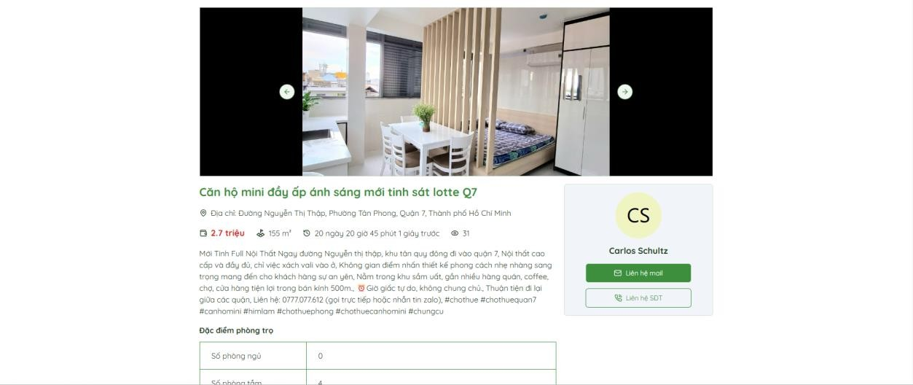
Figure 50: Room detail page

The ―Room Features‖ table is positioned in the middle of the page, clearly and explicitly showing factors such as: number of bedrooms (0), number of bathrooms (1), floor (0), eligible gender (Male), and particular location from ward, district to city. This information lets tenants simply assess whether the accommodation fulfills their needs. Below the information table is an integrated map using Google Maps, identifying the precise location of the room, allowing tenants estimate the distance and surrounding traffic.
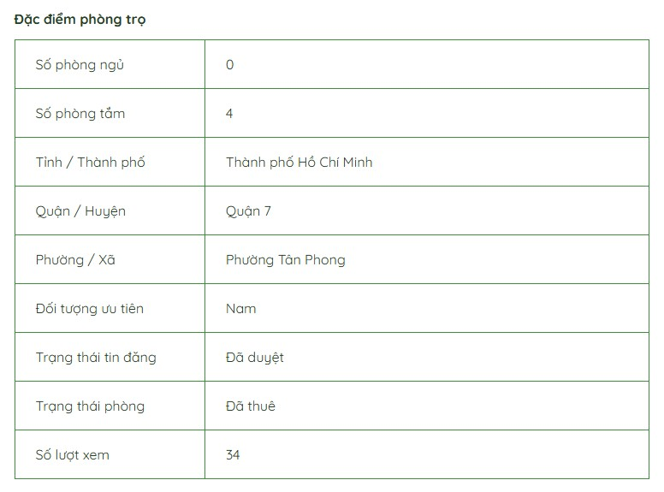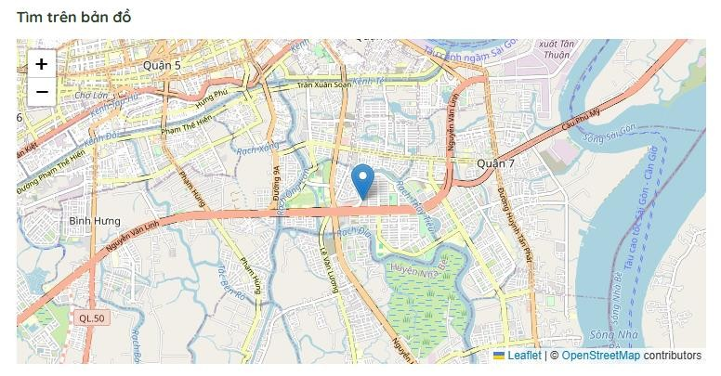

Figure 51: Room Features and Map

At the bottom of the page is a review and comment section, where Tenants may browse remarks from prior users or submit their own thoughts after their experience. Quality ratings are given on a 5/5 star system, with extensive information on the number of reviews at different levels. This area not only helps establish trust but also offers a transparent interaction atmosphere between tenants and landlords.
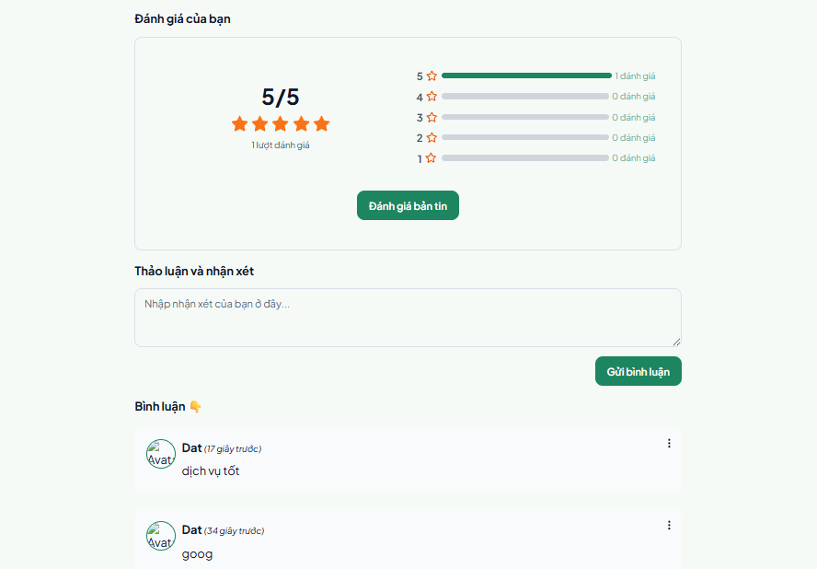

Figure 52: Information page review section

4.2.2.2. User dashboard
The User Dashboard feature enables Tenants manage personal information and account balances quickly and intuitively. The left navigation bar provides important things for tenants to conveniently manage information and conduct operations. Items include:
Personal:
- Personal information: Displays and updates user information (name, email, phone number, account type, etc.).
There is also an account upgrading feature: Tenants have the opportunity to upgrade their account to a landlord account to access more sophisticated capabilities.
.
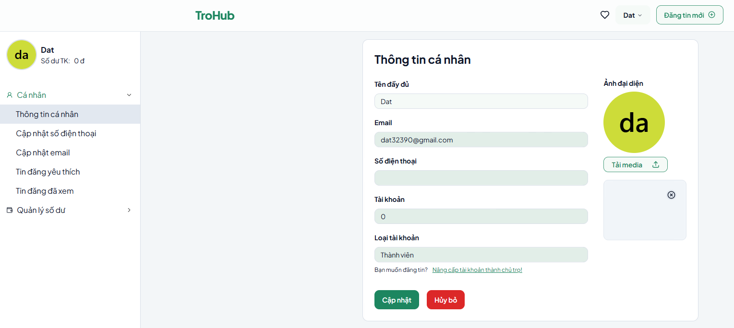
Figure 53: User Dashboard of Tenant
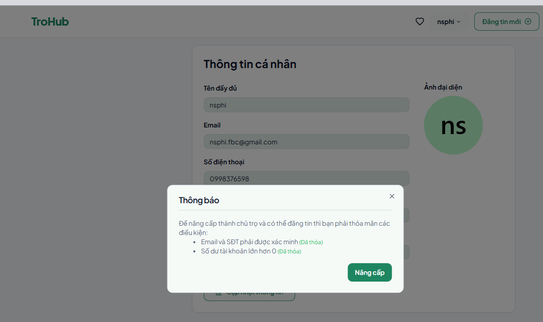
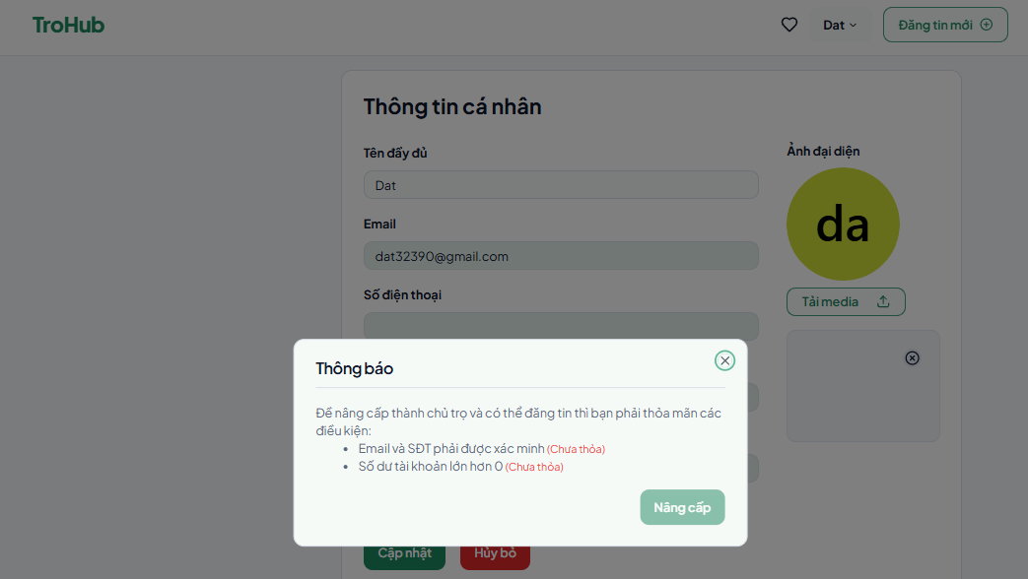
Figure 54: Account upgrade conditions

And to upgrade to a landlord account, the tenant must meet the following conditions

After successful upgrade, the tenant will be sent a successful upgrade notification and will be returned to the login page to log in again. And it will report unsatisfied if you do not meet the conditions.
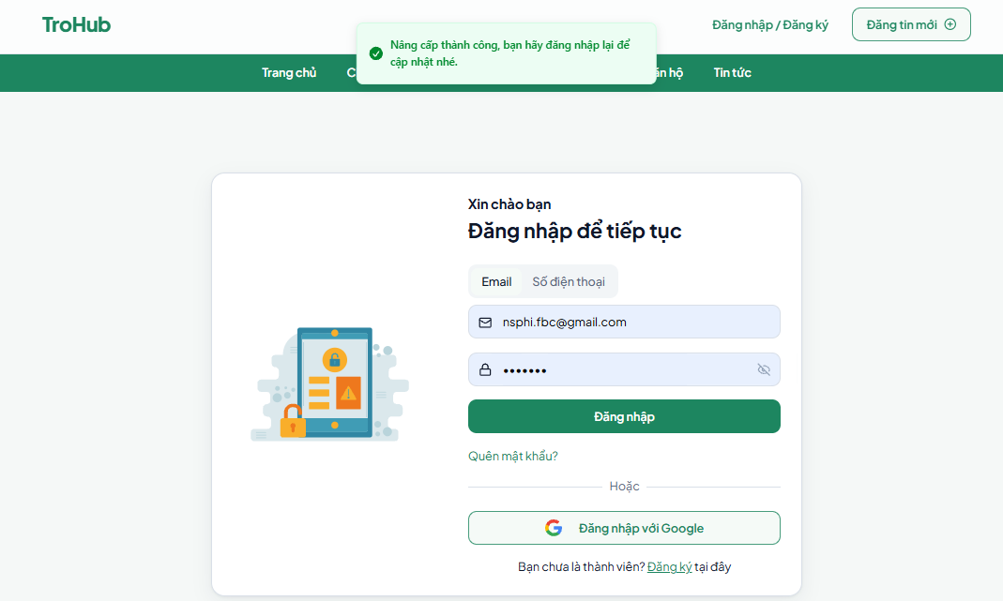

Figure 55: Notification when upgrade is successful
- Update phone number: Provides the feature to change phone number. - Update email: Allows tenants to update email. OTP code will be sent to the email you registered earlier.

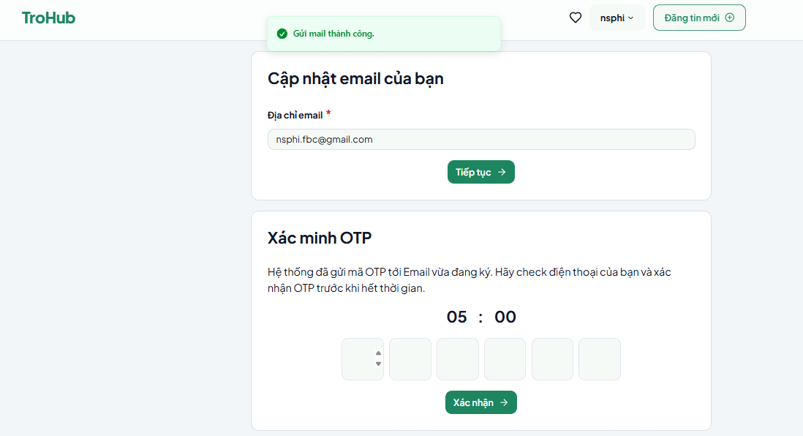
Figure 56: Email update section

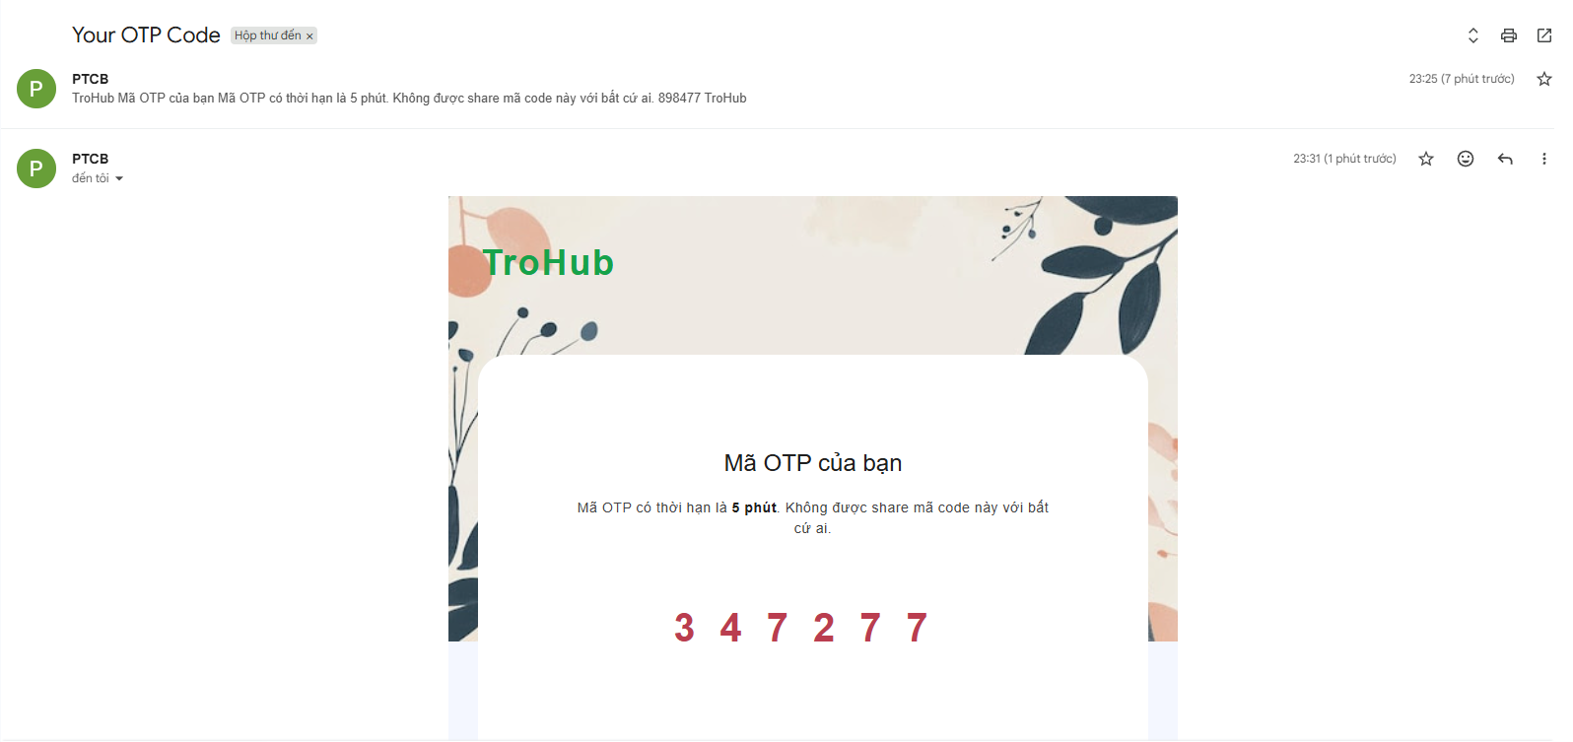
Figure 57: OTP code sent to email
- Favorite listings: Review listings that tenants have marked as favorites.
- Viewed listings: Displays the history of viewed listings.
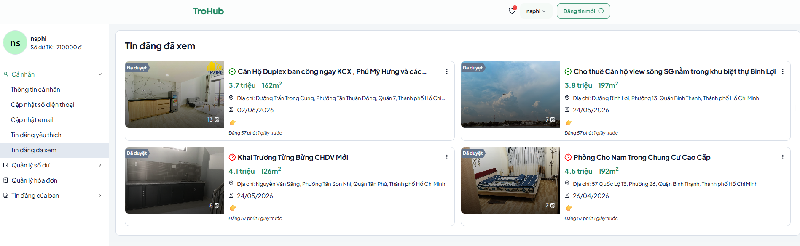
Figure 58: Page for saved viewed posts

- Balance management:

  - Balance information: Displays the balance in the tenant's account.
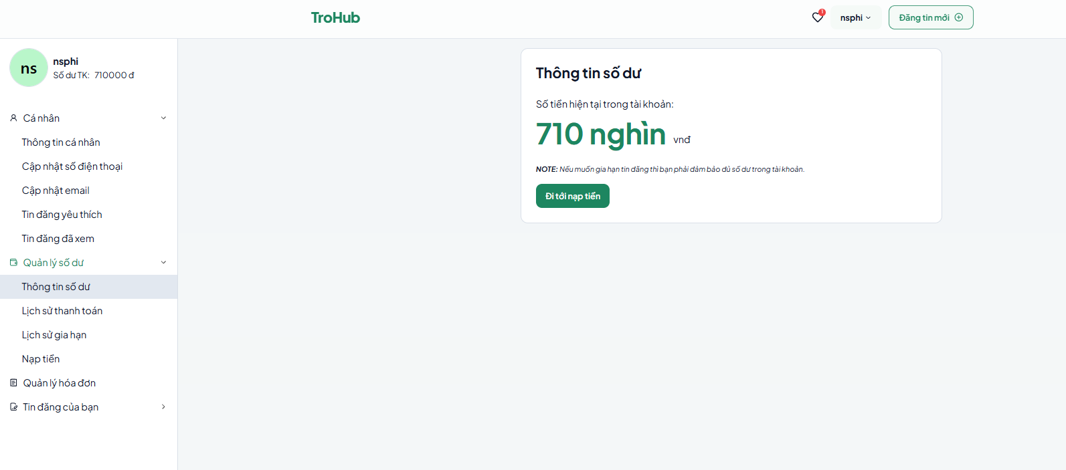
Figure 59: Balance information

  - Payment history: Records previous payment transactions.

Figure 60: Payment history
  - Renewal history: Displays the history of listing or service renewals.
  - MOMO top-up: Provides the feature to top up accounts via MOMO
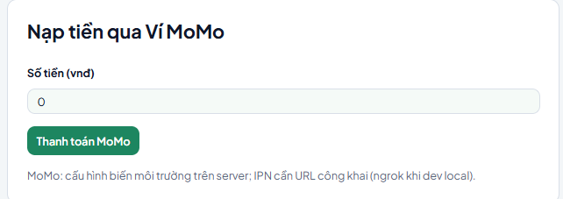

Figure 61: MOMO top-up
Once the user initiates the transaction, the platform orchestrates a secure redirect to the MoMo Payment Gateway, a leading third-party digital wallet ecosystem in Vietnam. This integration utilizes the MoMo Sandbox (Test Environment), enabling full end-to-end transaction simulation without utilizing real monetary assets. The gateway interface is architecturally divided to prioritize transparency and user security:

Order Specification (Left Panel): This section displays critical transaction metadata, including the Top-up Amount (e.g., 500,000 VND), a unique Order ID (e.g., PTCB-12345), and the service provider identification (TroHub - Rental Management System). All transaction fees are rendered as zero within this sandbox configuration to facilitate seamless testing.
Payment Interaction (Right Panel / Central Module): The primary interaction zone features a dynamically generated QR Code, compatible with the MoMo mobile application for "Scan and Pay" functionality. Alternatively, the interface provides a manual entry module for users to authenticate via their registered MoMo credentials. This module includes fields for phone number input and secure OTP (One-Time Password) verification to ensure cryptographic non-repudiation.
Users retain full autonomy throughout this stage, with available options to either authorize the deduction from their virtual wallet for balance increment or abort the transaction, redirecting them safely back to the TroHub dashboard. This sophisticated integration ensures ACID-compliant database updates via Server-to-Server (IPN) notifications, guaranteeing that account balances are only modified upon verified gateway success signals.
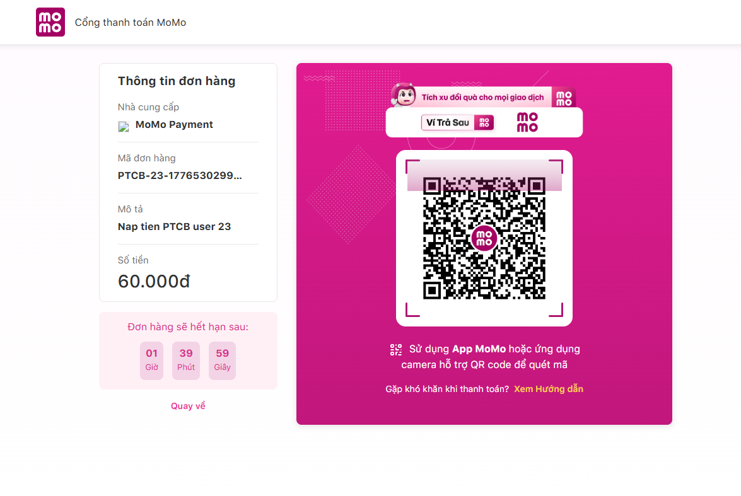

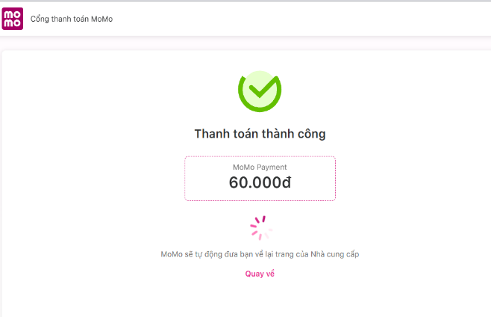
Figure 62: MOMO gateway



Figure 63: Payment successful interface

After entering OTP and successfully paying, the user will be returned to the personal page and account balance information will be updated.

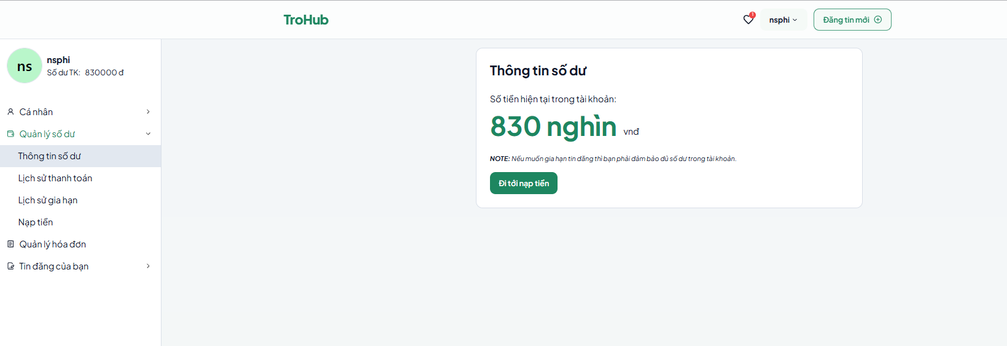

Figure 64: Update balance

4.2.3. Landlord

4.2.3.1. Display

The Landlord interface is architecturally aligned with the tenant-facing portal to ensure cross-platform consistency while incorporating specialized administrative capabilities for listing oversight. This unified design philosophy allows landlords to transition seamlessly between discovering properties and managing their own portfolio. The primary dashboard serves as a central monitoring station where proprietors can evaluate the real-time performance of their advertisements and monitor vacancy statuses through a structured data grid.

A critical component of this module is the Dynamic Status Synchronization feature. Landlords are empowered to mutate property states - toggling between "Available" and "Rented" - based on real-world occupancy transitions. By surfacing chronological metadata, such as the initial publication date and current visibility status, the system facilitates proactive portfolio management. This real-time synchronization is vital for mitigating communication overhead, as it prevents prospective tenants from inquiring about unavailable units, thereby enhancing the overall operational efficiency of the ecosystem.

4.2.3.2. User dashboard
In the landlord's dashboard in the room rental management system, the primary interface is separated into particular functional parts as follows:
- Personal and balance management section: Similar to the tenant dashboard, this part provides account information, current amount, and services like changing personal information, phone number, email, balance management, payment history, and top-up.
- Room posting section: This is the major place for landlords to develop and publish room rental advertising. This section offers extensive information entries such as:
- Basic information: Landlords pick the kind of posting (regular or special), input the particular location including province/city, district/county, ward/commune, and house number. The map will automatically update the location when we fill in all the information.

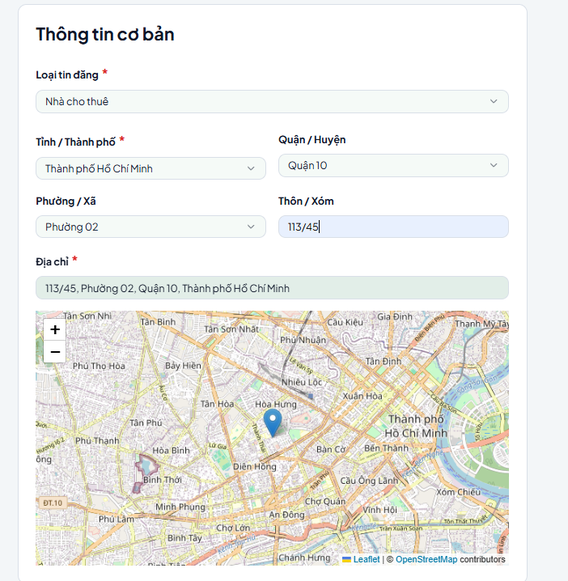

Figure 65: Basic information of the posting page

- Post information: Includes the post title and detailed description of the room. This section has a text editor that supports basic formatting such as bold, italic, underline, insert links, and customize formatting.
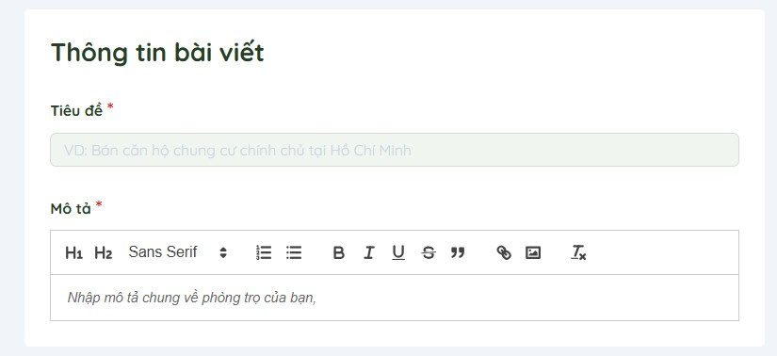

Figure 66: Post information of the posting page
- Room Information: The landlord enters important information such as:
  - Room size and rental price.
Posting package: Posting packages will be divided by level: diamond, platinum, gold, ... The higher the package, the more priority it will be displayed first. And the total payment will be calculated according to the formula:
  - Total payment = Amount of posting package x Number of days of posting deadline
  - Advertisement price and posting duration (e.g. 1 month).
  - Number of bedrooms, number of bathrooms, and desired tenants (e.g.
Male, female).
  - Amenities included (selected via button or checkbox).

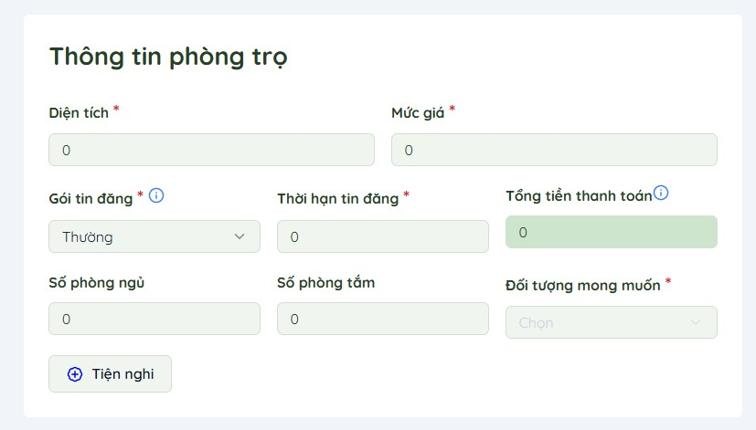
Figure 67: Room Information of the posting page

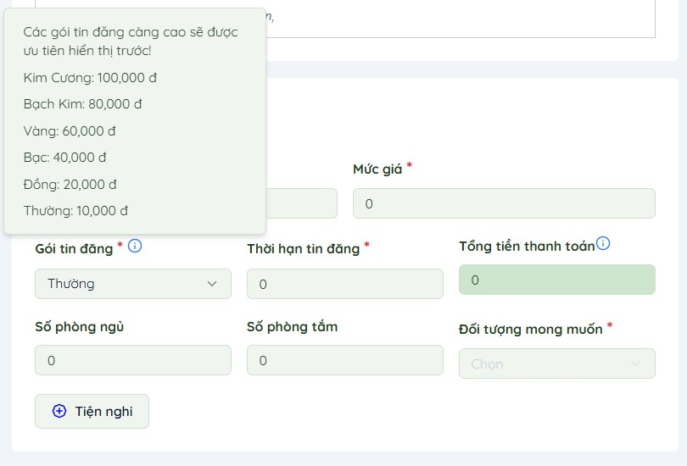
Figure 68: Posting package of the posting page
- Upload images and videos: The landlord can upload images or videos of the room for visual illustration.
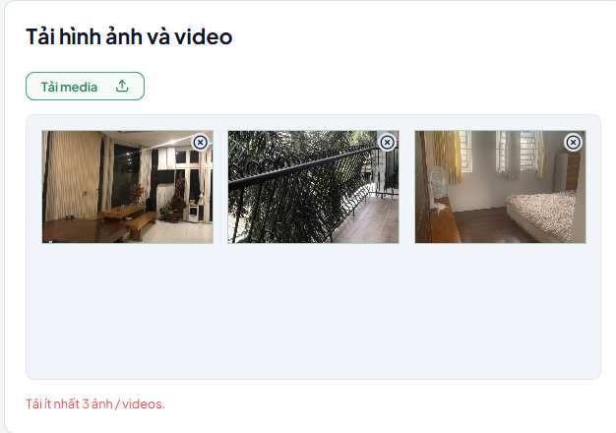
Figure 69: Upload images and videos

- Contact information: This section automatically displays the landlord's information including full name, phone number, and email that have been updated in the account.
- Payment information: A detailed summary of the posting cost, including:
- Posting package: The type of package the landlord chooses (e.g. regular).
Unit price and number of days the listing will be displayed.
Total payment amount after confirmation.
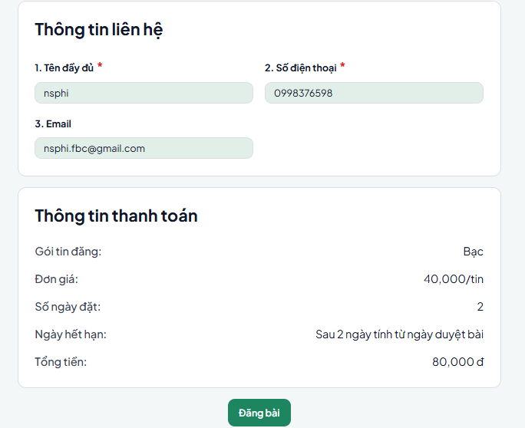

Figure 70: Contact and Payment information

After posting, your post will be archived in the Post Management section under the status of waiting for Admin approval.

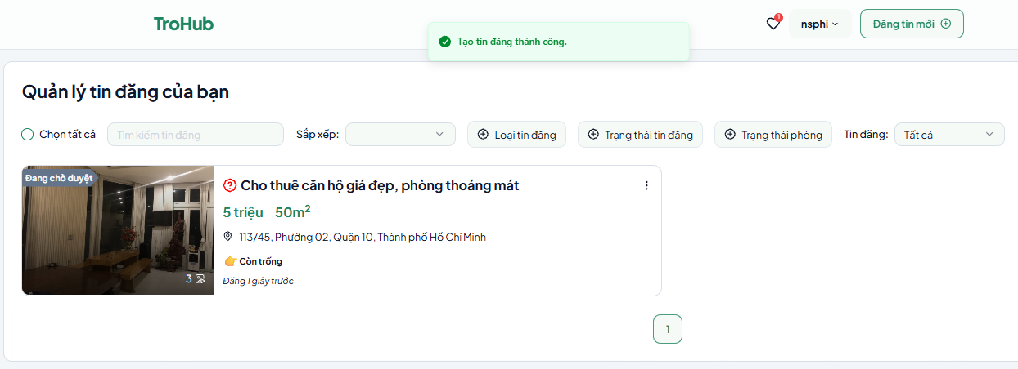
Figure 71: Post Management section

If the post is approved by Admin, a notification will be sent to your email.
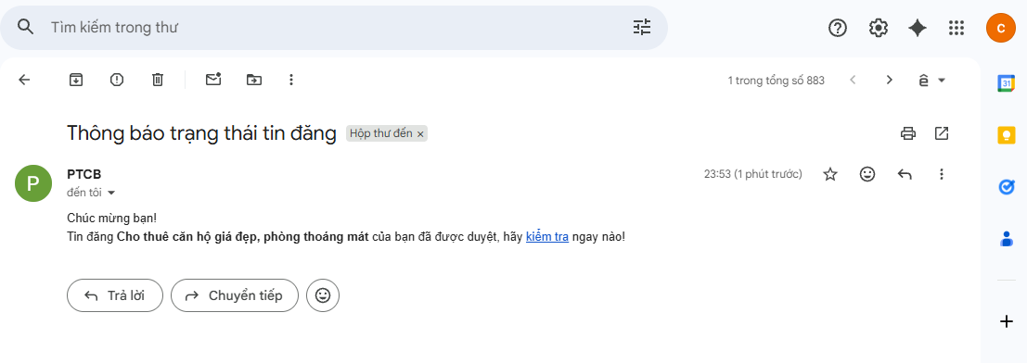
Figure 72: Notice of successful approval

And you can make payments, publish posts in the Bill Management section.
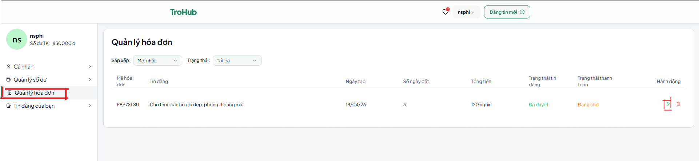
Figure 73: Bill Management section

The ad will be published and the payment status will be updated as successful, the invoice amount will be deducted directly from the user's account balance.
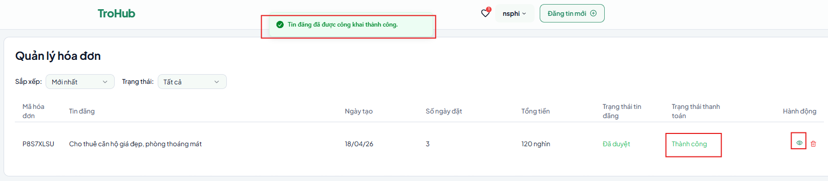
Figure 74: Posting success notification

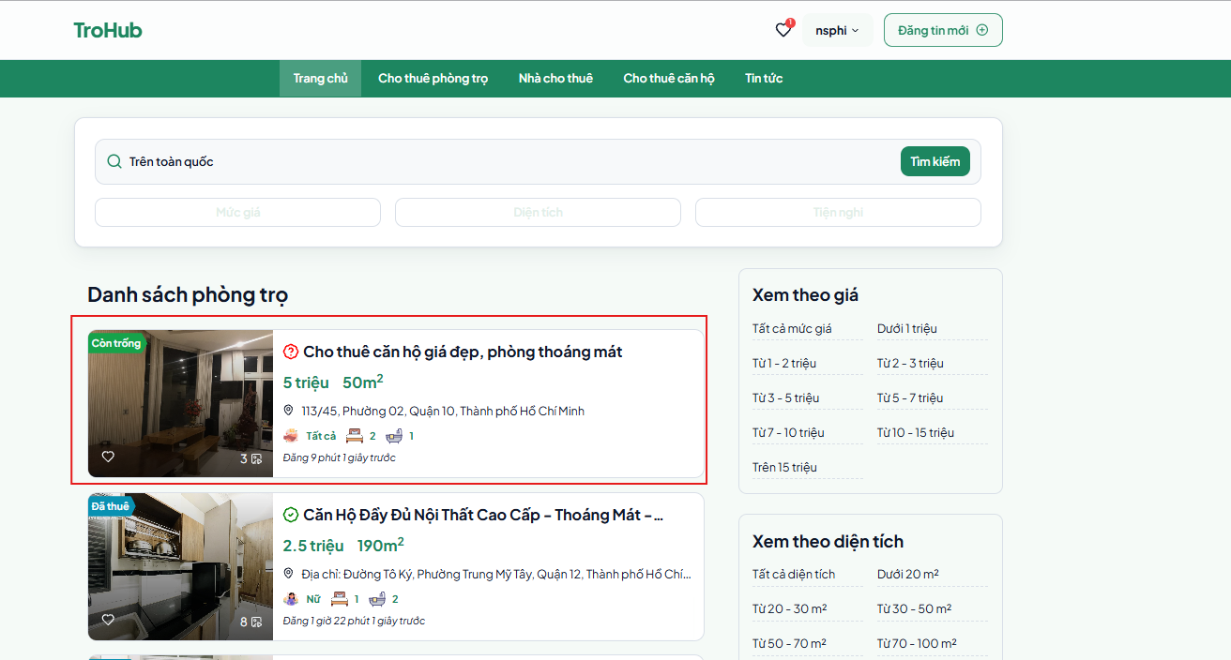
Figure 75: The newly published post appears on the home page

4.2.4. Admin

4.2.4.1. Display
The homepage for the admin keeps a similar appearance and key functionality as those for tenants and landlords but is extended with sophisticated tools and features specialized to administrative activities. As an Admin, the homepage works as a centralized center for controlling the platform, monitoring all activity, and assuring the seamless running of the rental website.

4.2.4.2. User dashboard
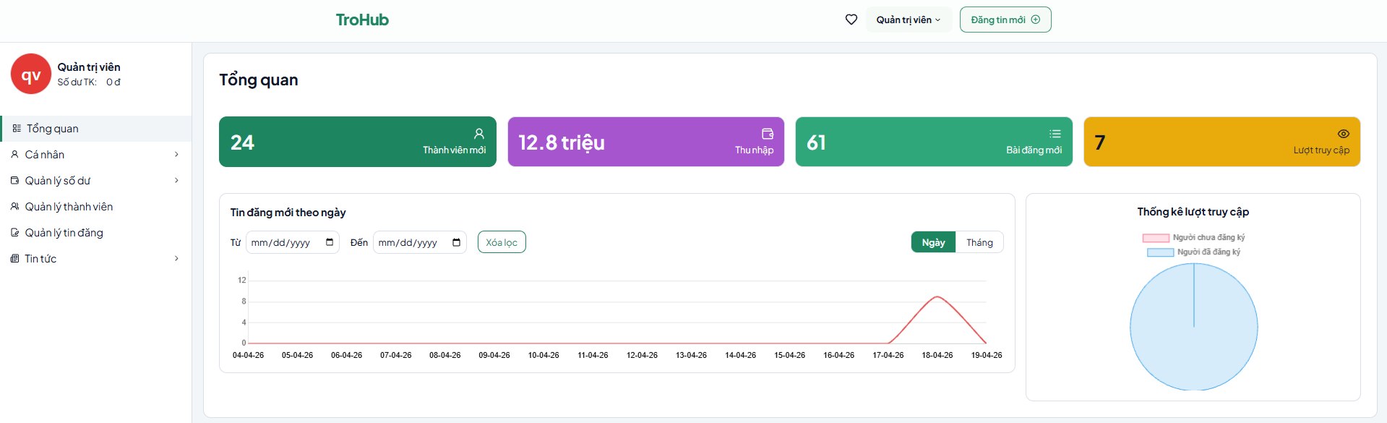

Figure 76: User dashboard of Admin

This is the main dashboard where Admin can track aggregated metrics on website activity with key metrics:
- New Members: Number of new users who have registered during the statistical period.
- Income: Total income or revenue from site activities such as posting fees, account upgrades, etc.
- New Posts: Total number of new posts created on the system.
- Visits: Total number of visits to the website during the statistical period.
- Line chart: Statistics of the number of new posts, The data is presented in a chart with:
  - X-axis: Time (days).
  - Y-axis: Number of new posts per day.
- Piece chart: Shows the ratio between registered and unregistered visitors.
- Green: People who have registered an account. Red: People who have not registered an account.
The Personal Information and Balance Management sections essentially share the same functionality as those for tenants and landlords. They include updating personal details, phone number, email, managing favorite or viewed listings, checking account balance, viewing payment history, renewal history, and topping up via VNPay.

- Member Management: Admin can control the list of users, including tenants and landlords. Functions include:
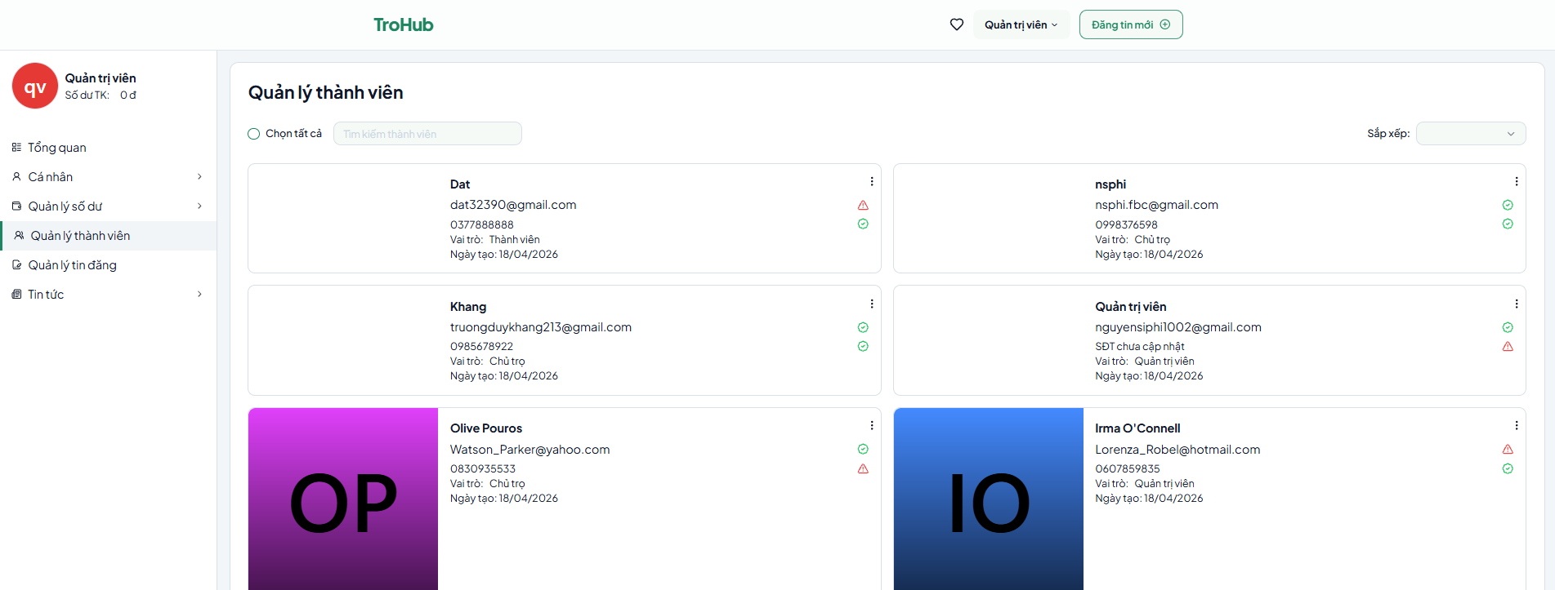
View, edit or delete user accounts. In addition, Admin can change the user's role

Figure 77: Member Management Page

- Posting Management: Admin can review, edit or delete landlord's room postings.
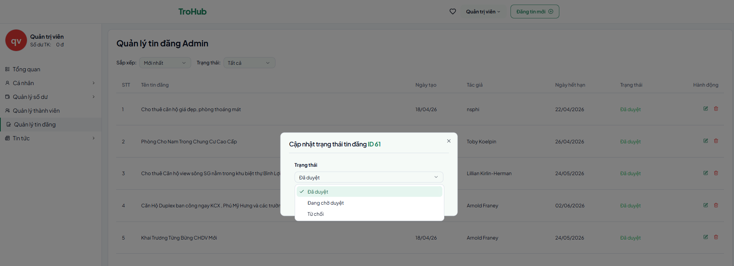
Figure 78: Manage post status

- News:
This is where Admin can manage news, update information or announcements on the website.
  - Create new news: Allow Admin to write and post new announcements.
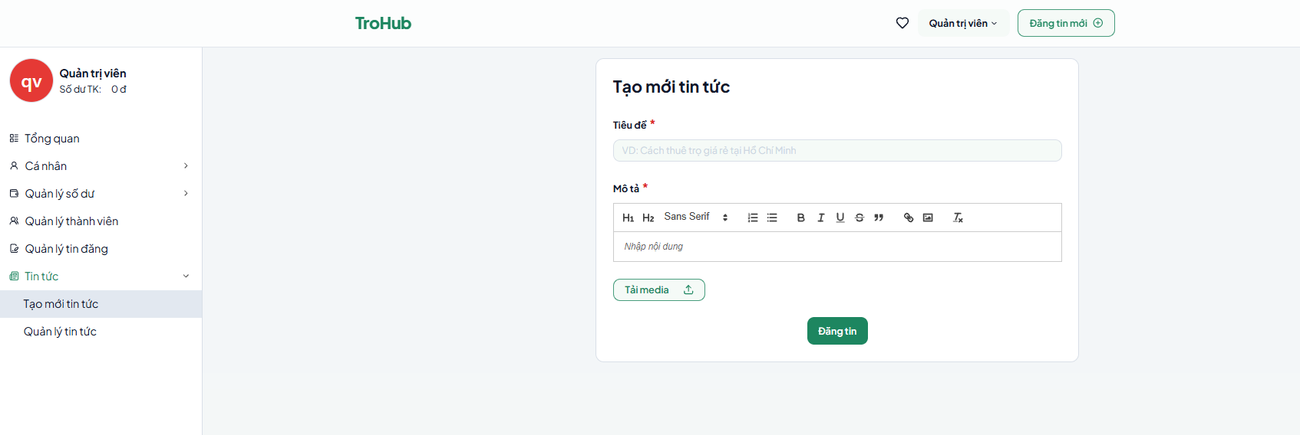
Figure 79: News article creation page
  - Manage news: Edit or delete created articles.
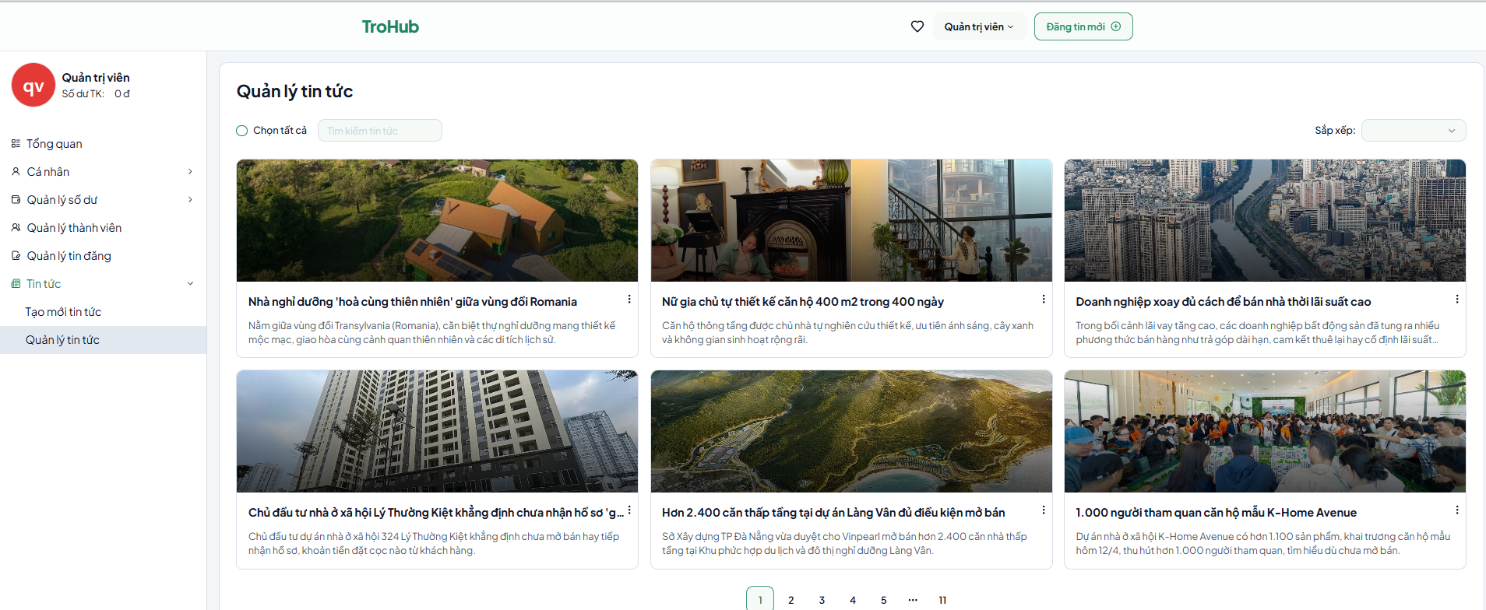

Figure 80: News management page

### CHAPTER 5. DISCUSSION AND EVALUATION

#### 5.1. Discussion
The development of the TroHub platform represents a multi-disciplinary effort, integrating modern full-stack web architectures to address the complexities of the residential rental market. Unlike traditional listing sites, this project emphasizes a comprehensive system design, leveraging a technical stack comprising **React.js for a responsive frontend** and **Node.js/Express.js for a robust, scalable backend**. The implementation was guided by qualitative research into user personas—tenants, landlords, and administrators—ensuring that the final product transcends a mere "proof of concept" to become a production-ready ecosystem.

The current iteration successfully demonstrates sophisticated functionality, particularly its high-performance filtering engines and automated property management lifecycle. For tenants, the platform mitigates the cognitive load of housing searches through precise multi-parameter queries. For landlords, the system digitizes the management workflow, offering real-time visibility and status control. Centrally, the administrative module provides a governance layer that ensures content integrity and platform stability, fulfilling the primary objective of creating a reliable, high-trust environment for rental transactions.

#### 5.2. Comparative Analysis
When benchmarked against established market incumbents such as **phongtro123.com**, TroHub introduces several innovative features that enhance the landlord's operational efficiency. While both platforms provide standard listing and discovery services, TroHub distinguishes itself through a **Dynamic Listing Extension (Renewal) Mechanism**. This feature allows landlords to prolong the expiration threshold of their advertisements via an integrated system wallet, eliminating the redundant manual effort of recreating expired listings. This not only preserves the historical performance data of the advertisement (such as view counts and ratings) but also significantly reduces the administrative overhead and costs associated with maintaining a persistent market presence.

Furthermore, a significant competitive advantage lies in TroHub’s **Advanced Administrative Intelligence**. While legacy platforms often focus exclusively on listing CRUD (Create, Read, Update, Delete) operations, TroHub incorporates analytical tools that aggregate and visualize market data. Using libraries like **Chart.js**, administrators can derive actionable insights into market trends, such as:
* Peak demand geographic zones.
* The most sought-after price brackets and spatial dimensions.
* Predictive indices for rental turnover rates.

These analytical capabilities empower administrators to make data-driven decisions, optimizing the platform's service delivery and providing landlords with the market intelligence required to align their offerings with current demand.

#### 5.3. Limitations and Future Trajectory
Despite its technical sophistication, TroHub faces certain strategic challenges when compared to well-established platforms. Legacy competitors benefit from substantial **network effects**, enjoying a larger user base and higher organic traffic, which facilitates faster matching between supply and demand. Currently, TroHub's ecosystem is in its initial growth phase, meaning it lacks the historical branding and extensive promotional packages available on larger platforms.

Additionally, as a contemporary development project, the system’s scalability and edge performance have yet to be tested against millions of concurrent users. Future development phases will focus on:
1. **Search Engine Optimization (SEO)** to drive organic growth.
2. **Infrastructure Scaling** through container orchestration (Docker/K8s) to handle increased traffic loads.
3. **Expansion of the Monetization Layer** to include promotional ad Tiering.

#### 5.4. Conclusion and Evaluation
The evaluation of the TroHub platform reveals a high degree of **operational utility and fiscal efficiency**. The automated renewal feature provides a cost-effective solution for landlords to maintain visibility, thereby increasing lead conversion rates without incurring additional labor costs. Simultaneously, the administrator dashboard adds value through its "intelligence-first" approach, uncovering hidden patterns in rental activity that can be used for platform-wide strategic planning.

In conclusion, while the platform acknowledges the current market dominance of established players, its focus on **data-driven decision-making and automated administrative workflows** positions it as a highly intelligent alternative in the rental market. TroHub successfully bridges the gap between simple listing directories and integrated management systems, demonstrating significant potential for future commercialization and scalability.

CHAPTER 6. CONCLUSION AND FUTURE WORK
6.1. Conclusion
The "TroHub" project has successfully achieved its primary objective of developing a high-fidelity, full-stack rental management ecosystem tailored to the Vietnamese market. Through the strategic integration of React.js, Node.js, and PostgreSQL, the platform has demonstrated a robust capacity to handle complex operational workflows, including secure user authentication, dynamic property discovery, and a sophisticated administrative analytics engine.
A pivotal milestone was the implementation of a seamless digital payment pipeline via MoMo Gateway, providing a reliable foundation for automated listing renewals and internal wallet management. This architectural decision, combined with the integration of Leaflet-based geospatial mapping, significantly enhances the platform's utility for both tenants and landlords. In its current state, TroHub transcends traditional listing directories by providing a data-driven environment that optimizes the property search lifecycle while ensuring fiscal transparency and operational autonomy for all stakeholders.

6.2. Future Work
While the current implementation provides a comprehensive feature set, several technical horizons have been identified to further elevate the platform's market competitiveness and user experience:
Intelligence and Personalization Layer: Future iterations aim to integrate AI-driven Recommendation Engines. By leveraging machine learning algorithms (such as collaborative filtering) to analyze historical user behavior and preferences, the platform will be capable of delivering hyper-personalized accommodation suggestions, thereby increasing user retention and conversion rates.
Real-time Communication Infrastructure: To further reduce friction in the leasing process, a Direct Messaging Module utilizing WebSockets (Socket.io) will be integrated. This will facilitate instantaneous, secure communication between landlords and tenants, allowing for real-time negotiations and document sharing within a supervised environment.
Cross-platform Mobile Sovereignty: Transitioning from a mobile-responsive web interface to a Native Mobile Application (via React Native or Flutter) is a priority. This will align the platform with "Mobile-First" consumption trends, enabling push notifications for new listings, real-time proximity alerts, and on-the-go property management.
Expansion of Governance and Security: Enhancements to the administrative module will include Automated Content Moderation using Computer Vision to verify property images and NLP (Natural Language Processing) to detect fraudulent listing descriptions, further solidifying TroHub as a high-trust digital marketplace.
Through these planned advancements, TroHub is positioned to evolve into a highly intelligent, scalable, and indispensable solution for the modern rental accommodation sector in Vietnam.

REFERENCES
- Keycafe. (2023, July 18). The history of Short-Term Rentals. Keycafe Blog. https://blog.keycafe.com/the-history-of-short-term-rentals
- Martin-Fuentes, E., & Mellinas, J. P. (2018). Hotels that most rely on
Booking.com – online travel agencies (OTAs) and hotel distribution channels.
Tourism Review, 73(4), 465–479. https://doi.org/10.1108/tr-12-2017-0201
- Trọ P. (2024, December 22). Cho Thuê Phòng Trọ, Giá Rẻ, Tiện Nghi, Mới Nhất 2024. Cho Thuê Phòng Trọ Nhà Trọ, Tìm Phòng Trọ. https://phongtro123.com/chothue-phong-tro
- P.V. (2024, April 6). Phongtro123 cung cấp giải pháp cho thuê phòng trọ chất lượng tại TP.Hồ Chí Minh. baoquangnam.vn. https://baoquangnam.vn/phongtro123cung-cap-giai-phap-cho-thue-phong-tro-chat-luong-tai-tp-ho-chi-minh-3132452.html [5] Phuongdung, & Phuongdung. (2023, November 24). Phongtro123: Website phòng trọ, nhà trọ TPHCM vị thế số 1 Việt Nam. HCMtoplist.com.
https://www.hcmtoplist.com/phongtro123-website-phong-tro-nha-tro-tphcm-vi-the-so1-viet-nam
- Nơi nghỉ dưỡng cho thuê là khách sạn tại Việt Nam | Airbnb. (n.d.). Airbnb.
https://www.airbnb.com.vn/vietnam/stays/hotels?_set_bev_on_new_domain=173367
0728_EAYmNiN2U0NzU2Mz
- William. (2022, March 25). How to Find an Apartment in Vietnam Online. Vietnam Daily.https://vietnamdaily.ca/travel/how-to-find-an-apartment-in-vietnamonlinehttps://vietnamdaily.ca/travel/how-to-find-an-apartment-in-vietnam-online
- React. (n.d.). https://react.dev/
- Simons, E. (2024, April 29). What is Vite (and why is it so popular)?
https://blog.stackblitz.com/posts/what-is-vite-introduction/
- Tailwind CSS - Rapidly build modern websites without ever leaving your HTML.
(n.d.). Tailwind CSS. https://tailwindcss.com/ https://github.com/expressjs/expressjs.com
- Emadamerho-Atori, N. (2024, June 4). Radix UI adoption guide: Overview, examples, and alternatives - LogRocket Blog. LogRocket Blog.
https://blog.logrocket.com/radix-ui-adoption-
guide/#:~:text=Radix%20UI%20is%20an%20open,%2C%20websites%2C%20and%
20web%20applications
- How to use Zustand. (2024, July 31). Refine. https://refine.dev/blog/zustandreact-state/
- Vadecha, A. (2024, October 3). React Hook Form - A Complete Guide. Hygraph. https://hygraph.com/blog/react-hook-form
- GeeksforGeeks. (2024, July 26). What is reactrouterdom ? GeeksforGeeks.
https://www.geeksforgeeks.org/what-is-react-router-dom/
- [JavaScript] - What is Axios? A JavaScript library for making HTTP requests. (n.d.). https://www.shecodes.io/athena/172357-what-is-axios-a-javascript-library-formaking-httprequests#:~:text=Axios%20is%20a%20popular%20JavaScript,and%20also%20handl es%20the%20response
- React Hooks for Data Fetching – SWR. (n.d.). SWR. https://swr.vercel.app/ [17] Node.js — Introduction to Node.js. (n.d.). https://nodejs.org/en/learn/gettingstarted/introduction-to-nodejs
- Codecademy. (n.d.). What is Express.js? Codecademy.
https://www.codecademy.com/article/what-is-express-js
- How to Handle Passwords Safely with BcryptsJS in JavaScript | DigitalOcean. (n.d.). https://www.digitalocean.com/community/tutorials/how-to-handle-passwordssafely-with-bcryptsjs-in-javascript
- auth0.com. (n.d.). JWT.IO - JSON Web Tokens Introduction. JSON Web Tokens
- jwt.io. https://jwt.io/introduction
- Reinman, A. (n.d.). Nodemailer :: Nodemailer.
https://www.nodemailer.com/#:~:text=Nodemailer%20is%20a%20module%20for,for %20most%20Node.js%20users.
- Valero, L. (2024, May 22). What is Twilio? All you need to know | Frizbit. Frizbit. https://frizbit.com/blog/what-is-twilio/
- What is PostgreSQL? - PostgreSQL Explained - AWS. (n.d.). Amazon Web
Services, Inc. https://aws.amazon.com/vi/rds/postgresql/what-is-postgresql/ [24] Sequelize. (n.d.). Feature-rich ORM for Modern TypeScript & JavaScript.
https://sequelize.org/#:~:text=Sequelize%20is%20a%20modern%20TypeScript,loadi ng%2C%20read%20replication%20and%20more.
- Le, T. T. V., & Do, P. C. (2022). https://hotrodoan.vn/project/nghien-cuu-xaydung-he-thong-website-quan-ly-va-cho-thue-nha-tro-PE202475
- Nguyen, M. T. (2020). https://tapchicongthuong.vn/nghien-cuu-hanh-vi-thue-nhatro-cua-sinh-vien-truong-dai-hoc-cong-nghiep-ha-noi-73954.htm
- Pham, T. N. (2019). https://luanvan.net.vn/luan-van/de-tai-tim-hieu-xu-huong-luachon-nha-tro-cua-sinh-vien-dai-hoc-dong-thap-35072/
- Hoang, D. T., & Tran, A. P. (2021). https://jst.iuh.edu.vn/index.php/jstiuh/article/download/4818/746
- Doan, L. T. (2023). https://kinhtevadubao.vn/phan-tich-cac-yeu-to-anh-huongden-y-dinh-duy-tri-cho-o-tro-cua-sinh-vien-tai-tp-ho-chi-minh-29646.htmls

