Project Java Web Application Development(PRJ301): Website bán Giày thể thao RewardFlat

Project gồm:

1. Login + SignUp
2. Phần quyền Admin+ customer
3. Sau khi Admin truy cập :

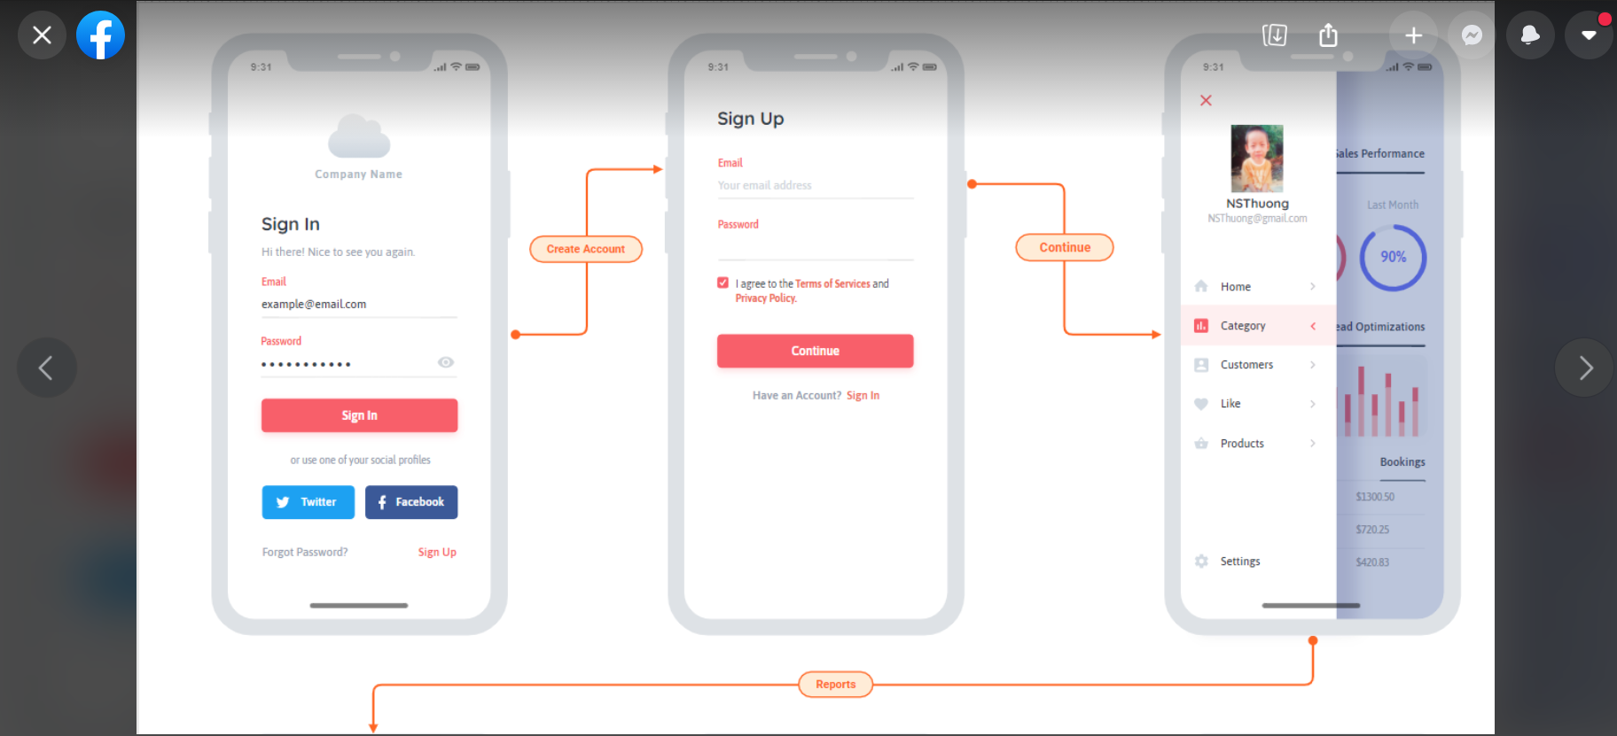

Admin có thể nhìn thấy được các list sản phẩm người dùng đặt mua + tổng giá trị các đơn hang đó.

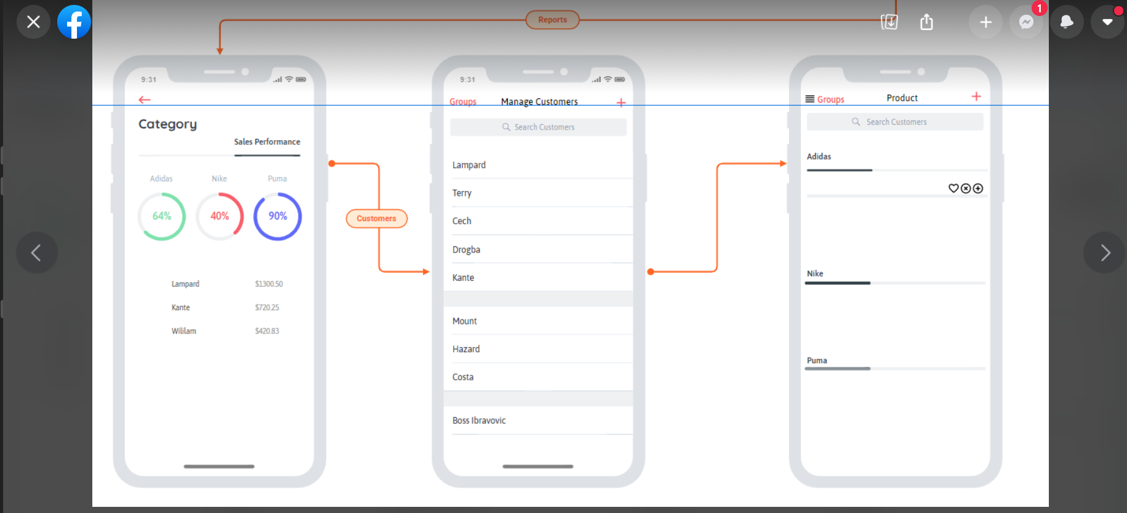

Tổng quan Admin :

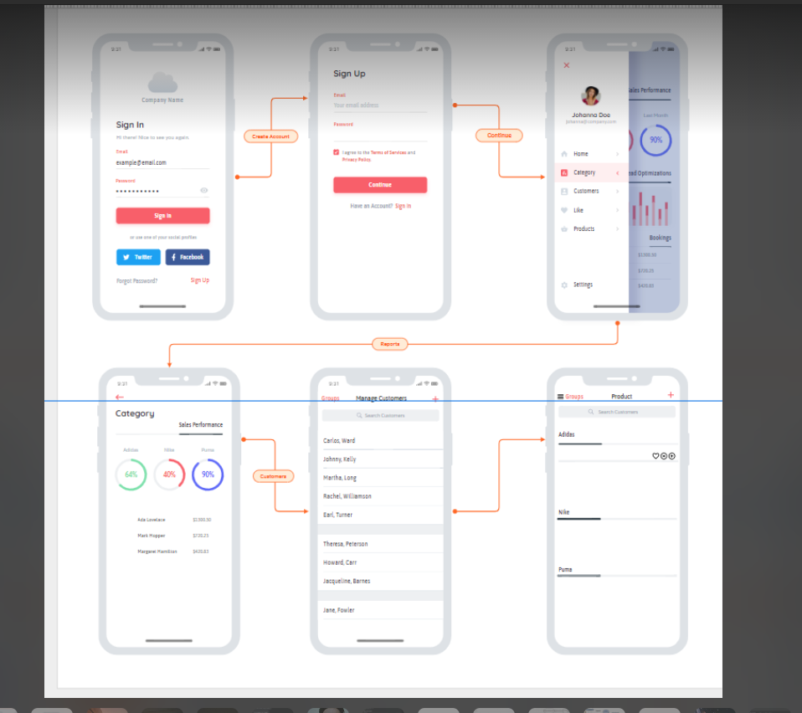

1. User truy cập:

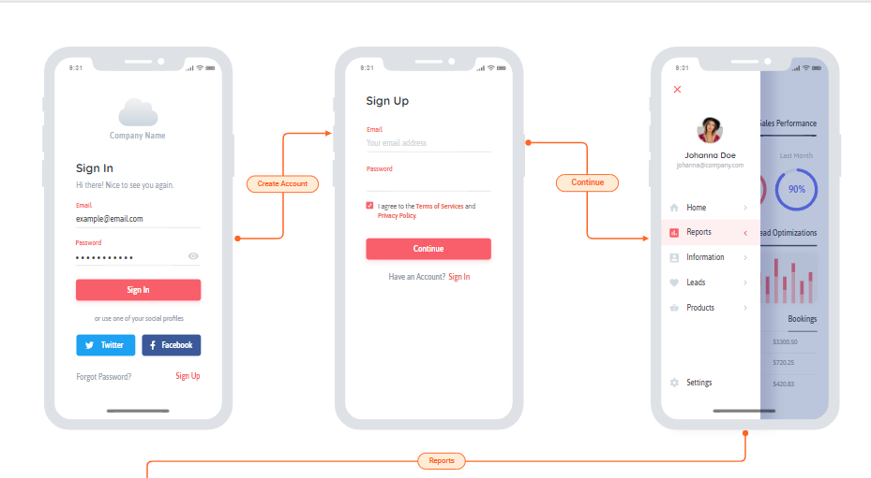

Sau khi truy cập thì có thể lựa chọn các sản phẩm có sẵn và order

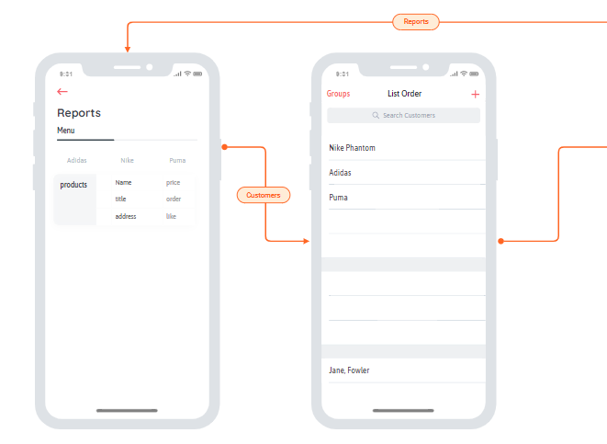

Mô hình tổng quan user:

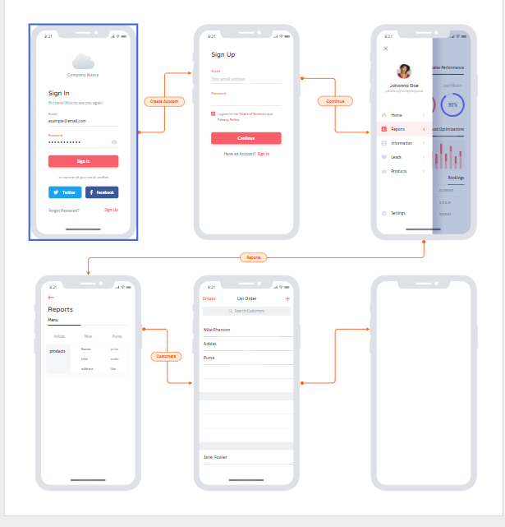

Detail:

* + - * Login
        + Decentralization(ph ân quyền):

Only Admin manager

User signup and login

* + - * + Using session : save to status of customer and admin in WEB
        + Using cookie : save to status of customer and admin in server pass to browser
        + Using filter(not done)
        + Forgot password(not done)

Using captcha

If Enter captcha true 🡪 View old password

If enter captcha false 3 slot 🡪

* + - * + Change password(not done)

Update password

* + - * Sign Up
        + Check Account is exist or not
        + Insert information to DB
      * Admin:
        + Manager Product

Add new product

Update product

get IDProduct data from browser to server

Then from the access server to the DB get the data of IDProduct

push back the data to the Update page

Admin just need to update the data you want

Delete product

* + - * + Manager Order

View list product of customer order in web site

If ship done, admin can delete

* + - * + Manager Account

Manager account sign up in Web can to control

* + - * User
        + Control information

Update information

* + - * + Add to cart
        + Search

Process: display all information of product that name or id of product contain content of Search text field.

If text field is empty, display all product

* + - * + Check out

Edit your cart

Save order

* + - * + Buy to cart Special

Product sale to 5-20% price

Free ship or tax

* + - * + Buy to more than 2000$

Goodwill (ưu đãi) to 10%

* + - * Pagging
        + Pagging in page Menu- 1 page to 6-8 product
        + Pagging in page Manager Account- 1 page to 5 Account
        + Pagging in page Manager Order – 1 page to 10 order.
        + How to pagging Product:

Count to all Product

If admin want to 1 page – 6 product after count product, we get to count value/6= count “Page”

If value%6 !=0 🡪 Page +1

* + - * Database

