April 24, 2015

PI DOCUMENTATION

Contents

1. Problems Description

Problems description
To calculate an approximation to the constant Pi formula. The solution to calculate Pi must use Java language to develop and judge on a number of criteria, including:
- It build and run actually produce an approximation to Pi.
- We can easily determine that the calculations are being done correctly.
- It’s using effectively the available resources as CPU, memory, etc.
- Another developer be able to pick up the solution and easily understand it.
- It easy to make changes to the code in the future.

Solutions description:

Using the following formula for the calculation:
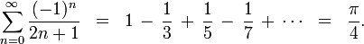
First I will design formula to calculate pi like this:
double piNo = 0.0;

for (long x = startNo; x <= endNo; x++) {
if (x % 2 == 0) {
piNo += (1.0 / (2.0 * x + 1));
} else {
piNo -= (1.0 / (2.0 * x + 1));
}
}

I have a variable name is piNo it will storage sum of pi value return after formula completed pi calculated.
First we create a number of threads and each of them have information to calculate Pi as below:

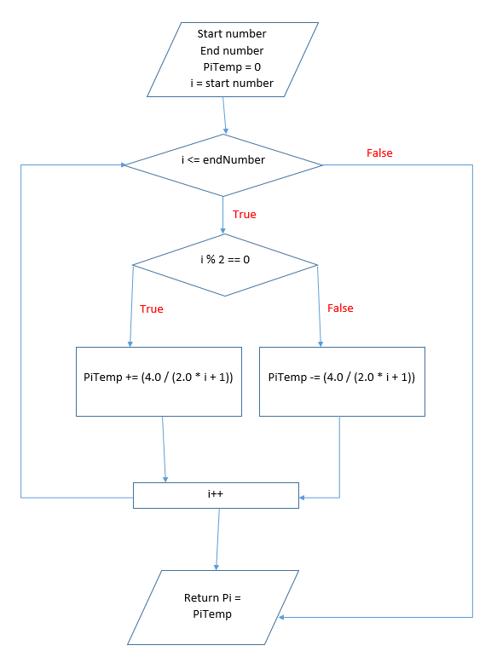

High level design:

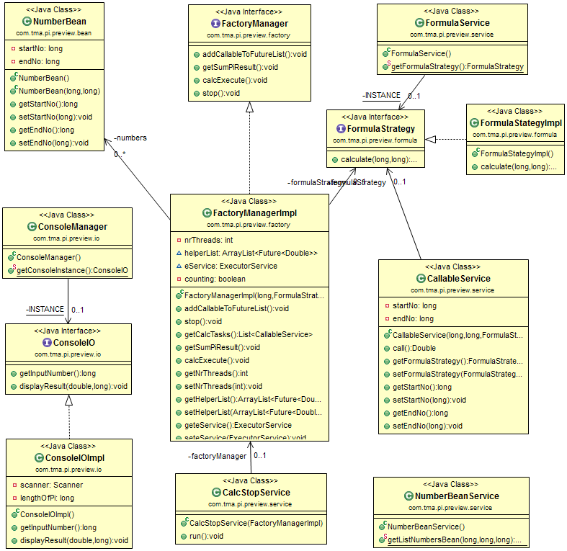

4- Achivement:
Successfully developing the solution in Java to calculate an approximation to constant Pi. The expectations is high. The solution used multi-thread to calculate Pi with the short time. With this solution, we can calculate the approximation to constant Pi with the very large number “n” then get the current Pi when the program is running.
The code have enough java doc, follow coding convention, no tabs,… It easy to read and have enough unit testcases.
5- Expansion:
In my Pi Exercise, I use two design pattern: Singleton and Strategy to calculate number Pi.
- The Executor interface is not only used for calculating Pi but also applied for others calculations.
- The ConsoleIo interface allows our application to interact with users.
By implementing Executor interface, ExecutorImpl provides calculating Pi number service. In this package, there are two other classes such as: PiCalculatorImpl and Range. Range represents a work with a range marking by begin number and end number and is attached with a thread. Since PiCalculatorImpl implements Callable interface, it is used for computing Pi number with Mutil-Threading technology by calling a computePi() method on an Task object.
We can overide threads to develop for calculation using multithreads,…

