Responsive Web Design practice

1. Application overview 2

1.1. Desktop view 2

1.2. Tablet view 3

1.3. Mobile view 4

2. Common style 4

2.1. Box sizing 4

2.2. Container 4

2.3. Navigation button 4

2.4. Clear fix 5

3. Project structure 6

4. Layout 6

4.1. HTML structure 6

4.2. Style 7

4.2.1 Tablet viewport 7

4.2.2 Desktop viewport 7

5. Off-canvas navigation 8

5.1. HTML structure 8

5.2. Style 9

5.2.1 Mobile-default viewport 9

5.2.2 Animation 10

5.2.3 Tablet & Desktop viewport 11

6. Listview 13

# Application overview

## Desktop view

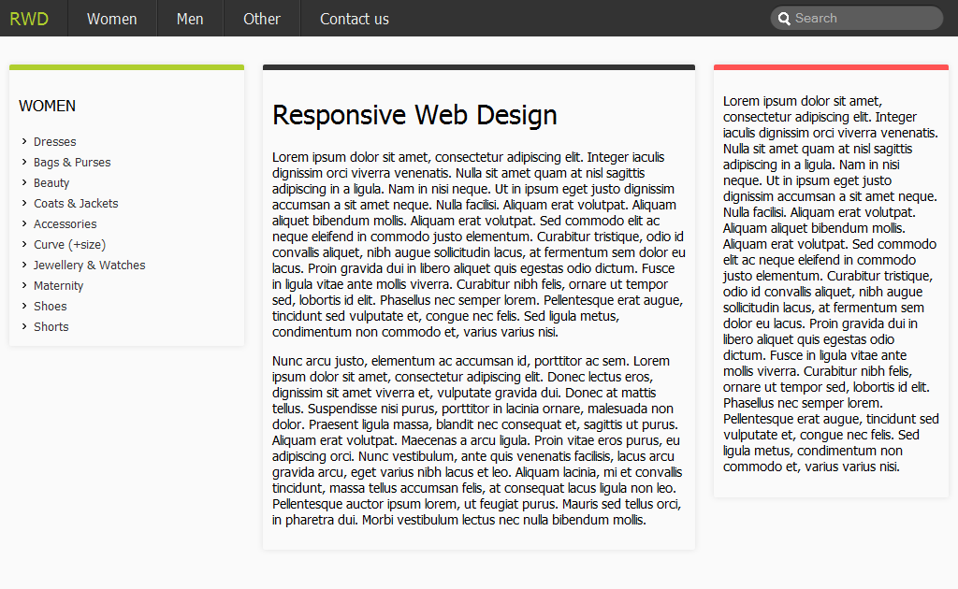

## Tablet view

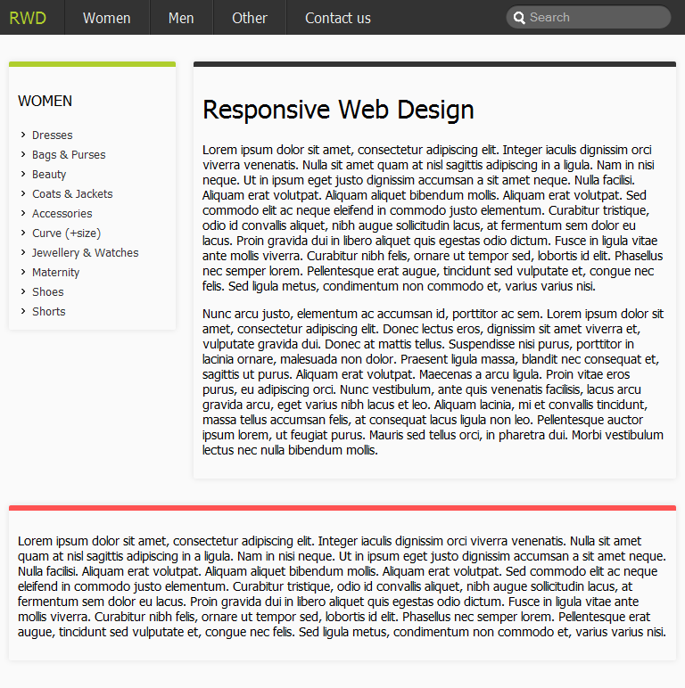

## Mobile view

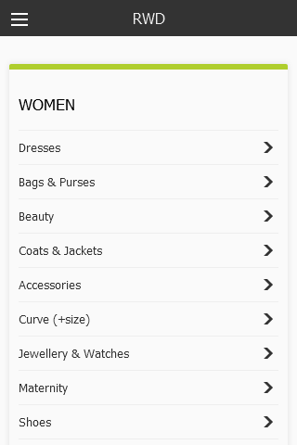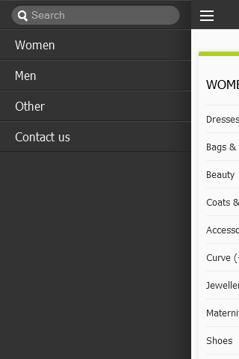

Normal state

Navigation activated state

# Common style

## Box sizing

Ensure using **Box-sizing** for fixing “Mixing fluid width + border + padding” problem

* {

-webkit-box-sizing: border-box;

-moz-box-sizing: border-box;

box-sizing: border-box;

}

## Container

That will keep content place at center when screen go wide

.container {

max-width: 1024px;

margin: 0 auto;

}

## Navigation button

Style with no image

.nav-btn {

color: #FFFFFF;

height: 2.8125rem;

line-height: 2.0625rem;

padding: 0;

position: absolute;

text-indent: 2.1875rem;

width: 2.8125rem;

top: 0;

overflow: hidden;

}

.nav-btn span {

box-shadow: 0 10px 0 1px #FFFFFF, 0 16px 0 1px #FFFFFF, 0 22px 0 1px #FFFFFF;

display: block;

height: 0;

left: 0.8125rem;

position: absolute;

top: 0.3125rem;

width: 1rem;

}

## Clear fix

.nav:before, .nav:after {

content: " ";

display: table;

}

.nav:after {

clear: both;

}

body {

background: #fafafa;

margin: 0;

font-size: 100%;

font-family: tahoma;

}

# Project structure

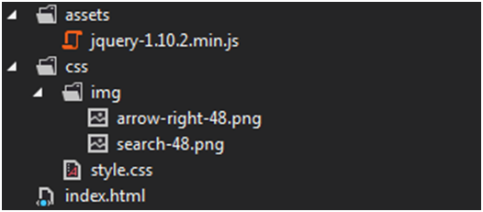

# Layout

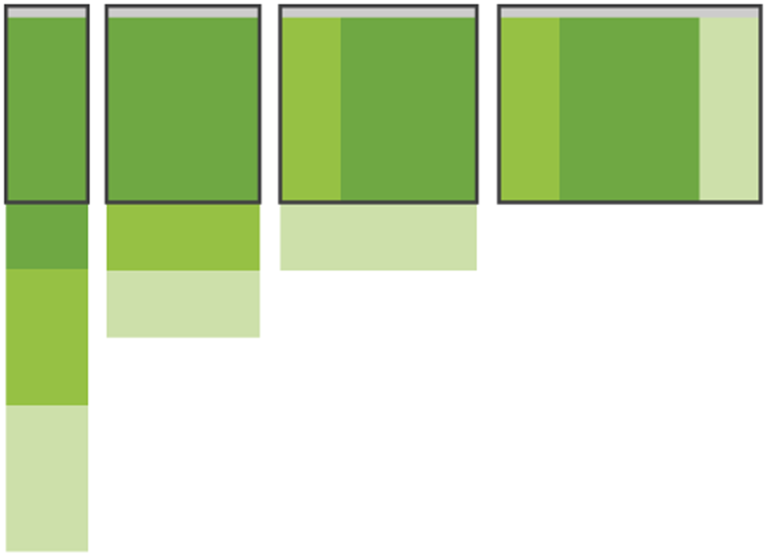

## HTML structure

Using two addition div (canvas-outer and canvas-inner) for off-canvas navigation later

<div class="canvas-outer">

<div class="canvas-inner">

<div class="header"></div>

<div class="content container">

<div class="main"></div>

<div class="left"></div>

<div class="right"></div>

</div>

</div>

</div>

## Style

### Tablet viewport

Using Media query with min-width:48em (=768px based on 16px font-size)

@media all and (min-width:48em){

.main {

float: left;

width: 75%;

margin-left: 25%;

padding-left: 20px;

}

.left {

float: left;

width: 25%;

margin-left: -100%;

}

.right {

clear: both;

}

}

### Desktop viewport

Using Media query with min-width:64em (=1024px based on 16px font-size)

@media all and (min-width:64em) {

.main {

width: 50%;

padding-right: 20px;

}

.left {

margin-left: -75%;

}

.right {

clear: none;

float: left;

width: 25%;

}

}

# Off-canvas navigation

## HTML structure

<div class="header">

<div class="container">

<a class="nav-btn" data-target="canvas-outer"><span>C1</span></a>

<a class="nav-brand">RWD</a>

<div class="nav-wrap">

<ul class="nav">

<li class="search-form">

<form method="GET">

<input type="search" placeholder="Search" />

</form>

</li>

<li><a href="#">Women</a></li>

<li><a href="#">Men</a></li>

<li><a href="#">Other</a></li>

<li><a href="#">Contact us</a></li>

</ul>

</div>

</div>

</div>

* nav-brand: that will keep showing on both small and large viewport
* nav-wrap: for transform3d animation

## Style

### Mobile-default viewport



Normal state

Navigation activated state

#### Normal state

.canvas-outer {

overflow-x: hidden;

}

.canvas-inner {

left: 0;

position: relative;

}

Use overflow:hidden for the “canvas-outer” to ensure layout won’t be broken when using negative left

.nav-wrap {

position: absolute;

top: 0;

left: -80%;

width: 80%;

background: #333;

height: 100%;

overflow: hidden;

}

#### Active state

.nav-push .canvas-inner {

left: 80%;

}

Use script to activate and deactivate the “active” state when nav-btn is clicked

$('.canvas-outer').toggleClass('nav-push');

Or something like that ☺

### Tablet & Desktop viewport



.nav-brand {

float: left;

font-size: 1.2em;

padding: 8px 20px 8px 10px;

color: #AFCE2D;

}

.nav-btn {

display: none;

}

.nav-wrap {

position: static;

width: 100%;

overflow: visible;

}

.nav > li {

float: left;

border: none;

border-left: 1px solid #222;

border-right: 1px solid #444;

}

.nav > li:last-child {

border-right: none;

}

.nav > li.search-form {

border: none;

float: right;

}

Handle screen change when off-cancas is activating

.nav-push .canvas-inner {

left: 0;

}

.transform3d .nav-push .canvas-inner {

transform: translate3d(0,0,0);

-webkit-transform: translate3d(0,0,0);

}

### Animation

#### Using left property

.canvas-inner {

left: 0;

-webkit-transition: left .2s ease;

transition: left .2s ease;

}

#### Using transform3d

Normal state

.canvas-inner {

transform: translate3d(0, 0, 0);

-webkit-transition: -webkit-transform 500ms ease 0s;

transition: transform 500ms ease 0s;

}

Active state

.transform3d .nav-push .canvas-inner {

left: 0;

-webkit-transform: translate3d(80%,0,0);

transform: translate3d(80%,0,0);

}

And with cooler animation

@media all and (max-width:47em) {

.transform3d .nav-wrap .nav {

-webkit-transform: translate3d(75%, 0, 0) scale3d(0.9, 0.9, 0.9);

transform: translate3d(75%, 0, 0) scale3d(0.9, 0.9, 0.9);

-webkit-transform-origin: 50% 0%;

transform-origin: 50% 0%;

-webkit-transition: -webkit-transform 500ms ease;

transition: transform 500ms ease;

}

.transform3d .nav-push .nav-wrap .nav {

-webkit-transform: translate3d(0, 0, 0);

transform: translate3d(0, 0, 0);

}

}

# Listview

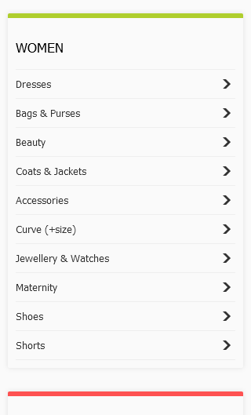

Time to resize the browser and see how it works ☺