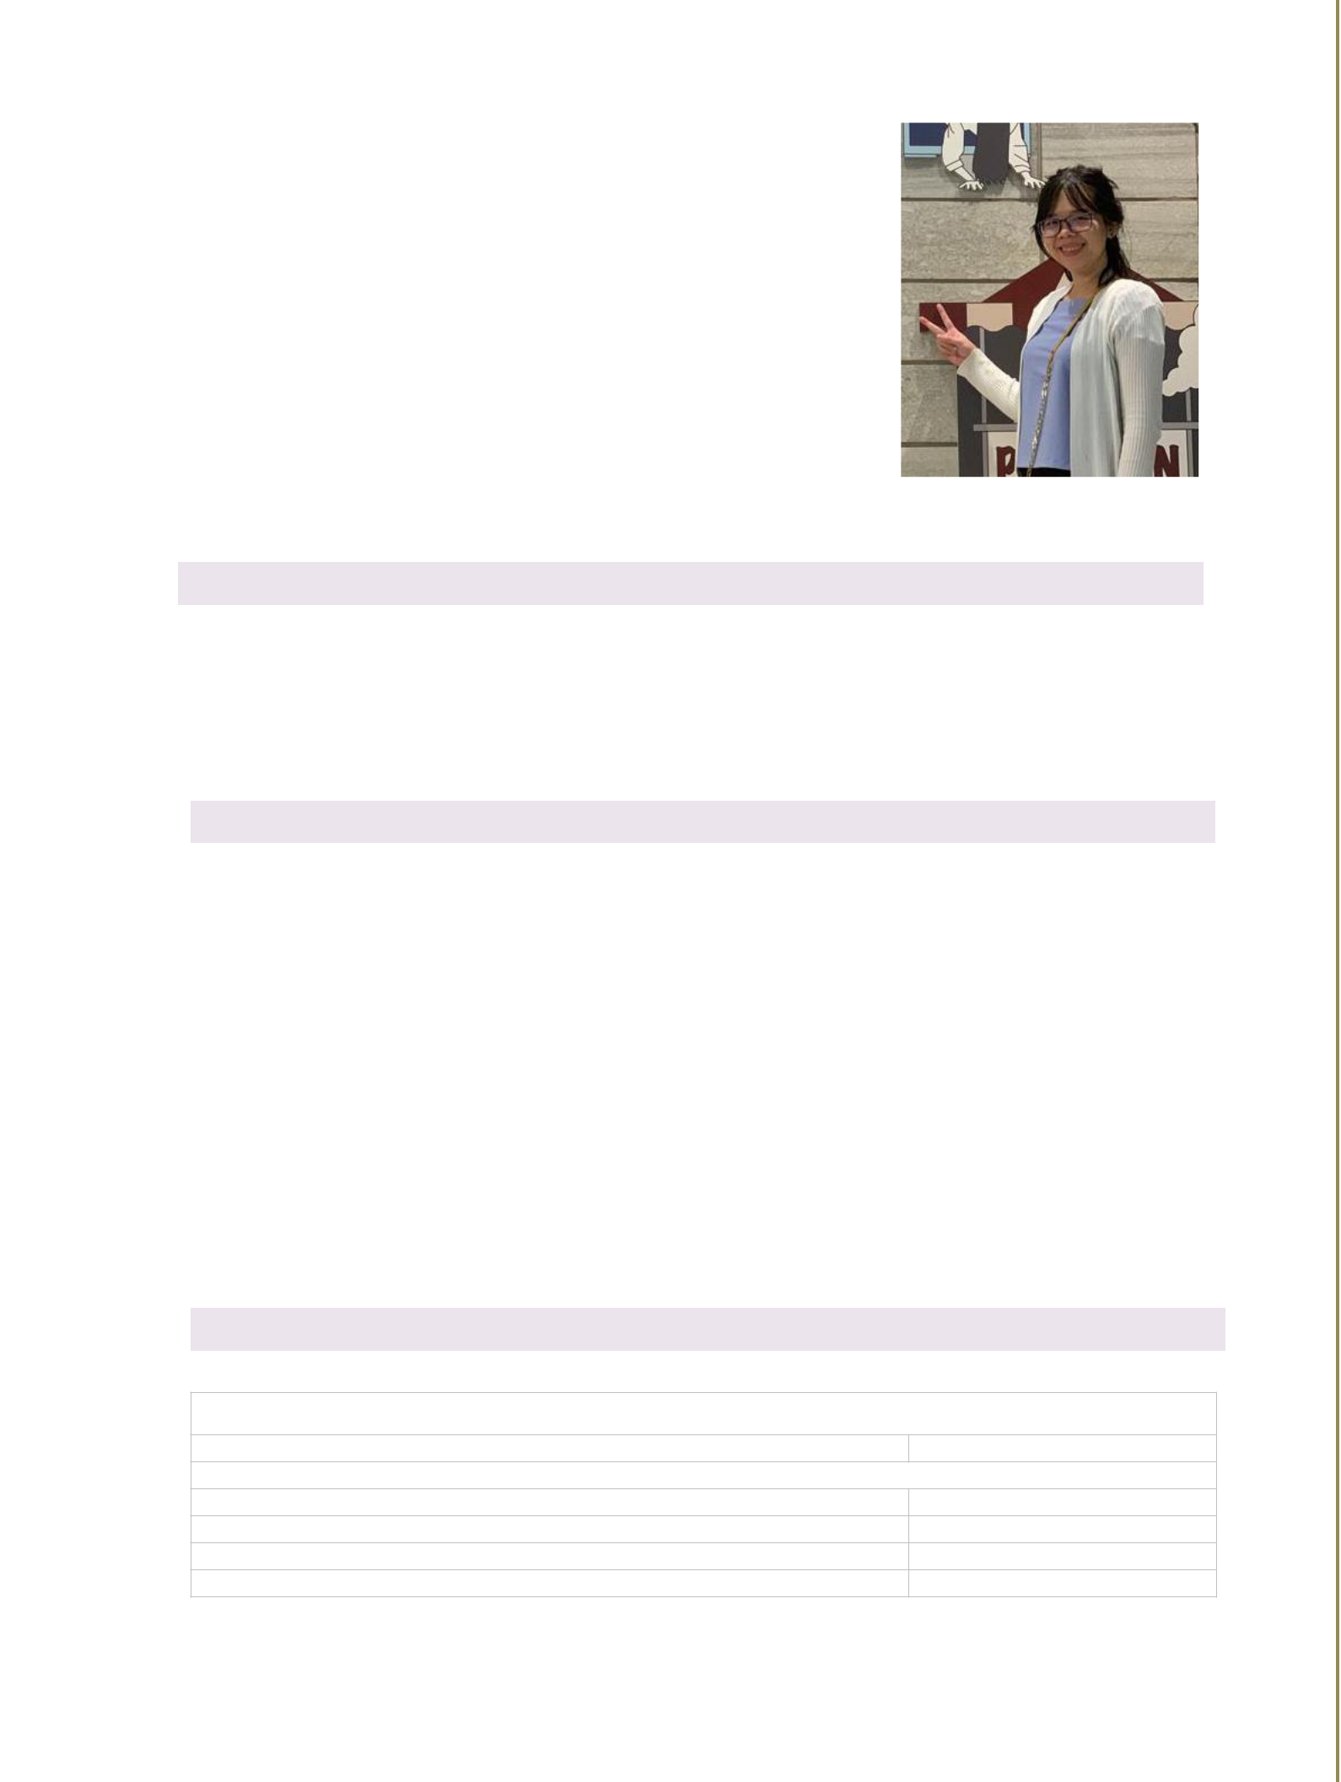**CURRICULUM VITAE**

**PERSONAL DETAILS**

|  |  |  |  |
| --- | --- | --- | --- |
| ● Name | | Nguyen Thanh Hong | |
| ● | Nationality | Vietnamese | |
| ● | Date of Birth | Jun 2nd, 1988 | |
| ● Sex | | Female | |
| ● | Marital status | Single | |
| ● | Address | 7/41/20/10 Thành Thái, District 10, | |
|  |  | HCM City | |
| ● | Email | [nguyenthanhhong26@gmail.com](mailto:nguyenthanhhong26@gmail.com) | |
| ● Skype | | hongnguyen2688 |  |
| ● Phone | | 038 303 4006 |  |

**OBJECTIVE**

My near target is to be a technical leader and far target is to be a solution architecture. I will study about new technologies and challenge problem solving and design system of technologies. My goal is producing applications with high performance and millions of users in the international environment. Build the better the future together.

**PROFESSIONAL SUMMARY**

Majority of my work experience is java and the strongest point is I have strong background, deep knowledge in java core, data structure and algorithms. I also worked with popular frameworks as spring. I can handle well the front end with HTML, CSS, Bootstraps, and JavaScript. Besides, I have some basic knowledge in C# and .Net, willing to join any project which use .Net if i am required. My other strength is database, I have mastered the syntax of databases like SQL Server, Oracle, PostgreSQL ... So I quickly figured out how to solve the problem.

|  |  |  |  |
| --- | --- | --- | --- |
|  | **EDUCATION & CERTIFICATIONS** | |  |
|  |  |  |  |
| From: 2007-2010 | **Tien Giang University (Bachelor of college in information** |  |  |
|  | **technology)** |  |  |
| From: 2010 - 2012 | **Ho Chi Minh University of Natural Science (Bachelor of science in** |  |  |
|  | **information technology)** |  |  |
|  |  |  |  |

**TECHNOLOGY AND SOFTWARE DEVELOPMENT SKILLS**

**Level**: 1-4 Aware (Basic, need to practise more); 5-7 Knowledgeable (Intermediate, can use it at work); 8-10 Proficient(Advanced, very good to use it at work)

|  |  |
| --- | --- |
| **Competencies** | **Level** |
| **Programing Languages** |  |
| Java Core | Proficient, 8/10 |
| JDBC | Proficient, 8/10 |
| Spring, Spring Boot | Proficient, 8/10 |
| Web Service | Knowledgeable, 7/10 |



|  |  |
| --- | --- |
| Web API | Knowledgeable, 7/10 |
| C# | Knowledgeable, 6/10 |
| **Front-end Web Technologies** |  |
| HTML, CSS, JavaScript, Bootstrap, JQuery | Proficient, 8/10 |
| Angular | Knowledgeable, 6/10 |
| **Databases** |  |
| SQL Server | Knowledgeable, 6/10 |
| Oracle | Proficient, 9/10 |
| PostgreSQL | Proficient, 8/10 |
| MySQL | Knowledgeable, 6/10 |
| **Server** |  |
| Linux | Aware, 4/10 |
| **Tools** |  |
| IDE: Eclipse, IntelliJ | Proficient, 8/10 |
| Source control: Git, SVN | Knowledgeable, 7/10 |

**PROJECT LIST**

**IMONE 7/2019 - 12/2019**

|  |  |  |
| --- | --- | --- |
| Client: | - |  |
|  |  |  |
| Project Description: | New setup project, my commission to develop basic function and |  |
| common function |  |
|  |  |
| Responsibilities: | Senior Developer |  |
|  |  |  |
| Programming | Java 8, Spring boot, Mybatis |  |
| Languages: |  |
|  |  |
| Tools | Intelliji IDEA, Gradle |  |
|  |  |  |
| Platform, server and | MySQL |  |
| database |  |
|  |  |
| Used technologies: | HTML, CSS, JavaScript, Bootstrap 3, Jquery 2 |  |
|  |  |  |
| **cinoX 06/2018 - 12/2019** | |  |
|  |  |  |
| Client: | CJ CGV Viet Nam/Indonesia |  |
|  |  |  |
|  | CinoX is a web application for ERP system of CGV Vietnam and CGV |  |
|  | Indonesia |  |
|  | I’m in charge of purchasing module (manager raw material item, setup |  |
|  | recipe and sale product (food and beverages), purchase request, |  |
|  | purchase order, payment) |  |
| Project Description: | I’m also in charge of accounting system manager module (this module |  |
|  | synchronized with SAP system) |  |
|  | My commission is fix bug, get requirement of end user and develop |  |
|  | new functions. |  |
|  | I also support user every end of month to closing stock, check the |  |
|  | system to make sure end user do in correct way |  |
| Responsibilities: | Senior Developer |  |
|  |  |  |
| Programming | Java 8, Spring MVC |  |
| Languages: |  |
|  |  |
| Tools | Eclipse |  |
|  |  |  |



|  |  |  |
| --- | --- | --- |
| Platform, server and | Oracle |  |
| database |  |
|  |  |
| Used technologies: | HTML, CSS, JavaScript |  |
|  |  |  |

**Sansho. 11/2017 - 05/2018**

|  |  |  |
| --- | --- | --- |
| Client: | Viet Nam |  |
|  |  |  |
|  | A web application for accounting system |  |
|  | - Manager purchase order invoice |  |
| Project Description: | - Manager asset, liability, Common Stock, Retained Earnings accounts |  |
|  | - Closing process monthly function: calculate revenue, expense, make |  |
|  | data for closing books |  |
| Responsibilities: | Senior Developer |  |
|  |  |  |
| Programming Languages: | Java, Spring, Doma |  |
|  |  |  |
| Tools | Eclipse |  |
|  |  |  |
| Platform, server and | PostgreSQL, Tomcat Server |  |
| database |  |
|  |  |
| Used technologies: | HTML, CSS, JavaScript, AngularJs |  |
|  |  |  |

**ISEV 06/2017 - 05/2018**

|  |  |  |
| --- | --- | --- |
| Client: | Viet Nam |  |
|  |  |  |
|  | A web application for human resource management system. In module I |  |
| Project Description: | work, the tasks I usually attend to create requirement analysis |  |
| document, develop new functions, maintain and fix bugs and test |  |
|  |  |
|  | carefully before delivering the final version to the end user. |  |
| Responsibilities: | Senior Developer |  |
|  |  |  |
| Programming Languages: | Java, Spring, Doma |  |
|  |  |  |
| Tools | Eclipse |  |
|  |  |  |
| Platform, server and | PostgreSQL, Tomcat Server |  |
| database |  |
|  |  |
| Used technologies: | HTML, CSS, JavaScript, AngularJs |  |
|  |  |  |

**Dounet TMS 06/2016 - 03/2017**

|  |  |  |
| --- | --- | --- |
| Client: | Viet Nam |  |
|  |  |  |
| Project Description: | A web application for Software Modeling & Process Innovation system |  |
|  |  |  |
| Responsibilities: | Developer |  |
|  |  |  |
| Programming Languages: | Java, Spring MVC |  |
|  |  |  |
| Tools | IntelliJ IDEA |  |
|  |  |  |
| Platform, server and | PostgreSQL, Oracle, Tomcat Server |  |
| database |  |
|  |  |

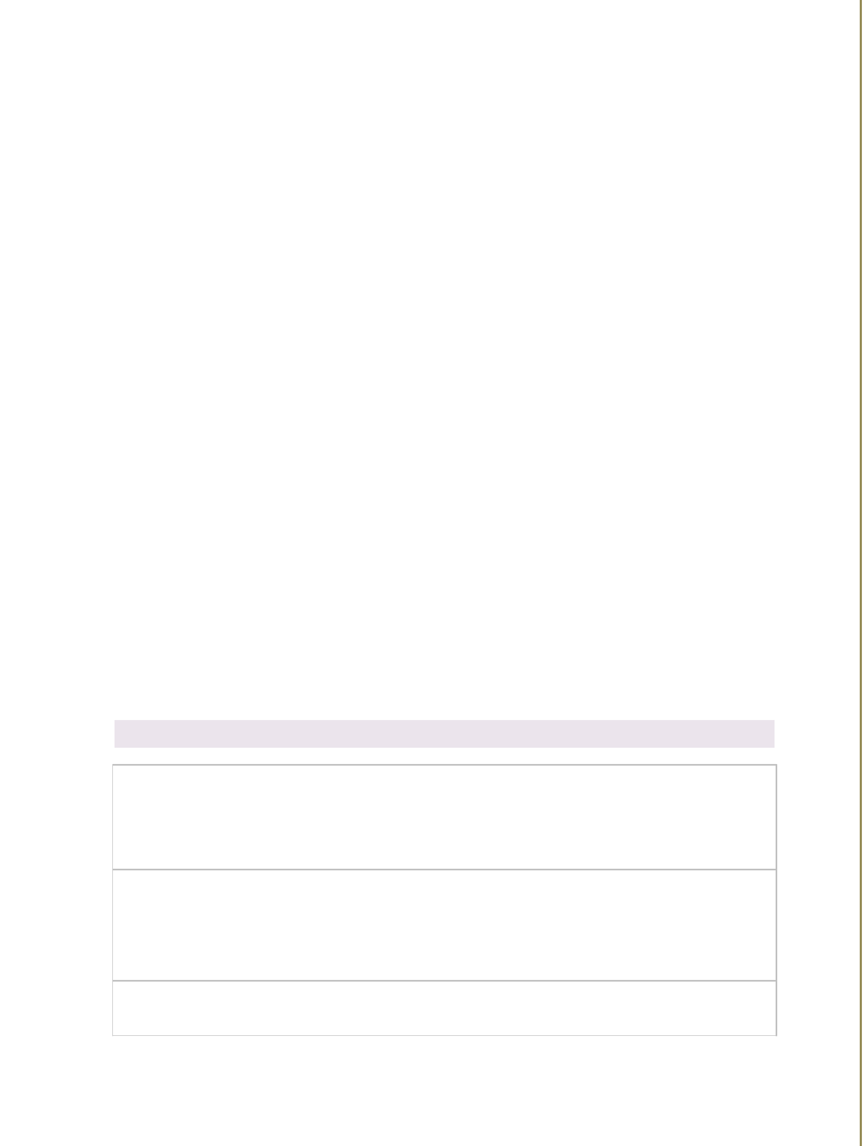

|  |  |
| --- | --- |
| Used technologies: | HTML, CSS, JavaScript, AngularJs |
|  |  |

**Nexttaurus 06/2014 - 05/2016**

|  |  |  |
| --- | --- | --- |
| Client: | Japan |  |
|  |  |  |
|  | A system about sales management website for pharmacies. The tasks I |  |
|  | usually attend to develop new functions, fix bugs and test before |  |
| Project Description: | delivering the final version to the end user. Our customers are Japanese |  |
|  | so the process must be absolutely accurate, so I learned how to work |  |
|  | carefully and I can work in high-pressure environments. |  |
| Responsibilities: | Developer |  |
|  |  |  |
| Programming Languages: | Front-end technology, Java |  |
|  |  |  |
| Tools | Notepad++, Eclipse |  |
|  |  |  |
| Platform, server and | PostgreSQL, Oracle |  |
| database |  |
|  |  |
| Used technologies: | HTML, JavaScript |  |
|  |  |  |

**Sure HCS 12/2012 - 05/2014**

|  |  |  |
| --- | --- | --- |
| Client: | Viet Nam |  |
|  |  |  |
| Project Description: | A web application for human resource management system |  |
|  |  |  |
| Responsibilities: | Developer |  |
|  |  |  |
| Programming Languages: | C#, Asp.net |  |
|  |  |  |
| Tools | Visual Studio |  |
|  |  |  |
| Platform, server and | SQL Server |  |
| database |  |
|  |  |
| Used technologies: | Entity Framework, Sencha touch |  |
|  |  |  |

**Personal Project**

Link: <https://github.com/nguyenthanhhong/NthSpringBoot>

Description: build frame work for ERP project, support basic function

Languages: Java 11

Database: MySQL, PostgreSQL

Technologies: Spring Boot, Gradle, Mybatis, Bootstrap 4, Jquery 3

Link: <https://play.google.com/store/apps/details?id=com.nthgames.taovetroi>

Description: control character to cross obstacles on the road, game play same way with flappy bird

Languages: C#

Framework: Unity

Review: <https://www.facebook.com/yeuchibi/videos/1759078520834098/>

Link: <https://play.google.com/store/apps/details?id=com.nthgames.chibimaker>

Description: girl game style, clothes style of chibi character.

Languages: C#

Framework: Unity

Review: <https://www.youtube.com/watch?v=IfMuIzizR3w>

|  |  |  |  |
| --- | --- | --- | --- |
|  |  | **HISTORY** |  |
|  |  |  |  |
|  | 12/2012 - 05/2014 | LAC VIET Computing Corp |  |
|  |  |  |  |
|  | 06/2014 - 05/2016 | Uniccs Vietnam Co., Ltd. |  |
|  |  |  |  |
|  | 06/2016 - 03/2017 | Dou networks (today is CyberLogitec Vietnam) |  |
|  |  |  |  |
|  | 06/2017 - 05/2018 | System EXE VN Co., Ltd. |  |
|  |  |  |  |
|  | 06/2018 - 02/2020 | CMC Global |  |
|  |  |  |  |