Machine Learning Report:
Sport Predict - Predicting Premier League Wins

Class 2 - Group 5

Team Members:
22BI13321 - Lê Hoài Nam
22BI13323 - Nguyễn Hoàng Phương Nam
22BI13325 - Nguyễn Thành Nam
22BI13327 - Tạ Hiếu Nam
22BI13328 - Trần Thành Nam

Introduction:
The objective of this project is to develop machine learning models to predict the number of wins for football teams in the English Premier League (EPL). The prediction of wins can provide valuable insights into team performance and success in the league. In this report, we will outline the data analysis, model development, evaluation, and insights derived from the project.

Table of Contents:
I. Introduction to the Dataset
II. Data Overview
III. AI-ML Models Used
IV. Model Development
V. Model Evaluation
VI. Results Analysis
VII. Conclusion
VIII. Code Implementation
IX. References

I. Introduction to the Dataset:

1. Purpose:
The dataset aims to analyze and predict outcomes in the English Premier League (EPL). Specifically, it seeks to understand patterns in team performance, goals, and standings to predict future wins.

2. Source:
The dataset used is a combination of custom-built data and publicly available data. It includes match results, player statistics, and season standings.

3. Size:
- The dataset consists of several files:
+ `results.csv`: Match outcomes
+ `stats.csv`: Team statistics
+ `EPL Standings 2000-2022.csv`: Historical standings
+ `with_goalscorers.csv`: Top scorer’s information

4. Data Split:
The data is divided into training, testing, and validation sets. Typically, 80% of the data is used for training, and 20% for testing. If applicable, a further split might be used to create a validation set.

II. Data Overview:

1. Dataset:
The dataset comprises several CSV files containing EPL match results, team statistics, league standings, and top goalscorers from the seasons 2000-2022.

2. Data Processing:
Initial data processing involved loading the datasets using pandas and numpy libraries. This included handling missing values, extracting relevant information, and merging datasets for further analysis.

League data:
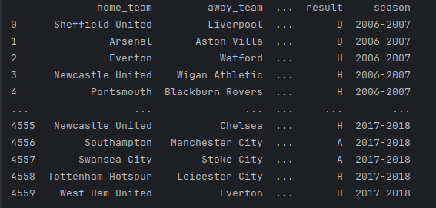

Standing 1 in each season:
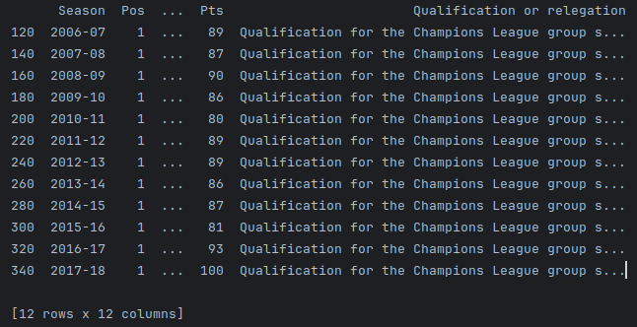

Ranking details(position,team, number of matchs, number of wins,..):
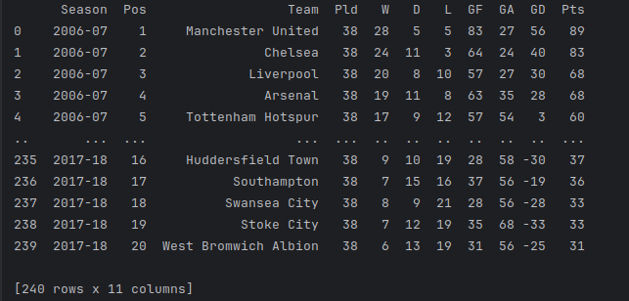

3. Data Analysis:
Descriptive statistics, visualizations, and exploratory data analysis (EDA) were performed to gain insights into team performances, top goalscorers, and league standings.

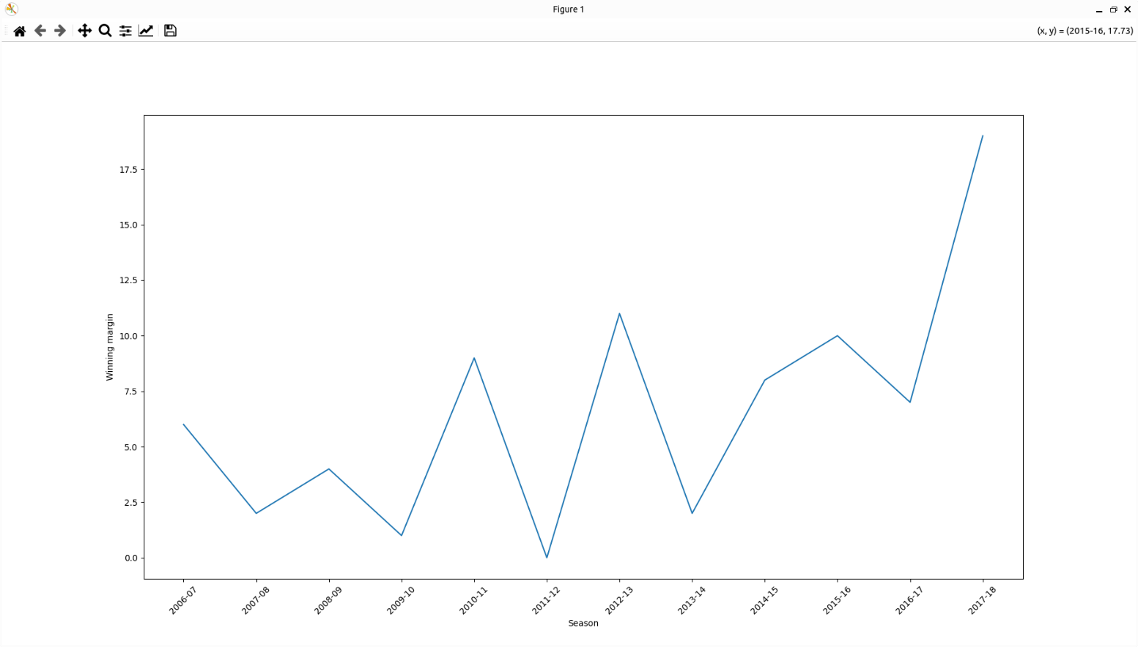
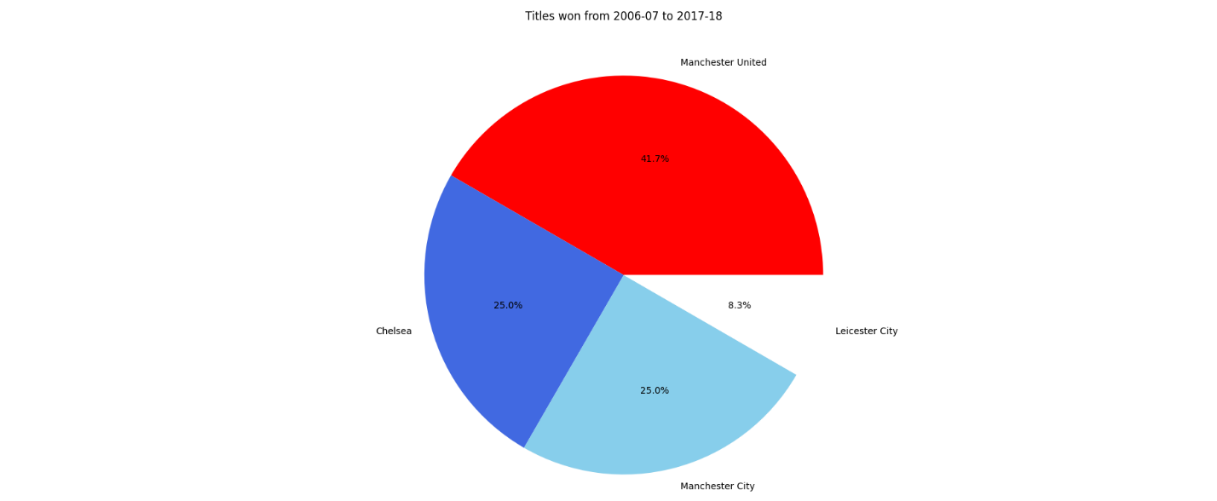

III. AI-ML Models Used:

1. Models:
The primary models used are Linear Regression, Logistic Regression, Random Forest Regressor . These models are built using the `scikit-learn` library.

2. Construction:
- Linear Regression: Used to predict the number of wins based on various team statistics.
- Logistic Regression: Used to classify outcomes, such as whether a team will win a championship or not.
- Random Forest Regressor: Utilized to predict continuous outcomes, such as the expected points scored by a team in a season, based on a combination of input features. This model aggregates the results from multiple decision trees to improve predictive accuracy and control over-fitting.

3. Implementation:
The code to implement these models uses `scikit-learn`, and the models are trained and evaluated using standard procedures from this library. The implementation is custom-written, with methodologies informed by online tutorials and documentation from `scikit-learn` and other reputable sources.

IV. Model Development:

1. Models Used:
Machine learning models were employed: Linear Regression, Logistic Regression and Random Forest Regressor

2. Feature Engineering:
Features such as goals scored, goals conceded, points and based on the number of wins, position were used to predict the number of wins.

3. Data Splitting:
The dataset was split into training and testing sets using the `train_test_split` function from `scikit-learn`.

4. Model Training:
Linear Regression, Logistic Regression, Random Forest Regressor models were trained on the training data using `scikit-learn's` Linear Regression, Logistic Regression, Random Forest Regressor classes.

V. Model Evaluation:

1. Evaluation Metrics:
The performance of the models was assessed using metrics such as Mean Absolute Error (MAE), Mean Squared Error (MSE), Accuracy, Precision, Recall, and F1 Score.

2. Results:
Evaluation results indicated the effectiveness of the models in predicting wins, with linear regression achieving lower error rates compared to and random forest regression.

VI. Results Analysis:

1. Evaluation Metrics:
- Linear Regression: Mean Absolute Error (MAE), Mean Squared Error (MSE), Root Mean Squared Error (RMSE) are used to evaluate performance.
- Logistic Regression: Accuracy, Precision, Recall, and F1 Score are used for classification performance.
- Random Forest Regressor: Mean Absolute Error (MAE), Mean Squared Error (MSE), Root Mean Squared Error (RMSE) are used to evaluate performance.

2. Results:
- Linear Regression: Provides a quantitative prediction of wins. Metrics like MAE, MSE, and RMSE indicate how close the predicted values are to the actual values.
- Logistic Regression: Provides a classification of outcomes. Metrics like accuracy and F1 Score indicate the balance between precision and recall in predictions.
- Random Forest Regressor: Delivers a quantitative prediction for continuous outcomes, such as the expected points scored by a team. Metrics like MAE, MSE, and RMSE help in understanding the accuracy and reliability of these predictions.

3. Comparison and Analysis:
By building and comparing multiple models, we can analyze which model provides better performance for the given task. For example, comparing the RMSE of Linear Regression and Random Forest Regressor helps in understanding which model better predicts quantitative outcomes, while comparing the accuracy of Logistic Regression helps in understanding its classification performance. This comprehensive comparison allows us to determine the most suitable model for our specific data and prediction goals.

Result of logistic and linear regression:
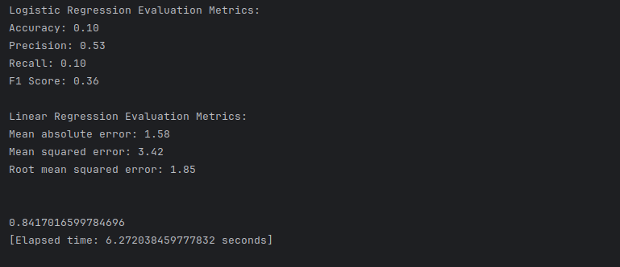
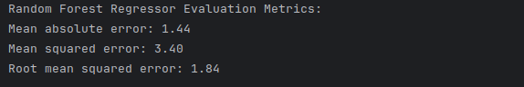

- The data after calculation of the linear function compared to the random function are almost the same, with very little difference:
+ MAE: 1.58 >< 1.44
+ MSE: 3.42 >< 3.40
+ RMSE: 1.85 >< 1.84

About difference between 2 function in chart, we can easily see it with our eyes:

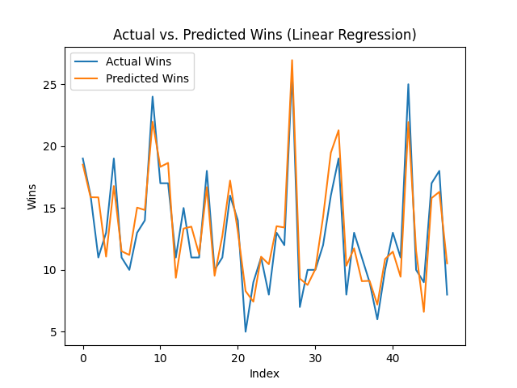 | 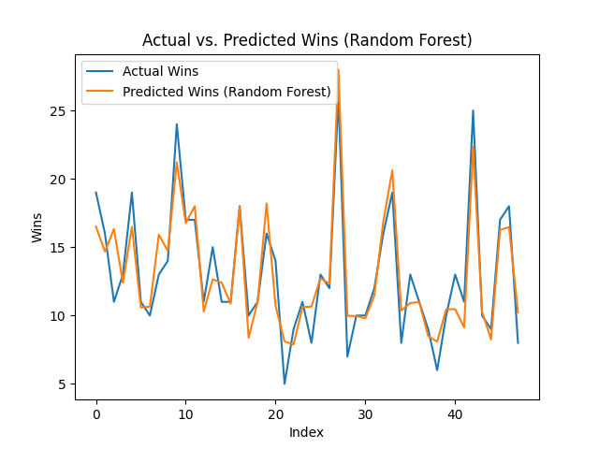
- Scatter plot:
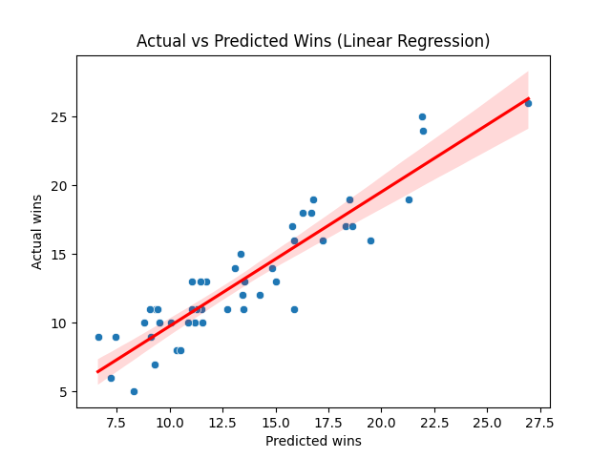
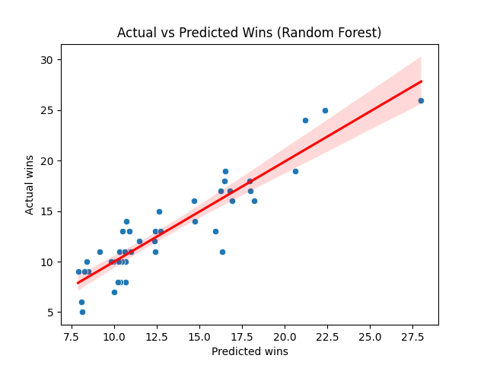

VII. Conclusion:

1. Key Findings:
The machine learning models demonstrated effectiveness in predicting EPL wins, with linear regression offering superior performance.

2. Recommendations:
Further refinement of features and exploration of advanced modeling techniques could enhance predictive accuracy.

3. Future Work:
Future research could focus on incorporating additional data sources and refining the models to predict other performance metrics.

VIII. Code Implementation:
The provided code includes data loading, preprocessing, model training, evaluation, and visualization using Python libraries such as pandas, scikit-learn, seaborn, and matplotlib. Detailed comments within the code explain each step and its relevance to the machine learning project.
Code:
```
import numpy as np
import pandas as pd
from sklearn.linear_model import LogisticRegression, LinearRegression
from sklearn.ensemble import RandomForestRegressor
from sklearn.model_selection import train_test_split
from sklearn.metrics import mean_absolute_error, mean_squared_error, accuracy_score, precision_score, recall_score, f1_score
from sklearn.impute import SimpleImputer
import seaborn as sns
import time
import matplotlib.pyplot as plt

start_time = time.time()

# Custom assert functions
def assert_is_not_none(obj):
assert obj is not None, "Object is None"

def assert_equal(a, b):
assert a == b, f"{a} != {b}"

# Load data
league_data = pd.read_csv("data/results.csv")
stats = pd.read_csv('data/stats.csv')
standings = pd.read_csv('data/EPL Standings 2000-2022.csv')
with_goalscorers = pd.read_csv('data/with_goalscorers.csv')

# Assertions
assert_is_not_none(league_data)
assert_is_not_none(stats)
assert_is_not_none(standings)
assert_is_not_none(with_goalscorers)

# Export league_data to Excel
league_data.to_excel("league_data.xlsx", index=False)
print(league_data)

# Check data integrity
expected_columns = ['home_team', 'away_team', 'home_goals', 'away_goals', 'result', 'season']
expected_shape = (4560, 6)
assert_equal(list(league_data.columns), expected_columns)
assert_equal(league_data.shape, expected_shape)

# Filter standings data
new_standings = standings[standings['Season'].between('2006-07', '2017-18')]
new_standings.to_excel("new_standings.xlsx", index=False)
print(new_standings[new_standings.Pos == 1])

# Clean new_standings
new_standings.reset_index(drop=True, inplace=True)
new_standings = new_standings.drop('Qualification or relegation', axis=1)
print(new_standings)
assert_equal(new_standings.shape, (240, 11))

# Process with_goalscorers
with_goalscorers[['Top Scorer Goals', 'Top Scorer Team']] = with_goalscorers['Top Scorer'].str.extract(r'(\d+)\((.*?)\)$')
with_goalscorers.drop('Top Scorer', axis=1, inplace=True)
with_goalscorers['Top Scorer Goals'] = with_goalscorers['Top Scorer Goals'].astype(int)
with_goalscorers.drop('# Squads', axis=1, inplace=True)
with_goalscorers_sorted = with_goalscorers[with_goalscorers.Season.between('2006-2007', '2017-2018')]
with_goalscorers.to_excel("with_goalscorers.xlsx", index=False)
assert_equal(with_goalscorers_sorted.shape, (12, 5))

# Data Analysis
champions = new_standings[new_standings.Pos == 1]
champions.reset_index(drop=True, inplace=True)
assert_equal(champions.shape, (12, 11))

most_goals_season = stats.loc[stats.goals.idxmax()][['team', 'goals', 'season']]
print(most_goals_season)

non_champions = new_standings[new_standings['Pos'] != 1]
non_champions.reset_index(drop=True, inplace=True)
most_goals_non_champion = non_champions.nlargest(1, 'GF')
print(most_goals_non_champion[['Team', 'GF', 'Season', 'Pts']])

champions_scored_less_1 = champions[champions['GF'] < non_champions['GF'].max()]
var = champions_scored_less_1.shape[0]
champions_scored_more = champions[champions.GF > non_champions.GF.max()]
print(champions_scored_more)

with_goalscorers_sorted.sort_values(by='Season', inplace=True)
with_goalscorers_sorted.reset_index(drop=True, inplace=True)
print(with_goalscorers_sorted)

goalscorer_champions = with_goalscorers_sorted[with_goalscorers_sorted.apply(lambda row: str(row['Champion']) in str(row['Top Scorer Team']), axis=1)]

# Verify the length of the intended slice
slice_length = len(with_goalscorers_sorted[14:26])
if slice_length == 0:
percentage_tg_ch = 0
else:
percentage_tg_ch = len(goalscorer_champions) / slice_length * 100
percentage_formatted = f"{percentage_tg_ch:.1f}%"
print(f"The percentage of the champions have had the single top goalscorer: {percentage_formatted}")

second_placed = new_standings[new_standings.Pos == 2]
second_placed.reset_index(drop=True, inplace=True)
winning_margin = champions.Pts - second_placed.Pts
champions = champions.assign(Winning_margin=winning_margin.values)
print(champions)

# Plots
plt.plot(champions.Season, champions.Winning_margin)
plt.xlabel('Season')
plt.ylabel('Winning margin')
plt.xticks(rotation=45)
plt.show()

times_champion = champions.Team.value_counts()
teams = times_champion.index.to_list()
plt.pie(times_champion, labels=teams, autopct='%1.1f%%', colors=['red', 'royalblue', 'skyblue', 'white'])
plt.title('Titles won from 2006-07 to 2017-18')
plt.show()

# Modeling
y = stats['wins']
X = stats.drop(['wins', 'season', 'team'], axis=1)

# Impute missing values with the mean
imputer = SimpleImputer(strategy='mean')
X_imputed = imputer.fit_transform(X)

# Split the data into training and testing sets
X_train, X_test, y_train, y_test = train_test_split(X_imputed, y, test_size=0.2, random_state=42)

# Linear Regression model
regressor = LinearRegression()
regressor.fit(X_train, y_train)
y_pred = regressor.predict(X_test)

actual_predicted = pd.DataFrame({'Actual wins': y_test.squeeze(), 'Predicted wins': y_pred.squeeze()}).reset_index(drop=True)
print(actual_predicted.head())

# Performance metrics
mae = mean_absolute_error(y_test, y_pred)
mse = mean_squared_error(y_test, y_pred)
rmse = np.sqrt(mse)
print(f'Mean absolute error: {mae:.2f}')
print(f'Mean squared error: {mse:.2f}')
print(f'Root mean squared error: {rmse:.2f}\n\n')

# Logistic Regression model
logistic_regressor = LogisticRegression(max_iter=2000, solver='saga')
logistic_regressor.fit(X_train, y_train)
y_pred_logistic = logistic_regressor.predict(X_test)

# Performance metrics for Logistic Regression
accuracy_logistic = accuracy_score(y_test, y_pred_logistic)
precision_logistic = precision_score(y_test, y_pred_logistic, average='weighted', zero_division=1)
recall_logistic = recall_score(y_test, y_pred_logistic, average='weighted', zero_division=1)
f1_logistic = f1_score(y_test, y_pred_logistic, average='weighted', zero_division=1)
print("Logistic Regression Evaluation Metrics:")
print(f"Accuracy: {accuracy_logistic:.2f}")
print(f"Precision: {precision_logistic:.2f}")
print(f"Recall: {recall_logistic:.2f}")
print(f"F1 Score: {f1_logistic:.2f}")
print()

# Print evaluation metrics for Linear Regression
print("Linear Regression Evaluation Metrics:")
print(f'Mean absolute error: {mae:.2f}')
print(f'Mean squared error: {mse:.2f}')
print(f'Root mean squared error: {rmse:.2f}\n\n')
print(regressor.score(X_test, y_test))

# Elapsed time
end_time = time.time()
elapsed_time = end_time - start_time
print(f"[Elapsed time: {elapsed_time} seconds]\n")

# Create a line plot for actual wins vs predicted wins
plt.plot(actual_predicted.index, actual_predicted['Actual wins'], label='Actual Wins')
plt.plot(actual_predicted.index, actual_predicted['Predicted wins'], label='Predicted Wins')
plt.xlabel('Index')
plt.ylabel('Wins')
plt.title('Actual vs. Predicted Wins (Linear Regression)')
plt.legend()
plt.show()

# Scatter plot for Linear Regression
sns.scatterplot(x='Predicted wins', y='Actual wins', data=actual_predicted)
sns.regplot(x='Predicted wins', y='Actual wins', data=actual_predicted, scatter=False, color='red')
plt.xlabel('Predicted wins')
plt.ylabel('Actual wins')
plt.title('Actual vs Predicted Wins (Linear Regression)')
plt.show()

# Random Forest Regressor model
random_forest_regressor = RandomForestRegressor(random_state=42)
random_forest_regressor.fit(X_train, y_train)
y_pred_rf = random_forest_regressor.predict(X_test)

# Performance metrics for Random Forest Regressor
mae_rf = mean_absolute_error(y_test, y_pred_rf)
mse_rf = mean_squared_error(y_test, y_pred_rf)
rmse_rf = np.sqrt(mse_rf)
print("Random Forest Regressor Evaluation Metrics:")
print(f'Mean absolute error: {mae_rf:.2f}')
print(f'Mean squared error: {mse_rf:.2f}')
print(f'Root mean squared error: {rmse_rf:.2f}\n\n')

# Create a DataFrame with actual and predicted values for Random Forest
actual_predicted_rf = pd.DataFrame({'Actual wins': y_test.squeeze(), 'Predicted wins': y_pred_rf.squeeze()}).reset_index(drop=True)

# Create a line plot for actual wins vs predicted wins (Random Forest)
plt.plot(actual_predicted_rf.index, actual_predicted_rf['Actual wins'], label='Actual Wins')
plt.plot(actual_predicted_rf.index, actual_predicted_rf['Predicted wins'], label='Predicted Wins (Random Forest)')
plt.xlabel('Index')
plt.ylabel('Wins')
plt.title('Actual vs. Predicted Wins (Random Forest)')
plt.legend()
plt.show()

# Scatter plot for Random Forest
sns.scatterplot(x='Predicted wins', y='Actual wins', data=actual_predicted_rf)
sns.regplot(x='Predicted wins', y='Actual wins', data=actual_predicted_rf, scatter=False, color='red')
plt.xlabel('Predicted wins')
plt.ylabel('Actual wins')
plt.title('Actual vs Predicted Wins (Random Forest)')
plt.show()

# Final elapsed time
end_time = time.time()
elapsed_time = end_time - start_time
print(f"[Elapsed time: {elapsed_time} seconds]\n")

# Feature importance
feature_importance = pd.Series(random_forest_regressor.feature_importances_, index=X.columns).sort_values(ascending=False)
print(feature_importance)
```

IX. References:
- Datasets: “https://github.com/RobertRusev/ML-Premier-League-Wins-Predictor/tree/main/data”
- Libraries: `pandas`, `numpy`, `scikit-learn`, `seaborn`, `matplotlib`, `Pylance`.
- Documentation:
+ Official documentation of Python libraries and online tutorials for machine learning practices.
+ Rusev, R. (2023). ML Premier League Wins Predictor. GitHub repository. Retrieved from https://github.com/RobertRusev/ML-Premier-League-Wins-Predictor

