

**online shop**

**Software Design Document**

– Hanoi, May 2021–

**Table of Contents**

I. Overview 7

1. Code Packages/Namespaces 7

2. Database Schema 8

II. Code Designs 9

1. Feedback 9

a. Class Diagram 9

b. Class Specifications 10

c. Sequence Diagram(s) 13

d. Database queries 14

2. Feedback List 15

a. Class Diagram 15

b. Class Specifications 15

c. Sequence Diagram(s) 19

d. Database queries 19

3. Feedback Details 20

a. Class Diagram 20

b. Class Specifications 20

c. Sequence Diagram(s) 24

d. Database queries 24

4. User Register 25

a. Class Diagram 25

b. Class Specifications 25

c. Sequence Diagram(s) 27

d. Database queries 27

5. Order Information 28

a. Class Diagram 28

b. Class Specifications 28

c. Sequence Diagram(s) 31

d. Database queries 31

6. Product Details 32

a. Class Diagram 32

b. Class Specification 32

c. Sequence Diagram 34

d. Database queries 35

7. Cart Details 36

a. Class Diagram 36

b. Class Specifications 36

c. Sequence Diagram(s) 38

d. Database queries 38

8. Cart Completion 39

a. Class Diagram 39

b. Class Specifications 39

9. Change Password 43

a. Class Diagram 43

b. Class Specifications 43

d. Database queries 46

10. User Profile 47

b. Class Specifications 47

c. Sequence Diagram(s) 49

d. Database queries 49

11. Home Page 50

a. Class Diagram 50

b. Class Specifications 50

c. Sequence Diagram(s) 53

d. Database queries 53

12. Product List 54

a. Class Diagram 54

b. Class Specifications 54

c. Sequence Diagram(s) 57

d. Database queries 57

13. User Login 58

a. Class Diagram 58

b. Class Specifications 58

c. Sequence Diagram(s) 60

d. Database queries 60

14. Reset Password 61

a. Class Diagram 61

b. Class Specifications 61

c. Sequence Diagram(s) 63

d. Database queries 63

15. Product List (Marketing) 64

a. Class Diagram 64

b. Class Specifications 64

c. Sequence Diagram(s) 67

d. Database queries 67

16. My Order History 68

a. Class Diagram 68

b. Class Specifications 68

c. Sequence Diagram(s) 69

d. Database queries 69

17. My order details 70

a. Class Diagram 70

b. Class Specifications 70

c. Sequence Diagram(s) 71

d. Database queries 71

18. Notifications 72

a. Class Diagram 72

b. Class Specifications 72

c. Sequence Diagram(s) 73

d. Database queries 73

19. View All Invocies 74

a. Class Diagram 74

b. Class Specifications 74

c. Sequence Diagram(s) 75

d. Database queries 75

20. View Invoice Detail 75

a. Class Diagram 75

b. Class Specifications 75

c. Sequence Diagram(s) 78

d. Database queries 78

21. Compare 80

a. Class Diagram 80

b. Class Specifications 80

c. Sequence Diagram(s) 82

d. Database queries 82

22. CompareFinal 83

a. Class Diagram 83

b. Class Specifications 83

c. Sequence Diagram(s) 84

d. Database queries 84

24. User List 85

a. Class Diagram 85

b. Class Specifications 85

c. Sequence Diagram(s) 87

d. Database queries 87

25. Blog List 87

a. Class Diagram 87

b. Class Specifications 87

c. Sequence Diagram(s) 89

d. Database queries 89

26. Blog Detail 90

a. Class Diagram 90

b. Class Specifications 90

c. Sequence Diagram(s) 91

d. Database queries 91

27. Post List 92

a. Class Diagram 92

b. Class Specifications 92

c. Sequence Diagram(s) 93

d. Database queries 93

28. Post Detail 94

a. Class Diagram 94

b. Class Specifications 94

c. Sequence Diagram(s) 96

d. Database queries 96

III. Database Tables 96

1. User Status 96

2. Users 96

3. Category 97

4. Product Status 97

5. Manufacturer 97

6. Product 97

7. Information 98

8. Cart 98

9. Order_Status 98

10. Orders 98

11. Order_Detail 99

12. Ship 99

13. UserAddress 99

14. ShipInfo 99

15. Notifications 100

16. Feedback 100

17. Feedback_Replies 100

18. Blog 100

# I. Overview

## 1. Code Packages/Namespaces

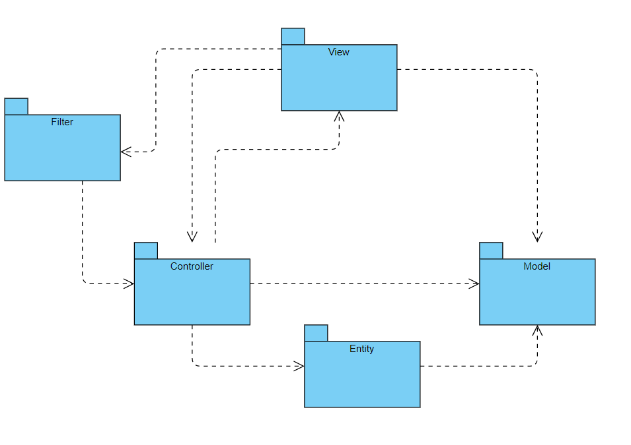

***Package descriptions & package class naming conventions***

|  |  |  |
| --- | --- | --- |
| **No** | **Package** | **Description** |
| *01* | *View (Web Pages)* | *Provide interaction with user, GUI*  *Java Class Naming Convention* |
| *02* | *Controller* | *Control the data flow between View and Model (DAO), Control the logic of the system*  *Java Class Naming Convention* |
| *03* | *DAO (Model)* | *Provide the connection to the Database, Extract data for the system* |
| *04* | *Filter* | *Control the redirection between Pages in View and from View to Controller*  *Java Class Naming Convention* |
| *05* | *Entity* | *Define the logic of data extracted from Database*  *Java Class Naming Convention* |

## 2. Database Schema

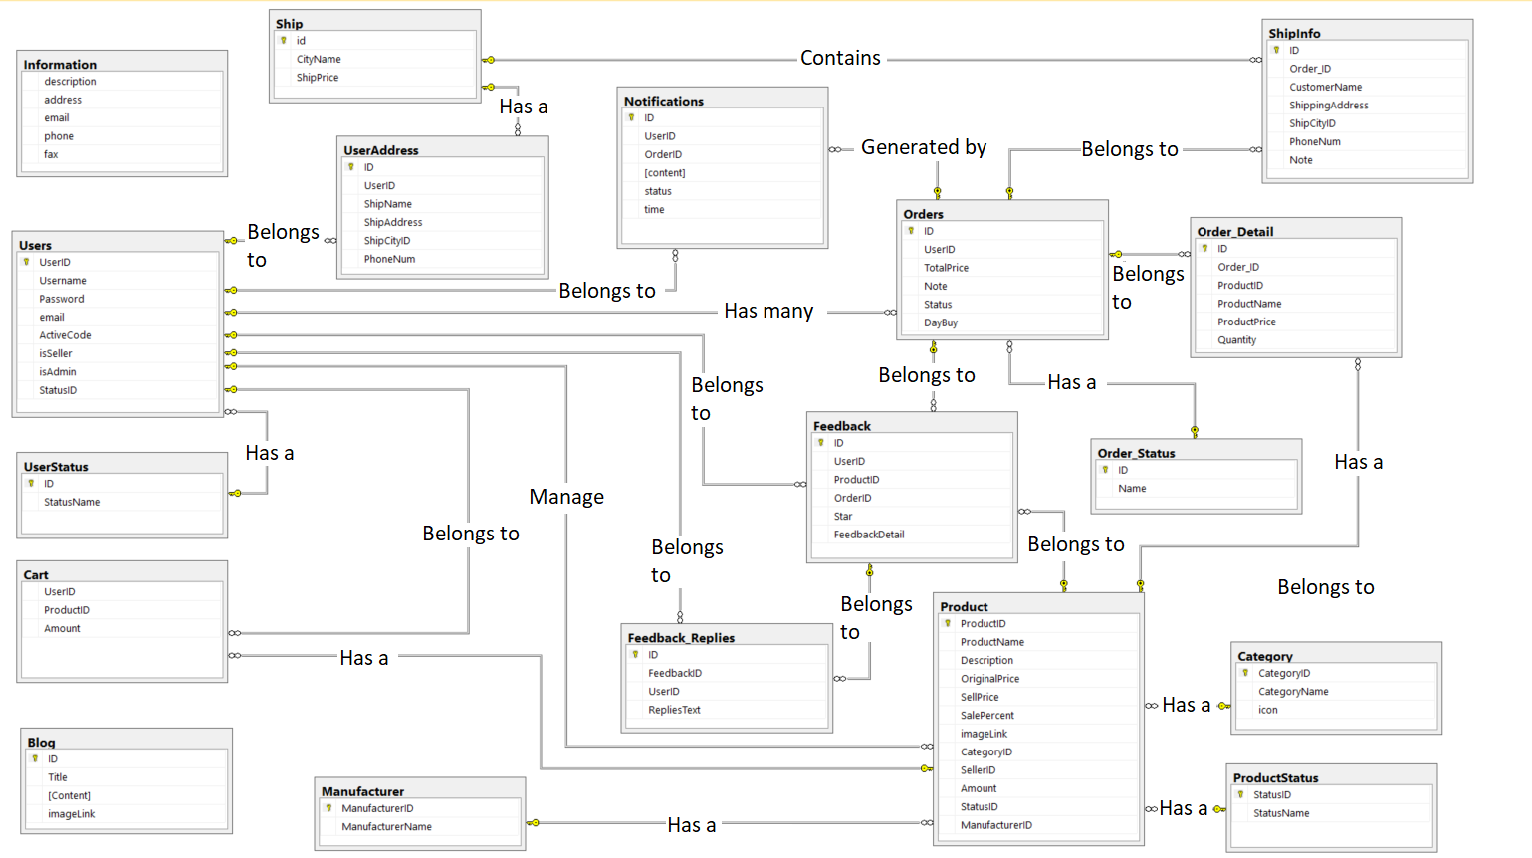

***Table descriptions & package class naming conventions are as below***

| **No** | **Table** | **Description** |
| --- | --- | --- |
| *01* | *User Status* | *Store the status of an Account* |
| *02* | *Users* | *Store the information of all users (including customers, sellers and admin)*  *- Primary keys: UserID*  *- Foreign keys: StatusID* |
| *03* | *Category* | *Store the information of Categories of products*  *- Primary keys: CategoryID* |
| *04* | *Product Status* | *Store the status of a Product (out of stock or not)*  *- Primary keys: StatusID* |
| *05* | *Manufacturer* | *Store the information of the Manufacturer of a Product*  *- Primary keys: ManufacturerID* |
| *06* | *Product* | *Store the information of all products*  *- Primary keys: ProductID*  *- Foreign keys: ManufacturerID, StatusID, SellerID, CategoryID* |
| *07* | *Information* | *Store some information of the shop* |
| *08* | *Cart* | *Store information of the Cart of each Customer*  *- Foreign keys: UserID, ProductID* |
| *09* | *Order_Status* | *Store the status of an Order*  *- Primary keys: ID* |
| *10* | *Orders* | *Store information of all orders*  *- Primary keys: ID*  *- Foreigns keys: UserID* |
| *11* | *Order_Detail* | *Store products information of all orders*  *- Primary keys: ID*  *- Foreigns keys: Order_ID, ProductID* |
| *12* | *Ship* | *Store the ship Price of each City*  *- Primary keys: ID* |
| *13* | *UserAddress* | *Store the Shipping Address of Customers*  *- Primary keys: ID*  *- Foreign keys: UserID, ShipCityID* |
| *14* | *ShipInfo* | *Store the ship info of all orders*  *- Primary keys: ID*  *- Foreign keys: UserID, ShipCityID* |
| *15* | *Notifications* | *Store the notifications of a Customer order*  *- Primary keys: ID*  *- Foreign keys: UserID, OrderID* |
| *16* | *Feedback* | *Store all information of Customer’s feedbacks on a Product*  *- Primary keys: ID*  *- Foreign keys: UserID, ProductID, OrderID* |
| *17* | *Feedback*  *_Replies* | *Store all replies of each feedback*  *- Primary keys: ID*  *- Foreign keys: UserID, FeedbackID* |
| *18* | *Blog* | *Store all blog posts of the system*  *- Primary keys: ID*  *- Foreign keys: SellerID* |

# II. Code Designs

## 1. Feedback

### a. Class Diagram

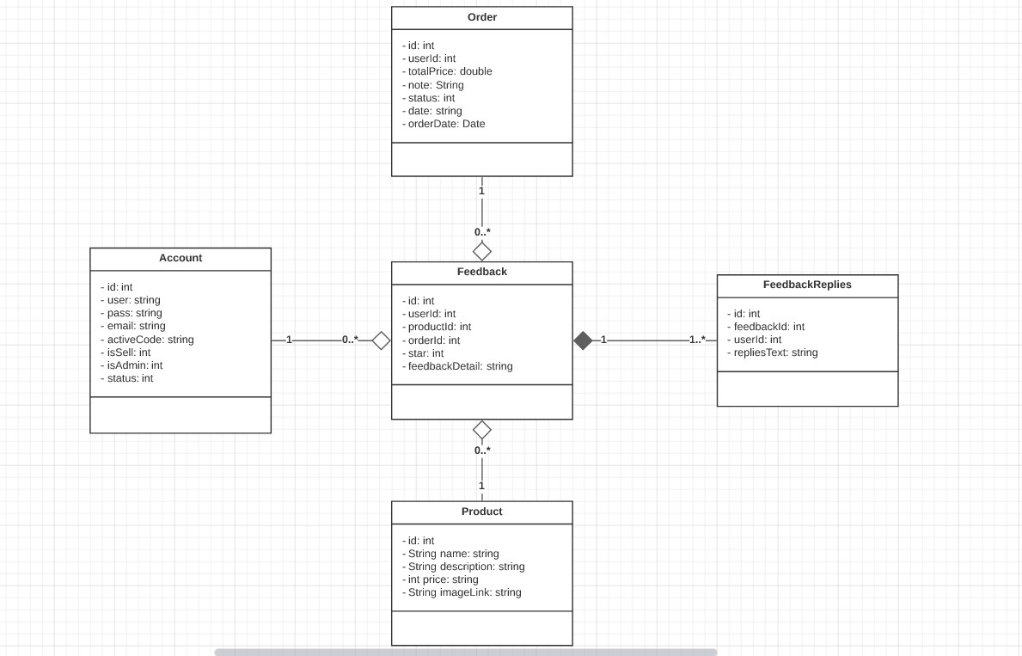

### b. Class Specifications

#### Feedback Class: This class stores information of a Feedback

|  |  |  |
| --- | --- | --- |
| **No** | **Method** | **Description** |
| 1 | getId() | Get the ID of a Feedback object |
| 2 | setId() | Set the ID of a Feedback object |
| 3 | getUserId() | Get the User ID of a Feedback object |
| 4 | setUserId() | Set the User ID of a Feedback object |
| 5 | getProductId() | Get the Product ID of a Feedback object |
| 6 | setProductId() | Set the Product ID of a Feedback object |
| 7 | getStar() | Get the Star of a Feedback object |
| 8 | setStar() | Set the Star of a Feedback object |
| 9 | getFeedbackDetail() | Get the Feedback Detail of a Feedback object |
| 10 | setFeedbackDetail() | Set the Feedback Detail of a Feedback object |
| 11 | getListReplies () | Get the list of Replies of a Feedback object |
| 12 | setListReplies () | Set the list of Replies of a Feedback object |
| 13 | getProduct() | Get the Product of a Feedback object |
| 14 | setProduct() | Set the Product of a Feedback object |
| 15 | getUser() | Get the User of a Feedback object |
| 16 | setUser() | Set the User of a Feedback object |
| 17 | getOrder() | Get the Order of a Feedback object |
| 18 | setOrder() | Set the Order of a Feedback object |
| 19 | toString() | Convert all information of a Feedback object to a string |

#### FeedbackReplies Class: This class stores information of a Feedback Replies

| **No** | **Method** | **Description** |
| --- | --- | --- |
| 1 | getId() | Get the ID of a FeedbackReplies object |
| 2 | setId() | Set the ID of a FeedbackReplies object |
| 3 | getFeedbackId() | Get the Feedback ID of a FeedbackReplies object |
| 4 | setFeedbackId() | Set the Feedback ID of a FeedbackReplies object |
| 5 | getUserId() | Get the User ID of a FeedbackReplies object |
| 6 | setUserId() | Set the User ID of a FeedbackReplies object |
| 7 | getRepliesText() | Get the Replies Text of a FeedbackReplies object |
| 8 | setRepliesText() | Set the Replies Text of a FeedbackReplies object |
| 9 | toString() | Convert all information of a FeedbackReplies object to a string |

#### Order Class: This class stores information of an Order

|  |  |  |
| --- | --- | --- |
| **No** | **Method** | **Description** |
| 1 | getId() | Get the ID of an Order object |
| 2 | setId() | Set the ID of an Order object |
| 3 | getUserId() | Get the User ID of an Order object |
| 4 | setUserId() | Set the User ID of an Order object |
| 5 | getTotalPrice() | Get the Subtotal of an Order object |
| 6 | setTotalPrice () | Set the Subtotal of an Order object |
| 7 | getNote () | Get the Note of an Order object |
| 8 | setNote() | Set the Note of an Order object |
| 9 | getStatus () | Get the Status of an Order object |
| 10 | setStatus() | Set the Status of an Order object |
| 11 | getDate() | Get the Order Date of an Order object |
| 12 | setDate() | Set the Order Date of an Order object |

#### Account Class: This class stores information of a Account

|  |  |  |
| --- | --- | --- |
| **No** | **Method** | **Description** |
| 1 | getId() | Get the ID of an Account |
| 2 | setId() | Set the ID of an Account |
| 3 | getUser() | Get the Username of an Account |
| 4 | setUser() | Set the Username of an Account |
| 5 | getPass() | Get the Password of an Account |
| 6 | setPass() | Set the Password of an Account |
| 7 | getEmail() | Get the Email of an Account |
| 8 | setEmail() | Set the Email of an Account |
| 9 | getIsSell() | Check if an Account has the seller role |
| 10 | setIsSell() | Add/remove seller role to/from an Account |
| 11 | getIsAdmin() | Check if an Account has the admin role |
| 12 | setIsAdmin() | Add/remove admin role to/from an Account |
| 13 | getStatus() | Get the Status of an Account |
| 14 | setStatus() | Set the Status of an Account |
| 15 | toString() | Convert all information of an Account to a string |

#### FeedbackDAO Class: This class performs CRUD actions to Feedback table in the database

|  |  |  |
| --- | --- | --- |
| **No** | **Method** | **Description** |
| 1 | getFeedbacksBy  ProductId() | Get a list of feedback by product id |
| 2 | getFeedbacks() | Get a list all feedback from the database |
| 3 | getFeedbacksById() | Get a feedback by id |
| 4 | getFeedbacks  ByUserId() | Get a list of feedback by user id |
| 5 | getFeedbacksBy  UserIdAndProductId() | Get a list of feedback by user id and product id |
| 6 | getFeedbacksBy  OrderId() | Get a list of feedback by order id |
| 7 | addFeedback() | Add a feedback to database |
| 8 | countTotalFeedback() | Count total number of feedback in the database |

#### FeedbackRepliesDAO Class: This class performs CRUD actions to Feedback_Replies table in the database

|  |  |  |
| --- | --- | --- |
| **No** | **Method** | **Description** |
| 1 | getFeedbacksBy  FeedbackId() | Get a list of replies by feedback id |
| 2 | getFeedbacksBy  UserId () | Get a list of replies by user id |
| 3 | addReplies() | Add a replies to a feedback to database |

#### UserDAO Class: This class performs CRUD actions to Users table in the database

| **No** | **Method** | **Description** |
| --- | --- | --- |
| 1 | Login() | For login an account to the website and return the account information of the account logging in, null if username or password does not exist |
| 2 | signUp() | Use for signup an account to the website |
| 3 | signUpFB() | Used when user try to login via FB, the password will be set automatically and the user will be added to database |
| 4 | getAllAccounts() | Get all account from database and return the list of account from the database |
| 5 | getSellerIdOfAn  Order() | Get the Seller ID of an order |
| 6 | deleteAccount() | Delete an account from the database |
| 7 | editAccount() | Update the information of an account |
| 8 | updatePassword() | Update the password of a user |
| 9 | getAccountByID() | Find an account by id and eturn the found account, null if the account does not exist in the database |
| 10 | getAccountByEmail  () | Find an account by email return the found account, null if the account does not exist in the database |
| 11 | getAccountBy  Username() | Find an account by username and return the found account, null if the account does not exist in the database |
| 12 | updateStatus() | Update status of an account and return true if update successful |
| 13 | countAllAccount() | Return the number of account in the database |
| 14 | checkForget  Password() | Get username and email of a user that forget password |
| 15 | searchAccountIn  Manager() | Get accounts by username |

#### OrderDAO Class: This class performs CRUD actions to Orders table in the database

| **No** | **Method** | **Description** |
| --- | --- | --- |
| 1 | getAllOrder() | Get all the current orders in database and return list order |
| 2 | add() | Adding a new order to database |
| 3 | addOrder() | Adding a new order to database, return the order Id |
| 4 | packaging() | Change the status of an specific order by the order id to packaging |
| 5 | delivering() | Change the status of an specific order by the order id to delivering |
| 6 | canceled() | Change the status of an specific order by the order id to canceled |
| 7 | finished() | Change the status of an specific order by the order id to finished |
| 8 | countOrders() | Count all the number of orders in database and return integer number |
| 9 | getOrderByOrderID() | Get a particular order by its id and return Order |
| 10 | getNewestOrderID() | Get the order id of the newest order |
| 11 | getOrderByUserID() | Get list of orders of a specific user and return List Order |
| 12 | getStatusOfAn  Order() | Get the status of an order by order id |
| 13 | getCompletedOrder  ByUserID() | Get all completed orders of an User by User ID |
| 14 | getRecentOrder() | Get all recent orders |
| 15 | Delete() | Delete a specific order by the order id |

#### OrderDetailDAO Class: This class performs CRUD actions to Order_Detail table in the database

|  |  |  |
| --- | --- | --- |
| **No** | **Method** | **Description** |
| 1 | addManyOrder  Details() | Adding many oder_detail to a specific order by the order ID |
| 2 | getOrderDetailBy  OrderID() | getting detailed orders by the order id return OrderDetail |
| 3 | getOrderDetailBy  OrderIDAnd  ProductId() | Getting an order details object by the order id and product id |
| 4 | deleteAmount() | Remove x number of items from a Product by Product ID |

#### DetailControl Class: This class process request for detail of a product

|  |  |  |
| --- | --- | --- |
| **No** | **Method** | **Description** |
| 1 | processRequest() | Return Detail of Product |
| 2 | doGet() | Handle GET request |
| 3 | doPost() | Handle POST request |
| 4 | getServletInfo() | return a String containing servlet description |

### c. Sequence Diagram(s)

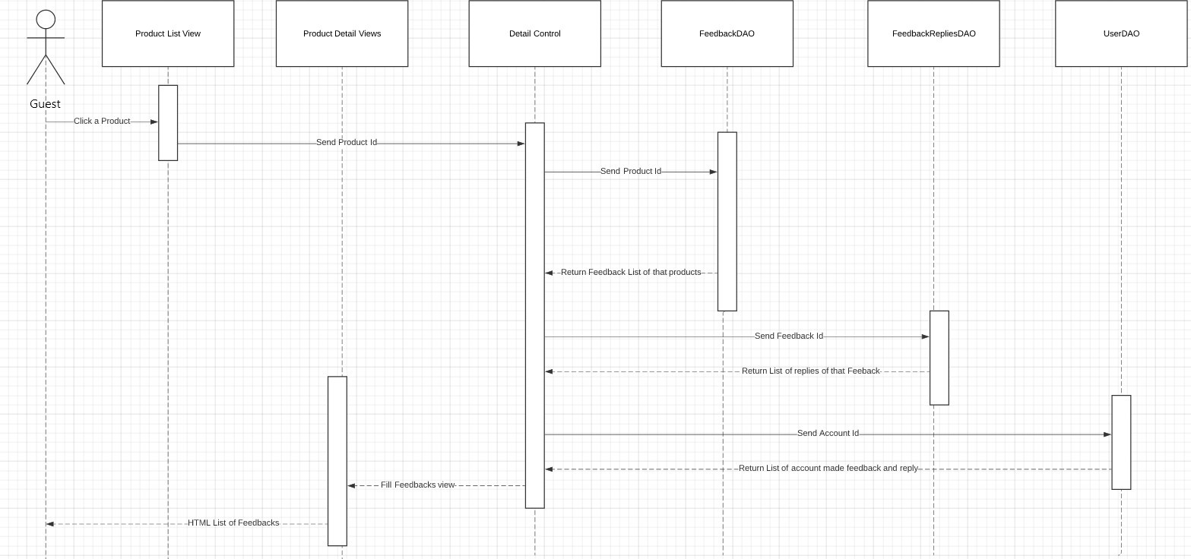

### d. Database queries

SELECT * FROM Feedback WHERE ProductID = ?

SELECT o.ID,o.UserId,o.TotalPrice, o.Note, o.DayBuy, os.Name FROM

Orders o INNER JOIN Order_Status os

ON o.Status = os.ID

WHERE o.ID = ?

SELECT * FROM Feedback_Replies WHERE FeedbackID = ?

SELECT * FROM Users WHERE UserID = ?

## 2. Feedback List

### a. Class Diagram



### b. Class Specifications

#### Feedback Class: This class stores information of a Feedback

|  |  |  |
| --- | --- | --- |
| **No** | **Method** | **Description** |
| 1 | getId() | Get the ID of a Feedback object |
| 2 | setId() | Set the ID of a Feedback object |
| 3 | getUserId() | Get the User ID of a Feedback object |
| 4 | setUserId() | Set the User ID of a Feedback object |
| 5 | getProductId() | Get the Product ID of a Feedback object |
| 6 | setProductId() | Set the Product ID of a Feedback object |
| 7 | getStar() | Get the Star of a Feedback object |
| 8 | setStar() | Set the Star of a Feedback object |
| 9 | getFeedbackDetail() | Get the Feedback Detail of a Feedback object |
| 10 | setFeedbackDetail() | Set the Feedback Detail of a Feedback object |
| 11 | getListReplies () | Get the list of Replies of a Feedback object |
| 12 | setListReplies () | Set the list of Replies of a Feedback object |
| 13 | getProduct() | Get the Product of a Feedback object |
| 14 | setProduct() | Set the Product of a Feedback object |
| 15 | getUser() | Get the User of a Feedback object |
| 16 | setUser() | Set the User of a Feedback object |
| 17 | getOrder() | Get the Order of a Feedback object |
| 18 | setOrder() | Set the Order of a Feedback object |
| 19 | toString() | Convert all information of a Feedback object to a string |

#### Product Class: This class stores information of a Product

| **No** | **Method** | **Description** |
| --- | --- | --- |
| 01 | getID | get ID Products |
| 02 | setID | set ID Products |
| 03 | getName() | get Name Products |
| 04 | setName() | set Name Products |
| 05 | getPrice() | get Price Products |
| 06 | setPrice() | set Price Products |
| 07 | getImageLink() | get ImageLink Products |
| 08 | setImageLink | set ImageLink Products |
| 09 | getDescription() | get Description Products |
| 10 | setDescription() | set Description Products |
| 11 | toString() | Output information |
| 12 | getPriceWithDot() | Function to write the Product's Price in proper form |

#### Account Class: This class stores information of a Account

|  |  |  |
| --- | --- | --- |
| **No** | **Method** | **Description** |
| 1 | getId() | Get the ID of an Account |
| 2 | setId() | Set the ID of an Account |
| 3 | getUser() | Get the Username of an Account |
| 4 | setUser() | Set the Username of an Account |
| 5 | getPass() | Get the Password of an Account |
| 6 | setPass() | Set the Password of an Account |
| 7 | getEmail() | Get the Email of an Account |
| 8 | setEmail() | Set the Email of an Account |
| 9 | getIsSell() | Check if an Account has the seller role |
| 10 | setIsSell() | Add/remove seller role to/from an Account |
| 11 | getIsAdmin() | Check if an Account has the admin role |
| 12 | setIsAdmin() | Add/remove admin role to/from an Account |
| 13 | getStatus() | Get the Status of an Account |
| 14 | setStatus() | Set the Status of an Account |
| 15 | toString() | Convert all information of an Account to a string |

#### FeedbackDAO Class: This class performs CRUD actions to Feedback table in the database

| **No** | **Method** | **Description** |
| --- | --- | --- |
| 1 | getFeedbacksBy  ProductId() | Get a list of feedback by product id |
| 2 | getFeedbacks() | Get a list all feedback from the database |
| 3 | getFeedbacksById() | Get a feedback by id |
| 4 | getFeedbacks  ByUserId() | Get a list of feedback by user id |
| 5 | getFeedbacksBy  UserIdAndProductId() | Get a list of feedback by user id and product id |
| 6 | getFeedbacksBy  OrderId() | Get a list of feedback by order id |
| 7 | addFeedback() | Add a feedback to database |
| 8 | countTotalFeedback() | Count total number of feedback in the database |

#### ProductDAO Class: This class performs CRUD actions to Product table in the database

|  |  |  |
| --- | --- | --- |
| **No** | **Method** | **Description** |
| 1 | getAllProduct() | Get all products from database |
| 2 | getHotProduct() | return Product with the highest sold amount |
| 3 | getFavoriteProduct  () | return get the first and the second product with most sold amount |
| 4 | getProductBy  SellID() | return the list of products of a particular seller |
| 5 | getProductsByCate  Id() | return the list of products of a particular category |
| 6 | Edit() | Edit the information of a particular product, select by product ID |
| 7 | Delete() | Delete a product, select by its ID |
| 8 | Add() | Adding a new product to the database, the ID is no need to be added because it is automatically added |
| 9 | countProduct() | return the total number of products |
| 10 | pagingProduct() | Every 6 products will be displayed in a single page and return list of 6 products |
| 11 | pagingByCategory() | categorizing products and return list of products with same category |
| 12 | pagingManager  Product() | Paging for manage product |
| 13 | countProductBy  Category() | count total product |
| 14 | countProductBy  Seller() | Count the products of a particular seller and return the number of product |
| 15 | getProductByID() | Get data of Product Table searched by UserID |
| 16 | getCateIdOfProductByID() | Get Category ID of a Product by Product ID |
| 17 | getProductDetailBy  ID() | Get Product for Detail |
| 18 | getProductForManager() | Get a particular product and return a product |
| 19 | SearchProductBy  Name() | Search for a particular product by filling its name |
| 20 | searchProductBy  NameAndCateId() | Search for a particular product by filling its name and Category ID |
| 21 | searchProductIn  Manager() | Search for a product in admin/moderator mode by filling its name |
| 22 | top3MostSell() | Select top 3 most sold products and return product |
| 23 | top3LeastSell() | Select top 3 least sold products and return product |
| 24 | countProductBy  Category() | Count the number of products by category |
| 25 | getRelatedProduct() | Get 3 related products to a Category by Category ID |

#### UserDAO Class: This class performs CRUD actions to Users table in the database

| **No** | **Method** | **Description** |
| --- | --- | --- |
| 1 | Login() | For login an account to the website and return the account information of the account logging in, null if username or password does not exist |
| 2 | signUp() | Use for signup an account to the website |
| 3 | signUpFB() | Used when user try to login via FB, the password will be set automatically and the user will be added to database |
| 4 | getAllAccounts() | Get all account from database and return the list of account from the database |
| 5 | getSellerIdOfAn  Order() | Get the Seller ID of an order |
| 6 | deleteAccount() | Delete an account from the database |
| 7 | editAccount() | Update the information of an account |
| 8 | updatePassword() | Update the password of a user |
| 9 | getAccountByID() | Find an account by id and eturn the found account, null if the account does not exist in the database |
| 10 | getAccountByEmail  () | Find an account by email return the found account, null if the account does not exist in the database |
| 11 | getAccountBy  Username() | Find an account by username and return the found account, null if the account does not exist in the database |
| 12 | updateStatus() | Update status of an account and return true if update successful |
| 13 | countAllAccount() | Return the number of account in the database |
| 14 | checkForget  Password() | Get username and email of a user that forget password |
| 15 | searchAccountIn  Manager() | Get accounts by username |

#### ManageFeedbackControl Class: This class process request for list of feedbacks for a seller

|  |  |  |
| --- | --- | --- |
| **No** | **Method** | **Description** |
| 1 | processRequest() | Return List of feedback of products of a seller |
| 2 | doGet() | Handle GET request |
| 3 | doPost() | Handle POST request |
| 4 | getServletInfo() | return a String containing servlet description |

### c. Sequence Diagram(s)

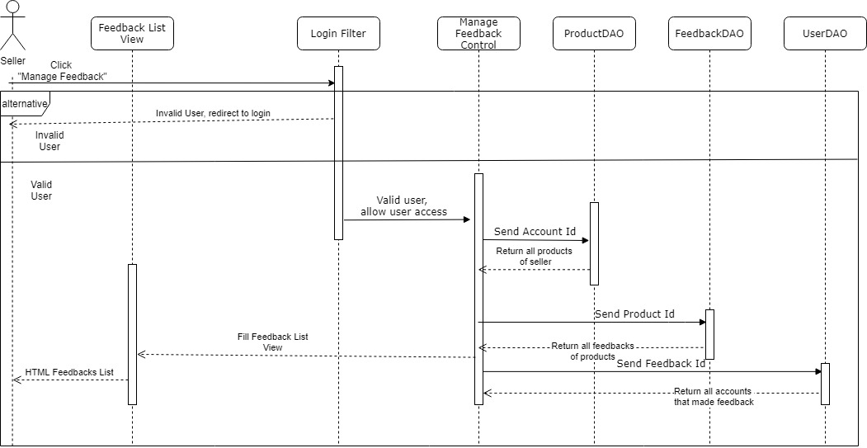

### d. Database queries

SELECT * FROM Product WHERE SellerID = ?

SELECT * FROM Feedback WHERE ProductID = ?

SELECT * FROM Users WHERE UserID = ?

## 3. Feedback Details

### a. Class Diagram



### b. Class Specifications

#### Feedback Class: This class stores information of a Feedback

| **No** | **Method** | **Description** |
| --- | --- | --- |
| 1 | getId() | Get the ID of a Feedback object |
| 2 | setId() | Set the ID of a Feedback object |
| 3 | getUserId() | Get the User ID of a Feedback object |
| 4 | setUserId() | Set the User ID of a Feedback object |
| 5 | getProductId() | Get the Product ID of a Feedback object |
| 6 | setProductId() | Set the Product ID of a Feedback object |
| 7 | getStar() | Get the Star of a Feedback object |
| 8 | setStar() | Set the Star of a Feedback object |
| 9 | getFeedbackDetail() | Get the Feedback Detail of a Feedback object |
| 10 | setFeedbackDetail() | Set the Feedback Detail of a Feedback object |
| 11 | getListReplies () | Get the list of Replies of a Feedback object |
| 12 | setListReplies () | Set the list of Replies of a Feedback object |
| 13 | getProduct() | Get the Product of a Feedback object |
| 14 | setProduct() | Set the Product of a Feedback object |
| 15 | getUser() | Get the User of a Feedback object |
| 16 | setUser() | Set the User of a Feedback object |
| 17 | getOrder() | Get the Order of a Feedback object |
| 18 | setOrder() | Set the Order of a Feedback object |
| 19 | toString() | Convert all information of a Feedback object to a string |

#### Product Class: This class stores information of a Product

| **No** | **Method** | **Description** |
| --- | --- | --- |
| 01 | getID | get ID Products |
| 02 | setID | set ID Products |
| 03 | getName() | get Name Products |
| 04 | setName() | set Name Products |
| 05 | getPrice() | get Price Products |
| 06 | setPrice() | set Price Products |
| 07 | getImageLink() | get ImageLink Products |
| 08 | setImageLink | set ImageLink Products |
| 09 | getDescription() | get Description Products |
| 10 | setDescription() | set Description Products |
| 11 | toString() | Output information |
| 12 | getPriceWithDot() | Function to write the Product's Price in proper form |

#### Account Class: This class stores information of a Account

|  |  |  |
| --- | --- | --- |
| **No** | **Method** | **Description** |
| 1 | getId() | Get the ID of an Account |
| 2 | setId() | Set the ID of an Account |
| 3 | getUser() | Get the Username of an Account |
| 4 | setUser() | Set the Username of an Account |
| 5 | getPass() | Get the Password of an Account |
| 6 | setPass() | Set the Password of an Account |
| 7 | getEmail() | Get the Email of an Account |
| 8 | setEmail() | Set the Email of an Account |
| 9 | getIsSell() | Check if an Account has the seller role |
| 10 | setIsSell() | Add/remove seller role to/from an Account |
| 11 | getIsAdmin() | Check if an Account has the admin role |
| 12 | setIsAdmin() | Add/remove admin role to/from an Account |
| 13 | getStatus() | Get the Status of an Account |
| 14 | setStatus() | Set the Status of an Account |
| 15 | toString() | Convert all information of an Account to a string |

#### FeedbackDAO Class: This class performs CRUD actions to Feedback table in the database

| **No** | **Method** | **Description** |
| --- | --- | --- |
| 1 | getFeedbacksBy  ProductId() | Get a list of feedback by product id |
| 2 | getFeedbacks() | Get a list all feedback from the database |
| 3 | getFeedbacksById() | Get a feedback by id |
| 4 | getFeedbacks  ByUserId() | Get a list of feedback by user id |
| 5 | getFeedbacksBy  UserIdAndProductId() | Get a list of feedback by user id and product id |
| 6 | getFeedbacksBy  OrderId() | Get a list of feedback by order id |
| 7 | addFeedback() | Add a feedback to database |
| 8 | countTotalFeedback() | Count total number of feedback in the database |

#### ProductDAO Class: This class performs CRUD actions to Product table in the database

| **No** | **Method** | **Description** |
| --- | --- | --- |
| 1 | getAllProduct() | Get all products from database |
| 2 | getHotProduct() | return Product with the highest sold amount |
| 3 | getFavoriteProduct  () | return get the first and the second product with most sold amount |
| 4 | getProductBy  SellID() | return the list of products of a particular seller |
| 5 | getProductsByCate  Id() | return the list of products of a particular category |
| 6 | Edit() | Edit the information of a particular product, select by product ID |
| 7 | Delete() | Delete a product, select by its ID |
| 8 | Add() | Adding a new product to the database, the ID is no need to be added because it is automatically added |
| 9 | countProduct() | return the total number of products |
| 10 | pagingProduct() | Every 6 products will be displayed in a single page and return list of 6 products |
| 11 | pagingByCategory() | categorizing products and return list of products with same category |
| 12 | pagingManager  Product() | Paging for manage product |
| 13 | countProductBy  Category() | count total product |
| 14 | countProductBy  Seller() | Count the products of a particular seller and return the number of product |
| 15 | getProductByID() | Get data of Product Table searched by UserID |
| 16 | getCateIdOfProductByID() | Get Category ID of a Product by Product ID |
| 17 | getProductDetailBy  ID() | Get Product for Detail |
| 18 | getProductForManager() | Get a particular product and return a product |
| 19 | SearchProductBy  Name() | Search for a particular product by filling its name |
| 20 | searchProductBy  NameAndCateId() | Search for a particular product by filling its name and Category ID |
| 21 | searchProductIn  Manager() | Search for a product in admin/moderator mode by filling its name |
| 22 | top3MostSell() | Select top 3 most sold products and return product |
| 23 | top3LeastSell() | Select top 3 least sold products and return product |
| 24 | countProductBy  Category() | Count the number of products by category |
| 25 | getRelatedProduct() | Get 3 related products to a Category by Category ID |

#### UserDAO Class: This class performs CRUD actions to Users table in the database

| **No** | **Method** | **Description** |
| --- | --- | --- |
| 1 | Login() | For login an account to the website and return the account information of the account logging in, null if username or password does not exist |
| 2 | signUp() | Use for signup an account to the website |
| 3 | signUpFB() | Used when user try to login via FB, the password will be set automatically and the user will be added to database |
| 4 | getAllAccounts() | Get all account from database and return the list of account from the database |
| 5 | getSellerIdOfAn  Order() | Get the Seller ID of an order |
| 6 | deleteAccount() | Delete an account from the database |
| 7 | editAccount() | Update the information of an account |
| 8 | updatePassword() | Update the password of a user |
| 9 | getAccountByID() | Find an account by id and eturn the found account, null if the account does not exist in the database |
| 10 | getAccountByEmail  () | Find an account by email return the found account, null if the account does not exist in the database |
| 11 | getAccountBy  Username() | Find an account by username and return the found account, null if the account does not exist in the database |
| 12 | updateStatus() | Update status of an account and return true if update successful |
| 13 | countAllAccount() | Return the number of account in the database |
| 14 | checkForget  Password() | Get username and email of a user that forget password |
| 15 | searchAccountInManager() | Get accounts by username |

#### ViewFeedbackDetail Class: : This class process request for detail of a feedback by seller

|  |  |  |
| --- | --- | --- |
| **No** | **Method** | **Description** |
| 1 | processRequest() | Return Detail of feedback |
| 2 | doGet() | Handle GET request |
| 3 | doPost() | Handle POST request |
| 4 | getServletInfo() | return a String containing servlet description |

### c. Sequence Diagram(s)

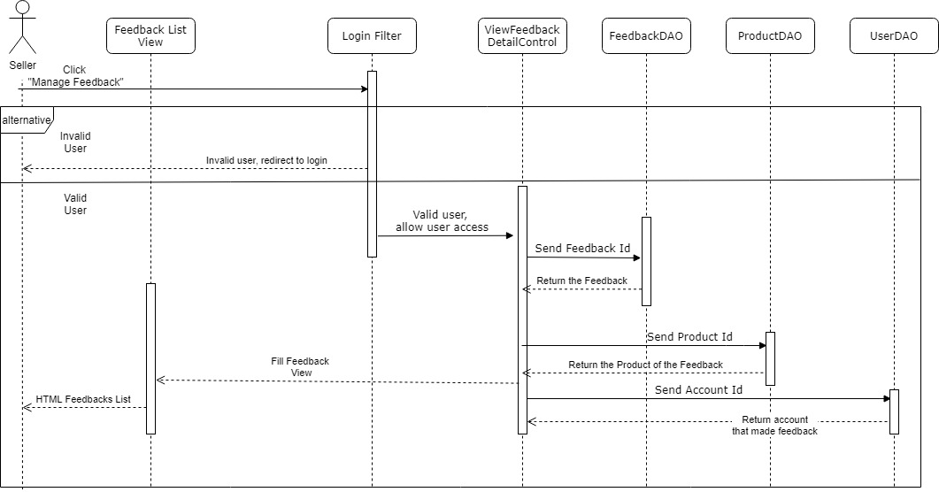

### d. Database queries

SELECT * FROM Feedback WHERE ID = ?

SELECT * FROM Product WHERE ProductID = ?

SELECT * FROM Users WHERE UserID = ?

## 4. User Register

### a. Class Diagram

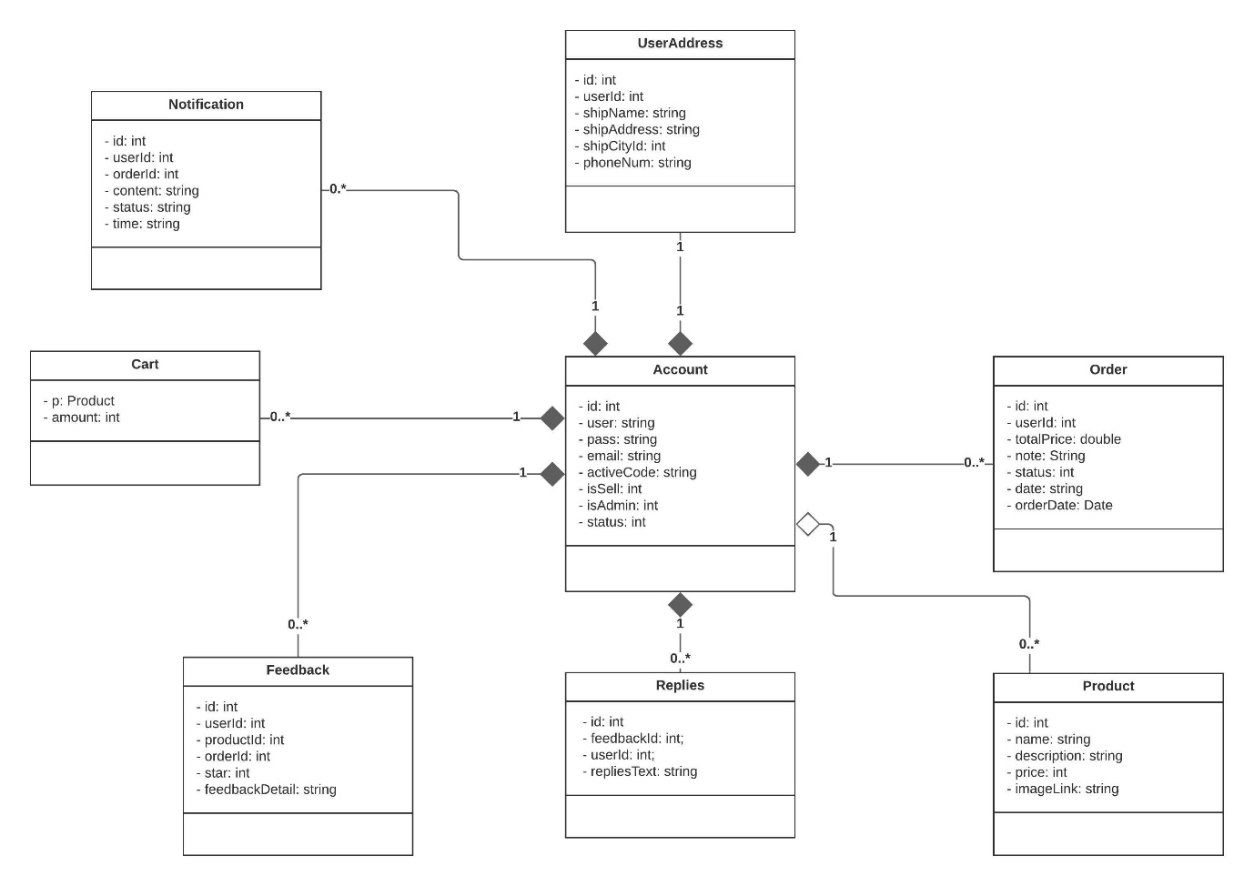

### b. Class Specifications

#### Account Class: This class stores information of a Account

| **No** | **Method** | **Description** |
| --- | --- | --- |
| 1 | getId() | Get the ID of an Account |
| 2 | setId() | Set the ID of an Account |
| 3 | getUser() | Get the Username of an Account |
| 4 | setUser() | Set the Username of an Account |
| 5 | getPass() | Get the Password of an Account |
| 6 | setPass() | Set the Password of an Account |
| 7 | getEmail() | Get the Email of an Account |
| 8 | setEmail() | Set the Email of an Account |
| 9 | getIsSell() | Check if an Account has the seller role |
| 10 | setIsSell() | Add/remove seller role to/from an Account |
| 11 | getIsAdmin() | Check if an Account has the admin role |
| 12 | setIsAdmin() | Add/remove admin role to/from an Account |
| 13 | getStatus() | Get the Status of an Account |
| 14 | setStatus() | Set the Status of an Account |
| 15 | toString() | Convert all information of an Account to a string |

#### UserDAO Class: This class performs CRUD actions to Users table in the database

| **No** | **Method** | **Description** |
| --- | --- | --- |
| 1 | Login() | For login an account to the website and return the account information of the account logging in, null if username or password does not exist |
| 2 | signUp() | Use for signup an account to the website |
| 3 | signUpFB() | Used when user try to login via FB, the password will be set automatically and the user will be added to database |
| 4 | getAllAccounts() | Get all account from database and return the list of account from the database |
| 5 | getSellerIdOfAn  Order() | Get the Seller ID of an order |
| 6 | deleteAccount() | Delete an account from the database |
| 7 | editAccount() | Update the information of an account |
| 8 | updatePassword() | Update the password of a user |
| 9 | getAccountByID() | Find an account by id and eturn the found account, null if the account does not exist in the database |
| 10 | getAccountByEmail  () | Find an account by email return the found account, null if the account does not exist in the database |
| 11 | getAccountBy  Username() | Find an account by username and return the found account, null if the account does not exist in the database |
| 12 | updateStatus() | Update status of an account and return true if update successful |
| 13 | countAllAccount() | Return the number of account in the database |
| 14 | checkForget  Password() | Get username and email of a user that forget password |
| 15 | searchAccountInManager() | Get accounts by username |

#### SendEmail Class: This class performs send email action

|  |  |  |
| --- | --- | --- |
| **No** | **Method** | **Description** |
| 1 | sentEmail() | Send an email |

#### SignUpControl Class: This class process request for register

|  |  |  |
| --- | --- | --- |
| **No** | **Method** | **Description** |
| 1 | processRequest() | Get information from user register form, register user account, redirect to code page |
| 2 | doGet() | Handle GET request |
| 3 | doPost() | Handle POST request |
| 4 | getServletInfo() | return a String containing servlet description |

#### ConfirmEmailControl Class: This class process request for active email

|  |  |  |
| --- | --- | --- |
| **No** | **Method** | **Description** |
| 1 | processRequest() | Get inputted code from user, active email |
| 2 | doGet() | Handle GET request |
| 3 | doPost() | Handle POST request |
| 4 | getServletInfo() | return a String containing servlet description |

### c. Sequence Diagram(s)

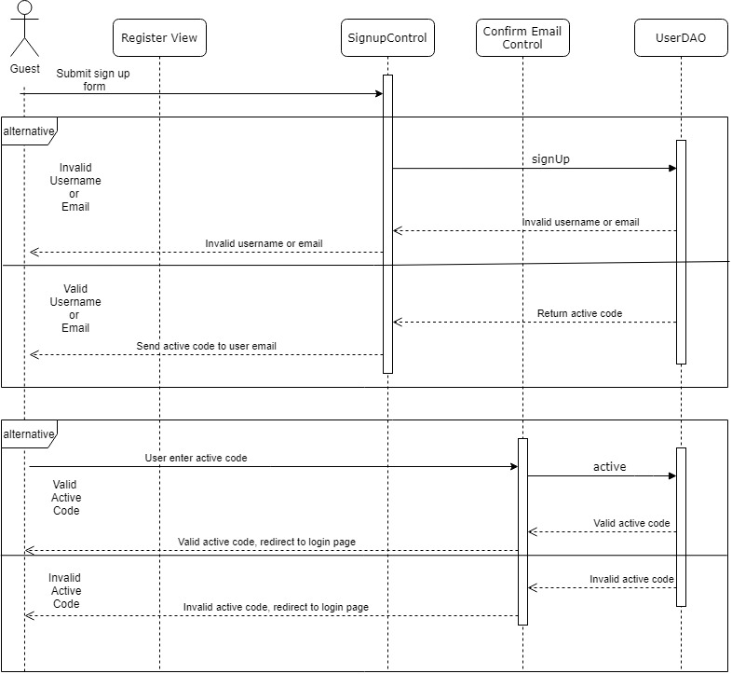

### d. Database queries

SELECT * FROM Users WHERE email = ?

SELECT * FROM Users WHERE Username = ?

INSERT INTO Users VALUES (?, ?, ?, ?, ?, ?,?)

## 5. Order Information

### a. Class Diagram

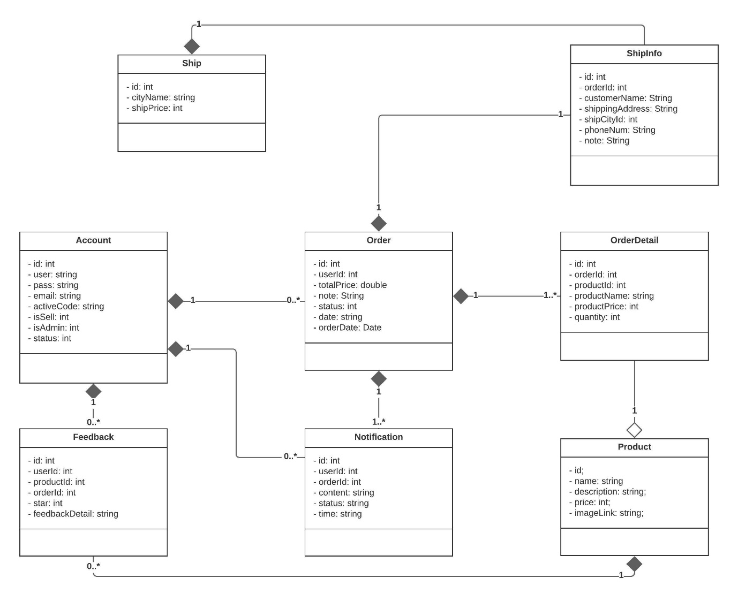

### b. Class Specifications

#### Feedback Class: This class stores information of a Feedback

| **No** | **Method** | **Description** |
| --- | --- | --- |
| 1 | getId() | Get the ID of a Feedback object |
| 2 | setId() | Set the ID of a Feedback object |
| 3 | getUserId() | Get the User ID of a Feedback object |
| 4 | setUserId() | Set the User ID of a Feedback object |
| 5 | getProductId() | Get the Product ID of a Feedback object |
| 6 | setProductId() | Set the Product ID of a Feedback object |
| 7 | getStar() | Get the Star of a Feedback object |
| 8 | setStar() | Set the Star of a Feedback object |
| 9 | getFeedbackDetail() | Get the Feedback Detail of a Feedback object |
| 10 | setFeedbackDetail() | Set the Feedback Detail of a Feedback object |
| 11 | getListReplies () | Get the list of Replies of a Feedback object |
| 12 | setListReplies () | Set the list of Replies of a Feedback object |
| 13 | getProduct() | Get the Product of a Feedback object |
| 14 | setProduct() | Set the Product of a Feedback object |
| 15 | getUser() | Get the User of a Feedback object |
| 16 | setUser() | Set the User of a Feedback object |
| 17 | getOrder() | Get the Order of a Feedback object |
| 18 | setOrder() | Set the Order of a Feedback object |
| 19 | toString() | Convert all information of a Feedback object to a string |

#### Order Class: This class stores information of an Order

|  |  |  |
| --- | --- | --- |
| **No** | **Method** | **Description** |
| 1 | getId() | Get the ID of an Order object |
| 2 | setId() | Set the ID of an Order object |
| 3 | getUserId() | Get the User ID of an Order object |
| 4 | setUserId() | Set the User ID of an Order object |
| 5 | getTotalPrice() | Get the Subtotal of an Order object |
| 6 | setTotalPrice () | Set the Subtotal of an Order object |
| 7 | getNote () | Get the Note of an Order object |
| 8 | setNote() | Set the Note of an Order object |
| 9 | getStatus () | Get the Status of an Order object |
| 10 | setStatus() | Set the Status of an Order object |
| 11 | getDate() | Get the Order Date of an Order object |
| 12 | setDate() | Set the Order Date of an Order object |

#### OrderDetailWithImage Class: This class stores information of an Order Detail with Image

| **No** | **Method** | **Description** |
| --- | --- | --- |
| 1 | getId() | Get the ID of an order detail object |
| 2 | setId() | Set the ID of an order detail object |
| 3 | getOrderId() | Get the Order ID of an order detail object |
| 4 | setOrderId() | Set the Order ID of an order detail object |
| 5 | getProductId() | Get the Product ID of an order detail object |
| 6 | setProductId() | Set the Product ID of an order detail object |
| 7 | getProductName() | Get the Product Name of an order detail object |
| 8 | setProductName() | Set the Product Name of an order detail object |
| 9 | getProductPrice() | Get the Product Price of an order detail object |
| 10 | setProductPrice() | Set the Product Price of an order detail object |
| 11 | getImageLink() | Get the Image Link of an order detail object |
| 12 | setImageLink() | Set the Image Link of an order detail object |
| 13 | toString() | Convert all information of an order detail object to a string |

#### FeedbackDAO Class: This class performs CRUD actions to Feedback table in the database

| **No** | **Method** | **Description** |
| --- | --- | --- |
| 1 | getFeedbacksBy  ProductId() | Get a list of feedback by product id |
| 2 | getFeedbacks() | Get a list all feedback from the database |
| 3 | getFeedbacksById() | Get a feedback by id |
| 4 | getFeedbacks  ByUserId() | Get a list of feedback by user id |
| 5 | getFeedbacksBy  UserIdAndProductId() | Get a list of feedback by user id and product id |
| 6 | getFeedbacksByOrderId() | Get a list of feedback by order id |
| 7 | addFeedback() | Add a feedback to database |
| 8 | countTotalFeedback() | Count total number of feedback in the database |

#### OrderDAO Class: This class performs CRUD actions to Order table in the database

| **No** | **Method** | **Description** |
| --- | --- | --- |
| 1 | getAllOrder() | Get all the current orders in database and return list order |
| 2 | add() | Adding a new order to database |
| 3 | addOrder() | Adding a new order to database, return the order Id |
| 4 | packaging() | Change the status of an specific order by the order id to packaging |
| 5 | delivering() | Change the status of an specific order by the order id to delivering |
| 6 | canceled() | Change the status of an specific order by the order id to canceled |
| 7 | finished() | Change the status of an specific order by the order id to finished |
| 8 | countOrders() | Count all the number of orders in database and return integer number |
| 9 | getOrderByOrderID() | Get a particular order by its id and return Order |
| 10 | getNewestOrderID() | Get the order id of the newest order |
| 11 | getOrderByUserID() | Get list of orders of a specific user and return List Order |
| 12 | getStatusOfAn  Order() | Get the status of an order by order id |
| 13 | getCompletedOrder  ByUserID() | Get all completed orders of an User by User ID |
| 14 | getRecentOrder() | Get all recent orders |
| 15 | Delete() | Delete a specific order by the order id |

#### OrderDetailWithImageDAO Class: This class performs CRUD actions to Order_Detail table in the database

|  |  |  |
| --- | --- | --- |
| **No** | **Method** | **Description** |
| 1 | getOrderDetail() | Get all order details with image by Order ID |

#### ViewOrderDetailClass: This class process request for detail of an order by customer

|  |  |  |
| --- | --- | --- |
| **No** | **Method** | **Description** |
| 1 | processRequest() | Return Detail of an order |
| 2 | doGet() | Handle GET request |
| 3 | doPost() | Handle POST request |
| 4 | getServletInfo() | return a String containing servlet description |

### c. Sequence Diagram(s)

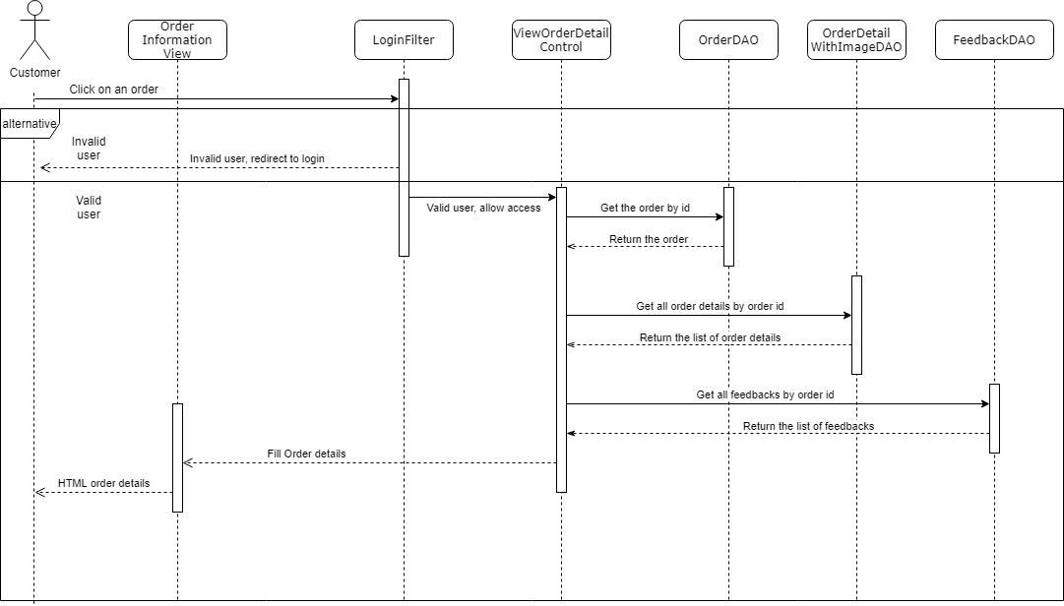

### d. Database queries

SELECT od.id, od.order_id, od.productId, od.productName, od.quantity, od.productPrice, p.imageLink FROM Order_Detail od INNER JOIN Product p

ON od.ProductID = p.ProductID

WHERE od.Order_ID = ?

SELECT o.ID,o.UserId,o.TotalPrice, o.Note, o.DayBuy, os.Name

FROM Orders o INNER JOIN Order_Status os

ON o.Status = os.ID

WHERE o.ID = ?

SELECT * FROM Feedback WHERE OrderID = ?

## 6. Product Details

### a. Class Diagram

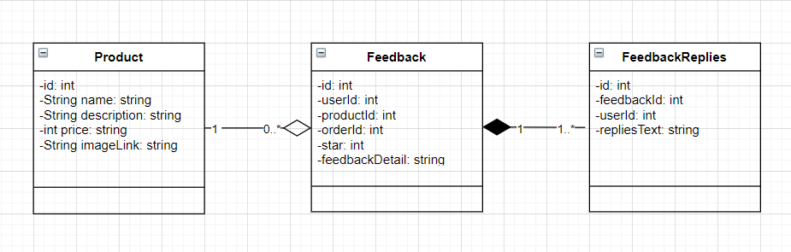

### b. Class Specification

#### Product Class: This class stores information of a Product

| **No** | **Method** | **Description** |
| --- | --- | --- |
| 01 | getID | get ID Products |
| 02 | setID | set ID Products |
| 03 | getName() | get Name Products |
| 04 | setName() | set Name Products |
| 05 | getPrice() | get Price Products |
| 06 | setPrice() | set Price Products |
| 07 | getImageLink() | get ImageLink Products |
| 08 | setImageLink | set ImageLink Products |
| 09 | getDescription() | get Description Products |
| 10 | setDescription() | set Description Products |
| 11 | toString() | Output information |
| 12 | getPriceWithDot() | Function to write the Product's Price in proper form |

#### Feedback Class: This class stores information of a Feedback

| **No** | **Method** | **Description** |
| --- | --- | --- |
| 1 | getId() | Get the ID of a Feedback object |
| 2 | setId() | Set the ID of a Feedback object |
| 3 | getUserId() | Get the User ID of a Feedback object |
| 4 | setUserId() | Set the User ID of a Feedback object |
| 5 | getProductId() | Get the Subtotal of a Feedback object |
| 6 | setProductId() | Set the Subtotal of a Feedback object |
| 7 | getStar() | Get the Star of a Feedback object |
| 8 | setStar() | Set the Star of a Feedback object |
| 9 | getFeedbackDetail() | Get the Feedback Detail of a Feedback object |
| 10 | setFeedbackDetail() | Set the Feedback Detail of a Feedback object |
| 11 | getListReplies () | Get the list of Replies of a Feedback object |
| 12 | setListReplies () | Set the list of Replies of a Feedback object |
| 13 | toString() | Convert all information of a Feedback object to a string |

#### FeedbackReplies Class: This class stores information of a Feedback Replies

|  |  |  |
| --- | --- | --- |
| **No** | **Method** | **Description** |
| 1 | getId() | Get the ID of a FeedbackReplies object |
| 2 | setId() | Set the ID of a FeedbackReplies object |
| 3 | getFeedbackId () | Get the Feedback ID of a FeedbackReplies object |
| 4 | setFeedbackId () | Set the Feedback ID of a FeedbackReplies object |
| 5 | getUserId () | Get the User ID of a FeedbackReplies object |
| 6 | setUserId () | Set the User ID of a FeedbackReplies object |
| 7 | getRepliesText() | Get the Replies Text of a FeedbackReplies object |
| 8 | setRepliesText() | Set the Replies Text of a FeedbackReplies object |
| 9 | toString () | Convert all information of a FeedbackReplies object to a string |

#### ProductDAO Class: This class performs CRUD actions to Product table in the database

| **No** | **Method** | **Description** |
| --- | --- | --- |
| 1 | getAllProduct() | … |
| 2 | getHotProduct() | return Product with the highest sold amount |
| 3 | getFavoriteProduct  () | return get the first and the second product with most sold amount |
| 4 | getProductBy  SellID() | return the list of products of a particular seller |
| 5 | Edit() | Edit the information of a particular product, select by product ID |
| 6 | Delete() | Delete a product, select by its ID |
| 7 | Add() | Adding a new product to the database, the ID is no need to be added because it is automatically added |
| 8 | countProduct() | return the total number of products |
| 9 | pagingProduct() | Every 6 products will be displayed in a single page and return list of 6 products |
| 10 | pagingByCategory() | categorizing products and return list of products with same category |
| 11 | pagingManager  Product() | … |
| 12 | countProductBy  Category() | count total product |
| 13 | countProductBy  Seller() | Count the products of a particular seller and return the number of product |
| 14 | getProductByID() | Get data of Product Table searched by UserID |
| 15 | getProductDetailBy  ID() | Get Product for Detail |
| 16 | getProductForManager() | Get a particular product and return a product |
| 17 | SearchProductBy  Name() | Search for a particular product by filling its name |
| 18 | searchProductIn  Manager() | Search for a product in admin/moderator mode by filling its name |
| 19 | top3MostSell() | Select top 3 most sold products and return product |
| 20 | top3LeastSell() | Select top 3 least sold products and return product |

#### FeedbackDAO Class: This class performs CRUD actions to Feedback table in the database

|  |  |  |
| --- | --- | --- |
| **No** | **Method** | **Description** |
| 1 | getFeedbacksBy  ProductId() | Get a list of feedback by product id |
| 2 | getFeedbacksBy  UserId() | Get a list of feedback by user id |

#### OrderDAO Class: This class performs CRUD actions to Order table in the database

|  |  |  |
| --- | --- | --- |
| **No** | **Method** | **Description** |
| 1 | getAllOrder() | Get all the current orders in database and return list order |
| 2 | add() | Adding a new order to database |
| 3 | addOrder() | adding a new order to database, return the order Id |
| 4 | packaging() | change the status of an specific order by the order id |
| 5 | delivering() | … |
| 6 | cancled() | … |
| 7 | countOrders() | Count all the number of orders in database and return integer number |
| 8 | getOrderByOrderID() | get a particular order by its id and return Order |
| 9 | getNewestOrderID() | … |
| 10 | getOrderByUserID() | get list of orders of a specific user and return List Order |
| 11 | Delete() | delete a specific order by the order id |

#### DetailControl Class: This class process request for detail of a product

|  |  |  |
| --- | --- | --- |
| **No** | **Method** | **Description** |
| 1 | processRequest() | Return Detail of Product |
| 2 | doGet() | … |
| 3 | doPost() | … |
| 4 | getServletInfo() | return a String containing servlet description |

### c. Sequence Diagram

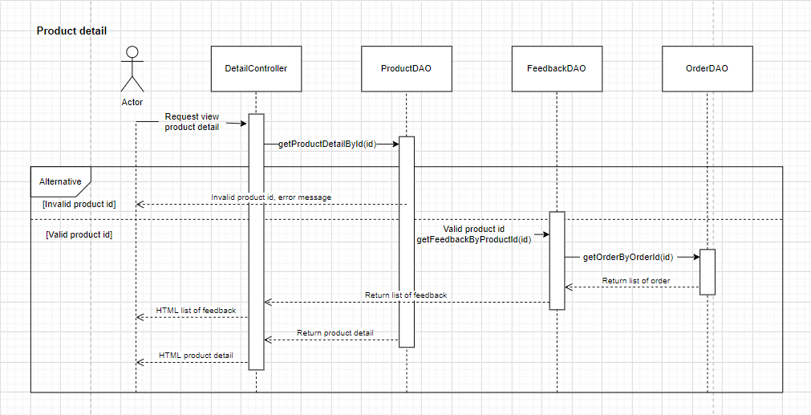

### d. Database queries

* SELECT *

FROM Product INNER JOIN Manufacturer

ON Product.ManufacturerID = Manufacturer.ManufacturerID

WHERE ProductID = ?

* SELECT * FROM Product WHERE ProductID = ?

## 7. Cart Details

### a. Class Diagram

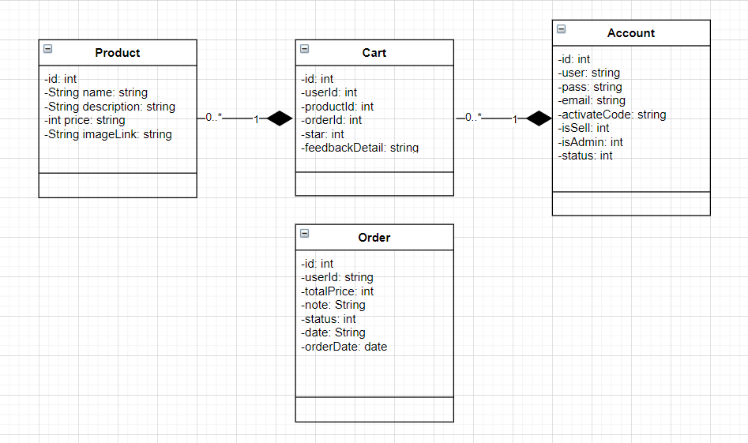

### b. Class Specifications

#### Product Class: This class stores information of a Product

| **No** | **Method** | **Description** |
| --- | --- | --- |
| 01 | getID | get ID Products |
| 02 | setID | set ID Products |
| 03 | getName() | get Name Products |
| 04 | setName() | set Name Products |
| 05 | getPrice() | get Price Products |
| 06 | setPrice() | set Price Products |
| 07 | getImageLink() | get ImageLink Products |
| 08 | setImageLink | set ImageLink Products |
| 09 | getDescription() | get Description Products |

#### Account Class: This class stores information of an Account

| **No** | **Method** | **Description** |
| --- | --- | --- |
| 1 | getId() | Get the ID of an Account |
| 2 | setId() | Set the ID of an Account |
| 3 | getUser() | Get the Username of an Account |
| 4 | setUser() | Set the Username of an Account |
| 5 | getEmail() | Get the Email of an Account |
| 6 | setEmail() | Set the Email of an Account |
| 7 | getIsSell() | Check if an Account has the seller role |
| 8 | setIsSell() | Add/remove seller role to/from an Account |
| 9 | getIsAdmin() | Check if an Account has the admin role |
| 10 | setIsAdmin() | Add/remove admin role to/from an Account |
| 11 | getStatus() | Get the Status of an Account |
| 12 | setStatus() | Set the Status of an Account |
| 13 | toString() | Convert all information of an Account to a string |

#### Order Class: This class stores information of an Order

|  |  |  |
| --- | --- | --- |
| **No** | **Method** | **Description** |
| 1 | getId() | Get the ID of an Order object |
| 2 | setId() | Set the ID of an Order object |
| 3 | getUserId() | Get the User ID of an Order object |
| 4 | setUserId() | Set the User ID of an Order object |
| 5 | getTotalPrice() | Get the Subtotal of an Order object |
| 6 | setTotalPrice () | Set the Subtotal of an Order object |
| 7 | getNote () | Get the Note of an Order object |
| 8 | setNote() | Set the Note of an Order object |
| 9 | getStatus () | Get the Status of an Order object |
| 10 | setStatus() | Set the Status of an Order object |
| 11 | getDate() | Get the Order Date of an Order object |
| 12 | setDate() | Set the Order Date of an Order object |

#### Cart Class: This class stores information of a Cart

|  |  |  |
| --- | --- | --- |
| **No** | **Method** | **Description** |
| 1 | getP() | Get the Product of a Cart object |
| 2 | setP() | Set the Product of a Cart object |
| 3 | getAmount() | Get the Amount of a Cart object |
| 4 | setAmount() | Set the Amount of a Cart object |
| 5 | toString() | Convert all information of a Cart object to a string |

#### CartDAO Class: This class performs CRUD actions to Cart table in the database

|  |  |  |
| --- | --- | --- |
| **No** | **Method** | **Description** |
| 1 | getCart() | Return list of products in cart of a particular customer |
| 2 | countCart() | Return number of different items in cart |
| 3 | countAllCart() | The number of all products in cart |
| 4 | addToCart() | Function returns a boolean to inform whether the product is added to cart or not |
| 5 | delete1Amount() | Minus 1 amount from Product after 1 Customer Add to cart |
| 6 | countAmountProduct() | Count the amount of a product to see if it is out of stock |
| 7 | countNumCart() | Return number of products in cart of a particular user |
| 8 | deleteCart() | Delete all products in cart of a particular user |
| 9 | add1ProductToCart() | Add 1 Product to Cart, Use when User Click "+" in ListCart |

#### ShowCartControlClass: This class process request for detail of a cart

|  |  |  |
| --- | --- | --- |
| **No** | **Method** | **Description** |
| 1 | processRequest() | … |
| 2 | getPriceWithDot() | … |
| 3 | doGet() | … |
| 4 | doPost() | … |
| 5 | getServletInfo() | return a String containing servlet description |

### c. Sequence Diagram(s)

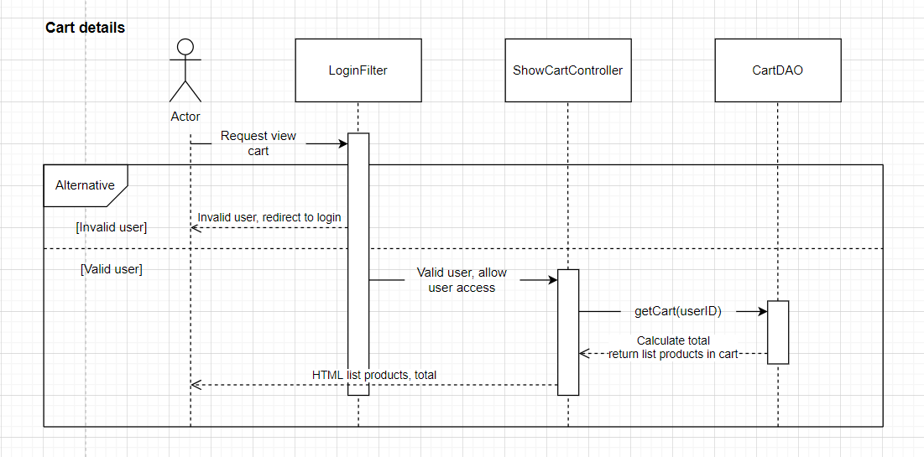

### d. Database queries

* UPDATE Cart

SET Amount = ?

WHERE UserID = ? AND ProductID = ?

## 8. Cart Completion

### a. Class Diagram



### b. Class Specifications

#### Product Class: This class stores information of a Product

| **No** | **Method** | **Description** |
| --- | --- | --- |
| 01 | getID | get ID Products |
| 02 | setID | set ID Products |
| 03 | getName() | get Name Products |
| 04 | setName() | set Name Products |
| 05 | getPrice() | get Price Products |
| 06 | setPrice() | set Price Products |
| 07 | getImageLink() | get ImageLink Products |
| 08 | setImageLink | set ImageLink Products |
| 09 | getDescription() | get Description Products |

#### Account Class: This class stores information of an Account

|  |  |  |
| --- | --- | --- |
| **No** | **Method** | **Description** |
| 1 | getId() | Get the ID of an Account |
| 2 | setId() | Set the ID of an Account |
| 3 | getUser() | Get the Username of an Account |
| 4 | setUser() | Set the Username of an Account |
| 5 | getEmail() | Get the Email of an Account |
| 6 | setEmail() | Set the Email of an Account |
| 7 | getIsSell() | Check if an Account has the seller role |
| 8 | setIsSell() | Add/remove seller role to/from an Account |
| 9 | getIsAdmin() | Check if an Account has the admin role |
| 10 | setIsAdmin() | Add/remove admin role to/from an Account |
| 11 | getStatus() | Get the Status of an Account |
| 12 | setStatus() | Set the Status of an Account |
| 13 | toString() | Convert all information of an Account to a string |

#### Order Class: This class stores information of an Order

|  |  |  |
| --- | --- | --- |
| **No** | **Method** | **Description** |
| 1 | getId() | Get the ID of an Order object |
| 2 | setId() | Set the ID of an Order object |
| 3 | getUserId() | Get the User ID of an Order object |
| 4 | setUserId() | Set the User ID of an Order object |
| 5 | getTotalPrice() | Get the Subtotal of an Order object |
| 6 | setTotalPrice () | Set the Subtotal of an Order object |
| 7 | getNote () | Get the Note of an Order object |
| 8 | setNote() | Set the Note of an Order object |
| 9 | getStatus () | Get the Status of an Order object |
| 10 | setStatus() | Set the Status of an Order object |
| 11 | getDate() | Get the Order Date of an Order object |
| 12 | setDate() | Set the Order Date of an Order object |

#### Cart Class: This class stores information of a Cart

|  |  |  |
| --- | --- | --- |
| **No** | **Method** | **Description** |
| 1 | getP() | Get the Product of a Cart object |
| 2 | setP() | Set the Product of a Cart object |
| 3 | getAmount() | Get the Amount of a Cart object |
| 4 | setAmount() | Set the Amount of a Cart object |
| 5 | toString() | Convert all information of a Cart object to a string |

#### CartDAO Class: This class performs CRUD actions to Cart table in the database

|  |  |  |
| --- | --- | --- |
| **No** | **Method** | **Description** |
| 1 | getCart() | Return list of products in cart of a particular customer |
| 2 | countCart() | Return number of different items in cart |
| 3 | countAllCart() | The number of all products in cart |
| 4 | addToCart() | Function returns a boolean to inform whether the product is added to cart or not |
| 5 | delete1Amount() | Minus 1 amount from Product after 1 Customer Add to cart |
| 6 | countAmountProduct() | Count the amount of a product to see if it is out of stock |
| 7 | countNumCart() | Return number of products in cart of a particular user |
| 8 | deleteCart() | Delete all products in cart of a particular user |
| 9 | add1ProductToCart() | Add 1 Product to Cart, Use when User Click "+" in ListCart |

#### ShipDAO Class: This class performs CRUD actions to Shipping table in the database

|  |  |  |
| --- | --- | --- |
| **No** | **Method** | **Description** |
| 1 | getAllShip() | Get every shipping orders and return list of ship |
| 2 | getShipPriceBy  CityName() | Get a shipping price from db using cityName and return a int number |
| 3 | getShipPriceByCId() | Get a shipping price from db using the id and return an int number |
| 4 | getCityByCId() | Get a shipping price from db using the id and return an int number |

#### ProductDAO Class: This class performs CRUD actions to Product table in the database

|  |  |  |
| --- | --- | --- |
| **No** | **Method** | **Description** |
| 1 | getAllProduct() | … |
| 2 | getHotProduct() | return Product with the highest sold amount |
| 3 | getFavoriteProduct  () | return get the first and the second product with most sold amount |
| 4 | getProductBy  SellID() | return the list of products of a particular seller |
| 5 | Edit() | Edit the information of a particular product, select by product ID |
| 6 | Delete() | Delete a product, select by its ID |
| 7 | Add() | Adding a new product to the database, the ID is no need to be added because it is automatically added |
| 8 | countProduct() | return the total number of products |
| 9 | pagingProduct() | Every 6 products will be displayed in a single page and return list of 6 products |
| 10 | pagingByCategory() | categorizing products and return list of products with same category |
| 11 | pagingManager  Product() | … |
| 12 | countProductBy  Category() | count total product |
| 13 | countProductBy  Seller() | Count the products of a particular seller and return the number of product |
| 14 | getProductByID() | Get data of Product Table searched by UserID |
| 15 | getProductDetailBy  ID() | Get Product for Detail |
| 16 | getProductForManager() | Get a particular product and return a product |
| 17 | SearchProductBy  Name() | Search for a particular product by filling its name |
| 18 | searchProductIn  Manager() | Search for a product in admin/moderator mode by filling its name |
| 19 | top3MostSell() | Select top 3 most sold products and return product |
| 20 | top3LeastSell() | Select top 3 least sold products and return product |

#### BuyControl Class: This class process request for buying products in a cart

|  |  |  |
| --- | --- | --- |
| **No** | **Method** | **Description** |
| 1 | processRequest() | … |
| 2 | doGet() | Use session to call id -> create necessary DAO -> get products in user's cart -> Get All Ships information -> calculate total sum -> Set attribute, send to Buy.jsp |
| 3 | doPost() | … |
| 4 | getPriceWithDot() | …. |

**c. Sequence Diagram(s)**

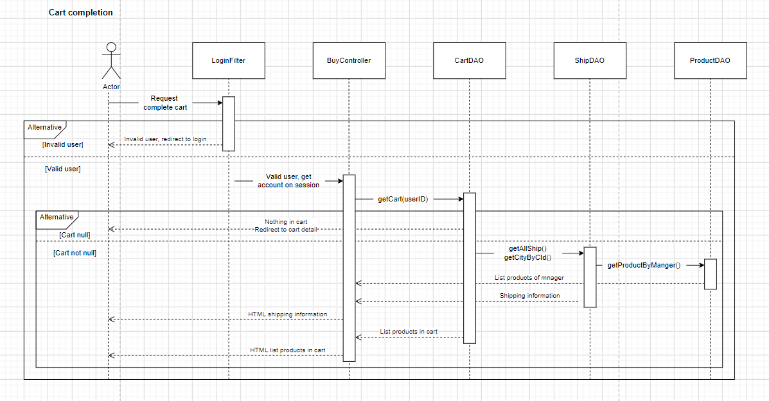

**d. Database queries**

* SELECT * FROM Product WHERE ProductID = ?
* SELECT Product.ProductID, Product.ProductName, Product.Description, Product.SellPrice, Product.imageLink, Cart.Amount FROM Cart INNER JOIN Product

ON Cart.ProductID = Product.ProductID WHERE Cart.UserID = ?

## 9. Change Password

### a. Class Diagram

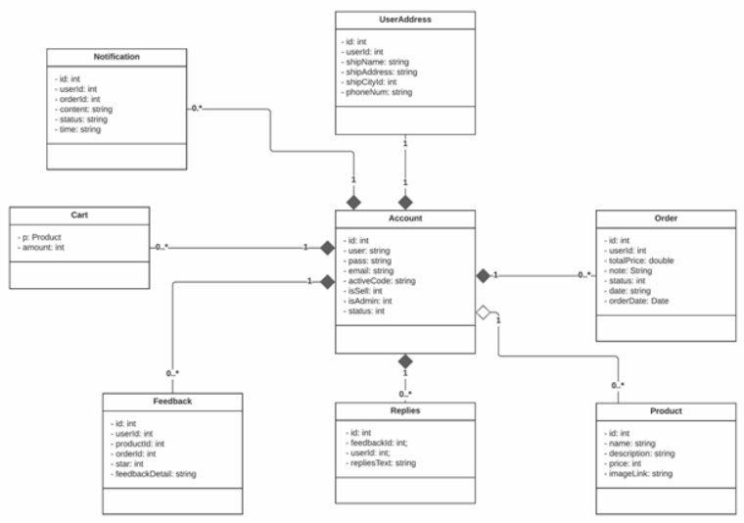

### b. Class Specifications

#### Account Class: This class stores information of an Account

|  |  |  |
| --- | --- | --- |
| **No** | **Method** | **Description** |
| 1 | getId() | Get the ID of an Account |
| 2 | setId() | Set the ID of an Account |
| 3 | getUser() | Get the Username of an Account |
| 4 | setUser() | Set the Username of an Account |
| 5 | getEmail() | Get the Email of an Account |
| 6 | setEmail() | Set the Email of an Account |
| 7 | getIsSell() | Check if an Account has the seller role |
| 8 | setIsSell() | Add/remove seller role to/from an Account |
| 9 | getIsAdmin() | Check if an Account has the admin role |
| 10 | setIsAdmin() | Add/remove admin role to/from an Account |
| 11 | getStatus() | Get the Status of an Account |
| 12 | setStatus() | Set the Status of an Account |
| 13 | toString() | Convert all information of an Account to a string |

#### Feedback Class: This class stores information of a Feedback

|  |  |  |
| --- | --- | --- |
| **No** | **Method** | **Description** |
| 1 | getId() | Get the ID of a Feedback object |
| 2 | setId() | Set the ID of a Feedback object |
| 3 | getUserId() | Get the User ID of a Feedback object |
| 4 | setUserId() | Set the User ID of a Feedback object |
| 5 | getProductId() | Get the Subtotal of a Feedback object |
| 6 | setProductId() | Set the Subtotal of a Feedback object |
| 7 | getStar() | Get the Star of a Feedback object |
| 8 | setStar() | Set the Star of a Feedback object |
| 9 | getFeedbackDetail() | Get the Feedback Detail of a Feedback object |
| 10 | setFeedbackDetail() | Set the Feedback Detail of a Feedback object |
| 11 | getListReplies () | Get the list of Replies of a Feedback object |
| 12 | setListReplies () | Set the list of Replies of a Feedback object |
| 13 | toString() | Convert all information of a Feedback object to a string |

#### Product Class: This class stores information of a Product

| **No** | **Method** | **Description** |
| --- | --- | --- |
| 01 | getID | get ID Products |
| 02 | setID | set ID Products |
| 03 | getName() | get Name Products |
| 04 | setName() | set Name Products |
| 05 | getPrice() | get Price Products |
| 06 | setPrice() | set Price Products |
| 07 | getImageLink() | get ImageLink Products |
| 08 | setImageLink | set ImageLink Products |
| 09 | getDescription() | get Description Products |
| 10 | setDescription() | set Description Products |
| 11 | toString() | Output information |
| 12 | getPriceWithDot() | Function to write the Product's Price in proper form |

#### Cart Class: This class stores information of a Cart

|  |  |  |
| --- | --- | --- |
| **No** | **Method** | **Description** |
| 1 | getP() | Get the Product of a Cart object |
| 2 | setP() | Set the Product of a Cart object |
| 3 | getAmount() | Get the Amount of a Cart object |
| 4 | setAmount() | Set the Amount of a Cart object |
| 5 | toString() | Convert all information of a Cart object to a string |

#### UserDAO Class

| **No** | **Method** | **Description** |
| --- | --- | --- |
| 1 | Login() | For login an account to the website and return the account information of the account logging in, null if username or password does not exist |
| 2 | signUp() | Use for signup an account to the website |
| 3 | signUpFB() | Used when user try to login via FB, the password will be set automatically and the user will be added to database |
| 4 | getAllAccounts() | Get all account from database and return the list of account from the database |
| 5 | deleteAccount() | Delete an account from the database |
| 6 | editAccount() | Update the information of an account |
| 7 | updatePassword() | Update the password of a user |
| 8 | getAccountByID() | Find an account by id and eturn the found account, null if the account does not exist in the database |
| 9 | getAccountByEmail  () | Find an account by email return the found account, null if the account does not exist in the database |
| 10 | getAccountBy  Username() | Find an account by username and return the found account, null if the account does not exist in the database |
| 11 | updateStatus() | Update status of an account and return true if update successful |
| 12 | countAllAccount() | Return the number of account in the database |
| 13 | checkForget  Password() | … |

#### ChangePasswordControl Class: This class process request for change user password

|  |  |  |
| --- | --- | --- |
| **No** | **Method** | **Description** |
| 1 | processRequest() | … |
| 2 | doGet() | … |
| 3 | doPost() | … |
| 4 | getServletInfo() | return a String containing servlet description |

**c. Sequence Diagram(s)**

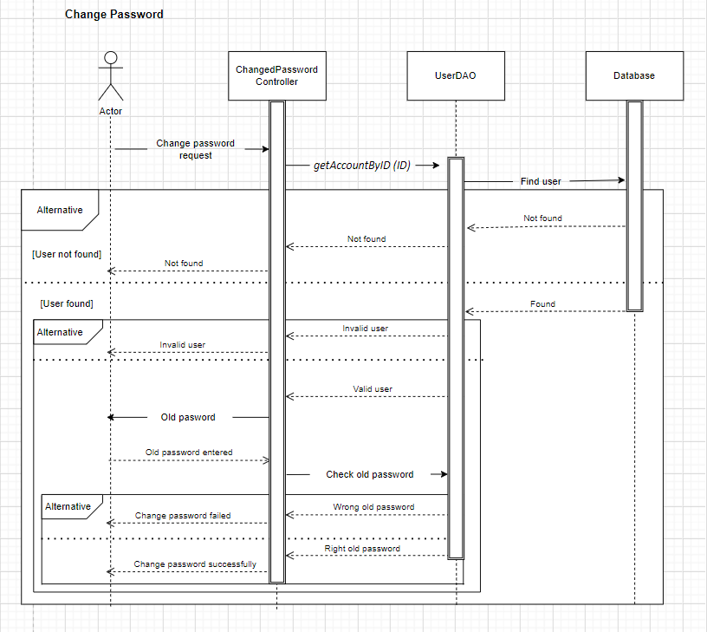

### d. Database queries

* SELECT * FROM Users WHERE UserID = ?
* UPDATE Users SET Password = ? WHERE UserID = ?

## 10. User Profile

**a. Class Diagram**



### b. Class Specifications

#### Account Class: This class stores information of an Account

|  |  |  |
| --- | --- | --- |
| **No** | **Method** | **Description** |
| 1 | getId() | Get the ID of an Account |
| 2 | setId() | Set the ID of an Account |
| 3 | getUser() | Get the Username of an Account |
| 4 | setUser() | Set the Username of an Account |
| 5 | getEmail() | Get the Email of an Account |
| 6 | setEmail() | Set the Email of an Account |
| 7 | getIsSell() | Check if an Account has the seller role |
| 8 | setIsSell() | Add/remove seller role to/from an Account |
| 9 | getIsAdmin() | Check if an Account has the admin role |
| 10 | setIsAdmin() | Add/remove admin role to/from an Account |
| 11 | getStatus() | Get the Status of an Account |
| 12 | setStatus() | Set the Status of an Account |
| 13 | toString() | Convert all information of an Account to a string |

#### Feedback Class: This class stores information of a Feedback

|  |  |  |
| --- | --- | --- |
| **No** | **Method** | **Description** |
| 1 | getId() | Get the ID of a Feedback object |
| 2 | setId() | Set the ID of a Feedback object |
| 3 | getUserId() | Get the User ID of a Feedback object |
| 4 | setUserId() | Set the User ID of a Feedback object |
| 5 | getProductId() | Get the Subtotal of a Feedback object |
| 6 | setProductId() | Set the Subtotal of a Feedback object |
| 7 | getStar() | Get the Star of a Feedback object |
| 8 | setStar() | Set the Star of a Feedback object |
| 9 | getFeedbackDetail() | Get the Feedback Detail of a Feedback object |
| 10 | setFeedbackDetail() | Set the Feedback Detail of a Feedback object |
| 11 | getListReplies () | Get the list of Replies of a Feedback object |
| 12 | setListReplies () | Set the list of Replies of a Feedback object |
| 13 | toString() | Convert all information of a Feedback object to a string |

#### Product Class: This class stores information of a Product

| **No** | **Method** | **Description** |
| --- | --- | --- |
| 01 | getID | get ID Products |
| 02 | setID | set ID Products |
| 03 | getName() | get Name Products |
| 04 | setName() | set Name Products |
| 05 | getPrice() | get Price Products |
| 06 | setPrice() | set Price Products |
| 07 | getImageLink() | get ImageLink Products |
| 08 | setImageLink | set ImageLink Products |
| 09 | getDescription() | get Description Products |
| 10 | setDescription() | set Description Products |
| 11 | toString() | Output information |
| 12 | getPriceWithDot() | Function to write the Product's Price in proper form |

#### Cart Class: This class stores information of a Cart

|  |  |  |
| --- | --- | --- |
| **No** | **Method** | **Description** |
| 1 | getP() | Get the Product of a Cart object |
| 2 | setP() | Set the Product of a Cart object |
| 3 | getAmount() | Get the Amount of a Cart object |
| 4 | setAmount() | Set the Amount of a Cart object |
| 5 | toString() | Convert all information of a Cart object to a string |

#### ProfileControlClass: This class process request for detail of a user’s profile

|  |  |  |
| --- | --- | --- |
| **No** | **Method** | **Description** |
| 1 | processRequest() | Get current account from session and push to UserProfile.jsp |
| 2 | doGet() | … |
| 3 | doPost() | … |
| 4 | getServletInfo() | return a String containing servlet description |

### c. Sequence Diagram(s)

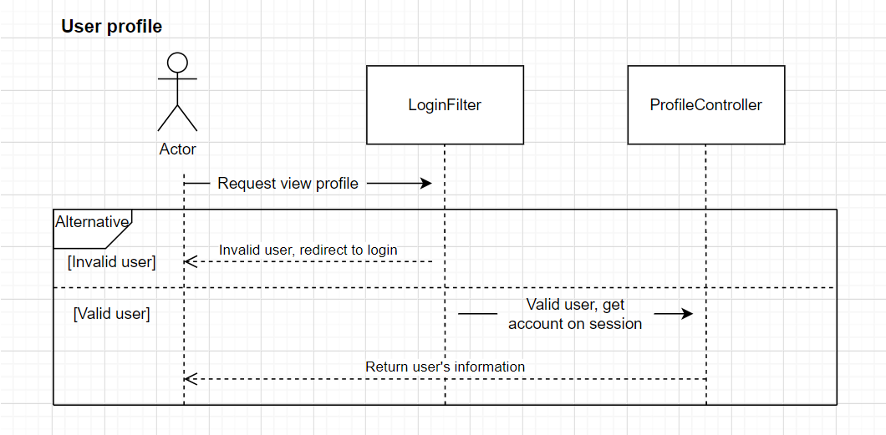

### d. Database queries

## 11. Home Page

### a. Class Diagram

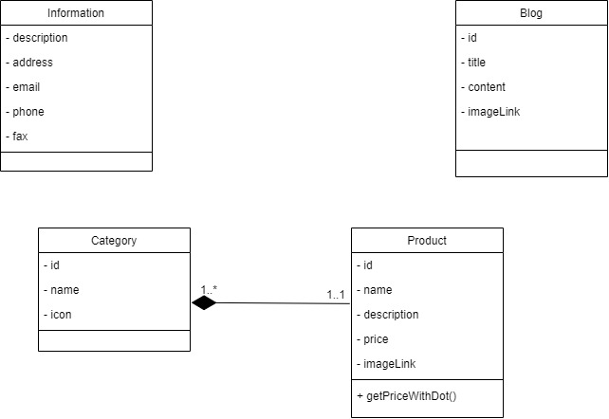

### b. Class Specifications

#### HomeControl Class

*This class takes the data from DAO and push it to JSP to display*

***Class Methods***

|  |  |  |
| --- | --- | --- |
| **No** | **Method** | **Description** |
| 1 | processRequest | This method contains all logic execution of the class |

#### ProductDAO Class

This class performs action to Data (CRUD) in Product Table in Database

***Class Methods***

|  |  |  |
| --- | --- | --- |
| **No** | **Method** | **Description** |
| 1 | getTop4SalePercent | This method get the Top 4 Products that has the highest Sale Percent   * Output: List<Product> |
| 2 | getAllProduct() | Get all Products in Database |
| 3 | getHotProduct() | Return Product with the highest sold amount |
| 4 | getFavoriteProduct  () | Return get the first and the second product with most sold amount |
| 5 | getProductBy  SellID() | Return the list of products of a particular seller |
| 6 | Edit() | Edit the information of a particular product, select by product ID |
| 7 | Delete() | Delete a product, select by its ID |
| 8 | Add() | Adding a new product to the database, the ID is no need to be added because it is automatically added |
| 9 | countProduct() | Return the total number of products |
| 10 | pagingProduct() | Every 6 products will be displayed in a single page and return list of 6 products |
| 11 | pagingByCategory() | Categorizing products and return list of products with same category |
| 12 | pagingManager  Product() | Return 6 Product for 1 Page in List Product of Seller |
| 13 | countProductBy  Category() | Count total product |
| 14 | countProductBy  Seller() | Count the products of a particular seller and return the number of product |
| 15 | getProductByID() | Get data of Product Table searched by UserID |
| 16 | getProductDetailBy  ID() | Get Product for Detail |
| 17 | getProductForManager() | Get a particular product and return a product |
| 18 | SearchProductBy  Name() | Search for a particular product by filling its name |
| 19 | searchProductIn  Manager() | Search for a product in admin/moderator mode by filling its name |
| 20 | top3MostSell() | Select top 3 most sold products and return product |
| 21 | top3LeastSell() | Select top 3 least sold products and return product |

#### Product Class

This class store the information of a Product

***Class Methods***

| **No** | **Method** | **Description** |
| --- | --- | --- |
| 01 | getID | get ID Products |
| 02 | setID | set ID Products |
| 03 | getName() | get Name Products |
| 04 | setName() | set Name Products |
| 05 | getPrice() | get Price Products |
| 06 | setPrice() | set Price Products |
| 07 | getImageLink() | get ImageLink Products |
| 08 | setImageLink | set ImageLink Products |
| 09 | getDescription() | get Description Products |
| 10 | setDescription() | set Description Products |
| 11 | toString() | Output information |
| 12 | getPriceWithDot() | Function to write the Product's Price in proper form |

#### InforDAO Class

This class performs action to Data (CRUD) in Information Table in Database

***Class Methods***

|  |  |  |
| --- | --- | --- |
| **No** | **Method** | **Description** |
| 1 | getInfor() | Return information of the shop |

#### Information Class

This class store the information about the Information Table

***Class Methods***

|  |  |  |
| --- | --- | --- |
| **No** | **Method** | **Description** |
| 1 | getDescription() | Get the Description of an Information object |
| 2 | setDescription() | Set the Description of an Information object |
| 3 | getAddress() | Get the Address of an Information object |
| 4 | setAddress() | Set the Address of an Information object |
| 5 | getEmail() | Get the Email of an Information object |
| 6 | setEmail() | Set the Email of an Information object |
| 7 | getPhone() | Get the Phone of an Information object |
| 8 | setPhone() | Set the Phone of an Information object |
| 9 | getFax() | Get the Fax of an Information object |
| 10 | setFax() | Set the Fax of an Information object |
| 11 | toString() | Convert all information of an Information object to a string |

#### CategoryDAO Class

This class performs action to Data (CRUD) in Category Table in Database

***Class Methods***

|  |  |  |
| --- | --- | --- |
| **No** | **Method** | **Description** |
| 1 | getAllCategory() | Return all list Category |
| 2 | getCateNameByID() | Select a specified category by its ID, used for categorizing products in homepage |

#### Category Class

This class store the information about a Category

***Class Methods***

|  |  |  |
| --- | --- | --- |
| **No** | **Method** | **Description** |
| 1 | getId() | Get the ID of a Category object |
| 2 | setId() | Set the ID of a Category object |
| 3 | getName() | Get the Name of a Category object |
| 4 | setName() | Set the Name of a Category object |
| 5 | getIcon() | Get the Icon of a Category object |
| 6 | setIcon() | Set the Icon of a Category object |
| 7 | toString() | Convert all information of a Category object to a string |

#### BlogDAO Class

This class performs action to Data (CRUD) in Blog Table in Database

***Class Methods***

|  |  |  |
| --- | --- | --- |
| **No** | **Method** | **Description** |
| 1 | getHotBlog () | Get the First Blog in Database |
| 2 | getAllBlog () | Get all Blogs in Database |
| 3 | getBlogByID() | Get a Blog by its ID |
| 4 | add () | Add a Blog to Database |
| 5 | edit () | Edit a Blog |
| 6 | delete () | Delete a Blog in Database |
| 7 | pagingBlog () | Get Blogs for Paging |

#### Blog Class

This class store the information about a Blog

***Class Methods***

|  |  |  |
| --- | --- | --- |
| **No** | **Method** | **Description** |
| 1 | getId () | Get the ID of a Blog object |
| 2 | setId () | Set the ID of a Blog object |
| 3 | getTitle () | Get the Title of a Blog object |
| 4 | setTitle () | Set the Title of a Blog object |
| 5 | getContent () | Get the Content of a Blog object |
| 6 | setContent () | Set the Content of a Blog object |
| 7 | getImageLink () | Get the ImageLink of a Blog object |
| 8 | setImageLink | Set the ImageLink of a Blog object |
| 9 | toString | Convert all information of a Category object to a string |

### c. Sequence Diagram(s)

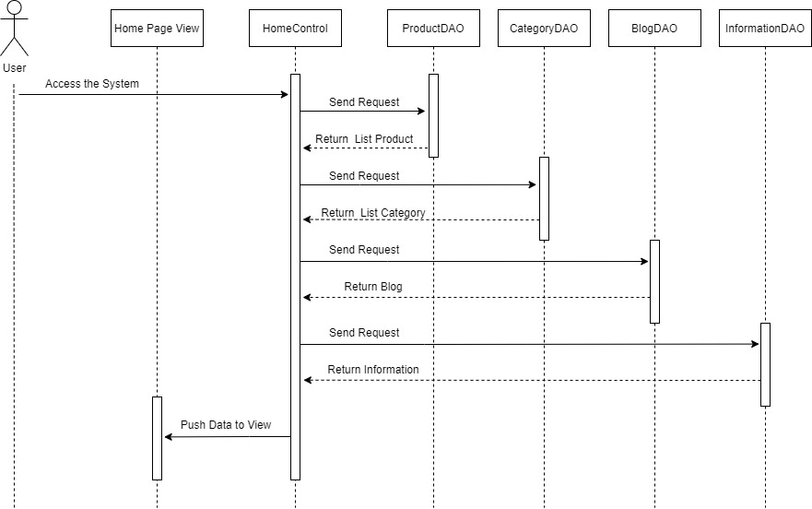

### d. Database queries

*- SELECT * FROM Category*

*- SELECT * FROM Information*

*- SELECT TOP 1 * FROM Blog ORDER BY id DESC*

*- SELECT TOP 4 * FROM Product ORDER BY SalePercent DESC*

## 12. Product List

### a. Class Diagram

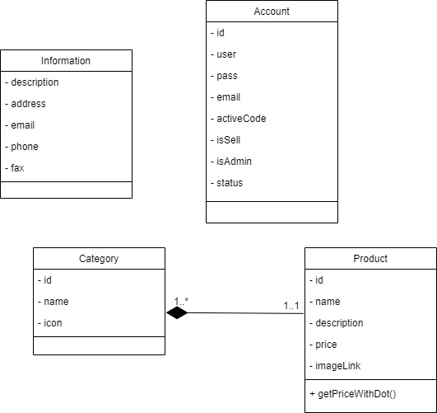

### b. Class Specifications

#### ProductListControl Class

*This class takes the data from DAO and push it to JSP to display*

***Class Methods***

|  |  |  |
| --- | --- | --- |
| **No** | **Method** | **Description** |
| 1 | processRequest | This method contains all logic execution of the class |

#### ProductDAO Class

This class performs action to Data (CRUD) in Product Table in Database

***Class Methods***

|  |  |  |
| --- | --- | --- |
| **No** | **Method** | **Description** |
| 1 | getTop4SalePercent | This method get the Top 4 Products that has the highest Sale Percent   * Output: List<Product> |
| 2 | getAllProduct() | Get all Products in Database |
| 3 | getHotProduct() | Return Product with the highest sold amount |
| 4 | getFavoriteProduct  () | Return get the first and the second product with most sold amount |
| 5 | getProductBy  SellID() | Return the list of products of a particular seller |
| 6 | Edit() | Edit the information of a particular product, select by product ID |
| 7 | Delete() | Delete a product, select by its ID |
| 8 | Add() | Adding a new product to the database, the ID is no need to be added because it is automatically added |
| 9 | countProduct() | Return the total number of products |
| 10 | pagingProduct() | Every 6 products will be displayed in a single page and return list of 6 products |
| 11 | pagingByCategory() | Categorizing products and return list of products with same category |
| 12 | pagingManager  Product() | Return 6 Product for 1 Page in List Product of Seller |
| 13 | countProductBy  Category() | Count total product |
| 14 | countProductBy  Seller() | Count the products of a particular seller and return the number of product |
| 15 | getProductByID() | Get data of Product Table searched by UserID |
| 16 | getProductDetailBy  ID() | Get Product for Detail |
| 17 | getProductForManager() | Get a particular product and return a product |
| 18 | SearchProductBy  Name() | Search for a particular product by filling its name |
| 19 | searchProductIn  Manager() | Search for a product in admin/moderator mode by filling its name |
| 20 | top3MostSell() | Select top 3 most sold products and return product |
| 21 | top3LeastSell() | Select top 3 least sold products and return product |

#### Product Class

This class store the information of a Product

***Class Methods***

| **No** | **Method** | **Description** |
| --- | --- | --- |
| 01 | getID | get ID Products |
| 02 | setID | set ID Products |
| 03 | getName() | get Name Products |
| 04 | setName() | set Name Products |
| 05 | getPrice() | get Price Products |
| 06 | setPrice() | set Price Products |
| 07 | getImageLink() | get ImageLink Products |
| 08 | setImageLink | set ImageLink Products |
| 09 | getDescription() | get Description Products |
| 10 | setDescription() | set Description Products |
| 11 | toString() | Output information |
| 12 | getPriceWithDot() | Function to write the Product's Price in proper form |

#### InforDAO Class

This class performs action to Data (CRUD) in Information Table in Database

***Class Methods***

|  |  |  |
| --- | --- | --- |
| **No** | **Method** | **Description** |
| 1 | getInfor() | Return information of the shop |

#### Information Class

This class store the information about the Information Table

***Class Methods***

|  |  |  |
| --- | --- | --- |
| **No** | **Method** | **Description** |
| 1 | getDescription() | Get the Description of an Information object |
| 2 | setDescription() | Set the Description of an Information object |
| 3 | getAddress() | Get the Address of an Information object |
| 4 | setAddress() | Set the Address of an Information object |
| 5 | getEmail() | Get the Email of an Information object |
| 6 | setEmail() | Set the Email of an Information object |
| 7 | getPhone() | Get the Phone of an Information object |
| 8 | setPhone() | Set the Phone of an Information object |
| 9 | getFax() | Get the Fax of an Information object |
| 10 | setFax() | Set the Fax of an Information object |
| 11 | toString() | Convert all information of an Information object to a string |

#### CategoryDAO Class

This class performs action to Data (CRUD) in Category Table in Database

***Class Methods***

|  |  |  |
| --- | --- | --- |
| **No** | **Method** | **Description** |
| 1 | getAllCategory() | Return all list Category |
| 2 | getCateNameByID() | Select a specified category by its ID, used for categorizing products in homepage |

#### Category Class

This class store the information about a Category

***Class Methods***

|  |  |  |
| --- | --- | --- |
| **No** | **Method** | **Description** |
| 1 | getId() | Get the ID of a Category object |
| 2 | setId() | Set the ID of a Category object |
| 3 | getName() | Get the Name of a Category object |
| 4 | setName() | Set the Name of a Category object |
| 5 | getIcon() | Get the Icon of a Category object |
| 6 | setIcon() | Set the Icon of a Category object |
| 7 | toString() | Convert all information of a Category object to a string |

#### Account Class

This class store the information about an Account

***Class Methods***

|  |  |  |
| --- | --- | --- |
| **No** | **Method** | **Description** |
| 1 | getId() | Get the ID of an Account |
| 2 | setId() | Set the ID of an Account |
| 3 | getUser() | Get the Username of an Account |
| 4 | setUser() | Set the Username of an Account |
| 5 | getEmail() | Get the Email of an Account |
| 6 | setEmail() | Set the Email of an Account |
| 7 | getIsSell() | Check if an Account has the seller role |
| 8 | setIsSell() | Add/remove seller role to/from an Account |
| 9 | getIsAdmin() | Check if an Account has the admin role |
| 10 | setIsAdmin() | Add/remove admin role to/from an Account |
| 11 | getStatus() | Get the Status of an Account |
| 12 | setStatus() | Set the Status of an Account |
| 13 | toString() | Convert all information of an Account to a string |

### c. Sequence Diagram(s)

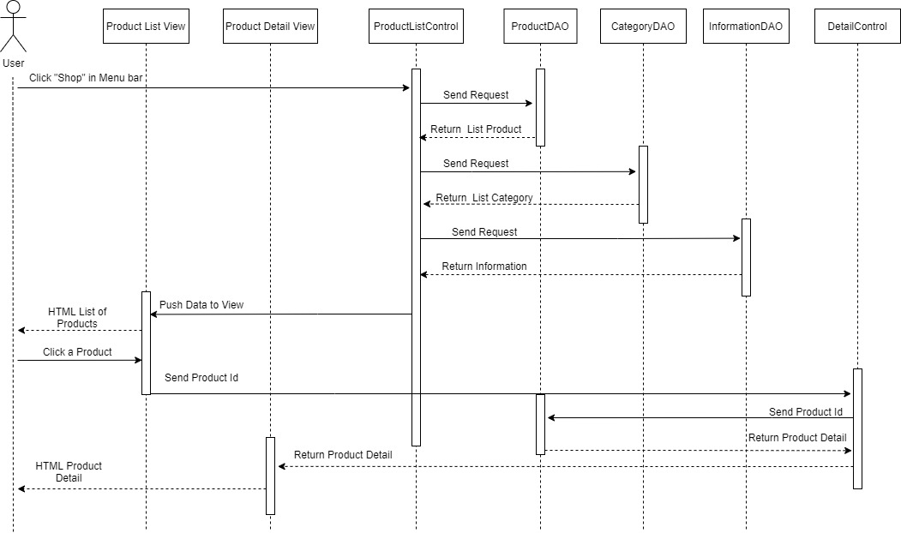

### d. Database queries

*- SELECT * FROM Category*

*- SELECT * FROM Information*

*- SELECT TOP 1 * FROM Product ORDER BY Amount DESC*

*- SELECT TOP 2 * FROM Product ORDER BY Amount DESC*

*- SELECT COUNT(*) FROM Product WHERE CategoryID = ?*

*- SELECT * FROM Product WHERE CategoryID = ? ORDER BY ProductID OFFSET ? ROWS FETCH NEXT 6 ROWS ONLY*

## 13. User Login

### a. Class Diagram

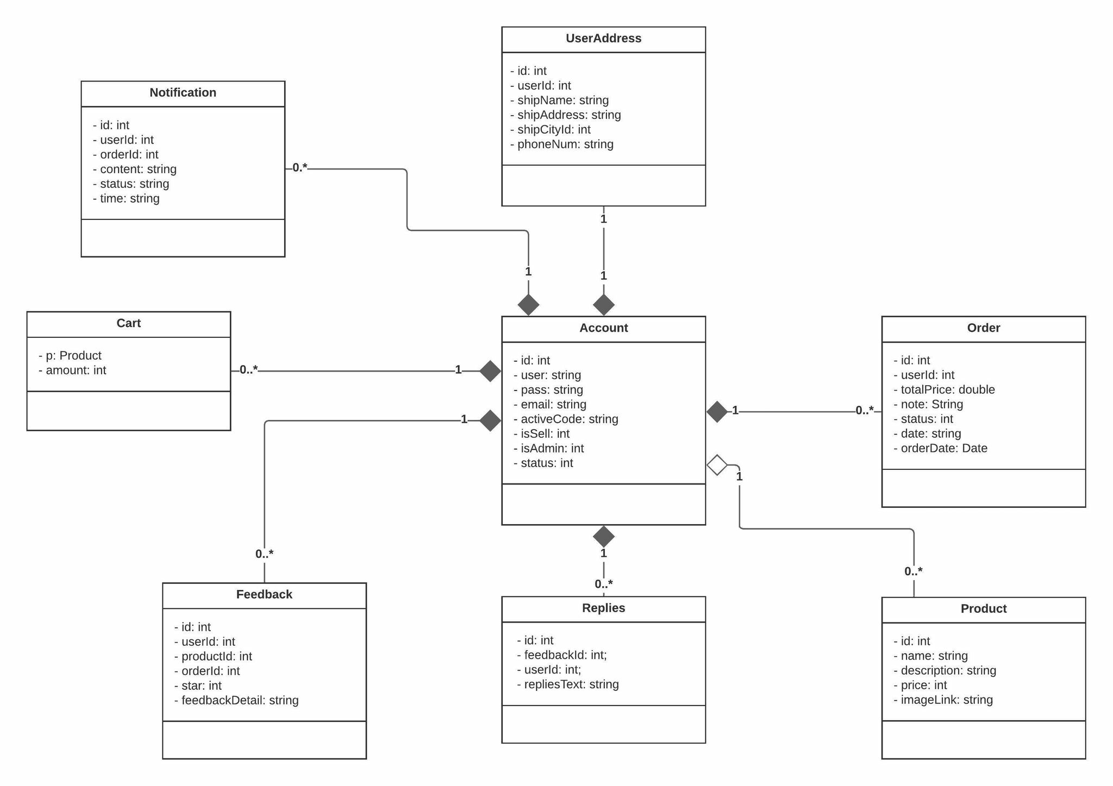

### b. Class Specifications

#### LoginControl Class

*This class takes the data from DAO and push it to JSP to display, as well as execute the Login function*

***Class Methods***

|  |  |  |
| --- | --- | --- |
| **No** | **Method** | **Description** |
| 1 | doGet | This method get the information from Cookie to display in JSP |
| 2 | doPost | This method get the information from Cookie to execute Function |

#### UserDAO Class

This class performs action to Data (CRUD) in Product Table in Database

***Class Methods***

|  |  |  |
| --- | --- | --- |
| **No** | **Method** | **Description** |
| 1 | Login() | For login an account to the website and return the account information of the account logging in, null if username or password does not exist |
| 2 | signUp() | Use for signup an account to the website |
| 3 | signUpFB() | Used when user try to login via FB, the password will be set automatically and the user will be added to database |
| 4 | getAllAccounts() | Get all account from database and return the list of account from the database |
| 5 | deleteAccount() | Delete an account from the database |
| 6 | editAccount() | Update the information of an account |
| 7 | updatePassword() | Update the password of a user |
| 8 | getAccountByID() | Find an account by id and eturn the found account, null if the account does not exist in the database |
| 9 | getAccountByEmail  () | Find an account by email return the found account, null if the account does not exist in the database |
| 10 | getAccountBy  Username() | Find an account by username and return the found account, null if the account does not exist in the database |
| 11 | updateStatus() | Update status of an account and return true if update successful |
| 12 | countAllAccount() | Return the number of account in the database |
| 13 | checkForget  Password() | … |

#### Account Class

This class store the information of an Account

***Class Methods***

|  |  |  |
| --- | --- | --- |
| **No** | **Method** | **Description** |
| 1 | getId() | Get the ID of an Account |
| 2 | setId() | Set the ID of an Account |
| 3 | getUser() | Get the Username of an Account |
| 4 | setUser() | Set the Username of an Account |
| 5 | getEmail() | Get the Email of an Account |
| 6 | setEmail() | Set the Email of an Account |
| 7 | getIsSell() | Check if an Account has the seller role |
| 8 | setIsSell() | Add/remove seller role to/from an Account |
| 9 | getIsAdmin() | Check if an Account has the admin role |
| 10 | setIsAdmin() | Add/remove admin role to/from an Account |
| 11 | getStatus() | Get the Status of an Account |
| 12 | setStatus() | Set the Status of an Account |
| 13 | toString() | Convert all information of an Account to a string |

### c. Sequence Diagram(s)

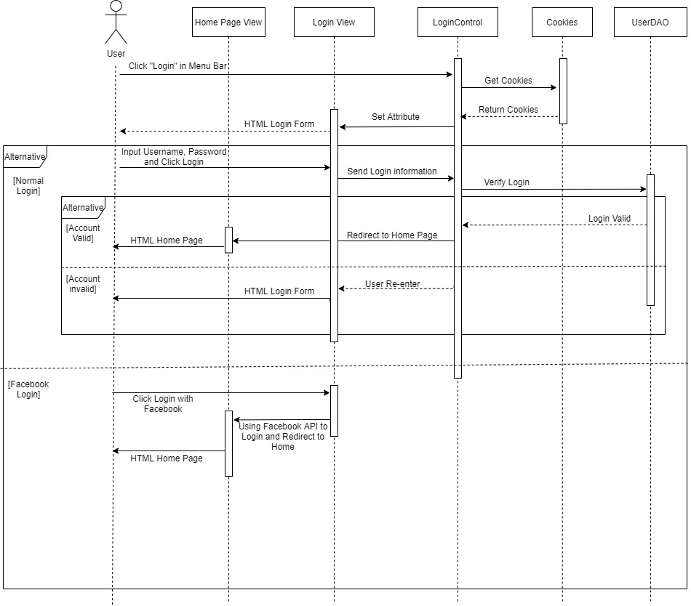

### d. Database queries

*- SELECT * FROM Users WHERE email = ?*

*- SELECT * FROM Users WHERE Username = ? AND Password = ?*

## 14. Reset Password

### a. Class Diagram



### b. Class Specifications

#### ForgetPasswordControl Class

*This class takes the information from JSP to send Verification Code*

|  |  |  |
| --- | --- | --- |
| **No** | **Method** | **Description** |
| 1 | processRequest | This method get the information from JSP, check it with Database and Send Verification Code through Email |
| 2 | doPost | This method get the Verification Code from JSP and Compare to make sure it’s correct |

#### Forget_ChangePasswordControl Class

*This class allows user to enter new Password and update it in Database*

***Class Methods***

|  |  |  |
| --- | --- | --- |
| **No** | **Method** | **Description** |
| 1 | processRequest | This method get the password from JSP to update in Database |

#### UserDAO Class

This class performs action to Data (CRUD) in Product Table in Database

***Class Methods***

|  |  |  |
| --- | --- | --- |
| **No** | **Method** | **Description** |
| 1 | Login() | For login an account to the website and return the account information of the account logging in, null if username or password does not exist |
| 2 | signUp() | Use for signup an account to the website |
| 3 | signUpFB() | Used when user try to login via FB, the password will be set automatically and the user will be added to database |
| 4 | getAllAccounts() | Get all account from database and return the list of account from the database |
| 5 | deleteAccount() | Delete an account from the database |
| 6 | editAccount() | Update the information of an account |
| 7 | updatePassword() | Update the password of a user |
| 8 | getAccountByID() | Find an account by id and eturn the found account, null if the account does not exist in the database |
| 9 | getAccountByEmail  () | Find an account by email return the found account, null if the account does not exist in the database |
| 10 | getAccountBy  Username() | Find an account by username and return the found account, null if the account does not exist in the database |
| 11 | updateStatus() | Update status of an account and return true if update successful |
| 12 | countAllAccount() | Return the number of account in the database |
| 13 | checkForget  Password() | … |

#### Account Class

This class store the information of an Account

***Class Methods***

|  |  |  |
| --- | --- | --- |
| **No** | **Method** | **Description** |
| 1 | getId() | Get the ID of an Account |
| 2 | setId() | Set the ID of an Account |
| 3 | getUser() | Get the Username of an Account |
| 4 | setUser() | Set the Username of an Account |
| 5 | getEmail() | Get the Email of an Account |
| 6 | setEmail() | Set the Email of an Account |
| 7 | getIsSell() | Check if an Account has the seller role |
| 8 | setIsSell() | Add/remove seller role to/from an Account |
| 9 | getIsAdmin() | Check if an Account has the admin role |
| 10 | setIsAdmin() | Add/remove admin role to/from an Account |
| 11 | getStatus() | Get the Status of an Account |
| 12 | setStatus() | Set the Status of an Account |
| 13 | toString() | Convert all information of an Account to a string |

### c. Sequence Diagram(s)

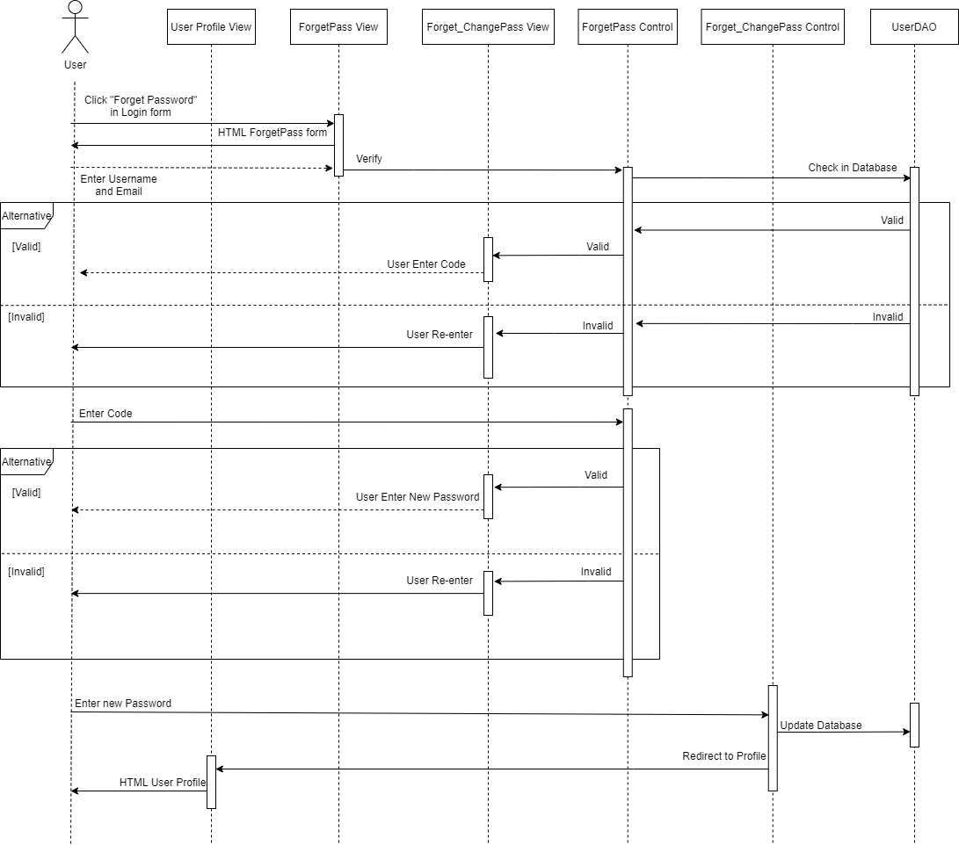

### d. Database queries

*- SELECT UserID FROM Users WHERE Username = ? AND email = ?*

*- SELECT * FROM Users WHERE UserID = ?*

*- UPDATE Users SET Password = ? WHERE UserID = ?*

## 15. Product List (Marketing)

### a. Class Diagram

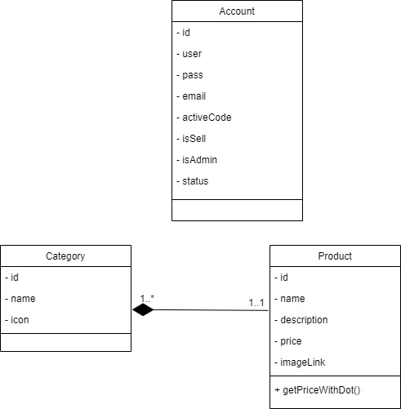

### b. Class Specifications

#### ManagerControl Class

*This class takes the List Product from Database and Display it in JSP*

***Class Methods***

|  |  |  |
| --- | --- | --- |
| **No** | **Method** | **Description** |
| 1 | processRequest | This method contains all the logic execution of the Class |

#### ProductDAO Class

This class performs action to Data (CRUD) in Product Table in Database

***Class Methods***

|  |  |  |
| --- | --- | --- |
| **No** | **Method** | **Description** |
| 1 | getAllProduct() | … |
| 2 | getHotProduct() | return Product with the highest sold amount |
| 3 | getFavoriteProduct  () | return get the first and the second product with most sold amount |
| 4 | getProductBy  SellID() | return the list of products of a particular seller |
| 5 | Edit() | Edit the information of a particular product, select by product ID |
| 6 | Delete() | Delete a product, select by its ID |
| 7 | Add() | Adding a new product to the database, the ID is no need to be added because it is automatically added |
| 8 | countProduct() | return the total number of products |
| 9 | pagingProduct() | Every 6 products will be displayed in a single page and return list of 6 products |
| 10 | pagingByCategory() | categorizing products and return list of products with same category |
| 11 | pagingManager  Product() | … |
| 12 | countProductBy  Category() | count total product |
| 13 | countProductBy  Seller() | Count the products of a particular seller and return the number of product |
| 14 | getProductByID() | Get data of Product Table searched by UserID |
| 15 | getProductDetailBy  ID() | Get Product for Detail |
| 16 | getProductForManager() | Get a particular product and return a product |
| 17 | SearchProductBy  Name() | Search for a particular product by filling its name |
| 18 | searchProductIn  Manager() | Search for a product in admin/moderator mode by filling its name |
| 19 | top3MostSell() | Select top 3 most sold products and return product |
| 20 | top3LeastSell() | Select top 3 least sold products and return product |

#### Account Class

This class store the information of an Account

***Class Methods***

|  |  |  |
| --- | --- | --- |
| **No** | **Method** | **Description** |
| 1 | getId() | Get the ID of an Account |
| 2 | setId() | Set the ID of an Account |
| 3 | getUser() | Get the Username of an Account |
| 4 | setUser() | Set the Username of an Account |
| 5 | getEmail() | Get the Email of an Account |
| 6 | setEmail() | Set the Email of an Account |
| 7 | getIsSell() | Check if an Account has the seller role |
| 8 | setIsSell() | Add/remove seller role to/from an Account |
| 9 | getIsAdmin() | Check if an Account has the admin role |
| 10 | setIsAdmin() | Add/remove admin role to/from an Account |
| 11 | getStatus() | Get the Status of an Account |
| 12 | setStatus() | Set the Status of an Account |
| 13 | toString() | Convert all information of an Account to a string |

#### Product Class

This class store the information of a Product

***Class Methods***

| **No** | **Method** | **Description** |
| --- | --- | --- |
| 01 | getID | get ID Products |
| 02 | setID | set ID Products |
| 03 | getName() | get Name Products |
| 04 | setName() | set Name Products |
| 05 | getPrice() | get Price Products |
| 06 | setPrice() | set Price Products |
| 07 | getImageLink() | get ImageLink Products |
| 08 | setImageLink | set ImageLink Products |
| 09 | getDescription() | get Description Products |
| 10 | setDescription() | set Description Products |
| 11 | toString() | Output information |
| 12 | getPriceWithDot() | Function to write the Product's Price in proper form |

#### CategoryDAO Class

This class performs action to Data (CRUD) in Category Table in Database

***Class Methods***

|  |  |  |
| --- | --- | --- |
| **No** | **Method** | **Description** |
| 1 | getAllCategory() | Return all list Category |
| 2 | getCateNameByID() | Select a specified category by its ID, used for categorizing products in homepage |

#### Category Class

This class store the information about a Category

***Class Methods***

|  |  |  |
| --- | --- | --- |
| **No** | **Method** | **Description** |
| 1 | getId() | Get the ID of a Category object |
| 2 | setId() | Set the ID of a Category object |
| 3 | getName() | Get the Name of a Category object |
| 4 | setName() | Set the Name of a Category object |
| 5 | getIcon() | Get the Icon of a Category object |
| 6 | setIcon() | Set the Icon of a Category object |
| 7 | toString() | Convert all information of a Category object to a string |

#### UserDAO Class

This class performs action to Data (CRUD) in Product Table in Database

***Class Methods***

|  |  |  |
| --- | --- | --- |
| **No** | **Method** | **Description** |
| 1 | Login() | For login an account to the website and return the account information of the account logging in, null if username or password does not exist |
| 2 | signUp() | Use for signup an account to the website |
| 3 | signUpFB() | Used when user try to login via FB, the password will be set automatically and the user will be added to database |
| 4 | getAllAccounts() | Get all account from database and return the list of account from the database |
| 5 | deleteAccount() | Delete an account from the database |
| 6 | editAccount() | Update the information of an account |
| 7 | updatePassword() | Update the password of a user |
| 8 | getAccountByID() | Find an account by id and eturn the found account, null if the account does not exist in the database |
| 9 | getAccountByEmail  () | Find an account by email return the found account, null if the account does not exist in the database |
| 10 | getAccountBy  Username() | Find an account by username and return the found account, null if the account does not exist in the database |
| 11 | updateStatus() | Update status of an account and return true if update successful |
| 12 | countAllAccount() | Return the number of account in the database |
| 13 | checkForget  Password() | … |

### c. Sequence Diagram(s)

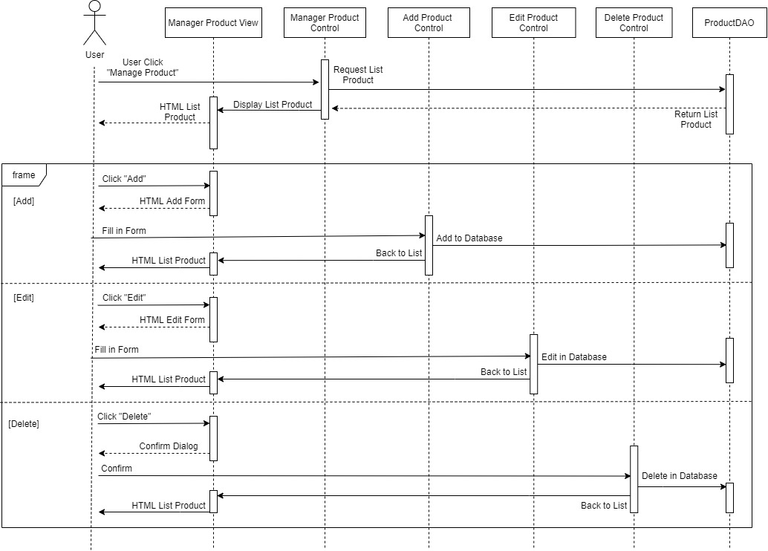

### d. Database queries

*- SELECT * FROM Product WHERE SellerID = ? ORDER BY ProductID OFFSET ? ROWS FETCH NEXT 6 ROWS ONLY*

*- SELECT COUNT(*) FROM Product WHERE SellerID = ?*

*- SELECT * FROM Category*

*- SELECT * FROM Users*

*- INSERT INTO Product VALUES (?, ?, 0, ?, 0, ?, ?, ?, ?, 1, 1);*

*- SELECT * FROM Product WHERE ProductID = ?*

*- UPDATE Product\n"*

*+ "SET ProductName = ?,\n"*

*+ "Description = ?,\n"*

*+ "SellPrice = ?,\n"*

*+ "imageLink = ?,\n"*

*+ "CategoryID = ?,\n"*

*+ "SellerID = ?,\n"*

*+ "Amount = ?\n"*

*+ "WHERE ProductID = ?*

*- DELETE FROM Cart WHERE ProductID = ?\n"*

*+ "DELETE FROM Product WHERE ProductID = ?*

## 16. My Order History

### a. Class Diagram

### b. Class Specifications

***ViewOrder***

|  |  |  |
| --- | --- | --- |
| **No** | **Method** | **Description** |
| *01* | *processRequest* | *Get the data from the database and dump it on the order history page to display the orders view’s user interface* |

***OrderDAO***

***Class Methods***

This class is used performs CRUD with Order table in database

|  |  |  |
| --- | --- | --- |
| **No** | **Method** | **Description** |
| 1 | getAllOrder() | Get all the current orders in database and return list order |
| 2 | add() | Adding a new order to database |
| 3 | addOrder() | adding a new order to database, return the order Id |
| 4 | packaging() | change the status of an order to packaging |
| 5 | delivering() | change the status of an order to delivering |
| 6 | cancled() | change the status of an order to canceled |
| 7 | countOrders() | Count all the number of orders in database and return integer number |
| 8 | getOrderByOrderID() | get a particular order by its id and return Order |
| 9 | getNewestOrderID() | Get the newest order ID |
| 10 | getOrderByUserID() | get list of orders of a specific user and return List Order |
| 11 | Delete() | delete a specific order by the order id |

### c. Sequence Diagram(s)

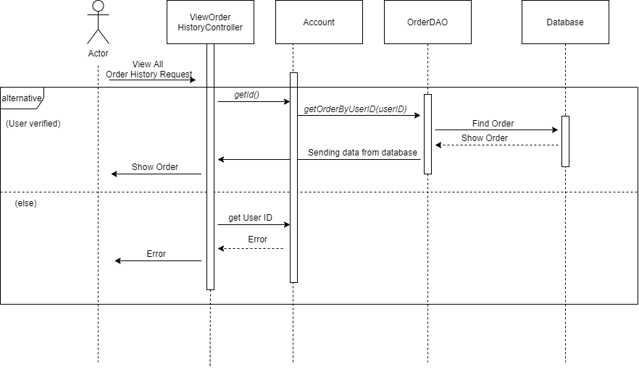

### d. Database queries

SELECT o.ID, o.UserID, o.TotalPrice, o.Note, os.Name, o.DayBuy FROM Orders o INNER JOIN Order_Status os ON o.Status = os.ID WHERE o.UserId = ?

## 17. My order details

### a. Class Diagram

### b. Class Specifications

***ViewOrderDetail***

|  |  |  |
| --- | --- | --- |
| **No** | **Method** | **Description** |
| *01* | *processRequest* | *Get the data from the database and dump it on the view order detail page to display the order detail’s user interface* |

***OrderDAO***

***Class Methods***

|  |  |  |
| --- | --- | --- |
| **No** | **Method** | **Description** |
| 1 | getAllOrder() | Get all the current orders in database and return list order |
| 2 | add() | Adding a new order to database |
| 3 | addOrder() | adding a new order to database, return the order Id |
| 4 | packaging() | change the status of an specific order by the order id |
| 5 | delivering() | … |
| 6 | cancled() | … |
| 7 | countOrders() | Count all the number of orders in database and return integer number |
| 8 | getOrderByOrderID() | get a particular order by its id and return Order |
| 9 | getNewestOrderID() | … |
| 10 | getOrderByUserID() | get list of orders of a specific user and return List Order |
| 11 | Delete() | delete a specific order by the order id |

***OrderWithImageDAO***

***Class Methods***

This class is used to perform CRUD with Order table in database

|  |  |  |
| --- | --- | --- |
| **No** | **Method** | **Description** |
| *01* | *getOrderDetail(int Id)* | *Get a specific order detail by its ID* |

***FeedbackDAO***

***Class Methods***

This class is used to perform CRUD with Feedback table in database

|  |  |  |
| --- | --- | --- |
| **No** | **Method** | **Description** |
| 1 | getId() | Get the ID of a Feedback object |
| 2 | setId() | Set the ID of a Feedback object |
| 3 | getUserId() | Get the User ID of a Feedback object |
| 4 | setUserId() | Set the User ID of a Feedback object |
| 5 | getProductId() | Get the Subtotal of a Feedback object |
| 6 | setProductId() | Set the Subtotal of a Feedback object |
| 7 | getStar() | Get the Star of a Feedback object |
| 8 | setStar() | Set the Star of a Feedback object |
| 9 | getFeedbackDetail() | Get the Feedback Detail of a Feedback object |
| 10 | setFeedbackDetail() | Set the Feedback Detail of a Feedback object |
| 11 | getListReplies () | Get the list of Replies of a Feedback object |
| 12 | setListReplies () | Set the list of Replies of a Feedback object |
| 13 | toString() | Convert all information of a Feedback object to a string |

### c. Sequence Diagram(s)

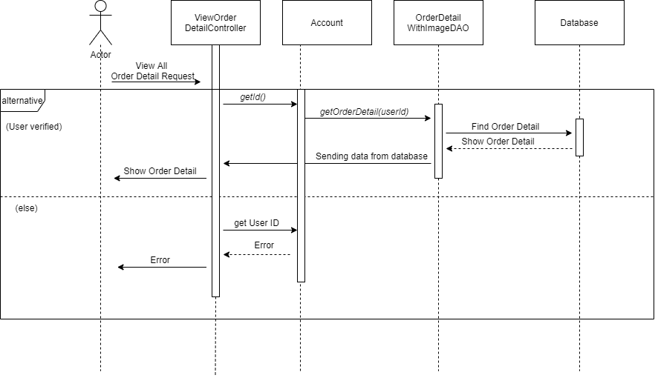

### d. Database queries

SELECT od.id, od.order_id, od.productId, od.productName,od.quantity, od.productPrice, p.imageLink

FROM Order_Detail od INNER JOIN Product p

ON od.ProductID = p.ProductID

WHERE od.Order_ID = ?

## 18. Notifications

### a. Class Diagram

### b. Class Specifications

***ViewAllNotifications***

|  |  |  |
| --- | --- | --- |
| **No** | **Method** | **Description** |
| *01* | *processRequest* | *Get the data from the database and dump it on the view all notifications page to display the notification’s user interface* |

***NotificationDAO***

***Class Methods***

This class performs CRUD with Notifications table in databse

|  |  |  |
| --- | --- | --- |
| **No** | **Method** | **Description** |
| *01* | *countNotifications(userId)* | *Get number of notifications received from a specific user* |
| *02* | *getAllNotificationsByUserID(id)* | *Get all notifications of an user by their ID* |
| *03* | *approveOrderAdminNoti(userId, orderId)* | *Send a notification to a specific user that their order has been approved* |
| *04* | *finishOrderUserNoti(userId, orderId)* | *Send a notification to admin that the customer order has been shipped successfully* |
| *05* | *deliverOrderAdminNoti(userId, orderId)* | *Send a notification to a specific user that their order has been packaged and now being delivered* |
| *06* | *userReceivedOrderNoti(userId, orderId, <adminSellerId>)* | *Inform to the seller and admin that the order has been paid successfully!* |
| *07* | *userBuyNoti(int userId, int orderId, <sellerId>)* | *Inform to seller of the product and admin that an customer has placed an order* |
| *08* | *userBuyNotiAdmin(userId, orderId)* | *Inform to admin that an customer has placed an order* |
| *09* | *cancelOrderNoti(userId, OrderId)* | *Adding a notification to user by admin that their order has been canceled* |
| *10* | *getTop5NotificationsByUserID(userId)* | *Get 5 most recently notifications of an user* |
| *11* | *getAllNotificationsByUserID(userID)* | *Get all notifications of an user* |
| *12* | *getUnreadNotificationsByUserID(userID)* | *Get all unread notifications of an user* |
| *13* | *read(userId)* | *Set all notifications to status read* |
| *14* | *readOneNoti(userId, orderID)* | *Set a specific notifications of an user to read* |
| *15* | *countUnreadNotifications(userId)* | *Count unread notifications of an user* |
| *16* | *countNotifications(userId)* | *Count all notifications of an user* |
| *17* | *adminApproveNotiSeller(userId, orderId, <sellerId>)* | *Inform seller of the product that their product has been placed in an order* |
| *18* | *userReceivedNotiSeller(userId, orderId, <sellerID>)* | *Inform seller of the product that their product has been purchased successfully* |

### c. Sequence Diagram(s)

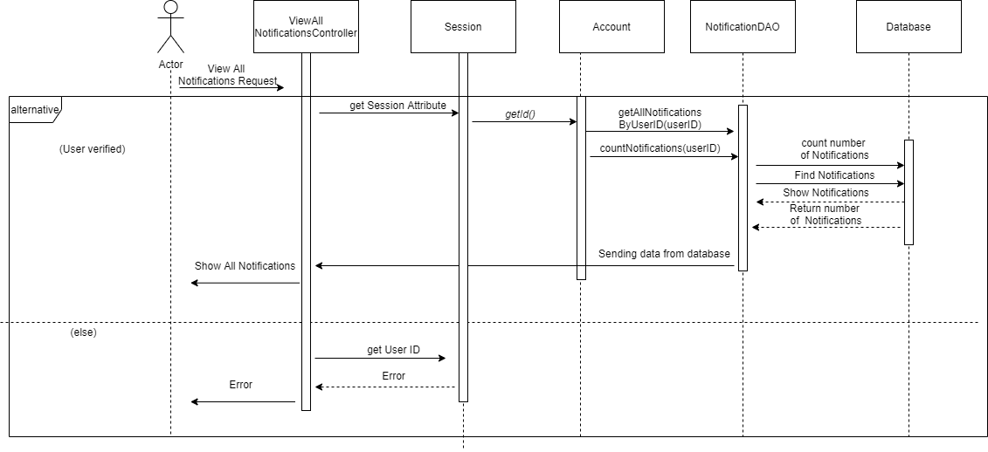

### d. Database queries

+ SELECT COUNT(*) FROM Notifications WHERE userId=?

+ SELECT * FROM Notifications WHERE userID=? ORDER BY id DESC

## 19. View All Invocies

### a. Class Diagram

### b. Class Specifications

***ViewAllInvoiceAdmin***

|  |  |  |
| --- | --- | --- |
| **No** | **Method** | **Description** |
| *01* | *processRequest* | *Get the data from the database and dump it on the view all invoices admin page to display all invoices with user interface* |

***OrderDAO***

***Class Methods***

This class performs CRUD with Order table in database

|  |  |  |
| --- | --- | --- |
| **No** | **Method** | **Description** |
| 1 | getAllOrder() | Get all the current orders in database and return list order |
| 2 | add() | Adding a new order to database |
| 3 | addOrder() | adding a new order to database, return the order Id |
| 4 | packaging() | change the status of an specific order by the order id |
| 5 | delivering() | … |
| 6 | cancled() | … |
| 7 | countOrders() | Count all the number of orders in database and return integer number |
| 8 | getOrderByOrderID() | get a particular order by its id and return Order |
| 9 | getNewestOrderID() | … |
| 10 | getOrderByUserID() | get list of orders of a specific user and return List Order |
| 11 | Delete() | delete a specific order by the order id |

### c. Sequence Diagram(s)

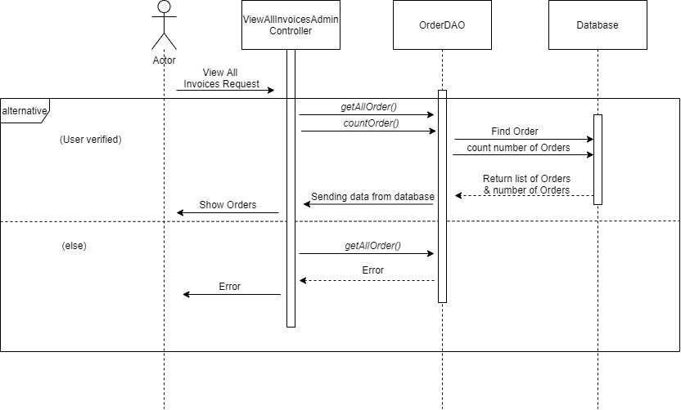

### d. Database queries

+ SELECT o.ID,o.USERID,o.TotalPrice, o.Note, os.Name, o.Daybuy

FROM Orders o INNER JOIN Order_Status os

ON o.Status = os.ID

+ SELECT COUNT(*) FROM Orders

## 20. View Invoice Detail

### a. Class Diagram

### b. Class Specifications

***ViewAllInvoiceAdmin***

|  |  |  |
| --- | --- | --- |
| **No** | **Method** | **Description** |
| *01* | *processRequest* | *Get the data from the database and dump it on the view invoice detail admin page to display detailed invoice with user interface* |

***NotificationDAO***

***Class Methods***

This class performs CRUD with Notifications table in databse

|  |  |  |
| --- | --- | --- |
| **No** | **Method** | **Description** |
| *01* | *countNotifications(userId)* | *Get number of notifications received from a specific user* |
| *02* | *getAllNotificationsByUserID(id)* | *Get all notifications of an user by their ID* |
| *03* | *approveOrderAdminNoti(userId, orderId)* | *Send a notification to a specific user that their order has been approved* |
| *04* | *finishOrderUserNoti(userId, orderId)* | *Send a notification to admin that the customer order has been shipped successfully* |
| *05* | *deliverOrderAdminNoti(userId, orderId)* | *Send a notification to a specific user that their order has been packaged and now being delivered* |
| *06* | *userReceivedOrderNoti(userId, orderId, <adminSellerId>)* | *Inform to the seller and admin that the order has been paid successfully!* |
| *07* | *userBuyNoti(int userId, int orderId, <sellerId>)* | *Inform to seller of the product and admin that an customer has placed an order* |
| *08* | *userBuyNotiAdmin(userId, orderId)* | *Inform to admin that an customer has placed an order* |
| *09* | *cancelOrderNoti(userId, OrderId)* | *Adding a notification to user by admin that their order has been canceled* |
| *10* | *getTop5NotificationsByUserID(userId)* | *Get 5 most recently notifications of an user* |
| *11* | *getAllNotificationsByUserID(userID)* | *Get all notifications of an user* |
| *12* | *getUnreadNotificationsByUserID(userID)* | *Get all unread notifications of an user* |
| *13* | *read(userId)* | *Set all notifications to status read* |
| *14* | *readOneNoti(userId, orderID)* | *Set a specific notifications of an user to read* |
| *15* | *countUnreadNotifications(userId)* | *Count unread notifications of an user* |
| *16* | *countNotifications(userId)* | *Count all notifications of an user* |
| *17* | *adminApproveNotiSeller(userId, orderId, <sellerId>)* | *Inform seller of the product that their product has been placed in an order* |
| *18* | *userReceivedNotiSeller(userId, orderId, <sellerID>)* | *Inform seller of the product that their product has been purchased successfully* |

***OrderDAO***

***Class Methods***

This class performs CRUD with Order table in database

|  |  |  |
| --- | --- | --- |
| **No** | **Method** | **Description** |
| 1 | getAllOrder() | Get all the current orders in database and return list order |
| 2 | add() | Adding a new order to database |
| 3 | addOrder() | adding a new order to database, return the order Id |
| 4 | packaging() | change the status of an specific order by the order id |
| 5 | delivering() | … |
| 6 | cancled() | … |
| 7 | countOrders() | Count all the number of orders in database and return integer number |
| 8 | getOrderByOrderID() | get a particular order by its id and return Order |
| 9 | getNewestOrderID() | … |
| 10 | getOrderByUserID() | get list of orders of a specific user and return List Order |
| 11 | Delete() | delete a specific order by the order id |

***InvoiceDAO***

***Class Methods***

This class performs CRUD with Order table in database

|  |  |  |
| --- | --- | --- |
| **No** | **Method** | **Description** |
| 1 | getInvoiceDetailBy  OrderID(orderId) | Get detailed invoice of an order ID |
| 2 | getInvoiceDetailBySellerID(sellerID) | Get all sold products of a seller |
| 3 | countProductSoldOfSeller(sellerID) | Count number of product sold of a seller |

***Order***

***Class Methods***

This class represents Order entity

|  |  |  |
| --- | --- | --- |
| **No** | **Method** | **Description** |
| 1 | getId() | Get the ID of an Order object |
| 2 | setId() | Set the ID of an Order object |
| 3 | getUserId() | Get the User ID of an Order object |
| 4 | setUserId() | Set the User ID of an Order object |
| 5 | getTotalPrice() | Get the Subtotal of an Order object |
| 6 | setTotalPrice () | Set the Subtotal of an Order object |
| 7 | getNote () | Get the Note of an Order object |
| 8 | setNote() | Set the Note of an Order object |
| 9 | getStatus () | Get the Status of an Order object |
| 10 | setStatus() | Set the Status of an Order object |
| 11 | getDate() | Get the Order Date of an Order object |
| 12 | setDate() | Set the Order Date of an Order object |

### c. Sequence Diagram(s)

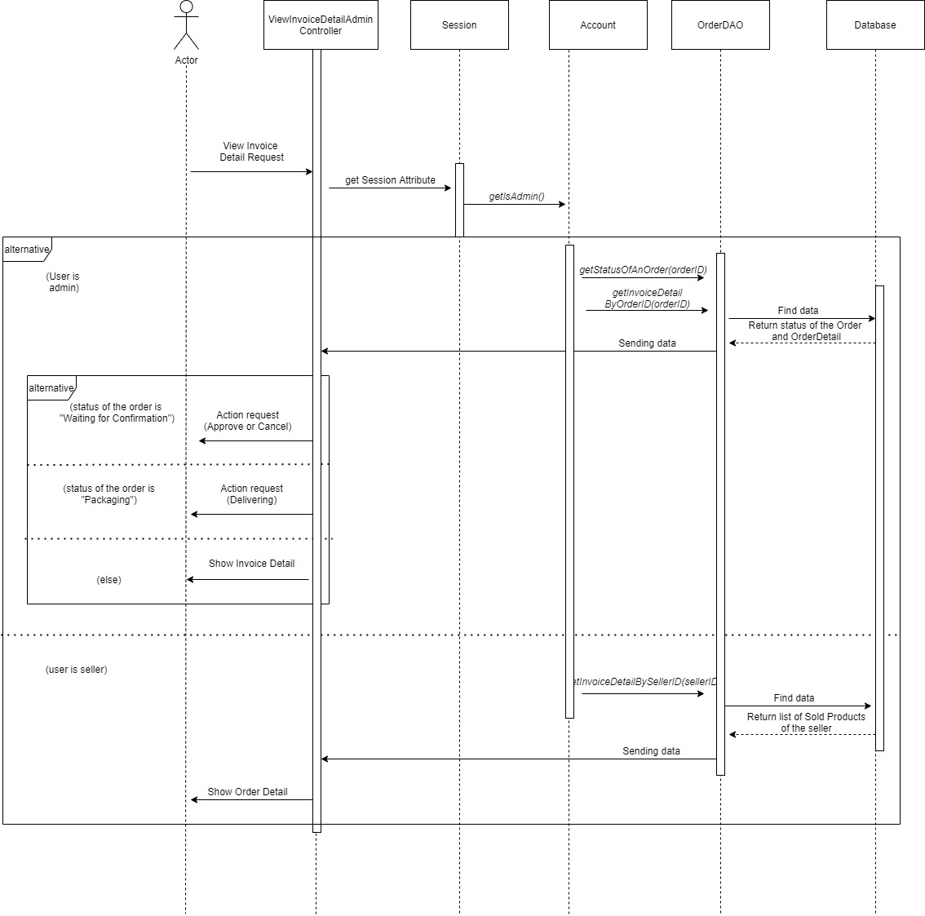

### d. Database queries

+ SELECT status FROM Orders WHERE ID=?

+ SELECT COUNT(*) FROM Orders

+ SELECT od.id,u.UserId, od.Order_ID, u.username,od.productId,

p.productName,p.imageLink,p.SellPrice,od.quantity,

si.shippingAddress, si.phoneNum

FROM Order_Detail od INNER JOIN Orders o

ON od.Order_ID = o.ID

INNER JOIN Users u

ON o.UserID = u.UserID

INNER JOIN Product p

ON od.ProductID = p.ProductID

INNER JOIN ShipInfo si

ON o.ID = si.Order_ID

WHERE od.Order_ID = ?

ORDER BY od.ID DESC

+ SELECT o.ID,o.UserId,o.TotalPrice, o.Note, o.DayBuy, os.Name

FROM Orders o INNER JOIN Order_Status os

ON o.Status = os.ID

WHERE o.ID = ?

+ SELECT od.id,u.userId, od.Order_ID, u.username,od.productId,

p.productName,p.imageLink,

p.SellPrice, si.shippingAddress,

si.phoneNum, od.quantity

FROM Order_Detail od INNER JOIN Orders o

ON od.Order_ID = o.ID

INNER JOIN Users u

ON o.UserID = u.UserID

INNER JOIN Product p

ON od.ProductID = p.ProductID

INNER JOIN ShipInfo si

ON o.ID = si.Order_ID

WHERE p.SellerID = ? and o.status <> 1 and o.Status<>4

ORDER BY od.ID DESC

+ SELECT COUNT(*) FROM Order_Detail od INNER JOIN Orders o

ON od.Order_ID = o.ID

INNER JOIN Users u

ON o.UserID = u.UserID

INNER JOIN Product p

ON od.ProductID = p.ProductID

INNER JOIN ShipInfo si

ON o.ID = si.Order_ID

WHERE p.SellerID = ? and o.status <> 1 and o.Status<>4

+ UPDATE Notifications SET Status = 'read' WHERE userID = ? AND orderID=?

## 21. Compare

### a. Class Diagram

### b. Class Specifications

***Compare***

|  |  |  |
| --- | --- | --- |
| **No** | **Method** | **Description** |
| *01* | *processRequest* | *Get the first chosen product and send it to the comparing page with user interface* |

***ProductDAO***

***Class Methods***

This class performs CRUD with Product table in database

|  |  |  |
| --- | --- | --- |
| **No** | **Method** | **Description** |
| 1 | getAllProduct() | … |
| 2 | getHotProduct() | return Product with the highest sold amount |
| 3 | getFavoriteProduct  () | return get the first and the second product with most sold amount |
| 4 | getProductBy  SellID() | return the list of products of a particular seller |
| 5 | Edit() | Edit the information of a particular product, select by product ID |
| 6 | Delete() | Delete a product, select by its ID |
| 7 | Add() | Adding a new product to the database, the ID is no need to be added because it is automatically added |
| 8 | countProduct() | return the total number of products |
| 9 | pagingProduct() | Every 6 products will be displayed in a single page and return list of 6 products |
| 10 | pagingByCategory() | categorizing products and return list of products with same category |
| 11 | pagingManager  Product() | … |
| 12 | countProductBy  Category() | count total product |
| 13 | countProductBy  Seller() | Count the products of a particular seller and return the number of product |
| 14 | getProductByID() | Get data of Product Table searched by UserID |
| 15 | getProductDetailBy  ID() | Get Product for Detail |
| 16 | getProductForManager() | Get a particular product and return a product |
| 17 | SearchProductBy  Name() | Search for a particular product by filling its name |
| 18 | searchProductIn  Manager() | Search for a product in admin/moderator mode by filling its name |
| 19 | top3MostSell() | Select top 3 most sold products and return product |
| 20 | top3LeastSell() | Select top 3 least sold products and return product |

***InforDAO***

***Class Methods***

This class interact with Information table in database

|  |  |  |
| --- | --- | --- |
| **No** | **Method** | **Description** |
| 1 | getInfor() | Return information of the administrator's place (There's only one) |

***CategoryDAO***

***Class Methods***

This class interact with Category table in database

|  |  |  |
| --- | --- | --- |
| **No** | **Method** | **Description** |
| 1 | getAllCategory() | Return all list Category |
| 2 | getCateNameByID() | Select a specified category by its ID, used for categorizing products in homepage |

***ProductCompareDAO***

***Class Methods***

This class interact with Product table in database

|  |  |  |
| --- | --- | --- |
| **No** | **Method** | **Description** |
| 1 | getProductByID(id) | Return information of the product |

### c. Sequence Diagram(s)

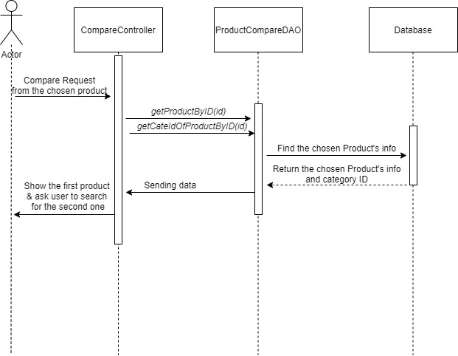

### d. Database queries

+ SELECT TOP 1 * FROM Product

ORDER BY Amount DESC

+ SELECT CategoryId FROM Product WHERE ProductID = ?

+ SELECT TOP 2 * FROM Product

ORDER BY Amount DESC

+ SELECT * FROM Information

+ SELECT * FROM Product WHERE ProductID = ?

+ SELECT * FROM Product

+ SELECT * FROM Category

## 22. CompareFinal

### a. Class Diagram

### b. Class Specifications

***Compare***

|  |  |  |
| --- | --- | --- |
| **No** | **Method** | **Description** |
| *01* | *processRequest* | *Get the second chosen product and send it to the comparing page with user interface* |

***ProductDAO***

***Class Methods***

|  |  |  |
| --- | --- | --- |
| **No** | **Method** | **Description** |
| 1 | getAllProduct() | … |
| 2 | getHotProduct() | return Product with the highest sold amount |
| 3 | getFavoriteProduct  () | return get the first and the second product with most sold amount |
| 4 | getProductBy  SellID() | return the list of products of a particular seller |
| 5 | Edit() | Edit the information of a particular product, select by product ID |
| 6 | Delete() | Delete a product, select by its ID |
| 7 | Add() | Adding a new product to the database, the ID is no need to be added because it is automatically added |
| 8 | countProduct() | return the total number of products |
| 9 | pagingProduct() | Every 6 products will be displayed in a single page and return list of 6 products |
| 10 | pagingByCategory() | categorizing products and return list of products with same category |
| 11 | pagingManager  Product() | … |
| 12 | countProductBy  Category() | count total product |
| 13 | countProductBy  Seller() | Count the products of a particular seller and return the number of product |
| 14 | getProductByID() | Get data of Product Table searched by UserID |
| 15 | getProductDetailBy  ID() | Get Product for Detail |
| 16 | getProductForManager() | Get a particular product and return a product |
| 17 | SearchProductBy  Name() | Search for a particular product by filling its name |
| 18 | searchProductIn  Manager() | Search for a product in admin/moderator mode by filling its name |
| 19 | top3MostSell() | Select top 3 most sold products and return product |
| 20 | top3LeastSell() | Select top 3 least sold products and return product |

***InforDAO***

***Class Methods***

This class interact with Information table in database

|  |  |  |
| --- | --- | --- |
| **No** | **Method** | **Description** |
| 1 | getInfor() | Return information of the administrator's place (There's only one) |

***ProductCompareDAO***

***Class Methods***

This class interact with Product table in database

|  |  |  |
| --- | --- | --- |
| **No** | **Method** | **Description** |
| 1 | getProductByID(id) | Return information of the product |

### c. Sequence Diagram(s)

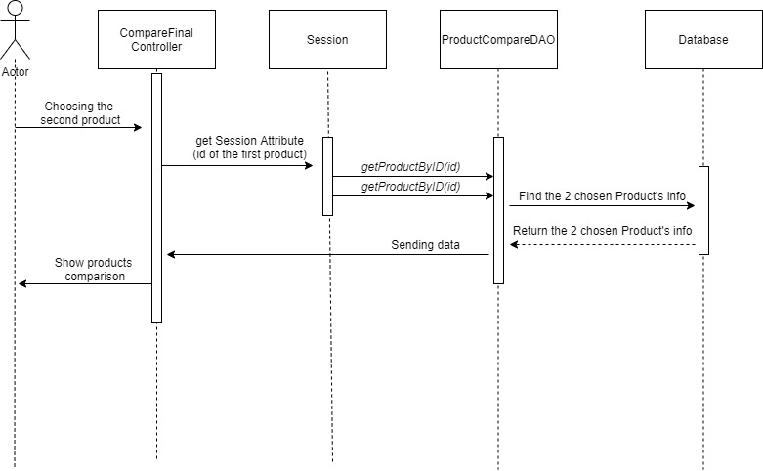

### d. Database queries

+ SELECT TOP 1 * FROM Product

ORDER BY Amount DESC

+ SELECT TOP 2 * FROM Product

ORDER BY Amount DESC

+ SELECT * FROM Information

+ SELECT * FROM Product WHERE ProductID = ?

## 24. User List

### a. Class Diagram



### b. Class Specifications

#### AccountManagerControl Class: This class process request for all list in Account

|  |  |  |
| --- | --- | --- |
| **No** | **Method** | **Description** |
| 1 | processRequest() | Select all list of Account in SQL server and return AccountManager.jsp |
| 2 | doGet() | Nothing |
| 3 | doPost() | Nothing |
| 4 | getServletInfo() | Return a String containing servlet description |

#### UserDAO Class

|  |  |  |
| --- | --- | --- |
| **No** | **Method** | **Description** |
| 1 | Login() | For login an account to the website and return the account information of the account logging in, null if username or password does not exist |
| 2 | signUp() | Use for signup an account to the website |
| 3 | signUpFB() | Used when user try to login via FB, the password will be set automatically and the user will be added to database |
| 4 | getAllAccounts() | Get all account from database and return the list of account from the database |
| 5 | deleteAccount() | Delete an account from the database |
| 6 | editAccount() | Update the information of an account |
| 7 | updatePassword() | Update the password of a user |
| 8 | getAccountByID() | Find an account by id and eturn the found account, null if the account does not exist in the database |
| 9 | getAccountByEmail  () | Find an account by email return the found account, null if the account does not exist in the database |
| 10 | getAccountBy  Username() | Find an account by username and return the found account, null if the account does not exist in the database |
| 11 | updateStatus() | Update status of an account and return true if update successful |
| 12 | countAllAccount() | Return the number of account in the database |

#### Account Class: This class stores information of a Account

|  |  |  |
| --- | --- | --- |
| **No** | **Method** | **Description** |
| 1 | getId() | Get the ID of an Account |
| 2 | setId() | Set the ID of an Account |
| 3 | getUser() | Get the Username of an Account |
| 4 | setUser() | Set the Username of an Account |
| 5 | getEmail() | Get the Email of an Account |
| 6 | setEmail() | Set the Email of an Account |
| 7 | getIsSell() | Check if an Account has the seller role |
| 8 | setIsSell() | Add/remove seller role to/from an Account |
| 9 | getIsAdmin() | Check if an Account has the admin role |
| 10 | setIsAdmin() | Add/remove admin role to/from an Account |
| 11 | getStatus() | Get the Status of an Account |
| 12 | setStatus() | Set the Status of an Account |
| 13 | toString() | Convert all information of an Account to a string |

### c. Sequence Diagram(s)

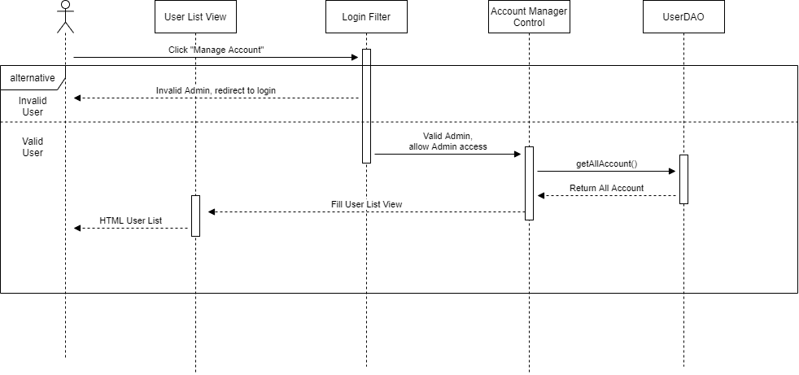

### d. Database queries

- " select * from Users";

## 25. Blog List

### a. Class Diagram

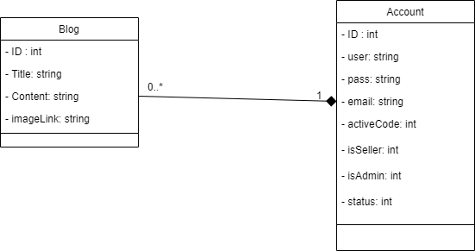

### b. Class Specifications

#### BlogListControl Class: This class process request for all list in Blog

|  |  |  |
| --- | --- | --- |
| **No** | **Method** | **Description** |
| 1 | processRequest() | Select all list of Blog in SQL server and return BlogList.jsp |
| 2 | doGet() | Nothing |
| 3 | doPost() | Nothing |
| 4 | getServletInfo() | Return a String containing servlet description |

#### BlogDAO Class: This class performs CRUD actions to Blog table in the database

|  |  |  |
| --- | --- | --- |
| **No** | **Method** | **Description** |
| 1 | getHotBlog() | Get First Blog in Database |
| 2 | getAllBlog() | Get All Blog In Database |
| 3 | getBlogByID() | Get Blog Need to View Detail |
| 4 | add() | Add new Blog |
| 5 | edit() | edit blog by ID |
| 6 | delete() | delete blog by ID |
| 7 | getBlogForManager() | Get Post List In Manage Blog For Seller |

**Blog Class: This class stores information of a Blog**

|  |  |  |
| --- | --- | --- |
| **No** | **Method** | **Description** |
| 1 | getId() | Get the ID of a Blog |
| 2 | setId() | Set the ID of an Blog |
| 3 | getTitle() | Get the Title of a Blog |
| 4 | setTitle() | Set the Title of a Blog |
| 5 | getContent() | Get the Content of a Blog |
| 6 | setContent() | Set the Content of a Blog |
| 7 | getImageLink() | Get the ImageLink of a Blog |
| 8 | setImageLink() | Set the ImageLink of a Blog |

### c. Sequence Diagram(s)

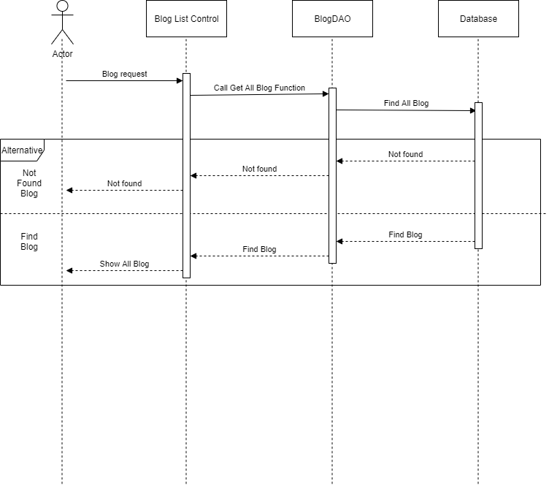

### d. Database queries

-"SELECT * FROM Blog"

## 26. Blog Detail

### a. Class Diagram



### b. Class Specifications

#### DetailBlogControll Class: This class process request for a detail of Blog

|  |  |  |
| --- | --- | --- |
| **No** | **Method** | **Description** |
| 1 | processRequest() | Get ID of Blog need to see and use function getBlogByID to view Detail of Blog in Database and push to BlogDetail.jsp |
| 2 | doGet() | Nothing |
| 3 | doPost() | Nothing |
| 4 | getServletInfo() | Return a String containing servlet description |

#### BlogDAO Class: This class performs CRUD actions to Blog table in the database

|  |  |  |
| --- | --- | --- |
| **No** | **Method** | **Description** |
| 1 | getHotBlog() | Get First Blog in Database |
| 2 | getAllBlog() | Get All Blog In Database |
| 3 | getBlogByID() | Get Blog Need to View Detail |
| 4 | add() | Add new Blog |
| 5 | edit() | edit blog by ID |
| 6 | delete() | delete blog by ID |
| 7 | getBlogForManager() | Get Post List In Manage Blog For Seller |

**Blog Class: This class stores information of a Blog**

|  |  |  |
| --- | --- | --- |
| **No** | **Method** | **Description** |
| 1 | getId() | Get the ID of a Blog |
| 2 | setId() | Set the ID of an Blog |
| 3 | getTitle() | Get the Title of a Blog |
| 4 | setTitle() | Set the Title of a Blog |
| 5 | getContent() | Get the Content of a Blog |
| 6 | setContent() | Set the Content of a Blog |
| 7 | getImageLink() | Get the ImageLink of a Blog |
| 8 | setImageLink() | Set the ImageLink of a Blog |

### c. Sequence Diagram(s)

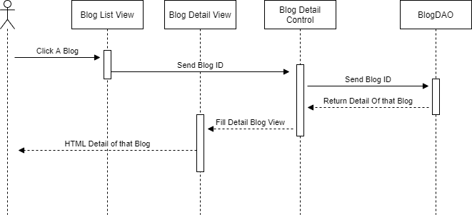

### d. Database queries

- "SELECT * FROM Blog WHERE ID = ?"

## 27. Post List

### a. Class Diagram



### b. Class Specifications

#### BlogManagerControl Class: This class process request for list of Blog create by SellerID

|  |  |  |
| --- | --- | --- |
| **No** | **Method** | **Description** |
| 1 | processRequest() | Select list Blog of Seller in SQL server and return ManageBlog.jsp |
| 2 | doGet() | Nothing |
| 3 | doPost() | Nothing |
| 4 | getServletInfo() | Return a String containing servlet description |

**BlogDAO Class: : This class performs CRUD actions to Blog table in the database**

|  |  |  |
| --- | --- | --- |
| **No** | **Method** | **Description** |
| 1 | getHotBlog() | Get First Blog in Database |
| 2 | getAllBlog() | Get All Blog In Database |
| 3 | getBlogByID() | Get Blog Need to View Detail |
| 4 | add() | Add new Blog |
| 5 | edit() | edit blog by ID |
| 6 | delete() | delete blog by ID |
| 7 | getBlogForManager() | Get Post List In Manage Blog For Seller |

**BlogInManager Class: This class stores information of a Blog create by Seller**

|  |  |  |
| --- | --- | --- |
| **No** | **Method** | **Description** |
| 1 | getId() | Get the ID of a Blog |
| 2 | setId() | Set the ID of an Blog |
| 3 | getTitle() | Get the Title of a Blog |
| 4 | setTitle() | Set the Title of a Blog |
| 5 | getContent() | Get the Content of a Blog |
| 6 | setContent() | Set the Content of a Blog |
| 7 | getImageLink() | Get the ImageLink of a Blog |
| 8 | setImageLink() | Set the ImageLink of a Blog |
| 9 | getSellerID() | Get the ID of Seller to Create Blog |
| 10 | setSellerID() | Set the ID of Seller to Create Blog |

### c. Sequence Diagram(s)

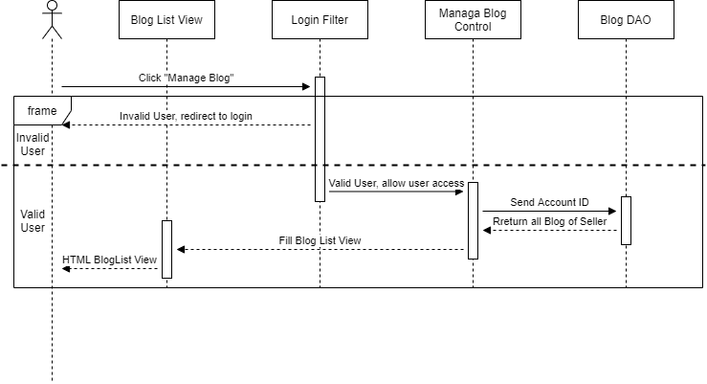

### d. Database queries

- "SELECT * FROM Blog WHERE ID = ?"

## 28. Post Detail

### a. Class Diagram



### b. Class Specifications

#### EditBlogControll Class: The doGet function is used to get the ID of the blog and then use the doPost function to edit the product

|  |  |  |
| --- | --- | --- |
| **No** | **Method** | **Description** |
| 1 | processRequest() | Nothing |
| 2 | doGet() | Get ID of Blog and push ID, title, content, imageLink, Seller ID to EditBlog.jsp to edit |
| 3 | doPost() | Get ID, title, content, imageLink, Seller ID in EditBlog.jsp when changed, use edit function in BlogDAO to edit blog and comback BlogManageControl Class |
| 4 | getServletInfo() | Return a String containing servlet description |

#### DeleteBlogControll Class: use process request function to get and delete blogs by ID

|  |  |  |
| --- | --- | --- |
| **No** | **Method** | **Description** |
| 1 | processRequest() | Get ID of Blog need to Delete and use function delete in BlogDAO to delete blog by ID and comeback Error.jsp |
| 2 | doGet() | Nothing |
| 3 | doPost() | Nothing |
| 4 | getServletInfo() | Return a String containing servlet description |

#### AddBlogControll Class: Use the process request function to add more Blogs

|  |  |  |
| --- | --- | --- |
| **No** | **Method** | **Description** |
| 1 | processRequest() | Get title, content, imageLink, SellerID and use function add in Blog DAO to create new Blog In Database |
| 2 | doGet() | Nothing |
| 3 | doPost() | Nothing |
| 4 | getServletInfo() | Return a String containing servlet description |

**BlogDAO Class: This class performs CRUD actions to Blog table in the database**

|  |  |  |
| --- | --- | --- |
| **No** | **Method** | **Description** |
| 1 | getHotBlog() | Get First Blog in Database |
| 2 | getAllBlog() | Get All Blog In Database |
| 3 | getBlogByID() | Get Blog Need to View Detail |
| 4 | add() | Add new Blog |
| 5 | edit() | edit blog by ID |
| 6 | delete() | delete blog by ID |
| 7 | getBlogForManager() | Get Post List In Manage Blog For Seller |

**BlogInManager Class: This class stores information of a Blog create by Seller**

|  |  |  |
| --- | --- | --- |
| **No** | **Method** | **Description** |
| 1 | getId() | Get the ID of a Blog |
| 2 | setId() | Set the ID of an Blog |
| 3 | getTitle() | Get the Title of a Blog |
| 4 | setTitle() | Set the Title of a Blog |
| 5 | getContent() | Get the Content of a Blog |
| 6 | setContent() | Set the Content of a Blog |
| 7 | getImageLink() | Get the ImageLink of a Blog |
| 8 | setImageLink() | Set the ImageLink of a Blog |
| 9 | getSellerID() | Get the ID of Seller to Create Blog |
| 10 | setSellerID() | Set the ID of Seller to Create Blog |

### c. Sequence Diagram(s)

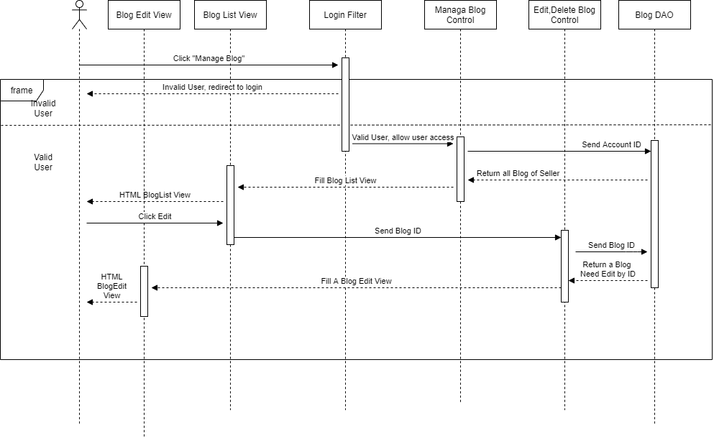

### d. Database queries

- "Delete FROM Blog WHERE ID = ?"

- "Update Blog SET Title =?, Content=?, imageLink=?, SellerID= ? Where ID =?""

- "INSERT INTO Blog VALUES (?,?,?,?)"

# III. Database Tables

## 1. User Status

*Store the status of an Account*

|  |  |  |  |  |  |  |  |
| --- | --- | --- | --- | --- | --- | --- | --- |
| **#** | **Field name** | **Type** | **Size** | **Unique** | **Not Null** | **PK/FK** | **Notes** |
| 1 | ID | int |  |  | Yes | PK |  |
| 2 | StatusName | nvarchar | 1000 |  |  |  |  |

## 2. Users

*Store the information of all users*

|  |  |  |  |  |  |  |  |
| --- | --- | --- | --- | --- | --- | --- | --- |
| **#** | **Field name** | **Type** | **Size** | **Unique** | **Not Null** | **PK/FK** | **Notes** |
| 1 | UserID | int |  |  | Yes | PK |  |
| 2 | Username | nvarchar | 500 |  |  |  |  |
| 3 | Password | nvarchar | 1000 |  |  |  |  |
| 4 | email | nvarchar | 1000 |  |  |  |  |
| 5 | ActiveCode | nvarchar | 11 |  |  |  |  |
| 4 | isSeller | int |  |  |  |  |  |
| 5 | isAdmin | int |  |  |  |  |  |
| 6 | StatusID | int |  |  |  | FK |  |

## 3. Category

*Store the information of all categories of products*

|  |  |  |  |  |  |  |  |
| --- | --- | --- | --- | --- | --- | --- | --- |
| **#** | **Field name** | **Type** | **Size** | **Unique** | **Not Null** | **PK/FK** | **Notes** |
| 1 | CategoryID | int |  |  | Yes | PK |  |
| 2 | CategoryName | nvarchar | 1000 |  |  |  |  |
| 3 | icon | nvarchar | 1000 |  |  |  |  |

## 4. Product Status

*Store the status of a Product (out of stock or not)*

|  |  |  |  |  |  |  |  |
| --- | --- | --- | --- | --- | --- | --- | --- |
| **#** | **Field name** | **Type** | **Size** | **Unique** | **Not Null** | **PK/FK** | **Notes** |
| 1 | StatusID | int |  |  | Yes | PK |  |
| 2 | StatusName | nvarchar | 1000 |  |  |  |  |

## 5. Manufacturer

*Store the information of the Manufacturer of a Product*

|  |  |  |  |  |  |  |  |
| --- | --- | --- | --- | --- | --- | --- | --- |
| **#** | **Field name** | **Type** | **Size** | **Unique** | **Not Null** | **PK/FK** | **Notes** |
| 1 | ManufacturerID | int |  |  | Yes | PK |  |
| 2 | Manufacturer  Name | nvarchar | 1000 |  |  |  |  |

## 6. Product

*Store the information of all products*

| **#** | **Field name** | **Type** | **Size** | **Unique** | **Not Null** | **PK/FK** | **Notes** |
| --- | --- | --- | --- | --- | --- | --- | --- |
| 1 | ProductID | int |  |  | Yes | PK |  |
| 2 | ProductName | nvarchar | 1000 |  |  |  |  |
| 3 | Description | nvarchar | 2000 |  |  |  |  |
| 4 | OriginalPrice | int |  |  |  |  |  |
| 5 | SellPrice | int |  |  |  |  |  |
| 6 | SalePercent | int |  |  |  |  | SalePercent>=1 AND SalePercent<=100 |
| 5 | imageLink | nvarchar | 1000 |  |  |  |  |
| 6 | CategoryID | int |  |  |  | FK |  |
| 7 | SellerID | int |  |  |  | FK |  |
| 8 | Amount | int |  |  |  |  |  |
| 9 | StatusID | int |  |  |  | FK |  |
| 10 | ManufacturerID | int |  |  |  | FK |  |
| 11 | height | float |  |  |  |  |  |
| 12 | width | float |  |  |  |  |  |
| 13 | weight | float |  |  |  |  |  |

## 7. Information

*Store some information of the shop*

|  |  |  |  |  |  |  |  |
| --- | --- | --- | --- | --- | --- | --- | --- |
| **#** | **Field name** | **Type** | **Size** | **Unique** | **Not Null** | **PK/FK** | **Notes** |
| 1 | description | nvarchar | max |  |  |  |  |
| 2 | address | nvarchar | max |  |  |  |  |
| 3 | email | nvarchar | max |  |  |  |  |
| 4 | phone | nvarchar | max |  |  |  |  |
| 5 | fax | nvarchar | max |  |  |  |  |

## 8. Cart

*Store information of the Cart of each Customer*

| **#** | **Field name** | **Type** | **Size** | **Unique** | **Not Null** | **PK/FK** | **Notes** |
| --- | --- | --- | --- | --- | --- | --- | --- |
| 1 | UserID | int |  |  | Yes | FK |  |
| 2 | ProductID | int |  |  |  | FK |  |
| 3 | Amount | int |  |  |  |  |  |

## 9. Order_Status

*Store the status of an Order*

|  |  |  |  |  |  |  |  |
| --- | --- | --- | --- | --- | --- | --- | --- |
| **#** | **Field name** | **Type** | **Size** | **Unique** | **Not Null** | **PK/FK** | **Notes** |
| 1 | ID | int |  |  | Yes | PK |  |
| 2 | Name | nvarchar |  |  |  |  |  |

## 10. Orders

*Store information of all orders*

|  |  |  |  |  |  |  |  |
| --- | --- | --- | --- | --- | --- | --- | --- |
| **#** | **Field name** | **Type** | **Size** | **Unique** | **Not Null** | **PK/FK** | **Notes** |
| 1 | ID | int |  |  | Yes | PK |  |
| 2 | UserID | int |  |  |  | FK |  |
| 3 | TotalPrice | float |  |  |  |  |  |
| 4 | Note | nvarchar | 2000 |  |  |  |  |
| 5 | Status | int |  |  |  |  |  |
| 6 | Daybuy | Datetime |  |  |  |  |  |

## 11. Order_Detail

*Store products information of all orders*

|  |  |  |  |  |  |  |  |
| --- | --- | --- | --- | --- | --- | --- | --- |
| **#** | **Field name** | **Type** | **Size** | **Unique** | **Not Null** | **PK/FK** | **Notes** |
| 1 | ID | int |  |  | Yes | PK |  |
| 2 | Order_ID | int |  |  |  | FK |  |
| 3 | ProductID | Int |  |  |  | FK |  |
| 4 | ProductName | nvarchar | 1000 |  |  |  |  |
| 5 | ProductPrice | int |  |  |  |  |  |
| 6 | Quantity | int |  |  |  |  |  |

## 12. Ship

*Store the ship Price of each City*

|  |  |  |  |  |  |  |  |
| --- | --- | --- | --- | --- | --- | --- | --- |
| **#** | **Field name** | **Type** | **Size** | **Unique** | **Not Null** | **PK/FK** | **Notes** |
| 1 | ID | int |  |  | Yes | PK |  |
| 2 | CityName | nvarchar | 1000 |  |  |  |  |
| 3 | ShipPrice | int |  |  |  |  |  |

## 13. UserAddress

*Store the Shipping Address of Customers*

|  |  |  |  |  |  |  |  |
| --- | --- | --- | --- | --- | --- | --- | --- |
| **#** | **Field name** | **Type** | **Size** | **Unique** | **Not Null** | **PK/FK** | **Notes** |
| 1 | ID | int |  |  | Yes | PK |  |
| 2 | UserID | Int |  |  |  | FK |  |
| 3 | ShipName | nvarchar | 500 |  |  |  |  |
| 4 | ShipAddress | nvarchar | 1000 |  |  |  |  |
| 5 | ShipCityID | int |  |  |  | FK |  |
| 6 | PhoneNum | varchar | 20 |  |  |  |  |

## 14. ShipInfo

*Store the ship info of all orders*

|  |  |  |  |  |  |  |  |
| --- | --- | --- | --- | --- | --- | --- | --- |
| **#** | **Field name** | **Type** | **Size** | **Unique** | **Not Null** | **PK/FK** | **Notes** |
| 1 | ID | int |  |  | Yes | PK |  |
| 2 | Order_ID | int |  |  |  | FK |  |
| 3 | CustomerName | int |  |  |  |  |  |
| 4 | ShippingAddress | nvarchar | 1000 |  |  |  |  |
| 5 | ShipCityID | int |  |  |  | FK |  |
| 6 | PhoneNum | Varchar | 20 |  |  |  |  |
| 7 | Note | nvarchar | 2000 |  |  |  |  |

## 15. Notifications

*Store the notifications of a Customer order*

|  |  |  |  |  |  |  |  |
| --- | --- | --- | --- | --- | --- | --- | --- |
| **#** | **Field name** | **Type** | **Size** | **Unique** | **Not Null** | **PK/FK** | **Notes** |
| 1 | ID | int |  |  | Yes | PK |  |
| 2 | UserID | int |  |  |  | FK |  |
| 3 | OrderID | int |  |  |  | FK |  |
| 4 | content | nvarchar | 1000 |  |  |  |  |

## 16. Feedback

*Store all information of Customer’s feedbacks on a Product*

|  |  |  |  |  |  |  |  |
| --- | --- | --- | --- | --- | --- | --- | --- |
| **#** | **Field name** | **Type** | **Size** | **Unique** | **Not Null** | **PK/FK** | **Notes** |
| 1 | ID | int |  |  | Yes | PK |  |
| 2 | UserID | int |  |  |  | FK |  |
| 3 | ProductID | int |  |  |  | FK |  |
| 4 | OrderID | int |  |  |  | FK |  |
| 5 | Star | int |  |  |  |  | Star < 6 AND Star > 0 |
| 6 | FeedbackDetail | nvarchar | 2000 |  |  |  |  |

## 17. Feedback_Replies

*Store all replies of each feedback*

|  |  |  |  |  |  |  |  |
| --- | --- | --- | --- | --- | --- | --- | --- |
| **#** | **Field name** | **Type** | **Size** | **Unique** | **Not Null** | **PK/FK** | **Notes** |
| 1 | ID | int |  |  | Yes | PK |  |
| 2 | FeedbackID | int |  |  |  | FK |  |
| 3 | UserID | int |  |  |  | FK |  |
| 4 | RepliesText | nvarchar | 2000 |  |  |  |  |

## 18. Blog

*Store all blog posts of the system*

|  |  |  |  |  |  |  |  |
| --- | --- | --- | --- | --- | --- | --- | --- |
| **#** | **Field name** | **Type** | **Size** | **Unique** | **Not Null** | **PK/FK** | **Notes** |
| 1 | ID | int |  |  | Yes | PK |  |
| 2 | Title | nvarchar | 2500 |  |  |  |  |
| 3 | Content | nvarchar | 2500 |  |  |  |  |
| 4 | imageLink | nvarchar | 2500 |  |  |  |  |
| 5 | SellerID | int |  |  |  | FK |  |