

**Online Shop**

**Software Requirement Specification**

– Hanoi, May 2021 –

**Table of Contents**

I. Overview 3

1. Introduction 3

2. System Functions 4

3. Common Requirements 5

II. Functional Requirements 6

1. <<Feature Name 1>> 6

a. <<Function Name 1>> 6

b. <<Function Name 2>> 6

2. <<Feature Name 2>> 6

# I. Overview

## 1. Introduction

The Online Electronic Shop is a new website system that replaces the current manual and telephone processes for ordering and picking up electronics products. The system is planned to evolve over several releases, ultimately helping to improve the ordering services for several local sellers and to create an online market for electronics products, where customers can have a large variety of choices and be able to order a product, have it deliverd as soon as possible to them.

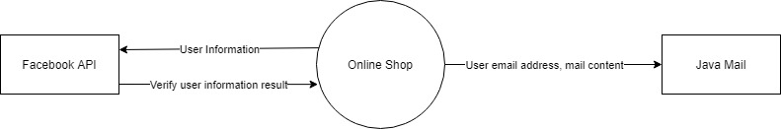

## 2. System Functions

#### a. Screen Flow

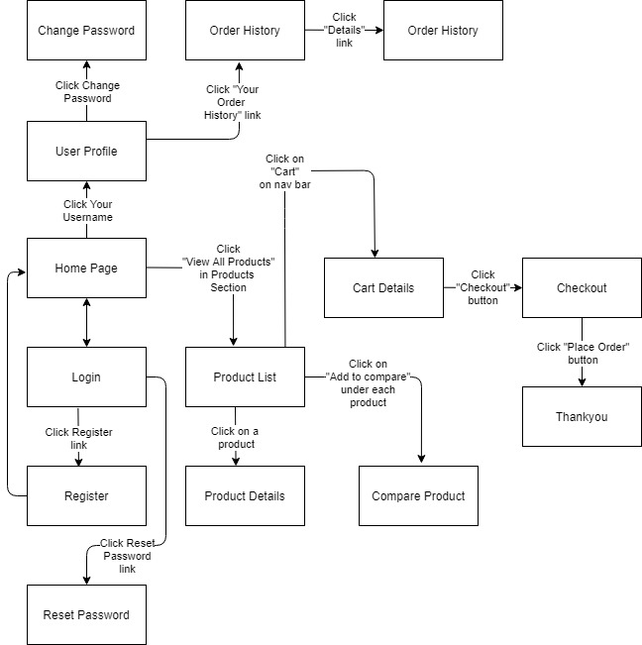

Screen Flow of User

#### b. Screen Details

|  |  |  |  |
| --- | --- | --- | --- |
| **#** | **Feature** | **Screen** | **Description** |
| 1 | Public | Home | Home page of the website |
| 2 | Login | Login | Screen to enter email/password to login |
| 3 | Login | Reset Password | Screen to reset password if forget |
| 4 | Register | Register | Register an account |
| 5 | Register | Authorize User Email | Authorize the newly registerd account |
| 6 | Product | Product List | View all products |
| 7 | Product | Product Details | View details of a product |
| 8 | Product | Compare Product | Compare 2 different product |
| 9 | Cart | Cart Details | View products in cart of user |
| 10 | Cart | Checkout | Enter shipping information, recheck cart details |
| 11 | Cart | Thankyou | Thanks customer for shopping |
| 12 | User | User Profile | View profile of the user |
| 13 | User | Order History | The order history of the user |
| 14 | User | Order Details | Details of an order of the user |
| 15 | Admin | Admin Dashboard | Show basic information for admin |
| 16 | Admin | Settings List | Show list of settings |
| 17 | Admin | Setting Details | Show details of setting |
| 18 | Admin | Users List | Show list of users |
| 19 | Admin | User Details | Show details of an user |

#### c. User Authorization

| **Screen** | **Guest** | **User** | **Seller** | **Admin** |
| --- | --- | --- | --- | --- |
| **Home Page** | X | X | X | X |
| Login | X |  |  |  |
| Log Out |  | X | X | X |
| Search | X | X |  |  |
| View Cart |  | X |  |  |
| Add to Cart |  | X |  |  |
| View Product Detail | X | X |  |  |
| View Product By Category | X | X |  |  |
| View Profile Detail |  | X | X | X |
| View Map | X | X |  |  |
| Back to top | X | X |  |  |
| Comparing Products | X | X |  |  |
| Hot Product | X | X |  |  |
| Favourite Product | X | X |  |  |
| **Product Details** | X | X |  |  |
| Log Out |  | X |  |  |
| Buy Now |  | X |  |  |
| Add to Cart |  | X |  | X |
| View Product by Category | X | X |  |  |
| Back to Home Page | X | X |  |  |
| Search | X | X |  |  |
| View Profile Detail |  | X |  |  |
| Hot Product | X | X |  |  |
| Favourite Product | X | X |  |  |
| **Cart** |  | X |  |  |
| Quantity editing |  | X |  |  |
| View Product Detail |  | X |  |  |
| Delete a Product from Cart |  | X |  |  |
| Pay |  | X |  |  |
| Delete all Products from Cart |  | X |  |  |
| Back to Home Page |  | X |  |  |
| Log Out |  | X |  |  |
| View Profile Details |  | X |  |  |
| Search Product by Name |  | X |  |  |
| **Admin Home Page** |  |  |  | X |
| Manage Products |  |  |  | X |
| ­ Manage Accounts |  |  |  | X |
| Log Out |  |  |  | X |
| **Manage Products** |  |  | X | X |
| Edit a Product |  |  | X | X |
| Delete a Product |  |  | X | X |
| Add a Product |  |  | X | X |
| View a Product Details |  |  | X | X |
| **Comparing Products** | X | X |  |  |
| Search for a Product | X | X |  |  |
| Add to Cart |  | X |  |  |
| View Product Details | X | X |  |  |
| Hot Product | X | X |  |  |
| Favourite Product | X | X |  |  |
| **Login** | X |  |  |  |
| Typing account | X |  |  |  |
| Typing password | X |  |  |  |
| Remember me | X |  |  |  |
| Forget Password | X |  |  |  |
| Sign in button | X |  |  |  |
| Sign up button | X |  |  |  |
| Sign in With Facebook Account | X |  |  |  |
| **Sign up** | X |  |  |  |
| Typing Username | X |  |  |  |
| Typing Email | X |  |  |  |
| Typing Password | X |  |  |  |
| Repeat Password | X |  |  |  |
| Accept terms & conditions check | X |  |  |  |
| Sign up Button | X |  |  |  |
|  |  |  |  |  |
|  |  |  |  |  |
|  |  |  |  |  |
|  |  |  |  |  |
|  |  |  |  |  |
|  |  |  |  |  |
|  |  |  |  |  |
|  |  |  |  |  |
|  |  |  |  |  |
|  |  |  |  |  |
|  |  |  |  |  |
|  |  |  |  |  |
|  |  |  |  |  |
|  |  |  |  |  |
|  |  |  |  |  |
|  |  |  |  |  |
|  |  |  |  |  |
|  |  |  |  |  |
|  |  |  |  |  |
|  |  |  |  |  |
|  |  |  |  |  |
|  |  |  |  |  |
|  |  |  |  |  |
|  |  |  |  |  |
|  |  |  |  |  |
|  |  |  |  |  |
|  |  |  |  |  |
|  |  |  |  |  |
|  |  |  |  |  |
|  |  |  |  |  |
|  |  |  |  |  |
|  |  |  |  |  |
|  |  |  |  |  |
|  |  |  |  |  |
|  |  |  |  |  |
|  |  |  |  |  |
|  |  |  |  |  |
|  |  |  |  |  |
|  |  |  |  |  |