|  |  |
| --- | --- |
|  |  |

**eProject Document**

ASKME-MOBILE

|  |  |
| --- | --- |
| **Group 5** | |
| **Members** | Mac Duy Thanh – Student1253302  Nguyen HuyHoang – Student1240567  Nguyen Thi Binh – Student1247034  Lai Thi Hanh – Student1247028 |
| **Instructor** | Nguyen Van Luan |
| **Batch** | C1908I1 |
| **Semester** | I |

**🙠 Implementation date 07/05/2020-26/05/2020 🙢**

**Table of Content**

1. **Problem definition**
   1. ***Introduction***
   2. ***Existing Scenario***
2. **Acknowlegements**
3. **Project Synopsis**
4. **Project Analysis**
5. **Customer Requirement Specification**
6. **Project Design**
   1. ***DFD’s***
   2. ***FlowCharts***
   3. ***Process Diagrams***
   4. ***Database Desin / Struture***
7. **Sreen Shot’s**
8. **Source Code With Comments**
9. **User Guide**
10. **Developer’s Guide**
    1. ***Module Descriptions***
11. **Problem Definition**
    1. **Introduction**

* Mobile Communication System is an organization system that provides two services like the telecommunications and Internet Services.
* It has now extended its service all over the territory due to the increase in demand for the internet service.
* They have opened the retail shops at each place so that increase the comfort level of the customers where the customers can make the payment, also they can place an order or enquire for a new connection by directly visiting to the retail shops at their place in that city, instead of applying at the office at their city.
  1. **Existing Scenario**
* As the demand of customers using mobile is increasing, the company has expanded its services throughout the territory and even started the retails stores everywhere, as well as to increase the comfort level of customers can make payments, place orders, request information of a connection.
* The company also has promotional mode for those potential customers who have large numbers of contracts connected with the company. They will be discounted by the applicable option: 10-15 connections they will receive 25% discount as well in advance and the security deposit, they will take advantage of 15-25 50% discount, 25-50 they will take advantage of 75% and over 50 they will get 100% discount.
* Customer information is stored, including payments (Monthly rentals, Security Deposit, dues if any, etc…), based on signed contracts (for broadband and dial-up connection), customers will be provided with equipment (Modem or Router). Besides personal information of customers will also be archived.
* The details of the product manufacturing vendors are maintained along with the orders placed, payment lists, name and contact details are maintained. So it includes huge amount of paper work as a whole, due to which slip ups take place.
* All information about customer records, as well as a list of product providers are stored in large quantities of work papers. So easy error occurred.   
  The detail of the equipment (stock), employees, vendors are maintained and updated solely by the Admin (Manager). They also maintain the list of the applications for the connection, some customers try to change their plan, and as well some gets connection but some don’t due to the feasibility reports, etc.

1. **Asknowlegements**

* The project would like to thank bachkhoa-aptech Information Technology Training System for creating good conditions for our group to implement this sem I projcet well.
* We would like to express our sincere thanks to the teachers inbachkhoa-aptech Information Technology Traning System who have devotedly taught and equipped the group with valuable knowledge during the past school days, helping the group have a foundation. Solid knowledge to complete this project. Specially, our team would like to express our sincere thanks to the enthusiastic

guidance and suggestions of Mr.Nguyen Van Luan for helping the projcet team successfully complete this sem I project.

* Although the research team has tried to complete the graduation projcet within the scope and ability, it is definitely inevitable. The project team hopes to receive sympathy and whole-hearted contribution of teachers.

1. **Project Synopsis**

* With the complexity and scale application, plus be a matter of time for the project “ Construction mobile website” stands at just learn a web programming language HTML5 & JavaScript and application of experimental applications of web-based sales website to mobile shops.
* Website for the purpose of providing its client with accurate information about the mobile products are available on the market and how to order goods online. The information is updated regularly and quickly. Thus, shortening the distance between buyers and sellers, provide information on new products quickly to customers.
* Because there are some limitations, should stop at the new site features view products and ordering. In the future, the system will evolve in the direction of electronic commerce (in the form of online payment thought credit cards, bank accounts, online shopping cart …). Due to limitations in the presentation should be written this paper, I just would like to present some important processes, from surveys, to analyze, design, install the system. Look forward to your understandind and your Teacher.

1. **Project Analysis**

Website that sell phones have basic function like:

* View product details: Customers access the address of website on the url bar, click on the page on the site to view information. And the information of the handset includes: phone name, manufacturer, color, size, price, status,…
* Order: Allows customers to view products on the site. When the customer submits order information, the item is sent to the shopping cart.
* Shopping cart: Allows customers to add, edit or delete the selected item. The function of calculating the total value of that order.
* Search products: In order not to waste time browing each product on the website, customers can know information about the product they want to buy by entering information in the search box.
* View the latest products: Customers can view the latest phone information of the store.The system will select the latest products on the top of the homepage.
* See best-selling products: Show information about best-selling phones of the store. The system will select the items with the most buyers to return results and display to users.

1. **Customer Requirement Specification**
   1. **Customer Requirement**
      1. **Users of the system**

- Customer

* + 1. **System functions**

|  |  |
| --- | --- |
| **User** | **Functions** |
| **Customers** | * Register, Login * Change Profile * Place an order * View the bill of him/her * Search the order status of him/her * Keep track connection of him/her * Feedback |

* 1. **Common functions**

|  |  |
| --- | --- |
| **Login** | |
| Input | Login to system, user must be enter username and password |
| Process | Access information |
| Output | Result of login |
| **Change Profile** | |
| Input | Information details of user such as Name, Address, Phone, Email … |
| Process | Maintain user’s information details |
| Output | Result of Change profile |

* 1. **Customer functions**

|  |  |
| --- | --- |
| **Place an order** | |
| Input | Customer fills required information: type of connection, area, name, Social Number Identification, address, email, equipment, etc… |
| Process | Send requirement to system. |
| Output | Result of send. |
| **View the bill of him/her** | |
| Input | View the bill |
| Process | Find the bill |
| Output | Display detail of bill |
| **Search the order status of him/her** | |
| Input | Customer fills appropriate information to search. |
| Process | Find the order. |
| Output | Display the result. |
| **Keep track connection of him/her** | |
| Input | Search connection status with Customer ID. |
| Process | Find the connection . |
| Output | Display connection status. |
| **Feedback** | |
| Input | Information which send to company. |
| Process | Maintain the information |
| Output | Result of feedback |

* 1. **Hardware – Software requirement**

### Hardware Requirements

* A minimum computer system that will help you access all the tools in the

courses is a Pentium 166 or better

* 64 Megabytes of RAM or better

### Software Requirements

* Notepad/HTML editor
* Dreamweaver
* IE 5.0/ Netscape 6.0

1. **Project Design**   
   **6.1. Flow chart**

6.1.1 Login

Start

Start

Display confirm exit

Input data

Check Data

Display Error

**false**

Logout

**true**

Stop

Successful login

b. System Logout

Stop

1. System Login

6.1.2 Search Data

Start

Input keyword

Check data

Display error

**false**

**true**

Display result

Stop

**6.2 DFD’s**

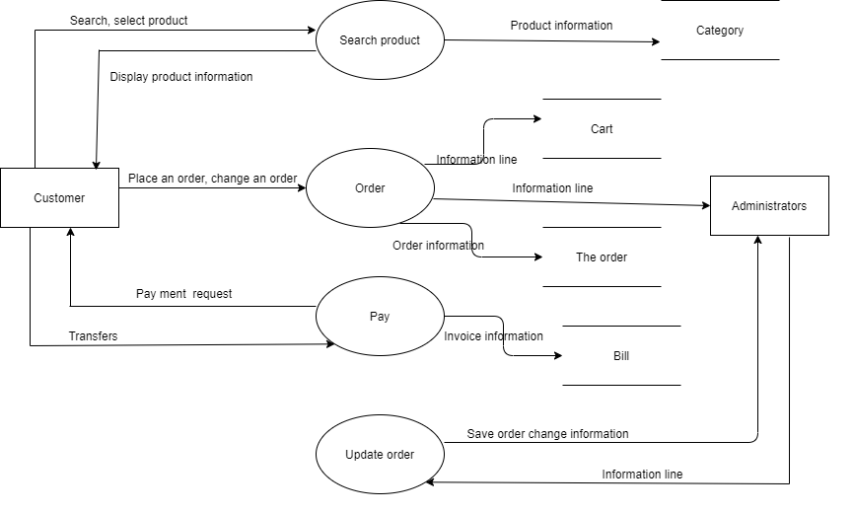

1. **Sreen Shot’s**

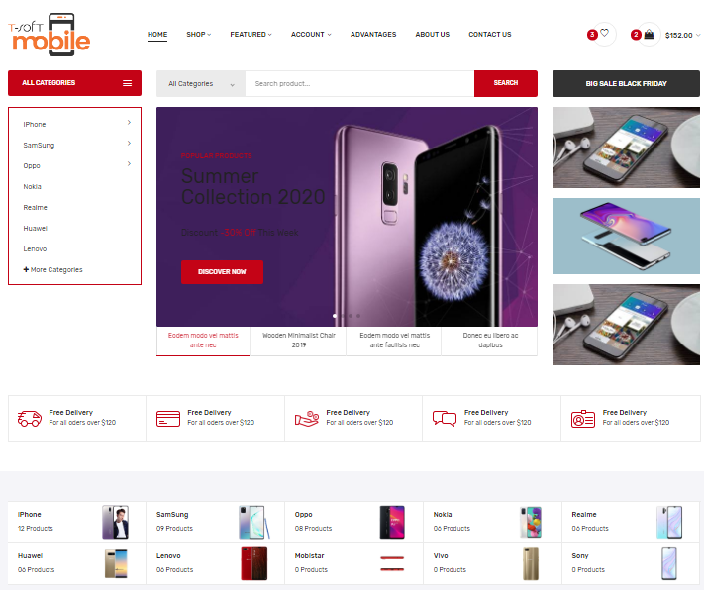

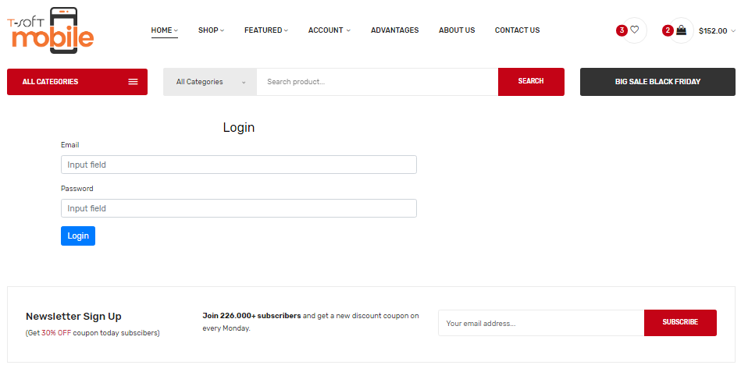

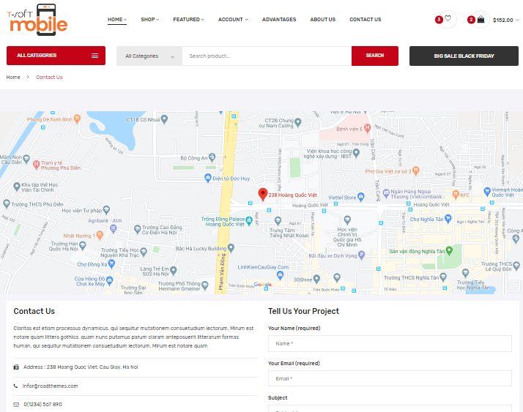

1. **User Guide**

8.1 View Products:

- First go to the website to see the products, you can click on the **Shop** function on the menu bar and select the brands you want to see.

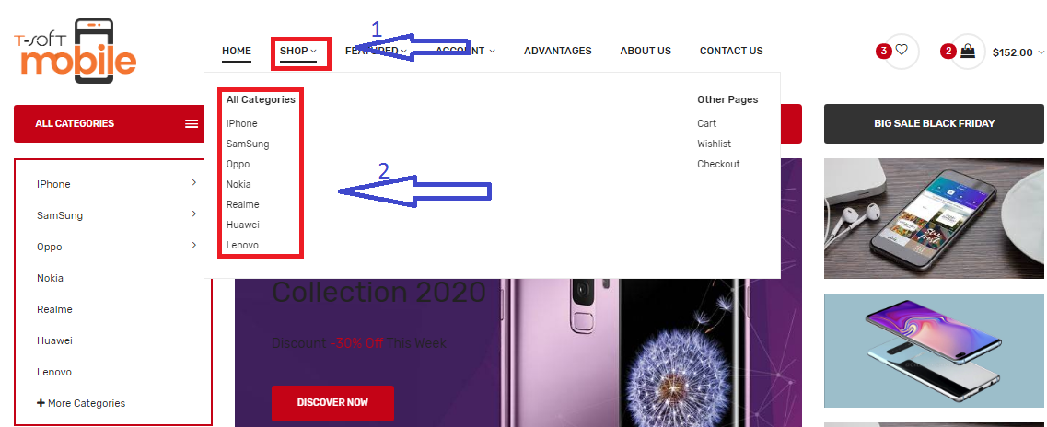

- Or you can look at the **All Category** section of the site

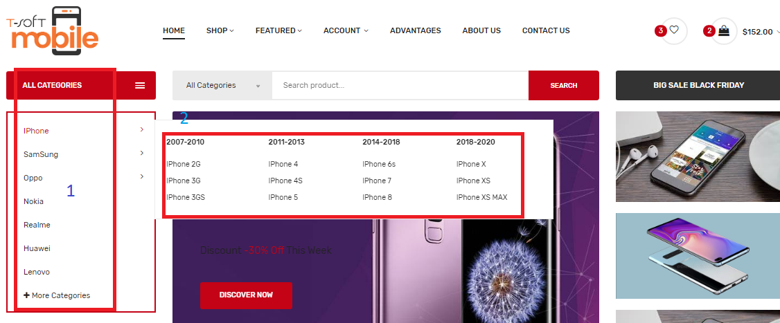

- To better understand the website and its products, customers can view the **Advantages** function on the menu bar

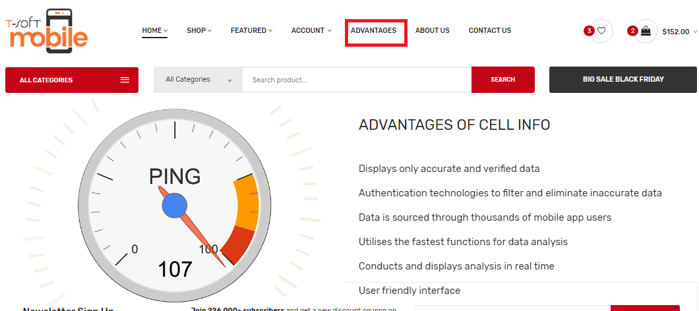

8.2 Account

- Users who want to purchase must have a login account to purchase

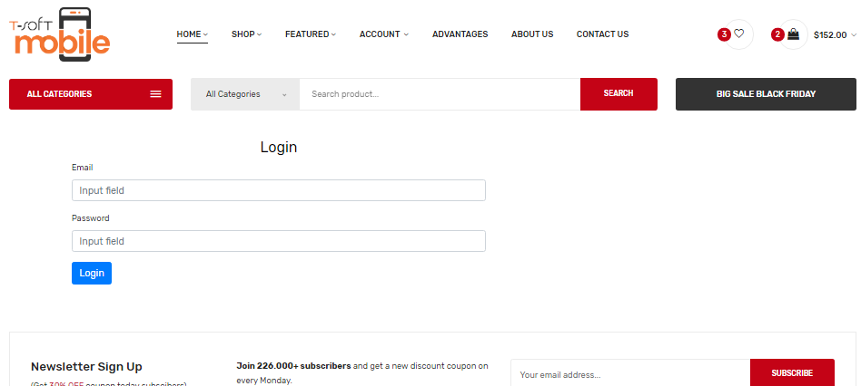

- If the user does not have an account, he can register immediately on the website.

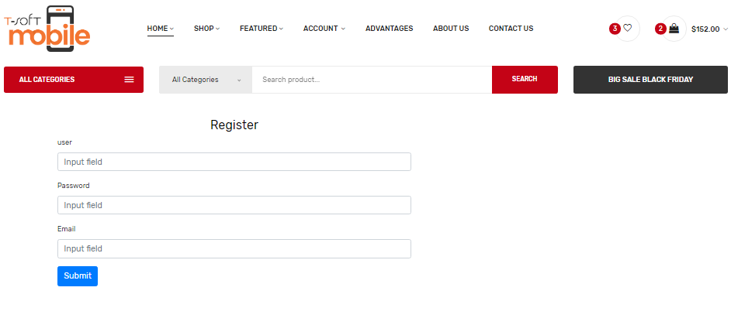

8.3 Cart

- After the user has viewed the product and added it to the cart, it will be displayed in the shopping cart

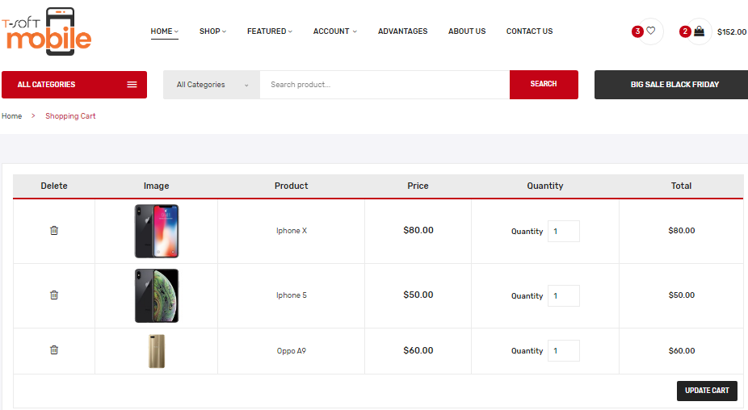

- And also users can delete products in the cart

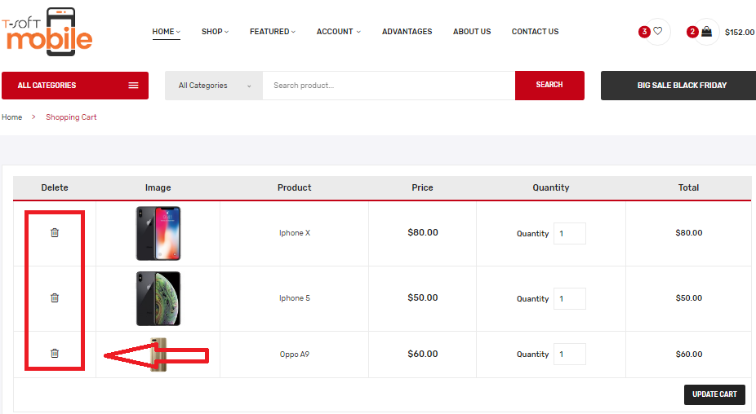

8.4 Feedback

- If customers have any questions about the product, you can view the information on the website and visit the address below to resolve.

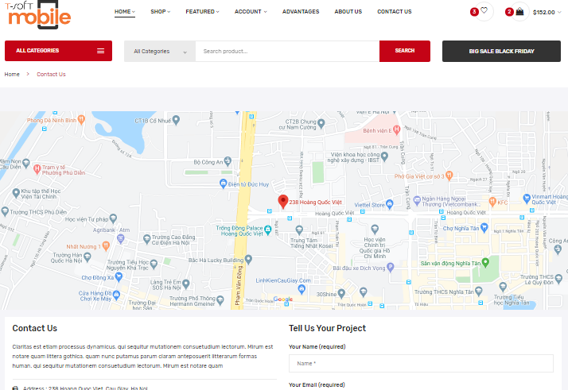

1. **Developer’s Guide**

**-** First to access the website you must copy the project in drive **C**

**-**Select **the Xampp-**>**htdocs** folder

**-**Then open brower and type write **localhost:8080/…**Enter the name of your project

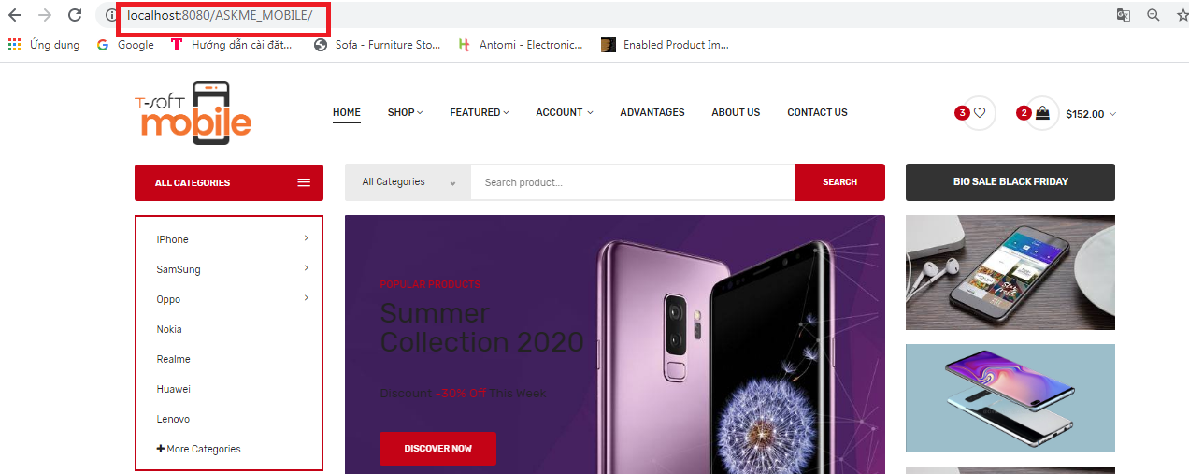

* 1. Module Descriptions

- Search Module: Helping web users to find products in the fastest way, our search module is designed specifically includind quick search and advanced search.

- Module Menu : Navigation module system (menu) helps website visitors go to product catalogs to product detailr or from menu bar features to view advantages, contact information, and how to register, login of a website. The menu module is designed in detail and classified by each level to help developers and customers can easily view products and related information.

-Module Map: This module helps customers find their way on the map and contact the website administrator more easily.

1. **Task Sheet**

|  |  |  |  |  |  |  |
| --- | --- | --- | --- | --- | --- | --- |
| **Project Ref. No: 1** | | Project Title: Askme - Mobile | **Date of Preparation of Activity Plan** | | | |
| **Sr. No.** | **Task** | | **Actual Start Date** | **Actual Days** | **Team Member Names** | **Status** |
| 1 | Problem definition | |  | 7 | Nguyen Huy Hoang | complete |
| 2 | Acknowledgements | | Nguyen Huy Hoang | complete |
| 3 | Project Synopsis | | Mac Duy Thanh | complete |
| 5 | Project Analysis | | Mac Duy Thanh | complete |
| 6 | DFD’s | | Lai Thi Hanh | complete |
| 7 | FlowCharts | | Lai Thi Hanh | complete |
| 8 | Screen Shot’s | | Nguyen Thi Binh | complete |
| 9 | User Guide | | Nguyen Thi Binh | complete |
| 10 | Developer’s Guide | | Lai Thi Hanh | complete |
| 11 | Installation Guide | |  | 13 | Lai Thi Hanh | complete |
| 12 | Home page | | Nguyen Thi Binh | complete |
| 13 | Product catalog page | | Nguyen Thi Binh | complete |
| 14 | Product details page | | Nguyen Huy Hoang | complete |
| 15 | Features page of products | | Mac Duy Thanh | complete |
| 16 | Account page | | Mac Duy Thanh | complete |
| 17 | Page advantages | | Lai Thi Hanh | complete |
| 18 | Page about us | | Nguyen Thi Binh | complete |
| 19 | Page contact us | | Lai Thi Hanh | complete |
| 20 | Page cart | | Nguyen Thi Binh | complete |
| 21 | Some other…..etc.. | |  |  | Nguyen Huy Hoang | complete |

1. **Check list of validation**

|  |  |
| --- | --- |
| Option | Validate |
| Can a new user who get registered, enter the application after logging in ? | Yes |
| Do all the option present in the application display the correct result | Yes |
| Does the application’s functionality resolve the user problem and satisfy their needs ? | Yes |
| Has the hardware and software been correctly chosen ? | Yes |

1. **Submission checklist**

|  |  |  |  |  |
| --- | --- | --- | --- | --- |
| Sr.No | Particular | Yes | No | Comments |
| 1 | Are the users able to login to application after validations is performed on the on the user name and password ? | Yes |  |  |
| 2 | Are the user able to modify their detail after getting registered | Yes |  |  |
| 3 | Are all the screen contents devoid spelling mistakes | Yes |  |  |
| 4 | Is the application user-friendly | Yes |  |  |

**THE END**