lab 08: Tạo form login

**Mục tiêu**

* Làm việc với form đăng nhập, đăng ký

**1.Tạo form đăng ký**

<link href="//netdna.bootstrapcdn.com/bootstrap/3.1.0/css/bootstrap.min.css" rel="stylesheet" id="bootstrap-css">

<script src="//netdna.bootstrapcdn.com/bootstrap/3.1.0/js/bootstrap.min.js"></script>

<script src="//code.jquery.com/jquery-1.11.1.min.js"></script>

<div class="container">

<div id="loginbox" style="margin-top:50px;" class="mainbox col-md-6 col-md-offset-3 col-sm-8 col-sm-offset-2">

<div class="panel panel-info" >

<div class="panel-heading">

<div class="panel-title">Sign In</div>

<div style="float:right; font-size: 80%; position: relative; top:-10px"><a href="#">Forgot password?</a></div>

</div>

<div style="padding-top:30px" class="panel-body" >

<div style="display:none" id="login-alert" class="alert alert-danger col-sm-12"></div>

<form class="form-horizontal" role="form" method="POST" action="{{route('postLogin')}}">

<div style="margin-bottom: 25px" class="input-group">

<span class="input-group-addon"><i class="glyphicon glyphicon-user"></i></span>

<input id="login-username" type="text" class="form-control" name="email" value="" placeholder="username or email">

</div>

<div style="margin-bottom: 25px" class="input-group">

<span class="input-group-addon"><i class="glyphicon glyphicon-lock"></i></span>

<input id="login-password" type="password" class="form-control" name="password" placeholder="password">

</div>

<input type="hidden" name="_token" value="{{csrf_token()}}">

<div style="margin-top:10px" class="form-group">

<!-- Button -->

<div class="form-group ">

<button type="submit" class="btn btn-primary btn-lg btn-block login-button">Đăng nhập</button>

</div>

</div>

</form>

</div>

</div>

</div>

</div>

</div>

<div class="container">

            <div class="row main">

                <div class="panel-heading">

     <div class="panel-title text-center">

          <h1 class="title">Nếu chưa có tài khoản hãy điền thông tin đăng ký</h1>

          <hr />

      </div>

     </div>

                <div class="main-login main-center">

                    <form class="form-horizontal" method="post" action="{{route('register')}}">

                        <div class="form-group">

                            <label for="name" class="cols-sm-2 control-label">Name</label>

                            <div class="cols-sm-10">

                                <div class="input-group">

                                    <span class="input-group-addon"><i class="fa fa-user fa" aria-hidden="true"></i></span>

                                    <input type="text" class="form-control" name="name" id="name" placeholder="Enter your Name"/>

                                </div>

                            </div>

                        </div>

                        <div class="form-group">

                            <label for="email" class="cols-sm-2 control-label">Email</label>

                            <div class="cols-sm-10">

                                <div class="input-group">

                                    <span class="input-group-addon"><i class="fa fa-envelope fa" aria-hidden="true"></i></span>

                                    <input type="text" class="form-control" name="email" id="email" placeholder="Enter your Email"/>

                                </div>

                            </div>

                        </div>

                        <div class="form-group">

                            <label for="password" class="cols-sm-2 control-label">Password</label>

                            <div class="cols-sm-10">

                                <div class="input-group">

                                    <span class="input-group-addon"><i class="fa fa-lock fa-lg" aria-hidden="true"></i></span>

                                    <input type="password" class="form-control" name="password" id="password" placeholder="Enter your Password"/>

                                </div>

                            </div>

                        </div>

                        <div class="form-group">

                            <label for="confirm" class="cols-sm-2 control-label">Confirm Password</label>

                            <div class="cols-sm-10">

                                <div class="input-group">

                                    <span class="input-group-addon"><i class="fa fa-lock fa-lg" aria-hidden="true"></i></span>

                                    <input type="password" class="form-control" name="repassword" id="confirm" placeholder="Confirm your Password"/>

                                </div>

                            </div>

                        </div>

<input type="hidden" name="_token" value="{{csrf_token()}}">

                        <div class="form-group ">

                            <button type="submit" class="btn btn-primary btn-lg btn-block login-button">Register</button>

                        </div>

                    </form>

                </div>

            </div>

        </div>

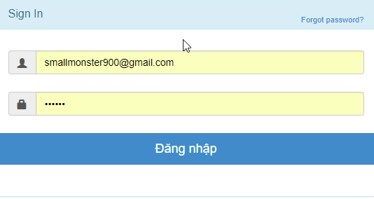

From đăng ký:

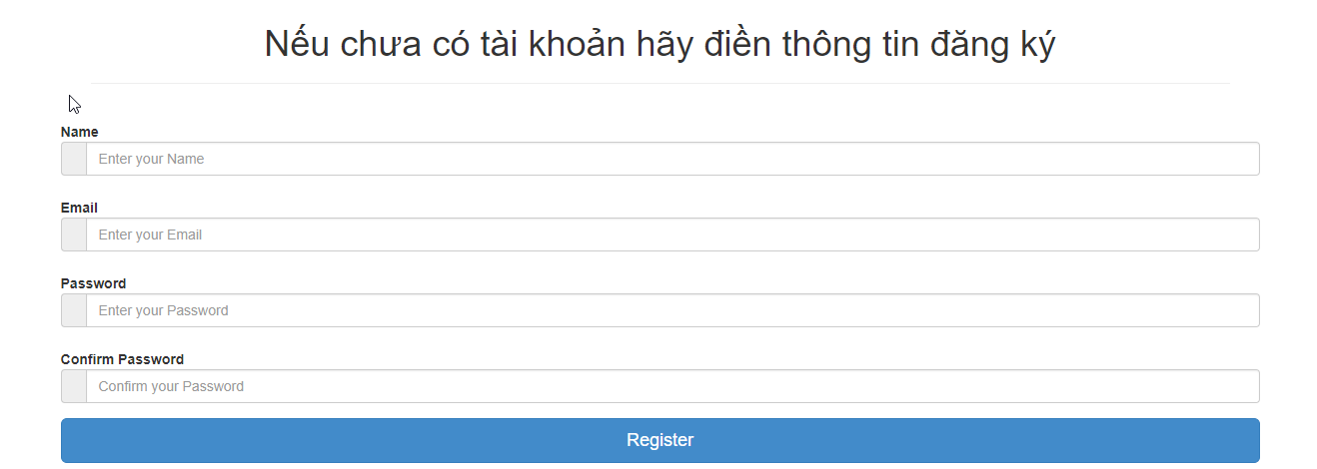

**Bước 2:**

**Tạo route:**

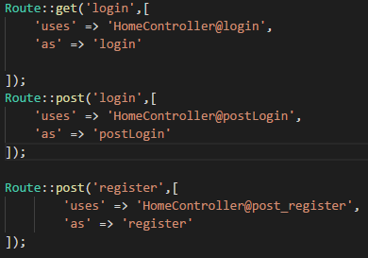

**Bước 3:**

**Tạo Controller:**

Ở đây chúng ta dùng Auth::attempt nên các bạn phải use Auth vào nó mới dùng được nhé

Đừng quên use Model User!

<?php

namespace App\Http\Controllers;

use Illuminate\Http\Request;

    use Auth;

use Mail;

use App\User;

class HomeController extends Controller

{

public function index()

{

return view('index',[

'name'=>'page home'

]);

}

public function login()

{

return view('login');

}

public function postLogin(Request $request)

     {

         if(Auth::attempt($request->only('email','password'),$request->has('remember'))){

             return redirect()->route('home')->with('success','Đăng nhập thành công');

         }else{

             return redirect()->back()->with('error','Tài khoản hoặc mật khẩu không đúng');

         }

}

public function post_register(Request $request)

     {

         User::create([

             'name' => $request->name,

             'email' => $request->email,

             'password' => bcrypt($request->password)

         ]);

         return redirect()->route('home')->with('success','Đăng ký thành công. Mời đăng nhập');

     }

}

?>

**Bước 4 đăng ký rồi đăng nhập nhé:**

Muốn đưa ra thông tin của user chúng ta sử dụng phương thức sau





CHÚC CÁC BẠN THỰC HIỆN THÀNH CÔNG