

**INTERNATIONAL SCHOOL**

**CAPSTONE PROJECT 1**

**CMU-CS 246**

**USER INTERFACE DESIGN DOCUMENT**

Version: 1.0

**CALCULATOR SYSTEM – CS**

**Mentor: Nguyen Dang Quang Huy**

***Team Member*:**

Le Trung Dung

Nguyen Thi Men

Nguyen Huu Thang

Tran Thi Nhu Ngoc

Le Thanh Nhat Minh

**Approved by Huy Nguyen Dang Quang**

**UserInterface Review Panel Representative:**

Name Signature Date

**Capstone Project 1- Mentor:**

Name Signature Date

Da Nang, 01/2024

**PROJECT INFORMATION**

|  |  |
| --- | --- |
| **Project Acronym** | CS |
| **Project Title** | Calculator | | | |
| **Start Date** | 22 – Jan –2024 | **End Date** | 28 – Jan –2024 | |
| **Lead Institution** | International School, Duy Tan University | | | |
| **Team Member** | **Name** | **Email** | | **Phone** |
| 28209048703 | Men, Nguyen Thi | nguyenthimen190504@gmail.com | | 0828041686 |
| 28206950780 | Ngoc, Tran Thi Nhu | tranthinhungoc16@gmail.com | | 0896500035 |
| 28211102537 | Thang, Nguyen Huu | thangnguyen04112024@gmail.com | | 0702377702 |
| 28211101895 | Dung, Le Trung | letrungdung.camlo@gmail.com | | 0396892906 |
| 28219005165 | Minh, Le Thanh Nhat | minhle130704@gmail.com | | 0853201868 |

**PROJECT PLAN DOCUMENT**

|  |  |  |  |
| --- | --- | --- | --- |
| **Document Title** | User Interface Design Document | | |
| **Author(s)** | Le Trung Dung, Le Thanh Nhat Minh | | |
| **Date** | Jan 29th, 2024 | **File name:** | User_Interface_Design_Document.docx |
| **URL** | https://drive.google.com/drive/folders/1GfXs51SGRq8U3NGXeDdY3DGB4YESZvDV?usp=sharing | | |
| **Access** | Project and CMU Program | | |

**SIGNATURE**

**Document Approvals:** The following signatures are required for approval of this document.

|  |  |  |  |
| --- | --- | --- | --- |
| **Mentor** | Huy, Nguyen Dang Quang | **Signature:** |  |
| **Date:** |  |
| **Project Manager** | Men, Nguyen Thi | **Signature:** |  |
| **Date:** |  |
| **ProDuct**  **Owner** | Ngoc, Tran Thi Nhu | **Signature:** |  |
| **Date:** |  |
| **Team member(s)** | Thang, Nguyen Huu | **Signature:** |  |
| **Date:** |  |
| Dung, Le Trung | **Signature:** |  |
| **Date:** |  |
| Minh, Le Thanh Nhat | **Signature:** |  |
| **Date:** |  |

**REVISION HISTORY**

|  |  |  |  |
| --- | --- | --- | --- |
| **Version** | **Person(s)** | **Date** | **Description** |
| **1.0** | Dung, Le Trung  Minh, Le Thanh Nhat | Jan 26th, 2024 | Draf |
| **1.1** | Dung, Le Trung  Minh, Le Thanh Nhat | Jan 28th, 2024 | Final |

TABLE OF CONTENTS

I. INTRODUCTION 6

**1. PURPOSE 6**

**2. SCOPE 6**

II. LIST OF USER INTERFACE 7

**1. BUSINESS FUNCTION DIAGRAM: 7**

**2. SYSTEM: 8**

III. DESCRIBE USER INTERFACE 12

**1. Calculator Page: 8**

**TABLES**

**[Table 1: List of Interface](https://docs.google.com/document/d/1l0D59sv483gd5wnQW3jct96xZbimA12J/edit" \l "heading=h.tyjcwt)**

**[Table 2: Describe User Interface Calcular System](https://docs.google.com/document/d/1l0D59sv483gd5wnQW3jct96xZbimA12J/edit" \l "heading=h.1t3h5sf)**

**[Table 3: Describe User Interface Addition](https://docs.google.com/document/d/1l0D59sv483gd5wnQW3jct96xZbimA12J/edit" \l "heading=h.2s8eyo1)**

**[Table 4: Describe User Interface Subtraction](https://docs.google.com/document/d/1l0D59sv483gd5wnQW3jct96xZbimA12J/edit" \l "heading=h.17dp8vu)**

**[Table 5: Describe User Interface Multiplication](https://docs.google.com/document/d/1l0D59sv483gd5wnQW3jct96xZbimA12J/edit" \l "heading=h.3rdcrjn)**

**[Table 6: Describe User Interface Divide](https://docs.google.com/document/d/1l0D59sv483gd5wnQW3jct96xZbimA12J/edit" \l "heading=h.3rdcrjn)**

**[Table 7: Describe User Interface Modulo](https://docs.google.com/document/d/1l0D59sv483gd5wnQW3jct96xZbimA12J/edit" \l "heading=h.3rdcrjn)**

**[Table 8: Describe User Interface Reset](https://docs.google.com/document/d/1l0D59sv483gd5wnQW3jct96xZbimA12J/edit" \l "heading=h.3rdcrjn)**

**[Table 9: Describe User Interface Exit](https://docs.google.com/document/d/1l0D59sv483gd5wnQW3jct96xZbimA12J/edit" \l "heading=h.3rdcrjn)**

# INTRODUCTION

## PURPOSE

* Document the design of user interface of functions of the Caculator System
* Be the primary document driving the implementation of the user interfaces.
* Introduce interface design for the reader. Including the background, content information display, buttons.

## SCOPE

* This document helps to better understand the interface of the System, detailed specification components and function of the System.
* With this document, the development team can understand the structure and composition to create a consistent and complete system.
* Overview of the stages and modules of the software and create a complete interface.

## SCOPE

This document is intended for the following audiences:

* Technical reviewers including:
* Project Management
* Product owner
* Implementers, including:
  + Developers.
  + Testers.

# LIST OF USER INTERFACE

## BUSINESS FUNCTION DIAGRAM:

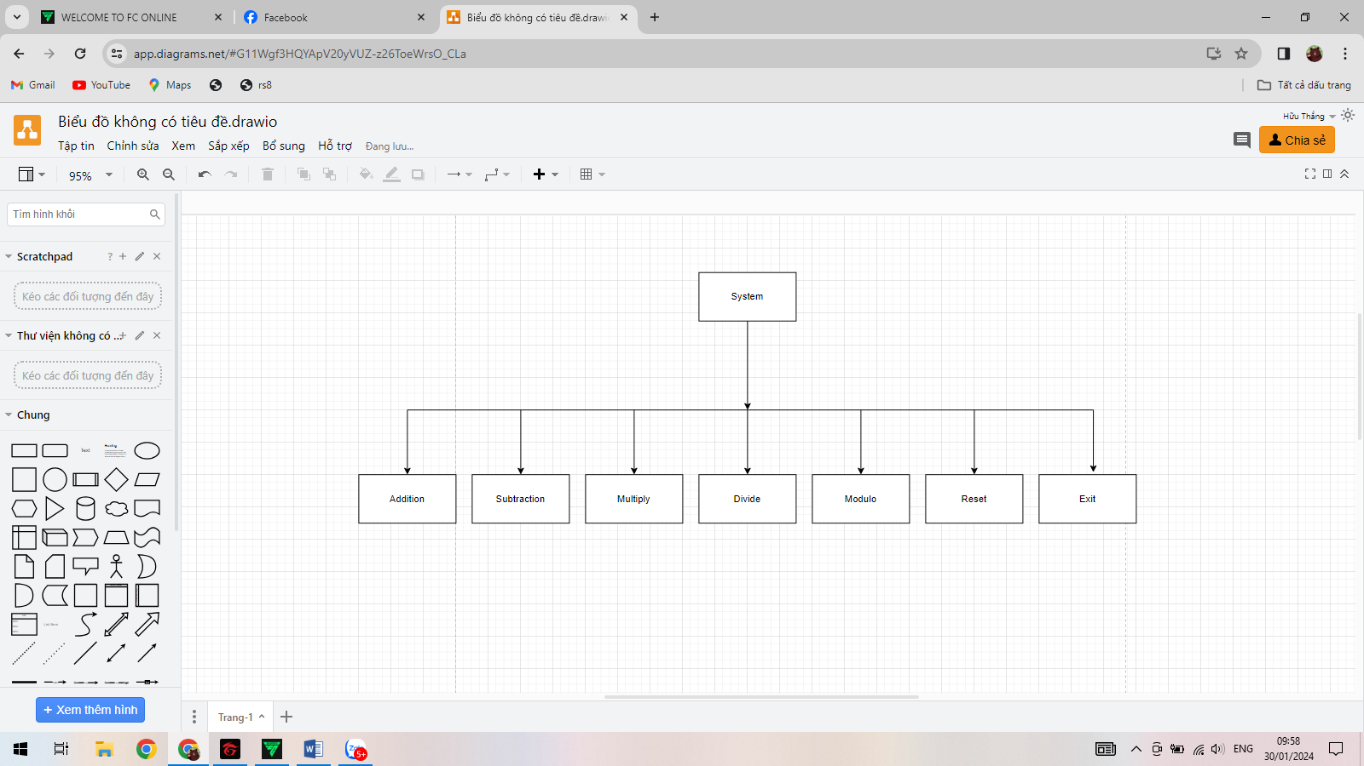

## CACULATOR SYSTEM:

|  |  |  |
| --- | --- | --- |
| **User Interface ID** | **UI Name** | **Description** |
| UI-01 | Addition | This use case allows the user to perform an arithmetic "+" operation. |
| UI-02 | Subtraction | This use case allows the user to perform an arithmetic "-" operation. |
| UI-03 | Multiplication | This use case allows the user to perform an arithmetic "*" operation. |
| UI-04 | Divide | This use case allows the user to perform an arithmetic "/" operation. |
| UI-05 | Modulo | This use case allows the user to perform an arithmetic "%" operation. |
| UI-06 | Reset | This use case allows the user to perform an or reset operation. |
| UI-07 | Exit | This use case allows the user exit from calculator system |

# DESCRIBE USER INTERFACE

## 1. INTERFACE:

# 

8

4

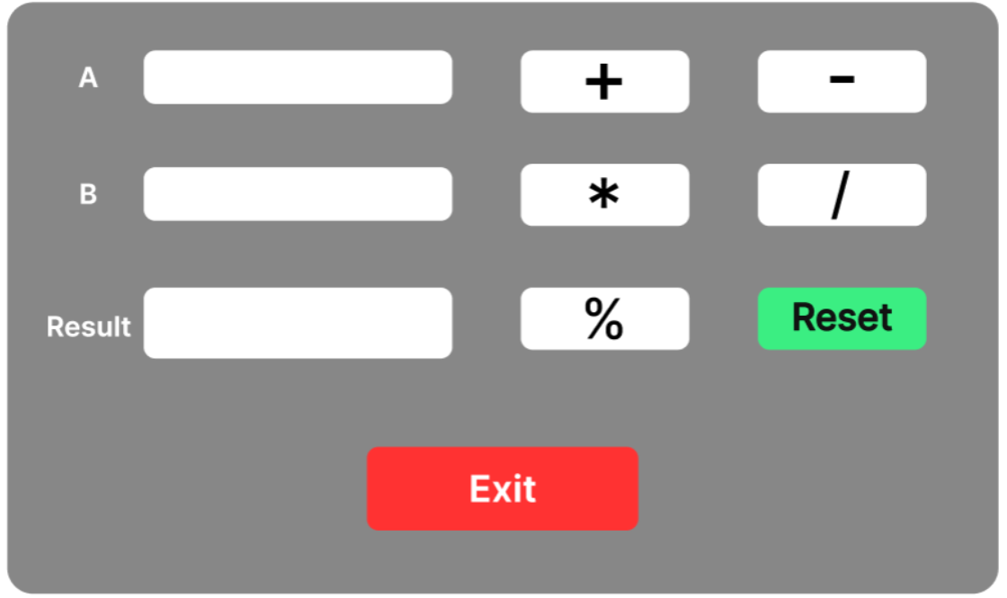

3

9

7

6

5



2

1

10

## 2. DESCRIBE UI:

|  |  |  |  |
| --- | --- | --- | --- |
| **ID** | **Condition** | **Control Type** | **Target** |
| 1 | Press | Textfield | Enter number A |
| 2 | Press | Textfield | Enter number B |
| 3 | Press | Button | Click to “+” button to plus 2 number A and number B |
| 4 | Press | Button | Click to “-” button to subtract 2 number A and number B |
| 5 | Press | Button | Click to “*” button to multiply 2 number A and number B |
| 6 | Press | Button | Click to “/” button to divide 2 number A and number B |
| 7 | Press | Button | Click to “%” button to modulo 2 number A and number B |
| 8 | None | Textfield | Display the result of calculations |
| 9 | Press | Button | Click to “Reset” button to reset the calculation |
| 10 | Press | Button | Click to “Exit” button to exit calculator system |