**Curriculum Vitae**

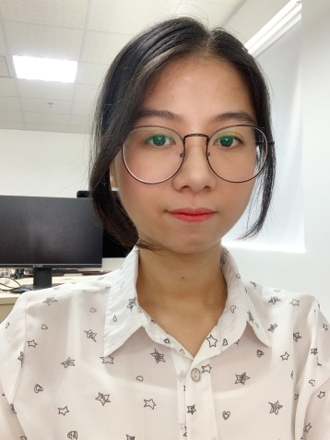Full name: NGUYEN THI NGOC TRAN

Major: Front-end web developer, UI-UX Designer

Birthday: 28/4/1994

Gender: Female

Phone: 0905 092 734

Address: K41/19 Le Do, Da Nang

Email: [ngoctran2841@gmail.com](mailto:ngoctran2841@gmail.com)

**Education**

I graduated from the UNIVERSITY OF EDUCATION, THE UNIVERSITY OF DANANG in 2016 majoring in Information Technology.

**Work Experience**

* 2018 – Current: WORK AT LEADPLUS COMPANY. Join in dev. team and build 3 tools for internal and produce 1 research tool.

Details:

**LPTool**: This is a tool to help and support website operating staff. Include management features from API Hubspot : report, customer, seminar blog, landing page, auto-create CTA for the blog, goal management for staff…

**MSPortal**: Report tool is a tool for customers. The main feature is customers can download the monthly report and yearly report have aggregated by the tool.

**MenuSpot**: This is a project in progress. It's like the booked management for the restaurant. We're in the project but to be affected by corona we're pending.

**SEMPlan Tool**: This is the tool to support marketing digital customers. Such as check ranking keywords by result google search, follow and analytics activity of guest use website, support competitor analytics...

My task

Receive requests from the manager. Use XD, Photoshop for design UIUX. If the blueprint pass, I use HTML, CSS, Javascript to create a template screen, I use Python hardcode data to fill the page look real. And I have the adjustment to the action of the website become convenient for the user. I don't do all front-end tasks. Because it's almost using old components or familiar action. I can assign to dev backend do it. And I have to analytics and looking for new component and how to using them.

* 4/2016 - 12/2017: SELF STUDY. Laravel Framework, CMS Framework, Bootstrap framework css
* 1/2016 - 3-2016: INTERNSHIP IN VNPT COMPANY. Build a Music Website. Use HTML5, CSS3. Use Management system database SQL, MVC, OOP. Programming language: PHP

**Skills**

Technique: HTML5, CSS3, Sass, Javascript, Jquery, ReactJS, Python, PHP

Framework: Bootstrap, CoreUI, Ant Design, Django Template

Other: Abode Xd, Photoshop, Sourcetree, MySQL

**Career Goals**

I'm improving myself every day. I want to do much more and become professional. I want to be useful for my organization where I work, and useful for my place where I live, I born. For me, the work does not only earn or fame, it journeys looking for good friends like-minded. When I think about this, I'm so excited to ready to join in work.

**Thank you for read my CV !!!**