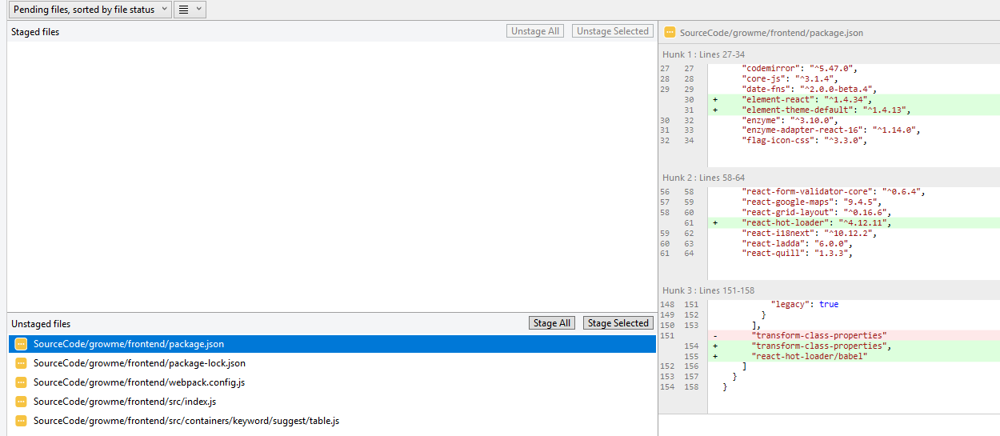

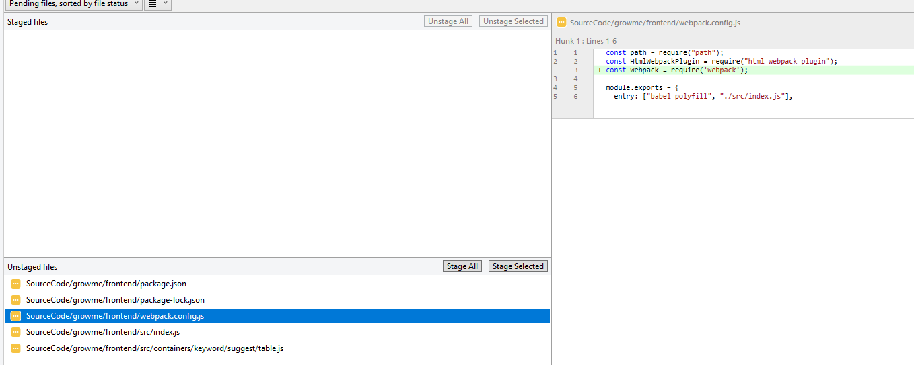

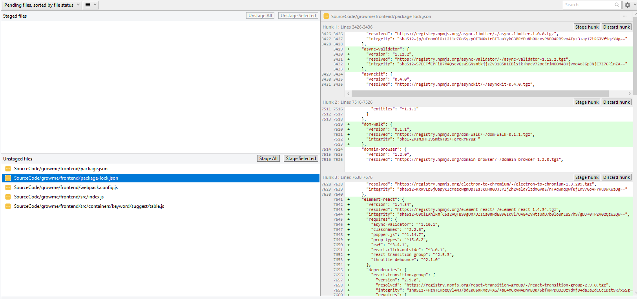

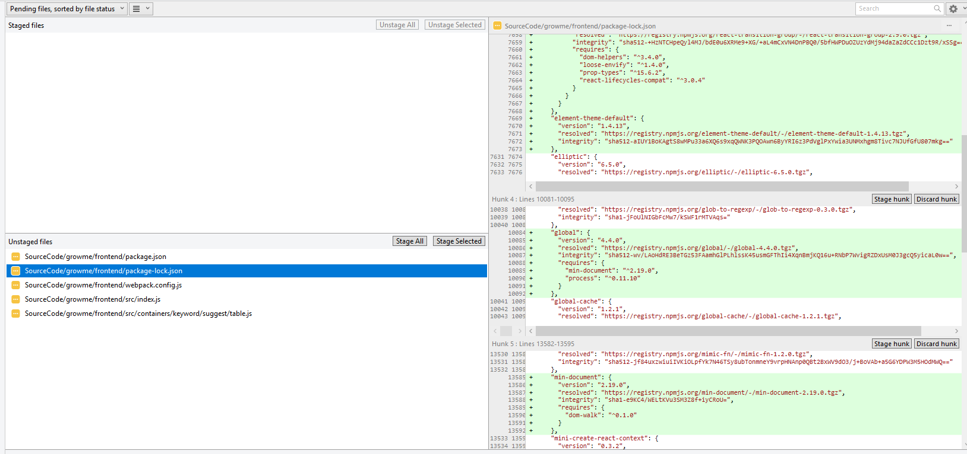

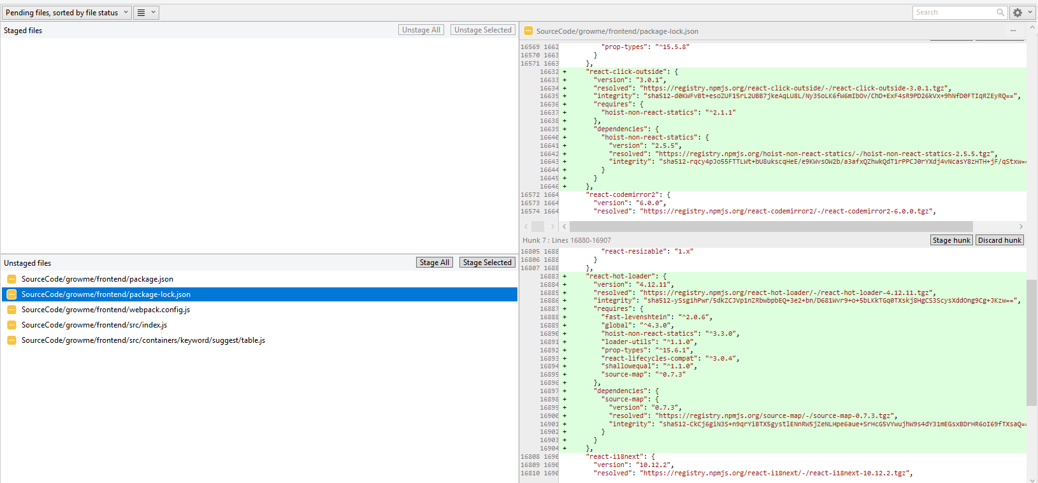

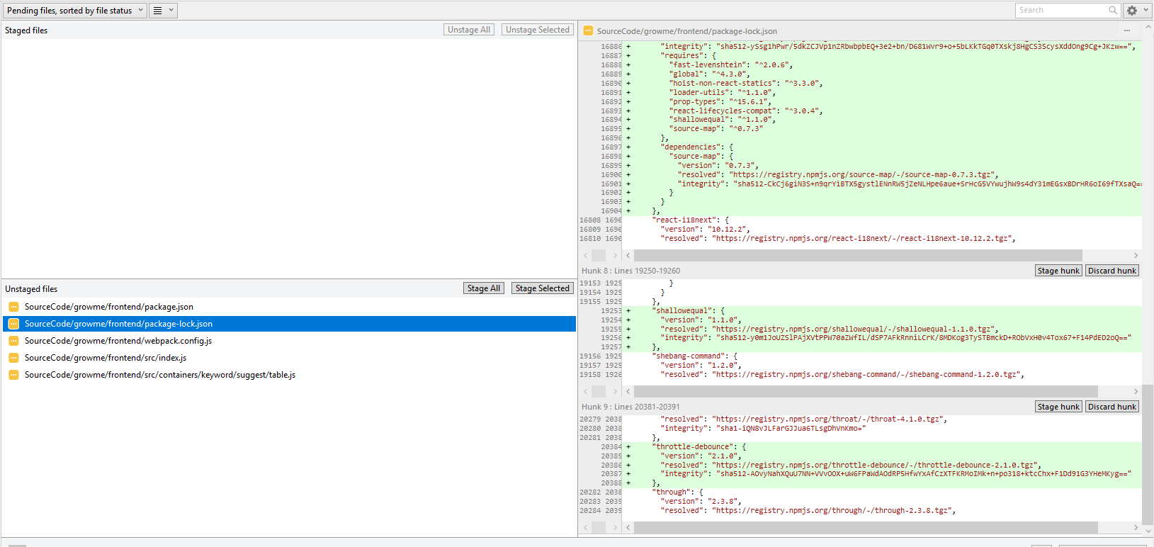

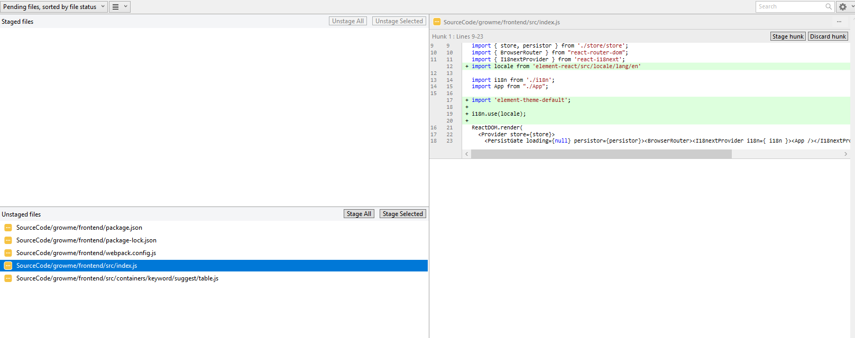

Datable

import React, { Component } from "react";

import { Col, Row } from "react-bootstrap";

import { connect } from "react-redux";

import { bindActionCreators } from "redux";

import SKSearchBox from "./sk_component/sk-search-box";

import { CardHeader, CardBody, GMLoadingLine, SwitchesLabelRight } from "../../../components/controls/index";

import * as keywordAction from 'store/modules/keyword/action';

import { withTranslation, Trans } from 'react-i18next';

import { AppSwitch } from '@coreui/react'

import {BootstrapTable, TableHeaderColumn} from 'react-bootstrap-table';

import { NavLink } from 'react-router-dom'

import { Table } from 'element-react';

export default class SuggestKeywordTable extends Component {

constructor(props) {

super(props);

this.state = {

columns: [

{

label: "Date",

prop: "date",

width: 180

},

{

label: "Name",

prop: "name",

width: 180

},

{

label: "Address",

prop: "address"

}

],

data: [{

date: '2016-05-03',

name: 'Tom',

address: 'No. 189, Grove St, Los Angeles'

}, {

date: '2016-05-02',

name: 'Tom',

address: 'No. 189, Grove St, Los Angeles'

}, {

date: '2016-05-04',

name: 'Tom',

address: 'No. 189, Grove St, Los Angeles'

}, {

date: '2016-05-01',

name: 'Tom',

address: 'No. 189, Grove St, Los Angeles'

}]

}

}

render() {

return (

<Table

style={{width: '100%'}}

columns={this.state.columns}

data={this.state.data}

/>

)

}

}