Software Requirements Specification

for

Shop Phone System

**Version 1.0 approved**

**Prepared by Group6**

**SE1620**

**Table of Contents**

**Table of Contents ii**

**Revision History iii**

**1.** **Introduction 1**

1.1 Purpose 1

1.2 Document Conventions 1

1.3 Project Scope 1

1.4 References 1

**2.** **Software Requirment 1**

2.1 User Case 1

2.2 Entity Relationship Diagram 2

2.3 Database Diagram 2

2.4 Active Diagram 2

2.5 Screen Flow 2

**Revision History**

| **Name** | **Date** | **Reason For Changes** | **Version** |
| --- | --- | --- | --- |
|  |  |  |  |
|  |  |  |  |

# Introduction

Phone shop is meant for the mobile phone shopping on the internet. This website includes the display and purchasing of mobile handsets of different companie. Users can go to Online Mobile phone store and get details about price and specification of any particular mobile handset and they can purchase it too.

## Purpose

The purpose of the project is to create an online phone selling website with a simple interface that is easy to use for everyone. users can easily view new phone models and can order online at any time admin can manage phone models in the site can edit them if needed and manage users and phone providers

## Project Scope

This document provides detailed requirements for admin for manage product, statistical of order, customer can buy product and check out online

# Software Requirment

## User Case

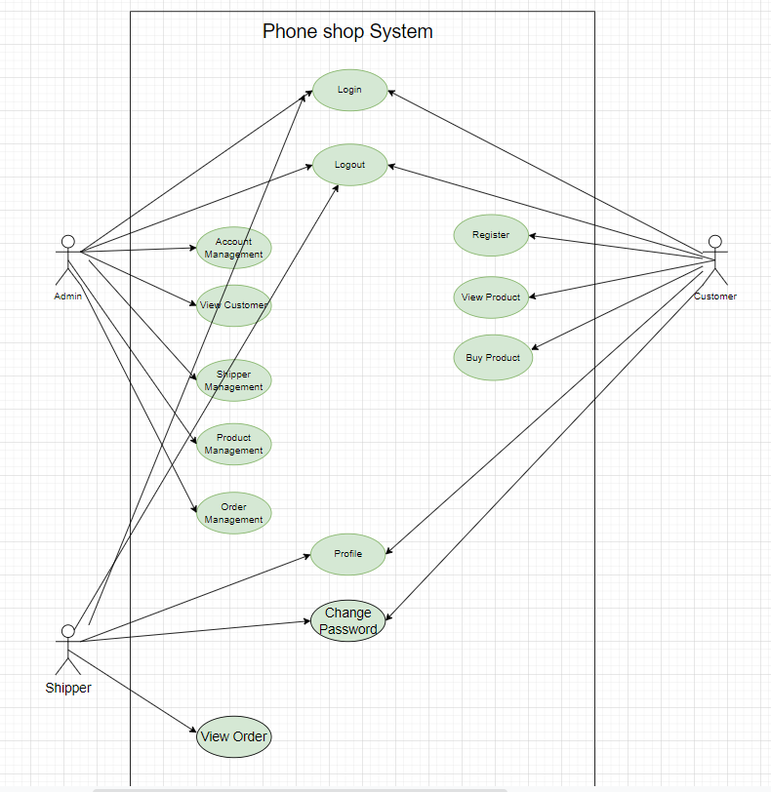

## Active Diagram

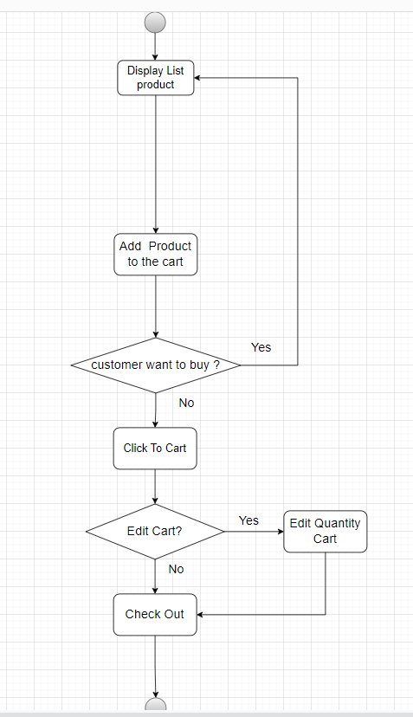

## Entity Relationship Diagram

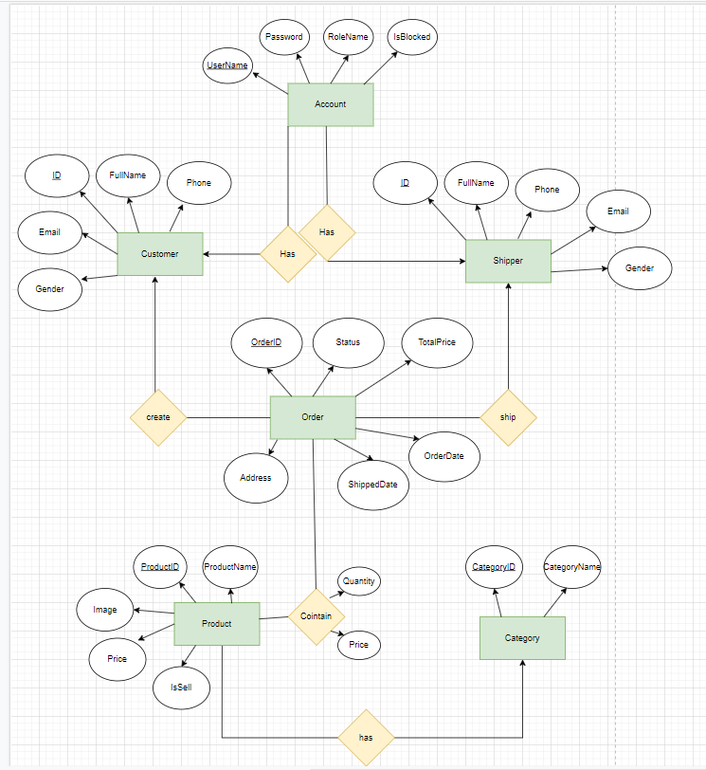

## Database Diagram

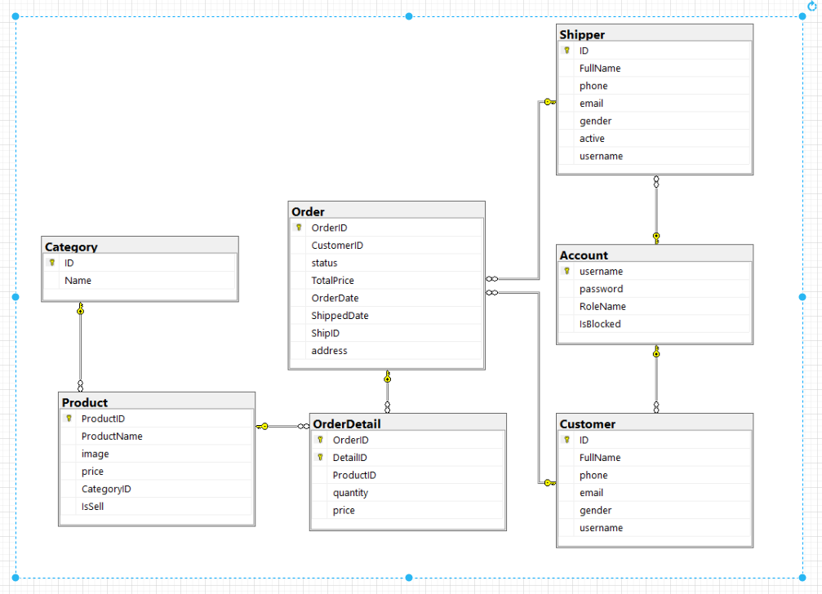

## Screen Flow

