**Vietnam general confederation of labour**

**Ton Duc Thang University**

**Information Technology major**



**COMPUTER NETWORK ASSIGNMENT**

**Build computer’s network for TDTU Dormitory**

*Instructor*: Mr Jae Young Hur and

Mr Bhagawan Nath

***Executor* : NGUYỄN TIẾN DŨNG – 51600017**

***Class* : 16050311**

***Course* : 20**

**Ho Chi Minh City, 2017**

**Acknowledgements**

During the period of doing a project, i received a plenty of enthusiastic help and support that guide and encourage me to overcome all difficulties and complete this project.firstly, i would like to express thanks to the teachers in Ton Duc Thang University and Information Technology creating favorable conditions for me to carry out my project. i am grateful to you for help and tranfer of precious experience which prepared me for knowledge and skills. secondly, i sincerely thank to Mr Nart and Mr Jae, my supervisor who gave me useful guidance and advice that help me do my project successfuly. from these advices, i can improve my research skills and written skills. without your devoted help, it is difficult for me to complete this project**.**

With my limited knowledge, i could not avoid making some mistakes. I hope that you sympathize with me. I am looking forward to receiving your comments about my project. Your comments will be the valuable knowledge for me. I am grateful to you for your comments.

**The essay is completed at Ton Duc Tang University**

I hereby declare that the project is the result of my own research with the guidance of Mr Nart and Mr Jae and has never been published in any work of others before. The number, the data and other contents which are used for analyzing, observing are the result of my own surveys and assemblage from different sources. All references in this project are clearly cited according to regulations.  
I bear full responsibility for the fidelity of the number, the data, and the contents of my project.

*Hồ Chí Minh city, October 25th ,2017*

*Author*

*(Sign and write full name)*

*Dũng*

*Nguyễn Tiến Dũng*

**CERTIFICATE AND ASSESSMENT OF THE TEACHER**

**Confirmation of the instructor**

_______________________________________________________________________________________________________________________________________________________________________________________________________________________________________________________________________________________________________________________________________________________________________________________________________________

Hồ Chí Minh city

*(Sign and write full name)*

**The assessment of the teacher marked**

_______________________________________________________________________________________________________________________________________________________________________________________________________________________________________________________________________________________________________________________________________________________________________________________________________________

Hồ Chí Minh city

*(Sign and write full name)*

**Table of contend**

Acknowledgement 3

Commitment 4

Lecturer’s assessment and opinion 5

Table of contend 6

1. DEFINITION OF THE INTERNET
2. What is the internet? 7
3. Configuration networks 7
4. What is the most popular network? 9
5. The internet equipment 9
6. Equipment’s principle working on the internet? 12
7. THE INTERNET BUILD GOALS
8. The request with the internet 12
9. Analyzing the requests 13
10. BULDING THE INTERNET MODEL
11. Cross section drawing model 14
12. Arranging and connecting network model 16
13. How to divide Subnetting? 16
14. How to wiring 17
15. ANALOGUE COMPUTER NETWORK ON CISCO PACKET TRACER
16. Building the internet on CSP 18
17. Configuration of SWITCH and ROUTER 19
18. Configuration of computer, server 24

Appendix 25

Reference material 25

1. **DEFINITION OF THE INTERNET AND NETWORK EQUIPMENT ARE USED**.
2. **What is the internet**?

* *Internet* is a system of many computers which are connected with the internet equipment or media by a structure; so computers can exchange the information to each other.

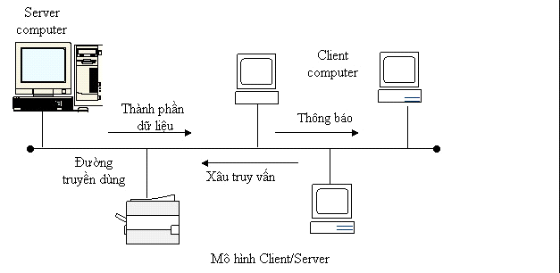

1. **How many configuration networks**?

* Configuration network (Topology network).
  + Star Network
    - advantage:
      * The speed is fastest.
      * Easy to check and fix when it has the trouble.
      * The network can be expanded.
    - disadvantage:
      * The cost is too expensive.
      * The distance between a computer and the center computer is limited (100 meters)
  + Bus Network
    - Advantage:
      * Easy to install and save money.
      * Computers are connected by a rope-way.
    - Disadvantage:
      * The speed is slow.
      * Difficulty in checking and fixing when it has trouble.
      * When the rope-way has troubles, the system will be stopped.
  + Ring Network
    - Advantage:
      * It can be expended.
      * The speed is more quickly than Bus.
    - Disadvantage:
      * When the rope-way has troubles, the system will be stopped.
      * Difficulty in checking and fixing when it has problems.
* Network type according to the distribution range:
* ***LAN***( Local Area Network): run in a small area(from 2 meters to 2 kilometers). It is usually used in the factory, office,…to share the resource and exchange the information .

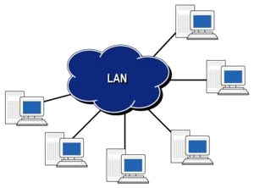

* ***MAN***( Metropolitan Area Network): the area is used is bigger than LAN(limit to use in 2 kilometers), and it is usually used in the near factories in the city.

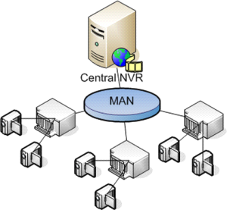

* ***GAN***( Global Area Network): The distance is from some countries. It can be connected by satellite or telecom.

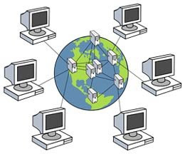

* ***WAN*** ( Wide Area Network): The distance from hundreds to millions kilometers. It can be come-over continents or even is nations.

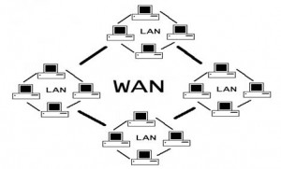

1. **What is the most popular network? Why?**

* In a large number of network, the most popular network is LAN: LAN( local area network) :
* It has a big band width, online app can be used by connecting the internet.
* The cost is low.
* Managing LAN is easy.
* WAN ( wide area network):
* The area used is big, unlimited.

1. **What is the equipment internet included?**

* Transmission equipment:
  + Landline equipment:
    - Coaxial cable: There are two kinds of coaxial cable(Thick-Thin Coaxial).
    - Twisted pair cable: includes four electric wires which are twisted one-on-one, inside it has sheath or not.
    - Fiber optic cable.
  + wireless: radio waves, microwaves, infrared waves , …
  + Coaxial cable:
    - ThinNet
      * Easy to execute
      * The largest distance is 185 meters.
    - ThinkNet
      * Hard and difficulty in executing.
      * The largest distance is 500 meters.
    - Advantage: Get abroad far
* Connecting equipment :
  + Reapeater

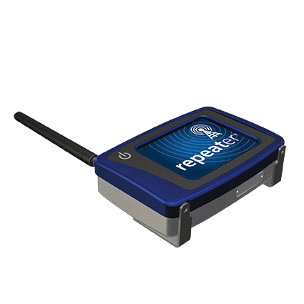

* + Hub

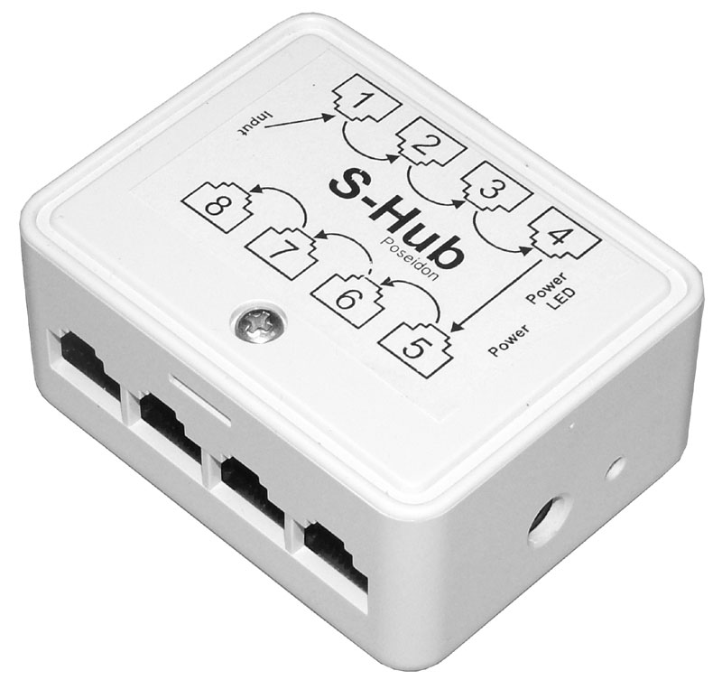

* + 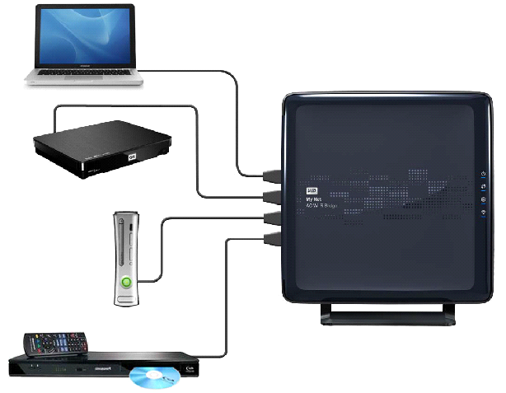Bridge
  + 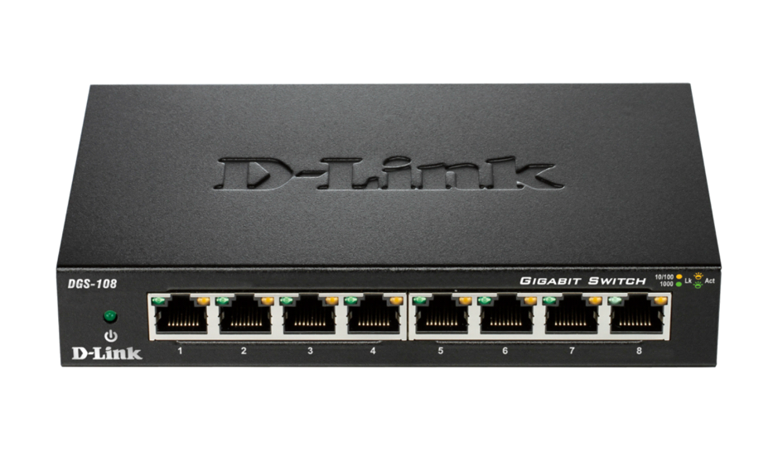Switch

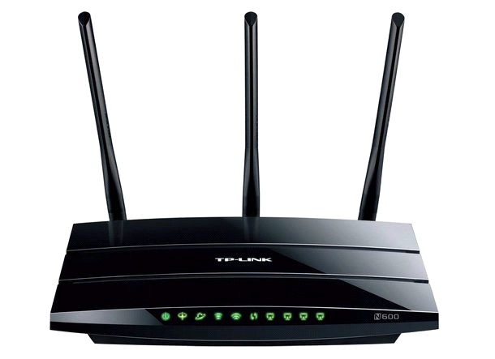

* + Router
  + 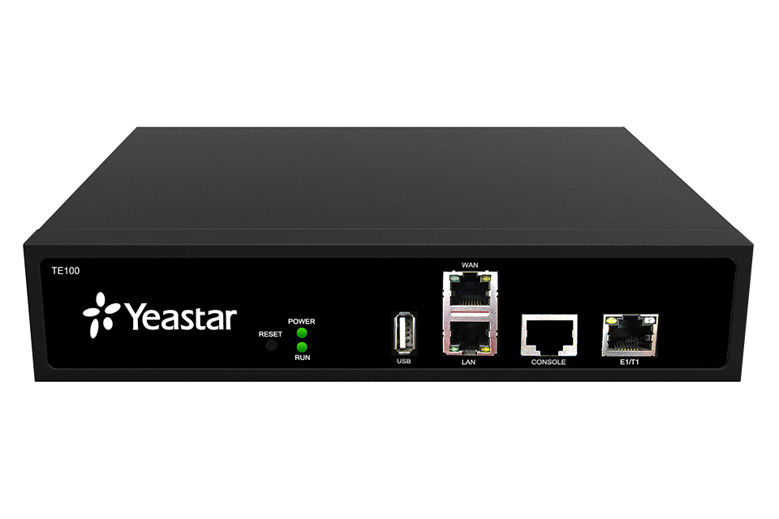Gateway

5. **Operating principle of the equipment in the computer network** .

* *Reapeater*: amplifies the physical signal at the input and energizes the signal at the output.
* *Hub*: : amplifies the incoming signal and outputs the remaining ports, ensuring the required signal level.
* *Bridge:* pair two networks to form a single large network, observing packets on every network. When a packet from a networked computer is moved to another computer on the network, Bridge copies and sends the packet to the destination network.
* *Switch*: move the data frames from the source to the destination, and build the switch table.
* *Router*: : handle many types of protocols, network routing.
* *Gateway*: pairing two types of protocols together, distinguish the application.
* *Modem*: : is a device used to connect two computers or two devices remotely through the telephone network.
* *Network*  card is a device that connects the computer and the network cable.

*Wireless Access Point*: Wireless IEEE 802.11 compliant, which allows LAN to LAN connection, using CSMA / CA mechanism.

1. **THE BUILDING INTERNET GOALS:**
2. **Demonstrate the requirements for computer networks**

* Logical network design: logical network design involves selecting network models, network protocols and setting configurations for network identity components. The most common issues when setting up a network model are:
  + Locates network components, including domain names, workgroups, computers, IP addresses for machines, and ports for each service .
  + Subdivide sub-network, make a roadmap for information on the network .
* Design a network diagram at the physical level.
* Network settings.
* Calculate funding for the network.
* Learn the technology popular in the market.
* Requirements of network stability and bandwidth.
* The network must be secure both in terms of data and information.

1. **Analyze the requirements and provide a rough configuration of the network (including what devices, requirements for equipment, how to connect network equipment)**

-After learning about the infrastructure of the unit, we have grasped the network of KTX Ton Duc Thang University is implemented as follows:

* + Ground floor consists of 1 room
  + 1st floor- 10th floor each floor consists of 16 rooms, each with 1wifi and 8 computers.
* Equipment needed :
  + Switch: 24 ports, each port can support all Ethernet LAN.
  + Router:
  + Computer: Minimum 256MB of RAM. Operating system: Microsoft Windows XP above .
* How to connect devices
  + Router: Used in connecting multiple networks and allowing packets to travel in different directions to the destination. Between the routers and switches are connected by Copper Strainght-Through cable
  + Switch: used to maintain the bridge between the network equipment. Between the switches are connected by Copper Cross-Over cable, between the switch and the computer connected by Copper Strainght-Through cable..

**III. BULDING THE INTERNET MODEL**

1. **Cross section drawing model.**

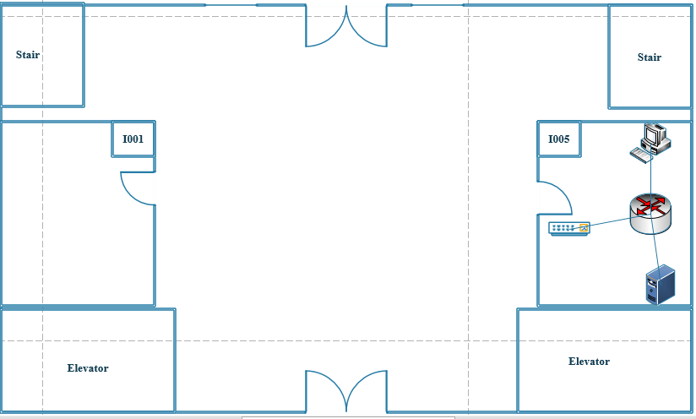

Ground floor dormitory

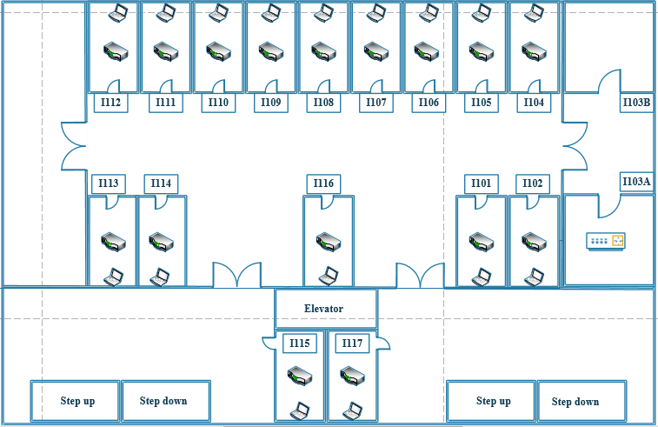

Floor 1 -> Floor 10

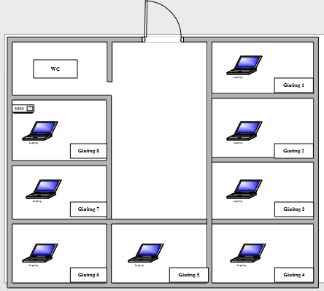

Room 1 -> Room 16

1. **Arranging and connecting network model.**

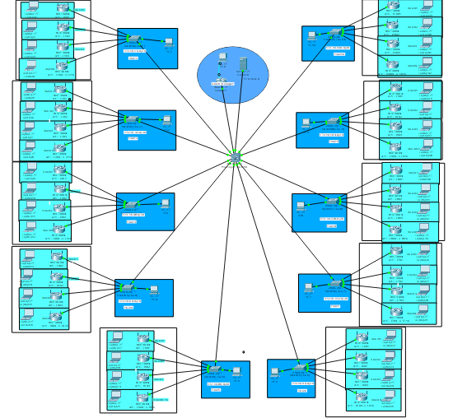

Analogue computer network on cisco packet tracer

1. **How to subnet from the command line to match the computer requirements**.

* In order to divide the subnet, we must understand the following concepts and formulas according to the Variable Length Subnet Masking (VLSM) method:
  + Understand the concepts of::
    - Bit, byte.
    - Binary, decimal.
    - Operation AND.
    - Các cách biến đổi số từ hệ Thập phân sang hệ Nhị phân và ngược lại.
    - IP address structure.
    - Subnet includes all bits for host 0.
    - The Broadcast section includes all the bits for the host with 1.
* Recipe :
  + Number of subnets created : 2*m( m is the number of bits borrowed from the host ID)
  + Số Host/Subnet: 2*n ( n is the number of remaining bits of the host ID after being borrowed).
  + New subnet mask = old subnet mask + m ( the number of bits borrowed).

1. **Calculate wiring and other requirements according to the assigned topic.**



G floor spacing dormitory

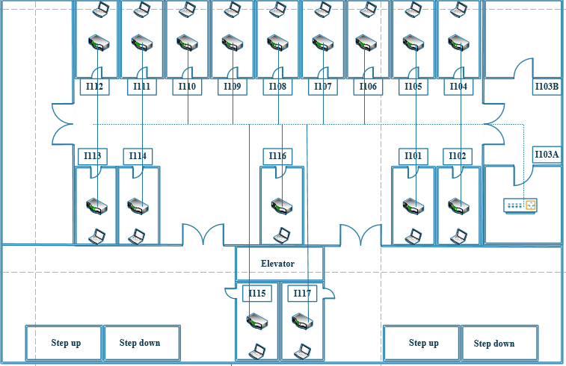

Distance of 1st floor -> 10th floor

**IV. ANALOGUE COMPUTER NETWORK ON CISCO PACKET TRACER**

1. **Building the internet on Cisco Packet Tracer.**



Analogue computer network on cisco packet tracer

1. **Configuration of SWITCH and ROUTER.**

* **Switch:**

switch#enable

switch#conf t

* **Configuring VLANs for each switch:**

Switch(config)#vlan 10

Switch(config-vlan)#name Floor1

Switch(config-vlan)#exit

Switch(config)#vlan 20

Switch(config-vlan)#name Floor2

Switch(config-vlan)#exit

Switch(config)#vlan 30

Switch(config-vlan)#name Floor3

Switch(config-vlan)#exit

Switch(config)#vlan 40

Switch(config-vlan)#name Floor4

Switch(config-vlan)#exit

Switch(config)#vlan 50

Switch(config-vlan)#name Floor5

Switch(config-vlan)#exit

Switch(config)#vlan 60

Switch(config-vlan)#name Floor6

Switch(config-vlan)#exit

Switch(config)#vlan 70

Switch(config-vlan)#name Floor7

Switch(config-vlan)#exit

Switch(config)#vlan 80

Switch(config-vlan)#name Floor8

Switch(config-vlan)#exit

Switch(config)#vlan 90

Switch(config-vlan)#name Floor9

Switch(config-vlan)#exit

Switch(config)#vlan 100

Switch(config-vlan)#name Floor10

Switch(config-vlan)#exit

Switch(config)#vlan 111

Switch(config-vlan)#name server

Switch(config-vlan)#exit

* **Assign VLAN to each interface accordingly:**
  + Floor1, assign fa0/1 to VLAN 10

Switch(config)#int fa0/1

Switch(config-if)#switchport mode access

Switch(config-if)#switchport access vlan 10

Switch(config-if)#exit

Switch(config)#

* + Floor2, assign fa0/2 to VLAN 20

Switch(config)#int fa0/2

Switch(config-if)#switchport mode access

Switch(config-if)#switchport access vlan 20

Switch(config-if)#exit

Switch(config)#

* + Floor3, assign fa0/3 to VLAN 30

Switch(config)#int fa0/3

Switch(config-if)#switchport mode access

Switch(config-if)#switchport access vlan 30

Switch(config-if)#exit

Switch(config)#

* + Floor4, assign fa0/4 to VLAN 40

Switch(config)#int fa0/1

Switch(config-if)#switchport mode access

Switch(config-if)#switchport access vlan 40

Switch(config-if)#exit

Switch(config)#

* + Floor5, assign fa0/5 to VLAN 50

Switch(config)#int fa0/5

Switch(config-if)#switchport mode access

Switch(config-if)#switchport access vlan 50

Switch(config-if)#exit

Switch(config)#

* + Floor6, assign fa0/6 to VLAN 60

Switch(config)#int fa0/6

Switch(config-if)#switchport mode access

Switch(config-if)#switchport access vlan 60

Switch(config-if)#exit

Switch(config)#

* + Floor7, assign fa0/7 to VLAN 70

Switch(config)#int fa0/7

Switch(config-if)#switchport mode access

Switch(config-if)#switchport access vlan 70

Switch(config-if)#exit

Switch(config)#

* + Floor8, assign fa0/8 to VLAN 80

Switch(config)#int fa0/8

Switch(config-if)#switchport mode access

Switch(config-if)#switchport access vlan 80

Switch(config-if)#exit

Switch(config)#

* + Floor9, assign fa0/9 to VLAN 90

Switch(config)#int fa0/9

Switch(config-if)#switchport mode access

Switch(config-if)#switchport access vlan 90

Switch(config-if)#exit

Switch(config)#

* + Floor10, assign fa0/10 to VLAN 100

Switch(config)#int fa0/1

Switch(config-if)#switchport mode access

Switch(config-if)#switchport access vlan 100

Switch(config-if)#exit

Switch(config)#

* + Server, assign fa0/11 to VLAN 111

Switch(config)#int fa0/11

Switch(config-if)#switchport mode access

Switch(config-if)#switchport access vlan 111

Switch(config-if)#exit

Switch(config)#

**Configure the interface between the switch and the router to mode trunk.**

* Router:
  + B1: Router(config)#int fa0/0

Router(config-if)#no shut

Router(config-if)#exit

Router(config)#

* + B2: Router(config)#int fa0/0.1

Router(config-subif)#encapsulation dot1q 10

Router(config-subif)#ip add 172.16.16.1 255.255.240.0

Router(config-subif)#exit

Router(config)#

* + B3: Router(config)#int fa0/0.2

Router(config-subif)# encapsulation dot1q 20

Router(config-subif)#ip add 172.16.32.1 255.255.240.0

Router(config-subif)#exit

Router(config)#

* + B4: Router(config)#int fa0/0.3

Router(config-subif)# encapsulation dot1q 30

Router(config-subif)#ip add 172.16.48.1 255.255.240.0

Router(config-subif)#exit

Router(config)#

* + B5: Router(config)#int fa0/0.4

Router(config-subif)# encapsulation dot1q 40

Router(config-subif)#ip add 172.16.64.1 255.255.240.0

Router(config-subif)#exit

Router(config)#

* + B6**:** Router(config)#int fa0/0.5

Router(config-subif)# encapsulation dot1q 50

Router(config-subif)#ip add 172.16.80.1 255.255.240.0

Router(config-subif)#exit

Router(config)#

* + B7**:** Router(config)#int fa0/0.6

Router(config-subif)#encapsulation dot1q 60

Router(config-subif)#ip add 172.16.96.1 255.255.240.0

Router(config-subif)#exit

Router(config)#

* + B8**:** Router(config)#int fa0/0.7

Router(config-subif)#encapsulation dot1q 70

Router(config-subif)#ip add 172.16.112.1 255.255.240.0

Router(config-subif)#exit

Router(config)#

* + B9**:** Router(config)#int fa0/0.8

Router(config-subif)#encapsulation dot1q 80

Router(config-subif)#ip add 172.16.128.1 255.255.240.0

Router(config-subif)#exit

Router(config)#

* + B10**:** Router(config)#int fa0/0.9

Router(config-subif)#encapsulation dot1q 90

Router(config-subif)#ip add 172.16.144.1 255.255.240.0

Router(config-subif)#exit

Router(config)#

* + B11**:** Router(config)#int fa0/0.10

Router(config-subif)#encapsulation dot1q 100

Router(config-subif)#ip add 172.16.160.1 255.255.240.0

Router(config-subif)#exit

Router(config)#

* + B11**:** Router(config)#int fa0/0.11

Router(config-subif)#encapsulation dot1q 100

Router(config-subif)#ip add 172.16.0.1 255.255.240.0

Router(config-subif)#exit

Router(config)#

**Configuration on interface DHCP và DNS .**

* + B1: Router(config)#ip dhcp pool Floor1

Router(dhcp-config)#network 172.16.16.0 255.255.240.0

Router(dhcp-config)#default-router 172.16.16.1

Router(dhcp-config)#dns-server 172.16.0.100

Router(dhcp-config)#ip dhcp excluded-add 172.16.16.1

Router(config)#

* + B2: Router(config)#ip dhcp pool Floor2

Router(dhcp-config)#network 172.16.32.0 255.255.240.0

Router(dhcp-config)#default-router 172.16.32.1

Router(dhcp-config)#dns-server 172.16.0.100

Router(dhcp-config)#ip dhcp excluded-add 172.16.32.1

Router(config)#

* + B3: Router(config)#ip dhcp pool Floor3

Router(dhcp-config)#network 172.16.48.0 255.255.240.0

Router(dhcp-config)#default-router 172.16.48.1

Router(dhcp-config)#dns-server 172.16.0.100

Router(dhcp-config)#ip dhcp excluded-add 172.16.48.1

Router(config)#

* + B4: Router(config)#ip dhcp pool Floor4

Router(dhcp-config)#network 172.16.60.0 255.255.240.0

Router(dhcp-config)#default-router 172.16.60.1

Router(dhcp-config)#dns-server 172.16.0.100

Router(dhcp-config)#ip dhcp excluded-add 172.16.60.1

Router(config)#

* + B5: Router(config)#ip dhcp pool Floor5

Router(dhcp-config)#network 172.16.80.0 255.255.240.0

Router(dhcp-config)#default-router 172.16.80.1

Router(dhcp-config)#dns-server 172.16.0.100

Router(dhcp-config)#ip dhcp excluded-add 172.16.80.1

Router(config)#

* + B6: Router(config)#ip dhcp pool Floor6

Router(dhcp-config)#network 172.16.96.0 255.255.240.0

Router(dhcp-config)#default-router 172.16.96.1

Router(dhcp-config)#dns-server 172.16.0.100

Router(dhcp-config)#ip dhcp excluded-add 172.16.96.1

Router(config)#

* + B7: Router(config)#ip dhcp pool Floor7

Router(dhcp-config)#network 172.16.112.0 255.255.240.0

Router(dhcp-config)#default-router 172.16.112.1

Router(dhcp-config)#dns-server 172.16.0.100

Router(dhcp-config)#ip dhcp excluded-add 172.16.112.1

Router(config)#

* + B8: Router(config)#ip dhcp pool Floor8

Router(dhcp-config)#network 172.16.128.0 255.255.240.0

Router(dhcp-config)#default-router 172.16.128.1

Router(dhcp-config)#dns-server 172.16.0.100

Router(dhcp-config)#ip dhcp excluded-add 172.16.128.1

Router(config)#

* + B9: Router(config)#ip dhcp pool Floor29

Router(dhcp-config)#network 172.16.144.0 255.255.240.0

Router(dhcp-config)#default-router 172.16.144.1

Router(dhcp-config)#dns-server 172.16.0.100

Router(dhcp-config)#ip dhcp excluded-add 172.16.144.1

Router(config)#

* + B10: Router(config)#ip dhcp pool Floor10

Router(dhcp-config)#network 172.16.160.0 255.255.240.0

Router(dhcp-config)#default-router 172.16.160.1

Router(dhcp-config)#dns-server 172.16.0.100

Router(dhcp-config)#ip dhcp excluded-add 172.16.160.1

Router(config)#

1. **Configuration of computer, server**

* Computer::
  + Configured on the switch..
* Server:
  + On the DNS Server:
    - Config static IP address

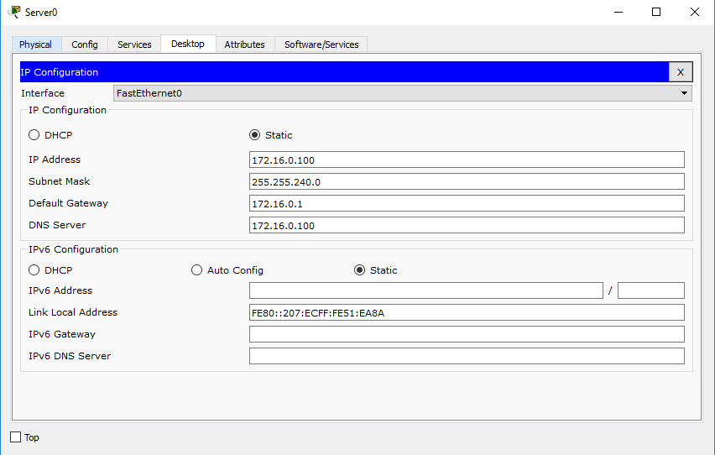

Configure the IP for the server

* APPENDIX

Calculate the cost of construction (not including the cost of buying machines for users). This cost may include the cost of buying a server as a Proxy Server or DNS Server.

Expected Device List:

* + - Router Cisco: 1 router.
    - Switch: 10 Switch 24 port.
    - Multilayer Switch: 1 Switch 24 port.
    - Network cables: use the cable STP (Shiel Twist Pair).
    - Cable connector : use RJ-45 connector.
  + Expense:

|  |  |  |  |  |  |
| --- | --- | --- | --- | --- | --- |
| **STT** | **Device** | **The company** | **Parameter** | **Number** | **price (VNĐ)** |
| 1. | Router Cisco 1841-SEC/K9 | CISCO | *Model: CISCO 1841-SEC/K9*  *Port number*: 2 x RJ45 10/100 Mbps Base-T  *Communication Standards:*ITU G.992.1, ITU G.992.2, TU-T G.991.2, ITU G992.3  *Nguồn*: AC 110-220V (60Hz) | 1 | 26.500.000 |
| 2. | Switch | CISCO | *Model*: Catalyst WS – C2950-24  *Port number*: 24 x RJ45 10/100 Mbps  *Communication Standards:*IEEE 802.3, IEEE 802.3u, IEEE 802.1d, IEEE 802.1p, IEEE 802.3x, IEEE 802.1x.  *Nguồn*: 100-240 VAC/50-60 Hz | 10 | 42.000.000 |
| 3. | Switch Cisco WS-C3560-24PS | CISCO | *Model*: WS-C3560X-24T-L  *Port number*: 24 x 10/100/1000 Mbps  *Communication Standards:*  IEEE 802.3, IEEE 802.3u, IEEE 802.3z, IEEE 802.1D, IEEE 802.1Q, IEEE 802.3ab, IEEE 802.1p, IEEE 802.3x, IEEE 802.3ad (LACP), IEEE 802.1w, IEEE 802.1x, IEEE 802.1s  *Source:* | 1 | 40.750.000 VND |
| 4. | Network Cable STP | CHINA | CAT 6 | 2000m | 16.000.000  (8.000/m) |
| 5. | IBM System X3500 M5 |  |  | 1 | 67.500.000 |
| 5. | Cable connectors RJ-45 |  |  | 170 | 680.000  (4.000) |
| 6. | Wireless router | CHINA |  | 160 | 40.000.000 |
| Total: | | | | | 225.430.000 |

* REFERENCES:

1. NUS Lecture Note, *Operating To Computer Network*.
2. <http://searchnetworking.techtarget.com/tip/How-to-subnet-Subnetting-calculations-and-shortcuts>
3. <http://searchnetworking.techtarget.com/definition/star-network>
4. <https://www.lifewire.com/local-area-network-816382>
5. https://www.google.com.vn/search?q=o%09LAN(+Local+Area+Network&tbm=isch&tbo=u&source=univ&sa=X&ved=0ahUKEwjH896JrbjXAhXClJQKHZK3AuUQsAQIRQ