1. FEEL View Plus Overview
1.1 Login Screen

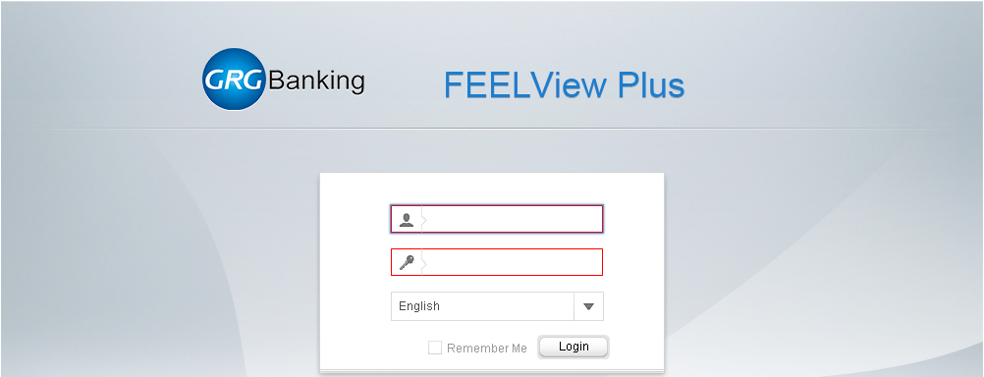

Username | Enter the username of the account
Password | Enter the password of the account
Language | Choose the language
Remember Me | Remember for the Login
Login | Login button to login into the system

1.2 Homepage
1.2.1 Dashboard Screen
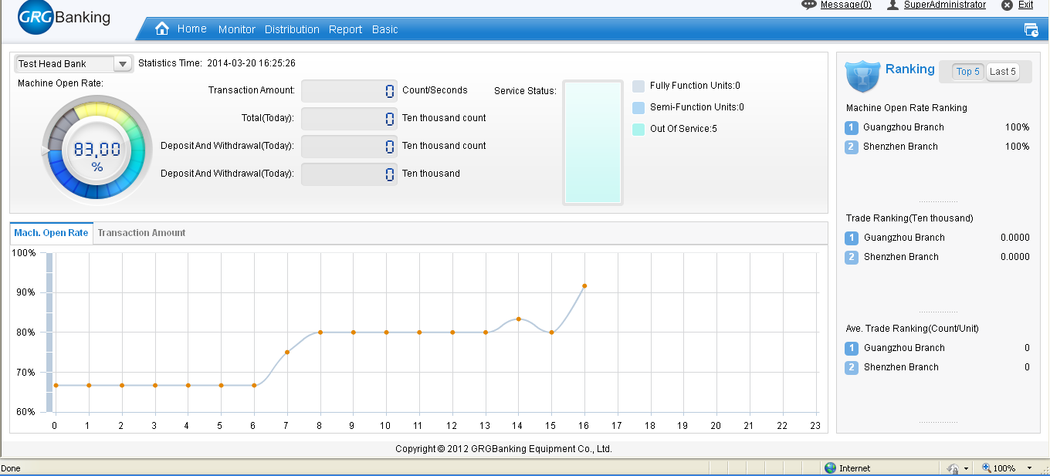

This is the summary screen for activities of the system

1.2.2 Main Menu



Home | Go to the Dashboard screen
Monitor | Functions to monitor terminals
Distribution | Functions to do distribution task to terminals
Report | Function to do reports
Basic | Functions to do configuration for the terminals and the system

2. Monitoring Function

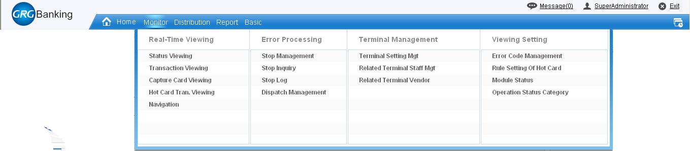

Real – Time Viewing | Real time checking the status, transaction and other info
Error Processing | Control errors within the system
Terminal Management | Functions to manage terminals within the system
Viewing Setting | Configure code used in displaying information within the system

2.1 Real Time Viewing
2.1.1 Status Viewing

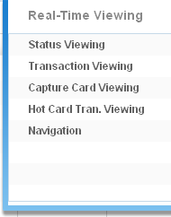

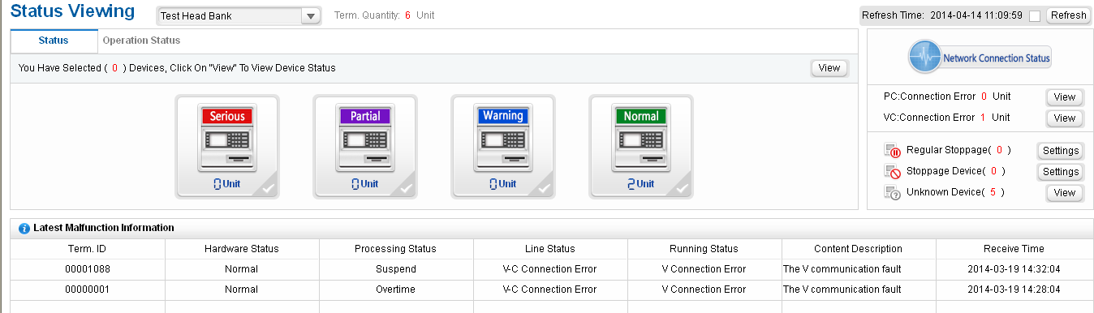

This function allows to real time monitor status for all of the ATM machines within the system

2.1.1.1 Details of ATM Status
Click on the group icon to show all the ATM belonging

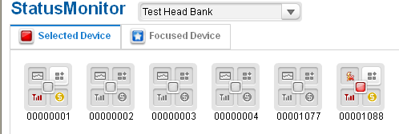

2.1.2 Transaction Viewing

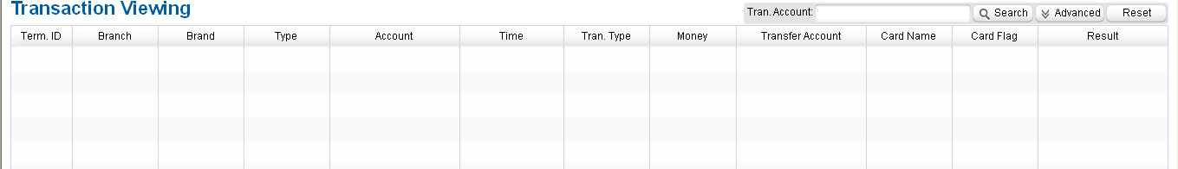

Term ID | The terminal ID
Branch | The branch of the terminal
Type | The terminal type
Account | The account number
Time | The time of the transaction
Tran. Type | The type of the transaction
Money | The transaction amount
Transfer Account | The account used to transfer
Card Name | The name on card
Card Flag | The card flag
Result | The transaction result

