GRG Banking CMS Card Issue and Account Binding Process

A. Part 1 – Generate the Card Number
This part guide to configure the Card Number

Step1: Card Type Design
Go to System Configuration → Card Type Design → Click on the Add button

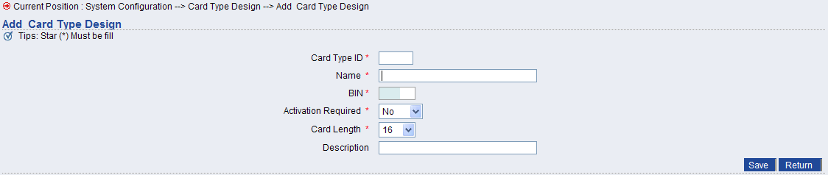

Fill in the form to create a card type

Step2: Card BIN Table
One Card Type has one or many BIN
Go to System Configuration → Card BIN Table → Click on the Add button

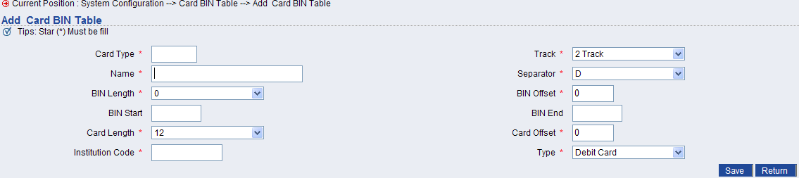

Fill in the form to create a BIN for a card type

Step3: Card Product Design
One Card Product has one or many Card Type
Go to System Configuration → Card Product Design → Click on the Add button

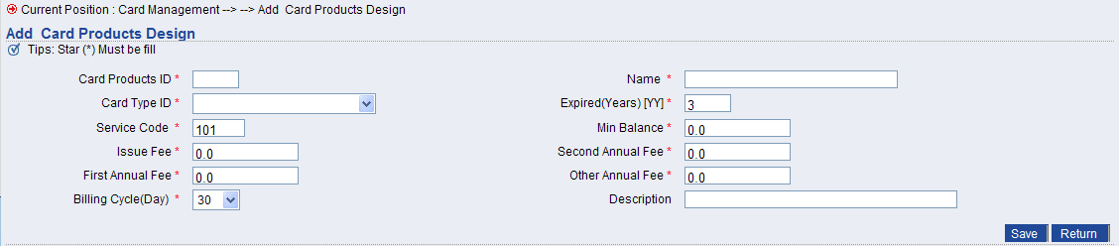

Fill in the form to create a card product

Step4: Card Group Design
This step to create Card Number in advance
Go to Card Management → Card Group Design

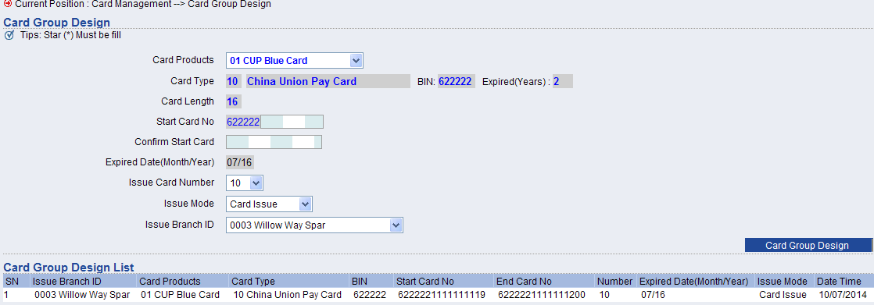

Fill in the form then click on the Card Group Design button

B. Part 2 – Issue the Card

Step 1: Fill up the Customer Information
The bank Staff need to collect the customer info first, then fill up this form
Go to Card Management → Customer Infomation → Click on Add button

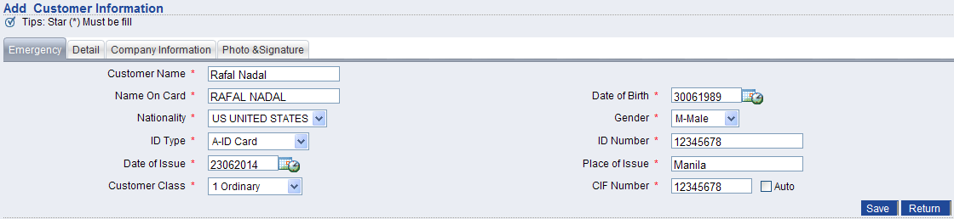

Click on Save button to Save for this customer

Step 2: Fill up the Application Form
Go to Card Management → Application Form → Click on Add button

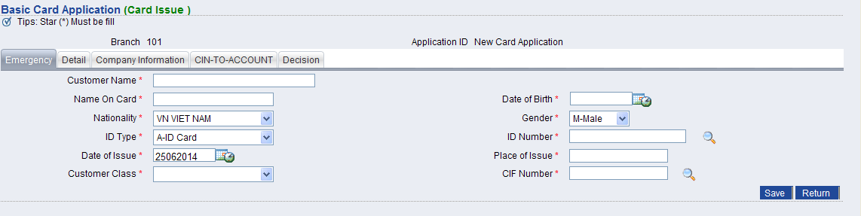

Click on Save button to Save for this Card

Step 3: Approve the Application Form
User an account that have the permission
Go to Card Management → Application Form → Click on the Application that need to approve

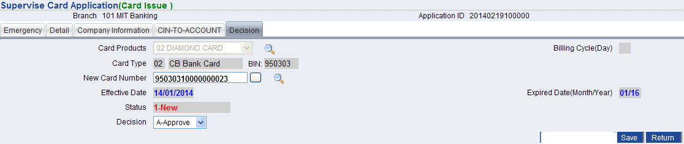

Choose Approve then Save

Step 4: Export to Embossing File
User an account that have the permission
Embossing File is the file that contains the info that used in the Card Printer

Go to Card Management → Embossing File → Click on the Export to Embossing File button
Then, you will be notify to download a file, pass this file to Card Printing Staff

Step 5: Confirm for Card that Already Printed
User an account that have the permission
After the staff take the embossing file to print for cards, when finished printing, then the staff need to confirm that which cards are already printed to prevent it is printed again
Go to Card Management → Card Making Confirm

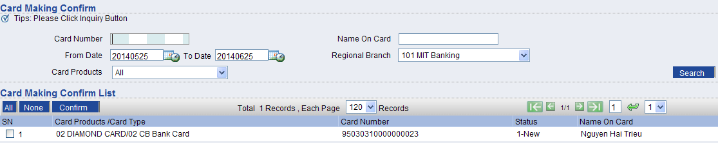

Tick on Cards that already printed then click on Confirm button

Step 6: Print PIN for a Card
User an account that have the permission
Go to Card Management → PIN Printing

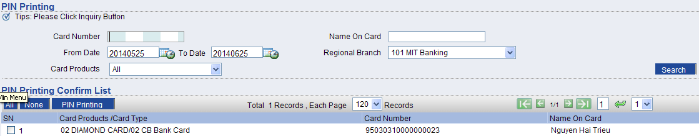

Tick on the Card that needs to print the PIN then click on the PIN Printing button
This action lead to PIN is sent to a printer to print PIN envelop

Step 7: Print PIN Confirm
User an account that have the permission
Go to Card Management → PIN Printing Confirm

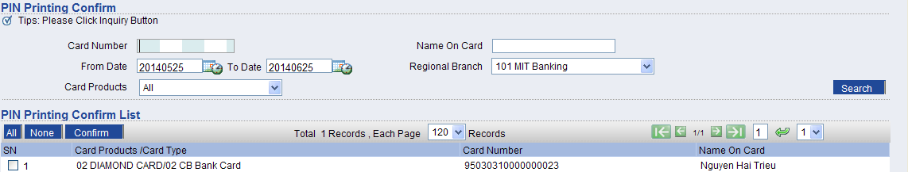

Tick on the cards that already got PIN printed to prevent that PIN is printed again

Step 8: Record that which cards are issue to customers
User an account that have the permission
When an card process is finished until step 7, then the bank staff need to physical deliver the card to customer. Then, we need to record this
Go to Card Management → Issue to Customer

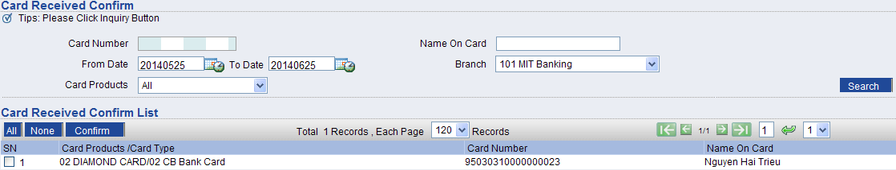

Tick on the card that already delivered to customer then click on the Confirm button

Written by Kevin Nguyen Tien Phuc
Version 1.0 at 25th June 2014
Email: Kevin.nguyen@grgbanking.com

