Assignment – Part 1

name "find-max"

org 100h ; directive make tiny com file.

; finds the largest element in a vector of N elements,
; store result in m.

; variables and constants

N equ 10

; number of elements:
mov cx, N

; push the number of elements to the stack
push cx
; push the vector starting address to the stack
push offset vector

call find_max

; wait for any key press:
mov ah, 0
int 16h

ret

vector dw 5, 4, 5, 2, 1, 10, 30, 99, 3, 1
m dw 0

;finds the maximum number within the vector address
;passed through the stack. size of the vector is
;passed through stack

find_max proc

;********
;
;Add your code here
;
;********
push bp
mov bp, sp

mov cx,6[bp]
mov bx,4[bp]
mov ax, m

loop1:
cmp ax ,word ptr [bx]
jge notupdate
mov ax, word ptr [bx]

notupdate:
add bx,2
dec cx

jnz loop1
mov m,ax

pop bp
ret
endp

Assignment – Part 2

1. The output message upon arrival of the interrupt

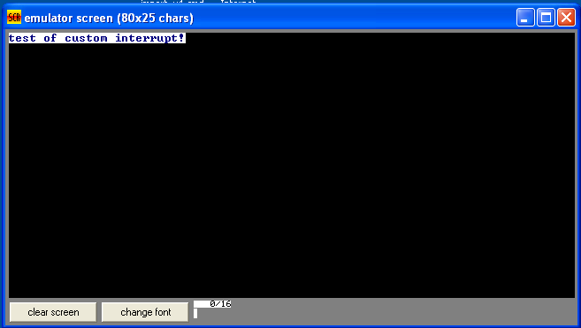

2. The hex hardware file
Student ID: 10110088

