Table of Content

A. Introduction 1

B. HTML 5 Learning Point 1
1. HTML 5 Tag Learning 1
1.1 HTML Editor 1
1.2 HTML Document 2
1.3 HTML Heading Element 2
1.4 HTML Paragraph 2
1.5 HTML Background Color 2
1.6 HTML Quotation 3
1.7 HTML Computer Code Elements 3
1.8 HTML Comments 3
1.9 HTML Styles – CSS 3
1.10 HTML Links Element 3
1.11 HTML Images Element 3
1.12 HTML Tables Elements 3
1.13 HTML Lists Elements 4
1.14 HTML Block and Inline Elements 4
1.15 HTML Layouts 4
2. Common Errors with HTML 5 5
2.1 Common Validation Errors 5
2.2 No Doctype at All 5
2.3 Forgetting to Close an Element 5
2.4 Missing / on Self Closing Elements 5
2.5 Forgetting to Convert Special Characters 6

C. CSS 3 Learning Point 6
1. CSS 3 Tag Learning 6
1.1 CSS Editor 6
1.2 CSS Syntax 6
1.3 CSS Comments 7
1.4 The Element Selector 7
1.5 The id Selector 7
1.6 The class Selector 8
2. Common Errors with CSS 3 8
2.1 Remember to Comment a Stylesheet 8
2.2. Forget the Punctuation 8
2.3 Use Shorthand Whenever Possible 8
2.4 Use the TROUBLE Method 9
2.5 Too Much Whitespace 9

D. Conclusion 9

Reference 10

HTML 5 and CSS 3

A. Introduction
HTML 5 (Hyper Text Markup Language 5) and CSS 3 (Cascading Style Sheets 3) is the two basic technology to design for the Graphic User Interface (GUI) in the web platform. If we need to create a website like online bookstore, airline ticket online, auction site or even mobile application on IOS or Android, we need HTML and CSS to make the interface for the software. Despite the different backend technology we may use as Java Platform, .NET Platform. PHP Platform, etc, HTML and CSS are compatible to create good look and feel interfaces. HTML and CSS are considered as the most simple, light weight and easy compatible front end technology in the online software development industry. Even though, there are many specific front end technology are developed as Java Server Page (JSP) and Java Server Faces (JSF) from Java, or Velocity from Apache, they cannot replace HTML and CSS. They even based on HTML to enhance their technology. So, we can say that HTML and CSS is the basic and essential front end technology that we must experience and master if we want to develop the career in the web and online software development industry.

B. HTML 5 Learning Point
HTML has a long development periods, it is first release with the basic HTML with standard tag to design interfaces. Then, it is improved to the XHTML, the Extensible HTML that allows use to defined their own tag besides the predefined tag. It offers developers more choices in designing. Next, the DHTML is released. It is the Dynamic HTML, which allow embedding dynamic content into the site. Finally, the HYML 5 is release as the latest version until now. As a student, we should learn the HTML 5 to experience about new tag that they offer for the social media like Youtube and Facebook. But, the basic of HTML knowledge is also needed to make us easy to catch up new ideas

1. HTML 5 Tag Learning
1.1 HTML Editor
HTML can be edited by using professional HTML editors like Microsoft WebMatrix Sublime Text. However, for student learning HTML we should use simple text editors like Notepad (PC) or TextEdit (Mac). We believe using a simple text editor is a good way to learn HTML.

We can name the file as "index.html" or any other name ending with html or htm. UTF-8 is the preferred encoding for HTML files. To open the saved HTML file in your favorite browser, double to the file.

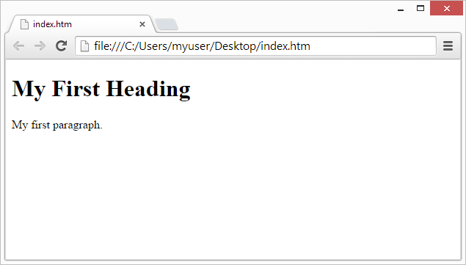

1.2 HTML Document
All HTML documents must start with a type declaration: <!DOCTYPE html>.
The HTML document itself begins with <html> and ends with </html>.
The visible part of the HTML document is between <body> and </body>.

Example:
<!DOCTYPE html>
<html>
<body>
<h1>My First Heading</h1>
<p>My first paragraph.</p>
</body>
</html>

1.3 HTML Heading Element
Headings are defined with the <h1> to <h6> tags.
<h1> defines the most important heading. <h6> defines the least important heading.

Example
<h1>This is a heading</h1>
<h2>This is a heading</h2>
<h3>This is a heading</h3>

1.4 HTML Paragraph
The HTML <p> element defines a paragraph.

Example
<p>This is a paragraph</p>
<p>This is another paragraph</p>

1.5 HTML Background Color
The background-color property defines the background color for an HTML element:

This example sets the background for a page to lightgrey:
Example
<body style="background-color:lightgrey;">
<h1>This is a heading</h1>
<p>This is a paragraph.</p>
</body>

1.6 HTML Quotation
The HTML <q> element defines a short quotation.
Browsers usually insert quotation marks around the <q> element.

Example
<p>WWF's goal is to: <q>Build a future where people live in harmony with nature.</q></p>

1.7 HTML Computer Code Elements
The <code></code> element to add code into the HTML, this is the new tag in the HTML 5

<code>
var x = 5;
var y = 6;
document.getElementById("demo").innerHTML = x + y;
</code>

1.8 HTML Comments
You can add comments to your HTML source by using the following syntax:
<!-- Write your comments here -->

1.9 HTML Styles - CSS
Inline styling is used to apply a unique style to a single HTML element:
Inline styling uses the style attribute.

This example changes the text color of the <h1> element to blue:
<h1 style="color:blue;">This is a Blue Heading</h1>

1.10 HTML Links Element
HTML Links - Syntax
In HTML, links are defined with the <a> tag:
<a href="url">link text</a>

1.11 HTML Images Elements
n HTML, images are defined with the <img> tag.
The <img> tag is empty, it contains attributes only, and does not have a closing tag.
The src attribute specifies the URL (web address) of the image:
<img src="url" alt="some_text">

1.12 HTML Tables Elements
Tables are defined with the <table> tag.
Tables are divided into table rows with the <tr> tag.
Table rows are divided into table data with the <td> tag.
A table row can also be divided into table headings with the <th> tag.

Example
<table style="width:100%">
<tr>
<td>Jill</td>
<td>Smith</td>
<td>50</td>
</tr>
<tr>
<td>Eve</td>
<td>Jackson</td>
<td>94</td>
</tr>
</table>

1.13 HTML Lists Elements
n unordered list starts with the <ul> tag. Each list item starts with the <li> tag.
The list items will be marked with bullets (small black circles):

Example
<ul>
<li>Coffee</li>
<li>Tea</li>
<li>Milk</li>
</ul>

1.14 HTML Block and Inline Elements
he <div> element is a block-level element that is often used as a container for other HTML elements.
The <div> element has no required attributes, but style and class are common.
When used together with CSS, the <div> element can be used to style blocks of content:

Example
<div style="background-color:black; color:white; padding:20px;">
<h2>London</h2>
<p>London is the capital city of England. It is the most populous city in the United Kingdom, with a metropolitan area of over 13 million inhabitants.</p>
</div>

1.15 HTML Layouts
This example uses four <div> elements to create a multiple column layout:

Example
<body>
<div id="header">
<h1>City Gallery</h1>
</div>
<div id="nav">
London<br>
Paris<br>
Tokyo
</div>
<div id="footer">
Copyright © W3Schools.com
</div>
</body>

2. Common Errors with HTML 5
2.1 Common Validation Errors
Many of the sites looked great, but as we can see, the quality of code just doesn’t match the quality of the design. The thing is, all of these errors can be easily fixed in minutes.

2.2 No Doctype at All
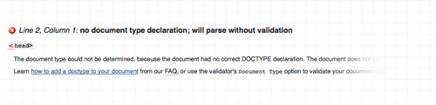
The worst thing we could do validation wise is to forget a Doctype. No Doctype means browsers will have to guess what language your page is written in. To fix this error and all the subsequent issues, add a HTML or XHTML doctype to your page.

2.3 Forgetting to Close an Element
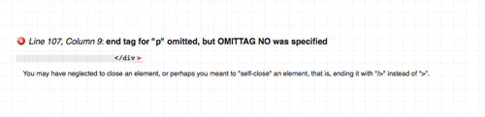
If we’ve opened a tag somewhere in our HTML document, you must remember to close it in the appropriate place. Forgetting to do so won’t just invalidate our HTML, it might also be the cause of some serious layout problems. The warning for this in the W3C validator is the cryptic message end tag for “p” omitted, but OMITTAG NO was specified, which basically means we forget to close that paragraph tag

2.4 Missing / on Self Closing Elements
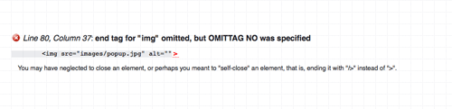
Most HTML elements have a separate closing tag, eg: </div>, but other elements like input, img and meta are self closing, this means they have a trailing slash before their closing bracket. Forgetting this is just the same as forgetting a closing tag altogether.

2.5 Forgetting to Convert Special Characters
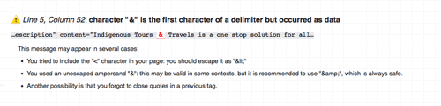
The ampersand is probably the most popular offender here, along with quotation marks that have been pasted in from Word. Always remember to check through your body copy and convert any & signs to the HTML entity &amp;, and all other special characters to their appropriate entity symbol.

C. CSS 3 Learning Point
Some student wonder that we HTML 5 is a powerful tool to design a GUI, so why we need the CSS? What is the usefulness for the CSS? Through the class lessons, we see that despite HTML is a powerful tool, CSS is much more power than in the positioning and navigation design for the page. We need to clarify that HTML just provide the elements as controls to display data. But, how is data is displayed, CSS will help to improve the visualization of the data. Besides, CSS will work with the JavaScript to produce wonderful effects to make the websites look more dynamic and attract users attention. Therefore, learning and master CSS 3 is compulsory for web and online application designers to make the products have a professional and good look and feel.

1. CSS 3 Tag Learning
1.1 CSS Editor
Like the HTML 5, CSS can be developed using simple tool as Notepad or Notepad++. The css file must ending with the extension .css. Then, we can embedded the css file in the HTML file using the <style></style> element.

1.2 CSS Syntax
A CSS rule-set consists of a selector and a declaration block:

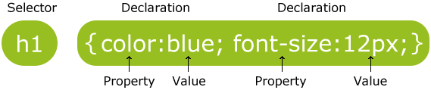

The selector points to the HTML element you want to style.
The declaration block contains one or more declarations separated by semicolons.
Each declaration includes a CSS property name and a value, separated by a colon.
A CSS declaration always ends with a semicolon, and declaration blocks are surrounded by curly braces.

In the following example all <p> elements will be center-aligned, with a red text color:
Example
p {
color: red;
text-align: center;
}

1.3 CSS Comments
Comments are used to explain the code, and may help when you edit the source code at a later date. Comments are ignored by browsers.
A CSS comment starts with /* and ends with */. Comments can also span multiple lines:

Example
p {
color: red;
/* This is a single-line comment */
text-align: center;
}
/* This is
a multi-line
comment */

1.4 The Element Selector
The element selector selects elements based on the element name.
You can select all <p> elements on a page like this (in this case, all <p> elements will be center-aligned, with a red text color):

Example
p {
text-align: center;
color: red;
}

1.5 The id Selector
The id selector uses the id attribute of an HTML element to select a specific element.
An id should be unique within a page, so the id selector is used if you want to select a single, unique element.

To select an element with a specific id, write a hash (#) character, followed by the id of the element.
The style rule below will be applied to the HTML element with id="para1":

Example
#para1 {
text-align: center;
color: red;
}

1.6 The class Selector
The class selector selects elements with a specific class attribute.
To select elements with a specific class, write a period (.) character, followed by the name of the class.
In the example below, all HTML elements with class="center" will be red and center-aligned:

Example
.center {
text-align: center;
color: red;
}

2. Common Errors with CSS3
2.1 Remember to Comment a Stylesheet
Most web designers new to stylesheets are actually unaware that they can add brief “comments” to their document as they create it, helping to break this large set of styles in to easy parts that can be searched, moved around, and deleted when they are no longer needed. Comments are denoted by slashes and asterisks both before and after the comment itself. When it’s put together, it looks like the following:
/* This is a CSS Comment */

2.2. Forget the Punctuation
The number one thing that causes a stylesheet to stop functioning is the lack of punctuation that can cause elements and classes to run together. While stylesheets are inherently rather basic and pragmatic, they do make extensive use of commas, brackets, and semi-colons when indicating the closure of an element, class, ID, or form element. A well-designed CSS class looks like the example below:
.class {
margin: 0;
padding: 0 3px 0 3px;
font-family: "Times New Roman", "Times Roman", Roman, serif;
color: #000;
}

2.3 Use Shorthand Whenever Possible
The key to a great CSS file is to cut down on the actual size of the file and make it perform all of its functions in the most efficient way possible. The best way to do this is to simply use shorthand wherever possible. Stylesheets actually have a robust number of elements that can be cut short and, as any web designer should know, less characters equals a smaller file size. This is especially true in text-only documents like stylesheets and raw XHTML files.

2.4 Use the TROUBLE Method to Avoid Repetitious Elements Throughout CSS Classes
The novice developer often assumes that each side of a box top, left, bottom, and right must be styled and defined separately. In fact, CSS even include such indicators in its specification. That’s why elements like “margin-right” and “padding-left” exist and are used so frequently. And while there is nothing invalid about this method of writing a stylesheet, it’s needlessly wasteful in terms of file size and can extend a page’s loading time significantly when used throughout the document. Here’s what a beginner’s stylesheet might look like when defining the padding of an element:
.class {
padding-left: 0;
padding-right: 0
padding-top: 0;
padding-bottom: 0;
}

2.5 Too Much Whitespace.
This common programming language does not require a single space between lines of code, classes, or other design definition elements. Those blank lines are permitted, however, and there is nothing preventing developers from using them. It’s not considered invalid or a bad practice at all. It is, however, considered a waste of space and the file’s size, and this can lead to slower page loading times. When in doubt, remove spaces and use comments to indicate the purpose of elements rather than spacing them out and causing the stylesheet file to become so excessive.

D. Conclusion
Finally, in my conclusion, I see that the class lesions of the HTML 5 and CSS 3 is so useful so student in the development of the Graphic User Interfaces. By study the learning points above, I see that HTML and CSS are rather simple and easy to learn, but they are really powerful tools. I also aware that HTML and CSS are important for any website or online application that need attractive and good look and feel interfaces. Therefore, I myself will try my best to master them as well as recommend all of the other students to learn the HTML and CSS.

References

A Tutorial For HTML 5. (n. d. ) . Retrieved from http://www.html5andcss3.org/

CSS 3 School Learning. (n. d. ) . Retrieved from https://www.codeschool.
com/courses/front-end-formations

Learn HTML5 Programming From Scratch. (n. d. ) . Retrieved from https://www.
udemy.com/learn-html5-programming-from-scratch/

Main Features of CSS 3. (n. d. ) . Retrieved from http://www.tutorialspoint.
com/css/css3_tutorial.htm

HTML 5 and CSS 3. (n. d. ) . Retrieved from http://www.hongkiat.
com/blog/tag/series-html5-css3-tuts/

HTML 5 Tutorial. (n. d. ) . Retrieved from http://www.html5tutorial.info/

Some Critical Point for HTML 5. (n. d. ) . Retrieved from http://www.
html-5-tutorial.com/

The Complete CSS 3 Tutorial. (n. d. ) . Retrieved from http://www.css3-tutorial.net/

The HTML 5 for Student Learning. (n. d. ) . Retrieved from http://www.tutorialspoint
.com/html5/

